##### REPORT

**INDEX**

**Chapter – 1**

Introduction

* 1. Purpose
  2. Scope
  3. Technologies to be Used
  4. Overview

**Chapter – 2**

Overall Description

2.1) The Goal of Proposed System

2.2) Requirements of Project

**Chapter – 3**

Feasibility Study

3.1) Technical Feasibility

3.2) Operational Feasibility

3.3) Economic Feasibility

**Chapter – 4**

Project work in 20 Days

**Chapter – 5**

Output Screens

**Pupose:** Our shipping software helps you focus on growing your business. Start by connecting your e-commerce platform to Shippo to automatically sync order information. Then, create all shipping labels and docs you may need for domestic and international orders.   
  
What’s more, Shippo helps you customize the user experience, offering branded emails and tracking pages. Plus, we make it easy to create affordable return labels, print in batch, and do so much more.

**Scope:** The scope of these services is very good. Through our website its very easy to handle all shipping facilities.

**Technologies to be used:**

1. **.net MVC**
2. **C#**
3. **SQL Server**
4. **Entity Framework**

**Overview:** This project is related to shipping services. In this project there are two levels Admin and Manager.Admin can manage all the modules. Where Manager can access only permissionable modules.

**Goals of proposed system:**

**1. Planned approach towards working: -** The working in the organization will be well planned and organized. The data will be stored properly in data stores, which will help in retrieval of information as well as its storage.

**2. Accuracy: -** The level of accuracy in the proposed system will be higher. All operation would be done correctly and it ensures that whatever information is coming from the center is accurate.

**3. Reliability: -** The reliability of the proposed system will be high due to the above stated reasons. The reason for the increased reliability of the system is that now there would be proper storage of information.

**4. No Redundancy: -** In the proposed system utmost care would be that no information is repeated anywhere, in storage or otherwise. This would assure economic use of storage space and consistency in the data stored.

**Hardware/Software Requirements**

**System Specifications Minimum Hardware Requirements:-**

* I3 Processor
* 4 GB Ram
* Hard disk 500 GB
* Microsoft Compatible 101 or more Key Board Software Requirements: -

**Operating System** :

* Windows 7 , 10
* Programming language: .NET
* Web-Technology: ASP.NET 4.5
* Front-End: ASP.NET MVC
* Back-End: SQL SERVER
* Web Server: IIS
* **Technical Feasibility:** The project entitles "Hospital Management System” is technically feasibility because of the below mentioned feature. The project was developed in Asp.net MVC which is depending upon Model View Controller. It provides the high level of reliability, availability and compatibility. All these make Asp.net MVC an appropriate language for this project. Thus the existing software Asp.net MVC is a powerful language.
* **Economical Feasibility:** The computerized system will help in automate the selection leading the profits and details of the organization. With this software, the machine and manpower utilization are expected to go up by 80-90% approximately. The costs incurred of not creating the system are set to be great, because precious time can be wanted by manually.
* **Operational Feasibility:** In this project, the management will know the details of each project where he may be presented and the data will be maintained as decentralized and if any inquires for that particular contract can be known as per their requirements and necessaries.

**Project Work In (20 Days)**

|  |  |
| --- | --- |
| 1st Day to 8th Day | Feasibility Study |
| 9thDay to 12th Day | **Requirement Gathering** |
| 13th Day to 15th Day | **Designing** |
| 16th Day to 18th Day | **Coding** |
| 19th Day to 21st Day | **Testing and Implementation** |

**Output Screens**

1. **Home Page**: When admin logins then he can access the all modules of website and home page will be shown. Which are shown in the picture.

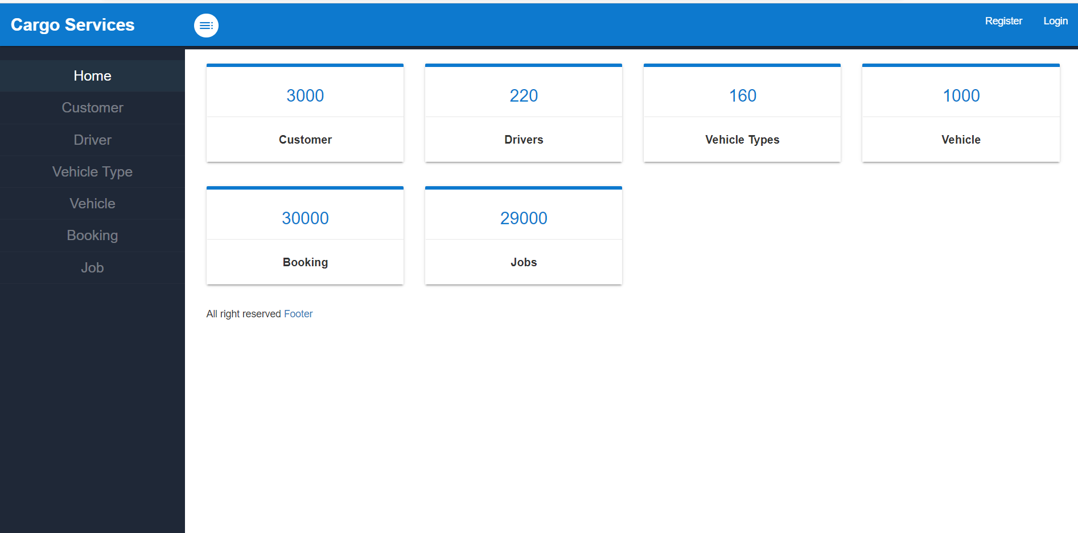

1. **Register Page: -** This is Register page in where you can register new user

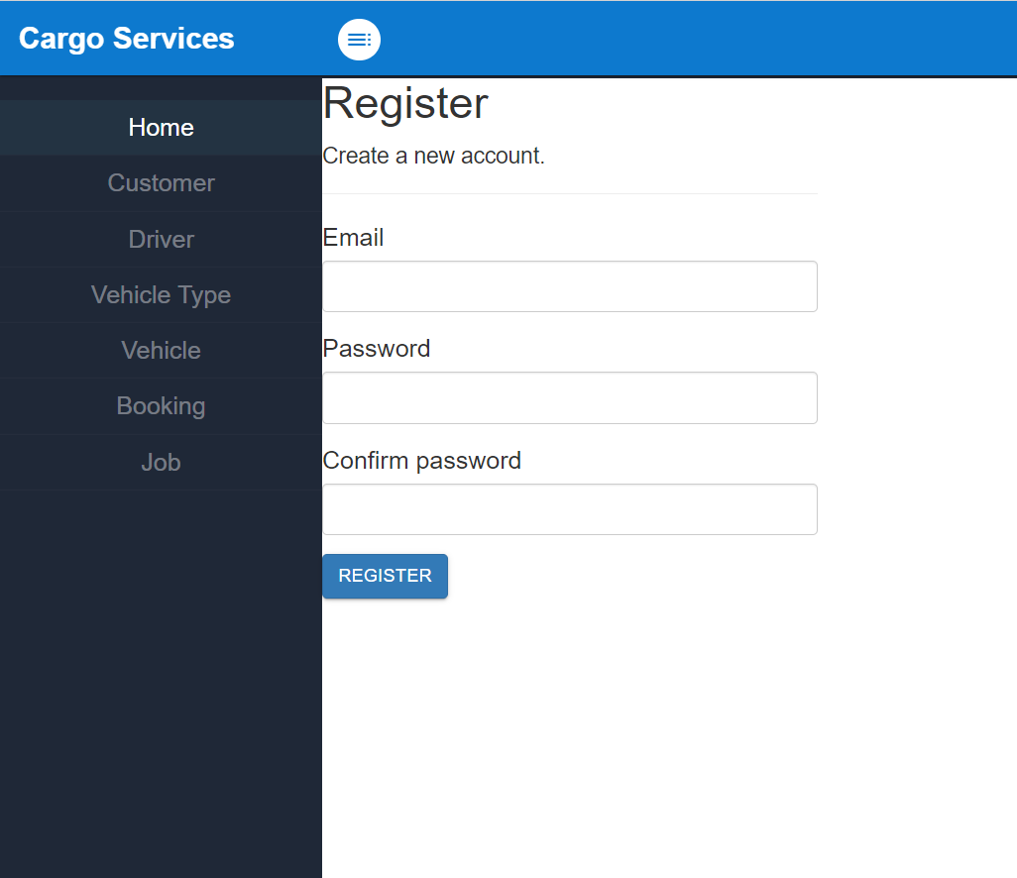

**3. Login Page: -** This is Login page of our website. In this page I can login as a Admin or as a Manager.

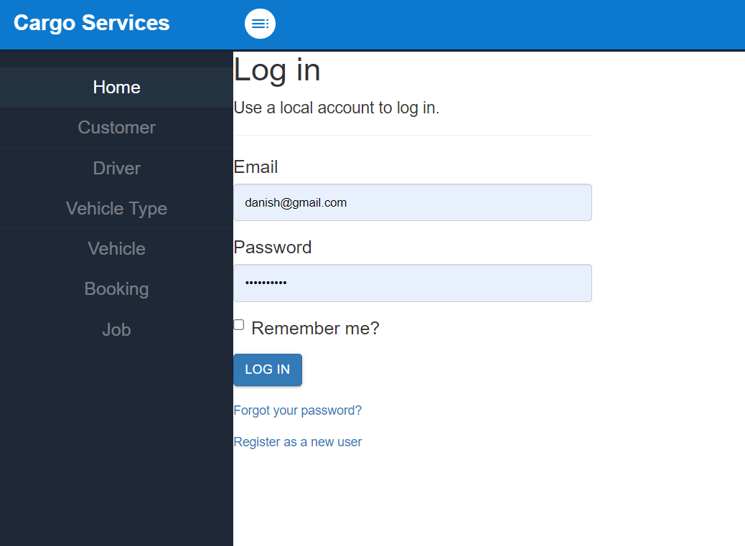

1. **Customer: -**  Here I can show the customer in my website. And clicking on the create new link I can create the customer. Edit and delete customer are also available here.

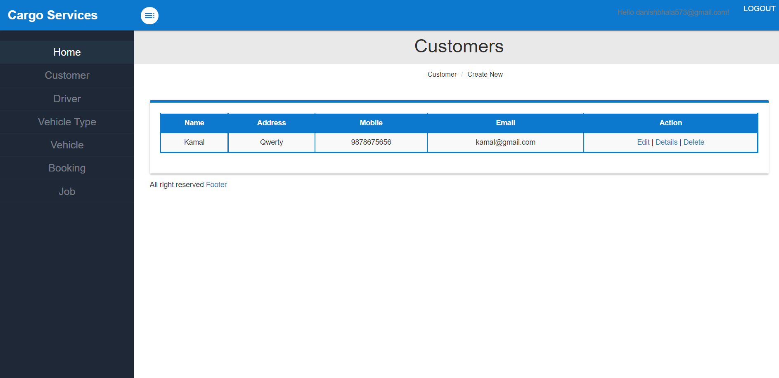

**4. Customer Add: -**  Here I can show the customer add form in my website. And clicking on the create new link I can create the driver. Edit and delete driver are also available here.

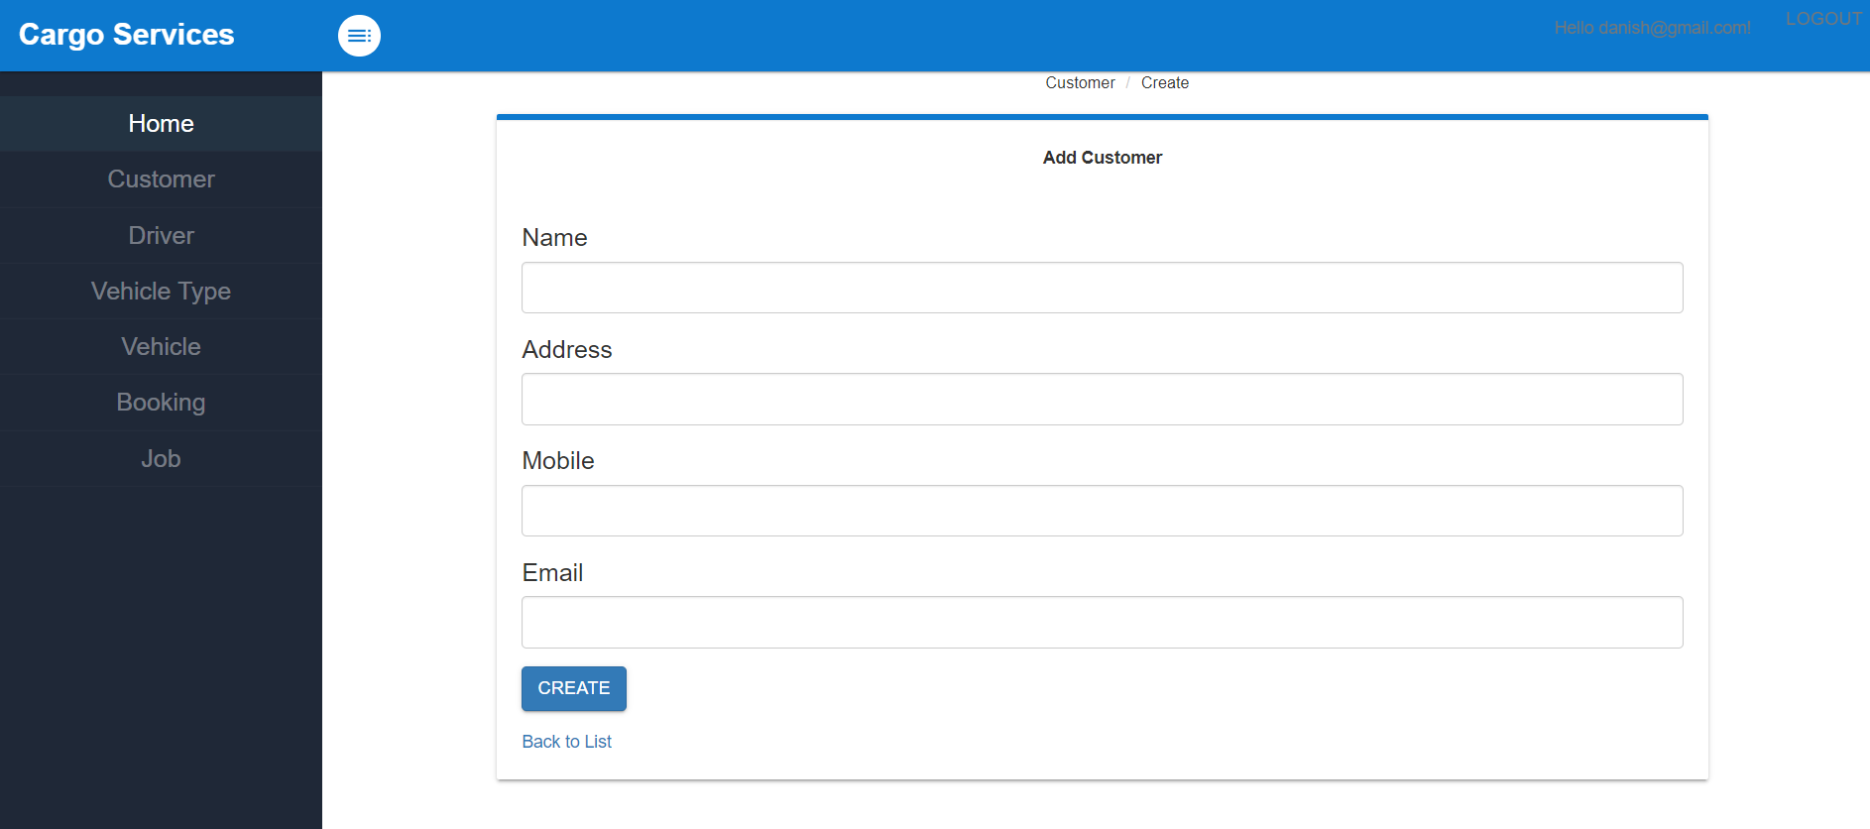

**5.Edit Customer:**

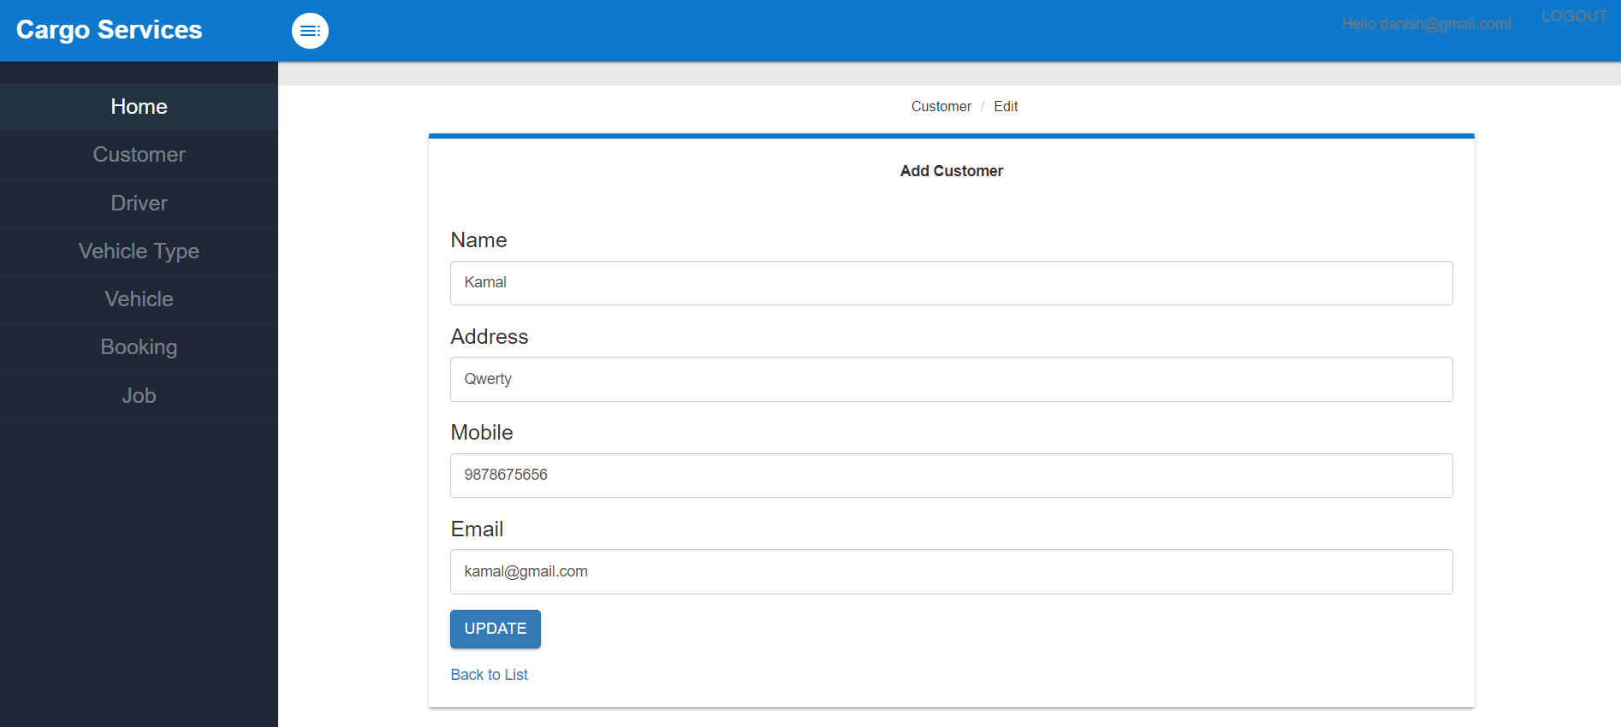

**6.Detail Customer:**

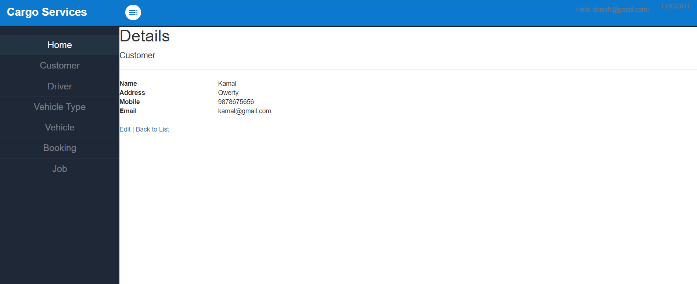

7.Driver

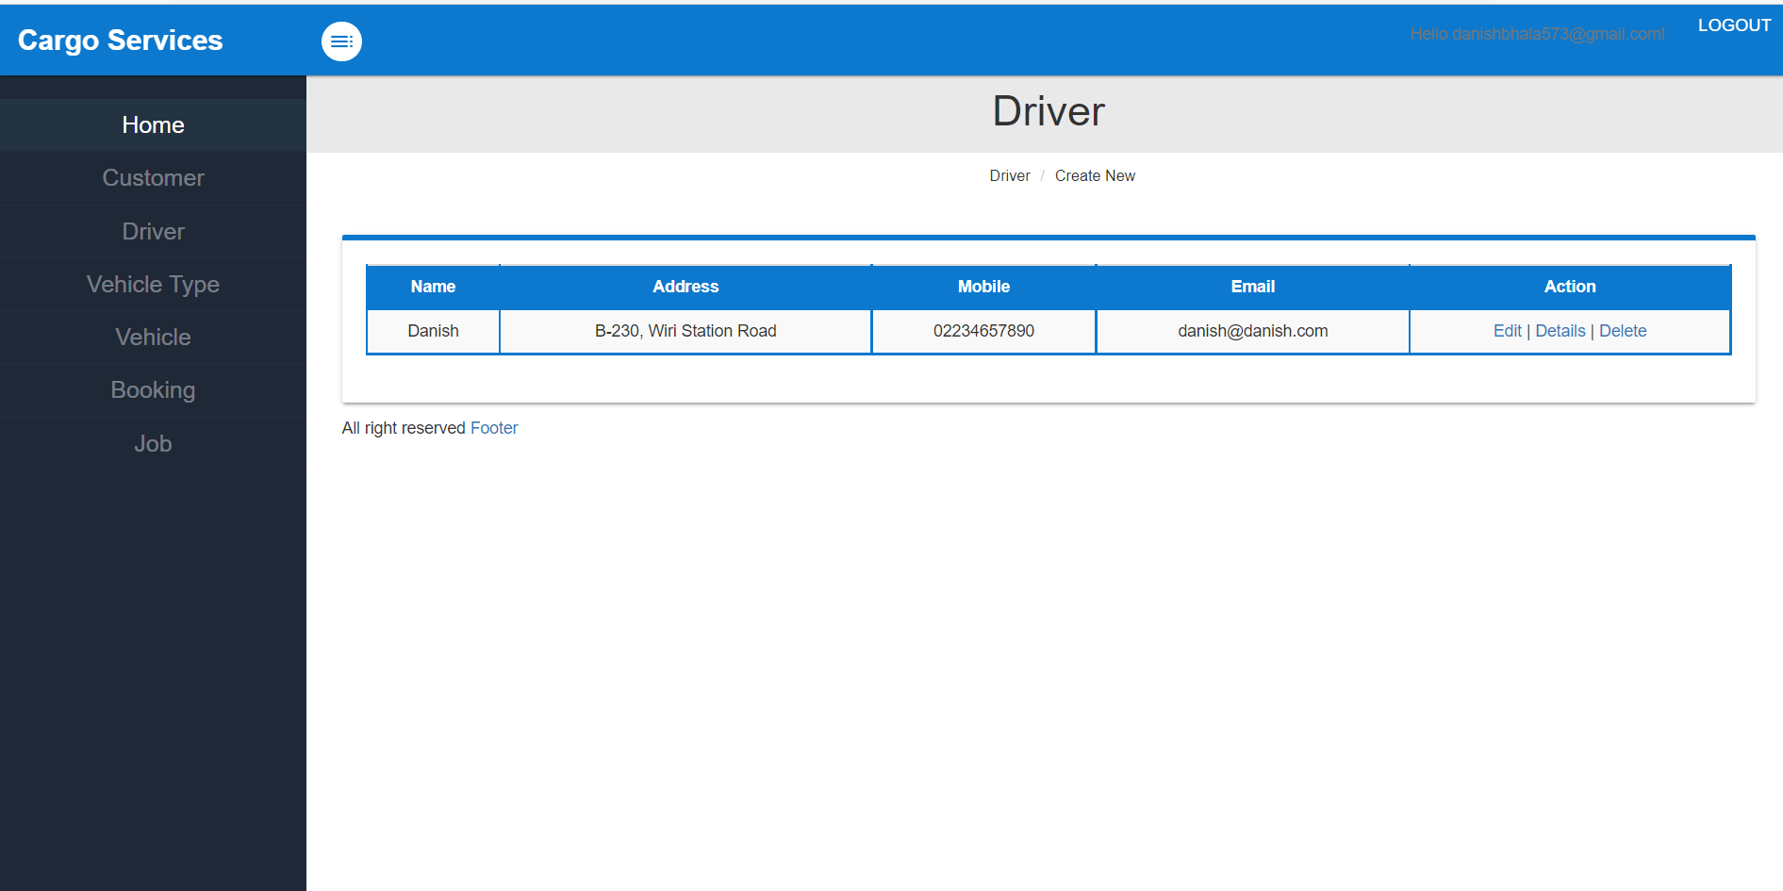

8. Vehicle Type:

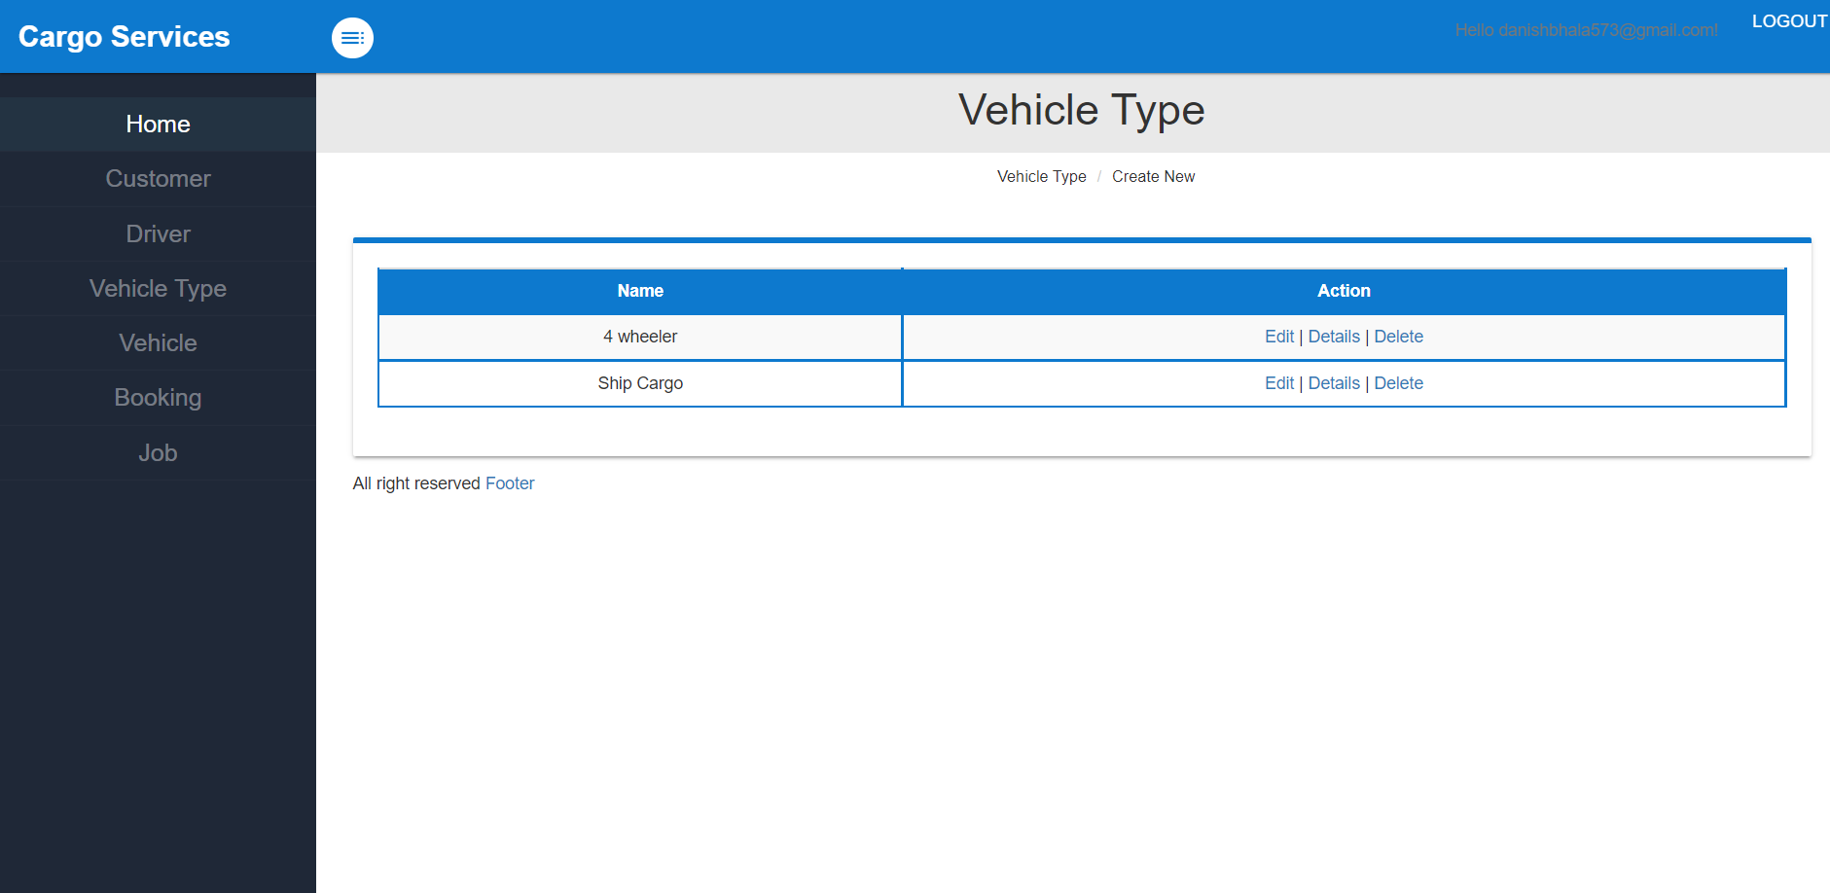

9. Vehicle:

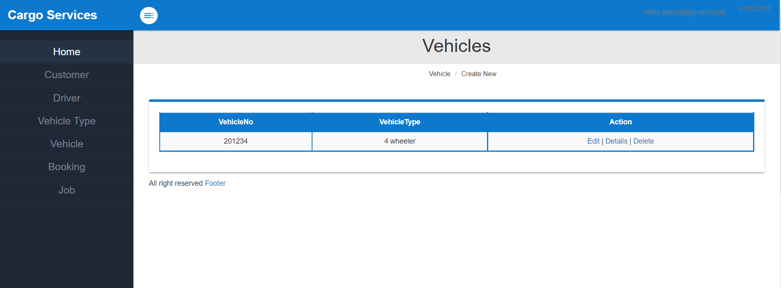

**10. Booking:**

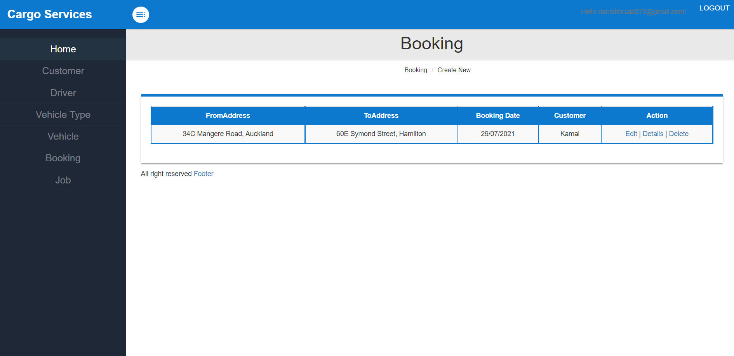

**11. Job**

