BestBuy.ca Product Reviews - Scraping Approach and Customer Insights
DEMO REPORT - generated from SYNTHETIC sample data to show the format. Not real customer data. Run the notebook with USE_SAMPLE_DATA = False and re-run build_report.py to produce the real report.

1. Scope
60 unique reviews were analysed (2023-01-15 to 2024-11-27). Average star rating: 3.57 / 5. Reviews were collected from the public product page only, using Selenium with the page's own filters (Most Helpful, Newest, Highest Rating, Lowest Rating, Most Relevant) and "Show more" paging, then de-duplicated. Sentiment was scored with VADER (rule-based) at review level and at aspect level (design, quality, ease of use, value, etc.).

2. Solutions for scraping challenges
Challenge | Solution implemented / recommended
Anti-scraping blockers & IP blocking | Implemented: real Chrome browser, realistic user-agent, random delays (1.5-3.5 s), single sequential session, rest between filters. If scaling: rotating residential proxies (one IP per session), lower request rate, off-peak runs.
CAPTCHA | Implemented: detection of CAPTCHA / 'access denied' pages; the scraper stops cleanly and keeps data collected so far. Recommended: do not bypass CAPTCHAs - slow down and retry later, ask the retailer for a data feed/partner API, or use a licensed review-data provider.
Network errors / timeouts | Implemented: retry with exponential backoff and jitter (2 s, 4 s, 8 s), per-filter isolation, partial results saved after every filter.
Dynamic (JavaScript) content & 'Show more' | Implemented: page scrolling for lazy loading; clicks 'Show more' until the review count stops growing (judged by effect, so unrelated 'show more' buttons are skipped); expands 'Read more'.
Layout / class-name changes | Implemented: content-based parser anchored on review dates instead of fragile CSS classes; page HTML saved to debug/ when nothing is parsed.
Duplicate reviews across filters | Implemented: content fingerprint used as primary key fallback; duplicates removed.
Legal / ethical | Public data only, no login, polite request rate. Review the site's Terms of Use and robots.txt before any large-scale or commercial use.

3. Sentiment results
Sentiment | Reviews | Share
Positive | 37 | 61.7%
Neutral | 1 | 1.7%
Negative | 22 | 36.7%

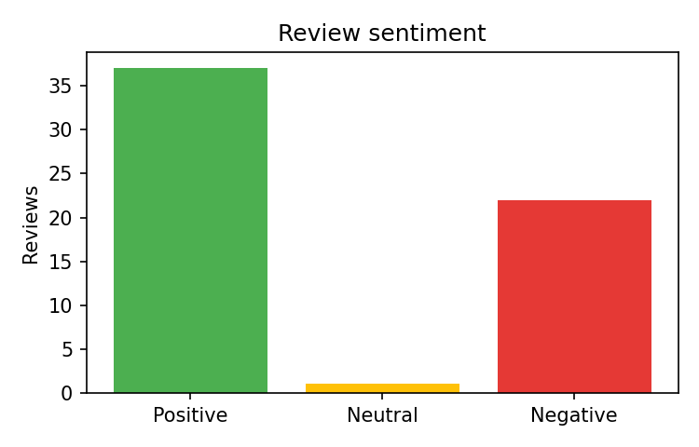
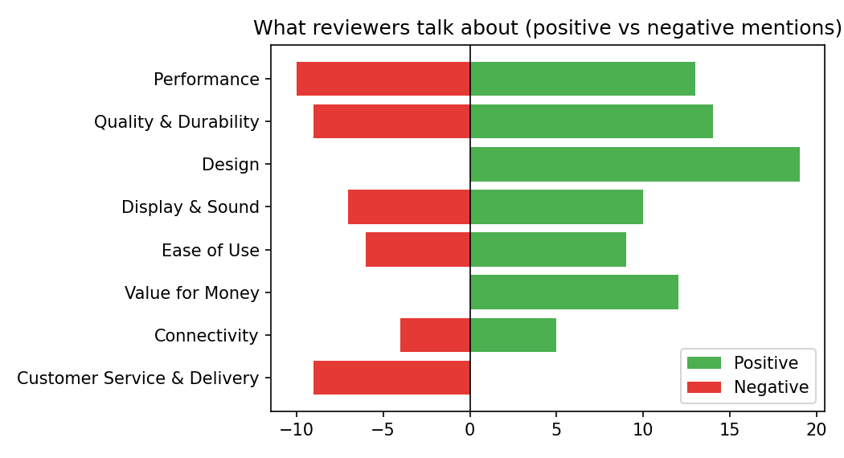
Reviews where the star rating and the text disagree: 2 (flagged in the data for manual checking).

4. Summary of insights for stakeholders

What customers like (drivers of satisfaction)
- Design: 19 positive vs 0 negative mentions.
- Quality & Durability: 14 positive vs 9 negative mentions.
- Performance: 13 positive vs 10 negative mentions.

What frustrates customers (drivers of dissatisfaction)
- Performance: 10 negative vs 13 positive mentions.
- Customer Service & Delivery: 9 negative vs 0 positive mentions.
- Quality & Durability: 9 negative vs 14 positive mentions.

5. Recommendations for improvement
- Performance (10 negative mentions): Share performance/lag/crash themes with the manufacturer and publish known fixes (firmware/app updates) on the product page.
- Customer Service & Delivery (9 negative mentions): Improve post-purchase experience: delivery-damage packaging checks, faster return handling, and proactive status updates.
- Quality & Durability (9 negative mentions): Investigate failure reports, tighten supplier quality checks, and consider a clearer warranty message; flag repeated defect themes to the vendor.
- Protect and promote strengths: feature design, quality & durability, performance prominently in product-page copy and marketing.
- Reply publicly to low-rated reviews and track sentiment monthly to measure whether changes work.

6. Limitations
- Only reviews visible on the public page were collected; the sample may not represent all customers.
- Aspect detection is keyword-based, and VADER is rule-based - it can miss sarcasm and mixed opinions. Spot-check the flagged rows.
- Relative dates such as '3 months ago' are converted approximately to YYYY-MM-DD.
- Counts are mentions, not unique customers; one review can mention several aspects.

