Zebraz – 2

Chapter01

Project Overview:

Chapter02

Design Methodology:

Chapter03

Standard cell library:

3.1 Inverter:
Objective: To design, verify and implement a 1-bit inverter using structural Verilog. The inverter acts as the fundamental standard cell of the Zebraz processor library and will be used extensively in higher-level combinational and sequential circuits.
Theory : An inverter, commonly referred to as a NOT gate, is the most fundamental combinational logic circuit in digital electronics. It performs the logical inversion of its input, producing an output that is always the complement of the applied input. If the input is logic '0', the output becomes logic '1', and if the input is logic '1', the output becomes logic '0'. Due to its simplicity and versatility, the inverter serves as the basic building block for constructing more complex digital circuits and is extensively used in processors, controllers, memory circuits, and digital communication systems.
In Register Transfer Level (RTL) design, an inverter is described using a simple logical NOT operation in Verilog HDL. The module consists of a single input and a single output, where the output continuously reflects the inverted state of the input. Since the inverter represents purely combinational logic, its output changes immediately in response to any change in the input without requiring a clock signal or memory elements. This behavior is typically implemented using a continuous assignment statement (assign) or within a combinational always block.
From a processor design perspective, inverters play an essential role in generating complemented control signals, implementing Boolean logic functions, and simplifying complex logic expressions. Many arithmetic and control circuits internally require inverted signals for proper operation, making the inverter an indispensable component in the datapath and control unit. Although the inverter is a simple module, it forms the basis for realizing universal logic gates, multiplexers, decoders, arithmetic circuits, and sequential logic components.
The inverter is also one of the first modules implemented during RTL development because it demonstrates the fundamental concepts of combinational logic modeling, module hierarchy, simulation, and functional verification. Successful implementation and verification of the inverter establish a foundation for designing increasingly complex modules that collectively form the complete 2-bit microprocessor.
Functional Description: The inverter accepts a single binary input (A) and generates a single binary output (Y). The output is always the logical complement of the input.
- Input: A
- Output: Y
- Operation: $Y=\overset{‾}{A}$
Since the inverter is a combinational circuit, the output depends solely on the present value of the input and does not require a clock or storage element.
Logic Equation: Y= ~A
Truth Table:
Input (A) | Output (Y)
0 | 0
1 | 1

RTL implementation:
The inverter is implemented in Verilog HDL as a combinational module using the logical NOT operator. The design consists of one input port and one output port, with the output continuously assigned the complement of the input using a continuous assignment statement. Since there is no sequential logic involved, the module does not require a clock signal, reset signal, or procedural blocks. The simplicity of the RTL implementation makes the inverter an ideal introductory module for understanding Verilog syntax, module declaration, signal assignment, and combinational logic design.
Working: The inverter continuously monitors its input signal. When the input is at logic '0', the output is driven to logic '1'. Conversely, when the input changes to logic '1', the output immediately changes to logic '0'. During simulation, every transition of the input is reflected by an opposite transition at the output, demonstrating the combinational nature of the circuit.
Applications:
• Generation of complemented logic signals.
• Building block for complex combinational circuits.
• Used in arithmetic and logic units (ALUs).
• Signal conditioning in digital systems.
• Clock and control signal inversion.
• Implementation of Boolean logic expressions.
Advantages:
• Simple and efficient RTL implementation.
• Minimal hardware complexity.
• High operating speed due to combinational behavior.
• Easy to verify through simulation.
• Fundamental building block for larger digital systems.
Limitations:
• Performs only logical inversion.
• Cannot store data or perform sequential operations.
• Requires additional logic gates for implementing complex functions.

Role in 2-bit microprocessor:
Within the 2-bit microprocessor, the inverter is used to generate complemented signals required by the datapath and control logic. It assists in implementing arithmetic operations, logic functions, and control signal generation. The module also serves as a foundational component for constructing more complex digital circuits that are integrated into the processor architecture.
Verification Summary:
The inverter module was verified using a dedicated Verilog testbench. Different input combinations were applied during simulation, and the output waveform was observed to ensure correct logical inversion. The simulated results matched the expected truth table, confirming the functional correctness of the RTL implementation.
Conclusion:
The inverter is the simplest combinational logic module and serves as the foundation of digital circuit design. Its RTL implementation demonstrates the use of basic Verilog constructs for modeling combinational logic. Functional verification through simulation confirmed the correct inversion of the input signal, making the module a reliable building block for the subsequent components of the 2-bit microprocessor.
Diagram:
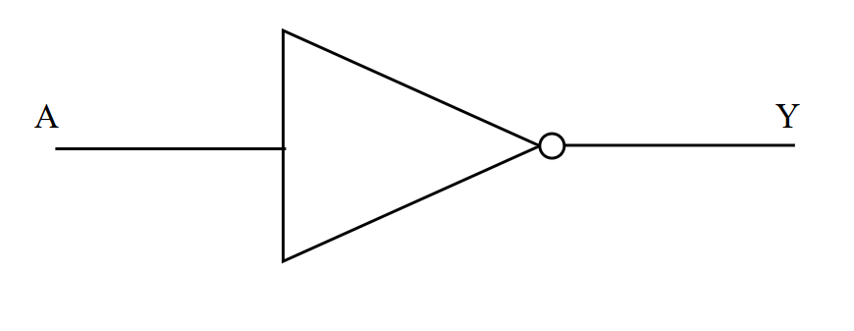

3.2 Nand2 :
Objective
The objective of this module is to design and implement a 2-input NAND gate using Verilog Hardware Description Language (HDL) at the Register Transfer Level (RTL). The module performs the NAND logical operation by generating an output that is the complement of the logical AND of two binary input signals. The design emphasizes creating a synthesizable combinational logic circuit, verifying its functionality through simulation using a dedicated testbench, and validating the output waveforms for all possible input combinations. This module also serves as a fundamental building block for implementing more complex digital circuits within the proposed 2-bit microprocessor.
Theory
A two-input NAND (NOT-AND) gate is one of the most fundamental combinational logic gates in digital electronics. It performs the logical AND operation on two binary inputs and then inverts the result. The output of a NAND gate is logic '0' only when both inputs are logic '1'; for all other input combinations, the output remains logic '1'. Because any Boolean function can be implemented using only NAND gates, it is known as a universal logic gate and is extensively used in the design of digital systems.
In Register Transfer Level (RTL) design, the NAND gate is modeled using Verilog HDL by combining the logical AND operator with the logical NOT operator. The module consists of two input signals and one output signal, where the output continuously represents the inverted AND of the inputs. Since the NAND gate is a combinational logic circuit, its output depends solely on the present values of the inputs and changes immediately whenever either input changes. This functionality is commonly implemented using a continuous assignment statement (assign), resulting in a concise, synthesizable, and efficient RTL description.
The NAND gate plays a crucial role in digital circuit design due to its versatility. It is widely used to construct combinational circuits such as multiplexers, decoders, encoders, and arithmetic circuits, as well as sequential circuits including latches, flip-flops, counters, and registers. In processor architectures, NAND gates contribute to implementing arithmetic logic units (ALUs), control units, and data-path logic.
Within the proposed 2-bit microprocessor, the NAND gate forms an essential building block for higher-level modules. Its successful RTL implementation and verification provide a strong foundation for designing more complex functional units while reinforcing the principles of modular and hierarchical digital system design.
Functional Description
The module accepts two binary inputs, A and B, and produces a single binary output, Y. The output represents the logical NAND of the two inputs, meaning it is the complement of their logical AND operation.
- Inputs: A, B
- Output: Y
- Type of Logic: Combinational
- Operation: The output becomes logic '0' only when both inputs are logic '1'. For all other input combinations, the output remains logic '1'.
Since the design is purely combinational, it does not require a clock signal or memory elements.
Logic Equation
$$Y=\overset{‾}{A⋅B}$$
Truth Table
A | B | Y
0 | 0 | 1
0 | 1 | 1
1 | 0 | 1
1 | 1 | 0

RTL Implementation
The NAND gate is implemented in Verilog HDL as a combinational module using the logical AND (&) operator followed by the logical NOT (~) operator. The design consists of two input ports and one output port. A continuous assignment statement is used to continuously evaluate the inputs and update the output whenever a change occurs. Since the module contains no sequential elements such as flip-flops or registers, it does not require a clock signal or reset mechanism. The resulting RTL description is compact, synthesizable, and suitable for FPGA and ASIC implementations.
Working
The NAND gate continuously monitors both input signals and evaluates their logical AND. If either input is logic '0', the AND operation results in logic '0', and the subsequent inversion produces an output of logic '1'. When both inputs become logic '1', the AND operation produces logic '1', which is then inverted to logic '0'. During simulation, the output responds immediately to changes in either input, confirming the combinational nature of the circuit and its correct logical functionality.

Applications
- Universal building block for implementing all Boolean logic functions.
- Design of combinational logic circuits.
- Construction of latches and flip-flops.
- Arithmetic and Logic Unit (ALU) design.
- Control logic implementation in processors.
- Memory circuits and digital integrated systems.
Advantages
- Universal gate capable of implementing any digital logic function.
- Simple and efficient RTL implementation.
- Fully synthesizable for FPGA and ASIC platforms.
- Fast combinational operation with minimal hardware complexity.
- Easy to verify through simulation.
Limitations
- Directly performs only the NAND logic operation.
- Complex digital functions require multiple interconnected NAND gates.
- Larger NAND-based designs may introduce additional propagation delay.
Role in the 2-Bit Microprocessor
The 2-input NAND gate serves as one of the fundamental building blocks in the 2-bit microprocessor architecture. It is used to develop more complex combinational and sequential modules required for arithmetic operations, control signal generation, data routing, and decision-making logic. Owing to its universal gate property, the NAND gate can also be used to construct other logic gates, enabling a modular and scalable processor design.
Verification Summary
The functionality of the NAND gate was verified using a dedicated Verilog testbench. All possible input combinations were applied during simulation, and the corresponding output waveforms were analyzed. The observed simulation results matched the expected truth table, confirming the correctness of the RTL implementation and validating the module's operation under all input conditions.

Conclusion
The 2-input NAND gate is a fundamental combinational logic module and one of the most versatile components in digital electronics due to its universal gate property. Its implementation in Verilog HDL demonstrates the effective modeling of combinational logic using continuous assignments. Functional verification through simulation confirmed that the module operates correctly for all input combinations. As a result, the NAND gate serves as a reliable and essential building block for constructing the higher-level modules of the proposed 2-bit microprocessor.
Diagram :
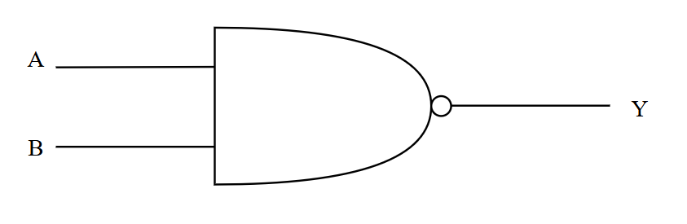

Chapter04

Arithemetic Unit:

Chapter05

ALU:

Chapter06

Registers:

Chapter07

Processor Unit:

