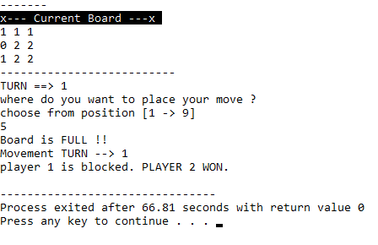

Cs182019 | Muhammad Danish | cs182019