Design of Controllers

Before designing the controllers, it is required to check the controllability and observability of the linearized state space model of planar quadrotor.

The controllability of the pair (A,B) was checked using MATLAB and it was found that the system is controllable. Similarly it was found that the pair (A,C) is found to be observable using MATLAB.

Results

1. LQR Controller

The design of LQR controller is based on selecting the Q and R matrices to minimize the objective function and obtain the optimal gain matrix K. A simplest case is selected in the design of LQR controller for planar quadrotor, where R = 1 and Q is selected to be CTC. This selection of the R and Q matrices equally penalizes the states and the inputs, thereby not sacrificing the dynamic performance or using large control energy input to achieve the response. The LQR controller was implemented in MATLAB and simulated for two test cases.

1.1 Case 1: Controllability to the origin using LQR

In the first case, the controller is checked for bringing the state response from any initial state to the origin, which is steady state value. Since, the non-linear dynamic model of planar quadrotor was linearized about the origin as equilibrium point with hover configuration, a state feedback of form u = -Kx with zero reference input is enough to control the states to the origin.

For this test case, the initial conditions are assumed as y = 10, z = 10, and Φ = 0. Based on the input conditions and state space model, the LQR controller is implemented to find the optimal gain matrix K, which balances both the dynamic response time and the input control energy.

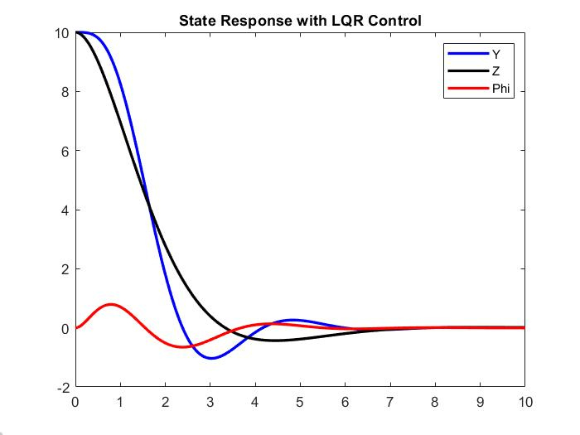

Figure 1. Controllability to the origin using LQR

1.2 Case 2: Controllability from the origin using LQR

In this case, the controller is checked for reachability of any steady state value from the origin as initial conditions. For a test case, the desired final steady states are defined as y = 10, z = 10, and Φ = 0. To achieve these conditions, the state feedback of form u = -Kx + Gr is given, where r is the reference step input. The optimal gain matrix K is found like Case 1, while the gain matrix G is found such that the desired steady state values are achieved.

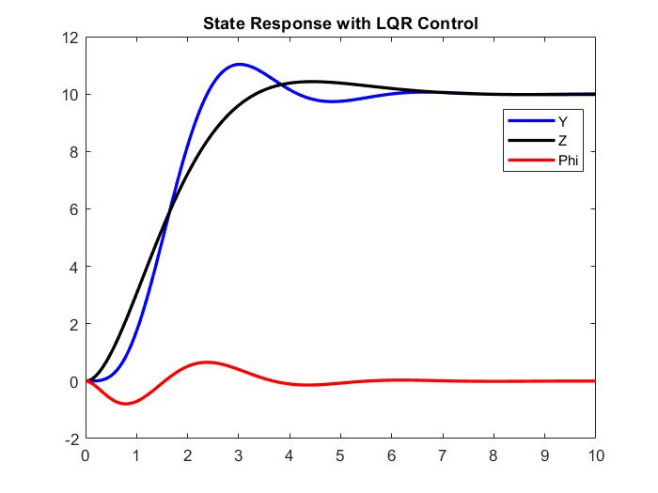

Figure 2. Controllability from the origin using LQR

2. Full-State Feedback Controller

The design of feedback controller is based on the selection of the desired pole locations. The desired eigenvalues were estimated by considering a second order spring-mass-damper system with certain natural frequency and damping ratio. These parameters were estimated by specifying the required percent overshoot and settling time of dynamic response. The feedback controller was simulated in MATLAB for two cases.

2.1 Case 1: Controllability to the origin using Feedback Controller

The controller was checked for bringing the initial state conditions to the origin. The initial conditions of the states were assumed to be same as that of LQR case: y = 10, z = 10, and Φ = 0. The shaping of desired dynamic response was determined from the selected specifications of 10% overshoot and settling time of 6 seconds. Using the defined specifications and a second order system model, the first two eigenvalues were determined. As an approximation, all the remaining eigenvalues were assumed to be 10 times farther away from the dominant poles. The desired eigenvalues of the closed-loop system were found as following:

Poles = -0.6667 + 0.9096i, -0.6667 - 0.9096i, -6.6667, -7.6667, -8.6667, -9.6667

A state feedback of form u = -Kx with zero reference input is enough to control the states to the origin. The gain matrix K was computed to place the poles at desired locations as following:

K = [2.5570 60.0300 -17.8957 5.4804 15.6092 -1.4229

-7.6676 -4.1588 77.9989 -10.0003 -0.5104 14.8965]

The response of the feedback controller is given in the below figure.

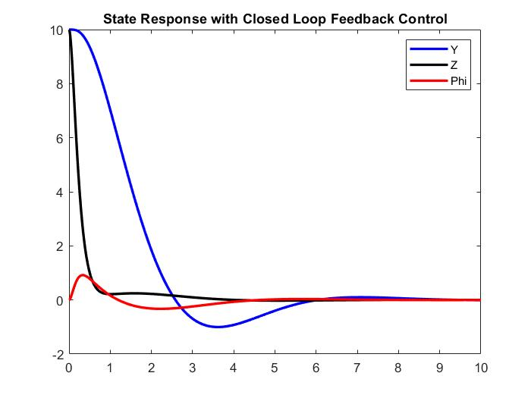

Figure 3. Controllability to the origin using Feedback Control

2.2 Case 2: Controllability from the origin using Feedback Controller

The controller was simulated to test its reachability to any desired location from the origin. The desired final steady states were assumed to be y = 10, z = 10, and Φ = 0. Again, to achieve these conditions, the state feedback of form u = -Kx + Gr is given, where r is the reference step input. The gain matrix K is same as in Case 1 by considering the same desired pole locations based on the specifications of 10 % overshoot and 6 seconds settling time. However, for the states converge to the desired final steady state values, the gain matrix G was computed as following:

G = [ 25.5704 600.3000

-76.6757 -41.5879]

The state response of the feedback controller with step response is shown in the below figure.

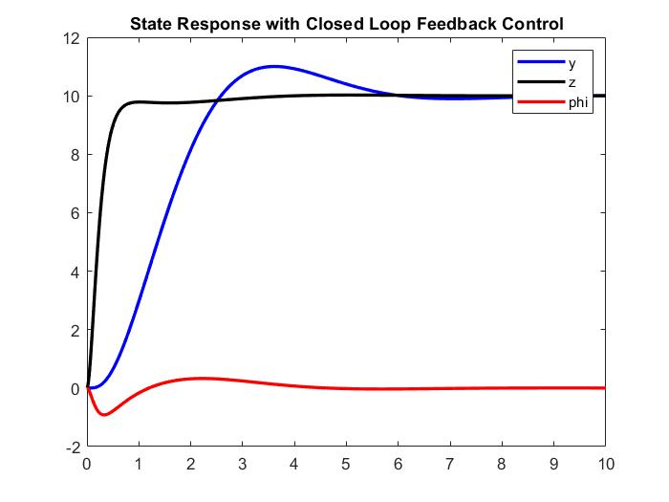

Figure 4. Controllability from the origin using Feedback Control

3. Observer based Feedback Controller

In the above design of closed-loop feedback controller, it was assumed that all the state variables are known at every point in time. In real world applications, however, it is difficult to measure all the state variables due to some physical constraints. Therefore, it is desirable to design an observer for the system, which provides an asymptotically convergent estimate for the states. The two cases were simulated in MATLAB for testing this controller.

3.1 Case 1: Controllability to the origin using Observer based Feedback Controller

The design of the observer is guided by the selection of the observer gain matrix L, which drives the convergence of the state estimator. It is desirable that the dynamic error response of the observer is much faster than the closed-loop response. Therefore, the poles of the observer state estimator were placed 10 times farther to the left of the closed-loop state poles of the system. The desired eigenvalues selected for the observer were found as following:

Poles = -6.667 + 0.9096i, -6.667 - 0.9096i, -66.667, -76.667, -86.667, -96.667

The observer gain matrix L was computed by placing the poles at desired location.

L =

[ 22.3333 0 0 0 0 0

0 16.3333 0 0 0 0

0 0 16.3333 0 0 0

124.4444 0 -9.8100 0 0 0

0 66.4444 0 0 0 0

0 0 64.4444 0 0 0]

The state response of the observer estimated feedback controller compared with the feedback controller designed earlier is shown in the below figure. The observer-based feedback response estimates the feedback response closely with a small error.

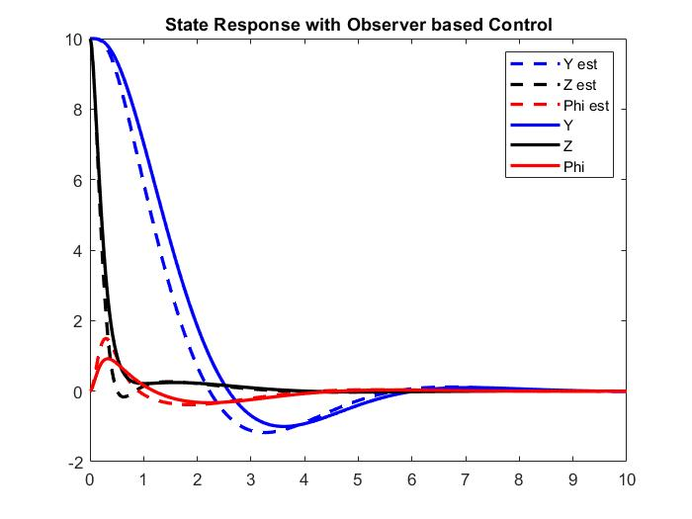

Figure 5. Controllability to the origin using Observer based Feedback Control

3.2 Case 2: Controllability from the origin using Observer based Feedback Controller

For the second case, the simulation is repeated with initial conditions at origin and the reachability of this controller is tested for the final states defined as y = 10, z = 10, and Φ = 0. The response of the observer estimated feedback controller in comparison with the feedback controller for this case is simulated as shown below.

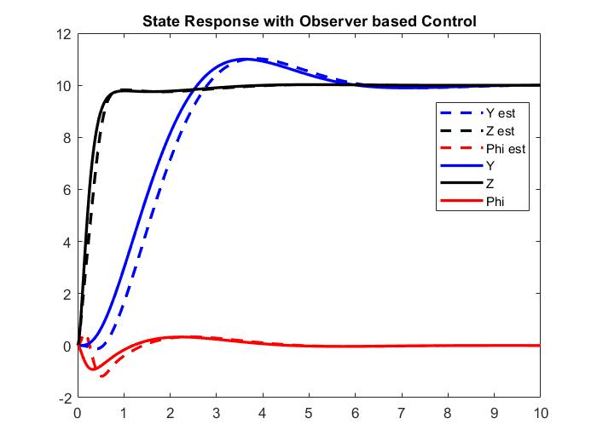

Figure 6. Controllability from the origin using Observer based Feedback Control

4. PID Controller

The PID controller takes the form of closed-loop control system where the three gains, proportional (KP), integral (KI), and derivative (KD) are adjusted such that their sum acting on the input drives the desired dynamic system response. It was implemented in MATLAB and simulated for altitude control of the quadrotor. The three values of gains were selected such that a low percent overshoot of response and faster settling time is achieved for an impulse disturbance induced on the system. Based on trial and error, the optimal values of gains were found as: KP = 100, KI = 10, and KD = 10. The dynamic response of the z state for a given impulse input is shown below. From the plot, it can be deduced that the maximum overshoot is close to 0.05 % with a settling time of around 1 second and the designed PID controllers works effectively in maintaining the steady state at the origin or hovering the quadrotor for an induced impulse disturbance.

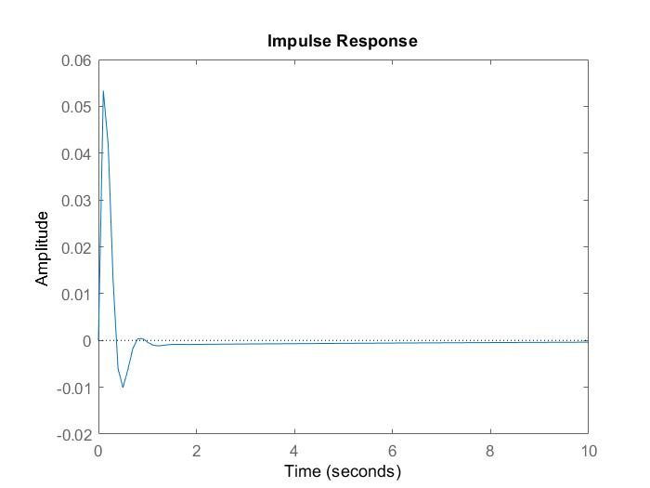

Figure 7. Impulse Response for altitude using PID controller