Virtualization:

It’s a process of creating virtual version of something be it network system, operating system or storage etc. It creates the virtual environment on which that system will run, completely isolated - Virtual Machines. So when we need to run multiple OS on a single machine, we can create a virtual machine which will allow us to run OS in that environment. This environments will be completely isolated yet using same hardware of physical machine on which you are running it.
Two key points: Isolation and Resource optimization
Physical machine called host machine and the virtual machines called guest machines.

To achieve this virtualization we need software component that manage those virtual environments ensuring all isolation and related configurations - called Hypervisor.

There is two type of Hypervisor. Type 1 which are directly installed on computer’s hardware, on top of that VMs will be managed. Type 2 are installed on the Host OS, and on top of that it manages the VMs. So type 2 hypervisor have an extra layer between VMs it creates and hardware which OS, Host OS.

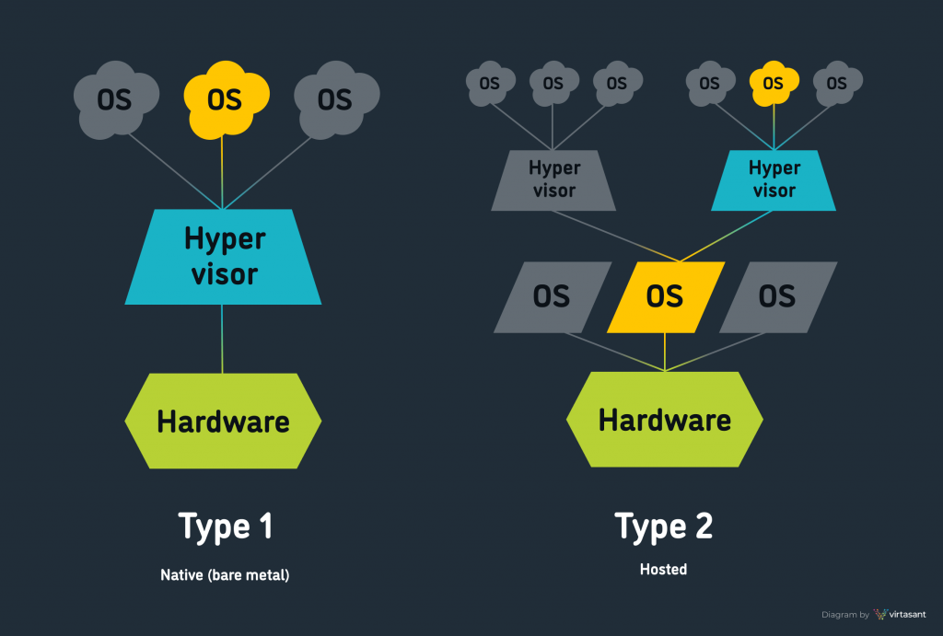

So there is multiple hypervisor providers like VMware, virtual Box. Let’s see the process of setting up the virtual Box and creating virtual machine of Linux distribution - Centos.
Install chocolaty first.

After that you can install the tools by the choco command

Installing Virtual Box:

choco install virtualbox --version=7.0.8 -y

Open virtual Box and You will see the option of new, click on that
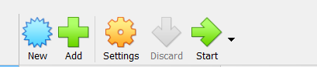

Now Fill the details. Do not select the ISO image right now, Select Linux in Type, and Red hate 64 bit in version

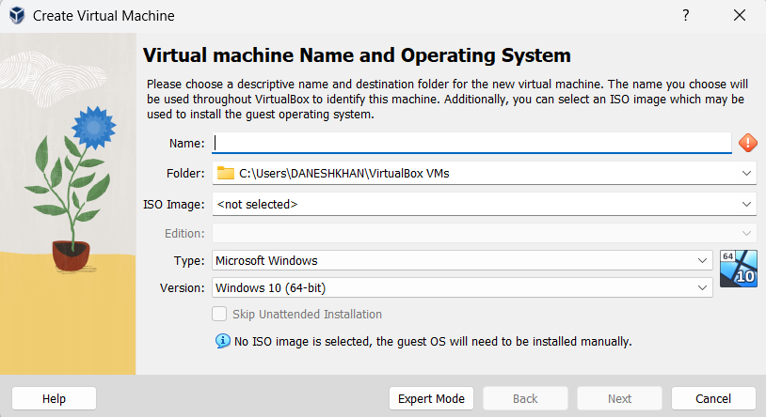

Then we have to allocate the resources to our VM, RAM memory and Processors. Usually 2048Mb and 2 cpu cores are fine

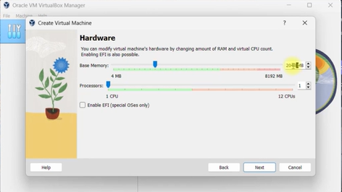
In next slide we have to select the virtual disk, 40 gb is fine, there will be two options of pre allocation, which means Despite of that VM need, 40 gb will be allocated at the starting of VM to it being closed, while if we not select that, it means that our VM will be allocated virtual memory dynamically as needed up to 40gb.

Now we have to download an ISO file for Linux distribution we want - centOS. Then we we have to attach that file to our VM created in virtual box. So when we will start our VM it will install that OS distribution
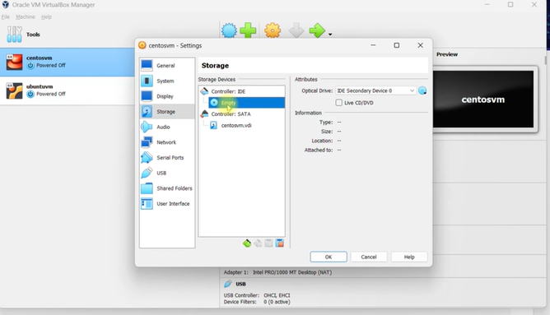

Before that we need to do network configurations for our VM. Just like how our physical device needs network configs of network adapters for internet access, the VMs also can be looked up a system inside our Physical machines which needs this configs. So we have to select the network adapters available in our Host OS to make it available for VM.
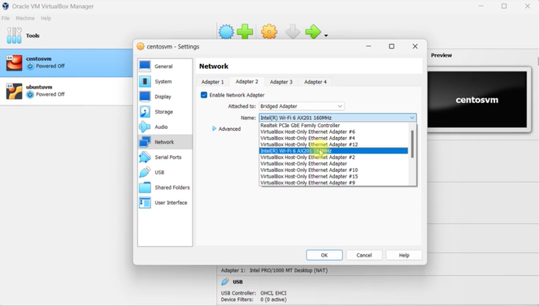

Then we will start the VM and there will be some options and process to install the centOS via ISO file which we attached. Now after process being completed we are all setup, After that stop the VM and go to storage again and remove that ISO file, so when we again start our VM it will not again install it as we have already.

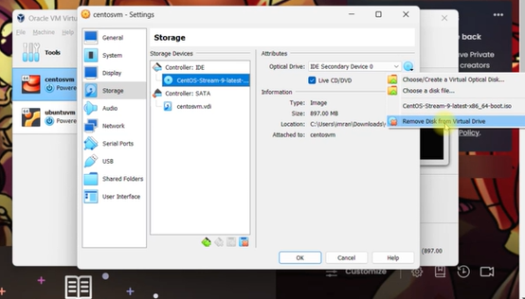

When VM is running we can login into CLI via ssh. We need to note IP of bridge adapter we selected in network configs and the username and password You selected in the login process.

Vagrant

Now we will look up another method to setup VMs and managing them.

