Networking

Introduction:
Networking refers to a system where devices are connected together to communicate and share resources. A network can consist of computers, servers, printers, and other devices linked in various ways, forming a system that allows these devices to interact. The internet is the most expansive example of a network, often described as a global network of interconnected networks. While how the internet functions will be discussed later, it's important to understand that these connections enable the sharing of information across the globe.
Let’s start with abstract understanding and then go in deep further on as we move on.
We have devices in network. We call them nodes. Node can be client or server. If it’s sending data, it’s server, if it’s requesting data it’s client. Most of the devices are capable of both. So we call them as peer. Cool.

How the Internet Works
Consider a scenario where your PC is connected to the internet via your mobile's hotspot. Your mobile device has an internet connection provided by an ISP (Internet Service Provider). The ISP assigns a unique public IP address to your mobile device, which is typically both an IPv4 and an IPv6 address. These public IP addresses are unique across the entire internet. Here’s how my mobile IPs looks like
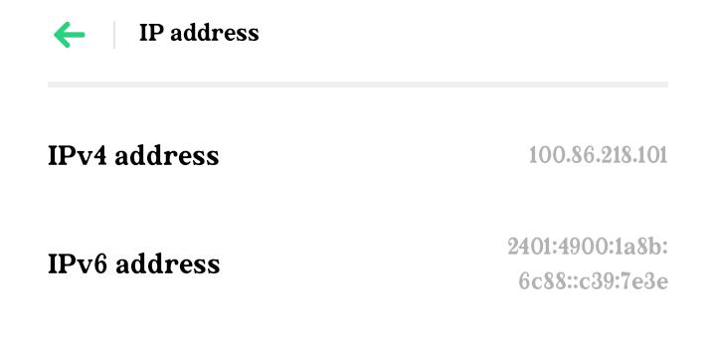
When your PC connects to the mobile's network, it becomes part of a Local Area Network (LAN) managed by the mobile device, which acts as a router. Within this local network, your PC is assigned a local (private) IPv4 and potentially an IPv6 address by the mobile device. The router (your mobile) also has a default gateway address, which is the point where all devices on the local network send their internet requests.
Do ipconfig command in PC: so if you see the ip address 192.168.x.x everywhere, I mean everywhere, do not be confused like, shouldn’t be it unique? These are Local addresses. Open up your mobile and pc and try this command to remove your confusion.
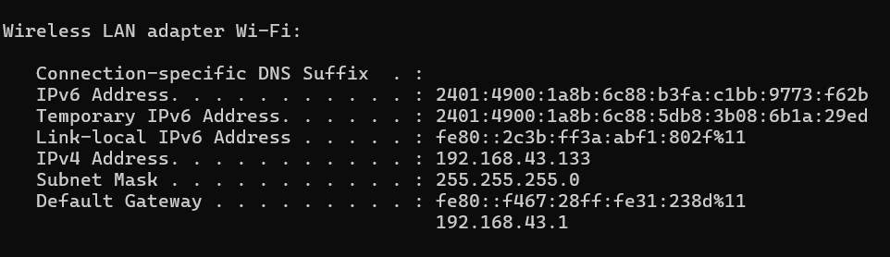
Here, all the address are given by mobile(router) of the LAN. Which is default gateway
When you type "google.com" into your PC's browser, the process begins with your PC needing to find the IP address of the Google server that hosts the requested resources. This is where the DNS (Domain Name System) comes into play. Your PC forwards the request to the mobile network, by sending it to default gateway address(192.168.43.1) here, which then queries a DNS server to resolve "google.com" to its corresponding IP address. Once the IP address is determined, your mobile device makes an HTTPS request to the Google server.
However, the request originating from your PC contains your PC's local IP address(192.168.43.133 here), which is not routable on the internet. So yeah, typical ip addresses you see 192.168.x.x on different tutors explaining, is not which are rout on the networks, FUCK that tutor for not clearing this concept, and kiss my forehead.
Before the request is sent out to the internet, the NAT (Network Address Translation) function on your mobile device replaces the PC's local IP address with the mobile's public IP address(100.86.218.101). The request is then sent to the local cellular tower, through the ISP, and eventually reaches Google's server.
The server processes the request and sends a response back. This response first travels through the ISP, which forwards it to your mobile device's public IP address. NAT on your mobile device translates the public IP address back to your PC's private IP address, ensuring the response reaches the correct device within your local network.
Each device on a network can run multiple applications, each potentially requiring a response from the internet. Here in case if you are playing Game online, how do we know that response should reach to this particular application? To manage this, network communication relies on ports. When your PC's browser made the request, it used a specific port, which is noted in the response. The NAT keeps track of these ports, so when the response comes back, it knows which application (in this case, your web browser) to deliver the data to. This way, the correct application on your PC receives the appropriate response.
Cool. From above there are many definitions and concepts derived which we will walk through.

Key Terminologies Explained
ISP (Internet Service Provider): The company that provides your mobile device with internet access, assigning it a public IP address to connect to the internet.
Public IP Address: An IP address assigned by the ISP that is unique and accessible over the internet. It identifies your mobile device on the global network.Note that, these addresses are ever changing. ISP which assigns this unique public IP addresses, it’s temporary, yet unique. At the moment of assignment, ISP has multiple available addresses which are not used & available for public. When some devices disconnect from internet, that IP becomes available for ISP to assign it to other devices. Details in further sections…
Local Area Network (LAN): A network within a localized area, such as your mobile's hotspot, where devices like your PC connect and communicate.
Private IP Address: An IP address assigned to devices within a LAN, not routable on the public internet, used for internal communication within the network.
Default Gateway: The routing device (your mobile) that connects your LAN to the internet, serving as the point where all outbound internet requests are sent.
DNS (Domain Name System): The system that translates domain names (like google.com) into IP addresses, allowing devices to locate and communicate with servers on the internet.
NAT (Network Address Translation): A process that modifies network address information in packet headers, translating private IP addresses to public IP addresses and vice versa, enabling devices within a LAN to access the internet.
Ports: Virtual endpoints in a device's operating system used for managing multiple communication sessions, ensuring that responses from the internet are delivered to the correct application.
1 GB = 1 giga bits, 1 MB = 1 mega bits, b in MB GB represent bits not bytes. 1 byte = 8 bits.
Now we understand the concept of how the data roams from your laptop to the server and what are steps involved, we can visualize and understand OSI model properly which if we try to understand in first place, we cannot relate it. So keep this example of Sending request to Google.com, we discussed above.

OSI and TCP/IP Models in Brief
Another note is OSI model has 7 Layer, not the process of Networking. OSI is not the process. It is model, not real, A conceptual model to understand the process of networking. There is no such 7 layer in the process. We divided the process in conceptual way to understand it, in 7 parts. TCP/IP model has 5 layers, These models are not separate methods for networking but theoretical concepts for understanding how the internet and data transmission work.
Physical Layer: This is where the physical connection between devices happens. In our scenario, this includes the Wi-Fi connection between your PC and your mobile device, and the cellular connection between your mobile and the ISP's network. It's responsible for the raw data transmission over these physical mediums. Analog signals -> binary and binary -> analog. Because 0 and 1 can’t fly or transmit through wires over the network. Easy? Pretty eazy…
Data Link Layer: This layer ensures error-free data transfer between two directly connected devices. For instance, when your PC communicates with your mobile via Wi-Fi, the Data Link layer handles the framing of data and manages the MAC addresses to ensure the data is sent to the correct device within the local network. Like there may be multiple devices connected to hotspot, so this layer basically keep MAC addresses of everyone to identify that devices withing that hotspot range(LAN). Also note that, for Bluetooth there is different MAC address, obviously data type of sound let’s say, how do we know at which address to send, and at which driver? HTTP request to bluetooth? LOL. To the Bluetooth adapter or wifi? So for each type of network there is different MAC address.
Network Layer (Internet Layer in TCP/IP): This layer is responsible for IP addressing and routing the data across networks. In our example, once your mobile device receives a request from your PC, the Network layer (using IP addresses) determines how to route this request through the ISP and eventually to Google's servers. It handles the IP address assigned to your mobile and ensures the data packet reaches the correct destination.
Transport Layer: The Transport layer ensures that data is transmitted reliably and in the correct sequence. When your PC sends a request to Google, TCP (Transmission Control Protocol) at this layer ensures that the data segments arrive intact and in order at Google’s server. Like obviously we do not transfer 20MB data in one flow, not even of 20kb data gets transferred in one go, all the data gets divided into chunks of kb or bytes. Detail in further sections…
If any part of the data is lost during transmission, TCP will re-transmit it, ensuring reliability.
Session Layer (Part of Application Layer in TCP/IP): This layer manages the sessions or connections between applications. For example, it maintains the session between your web browser and Google's server, ensuring that all communications during this session are synchronized and managed properly.
Presentation Layer (Part of Application Layer in TCP/IP): Think of this layer as the translator, making sure data is properly formatted and secure. When you’re sending an HTTPS request to Google, this layer encrypts your data before it hits the road, keeping it safe from prying eyes. Hijab layer basically.
Application Layer: This is where network services and end-user applications operate. In our example, when you type "google.com" into your browser, the request is initiated at the Application layer using HTTP/HTTPS. This layer interacts directly with the web services, sending the request to Google's server and receiving the response, which is then displayed in your browser.
Now we can add network engineer in resume. We+ get the idea in total. Now let’s look up in a bit extra details, so we can add “5 years of experience in resume.”
Refreshing the server-client architecture, client is one who request. Server is one who take request and do stuff and send response.
Now, google.com example is boring, now the example we will use next, is You are on amazon app. You clicked on checkout, money from your bank account got deducted, your order got placed and you received an confirmation email.
Application layer:
The application layer is where end-user application and services interact with network.
The Application layer is the point where end-user applications and network services converge. When you're logged into the Amazon app, a session cookie is stored on your device to authenticate your requests, ensuring the server recognizes you as a logged-in user. As you proceed to checkout, the app sends an API request to Amazon's server. To facilitate this, DNS (Domain Name System) translates Amazon's domain name into an IP address, directing the request to the correct server. Request contains the headers which includes many many details, like type, url, ip of the server on which resource being hosted. open up amazon(or any website). inspect it, go to the network tab. Hit refresh to the page. Click on any resources, this is how it looks like:
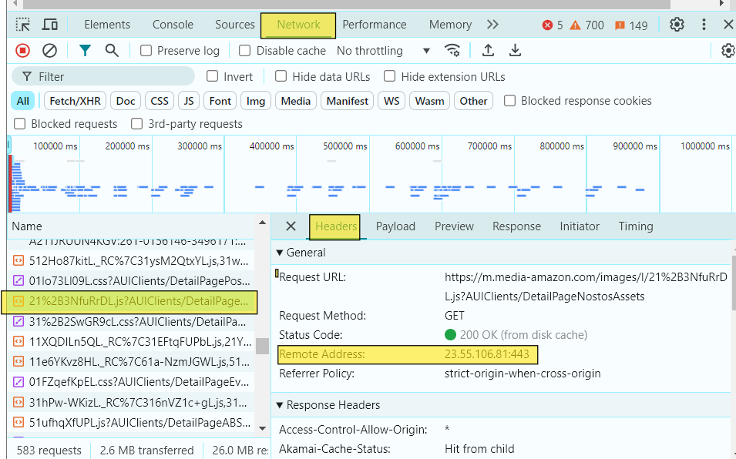
Remote address is ip of the server which is hosting that resources and port 443 which we will talk in next section. You can also check the original IP of amazon.com, here in pic there is IP of server which is hosting the resource we clicked on. On powershell, command: ping amazon.com. It will test the request is sent to the domain successfully or not. Which also includes the IP of amazon.com

The request itself includes encrypted JSON data containing details like payment information, product specifics, and shipping address, all transmitted securely using the HTTPS protocol.
On the server side, the Application layer processes this incoming JSON data, handles the payment, updates the order status, and prepares a response. This response, sent back to your app, includes an HTTP status code and a JSON payload with order confirmation details. Once the app receives this response, the Application layer on your device decrypts the data, updates the user interface, and may redirect you to a confirmation page.
Additionally, as part of the checkout process, Amazon's server sends a confirmation email using the SMTP (Simple Mail Transfer Protocol). This email is then retrieved by your email client through IMAP (Internet Message Access Protocol) or POP3 (Post Office Protocol 3), allowing you to view it in your inbox.
There is also more stuff like, caching, OAuth protocols for token authentication. Caching storage, error handling, SSL and TLS protocols for encryption and decryption etc can be visualized in this layer.
So Application layer has - session management, HTTP/S, SMTP, IMAP or any other transfer protocol for secure data transmission, DNS - Domain Name Service for getting IP from domain name. That’s it.
Transport layer:
Application layer does app related things, physical and DLL do some physical things, Most important thing of networking process is of these two layers - networking and transport.
The Network layer is responsible for transmitting data between different devices across networks (like from one server/client to another server/client). Once the data reaches its destination device (client or server), the Transport layer takes over to manage the delivery of that data to the correct application on the device, ensuring it reaches the intended process or service. That thing you never knew even after getting A+ grade in your networking course in CS degree, ask yourself buddy.
Now where we left of in Application layer, our authentication got checked by sessions, our data get encrypted using HTTPS, IP of amazon determined using DNS. Now these whole thing is ready to be transmitted to the network, or server of the IP address. Transport layer comes into play. First of all it will send this data to the socket associated with port number.
Repeat after me,
” IP address recognizes devices on the network, Port number recognizes applications on the device”
Again…
” IP address recognizes devices on the network, Port number recognizes applications on the device”
You are running multiple chrome instances, HTTPS requests are by default send to port 443(HTTP to 80). but how does that determine the data transmitted from that particular instance of chrome, is called ephermal ports which is managed by chrome itself.
Right now, open the command prompt, before that run multiple browser instances(tab I mean).
Command: netstat -ano | findstr :443
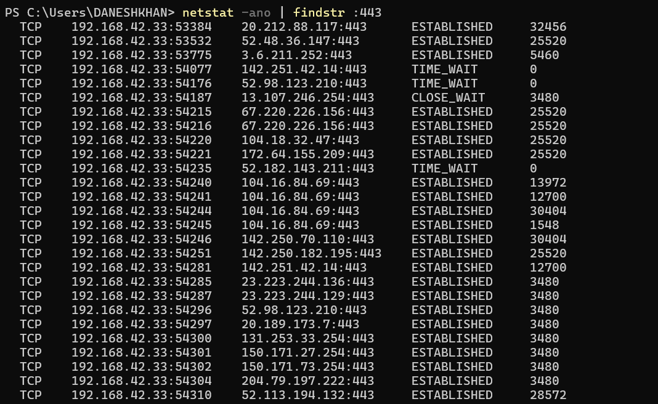
This is my output. 192.168.42.33 is my local ip, followed by 5 digit number which is ephermal port number of that chrome instance. Next column, these where the public IPs of the websites which you are running on that instance(tab). and followed by general port number, which obvious as they won’t show ephermal port number. Next column is connection indicates the state of connection. And next column is process ID.
Ports will have encrypted data, which will get divided into chunks of bytes - data segments and each associated with a number so the order of the delivery get maintained. Data segments also has checksum, you will get to know why exactly so. Now on the other hand server receives your bits of data, it will re-combine them. Now it will check the checksum and ensure that matches with the original checksum to ensure data received in same order. After that all the process happen of preparing response which we discussed in the application layer. This again received at the port of the application, This response contains https response and an email, port will send this packets of response to particular application(chrome instance and email service) by ports and ephermal ports. And will recombine those data segments and check the checksum to ensure data transmission.
That was the job of Transport layer. Now as in application layer we had https protocol, we have UDP and TCP protocol at transport layer.
We talked about data segments. Which have associated number with it - sequence number. The whole data packet has checksum. Which on the receiver side get checked for purpose to determine data has arrived without any loss and sequence number for re-arranging the data segments in order.
This transmission can be of two types, one is when client-receiver has established connection: TCP, and one is they communicate without establishing the connection: UDP. The example we are taking till now is of TCP. Because HTTP/S built over the TCP. Every http/s request is TCP by default.
See, why we use TCP, it does not prevent the data lose. Again carefully, say it with me, “TCP does not prevent data loss”. It simply know that data lost, so it re-transmit the data.So, while you might say it prevents data loss, but, but, holy but, it doesn't stop the loss from happening in the first place. UDP simply sends the data packets and forget it, while TCP sends data packets and remembers it, verifies it and re sends it if any errors. Now some applications or services which does not require re sending data packets, where re transmission of data does not make any sense, that’s where UDP should be used.
Where do the re transmission of data packets does not make sense? Think about it, get some load on your brain. Video conferences. If in between the video conference there might be an error and no voice or video got transmitted. By the time you realize some packets were lost, the conversation has already moved on, and re-transmitting those packets. So implementing video conference functionality should be in UDP protocol.
One example which will rest the case for this is live gaming. See, game it self has different functionalities, which TCP oriented obviously. But the actual game when it starts, it runs on UDP. Before that like creating game room, joining all that is TCP stuff. You are in free fire game, your connection of internet got weak. But still you will be playing, you are killing someone and you are firing here and there, this data is not actually received by the game server. That’s why this data - means your activity of player is not visible or impacting the game, now does it make sense to re transmit this data again when your connection get stable? No, because if so you have killed many players, you fired here and there, whole game flow is now corrupted. So when you use UDP here, it make perfectly sense, that you continue where you left without worrying about the data you sent - actions you did - while in weak connection which didn’t get sent - action actually didn’t happen in game. Give me 1000 on my Paytm, I’m sure no teacher has ever explained you UDP and TCP this good. Or send me prayers at-least.
So the for both transmission protocol, data packets would be different. And also the connection establishment.
When you join a Zoom meeting, there is an initial connection process that sets up the session. This often involves TCP to manage the login, authentication, and setup process (e.g., establishing a secure connection with the Zoom servers).
Once you're in the meeting, the actual audio and video data will be transmitted using UDP.

UDP packet:
It contains the UDP header and data. Header is of 8 bytes: 64 bits. At this moment do not forget, we are still in the Transport layer. IP of server fetched by DNS is not wrapped in any packet yet. At this moment we have only UDP/TCP packets which only knows the ports and the data. Source port destination port length and checksum, that’s pretty much self explanatory I think. See, checksum is still. UDP also knows that. But it simply does not care about it being correct or wrong. Data can be of variable size like 1500 bits or something.
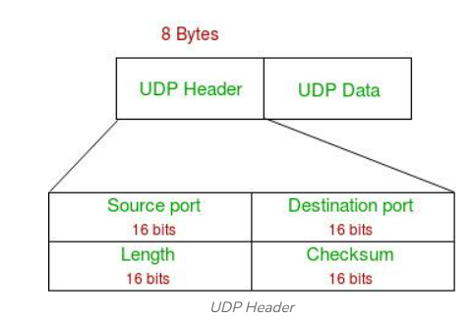

Now see the TCP data packet:
Besides, source port, destination port, checksum, window size, we have other fields which are for either connection establishment or identifying and resolving errors of data transmission for re-transmitting.

Three way handshake process happens before actual transmission process get started. Flags here in diagram represents that. SYN ACK flags.
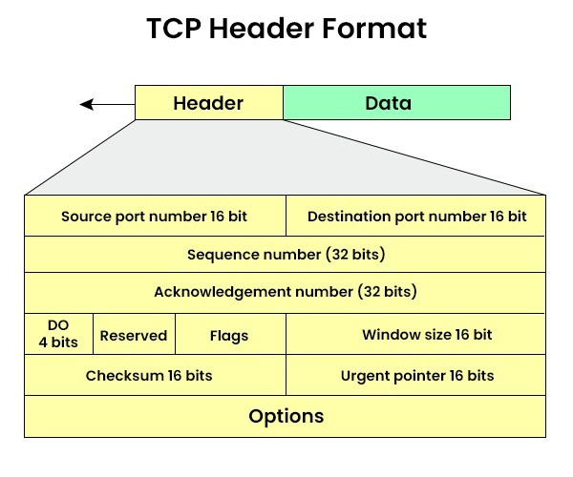
It has also sequence number and acknowledgment numbers.
While reading below process, please do not confuse the ACK flag and acknowledgment number both are different things

1.…Client sends TCP segment to server which has SYN flag to set, and sequence number with value x, server receives that.
2.… it set SYN and ACK flag to set. It also set it’s sequence number to y, and acknowledgement number to x+1, x is received sequence number from client. Now server sends this segment to client
3.… client receives both SYN & ACK flag as set, and sequence number y. client set it’s acknowledgement number y+1 and sends back to server. So now connection is established.

Network layer:

Quickly, what happened till now,
For client: data got encrypted, server IP determined by DNS, data divided into segments, each data segments got wrapped with TCP or UDP header with details like ports, sequence number etc.
For server: data reached to the server, re-assembled, it got to port mentioned in header, and handed over to application layer, and again response to client which client received in same way as server received.

So in this layer, we will learn, for client POV, process, after data get wrapped with TCP/UDP header, and for server POV, process, before data reaches to server port. - THE ROUTING OF DATA

Now the TCP header and data packet will be wrapped up by another header - IP header. So combining all we call it IP packet.
This IP packet will have many things, first focusing on IP addresses.

IP Addressing and Subnetting in Local Networks
When your device connects to the local network through your mobile hotspot, it gets an IP address through DHCP (Dynamic Host Configuration Protocol). As seen below, both the IPv4 default gateway and the DHCP server have the same address, which is your mobile device's local IP. This shows that your mobile is managing the local network, acting as both the DHCP server and the default gateway.
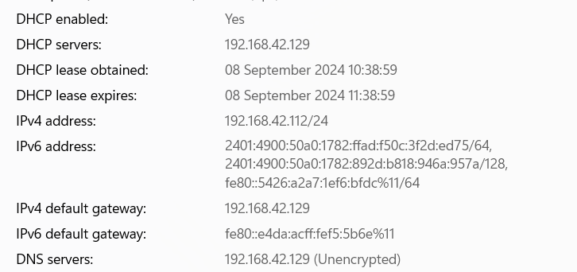

How Subnetting Works:
Your laptop is assigned an IP address like 192.168.42.112/24.
/24 means that the first 24 bits (or the first three octets: 192.168.42) represent the network portion, while the last 8 bits (112) represent the device portion. This defines a subnet, which allows multiple devices to exist within the same local network, all sharing the same network portion (192.168.42.x), with the last 8 bits representing different devices (like your laptop or another device connected to the same mobile network).
Subnetting is represented by the subnet mask: 255.255.255.0. This mask means that the first three segments (or octets) represent the network portion, and the last segment is reserved for devices (as 0 means bits are available for device addressing). It can be also like 255.255.0.0

Classes of IP Addresses:
IP addresses are categorized into classes (A, B, C, D, and E) based on how the network and host portions are divided.
Class A: 1.0.0.0 - 126.255.255.255 (large networks)
Class B: 128.0.0.0 - 191.255.255.255 (medium-sized networks)
Class C: 192.0.0.0 - 223.255.255.255 (small networks)
Private IP Range (Local Networks):
Class A: 10.0.0.0 - 10.255.255.255
Class B: 172.16.0.0 - 172.31.255.255
Class C: 192.168.0.0 - 192.168.255.255 (where your mobile assigns local addresses like 192.168.42.112).
In our case, we are havingg a Class C private IP address, which is not globally routable and is confined to your local network.

Network Address Translation (NAT) and IP Packet Routing
Routing to the Default Gateway:
Your laptop sees that the destination IP (Amazon’s server IP) is not in the local network, so it routes the packet to the default gateway (192.168.42.129), which is your mobile device.
Network Address Translation (NAT) on the Gateway:
Since the local IP addresses like 192.168.42.112 are not routable on the internet, your mobile device uses NAT (Network Address Translation).
NAT replaces your laptop's local IP (192.168.42.112) with the mobile's public IP address (assigned by your ISP). Now this public IP address to your mobile is assigned by ISP using DHCP protocol. Basically they have storage of different available IPs. Which can be assigned to device after it’s lease time expires. In the pic, see our IP has lease obtained and expiry time.
NAT also keeps a table that maps your local IP to your mobile’s public IP, so responses can be correctly routed back to your device.

Sending the IP Packet to the ISP:
After the IP packet is updated with the public IP, it is sent to your ISP (Internet Service Provider). The ISP acts as an intermediary, forwarding the packet across the internet towards Amazon's server using routing protocols. These protocols rely on various graph algorithms to determine the best path from the ISP to the Amazon server. Once the packet reaches the Amazon server, the server prepares a response and sends an IP packet back. This response is routed through the same process in reverse: from the server to the ISP, then back to your mobile device, and finally to your laptop.
Key concepts include hop count, which refers to the number of routers a packet passes through from source to destination, and latency, the time it takes for a packet to travel between two points. Routers generally aim to minimize this delay. Every router maintains a routing table, a database that lists possible routes to various destinations, including information like the destination IP range, subnet mask, and the next hop.
On a larger scale, this functions similarly to how routing works within a LAN. One of the most important routing protocols is BGP (Border Gateway Protocol), which helps routers determine the best path for data to travel between different autonomous systems (e.g., between your ISP’s network and Amazon’s network).
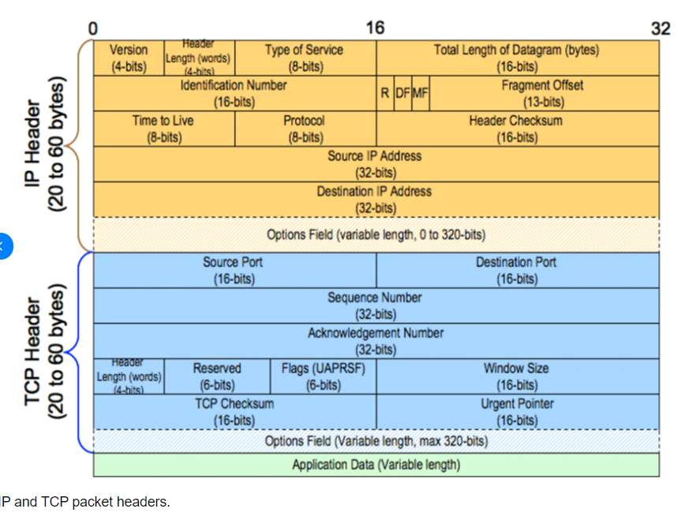

Ip packet now contains TCP header, IP header and data. IP header includes the fields which we discussed above. Besides that it contains flags and checksum and other fields. There is field for TTL - time to live which determines the time a packet can live in network before it get discarded, preventing it from circulating endlessly for any reason.
Now, when we say IP packets will rout to the ISP and then to the amazon server, what actually routs is not packet, JSON and HTML are not flying over the sky, nor SQL or any images got wings even they drank red bull or black. This is where Data link layer and Phhysical layer comes into play.

Data Link Layer and Physical Layer

First of our example includes that our pc is connected to Hotspot of mobile, so there is Local routing happening, then from Mobile to ISP, and from ISP to different routers and Amazon server, bunch of routing will happen.
So before routing, It get encapsulated- a stylish word for wrapping up, into frames. Which has MAC address of destination router, so laptop will have MAC address of mobile, and of wifi type. Yes As we have different type of network adapters which are Data link layer devices. We have different type of MAC address, so here Wifi MAC address. Now our mobile will have MAC address of next router and next router will be having the MAC address of ISP and so on. This data is transimitted via signals, which are generated from the binary digits - phhysical layer generates from the data frames received by the DLL. This signals reach to each router and got decaapsulated and again framed with next IP or MAC address. That’s how data routs over the network.
The process of physical transmission of data is in itself big Subject, But as our interest was to learn about Networking in the context of How internet works. This is How it works…..

