
BHARTI VIDYAPEETH DEEMED UNIVERSITY
(DEEMED TO BE UNIVERSITY)
Kharghar, Navi Mumbai

BCA 2nd year (SEMESTER 4)
SESSION: 2023-2024

JOURNAL: - Lab on Advanced Java Journal

Name: - Danish Shaikh
Roll no: B-37

Teacher In-Charge: Prof. Alok Shah


Bharati Vidyapeeth’s
Department Of Management Studies
Kharghar, Navi Mumbai
CERTIFICATE
This is to certify that the journal has been prepared by
Mr. Danish Shaikh Roll No. 37 Of BCA (Sem- IV) Div-B for the academic year 2023-2024 in the subject of Lab on Advanced Java Journal for the fulfilment of BCA.

___________ ____________
Professor-In-Charge External Examiner

Date: _________________ Date: _________________

Index
Unit- 1
1. | Write a program to demonstrate multi-threading using Thread Class.
2. | Write java program to implement Runnable interface.
3. | Write java program for demonstrating concept of Thread synchronization.
4. | Write java code for implementing the following Inter-thread communication  methods:  wait(),  notify(),  notifyAll().
Unit-2
1. | Develop java programs to implement Simple generic class and methods.
2. | Write java programs to demonstrate concept of Vector.
3. | Write java programs to demonstrate concept of LinkedList.
4. | Write java code to implement Iterator to access collection elements.
Unit-3
1. | Implement jdbc connectivity to insert  Records.
2. | Implement jdbc connectivity to delete  Records.
3. | Implement jdbc connectivity to demonstrate  PreparedStatement.
4. | Write java code to Making use of Database  Metadata and ResultSetMetadata
Unit-4
1. | Write a servlet program to create a simple servlet and test it.
2. | Write a servlet program to read the client request parameters.
3. | Implement a Servlet to generate Multiplication Table for a Number Entered in Html Page
Unit-5
1. | Develop an application to demonstrate Declaration tag available in JSP.
2. | Develop an application to demonstrate Expression tag available in JSP.
3. | Develop an application to demonstrate Scriplet tag available in JSP.
2. | Develop a JSP Application to accept  Details from user and store it into the database table.
3. | Develop a JSP Application to Authenticate User login as per registration details.  If login success the forward user to Index Page otherwise show login failure Message.
4. | Write a web based student registration application where students can register online with their enrolment number. The registered students should be able to log on to the site after getting registered. You are  required to use JSP, Servlet and JDBC

Q.1.Write a program to demonstrate multi-threading using Thread Class.

class MyThread extends Thread {
public void run() {
System.out.println("Thread: " + Thread.currentThread().getName() + " is running");
}
}
public class Program1 {
public static void main(String[] args) {
MyThread thread1 = new MyThread();
MyThread thread2 = new MyThread();
thread1.start();
thread2.start();
}
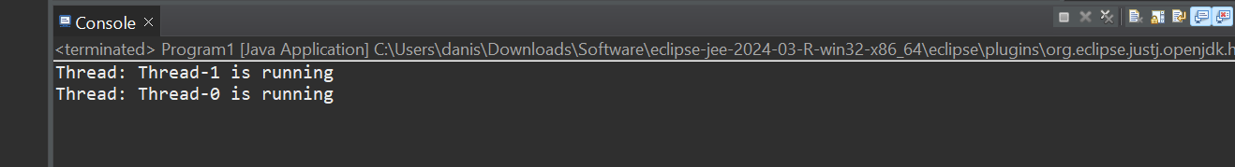
}

Q.2.Write java program to implement Runnable interface.

class MyRunnable implements Runnable {
public void run() {
System.out.println("Thread is running");
}
}
public class P2 {
public static void main(String[] args) {
MyRunnable myRunnable1 = new MyRunnable();
MyRunnable myRunnable2 = new MyRunnable();
Thread thread1 = new Thread(myRunnable1);
Thread thread2 = new Thread(myRunnable2);
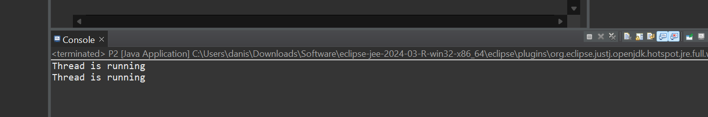
thread1.start();
thread2.start();
}
Q.3 . Write java program for demonstrating concept of Thread synchronization.

class MessageThread extends Thread {
private Object lock;
public MessageThread(Object lock) {
this.lock = lock;
}
public void run() {
synchronized (lock) {
for (int i = 0; i < 5; i++) {
System.out.println(Thread.currentThread().getName() + ": Message " + (i + 1));
}
}
}
}
public class Main {
public static void main(String[] args) {
Object lock = new Object(); // Object for synchronization
MessageThread thread1 = new MessageThread(lock);
MessageThread thread2 = new MessageThread(lock);
thread1.setName("Thread 1");
thread2.setName("Thread 2");
thread1.start();
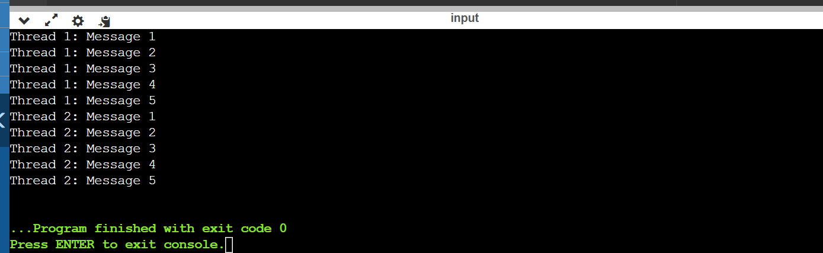
thread2.start();
}
Q.4. Write java code for implementing the following Inter-thread communication
methods: wait(), notify(), notifyAll().
class Customer{
int amount=10000;
synchronized void withdraw(int amount){
System.out.println("going to withdraw...");
if(this.amount<amount){
System.out.println("Less balance; waiting for deposit...");
try{wait();}catch(Exception e){}
}
this.amount-=amount;
System.out.println("withdraw completed...");
}
synchronized void deposit(int amount){
System.out.println("going to deposit...");
this.amount+=amount;
System.out.println("deposit completed... ");
notify();
}
}
class Main {
public static void main(String args[]){
final Customer c=new Customer();
new Thread(){
public void run(){c.withdraw(15000);}
}.start();
new Thread(){
public void run(){c.deposit(10000);}
}.start();
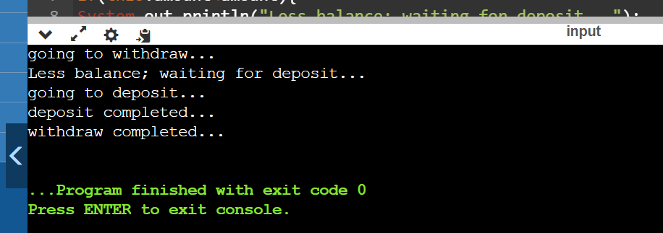
}}
UNIT 2
Q.1Develop java programs to implement Simple generic class and methods.
public class MyGeneric<T> {
private T data;
public MyGeneric(T data) {
this.data = data;
}
public T getData() {
return data;
}
public void setData(T data) {
this.data = data;
}
public static <E> void printArray(E[] array) {
for (E element : array) {
System.out.print(element + " ");
}
System.out.println();
}
public static void main(String[] args) {
MyGeneric<Integer> integerGeneric = new MyGeneric<>(10);
MyGeneric<String> stringGeneric = new MyGeneric<>("Hello");
System.out.println("Integer data: " + integerGeneric.getData());
System.out.println("String data: " + stringGeneric.getData());
Integer[] intArray = {1, 2, 3, 4, 5};
String[] strArray = {"One", "Two", "Three", "Four", "Five"};
System.out.print("Integer Array: ");
printArray(intArray);
System.out.print("String Array: ");
printArray(strArray);
}
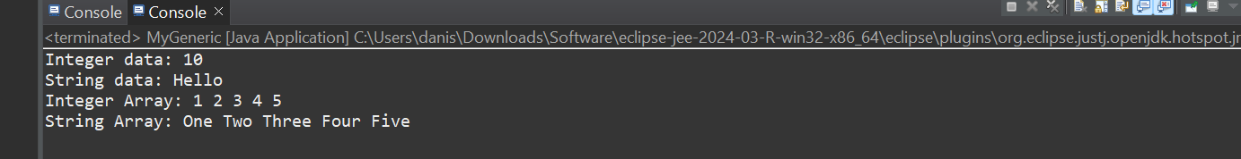
}

Q.2. Write java programs to demonstrate concept of Vector.
import java.util.Vector;
public class VectorDemo {
public static void main(String[] args) {
Vector<String> vector = new Vector<>();
vector.add("Apple");
vector.add("Banana");
vector.add("Orange");
System.out.println("Elements in the Vector:");
for (String fruit : vector) {
System.out.println(fruit);
}
}
}
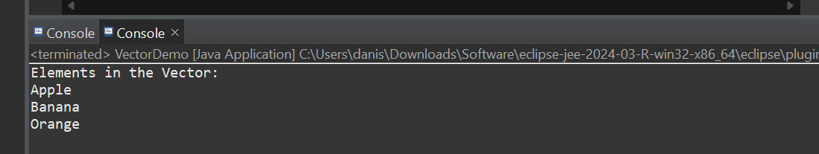

Q,3. Write java programs to demonstrate concept of LinkedList.
import java.util.LinkedList;
public class LinkedListDemo {
public static void main(String[] args){
LinkedList<String> linkedList = new LinkedList<>();
linkedList.add("Apple");
linkedList.add("Banana");
linkedList.add("Orange");
System.out.println("Elements in the LinkedList:");
for (String fruit : linkedList) {
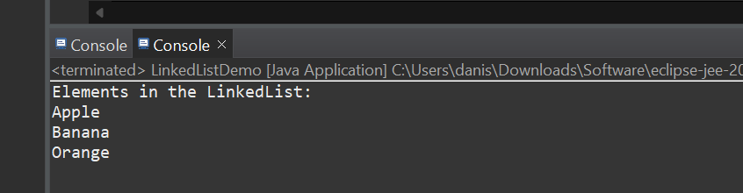
System.out.println(fruit);
}

Q.4. Write java code to implement Iterator to access collection elements.
import java.util.ArrayList;
import java.util.Iterator;
public class IteratorDemo {
public static void main(String[] args) {
ArrayList<String> list = new ArrayList<>();
list.add("Apple");
list.add("Banana");
list.add("Orange");
Iterator<String> iterator = list.iterator();
System.out.println("Elements in the ArrayList:");
while (iterator.hasNext()) {
String element = iterator.next();
System.out.println(element);
}
}
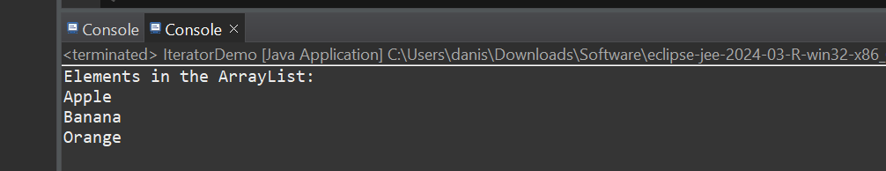
}
UNIT 3
1. Implement jdbc connectivity to insert Records.
package Unit3;
import java.sql.*;
import java.util.Scanner;

public class p1{
public static void main(String[] ar) {

try{
Class.forName("com.mysql.jdbc.Driver");
Connection con=DriverManager.getConnection(
"jdbc:mysql://localhost:3306/alpha","root","");
PreparedStatement pstmt;
int Roll_No,Fees;
String Full_Name,Course;

Scanner sc = new Scanner(System.in);

System.out.println("Enter Roll_No");
Roll_No=sc.nextInt();

System.out.println("Enter Full_Name");
Full_Name=sc.next();

System.out.println("Enter Course");
Course= sc.next();

System.out.println("Enter Fees");
Fees=sc.nextInt();

pstmt=con.prepareStatement("insert into student (Roll_No,Full_Name,Course,Fees) values(?,?,?,?)");
pstmt.setInt(1,Roll_No);
pstmt.setString(2,Full_Name);
pstmt.setString(3,Course);
pstmt.setInt(4,Fees);
pstmt.executeUpdate();
System.out.println("Updated");
con.close();
}
catch (Exception e){
e.printStackTrace();
}
}
}
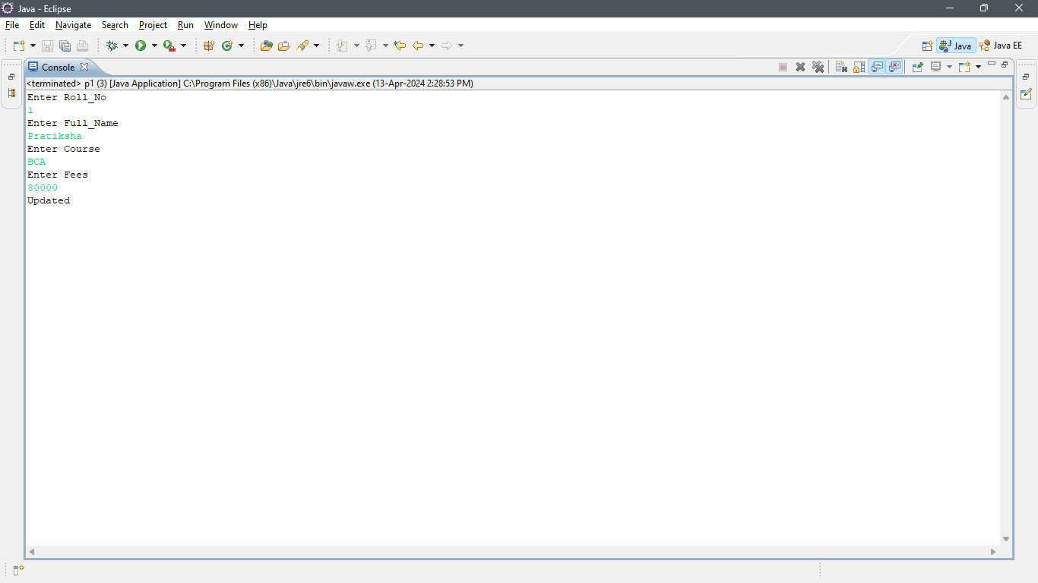
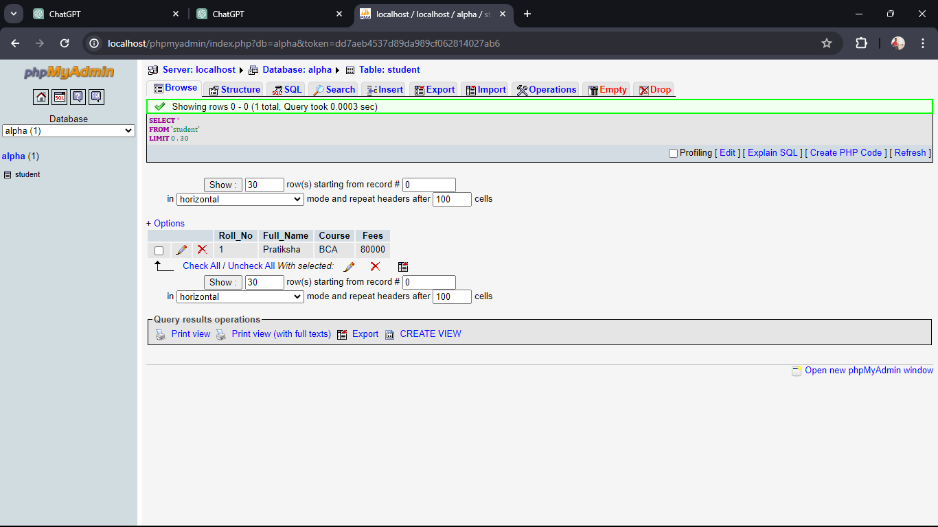
2. Implement jdbc connectivity to delete Records.
import java.sql.*;

public class p5{
public static void main(String[] ar) {

try{
Class.forName("com.mysql.jdbc.Driver");
Connection con=DriverManager.getConnection(
"jdbc:mysql://localhost:3306/alpha","root","");
Statement stmt=con.createStatement();
stmt.executeUpdate("delete from Student");
con.close();
System.out.println("Record Deleted ");

}
catch (Exception e){
e.printStackTrace();
}
}
}
Output 2 :- 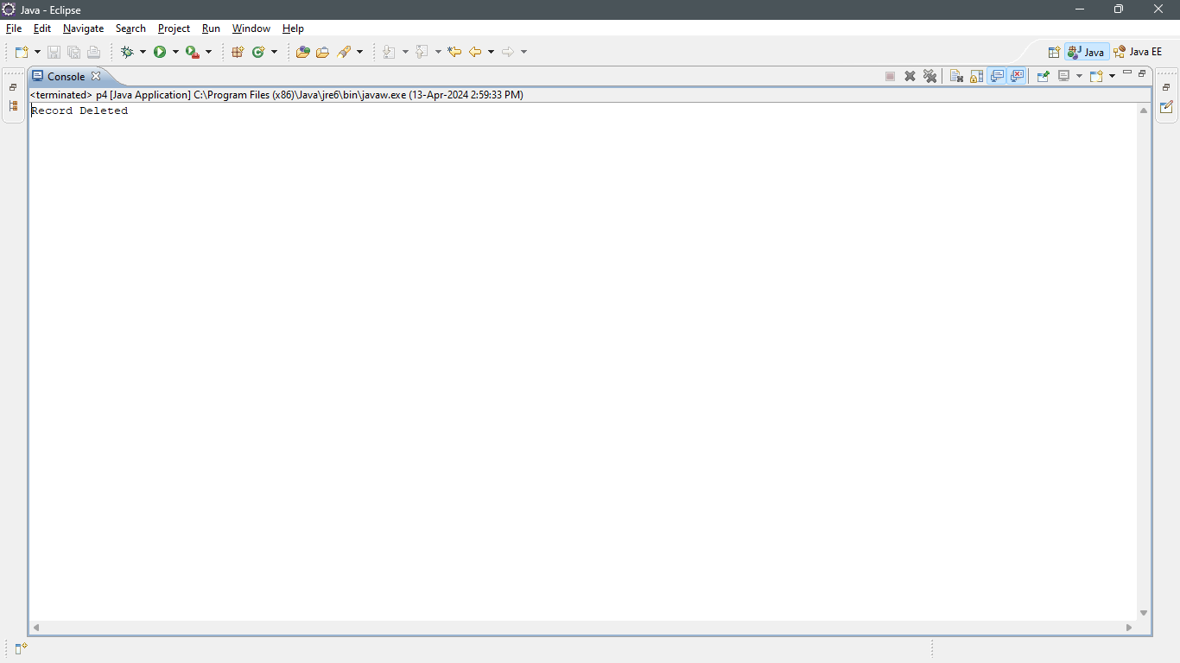

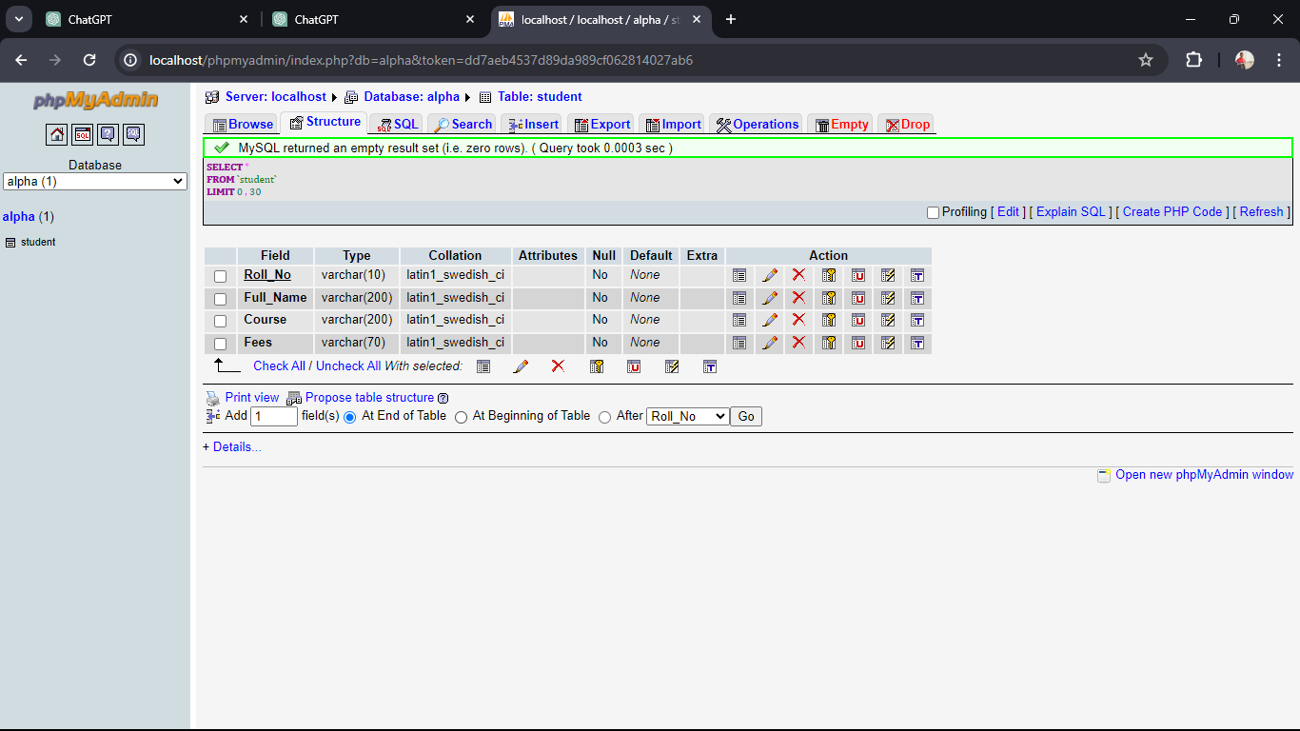
3. Implement jdbc connectivity to demonstrate PreparedStatement.
import java.sql.*;

public class p1 {
public static void main(String[] args) {
try {
// Registering the MySQL JDBC driver
Class.forName("com.mysql.jdbc.Driver");

// Establishing a connection to the database
Connection connection = DriverManager.getConnection("jdbc:mysql://localhost:3306/alpha","root","");

// Creating a PreparedStatement
String sql = "INSERT INTO student (Roll_No,Full_Name,Course,Fees) VALUES (?, ?, ?, ?)";
PreparedStatement preparedStatement = connection.prepareStatement(sql);

// Setting parameters for PreparedStatement
preparedStatement.setInt(1, 1);
preparedStatement.setString(2, "Jayesh_Bonde");
preparedStatement.setString(3, "BCA");
preparedStatement.setInt(4, 80000);

// Executing the PreparedStatement
int rowsInserted = preparedStatement.executeUpdate();
if (rowsInserted > 0) {
System.out.println("A new record has been inserted successfully.");
}

// Closing resources
preparedStatement.close();
connection.close();
} catch (ClassNotFoundException e) {
e.printStackTrace();
} catch (SQLException e) {
e.printStackTrace();
}
}
}
Output 3 :- 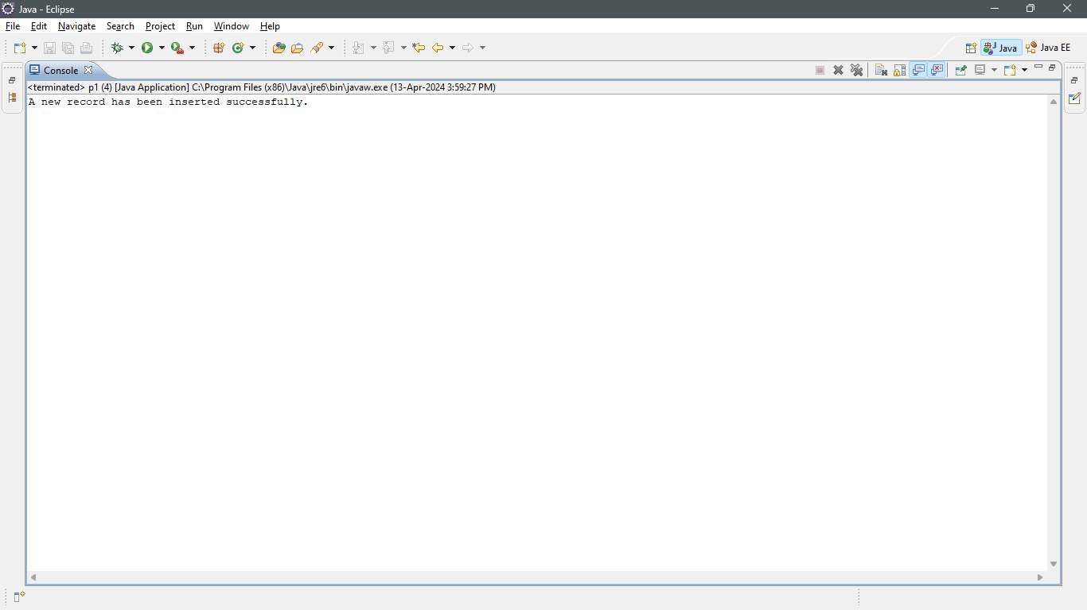
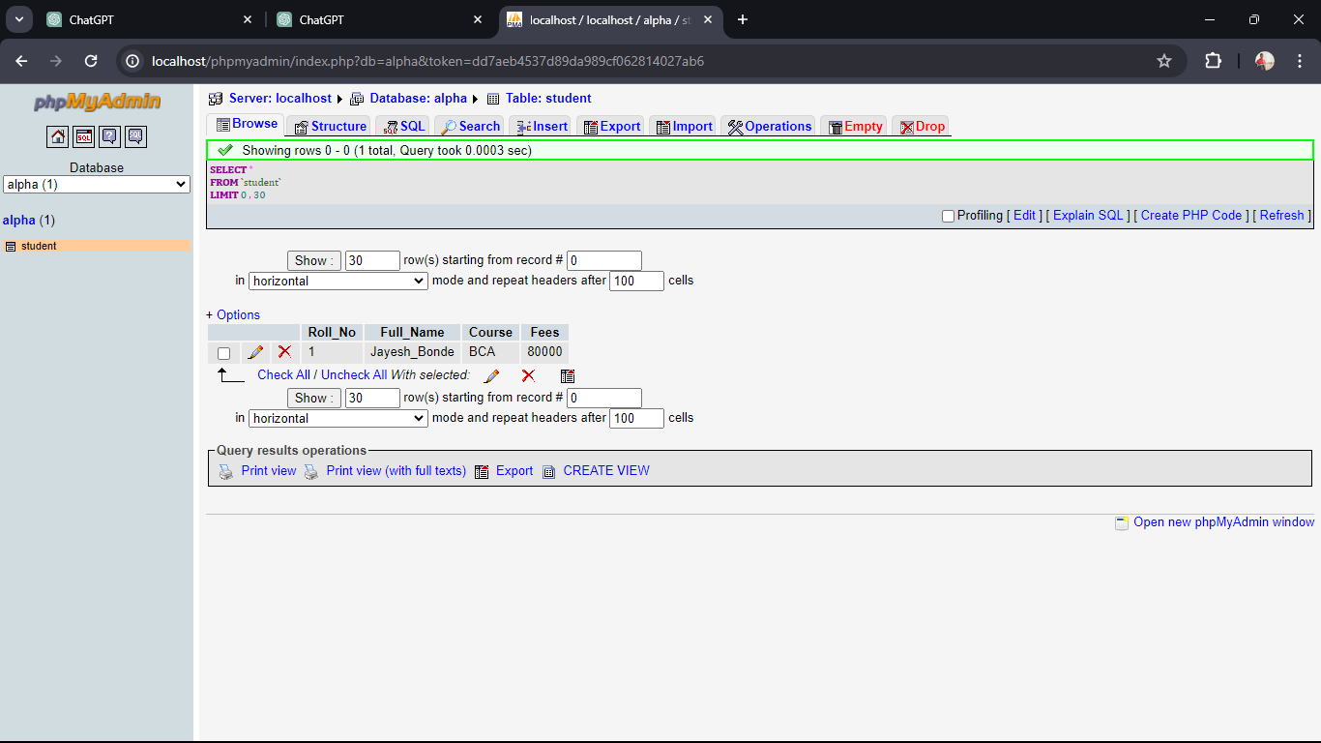
4. Write java code to Making use of Database Metadata and ResultSetMetadata.
i. Database Metadata
package Unit3;
import java.sql.*;

public class p4 {
public static void main(String[] ar) {

try {

Class.forName("com.mysql.jdbc.Driver");
Connection con = DriverManager.getConnection("jdbc:mysql://localhost:3306/alpha", "root", "");
DatabaseMetaData b = con.getMetaData();
System.out.println("Driver Name: "+b.getDriverName());
System.out.println("Driver Version: "+b.getDriverVersion());
System.out.println("UserName: "+b.getUserName());
System.out.println("Database Product Name: "+b.getDatabaseProductName());
System.out.println("Database Product Version: "+b.getDatabaseProductVersion());

con.close();
} catch (Exception e) {
e.printStackTrace();
}
}
}
Output i. :- 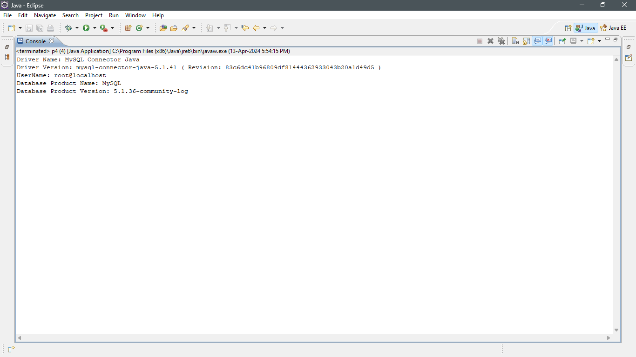

ii. ResultSetMetadata.
package Unit3;
import java.sql.*;

public class p4ii {
public static void main(String[] ar) {

try {

Class.forName("com.mysql.jdbc.Driver");
Connection con = DriverManager.getConnection("jdbc:mysql://localhost:3306/alpha", "root", "");
PreparedStatement ps=con.prepareStatement("select * from student");
ResultSet rs=ps.executeQuery();
ResultSetMetaData rsmd=rs.getMetaData();

System.out.println("Total columns: "+rsmd.getColumnCount());
System.out.println("Column Name of 1st column: "+rsmd.getColumnName(1));
System.out.println("Column Type Name of 1st column: "+rsmd.getColumnTypeName(1));

con.close();
} catch (Exception e) {
e.printStackTrace();
}
}
}
Output ii. :- 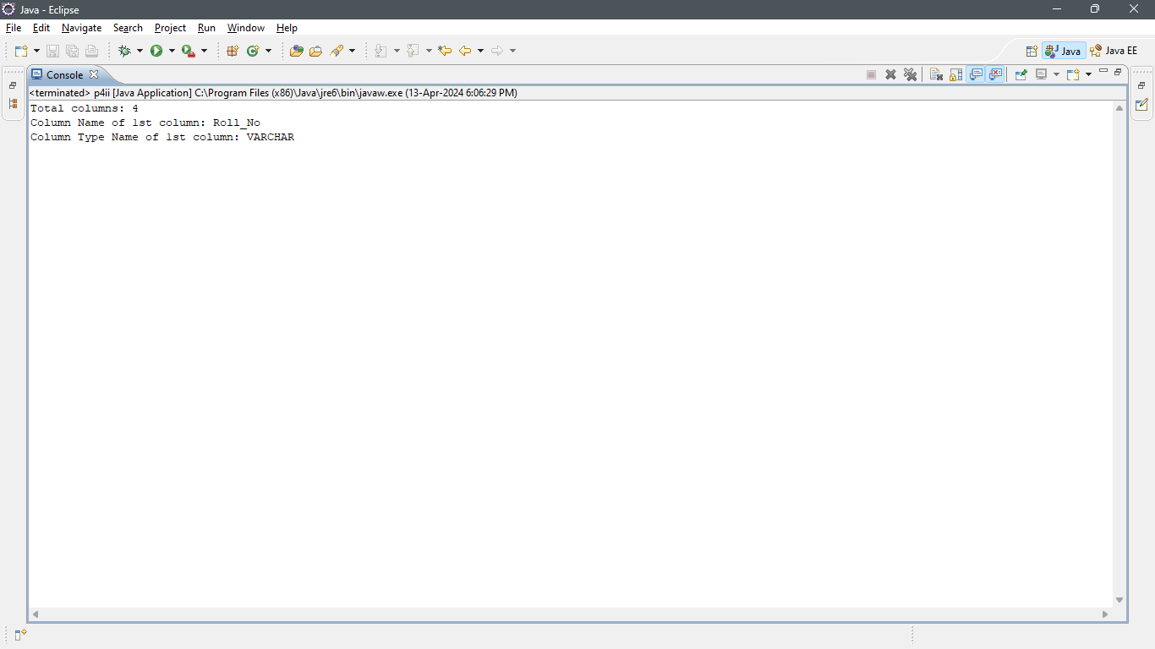

Unit 4
Q.1. Write a servlet program to create a simple servlet and test it.
package in.sp.backend;
import java.io.IOException;
import jakarta.servlet.ServletException;
import jakarta.servlet.http.HttpServlet;
import jakarta.servlet.http.HttpServletRequest;
import jakarta.servlet.http.HttpServletResponse;
public class Login extends HttpServlet {
@Override
protected void service(HttpServletRequest request, HttpServletResponse response) throws ServletException, IOException {
System.out.println("Hello I am in Servlet");
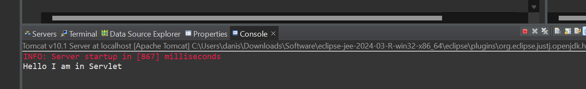
}

}

Q.2. Write a servlet program to read the client request parameters.

package in.sp.backend;
import java.io.IOException;
import java.io.PrintWriter;
import jakarta.servlet.ServletException;
import jakarta.servlet.annotation.WebServlet;
import jakarta.servlet.http.HttpServlet;
import jakarta.servlet.http.HttpServletRequest;
import jakarta.servlet.http.HttpServletResponse;
@WebServlet("/ParameterServlet")
public class ParameterServlet extends HttpServlet {
private static final long serialVersionUID = 1L;
protected void doGet(HttpServletRequest request, HttpServletResponse response)
throws ServletException, IOException {
response.setContentType("text/html");
String name = request.getParameter("name");
String age = request.getParameter("age");
PrintWriter out = response.getWriter();
out.println("<html><body>");
out.println("<h2>Client Request Parameters:</h2>");
out.println("<p>Name: " + name + "</p>");
out.println("<p>Age: " + age + "</p>");
out.println("</body></html>");
}
protected void doPost(HttpServletRequest request, HttpServletResponse response)
throws ServletException, IOException {
doGet(request, response);
}
}
HTML Code
<!DOCTYPE html>
<html>
<head>
<title>Parameter Servlet Test</title>
</head>
<body>
<h2>Enter your details:</h2>
<form action="ParameterServlet" method="GET">
<label for="name">Name:</label>
<input type="text" id="name" name="name"><br><br>
<label for="age">Age:</label>
<input type="text" id="age" name="age"><br><br>
<input type="submit" value="Submit">
</form>
</body>
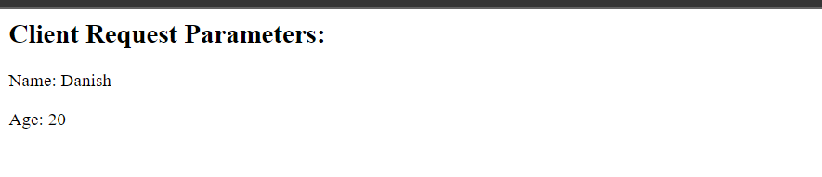
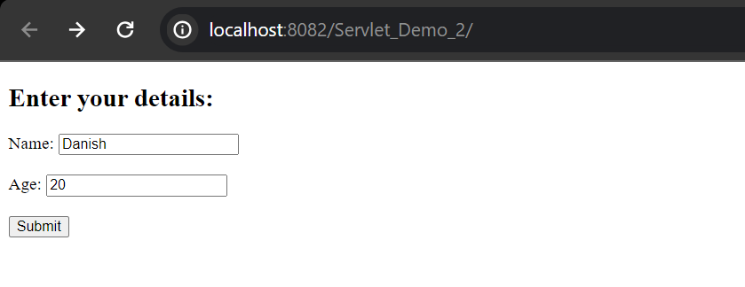
</html>

Q.3. Implement a Servlet to generate Multiplication Table for a Number Entered in Html Page

package in.sp.backend;
import java.io.IOException;
import java.io.PrintWriter;
import jakarta.servlet.ServletException;
import jakarta.servlet.annotation.WebServlet;
import jakarta.servlet.http.HttpServlet;
import jakarta.servlet.http.HttpServletRequest;
import jakarta.servlet.http.HttpServletResponse;
@WebServlet("/MultiplicationTableServlet")
public class MultiplicationTableServlet extends HttpServlet {
private static final long serialVersionUID = 1L;
protected void doPost(HttpServletRequest request, HttpServletResponse response)
throws ServletException, IOException {
String numberStr = request.getParameter("number");
int number = Integer.parseInt(numberStr);
response.setContentType("text/html");
PrintWriter out = response.getWriter();
out.println("<html><body>");
out.println("<h2>Multiplication Table for " + number + ":</h2>");
out.println("<table border='1'>");
for (int i = 1; i <= 10; i++) {
out.println("<tr><td>" + number + " * " + i + "</td><td>=</td><td>" + (number * i) + "</td></tr>");
}
out.println("</table>");
out.println("</body></html>");
}
}
HTML code
<!DOCTYPE html>
<html>
<head>
<title>Multiplication Table Generator</title>
</head>
<body>
<h2>Enter a Number to Generate Multiplication Table:</h2>
<form action="MultiplicationTableServlet" method="post">
<label for="number">Enter Number:</label>
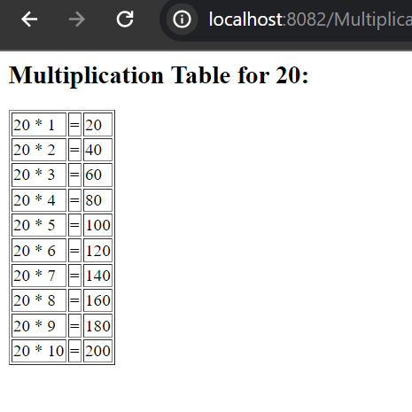
<input type="number" id="number" name="number" required><br><br>
<input type="submit" value="Generate Table">
</form>
</body>
</html>
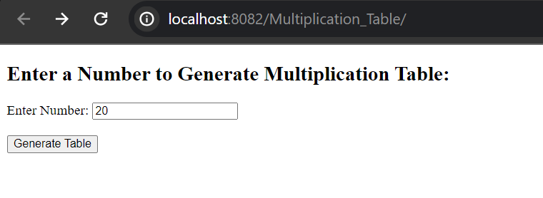

UNIT 5
Q.1. Develop an application to demonstrate Declaration tag available in JSP.

<%@ page language="java" contentType="text/html; charset=UTF-8"
pageEncoding="UTF-8"%>
<!DOCTYPE html>
<html>
<head>
<meta charset="UTF-8">
<title>Declaration Tag Demo</title>
</head>
<body>
<%!
int number = 10;
String message = "Hello from JSP!";
%>
<%!
private String getMessage() {
return "This message is from a method declared in JSP!";
}
%>
<h2>Declaration Tag Demo</h2>
<p>The value of the declared number is: <%= number %></p>
<p><%= message %></p>
<p><%= getMessage() %></p>
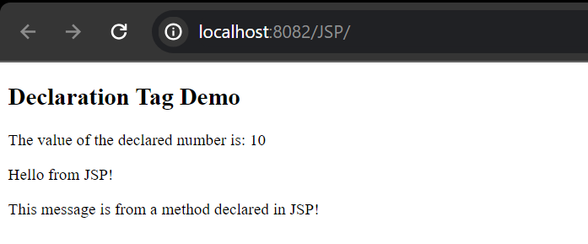
</body></html>

Q.2. Develop an application to demonstrate Expression tag available in JSP.
<!DOCTYPE html>
<html>
<head>
<meta charset="UTF-8">
<title>Expression Tag Demo</title>
</head>
<body>
<%-- Declaration tag to declare variables --%>
<%! String greeting = "Hello"; %>
<%! String name = "World"; %>
<%-- Expression tag to concatenate strings --%>
<h2>Greeting Message</h2>
<p><%= greeting + ", " + name + "!" %></p>
<%-- Expression tag to perform arithmetic operation --%>
<%! int num1 = 10; %>
<%! int num2 = 5; %>
<h2>Arithmetic Operation</h2>
<p>Sum: <%= num1 + num2 %></p>
</body>
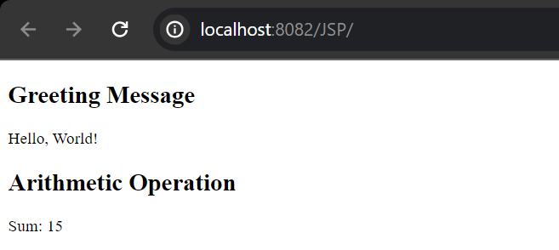
</html>

Q.3. Develop an application to demonstrate Scriplet tag available in JSP.

<!DOCTYPE html>
<html>
<head>
<meta charset="UTF-8">
<title>Scriptlet Tag Demo</title>
</head>
<body>
<%
String firstName = "Danish";
String lastName = "Shaikh";
%>
<h2>Welcome Message</h2>
<%>
out.println("<p>Welcome, " + firstName + " " + lastName + "!</p>");
%>
</body>
</html>
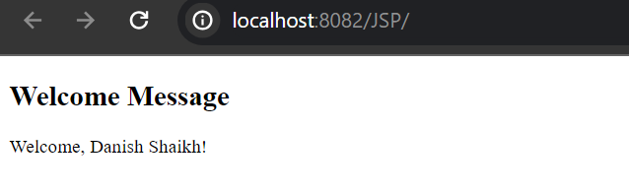

Q.4. Develop a JSP Application to accept, Details from user and store it into the database table.
JSP
<!DOCTYPE html>
<html>
<head>
<meta charset="UTF-8">
<title>User Details Form</title>
</head>
<body>
<h2>User Details Form</h2>
<form action="save_user.jsp" method="post">
<label for="name">Name:</label>
<input type="text" id="name" name="name" required><br><br>
<label for="email">Email:</label>
<input type="email" id="email" name="email" required><br><br>
<label for="phone">Phone:</label>
<input type="text" id="phone" name="phone" required><br><br>
<input type="submit" value="Submit">
</form>
</body>
</html>
<%@ page import="java.sql.*" %>
<%@ page import="javax.naming.*" %>
<%@ page import="javax.sql.*" %>
<%@ page contentType="text/html;charset=UTF-8" %>
<%
String name = request.getParameter("name");
String email = request.getParameter("email");
String phone = request.getParameter("phone");
String jdbcUrl = "jdbc:mysql://localhost:3306/your_database";
String dbUsername = "your_username";
String dbPassword = "your_password";
Connection conn = null;
PreparedStatement pstmt = null;

try {
Class.forName("com.mysql.jdbc.Driver");
conn = DriverManager.getConnection(jdbcUrl, dbUsername, dbPassword);
String sql = "INSERT INTO user_details (name, email, phone) VALUES (?, ?, ?)";
pstmt = conn.prepareStatement(sql);
pstmt.setString(1, name);
pstmt.setString(2, email);
pstmt.setString(3, phone);
pstmt.executeUpdate();
pstmt.close();
conn.close();
response.sendRedirect("success.jsp");
} catch (SQLException | ClassNotFoundException e) {
e.printStackTrace();
response.sendRedirect("error.jsp");
} finally {
if (pstmt != null) pstmt.close();
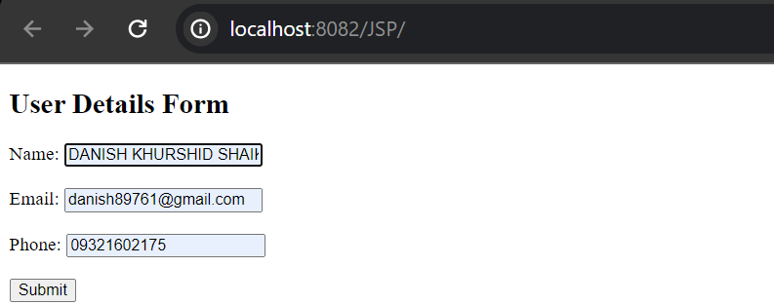
if (conn != null) conn.close();
Q.5. Develop a JSP Application to Authenticate User login as per registration details.
If login success the forward user to Index Page otherwise show login failure Message.

<%@ page language="java" contentType="text/html; charset=ISO-8859-1"
pageEncoding="ISO-8859-1"%>
<!DOCTYPE html PUBLIC "-//W3C//DTD HTML 4.01 Transitional//EN" "http://www.w3.org/TR/html4/loose.dtd">
<html>
<head>
<meta http-equiv="Content-Type" content="text/html; charset=ISO-8859-1">
<title>Insert title here</title>
</head>
<body>
<h1>Login</h1>
<form action="processloginp5.jsp" method="post">
Username: <input type="text" name="username"><br>
Password: <input type="password" name="password"><br>
<input type="submit" value="Login">
</form>
</body>
</html>
Process:- <%@ page language="java" contentType="text/html; charset=UTF-8" pageEncoding="UTF-8"%>
<%@ page import="java.io.*,java.util.*" %>

<!DOCTYPE html>
<html>
<head>
<meta charset="UTF-8">
<title>Login Process</title>
</head>
<body>
<%
// Get form parameters
String username = request.getParameter("username");
String password = request.getParameter("password");

// Validate username and password (this is a basic example, you should use secure methods for password handling)
if ("admin".equals(username) && "password".equals(password)) {
// Forward to index page
response.sendRedirect("indexloginp5.jsp");
} else {
// Show login failure message
out.println("<p>Login failed. Please try again.</p>");
}
%>
</body>
</html>
Index- <%@ page language="java" contentType="text/html; charset=ISO-8859-1"
pageEncoding="ISO-8859-1"%>
<!DOCTYPE html PUBLIC "-//W3C//DTD HTML 4.01 Transitional//EN" "http://www.w3.org/TR/html4/loose.dtd">
<html>
<head>
<meta http-equiv="Content-Type" content="text/html; charset=ISO-8859-1">
<title>Insert title here</title>
</head>
<body>
<h1>Welcome to the Index Page</h1>
<p>This is a protected page accessible only after successful login.</p>
</body>
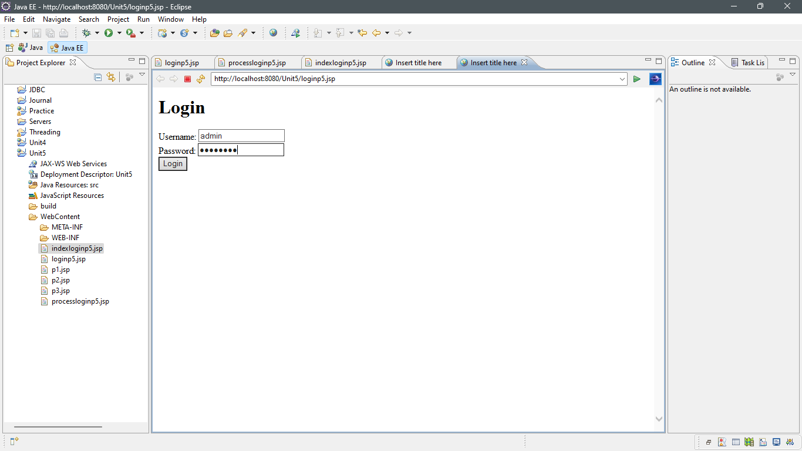
</html>
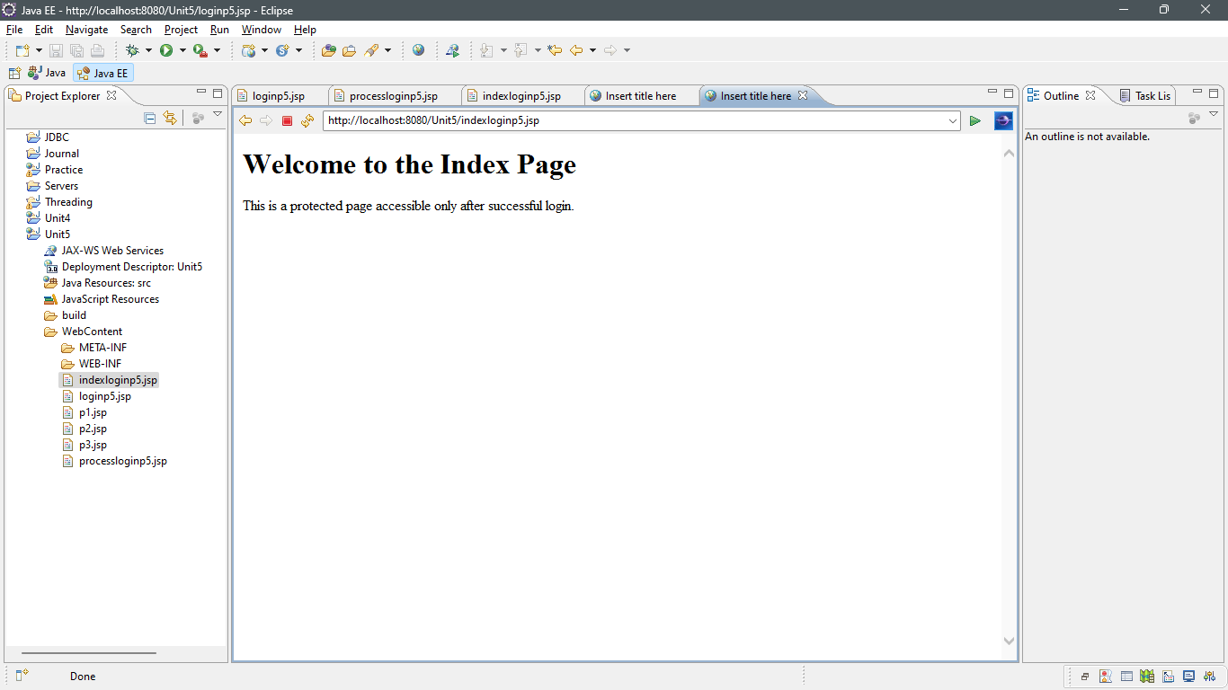

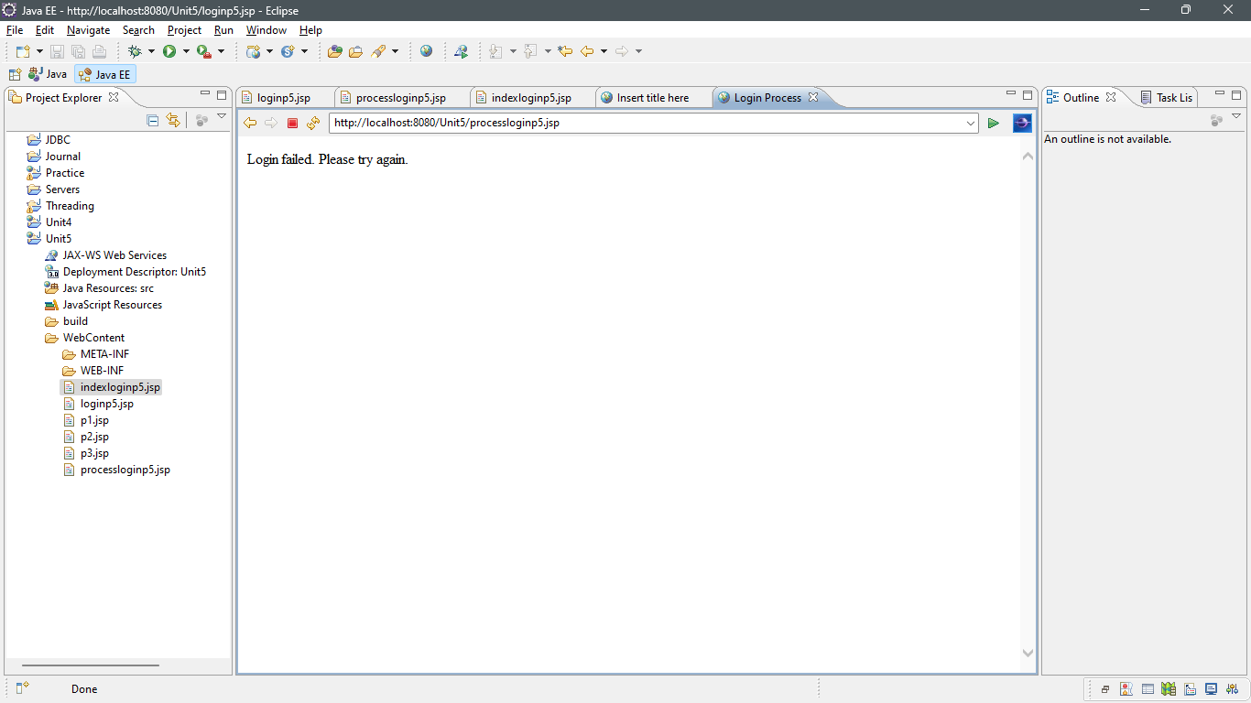
6. Write a web based student registration application where students can register online with their enrolment number. The registered students should be able to log on to the site after getting registered. You are required to use JSP, Servlet and JDBC
<%@ page language="java" contentType="text/html; charset=ISO-8859-1"
pageEncoding="ISO-8859-1"%>
<!DOCTYPE html PUBLIC "-//W3C//DTD HTML 4.01 Transitional//EN" "http://www.w3.org/TR/html4/loose.dtd">
<html>
<head>
<meta http-equiv="Content-Type" content="text/html; charset=ISO-8859-1">
<title>Insert title here</title>
</head>
<body>
<h2>Student Registration</h2>
<form action="RegisterServlet" method="post">
Roll No: <input type="text" name="rollNo"><br>
Name: <input type="text" name="name"><br>
Course: <input type="text" name="course"><br>
<input type="submit" value="Register">
</form>
</body>
</html
import java.io.IOException;
import java.sql.*;
import javax.servlet.ServletException;
import javax.servlet.annotation.WebServlet;
import javax.servlet.http.HttpServlet;
import javax.servlet.http.HttpServletRequest;
import javax.servlet.http.HttpServletResponse;

/**
* Servlet implementation class RegisterServlet
*/
@WebServlet("/RegisterServlet")
public class RegisterServlet extends HttpServlet {
private static final long serialVersionUID = 1L;

/**
* @see HttpServlet#HttpServlet()
*/
public RegisterServlet() {
super();
// TODO Auto-generated constructor stub
}

/**
* @see HttpServlet#doGet(HttpServletRequest request, HttpServletResponse response)
*/
protected void doGet(HttpServletRequest request, HttpServletResponse response) throws ServletException, IOException {
// TODO Auto-generated method stub
}

/**
* @see HttpServlet#doPost(HttpServletRequest request, HttpServletResponse response)
*/
protected void doPost(HttpServletRequest request, HttpServletResponse response) throws ServletException, IOException {
// TODO Auto-generated method stub
String rollNo = request.getParameter("rollNo");
String name = request.getParameter("name");
String course = request.getParameter("course");

String url = "jdbc:mysql://localhost:3306/alpha";
String user = "root";
String password = "";

try {
Class.forName("com.mysql.jdbc.Driver");
Connection con = DriverManager.getConnection(url, user, password);
PreparedStatement pstmt = con.prepareStatement("INSERT INTO mytable (`Roll no`, Name, Course) VALUES (?, ?, ?)");
pstmt.setString(1, rollNo);
pstmt.setString(2, name);
pstmt.setString(3, course);
int rowsInserted = pstmt.executeUpdate();
pstmt.close();
con.close();

if (rowsInserted > 0) {
response.sendRedirect("login.jsp");
} else {
response.getWriter().println("Registration failed!");
}
} catch (Exception e) {
e.printStackTrace();
}
}
}
<%@ page language="java" contentType="text/html; charset=ISO-8859-1"
pageEncoding="ISO-8859-1"%>
<!DOCTYPE html PUBLIC "-//W3C//DTD HTML 4.01 Transitional//EN" "http://www.w3.org/TR/html4/loose.dtd">
<html>
<head>
<meta http-equiv="Content-Type" content="text/html; charset=ISO-8859-1">
<title>Insert title here</title>
</head>
<body>
<h2>Student Login</h2>
<form action="LoginServlet" method="post">
Roll No: <input type="text" name="rollNo"><br>
<input type="submit" value="Login">
</form>
</body>
</html>
import java.io.IOException;
import java.sql.*;
import javax.servlet.ServletException;
import javax.servlet.annotation.WebServlet;
import javax.servlet.http.HttpServlet;
import javax.servlet.http.HttpServletRequest;
import javax.servlet.http.HttpServletResponse;

/**
* Servlet implementation class LoginServlet
*/
@WebServlet("/LoginServlet")
public class LoginServlet extends HttpServlet {
private static final long serialVersionUID = 1L;

/**
* @see HttpServlet#HttpServlet()
*/
public LoginServlet() {
super();
// TODO Auto-generated constructor stub
}

/**
* @see HttpServlet#doGet(HttpServletRequest request, HttpServletResponse response)
*/
protected void doGet(HttpServletRequest request, HttpServletResponse response) throws ServletException, IOException {
// TODO Auto-generated method stub
}

/**
* @see HttpServlet#doPost(HttpServletRequest request, HttpServletResponse response)
*/
protected void doPost(HttpServletRequest request, HttpServletResponse response) throws ServletException, IOException {
// TODO Auto-generated method stub
String rollNo = request.getParameter("rollNo");

String url = "jdbc:mysql://localhost:3306/alpha";
String user = "root";
String password = "";

try {
Class.forName("com.mysql.jdbc.Driver");
Connection con = DriverManager.getConnection(url, user, password);
PreparedStatement pstmt = con.prepareStatement("SELECT * FROM mytable WHERE `Roll No` = ?");
pstmt.setString(1, rollNo);
ResultSet rs = pstmt.executeQuery();

if (rs.next()) {
response.sendRedirect("Index.jsp"); // Redirect to index.jsp if login is successful
} else {
response.getWriter().println("Please Register First!");
}

rs.close();
pstmt.close();
con.close();
} catch (Exception e) {
e.printStackTrace();
}
}

}
<%@ page language="java" contentType="text/html; charset=ISO-8859-1"
pageEncoding="ISO-8859-1"%>
<!DOCTYPE html PUBLIC "-//W3C//DTD HTML 4.01 Transitional//EN" "http://www.w3.org/TR/html4/loose.dtd">
<html>
<head>
<meta http-equiv="Content-Type" content="text/html; charset=ISO-8859-1">
<title>Insert title here</title>
</head>
<body>
<h2>You have Been Logged In Successfully</h2>
</body>
</html>


