MY SQL QUERIES
PHONEPE ANALYSIS PROJECT
Rename & Change Data Type of the Column with Special Characters
alter table PhonePe_Data change column ï»¿Transaction_ID Transaction_ID text;
ALTER Date COLUMN TO DATE DATA TYPE
alter table PhonePe_Data modify column Date date;

DATA TYPES OF DIFFERENT COLUMNS
describe PhonePe_Data;
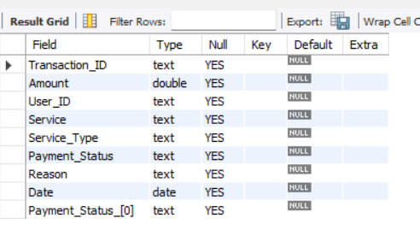

TOTAL TRANSACTION AMOUNT - KPI
SELECT
CONCAT(ROUND(SUM(Amount) / 1000000, 2), 'M') AS Total_Transaction_Amt
FROM
PhonePe_Data;

Explaination:
SELECT clause:
- SUM(Amount): Adds all transaction amounts.
- / 1000000: Converts the total into millions.
- ROUND(..., 2): Rounds to 2 decimals.
- CONCAT(..., 'M'): Adds “M” to indicate millions.
FROM clause:
• PhonePe_Data
The table from which the transaction amounts are taken.
Business Insight:
• Helps understand the overall transaction value processed by PhonePe.
• Useful for tracking business growth, financial performance, and user activity level.
• A higher value indicates strong platform usage and high customer engagement.

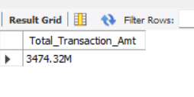

TOTAL TRANSACTION – KPI
SELECT
CONCAT(ROUND(COUNT(Transaction_ID) / 1000, 2),
'K') AS Total_Transactions
FROM
PhonePe_Data;
Explanation:
SELECT clause:
• COUNT(Transaction_ID): Counts all transactions.
• / 1000: Converts the value into thousands.
• ROUND(..., 2): Rounds to 2 decimal places.
• CONCAT(..., 'K'): Adds "K" to indicate thousands.
• AS Total_Transactions: Renames the final calculated value.
FROM clause:
• PhonePe_Data
The table from which all transaction IDs are counted.
Business Insight:
• Shows how many total transactions were performed on PhonePe.
• Useful for measuring platform usage and user activity levels.
• A higher transaction count indicates strong engagement and frequent use of services.

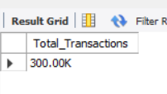

TOTAL TRANSACTION AMT FAILED – KPI
SELECT
CONCAT(ROUND(SUM(Amount) / 1000000, 3), 'M') AS Total_Transaction_Amt_Failed
FROM
PhonePe_Data
WHERE
Payment_Status NOT IN ('Successful');
Explanation:
SELECT clause:
• SUM(Amount): Adds all failed transaction amounts.
• / 1000000: Converts the total amount into millions.
• ROUND(..., 3): Rounds the value to 3 decimal places.
• CONCAT(..., 'M'): Adds "M" to indicate the amount is in millions.
• AS Total_Transaction_Amt_Failed: Renames the final calculated value.
FROM clause:
• PhonePe_Data
The table from which failed transaction amounts are taken.
WHERE clause:
• Payment_Status NOT IN ('Successful')
Filters the data to include only failed transactions and exclude successful ones.
Business Insight:
• Shows the total monetary value lost due to failed transactions.
• Helps identify financial impact caused by failed payment attempts.
• Useful for analyzing system issues, user errors, or service-related failures.

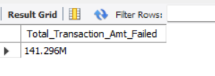

TOTAL TRANSACTION FAILED – KPI
SELECT
CONCAT(ROUND(COUNT(Transaction_ID) / 1000, 3),
'K') AS Total_Transactions_Failed
FROM
PhonePe_Data
WHERE
Payment_Status NOT IN ('Successful');
Explanation:
SELECT clause:
• COUNT(Transaction_ID): Counts all failed transactions.
• / 1000: Converts the count into thousands.
• ROUND(..., 3): Rounds the value to 3 decimal places.
• CONCAT(..., 'K'): Adds "K" to indicate thousands.
• AS Total_Transactions_Failed: Renames the final calculated value.
FROM clause:
• PhonePe_Data
The table from which failed transaction IDs are counted.
WHERE clause:
• Payment_Status NOT IN ('Successful')
Filters the data to include only failed transactions.
Business Insight:
• Helps determine how many transactions failed on PhonePe.
• Useful for analyzing system reliability and user experience issues.
• A higher failure count indicates potential technical or user-related problems.

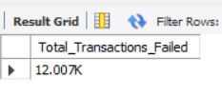

Charts

TRANSACTION FAILED REASONS (DONUT CHART)
SELECT
Reason,
CONCAT(ROUND(COUNT(Transaction_ID) / 1000, 3),
'K') AS Total_Transactions
FROM
PhonePe_Data
WHERE
Payment_Status NOT IN ('Successful')
GROUP BY Reason;
Explanation:
SELECT clause:
• Reason: Retrieves the failure reason for each failed transaction.
• COUNT(Transaction_ID): Counts the number of failed transactions for each reason.
• / 1000: Converts the count into thousands.
• ROUND(..., 3): Rounds the value to 3 decimal places.
• CONCAT(..., 'K'): Adds "K" to indicate thousands.
• AS Total_Transactions: Renames the final calculated value.
FROM clause:
• PhonePe_Data
The table from which failed transaction data is retrieved.
WHERE clause:
• Payment_Status NOT IN ('Successful')
Includes only failed transactions and filters out successful ones.
GROUP BY clause:
• Reason
Groups the failed transactions by each failure reason.
Business Insight:
• Shows which failure reasons occur most frequently.
• Helps identify the top causes behind failed transactions on PhonePe.
• Useful for reducing errors, improving system reliability, and enhancing customer experience.
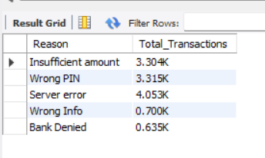

TRANSACTION FAILED SERVICES(DONUT CHART)
SELECT
Service,
CONCAT(ROUND(COUNT(Transaction_ID) / 1000, 3),
'K') AS Total_Transactions
FROM
PhonePe_Data
WHERE
Payment_Status NOT IN ('Successful')
GROUP BY Service;
Explanation:
SELECT clause:
•Service: Retrieves each failure service.
• COUNT(Transaction_ID): Counts the number of failed transactions for each reason.
• / 1000: Converts the count into thousands.
• ROUND(..., 3): Rounds the value to 3 decimal places.
• CONCAT(..., 'K'): Adds "K" to indicate thousands.
• AS Total_Transactions: Renames the final calculated value.
FROM clause:
• PhonePe_Data
The table from which failed transaction data is retrieved.
WHERE clause:
• Payment_Status NOT IN ('Successful')
Filters the data to include only failed transactions.
GROUP BY clause:
• service
Groups the result based on each failure service.
Business Insight:
• Server Error appears more frequently than other failure reasons, showing a major backend or system-level issue.
• High server failures negatively impact customers by causing repeated transaction attempts and reducing trust in the platform.
• Addressing server-related problems can significantly improve customer experience and increase successful transaction rates.
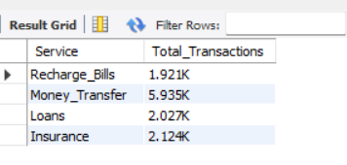

Total Transaction by service Type
SELECT
Service_Type,
CONCAT(ROUND(COUNT(Transaction_ID) / 1000, 3),
'K') AS Total_Transactions
FROM
PhonePe_Data
GROUP BY Service_Type
ORDER BY Total_Transactions DESC;
Explanation:
SELECT clause:
• Service_Type: Retrieves each category of service used in PhonePe (UPI, QR Code, Recharge, etc.).
• COUNT(Transaction_ID): Counts the total number of transactions for each service.
• / 1000: Converts the count into thousands.
• ROUND(..., 3): Rounds the value to 3 decimal places.
• CONCAT(..., 'K'): Adds “K” to indicate thousands.
• AS Total_Transactions: Renames the final calculated value.
FROM clause:
• PhonePe_Data
The table from which all service-wise transaction data is taken.
GROUP BY clause:
• Service_Type
Groups the transactions based on each service category.
ORDER BY clause:
• Total_Transactions DESC
Sorts the services from the highest transaction count to the lowest.
Business Insight:
• Understanding which service type has the highest number of transactions helps the business identify what customers use the most.
• Services with high transaction counts indicate strong customer dependence and popularity.
• Focusing on these high-usage services allows the business to improve reliability, performance, and customer satisfaction.
• This insight also helps in making strategic decisions such as feature enhancement, marketing focus, and resource allocation.
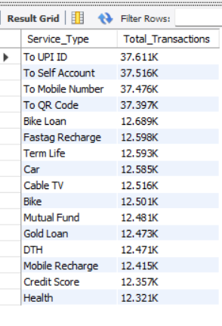
TOTAL TRANSACTION BY MONTH
SELECT
MONTH(Date) AS Month,
CONCAT(ROUND(COUNT(Transaction_ID) / 1000, 3),
'K') AS Total_Transactions
FROM
PhonePe_Data
GROUP BY MONTH(Date)
ORDER BY MONTH(date) ASC;
Explanation:
SELECT clause:
• MONTH(Date): Extracts the month number (1–12) from the Date column.
• COUNT(Transaction_ID): Counts the total number of transactions in each month.
• / 1000: Converts the transaction count into thousands.
• ROUND(..., 3): Rounds the value to 3 decimal places.
• CONCAT(..., 'K'): Adds “K” to show the value in thousands.
• AS Total_Transactions: Renames the final calculated value.
FROM clause:
• PhonePe_Data
The table from which monthly transaction data is taken.
GROUP BY clause:
• MONTH(Date)
Groups the transactions based on the month extracted from the Date column.
ORDER BY clause:
• MONTH(Date) ASC
Sorts the result from January to December.
Business Insight:
• Shows which months have higher or lower transaction activity.
• Helps identify seasonal trends, monthly usage patterns, and peak transaction periods.
• Useful for planning marketing strategies, managing server load, and improving customer experience during high-traffic periods.

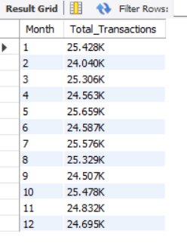
MONEY TRANSFER

TOTAL TRANSACTION BY REASON (DONUT CHART)
SELECT
Reason,
CONCAT(ROUND(COUNT(Transaction_ID) / 1000, 3),
'K') AS Total_Transactions_Failed
FROM
PhonePe_Data
WHERE
Payment_Status NOT IN ('Successful')
AND Service = 'Money_Transfer'
GROUP BY Reason;

EXPLANATION
SELECT clause:
• Reason: Retrieves each failure reason related to Money Transfer transactions.
• COUNT(Transaction_ID): Counts the total number of failed Money Transfer transactions for each reason.
• / 1000: Converts the count into thousands.
• ROUND(..., 3): Rounds the value to 3 decimal places.
• CONCAT(..., 'K'): Adds “K” to indicate thousands.
• AS Total_Transactions_Failed: Renames the final calculated value.
FROM clause:
• PhonePe_Data
The table from which all transaction and failure data is taken.
WHERE clause:
• Payment_Status NOT IN ('Successful'): Filters only failed transactions.
• AND Service = 'Money_Transfer': Includes only the Money Transfer service.
GROUP BY clause:
• Reason
Groups the results based on each specific failure reason.

Business Insight:
• Helps understand which failure reasons are most common specifically in Money Transfer transactions.
• Identifying major issues in this service type supports improving transaction reliability.
• Insights help the business reduce failures, improve customer satisfaction, and strengthen the overall Money Transfer process.

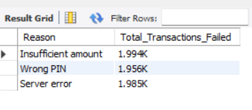
TOTAL TRANSACTION BY PAYMENT STATUS (DONUT CHART)
SELECT
Payment_Status,
CONCAT(ROUND(COUNT(Transaction_ID) / 1000, 3),
'K') AS Total_Transactions_Failed
FROM
PhonePe_Data
WHERE
Service = 'Money_Transfer'
GROUP BY Payment_Status;

EXPLANATION:
SELECT clause:
• Payment_Status: Retrieves each payment status related to Money Transfer transactions.
• COUNT(Transaction_ID): Counts the number of transactions for each payment status.
• / 1000: Converts the count into thousands.
• ROUND(..., 3): Rounds the value to 3 decimal places.
• CONCAT(..., 'K'): Adds “K” to indicate thousands.
• AS Total_Transactions_Failed: Renames the final calculated value.
FROM clause:
• PhonePe_Data
The table from which all Money Transfer transaction details are taken.
WHERE clause:
• Service = 'Money_Transfer'
Filters the data to include only transactions related to Money Transfer.
GROUP BY clause:
• Payment_Status
Groups the results based on each payment status (Successful, Failed, etc.).

Business Insight:
• Shows how many Money Transfer transactions fall under each payment status.
• Helps identify the success and failure distribution of Money Transfer services.
• Useful for analyzing performance, user experience, and areas requiring improvement within Money Transfer transactions.

TOTAL TRANSACTION BY TRANSFER TYPE (CLUSTERED BAR CHART):
SELECT
Service_Type AS Transfer_Type,
CONCAT(ROUND(COUNT(Transaction_ID) / 1000, 3),
'K') AS Total_Transactions
FROM
PhonePe_Data
WHERE
Service = 'Money_Transfer'
GROUP BY Service_Type;
EXPLANATION
SELECT clause:
• Service_Type AS Transfer_Type: Renames the service type column to Transfer_Type for clarity.
• COUNT(Transaction_ID): Counts all Money Transfer transactions for each transfer type.
• / 1000: Converts the count into thousands.
• ROUND(..., 3): Rounds the value to 3 decimal places.
• CONCAT(..., 'K'): Adds “K” to represent thousands.
• AS Total_Transactions: Renames the final calculated value.
FROM clause:
• PhonePe_Data
The table from which all Money Transfer transaction data is extracted.
WHERE clause:
• Service = 'Money_Transfer'
Filters the data to include only Money Transfer–related transactions.
GROUP BY clause:
• Service_Type
Groups the results based on each transfer type within Money Transfer.

BUSINESS INSIGHT:
• Helps identify which transfer method (UPI ID, Mobile Number, QR Code, etc.) is used the most under Money Transfer.
• Shows customer preference and behavior across different transfer types.
• Useful for enhancing the most popular transfer types and improving low-performing ones to increase overall reliability.
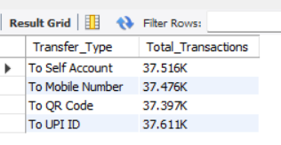
TOTAL TRANSACTION BY MONTH (LINE CHART):
SELECT
MONTH(Date) AS Month,
CONCAT(ROUND(COUNT(Transaction_ID) / 1000, 3),
'K') AS Total_Transactions
FROM
PhonePe_Data
WHERE
Service = 'Money_Transfer'
GROUP BY Month
ORDER BY Month ASC;

EXPLAINATION:
SELECT clause:
• MONTH(Date): Extracts the month number (1–12) from the Date column.
• COUNT(Transaction_ID): Counts the total number of Money Transfer transactions for each month.
• / 1000: Converts the transaction count into thousands.
• ROUND(..., 3): Rounds the value to 3 decimal places.
• CONCAT(..., 'K'): Adds “K” to show the value in thousands.
• AS Total_Transactions: Renames the final calculated value.
FROM clause:
• PhonePe_Data
The table from which all Money Transfer transaction data is taken.
WHERE clause:
• Service = 'Money_Transfer'
Filters the dataset to include only Money Transfer transactions.
GROUP BY clause:
• Month
Groups the monthly transaction counts based on the extracted month value.
ORDER BY clause:
• Month ASC
Arranges the months from January to December in ascending order.

Business Insight:
• Shows monthly transaction patterns specifically for Money Transfer services.
• Helps identify peak months where users perform more transfers.
• Useful for analyzing seasonal behavior, planning resources, and improving service stability during high-traffic months.
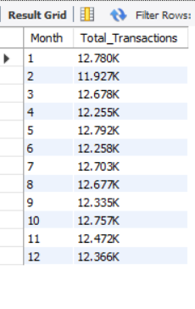
RECHARGE BILLS
TOTAL TRANSACTION FAILED BY REASON (DONUT CHART):
SELECT
Reason,
ROUND(COUNT(Transaction_ID), 3) AS Total_Transactions_Failed
FROM
PhonePe_Data
WHERE
Payment_Status NOT IN ('Successful')
AND Service = 'Recharge_Bills'
GROUP BY Reason;

EXPLANATION:
SELECT clause:
• Reason: Retrieves each failure reason related to Recharge_Bills transactions.
• COUNT(Transaction_ID): Counts the number of failed Recharge_Bills transactions for each reason.
• ROUND(..., 3): Rounds the count to 3 decimal places.
• AS Total_Transactions_Failed: Renames the final calculated value.
FROM clause:
• PhonePe_Data
The table from which all Recharge_Bills transaction data is taken.
WHERE clause:
• Payment_Status NOT IN ('Successful'): Filters to include only failed transactions.
• AND Service = 'Recharge_Bills': Ensures only Recharge_Bills service data is used.
GROUP BY clause:
• Reason
Groups the result based on each failure reason.

Business Insight:
• Helps identify the most common reasons for failed Recharge_Bills transactions.
• Highlights areas where customers experience issues during recharge or bill payments.
• Useful for improving service reliability and reducing customer frustration in the Recharge_Bills category.

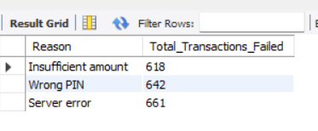

TOTAL TRANSACTION BY PAYMENT STATUS (DONUT CHART):
SELECT
Payment_Status,
CONCAT(ROUND(COUNT(Transaction_ID) / 1000, 3), 'K') AS Total_Transactions
FROM
PhonePe_Data
WHERE
Service = 'Recharge_Bills'
GROUP BY Payment_Status;

Explanation :
SELECT clause:
• Payment_Status: Retrieves each payment status related to Recharge_Bills transactions.
• COUNT(Transaction_ID): Counts the number of transactions for each status.
• / 1000: Converts the count into thousands.
• ROUND(..., 3): Rounds the value to 3 decimal places.
• CONCAT(..., 'K'): Adds “K” to indicate thousands.
• AS Total_Transactions: Renames the final calculated value.
FROM clause:
• PhonePe_Data
The table from which Recharge_Bills transaction details are taken.
WHERE clause:
• Service = 'Recharge_Bills'
Filters the data to include only Recharge_Bills transactions.
GROUP BY clause:
• Payment_Status
Groups the results based on each payment status (Successful, Failed, etc.).

Business Insight:
• Shows how many Recharge_Bills transactions were successful or failed.
• Helps analyze the reliability and performance of the Recharge/Bill payment service.
• Useful for identifying trends in customer experience and improving service stability.
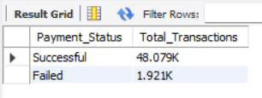
TOTAL TRANSACTION BY RECHARGE TYPE (CLUSTERED BAR CHART):
SELECT
Service_Type AS Recharge_Type,
CONCAT(ROUND(COUNT(Transaction_ID) / 1000, 3),
'K') AS Total_Transactions
FROM
PhonePe_Data
WHERE
Service = 'Recharge_Bills'
GROUP BY Service_Type;

Explanation:
SELECT clause:
• Service_Type AS Recharge_Type: Renames the service type column to Recharge_Type for clear understanding.
• COUNT(Transaction_ID): Counts all Recharge_Bills transactions for each service type.
• / 1000: Converts the count into thousands.
• ROUND(..., 3): Rounds the value to 3 decimal places.
• CONCAT(..., 'K'): Adds “K” to represent thousands.
• AS Total_Transactions: Renames the final calculated value.
FROM clause:
• PhonePe_Data
The table from which all Recharge_Bills transaction data is taken.
WHERE clause:
• Service = 'Recharge_Bills'
Filters the data to include only Recharge/Bill payment transactions.
GROUP BY clause:
• Service_Type
Groups the results based on each service type under the Recharge_Bills category.
Business Insight:
• Helps identify which recharge or bill payment type is used the most by customers.
• Shows customer preferences across different recharge methods (mobile recharge, DTH, electricity bill, etc.).
• Useful for focusing improvements and ensuring reliability in the most-used recharge types.
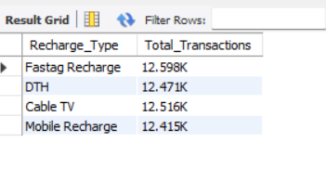
TOTAL TRANSACTION BY MONTH (LINE CHART):
SELECT
MONTH(Date) AS Month,
CONCAT(ROUND(COUNT(Transaction_ID) / 1000, 3),
'K') AS Total_Transactions
FROM
PhonePe_Data
WHERE
Service = 'Recharge_Bills'
GROUP BY Month
ORDER BY Month ASC;

EXPLAINATION:
SELECT clause:
• MONTH(Date): Extracts the month number (1–12) from the Date column.
• COUNT(Transaction_ID): Counts the total number of Recharge_Bills transactions for each month.
• / 1000: Converts the transaction count into thousands.
• ROUND(..., 3): Rounds the value to 3 decimal places.
• CONCAT(..., 'K'): Adds “K” to show the value is in thousands.
• AS Total_Transactions: Renames the final calculated value.
FROM clause:
• PhonePe_Data
The table from which Recharge_Bills transaction data is taken.
WHERE clause:
• Service = 'Recharge_Bills'
Filters the dataset to include only Recharge/Bill payment transactions.
GROUP BY clause:
• Month
Groups the monthly transaction count based on the extracted month value.
ORDER BY clause:
• Month ASC
Sorts the results from January to December.

Business Insight:
• Shows monthly transaction patterns for the Recharge/Bills service.
• Helps identify peak and low months for recharge and bill payments.
• Useful for resource planning, demand forecasting, and improving system performance during high-traffic months.
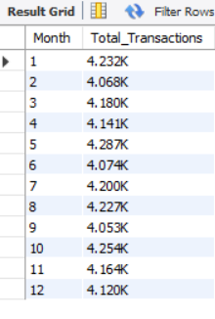

LOANS
TOTAL TRANSACTION BY REASON FAILED (DONUT CHART):
SELECT
Reason,
ROUND(COUNT(Transaction_ID), 3) AS Total_Transactions_Failed
FROM
PhonePe_Data
WHERE
Payment_Status NOT IN ('Successful')
AND Service = 'Loans'
GROUP BY Reason;

EXPLAINATION:
SELECT clause:
• Reason: Retrieves each failure reason related to Loans transactions.
• COUNT(Transaction_ID): Counts the total number of failed Loans transactions for each reason.
• ROUND(..., 3): Rounds the count to 3 decimal places.
• AS Total_Transactions_Failed: Renames the final calculated value.
FROM clause:
• PhonePe_Data
The table from which all Loans transaction data is taken.
WHERE clause:
• Payment_Status NOT IN ('Successful'): Filters to include only failed transactions.
• AND Service = 'Loans': Ensures only Loan-related transactions are included.
GROUP BY clause:
• Reason
Groups the result based on each specific failure reason.

Business Insight:
• Helps identify the most common reasons behind failed loan-related transactions.
• Helps the business understand where customers face issues during loan payments or loan-related processes.
• Useful for improving service reliability, reducing customer obstacles, and enhancing the overall Loans service experience.
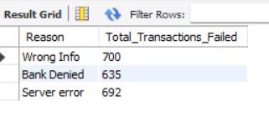
TOTAL TRANSACTION BY PAYMENT STATUS (DONUT CHART):
SELECT
CASE
WHEN Payment_Status IN ('Wrong PIN', 'Insufficient amount', 'Server error')
THEN 'Failed'
ELSE 'Successful'
END AS Status_Category,
COUNT(Transaction_ID) AS Total_Transactions
FROM PhonePe_Data
WHERE Service = 'Loans'
GROUP BY
CASE
WHEN Payment_Status IN ('Wrong PIN', 'Insufficient amount', 'Server error')
THEN 'Failed'
ELSE 'Successful'
END;

EXPLAINATION:
SELECT clause:
• CASE…END AS Status_Category: Categorizes each loan transaction as either “Failed” or “Successful” based on the Payment_Status.
• COUNT(Transaction_ID): Counts the number of loan transactions under each status category.
• AS Total_Transactions: Renames the final calculated value.
FROM clause:
• PhonePe_Data
The table from which all loan-related transactions are taken.
WHERE clause:
• Service = 'Loans'
Filters the data to include only transactions related to the Loans service.
GROUP BY clause:
• CASE…END
Groups the data into Failed and Successful categories using the same logic as in the SELECT clause.

Business Insight:
• Helps understand the success and failure distribution specifically within the Loans service.
• Useful for identifying loan-related issues affecting customers and overall service reliability.
• Knowing the proportion of failed loan transactions helps the business prioritize improvements and enhance the user experience for loan services.

TOTAL TRANSACTION BY LOAN TYPE (CLUSTERED BAR CHART):

SELECT
Service_Type AS Loan_Type,
CONCAT(ROUND(COUNT(Transaction_ID) / 1000, 3),
'K') AS Total_Transactions
FROM
PhonePe_Data
WHERE
Service = 'Loans'
GROUP BY Service_Type;

EXPLAINATION:
SELECT clause:
• Service_Type AS Loan_Type: Renames the service type column to Loan_Type for better clarity.
• COUNT(Transaction_ID): Counts all loan-related transactions for each loan type.
• / 1000: Converts the total count into thousands.
• ROUND(..., 3): Rounds the value to 3 decimal places.
• CONCAT(..., 'K'): Adds “K” to represent thousands.
• AS Total_Transactions: Renames the final calculated value.
FROM clause:
• PhonePe_Data
The table from which all loan-related transaction data is taken.
WHERE clause:
• Service = 'Loans'
Filters the data to include only transactions related to the Loans service.
GROUP BY clause:
• Service_Type
Groups the transaction count based on each loan type.

Business Insight:
• Helps identify which loan type (such as personal loan, bike loan, or other loan services) is used the most by customers.
• Shows customer preference and behavior across different loan categories.
• Useful for improving service reliability, prioritizing popular loan types, and enhancing customer experience in loan-based services.
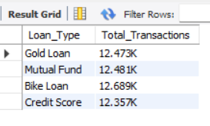
TOTAL TRANSACTION BY MONTH (LINE CHART):
SELECT
MONTH(Date) AS Month,
CONCAT(ROUND(COUNT(Transaction_ID) / 1000, 3),
'K') AS Total_Transactions
FROM
PhonePe_Data
WHERE
Service = 'Loans'
GROUP BY Month
ORDER BY Month ASC;

EXPLAINATION:
SELECT clause:
• MONTH(Date): Extracts the month number (1–12) from the Date column.
• COUNT(Transaction_ID): Counts all loan-related transactions for each month.
• / 1000: Converts the monthly transaction count into thousands.
• ROUND(..., 3): Rounds the value to 3 decimal places.
• CONCAT(..., 'K'): Adds “K” to show the value is in thousands.
• AS Total_Transactions: Renames the final calculated value.
FROM clause:
• PhonePe_Data
The table from which all loan-related transaction data is taken.
WHERE clause:
• Service = 'Loans'
Filters the data to include only transactions from the Loans service.
GROUP BY clause:
• Month
Groups the monthly transaction count based on the extracted month value.
ORDER BY clause:
• Month ASC
Sorts the results from January to December in ascending order.

Business Insight:
• Shows monthly transaction patterns specifically for loan-related services.
• Helps identify months with high or low customer engagement in Loans.
• Useful for understanding seasonal loan demand, planning resources, and improving service reliability during high-volume months.
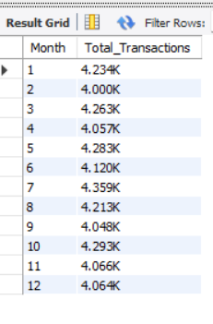

INSURANCE
TOTAL TRANSACTION FAILED BY REASON (DONUT CHART):
SELECT
Reason,
ROUND(COUNT(Transaction_ID), 3) AS Total_Transactions_Failed
FROM
PhonePe_Data
WHERE
Payment_Status NOT IN ('Successful')
AND Service = 'Insurance'
GROUP BY Reason;

EXPLAINATION:
SELECT clause:
• Reason: Retrieves each failure reason related to Insurance transactions.
• COUNT(Transaction_ID): Counts the number of failed Insurance transactions for each reason.
• ROUND(..., 3): Rounds the count to 3 decimal places.
• AS Total_Transactions_Failed: Renames the final calculated value.
FROM clause:
• PhonePe_Data
The table from which all Insurance transaction data is taken.
WHERE clause:
• Payment_Status NOT IN ('Successful')
Filters the data to include only failed transactions.
• AND Service = 'Insurance'
Ensures only Insurance-related transactions are included.
GROUP BY clause:
• Reason
Groups the failed transactions based on each failure reason.

Business Insight:
• Helps identify the most common reasons behind failed Insurance transactions.
• Shows where customers face issues while making insurance-related payments.
• Useful for improving reliability, reducing payment failures, and enhancing user trust in Insurance services.

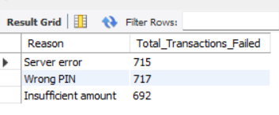
TOTAL TRANSACTION BY PAYMENT STATUS (DONUT CHART):
SELECT
Payment_Status,
CONCAT(ROUND(COUNT(Transaction_ID) / 1000, 3),
'K') AS Total_Transactions
FROM
PhonePe_Data
WHERE
Service = 'Insurance'
GROUP BY Payment_Status;

EXPLAINATION:
SELECT clause:
• Payment_Status: Retrieves each payment status related to Insurance transactions.
• COUNT(Transaction_ID): Counts the number of Insurance transactions for each status.
• / 1000: Converts the transaction count into thousands.
• ROUND(..., 3): Rounds the value to 3 decimal places.
• CONCAT(..., 'K'): Adds “K” to represent thousands.
• AS Total_Transactions: Renames the final calculated value.
FROM clause:
• PhonePe_Data
The table from which Insurance transaction data is taken.
WHERE clause:
• Service = 'Insurance'
Filters the data to include only transactions related to the Insurance service.
GROUP BY clause:
• Payment_Status
Groups the transaction count based on each payment status (Successful, Failed, etc.).

Business Insight:
• Helps understand the success and failure distribution within Insurance transactions.
• Useful for analyzing the reliability of Insurance-related payments on the platform.
• Identifies whether customers face more failures, allowing the business to focus on improving the Insurance payment experience.
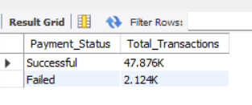
TOTAL TRANSACTION BY RECHARGE TYPE (CLUSTERED BAR CHART):
SELECT
Service_Type AS Insurance_Type,
CONCAT(ROUND(COUNT(Transaction_ID) / 1000, 3),
'K') AS Total_Transactions
FROM
PhonePe_Data
WHERE
Service = 'Insurance'
GROUP BY Service_Type;

EXPLAINATION:
SELECT clause:
• Service_Type AS Insurance_Type: Renames the service type column to Insurance_Type for clearer understanding.
• COUNT(Transaction_ID): Counts all Insurance-related transactions for each insurance type.
• / 1000: Converts the transaction count into thousands.
• ROUND(..., 3): Rounds the value to 3 decimal places.
• CONCAT(..., 'K'): Adds “K” to represent thousands.
• AS Total_Transactions: Renames the final calculated value.
FROM clause:
• PhonePe_Data
The table from which Insurance transaction data is taken.
WHERE clause:
• Service = 'Insurance'
Filters the data to include only Insurance-related transactions.
GROUP BY clause:
• Service_Type
Groups the transaction counts based on each insurance type.

Business Insight:
• Helps identify which insurance type is most used by customers on PhonePe.
• Useful for understanding customer interest across different insurance categories.
• Supports decision-making by showing which insurance types need more focus, support, or feature enhancement.
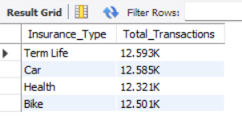

TOTAL TRANSACTION BY MONTH (CLUSTERED BAR CHART):
SELECT
MONTH(Date) AS Month,
CONCAT(ROUND(COUNT(Transaction_ID) / 1000, 3),
'K') AS Total_Transactions
FROM
PhonePe_Data
WHERE
Service = 'Insurance'
GROUP BY Month
ORDER BY Month ASC;

EXPLAINATION:
SELECT clause:
• MONTH(Date): Extracts the month number (1–12) from the Date column.
• COUNT(Transaction_ID): Counts all Insurance-related transactions for each month.
• / 1000: Converts the monthly transaction count into thousands.
• ROUND(..., 3): Rounds the value to 3 decimal places.
• CONCAT(..., 'K'): Adds “K” to show the value is in thousands.
• AS Total_Transactions: Renames the final calculated value.
FROM clause:
• PhonePe_Data
The table from which Insurance transaction data is taken.
WHERE clause:
• Service = 'Insurance'
Filters the data to include only Insurance-related transactions.
GROUP BY clause:
• Month
Groups the monthly transaction count based on the extracted month.
ORDER BY clause:
• Month ASC
Sorts the results from January to December in ascending order.

Business Insight:
• Shows monthly usage patterns for Insurance-related services.
• Helps identify which months have higher or lower insurance activity.
• Useful for understanding seasonal trends and improving service efficiency during peak months.

