
Parkinox Data Analytics Report
Session Dataset Charts & Measured Date/Time Insights
Blue Theme · Data-Only Document (CSV Driven)
Rows: 3,153 · Unique plates: 1,324
Window: 2026-05-16 12:19:18 → 2026-07-30 19:14:40 (Tehran)
Generated: 2026-08-01 12:51 Asia/Tehran
Source file: parkinox_sessions.csv

1. Dataset Overview
This report contains only measurements derived from the provided parking sessions CSV. Timestamps were converted from UTC to Asia/Tehran (UTC+03:30) for traffic analysis. Duration and fee fields are taken as exported; sessions without exit_time are treated as open/flagged.
3,153  Sessions | 1,324  Unique Plates | 2,837  With Exit | 316  No Exit | 148,098,672  Fee Total

2. Schema
Field | Meaning
plate | Iranian plate string (Persian digits + letter)
status | completed | waived | flagged
entry_time / exit_time | ISO-8601 UTC timestamps
duration_minutes | Measured stay length when exited
fee | Calculated fee in Tomans
payment_method | wallet | cash | waived | none
entry_camera / exit_camera | Camera tags when present
user_name | Linked user display name when registered
session_uuid | Stable session identifier

3. Status & Payment Counts
Status counts:
- waived: 2,810 (89.1%)
- flagged: 316 (10.0%)
- completed: 27 (0.9%)
Payment method counts:
- waived: 2,810 (89.1%)
- none: 316 (10.0%)
- cash: 16 (0.5%)
- wallet: 11 (0.3%)

4. Time-Series Charts
Peak day: 2026-07-29 with 448 entries. Peak hour (Tehran): 08:00. Average closed duration: 1d 0h; median: 7h 47m.
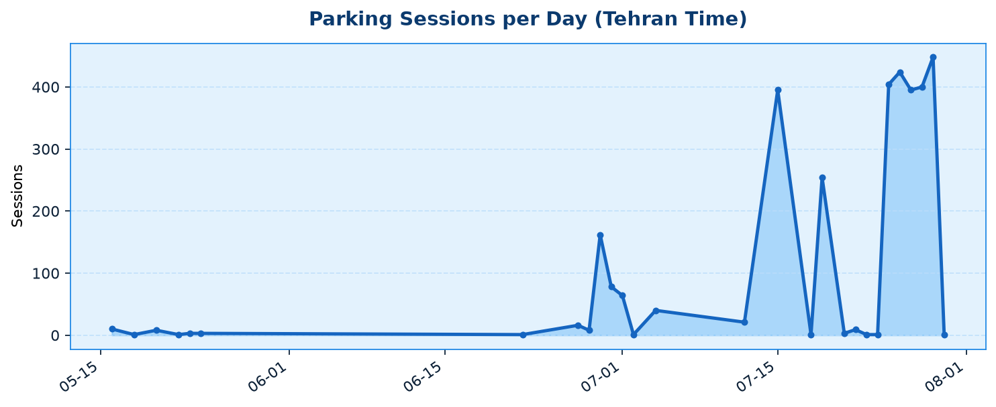
Chart A — Sessions per day
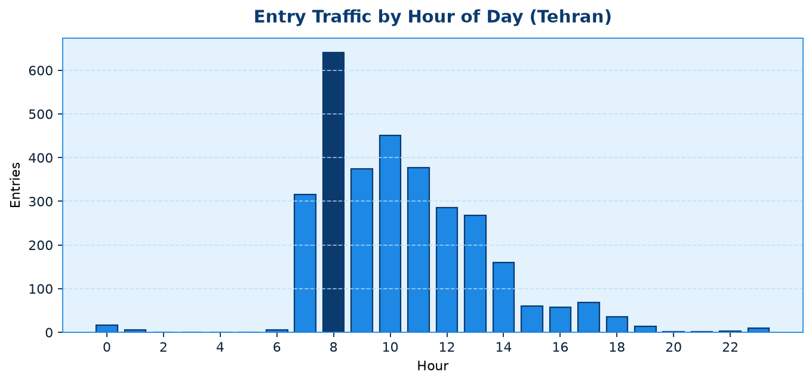
Chart B — Entries by hour of day
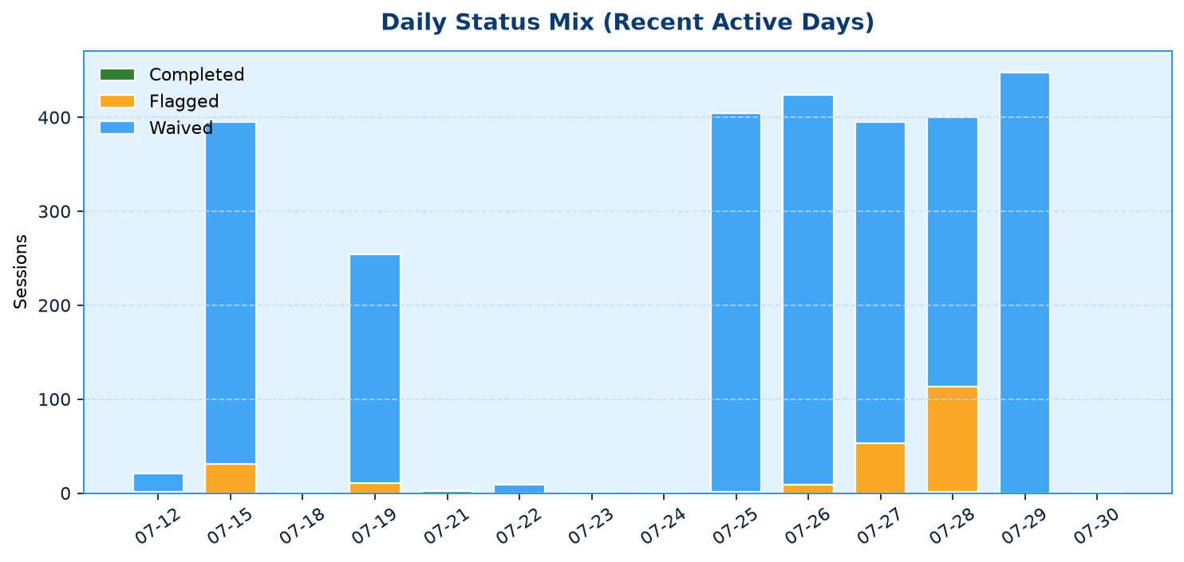
Chart C — Status mix on recent active days

5. Composition Charts
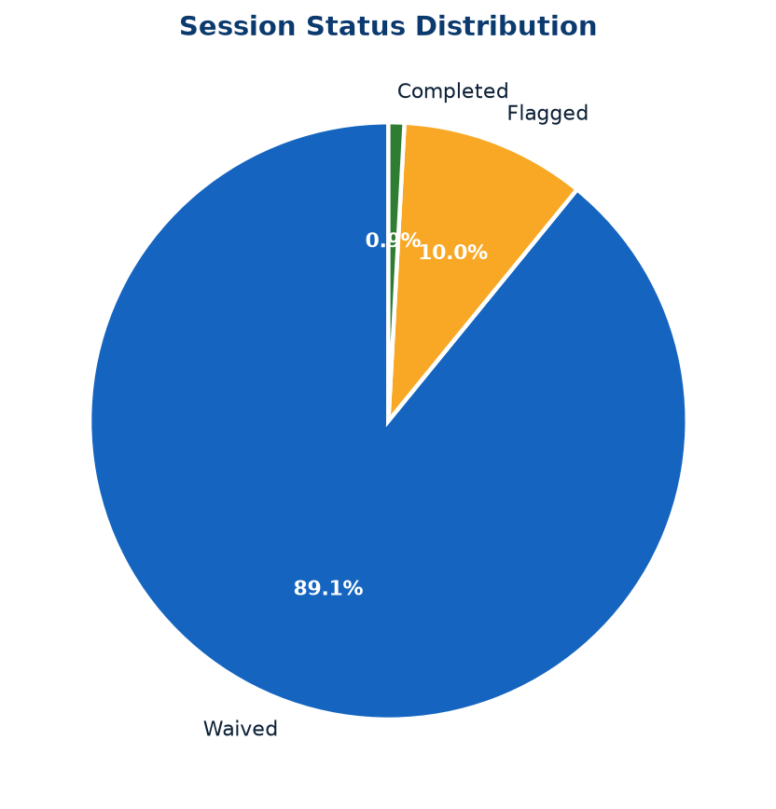
Chart D — Status distribution
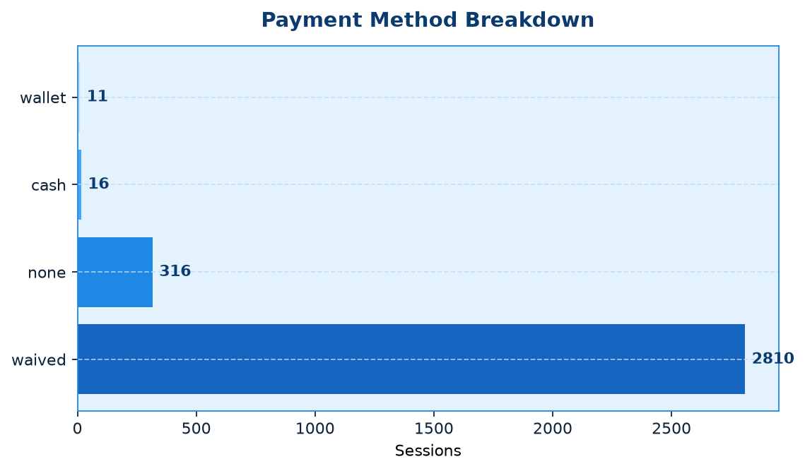
Chart E — Payment methods
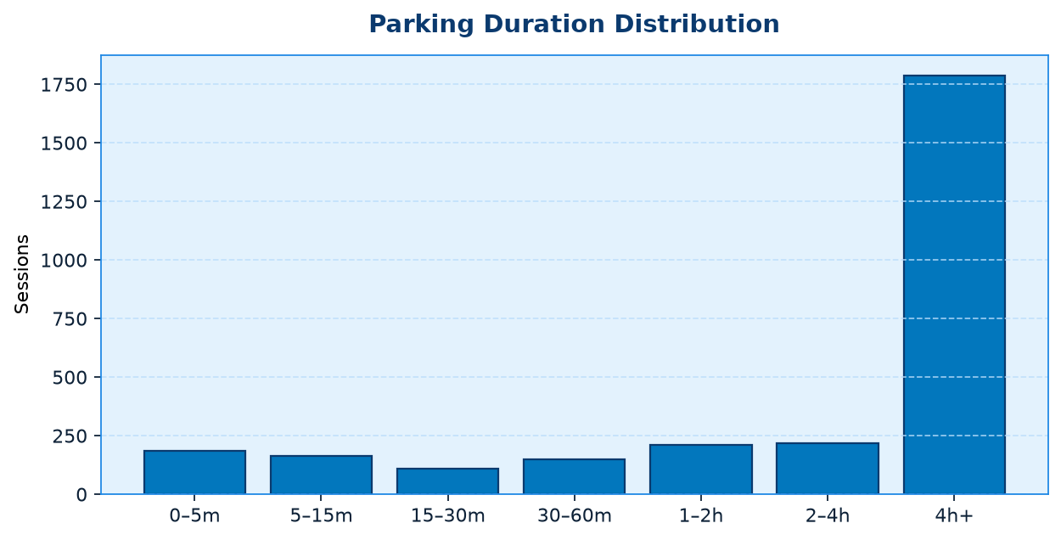
Chart F — Duration distribution
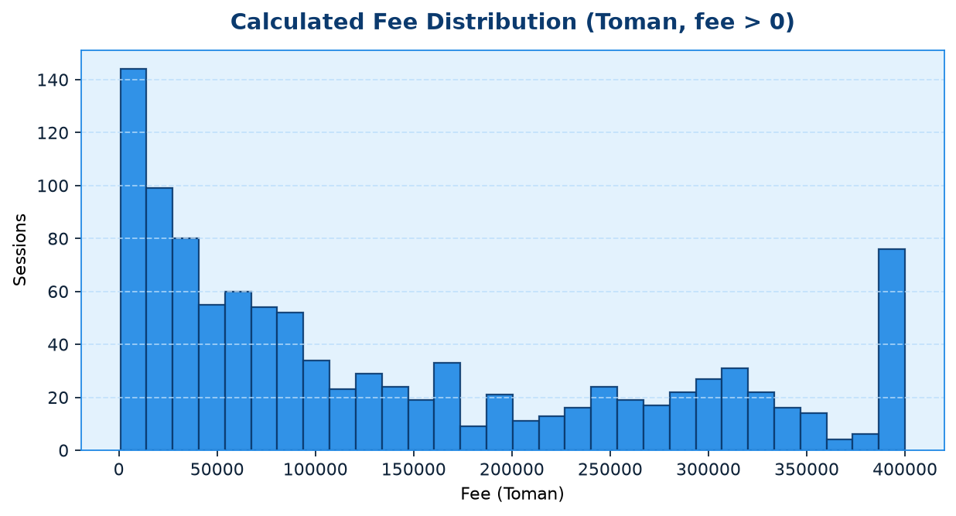
Chart G — Fee distribution (fee > 0)
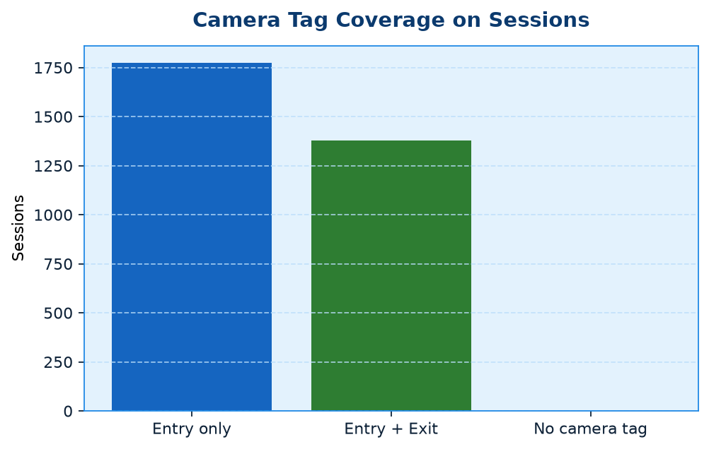
Chart H — Camera tag coverage

6. Daily Traffic Table
Date | Sessions | Unique | Completed | Waived | Flagged | Fee Sum
2026-05-16 | 10 | 8 | 5 | 4 | 1 | 24,313
2026-05-18 | 1 | 1 | 1 | 0 | 0 | 7,332
2026-05-20 | 8 | 6 | 8 | 0 | 0 | 53,197
2026-05-22 | 1 | 1 | 1 | 0 | 0 | 732
2026-05-23 | 3 | 2 | 3 | 0 | 0 | 4,666
2026-05-24 | 3 | 3 | 3 | 0 | 0 | 0
2026-06-22 | 1 | 1 | 0 | 1 | 0 | 0
2026-06-27 | 16 | 14 | 0 | 14 | 2 | 480,000
2026-06-28 | 8 | 3 | 0 | 7 | 1 | 0
2026-06-29 | 162 | 121 | 0 | 118 | 44 | 338,495
2026-06-30 | 78 | 55 | 0 | 55 | 23 | 83,249
2026-07-01 | 64 | 47 | 1 | 46 | 17 | 1,247,000
2026-07-02 | 1 | 1 | 0 | 1 | 0 | 0
2026-07-04 | 40 | 30 | 0 | 30 | 10 | 272,496
2026-07-12 | 21 | 20 | 0 | 20 | 1 | 0
2026-07-15 | 395 | 348 | 0 | 364 | 31 | 5,999,138
2026-07-18 | 1 | 1 | 0 | 0 | 1 | 0
2026-07-19 | 254 | 237 | 0 | 243 | 11 | 3,307,477
2026-07-21 | 3 | 1 | 2 | 1 | 0 | 443,333
2026-07-22 | 9 | 4 | 0 | 9 | 0 | 408,332
2026-07-23 | 1 | 1 | 0 | 1 | 0 | 320,000
2026-07-24 | 1 | 1 | 0 | 1 | 0 | 0
2026-07-25 | 404 | 328 | 1 | 403 | 0 | 27,702,448
2026-07-26 | 424 | 344 | 0 | 415 | 9 | 23,022,458
2026-07-27 | 395 | 325 | 0 | 342 | 53 | 29,271,622
2026-07-28 | 400 | 369 | 1 | 287 | 112 | 29,575,774
2026-07-29 | 448 | 354 | 0 | 448 | 0 | 25,536,610
2026-07-30 | 1 | 1 | 1 | 0 | 0 | 0

7. Hourly Traffic Table
Hour (Tehran) | Entries
00:00 | 17
01:00 | 6
02:00 | 0
03:00 | 0
04:00 | 0
05:00 | 0
06:00 | 6
07:00 | 316
08:00 | 641
09:00 | 375
10:00 | 451
11:00 | 377
12:00 | 286
13:00 | 268
14:00 | 160
15:00 | 60
16:00 | 57
17:00 | 69
18:00 | 35
19:00 | 14
20:00 | 1
21:00 | 1
22:00 | 3
23:00 | 10

8. Duration & Fee Statistics
- Closed sessions: 2,823
- Duration mean: 1d 0h
- Duration median: 7h 47m
- Duration p90: 3d 19h
- Duration max: 13d 22h
- Total calculated fees: 148,098,672 Tomans
- Mean fee where fee > 0: 140,511 Tomans
- Sessions with fee = 0: 2,099

9. Notes on Measurement
Entry and exit instants are parsed from ISO timestamps with timezone offsets, then converted to Tehran local time for hourly/daily aggregation. Duration uses the CSV duration_minutes field (not re-derived) to stay faithful to the export. Status and payment_method are categorical counts; empty payment_method values are labeled none. This document intentionally excludes product narrative — see Parkinox_Success_Report.docx for system function and error handling.

