LECTURE 9
What is Thread?
A thread is the smallest unit of execution in a program.
You can think of it as a lightweight subprocess —a single sequence of instructions that the CPU can execute independently.
Imagine your program is a factory:
- The process is the entire factory (your Java program).
- The threads are the workers inside that factory.
- If there is only one worker (main thread), that worker has to do all the tasks one by one
— slow! But if you hire multiple workers (threads), each can handle a different task simultaneously — faster and more efficient.
Purpose: To allow a program to perform multiple tasks concurrently. For example, a game can use one thread for the timer and another for user input, so the game doesn't freeze while waiting for the user.
Mechanism: A thread is the smallest unit of execution within a process. Multiple threads can run within the same process, sharing the same memory space but executing independently.
Creation: A new thread can be created by implementing the Runnable interface or by extending the Thread class. The start() method is called on a thread object to begin its execution.
Example: A web server uses threads to handle multiple client requests simultaneously, making it more efficient.
Synchronization: Since threads share data, mechanisms like mutex locks and semaphores are used to control access and prevent conflicts.

Thread in Operating System
- A thread is a single sequence stream within a process. Threads are also
called lightweight processes as they possess some of the properties of processes. Each thread belongs to exactly one process.
- In an operating system that supports multithreading, a process can consist of many threads.
- All threads belonging to the same process share code section, data section, and OS resources (e.g. open files and signals), but each thread has its own (thread control block)
- thread ID, program counter, register set, and a stack.

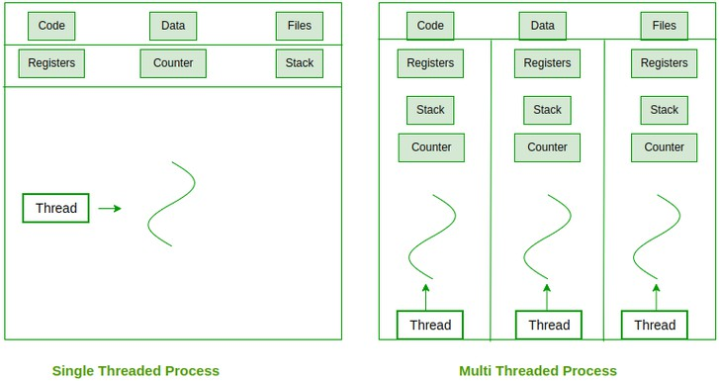

Why Do We Need Threads (and Their Benefits)
Threads are needed in modern operating systems and applications because they:
- Improve Application Performance: Threads can run in parallel, making programs execute faster.
- Increase Responsiveness: Even if one thread is busy, another can return results or handle user actions immediately.
- Enable Concurrency: Multiple things can happen at once, such as background saving, formatting, and user input in Microsoft Word or Google Docs.
- Simplify Communication: Since threads share the same memory space, they can directly exchange data without special inter-process communication mechanisms.
- Support Prioritization: Like processes, threads can have priorities; the highest-priority thread gets scheduled first.
- Efficient Context Switching: Switching between threads takes less time than switching between processes because threads use the same address space.
- Better Multiprocessor Utilization: Threads from the same process can run on different processors simultaneously, speeding up execution.
- Resource Sharing: Threads within a process share code, data, and files, which saves resources.
- Higher Throughput: Dividing a process into multiple threads allows more jobs to finish per unit time.
- Synchronization Support: Since threads share resources, synchronization tools (locks, semaphores, etc.) ensure safe access to shared data.
- Thread Management: Each thread has a Thread Control Block (TCB) that stores its state, register values, and scheduling info for context switching.

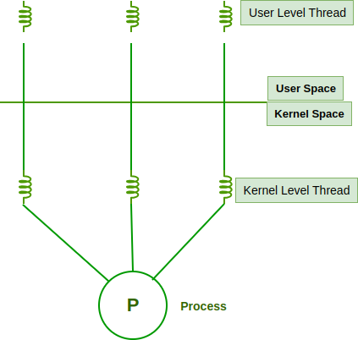
Types of Thread in Operating System
Threads are of two types.
- User Level Thread
- Kernel Level Thread

User-Level Threads (ULTs)
  - Managed entirely in user space using a thread library; the kernel is unaware of them.
  - Switching between ULTs is fast since only program counter, registers, and stack need to be saved/restored.
  - Do not require system calls for creation or management, making them lightweight.
  - Blocking Limitation: If one thread makes a blocking system call, the entire process (all threads) is blocked.
  - Scheduling is done by the application itself, which may not be as efficient as kernel-level scheduling.
  - Cannot fully utilize multiprocessor systems because the kernel schedules processes, not individual user-level threads.

Advantages of ULT
  - Can be implemented on an OS that doesn't support multithreading.
  - Simple representation since thread has only program counter , register set, stack space.
  - Simple to create since no intervention of kernel.
  - Thread switching is fast since no OS calls need to be made.

Disadvantages of ULT
  - No or less co-ordination among the threads and Kernel.
  - If one thread causes a page fault, the entire process blocks.

Kernel-Level Threads (KLTs)
  - Managed directly by the operating system kernel; each thread has an entry in the
kernel’s thread table.
  - The kernel schedules each thread independently, allowing true parallel execution on multiple CPUs/cores.

  - Handles blocking system calls efficiently; if one thread blocks, the kernel can run another thread from the same process.
  - Provides better load balancing across processors since the kernel controls all threads.
  - Context switching is slower compared to ULTs because it requires switching between user mode and kernel mode.
  - Implementation is more complex and requires frequent interaction with the kernel.
  - Large numbers of threads may add extra load on the kernel scheduler, potentially affecting performance.

Advantages of KLT
  - Since kernel has full knowledge about the threads in the system, scheduler may decide to give more time to processes having large number of threads.
  - Good for applications that frequently block.

Disadvantages of KLT
  - Slow and inefficient.
  - It requires thread control block so it is an overhead.

Differences Between Threads and Process
  - Resources: Processes have their own address space and resources, such as memory and file handles, whereas threads share memory and resources with the program that created them.
  - Scheduling: Processes are scheduled to use the processor by the operating system, whereas threads are scheduled to use the processor by the operating system or the program itself.
  - Creation: The operating system creates and manages processes, whereas the program or the operating system creates and manages threads.
  - Communication: Because processes are isolated from one another and must rely on inter-process communication mechanisms, they generally have more difficulty communicating with one another than threads do. Threads, on the other hand, can interact with other threads within the same program directly.
  - Threads, in general, are lighter than processes and are better suited for concurrent execution within a single program. Processes are commonly used to run separate program or to isolate resources between program.

Similarity Between Threads and Process
  - Only one thread or process is active at a time in an operating system.
  - Within the process, both execute in a sequential manner.
  - Both can create children.
  - Both can be scheduled by the operating system: Both threads and processes can be scheduled by the operating system to execute on the CPU. The operating system is responsible for assigning CPU time to the threads and processes based on
various scheduling algorithms.
  - Both have their own execution context: Each thread and process has its own execution context, which includes its own register set, program counter, and stack. This allows each thread or process to execute independently and make progress without interfering with other threads or processes.
  - Both can communicate with each other: Threads and processes can communicate with each other using various inter-process communication (IPC) mechanisms such as shared memory, message queues, and pipes. This allows threads and processes to share data and coordinate their activities.
  - Both can be preempted: Threads and processes can be preempted by the operating system, which means that their execution can be interrupted at any time. This allows the operating system to switch to another thread or process that needs to execute.
  - Both can be terminated: Threads and processes can be terminated by the operating system or by other threads or processes. When a thread or process is terminated, all of its resources, including its execution context, are freed up and made available to other threads or processes.

Threading Issues
  - The fork() and exec() System Calls : The semantics of the fork() and exec() system calls change in a multithreaded program. If one thread in a program calls fork(), does the new process duplicate all threads, or is the new process single-threaded? Some UNIX systems have chosen to have two versions of fork(), one that duplicates all threads and another that duplicates only the thread that invoked the fork() system call. The exec() system , That is, if a thread invokes the exec() system call, the program specified in the parameter to exec() will replace the entire process—including all threads.
  - Signal Handling: A signal is used in UNIX systems to notify a process that a particular event has occurred. A signal may be received either synchronously or asynchronously depending on the source of and the reason for the event being signaled. All signals, whether synchronous or asynchronous, follow the same pattern:

    - A signal is generated by the occurrence of a particular event.
    - The signal is delivered to a process.
    - Once delivered, the signal must be handled.
A signal may be handled by one of two possible handlers:
    - A default signal handler .
    - A user-defined signal handler. Every signal has a default signal handler that the kernel runs when handling that signal. This default action can be overridden by a user-defined signal handler that is called to handle the signal.
  - Thread Cancellation: Thread cancellation involves terminating a thread before it has completed. For example, if multiple threads are concurrently searching through a database and one thread returns the result, the remaining threads might be canceled. Another situation might occur when a user presses a button on a web browser that stops a web page from loading any further. Often, a web page loads using several threads—each image is loaded in a separate thread. When a user presses the stop button on the browser, all threads loading the page are canceled. A thread that is to be canceled is often referred to as the target thread.
Cancellation of a target thread may occur in two different scenarios:
    - Asynchronous cancellation: One thread immediately terminates the target thread.
    - Deferred cancellation: The target thread periodically checks whether it should terminate, allowing it an opportunity to terminate itself in an orderly fashion.
  - Thread-Local Storage: Threads belonging to a process share the data of the process. Indeed, this data sharing provides one of the benefits of multithreaded programming. However, in some circumstances, each thread might need its own copy of certain data. We will call such data thread-local storage (or TLS.) For example, in a transaction- processing system, we might service each transaction in a separate thread. Furthermore, each transaction might be assigned a unique identifier. To associate each thread with its unique identifier, we could use thread-local storage.
  - Scheduler Activations: One scheme for communication between the user-thread library and the kernel is known as scheduler activation. It works as follows: The kernel provides an application with a set of virtual processors (LWPs), and the application can schedule user threads onto an available virtual processor.

Advantages of Threading
  - Responsiveness: A multithreaded application increases responsiveness to the user.
  - Resource Sharing: Resources like code and data are shared between threads, thus allowing a multithreaded application to have several threads of activity within the same address space.
  - Increased Concurrency: Threads may be running parallelly on different processors, increasing concurrency in a multiprocessor machine.
  - Lesser Cost: It costs less to create and context-switch threads than processes.
  - Lesser Context-Switch Time: Threads take lesser context-switch time than processes.

Disadvantages of Threading
  - Complexity: Threading can make programs more complicated to write and debug because threads need to synchronize their actions to avoid conflicts.
  - Resource Overhead: Each thread consumes memory and processing power, so having too many threads can slow down a program and use up system resources.
  - Difficulty in Optimization: It can be challenging to optimize threaded programs for different hardware configurations, as thread performance can vary based on the number of cores and other factors.
  - Debugging Challenges: Identifying and fixing issues in threaded programs can be more difficult compared to single-threaded programs, making troubleshooting complex.

LECTURE 10
Key Concepts
- start() method: Calling start() on a Thread object begins the execution of the thread by invoking its run() method. Do not call run() directly, as it would execute in the main thread.
- Concurrency: Threads allow different parts of your program to execute seemingly simultaneously, improving responsiveness and efficiency for long-running tasks.
- Main Thread: Every Java application starts with a main thread, which executes the main() method.
- Thread Lifecycle: Threads go through various states (New, Runnable, Running, Blocked, Waiting, Timed Waiting, Terminated) during their execution.

Basic Thread Operations:
- Thread.sleep(milliseconds): Pauses the current thread for a specified duration.
- join(): Makes the current thread wait until the thread it's called on finishes its execution.

When to Use Which Method:
- Extending Thread: Simpler for basic threading when your class doesn't need to inherit from another class.
- Implementing Runnable: More flexible and recommended for most scenarios, especially when your class already extends another class, as Java does not support multiple inheritance.

Life Cycle of a Thread
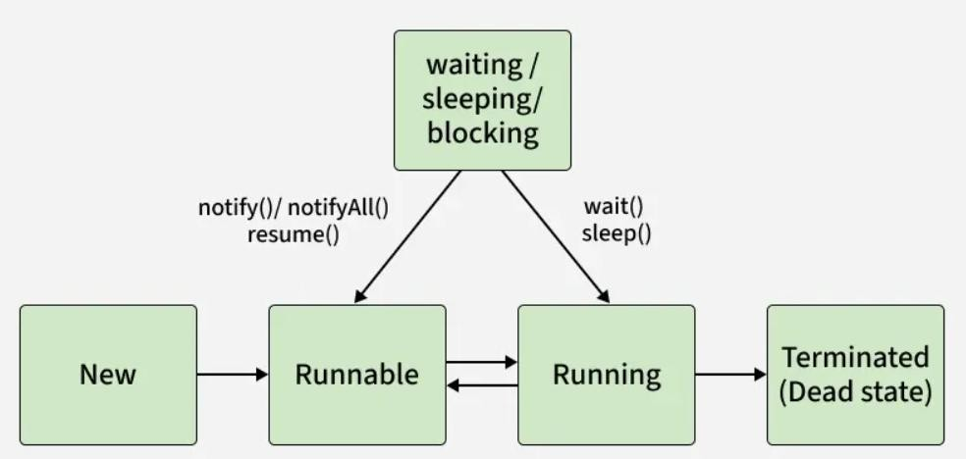

- New: Thread object is created but not started.
- Runnable: Thread is ready to run and waiting for CPU allocation.
- Running: Thread is executing its run() method.
- Waiting/Blocked: Thread waits for a resource or another thread.
- Terminated: Thread completes execution or is stopped

Running Threads in Java
There are two methods used for running Threads in Java:
- run() Method: Contains the code for the thread. Calling it directly behaves like a normal method call.
- start() Method: Launches a new thread and internally calls run() concurrently.
We use start() to launch a new thread, which then calls the run() method in parallel. If we call run() directly, it works like a normal method call and no new thread is created.

LECTURE 11
Memory Hierarchy
The memory hierarchy is the structure of different types of memory arranged based on speed, cost, and capacity. The goal is to provide fast access to data while keeping overall cost low.
Think of it like storing your belongings:
- Very important items are kept in your pockets (fast access, small space).
- Less-used items go in your bag.
- Rarely used things stay at home.
Similarly, computers organize memory from fastest (and smallest) to slowest (and largest).
In parallel and distributed computing, memory hierarchy is a structured system of different memory types—from fast, small, on-chip caches to slower, larger main memory and secondary storage. This hierarchy is crucial for performance, as it optimizes data access by keeping frequently used data in faster levels and managing the complexity of shared memory and data distribution across multiple processors or nodes.

Why is a Memory Hierarchy Needed?
To solve the speed gap between CPU and memory.
- Without hierarchy: CPU would remain idle waiting for data → slow performance.
- With hierarchy: Frequently used data is placed in faster memory → CPU works
continuously.

Levels of Memory Hierarchy (Components)
- Registers
Location: Inside the CPU (part of the processor).

Characteristics
  - Fastest memory in the computer.
  - Access time: 1 CPU clock cycle.
  - Very small storage (typically 32–256 registers).
  - Used for immediate calculations.
Example: Address register, Instruction register, Program counter, General-purpose registers (AX, BX, etc.)

Cache Memory
Location: Between CPU and main memory (RAM).
Purpose: Reduces the time CPU waits for data by storing frequently used instructions.

Types/Levels

- L1 Cache
  - Smallest (32–128 KB)
  - Fastest cache
  - Private to each CPU core

L2 Cache
  - Larger (256 KB – 1 MB)
  - Slower than L1
  - Sometimes shared, sometimes private

L3 Cache
- Largest (2–30 MB)
- Slowest among caches
- Usually shared among all cores

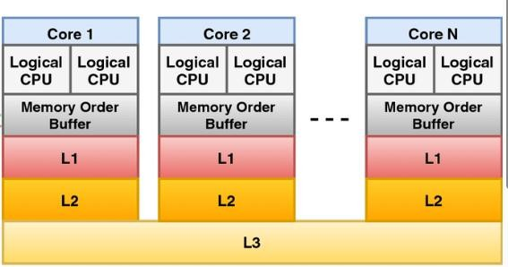

Techniques used by Cache:
- Temporal locality (recently used data is reused):
A program is likely to reuse the same data or instructions that it has recently used. Example: A loop that repeatedly uses the same variable or function.
- Spatial locality (nearby data is likely to be used):
A program is likely to access data or instructions at memory addresses near a recently accessed address.
Example: Accessing elements of an array.
- Replacement policies (LRU, FIFO, Random)
Replacement policies like LRU (Least Recently Used), FIFO (First-In, First-Out),
and Random are algorithms used to decide which data to remove from a cache when it is full and a new item needs to be added. LRU removes the block that has been accessed least recently, FIFO removes the oldest block that was loaded first, and Random removes a block chosen at random from the set. Each policy has different performance characteristics, with LRU often performing well but being more complex to implement than the simple FIFO or Random policies.
- Write policies (write-through, write-back)
When the processor core writes to memory, the cache controller has two alternatives for its write policy.
  - write-back: The data is updated only in the cache and updated into the memory at a later time.

  - write-through: The controller can write to both the cache and main memory, updating the values in both locations; this approach is known as write through.

Main Memory (RAM)
Location: Connected to CPU through memory bus.

Characteristics:
  - Slower than cache but much larger.
  - Stores: OS, Running programs, Currently active data
  - Volatile — data lost when power is off.

Types of RAM
  - DRAM (Dynamic RAM) — slower but cheaper; used as main RAM.
  - SRAM (Static RAM) — faster but expensive; used in cache.

Secondary Storage
Examples: SSD (Solid State Drive), HDD (Hard Disk Drive)

Characteristics
  - Non-volatile — data stays even when power is off.
  - Much bigger capacity (GBs to TBs).
  - Much slower than RAM.

Tertiary Storage (Slowest)
  - External or backup storage such as USB drives, DVDs, or cloud backups.
  - Least frequently accessed.
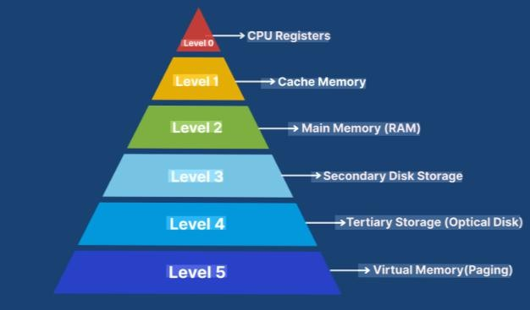

Volatile memory Vs Non Volatile memory
- Volatile memory is temporary and loses data when power is off, while non-volatile memory is permanent and retains data without power.
- Volatile memory is faster and used for short-term tasks like running programs (e.g., RAM, cache), whereas non-volatile memory is slower but used for long-term storage (e.g., hard drives, SSDs, ROM).

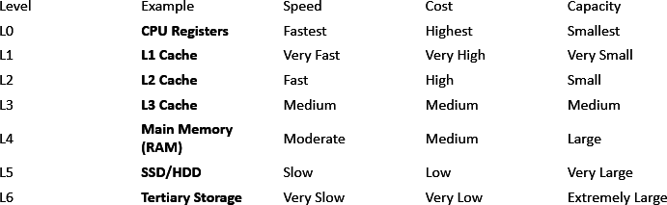

LECTURE 12
What is the message passing interface (MPI)?
- The Message Passing Interface (MPI) is a standardized and widely adopted
programming interface for parallel and distributed computing.
- It provides a library of functions and routines that enable communication and synchronization between processes running on different nodes in a distributed memory environment.
In parallel computing, multiple computers – or even multiple processor cores within the same computer – are called nodes. Each node in the parallel arrangement typically works on a portion of the overall computing problem. The challenge then is to synchronize the actions of each parallel node, exchange data between nodes, and provide command and control over the entire parallel cluster. The message passing interface defines a standard suite of functions for these tasks. The term message passing itself typically refers to the sending of a message to an object, parallel process, subroutine, function or thread, which is then used to start another process.
MPI defines useful syntax for routines and libraries in programming languages including Fortran, C, C++ and Java.

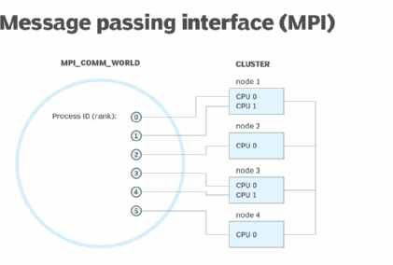

Key aspects of MPI:
- Distributed Memory Model: MPI is primarily designed for systems where each process has its own local memory. Processes communicate by explicitly sending and receiving messages to exchange data, rather than directly sharing memory.
- Parallelization of Tasks: MPI allows complex computational problems to be broken down into smaller, independent tasks that can be executed concurrently by multiple processes.
- Communication Primitives: MPI offers a comprehensive set of communication operations, including:

  - Point-to-point communication: Sending and receiving messages between specific pairs of processes.
  - Collective communication: Operations involving groups of processes, such as broadcasting data to all processes, gathering data from all processes to a single process, or performing reductions (e.g., summing values) across a group.
Point-to-point communication
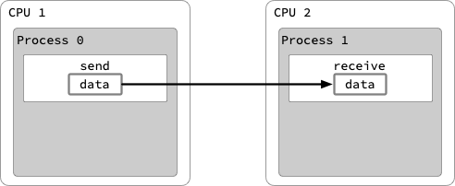

Collective communication
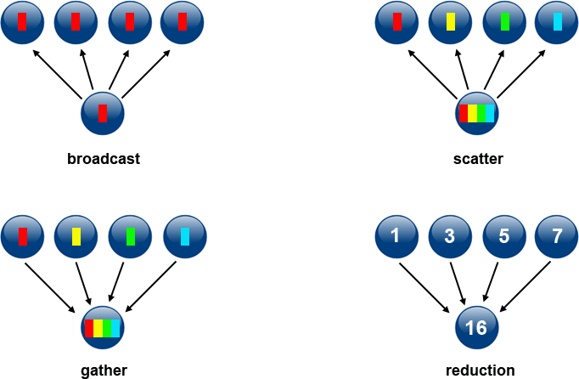

Advantages of MPI
- Portability and Scalability: MPI implementations are available for a wide range of hardware and network architectures, making MPI programs portable across different parallel computing environments. It also enables applications to scale from small clusters to large supercomputers.
- Standardization: While not formally endorsed by a traditional standards organization, MPI is the de facto standard for message passing in parallel computing, ensuring interoperability between different implementations.
- Programming Languages: MPI can be used with various programming languages, including C, C++, and Fortran.
- Applications: MPI is a fundamental tool in high-performance computing (HPC) and is used in diverse fields such as scientific simulations, data analysis, artificial intelligence, and engineering.

Disadvantages of MPI
- Complexity and programming effort
- High programming effort: MPI requires developers to manually manage communication and coordination between processes, making it more complex than higher-level frameworks.
- Steep learning curve: Effective use of MPI demands a deep understanding of parallel programming concepts, which can slow down development.
- Debugging difficulty: Debugging can be challenging due to intricate interactions, race conditions, and the potential for deadlocks and other errors.

- Error handling: Error handling is complex and requires careful implementation, especially with issues like network failures.

Scalability and performance
- Scalability limitations: As the number of processes increases, the complexity of communication and coordination can become problematic.
- Performance bottlenecks: It is easy to write code that performs poorly, and issues can arise from the communication network between nodes.
- Overhead: Message passing can introduce significant overhead and latency, although it can be optimized.
- Recombination of results: While data isn't shared, the results of parallel processing must be recombined, which can be an engineering challenge.

Fault tolerance and integration
- No built-in fault tolerance: A failure in a single node can halt the entire process, as MPI lacks native fault tolerance mechanisms.
- Integration issues: MPI does not natively integrate with modern cluster management systems like Kubernetes, requiring additional layers for orchestration.

Real-World Scenarios Where MPI is Used Weather Forecasting (Meteorology)
Weather prediction requires analyzing huge amounts of data:
- Temperature
- Pressure
- Wind speed
- Satellite images
- Climate models
Single computers cannot handle this load. MPI helps by:
- Splitting the Earth’s map into regions
- Assigning each region to a different process
- Exchanging data between regions (cloud movement, storms, etc.)
- This makes forecasts faster and more accurate.
- Real-World Scenarios Where MPI is Used

Simulating Natural Disasters
MPI is used for:
- Earthquake simulations
- Flood modelling
- Tsunami impact prediction
These simulations need thousands of processors working together to simulate millions of particles or waves.

Medical Imaging and DNA Analysis
MPI is used in:
- MRI scan processing
- 3D medical image reconstruction
- Genome sequencing
- Drug discovery simulations
- Large datasets are processed in parallel to speed up medical research.

Financial Market Analysis
Banks and trading firms use MPI for:
- Predicting stock market trends
- Running risk calculations
- Analyzing millions of transactions
- High-frequency trading models
- MPI enables real-time calculations by splitting workload across many processors.

Machine Learning on Supercomputers
Large deep learning models (e.g., GPT, BERT) sometimes train on:
- Multiple GPUs
- Many compute nodes
MPI-based libraries like Horovod and DeepSpeed help:
- Synchronize model weights
- Distribute training batches
- Speed up model training

MPI Programming
- MPI (Message Passing Interface) is a standard way for computers or processors to
communicate with each other when running a program in parallel.
- Think of MPI as a communication language that different computers, CPUs, or cores use to send messages, receive messages, and work together on a large problem.

Why do we need MPI?
- When a big task is too slow for one computer, we divide it into smaller tasks and give each part to a different processor. But these processors must share information with each other.
- MPI allows them to:
  - Send data
  - Receive data
  - Work together without confusion
  - Complete tasks faster.
So MPI is like a post office for parallel programs.

Basic Ideas in MPI
- Processes
  - A parallel program uses many processes.
  - Each process runs the same program but on different data.
Example:
  - Process 0 → first part of the problem
  - Process 1 → second part
  - Process 2 → third part

Message Passing
  - MPI lets processes talk using:
  - send() → to send data
  - receive() → to receive data

It is like: Process A → sends a message → Process B receives it

- Rank
  - Every process gets a unique ID number called a rank.
  - It is used to know who is talking to whom.
Example:
  - Rank 0
  - Rank 1
  - Rank 2
  - …

Communicators
  - A communicator is a group of processes that can talk to each other.
  - The most common one is MPI_COMM_WORLD, which includes all processes.

Simple MPI Program
A typical MPI program does these steps:
  - Start MPI
  - Get total number of processes
  - Get your rank (ID)
  - Do your part of the work
  - Send/receive messages if needed
  - Finish MPI Example
Imagine 4 workers cleaning a field:
    - Worker 0 cleans area A
    - Worker 1 cleans area B
    - Worker 2 cleans area C
    - Worker 3 cleans area D
    - If worker 1 needs a tool from worker 0:
    - Worker 1 sends a request → message
    - Worker 0 replies → message
This is exactly how MPI works in parallel programs.

Lecture 15

Apache Hadoop is an open-source framework used to store, process, and analyze very large amounts of data (Big Data) across clusters of inexpensive computers at the same time, using distributed storage (HDFS) and parallel processing (MapReduce) for scalability and fault tolerance, letting you analyze huge amounts of data quickly by breaking tasks into smaller pieces across many machines.
Think of it as a powerful system that uses many regular computers (nodes) to do big jobs, instead of one super-expensive one, with built-in ways to handle data safety and failures.

Why do we need Hadoop?
Traditional systems fail when:
  - Data becomes too large (terabytes & petabytes)
  - Data comes very fast (social media, sensors, logs)
  - Data is unstructured (videos, text, images)
Hadoop solves this by:
  - Splitting data into pieces
  - Storing it on many computers
  - Processing it in parallel

Main Components of Hadoop

1. HDFS (Hadoop Distributed File System)
- This is Hadoop’s storage system.
- Stores large files across many machines
- Automatically handles data backup (replication)
Two main parts:
  - NameNode → Master (keeps track of files)
  - DataNode → Workers (store actual data)
Example: A 1GB file is split into smaller blocks and stored on different computers.

2. MapReduce (Processing Engine)
- This is Hadoop’s data processing model.
- It works in two steps:
  - Map → Break big data into smaller parts and process them
  - Reduce → Combine results into final output
Example: Counting words in 1 million documents:
- Map: Each file counts its words
- Reduce: All counts are added together
3. YARN (Resource Manager)
- YARN manages CPU, memory, and jobs in Hadoop.
- Decides which job runs where
- Shares resources among users
- Keeps the system efficient
YARN decides which application gets how much CPU, memory, and when, across the Hadoop cluster.

YARN (Yet Another Resource Negotiator) is the resource management and job scheduling layer of Hadoop. It was introduced in Hadoop 2.x to overcome the limitations of the old Hadoop 1.x (where MapReduce handled both processing and resource management).

4. Hadoop Common
Contains:
- Libraries
- Utilities
- Tools needed to run Hadoop

Instead of each Hadoop component (HDFS, YARN, MapReduce) creating its own:
- File system support
- Configuration system
- Networking code
- Security features
All these common services are placed in Hadoop Common so every module can reuse them.

How Hadoop Works

- Data is stored in HDFS
- Job is submitted
- YARN assigns resources
- MapReduce processes data
- Final result is stored back in HDFS

Hadoop Cluster Types

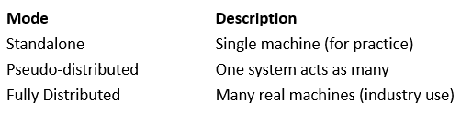

Where is Hadoop Used?
- Facebook, Google, Amazon
- Banking & Finance
- Weather forecasting
- Healthcare
- E-commerce
- IoT systems

HDFS (Hadoop Distributed File System) in Detail
- HDFS (Hadoop Distributed File System) is the storage system of Hadoop.
It is designed to store very large files (GBs–TBs–PBs) across multiple computers in a distributed way.
- HDFS breaks huge files into small blocks and stores them on different machines, with automatic backup and recovery.

Main Objectives of HDFS
HDFS is designed to:
- Handle very large files
- Work on low-cost hardware
- Provide high fault tolerance
- Allow fast data access
- Support parallel processing
- Store write once, read many data
HDFS follows Write Once Read Many philosophies. So we cannot edit files already stored in HDFS, but we can append new data to these files by re-opening them. To read the files stored in HDFS, the HDFS client interacts with the NameNode and DataNode.

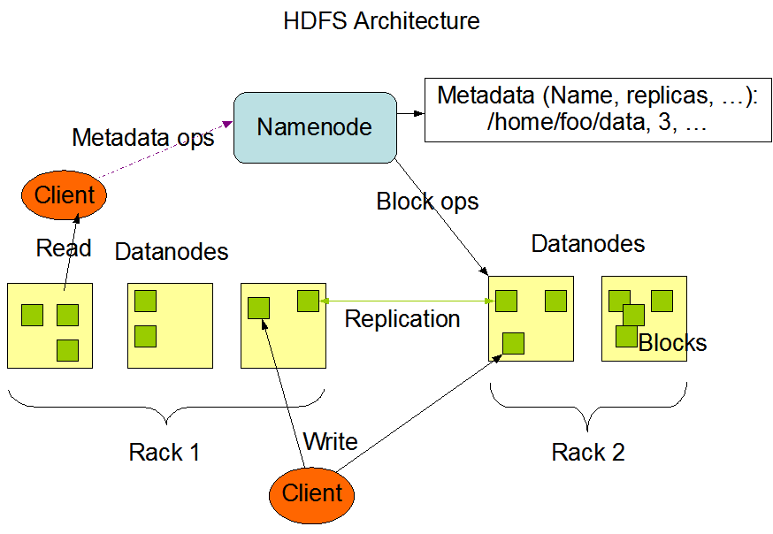
Core Components of HDFS

- NameNode — Master Node: Controls the file system.

Responsibilities:
- Stores metadata
- Keeps file names
- Knows which block is on which DataNode
- Tracks replication information
- Manages permissions
Note: It does not store actual data.

- DataNode — Worker Node: Stores the actual file blocks.

Responsibilities:
- Stores data blocks
- Sends heartbeat to NameNode
- Performs read/write operations
- Replicates data as instructed

- Secondary NameNode (Checkpoint Node)
- Creates backup of metadata
- Prevents NameNode overload
- Helps in recovery
Note: The Secondary NameNode is NOT a real backup or standby NameNode. It does not take over automatically if the NameNode fails. Its just a helper.

HDFS Block and Replication Concept

Block Size
- Default block size: 128 MB
- A large file is divided into blocks of equal size.
Replication Factor
- Default: 3 copies
- Each block is stored on 3 different DataNodes
- Ensures fault tolerance
Example:
- If a file is 300 MB:
- It becomes 3 blocks:
  - Block 1 → Node A, B, C
  - Block 2 → Node B, C, D
  - Block 3 → Node A, C, D

How HDFS Read Operation Works

- Client requests file from NameNode
- NameNode sends block locations
- Client reads blocks from nearest DataNode
- Data is combined and delivered to client
- NameNode never touches the actual data.

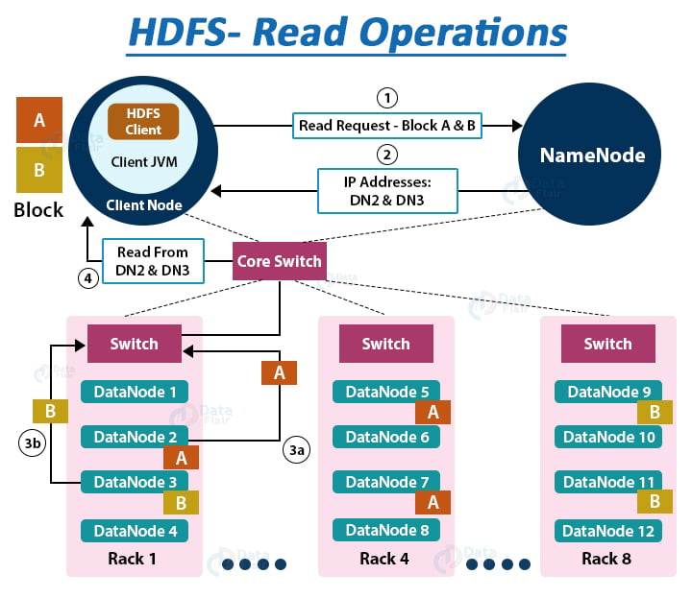

Suppose the HDFS client wants to read a file “File.txt”. Let the file be divided into two blocks say, A and B. The following steps will take place during the file read:

1. The Client interacts with HDFS NameNode
- As the NameNode stores the block’s metadata for the file “File.txt’, the client will reach out to NameNode asking locations of DataNodes containing data blocks.
- The NameNode first checks for required privileges, and if the client has sufficient privileges, the NameNode sends the locations of DataNodes containing blocks (A and B). NameNode also gives a security token to the client, which they need to show to the DataNodes for authentication. Let the NameNode provide the following list of IPs for block A and B – for block A, location of DataNodes D2, D5, D7, and for block B, location of DataNodes D3, D9, D11.

2. The Client interacts with HDFS DataNode

- After receiving the addresses of the DataNodes, the client directly interacts with the DataNodes. The client will send a request to the closest DataNodes (D2 for block A and D3 for block B) through the FSDataInputstream object. The DFSInputstream manages the interaction between client and DataNode.
- The client will show the security tokens provided by NameNode to the DataNodes and start reading data from the DataNode. The data will flow directly from the DataNode to the client.
- After reading all the required file blocks, the client calls close() method on the FSDataInputStream object.

Now let us see how internally read operation is carried out in Hadoop HDFS, how data flows between the client, the NameNode, and DataNodes during file read.

Internals of file read in HDFS (video in slides)

- In order to open the required file, the client calls the open() method on the FileSystem object, which for HDFS is an instance of DistributedFilesystem.
- DistributedFileSystem then calls the NameNode using RPC to get the locations of the first few blocks of a file. For each data block, NameNode returns the addresses of Datanodes that contain a copy of that block. Furthermore, the DataNodes are sorted based on their proximity to the client.
- The DistributedFileSystem returns an FSDataInputStream to the client from where the client can read the data. FSDataInputStream in succession wraps a DFSInputStream. DFSInputStream manages the I/O of DataNode and NameNode.
- Then the client calls the read() method on the FSDataInputStream object.
- The DFSInputStream, which contains the addresses for the first few blocks in the file, connects to the closest DataNode to read the first block in the file. Then, the data flows from DataNode to the client, which calls read() repeatedly on the FSDataInputStream.
- Upon reaching the end of the file, DFSInputStream closes the connection with that DataNode and finds the best suited DataNode for the next block.
- If the DFSInputStream during reading, faces an error while communicating with a DataNode, it will try the other closest DataNode for that block. DFSInputStream will also remember DataNodes that have failed so that it doesn’t needlessly retry them for later blocks. Also, the DFSInputStream verifies checksums for the data transferred to it from the DataNode. If it finds any corrupt block, it reports this to the NameNode and reads a copy of the block from another DataNode.
- When the client has finished reading the data, it calls close() on the FSDataInputStream.

LECTURE 16

1. What is MapReduce?
MapReduce is the data processing engine of Hadoop. It is used to process huge amounts of data in parallel across many machines.

MapReduce:
- Breaks big data into small parts
- Processes each part separately
- Combines all results into one final output

2. Why MapReduce is Needed?
When data becomes:
- Too large
- Too fast
- Too complex
A single computer becomes:
- Slow
- Unreliable
- Expensive
MapReduce solves this by:
- Parallel processing
- Automatic task distribution
- Fault tolerance
- High-speed data analysis

3. Core Concept of MapReduce (Two Phases)

(A) MAP Phase
- Input data is divided into chunks
- Each chunk is processed separately
- Produces key–value pairs
(B) REDUCE Phase
- Combines all values of the same key
- Produces final output

4. Components of MapReduce Architecture

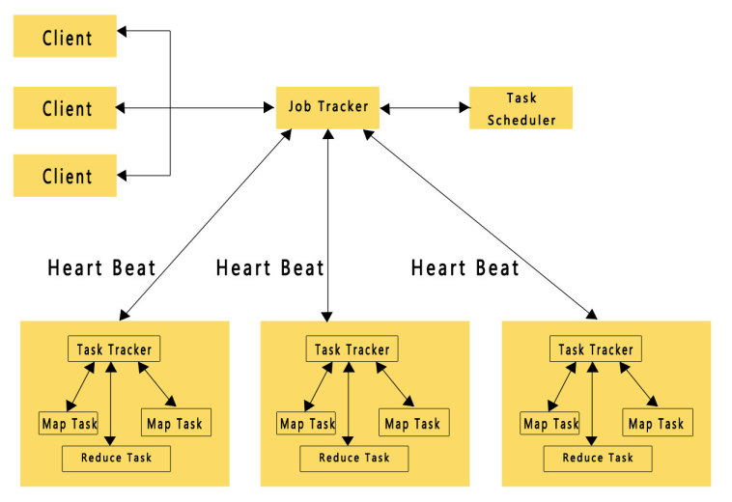

1. Client
- Submits the job to Hadoop
2. JobTracker (Master)
- Divides job into smaller tasks
- Assigns tasks to TaskTrackers
- Monitors execution
3. TaskTracker (Worker)
- Executes Map and Reduce tasks
- Sends status to JobTracker
Note:
In modern Hadoop, JobTracker & TaskTracker are replaced by YARN (ResourceManager & NodeManager).

5. How Input Data is Handled in MapReduce
- Data is stored in HDFS
- File is divided into blocks
- Each block is processed by one Map task
- Faster processing due to parallelism

6. Detailed Working of MapReduce (Step-by-Step)

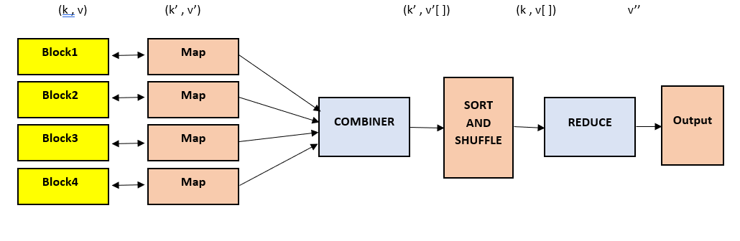

Step 1: Input Splitting
- Input file divided into blocks
- Each block sent to a Map task
Step 2: Mapping
- Mapper reads data
- Converts into key–value pairs
Step 3: Shuffling
- Output of Map is shuffled
- Same keys go to the same Reducer
Step 4: Sorting
- Data is sorted by keys
Step 5: Reducing
- Reducer combines data
- Produces final result
Step 6: Output Storage
- Final output stored in HDFS

8. Basic MapReduce Program Structure (Concept Only)
Mapper:
- Reads input
- Produces key–value pairs
Reducer:
- Gets same keys
- Combines values
- Produces final result
(Usually written in Java, but can also be done with Python, C++ via streaming)

9. Types of MapReduce Jobs

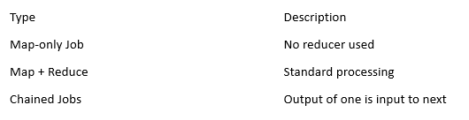

10. Fault Tolerance in MapReduce
If:
- A DataNode fails
- A task crashes
Then:
- Task is automatically re-run on another node
- Data is recovered using HDFS replication
- Job continues without restarting everything

CASE STUDY

Understanding Memory Hierarchy Through a Real CPU System

- Introduction
Modern computer systems execute millions of instructions per second. For the CPU to run efficiently, it needs fast access to data. However, fast memory is expensive, and large memory is slow but affordable.
To solve this problem, computers use a memory hierarchy — a layered arrangement of storage components that balances speed, cost, and size.
This case study uses a real-world example of how a laptop processes a task and how different memory levels participate.

The Scenario (Real-World Task)
Imagine a student opens MS Word, writes paragraphs, scrolls, saves the file, and eventually shuts down the laptop.
During these steps, data travels through different layers of the memory hierarchy.

System Specifications (For Case Study)
Consider a typical modern system:
  - CPU: 3.4 GHz processor
  - Registers: 64 general-purpose registers

Cache:
    - L1 Cache: 64 KB (per core)
    - L2 Cache: 512 KB (per core)

    - L3 Cache: 8 MB (shared)
  - RAM: 16 GB DDR4
  - Storage: 512 GB SSD

Step-by-Step Data Journey Through Memory Hierarchy
Let’s follow what happens when the student types a sentence.

Step 1 — CPU Registers (Fastest)
When a character is typed:
- The keyboard generates a signal.
- CPU receives the character.
- Registers hold:
  - ASCII value of the pressed key
  - Instruction data (e.g., “display this character”)
  - Temporary arithmetic or logic results

Why registers?
- They are inside the CPU, so access time is less than 1 nanosecond.
- Perfect for storing temporary values.

Real example
When typing “A”, register R1 might hold the value 65 (ASCII for A).

Step 2 — L1 Cache (Extremely Fast)
The CPU checks L1 cache for commonly used instructions:
- "Display character"
- "Update cursor"

- “Store character in buffer”
These instructions are used repeatedly, so L1 cache keeps them ready.

Why L1?
- Very fast (~0.5 ns access time).
- Holds the most frequently used code/data.

Real behavior
L1 Cache hits almost 95% of time for repeated typing actions.

Step 3 — L2 Cache (Fast, Larger)
If data is not found in L1, CPU checks L2 cache. Example:
When the user scrolls/pages up/down, CPU needs formatting data that may not be in L1. L2 has:
- Word formatting rules
- Font rendering instructions
- Paragraph data previously accessed

Why L2?
- Larger capacity allows storage of more data.
- Slightly slower (~5 ns).

Step 4 — L3 Cache (Shared Between CPU Cores)
When the user opens a large document (say 50 pages), L3 cache helps:
- Stores large chunks of document data.
- Shares data between cores (useful if multiple threads are running — spell check, auto- save, UI rendering).

Why L3?
- Balances size and speed.
- Much larger (~8 MB) but slower (~15 ns).

Step 5 — Main Memory (RAM)
All active parts of MS Word are loaded into RAM:
- The open .docx file
- Running Word application
- Dictionary for spell check
- Clipboard data
- Temporary autosave files

Why RAM?
- Much larger (GBs).
- Faster than SSD but slower than cache (~70 ns).
- Stores entire active programs.

Real example
If the Word file is 5 MB, it is loaded fully into RAM.

Step 6 — SSD (Long-Term Storage)
When the student saves the document, it is written permanently to SSD.
- SSD stores the .docx file.
- File stays even after shutdown.
- Opening the file later loads it from SSD into RAM.

Why SSD?
- Non-volatile.
- Stores data even when powered off.
- Slowest compared to upper memory levels (~100,000 ns).

ACTIVITY

Matrix Multiplication – Serial, Multithreaded & OpenMP Parallel Version

- Serial Matrix Multiplication (Java)
Uses the classical 3-nested-loop method.

public class SerialMatrix {
public static void main(String[] args) {

int n = 3;
int[][] A = { {1,2,3}, {4,5,6}, {7,8,9} };
int[][] B = { {9,8,7}, {6,5,4}, {3,2,1} };
int[][] C = new int[n][n];

// Serial matrix multiplication for (int i = 0; i < n; i++) {
for (int j = 0; j < n; j++) {
for (int k = 0; k < n; k++) { C[i][j] += A[i][k] * B[k][j];
}
}
}

System.out.println("Serial Result:"); for (int[] row : C) {
for (int x : row) System.out.print(x + " "); System.out.println();
}
}
}

Multithreaded Matrix Multiplication (Java)
Each thread computes one row of result matrix.

class RowMultiplier extends Thread { int row;
int[][] A, B, C;
int n;

public RowMultiplier(int row, int[][] A, int[][] B, int[][] C, int n) { this.row = row;
this.A = A; this.B = B; this.C = C; this.n = n;
}

public void run() {
for (int j = 0; j < n; j++) {
for (int k = 0; k < n; k++) { C[row][j] += A[row][k] * B[k][j];
}
}
}
}

public class MultiThreadMatrix {
public static void main(String[] args) {
int n = 3;
int[][] A = { {1,2,3}, {4,5,6}, {7,8,9} };
int[][] B = { {9,8,7}, {6,5,4}, {3,2,1} };
int[][] C = new int[n][n]; Thread[] threads = new Thread[n];
for (int i = 0; i < n; i++) {
threads[i] = new RowMultiplier(i, A, B, C, n); threads[i].start();
}

try {
for (int i = 0; i < n; i++) threads[i].join();
} catch (Exception e) {}

System.out.println("Multithreaded Result:"); for (int[] row : C) {
for (int x : row) System.out.print(x + " "); System.out.println();
}
}
}

OpenMP Parallel Version With collapse()
(C program, as OpenMP is for C/C++/Fortran)

#include <stdio.h> #include <omp.h>

int main() {

int n = 3;
int A[3][3] = {{1,2,3},{4,5,6},{7,8,9}};
int B[3][3] = {{9,8,7},{6,5,4},{3,2,1}}; int C[3][3] = {0};
#pragma omp parallel for collapse(2) for (int i = 0; i < n; i++) {
for (int j = 0; j < n; j++) {
for (int k = 0; k < n; k++) { C[i][j] += A[i][k] * B[k][j];
}

}
}
printf("OpenMP Result:\n"); for (int i = 0; i < n; i++) {
for (int j = 0; j < n; j++) printf("%d ", C[i][j]);
printf("\n");
}
}

What is the level of parallelism in matrix multiplication?
Matrix multiplication has very high parallelism because:

✔ Each element of C[i][j] can be computed independently
✔ A matrix of size N×N has N² independent tasks
✔ No data dependency among rows or columns (inside outer loops)

Parallelism level = N × N independent computations.

Example:
1000×1000 matrix → 1,000,000 parallel tasks.

Why do we NOT use locks in matrix multiplication?
We do not use locks because:

✔ Each thread writes to a different element of C[i][j]
No two threads modify the same memory location.

✔ No shared-write conflict
Threads only read from A and B (safe). Thread writes to its own part of result matrix.

✔ Using locks would slow it down
They would cause:

- Blocking
- Waiting
- Loss of parallel performance

So locks are unnecessary and harmful.

Using shared memory or not?

✔ Yes, matrix multiplication uses shared memory (in multithreading & OpenMP)
Reason:

  - All threads read the same matrices A and B
  - Each writes to different parts of matrix C
  - No conflicts occur → safe shared memory usage

In OpenMP and Java threads, shared memory allows fast communication.

