

Lexical Analyzer for “GhazalScript”

Compiler Construction

Name: DANIYAL SHAHID
Roll Number: L1F22BSCS1106
Section: G-15

Submitted To (Instructor Name): Prof. Aneela Mehmood

Introduction

This project implements the Lexical Analysis Phase of a custom poetic programming language called GhazalScript.
GhazalScript uses elegant Urdu-poetry–inspired words to make the coding experience artistic, expressive, and culturally unique.

The lexical analyzer is built using:
- Flex (Fast Lexical Analyzer Generator)
- C Compiler (GCC)

The scanner reads the input source file and generates two output files:
- tokens.txt → Contains all recognized tokens
- errors.txt → Contains all illegal or unrecognized lexemes

Description of the Language (SillyScript)
SillyScript is designed using easy and funny English words for programming.
- Keywords
Keyword | Meaning
Aaghaaz-e-Ghazal | Start of program
Anjaam-e-Naghma | End of program / Return
Lehja-e-Hisaab | Integer
Bole-e-Mohabbat | String
Saaya-e-Khayaal | Void
Sachchi-Sadaa | Boolean
Naghma-e-Haq | true
Saaz-e-Fareb | false
Gar-Yun-Ho | if
Warna-Yun-Na-Ho | while
Suno-Aey-Dilbar | print
Raqs-e-Jaari | continue
Toota-Hua-Alfaaz | break
Anjaam-e-Naghma | return

- Operators
Poetic Operator | Meaning
ishq+ | + (addition)
gham- | – (subtraction)
junoon* | * (multiplication)
%rubaa% | == (equality)
= | assignment
> | greater than
< | less than

- Punctuations
Symbol | Meaning
::bahaar:: | Block start {
;khamoshi; | Block end }
!aasar! | Statement terminator
(nazar | (
khwaab) | )
,sukoon, | separator ,

- Regular Expressions Used
  Token Type
  Token Type | Regex
  Identifier
  [A-Za-z_][A-Za-z0-9_]*
  Integer
  [0-9]+
  Float
  [0-9]+\.[0-9]+
  Exponential
  `({INTEGER}
  String
  "[^"]*"
  Char
  '[^']'
  Whitespace
  [ \t\r]+
  Newline
  \n
  Comments
  //.*

Sample Input Code (my_code.txt)

Aaghaaz-e-Ghazal ::bahaar::

Lehja-e-Hisaab umar = 25 ;
Lehja-e-Hisaab saal = 2 ;

Bole-e-Mohabbat shayari = "Chaand bhi sharma jaye" ;
Sachchi-Sadaa ishqKaHaal = Naghma-e-Haq ;

Suno-Aey-Dilbar (nazar "Umar: " ,sukoon, umar khwaab!) ;

Gar-Yun-Ho (nazar umar > saal khwaab!) ::bahaar::
Suno-Aey-Dilbar (nazar "Safar lamba hai" khwaab!) ;
::bahaar::

Warna-Yun-Na-Ho (nazar umar < 100 khwaab!) ::bahaar::
Suno-Aey-Dilbar (nazar "Safar chota hai" khwaab!) ;
::bahaar::

umar = umar ishq+ 5 ;
saal = saal gham- 1 ;

Toota-Hua-Alfaaz ;

Anjaam-e-Naghma !aasar!

### ERRORS BELOW ###

@illegalSymbol
"Unfinished string
ishq+??

FA for IDENTIFIERS

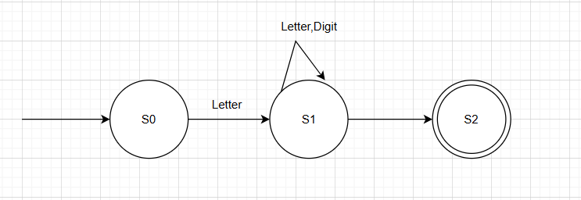

FA for NUMBERS

- FA for INTEGER NUMBERS
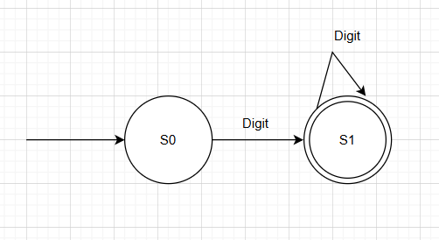

- FA for FLOAT NUMBERS

