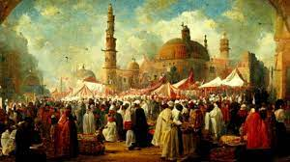

*Mawlid, also known as Mawlid al-Nabi, is a significant observance in Islam that commemorates the birth of the Prophet Muhammad.*

**MAWLID**