Full Stack Web Development
Lab # 04(JavaScript)
Name: Daniyal Haider
Rollno: 241947
Class: BSCS 5A

Task # 01
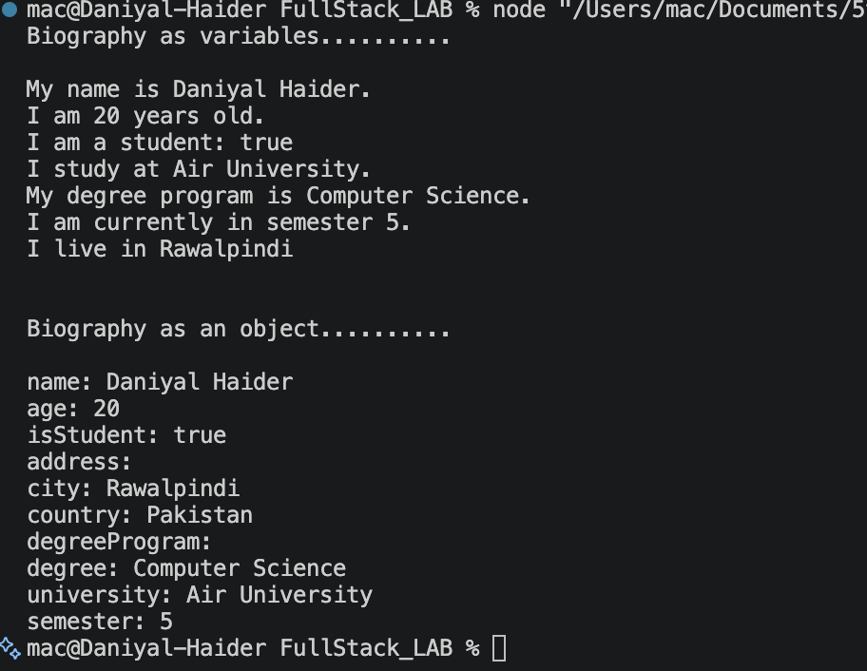
Task # 02
Task # 03
Task # 04
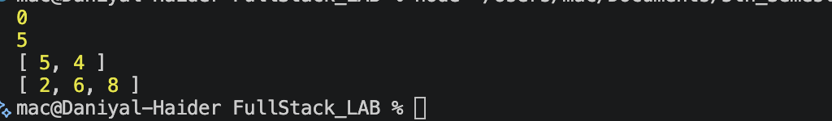
Task # 05
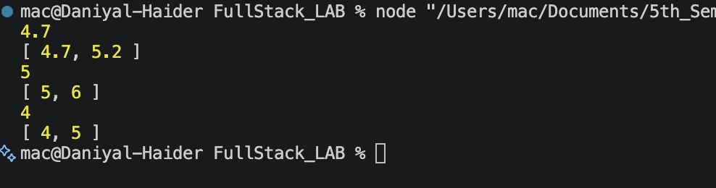
Task # 06

