FullStack Web Development
Lab # 07

Name: Daniyal Haider
Class: BSCS 5A
Rollno: 241947

Task # 01
Student Management System
Students
- POST

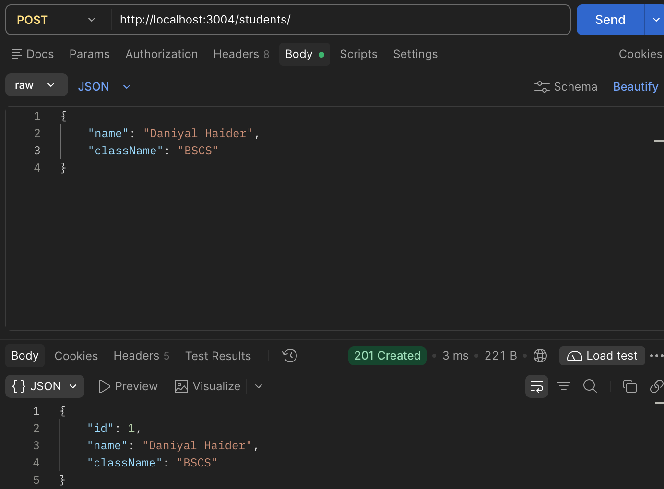
- GET
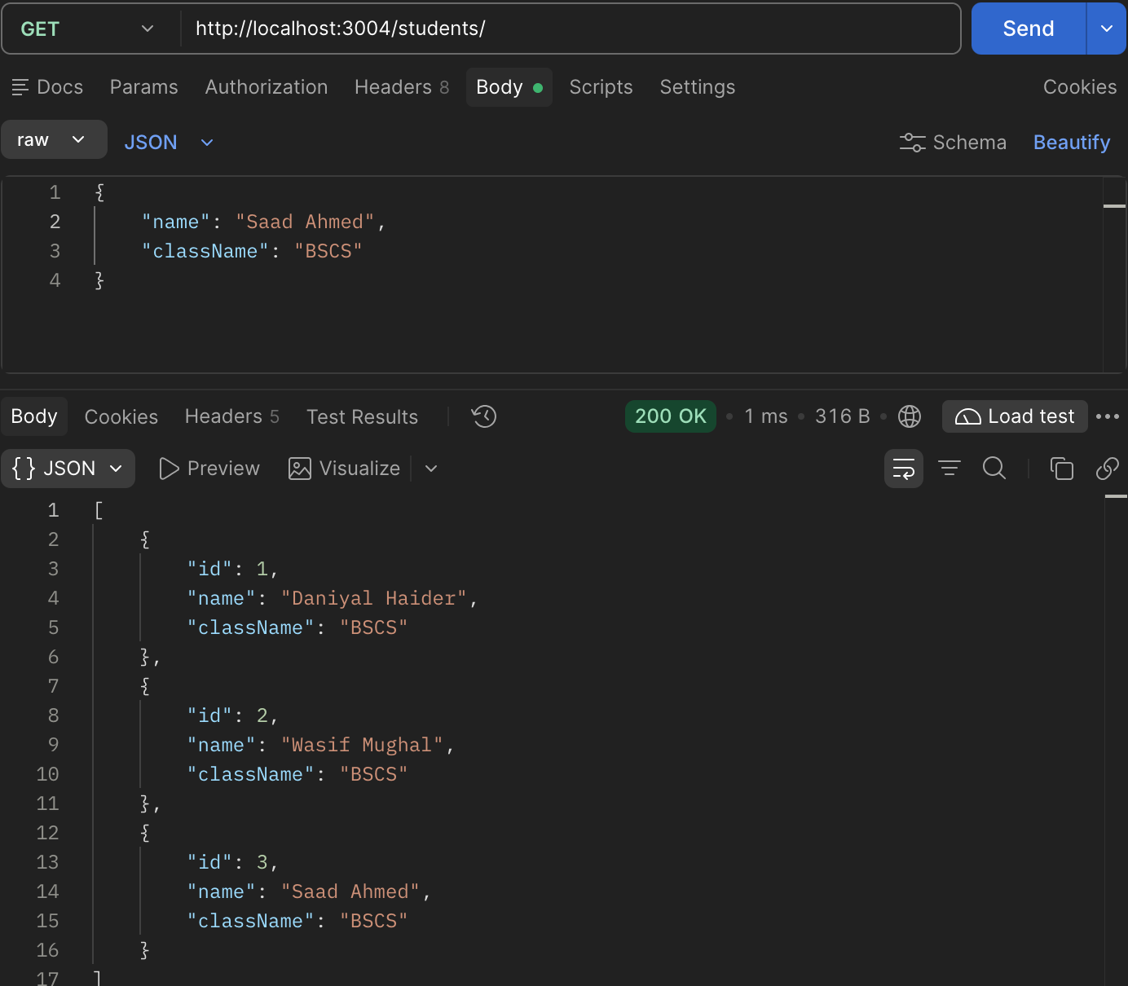
- PUT
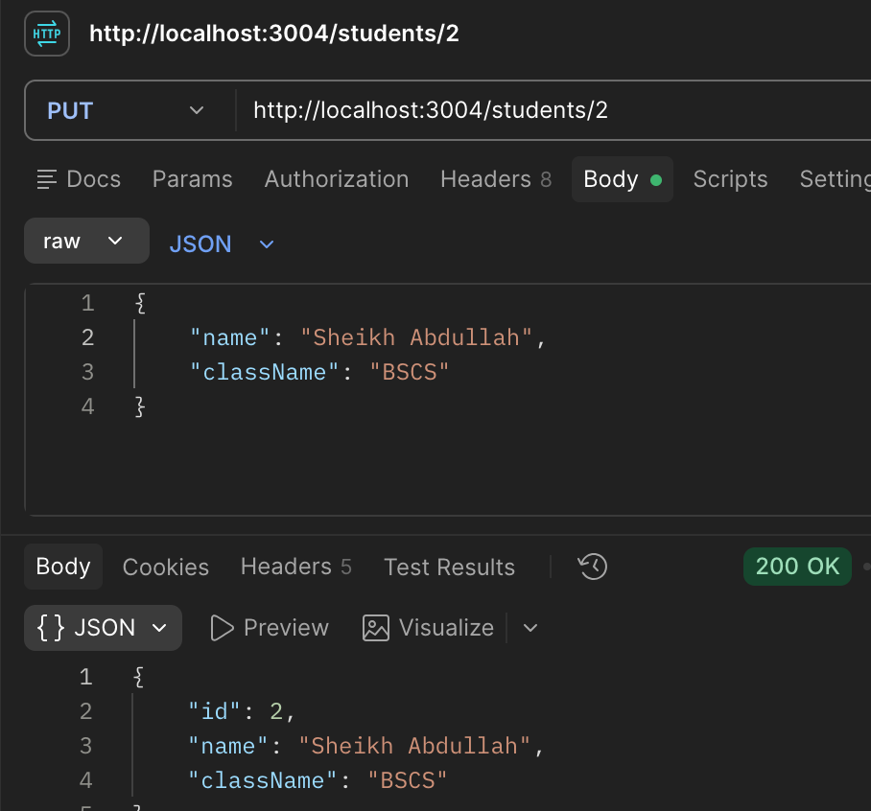
- DELETE
