Investigating Volumetric Analysis of
Constituents Of Brain Soft Tissue



by

Daniyal Ahmed Gul (BCS223030)
Muhammad Hasan Nauman (BCS223033)
Hadia khan (BCS223216)

Supervisor : Dr. Masroor Ahmed

Proposal submitted as a
Final Year Project for
CS4912 Design Project

Department of Computer Sciences
Capital University of Science & Technology, Islamabad
May, 2026

Table of Contents

Abstract ....................................................................................................................... 7

CHAPTER 1: Introduction ..................................................................................... 10
1.1 Project Introduction ............................................................................................. 10
1.2 Existing Solutions and Research Gap .................................................................. 12
1.3 Research Scope and Objectives ........................................................................... 12
1.4 Tools and Technologies ....................................................................................... 13
1.5 Project Work Breakdown ..................................................................................... 15
1.6 Methodology ........................................................................................................ 16
1.6.1 Overview of Methodology ............................................................................ 16
1.6.2 Image Preprocessing ..................................................................................... 18
1.6.3 Feature Extraction and Reduction ................................................................. 18
1.6.4 Model Training and Classification ................................................................ 19
1.6.5 Clustering and Volumetric Estimation .......................................................... 20
1.6.6 Evaluation and Visualization ......................................................................... 21

CHAPTER 2: Requirement Specification and Analysis ....................................... 22
2.1 Functional Requirements ...................................................................................... 22
2.2 Non-Functional Requirements .............................................................................. 23
2.3 Selected Functional Requirements ....................................................................... 24
2.4 System Use Case Modeling .................................................................................. 27
2.5 System Sequence Diagram ................................................................................... 41
2.6 Domain Model ...................................................................................................... 47

CHAPTER 3: System Design ................................................................................... 48
3.1 Layer Definition .................................................................................................... 48
3.1.1 Presentation Layer .......................................................................................... 49
3.1.2 Application / Business Logic Layer ............................................................... 49
3.1.3 Data Layer ...................................................................................................... 50
3.2 Software Architecture ........................................................................................... 50
3.3 Class Diagram ....................................................................................................... 51
3.4 Sequence Diagram ................................................................................................ 54
3.4.1 Researcher Registration ................................................................................. 54
3.4.2 Researcher Login ........................................................................................... 55
3.4.3 Upload MRI Image & Start Preprocessing .................................................... 55
3.4.4 Feature Extraction, PCA, Classification & Volumetric Analysis .................. 56
3.4.5 View & Download Volumetric Report .......................................................... 57
3.5 Entity Relationship Diagram ................................................................................ 57
3.6 Database Schema .................................................................................................. 59
3.7 User Interface Design ........................................................................................ 60

CHAPTER 4: Implementation Issues .................................................................. 62
4.1 Coding Standards ............................................................................................... 62
4.1.1 Indentation .................................................................................................. 62
4.1.2 Declaration .................................................................................................. 62
4.1.3 Statement Standards .................................................................................... 62
4.1.4 Naming Conventions ................................................................................... 62
4.2 Development Environment ................................................................................. 63
4.3 Database Management System ........................................................................... 63
4.4 Software Description .......................................................................................... 64
4.4.1 User Authentication Module ....................................................................... 65
4.4.2 Dashboard Interface .................................................................................... 66
4.4.3 MRI Image Upload Module ........................................................................ 67
4.4.4 Image Preprocessing Module ...................................................................... 68
4.4.5 Output Visualization Module ...................................................................... 69

CHAPTER 5: Software Testing ............................................................................ 70
5.1 Testing Methodology ......................................................................................... 70
5.2 Testing Environment .......................................................................................... 70
5.3 Test Case: User Sign In ...................................................................................... 71
5.4 Test Case: Invalid Sign In .................................................................................. 71
5.5 Test Case: MRI Image Upload ........................................................................... 72
5.6 Test Case: Invalid File Upload ........................................................................... 72
5.7 Test Case: Image Preprocessing ......................................................................... 73
5.8 Test Case: Output Visualization ......................................................................... 73

List of Tables
Table 1.1 | Tools and Technologies.......................................................................................... | 11
Table 1.2 | Project Work Breakdown. ..................................................................................... | 12
Table 2.1 | Functional Requirements........................................................................................ | 19
Table 2.2 | Non-Functional Requirements................................................................................. | 20
Table 2.3 | Selected Functional Requirements............................................................................ | 21
Table 2.4 | Register & Login................................................................................................... | 24
Table 2.5 | Recover Password................................................................................................. | 25
Table 2.6 | Upload MRI Images............................................................................................... | 26
Table 2.7 | Validate Format.................................................................................................... | 28
Table 2.8 | Image Processing Pipeline...................................................................................... | 29
Table 2.9 | Extract Features.................................................................................................... | 30
Table 2.10 | Train Model.......................................................................................................... | 31
Table 2.11 | Perform Clustering................................................................................................ | 32
Table 2.12 | Compute Volumetric Ratio...................................................................................... | 34
Table 2.13 | Evaluate Model Performance................................................................................... | 35
Table 2.14 | Output Results...................................................................................................... | 36
Table 3.1 | Layers Definition............................................................................................ | 44
Table 5.1 | User Sign In......................................................................................................... | 70
Table 5.2 | Invalid Login Attempt............................................................................................ | 71
Table 5.3 | Upload MRI Image................................................................................................ | 72
Table 5.4 | Unsupported File Format....................................................................................... | 72
Table 5.5 | Preprocessing Execution......................................................................................... | 72
Table 5.6 | Display Preprocessed Image.................................................................................. | 72
Table 5.7 | FCM Tissue Segmentation.................................................................................... | 73
Table 5.8 | ROI Extraction and Tumor Detection...................................................................... | 73
Table 5.9 | Volumetric Ratio Calculation................................................................................. | 73

List of Figures
Figure 1 | Overview of Methodology………………………………………………………… | 16
Figure 2.1 | Use Case Diagram…………………………………………………………………. | 23
Figure 2.2 | SSD (Register) ……………………………………………………………………. | 37
Figure 2.3 | SSD (Login) ………………………………………………………………………. | 37
Figure 2.4 | SSD (Recover Password) …………………………………………………………. | 38
Figure 2.5 | SSD (Upload MRI Images) ………………………………………………………. | 38
Figure 2.6 | SSD (Validate Format) …………………………………………………………… | 39
Figure 2.7 | SSD (Image Processing Pipeline) ………………………………………………… | 39
Figure 2.8 | SSD (Extract Features) …………………………………………………………… | 39
Figure 2.9 | SSD (Train Model) ………………………………………………………………. | 40
Figure 2.10 | SSD (Perform Clustering) ………………………………………………………… | 40
Figure 2.11 | SSD (Compute Volumetric Ratio) ………………………………………………. | 41
Figure 2.12 | SSD (Evaluate Model Performance) ……………………………………………… | 41
Figure 2.13 | SSD (Output Results) ……………………………………………………………... | 42
Figure 3.1 | Software Architecture Diagram…………………………………………………… | 46
Figure 3.2 | UML Class Diagram……………………………………………………………… | 47
Figure 3.3 | Researcher Registration…………………………………………………………… | 50
Figure 3.4 | Researcher Login…………………………………………………………………. | 51
Figure 3.5 | Upload MRI Image and Start Processing…………………………………………. | 51
Figure 3.6 | Feature Extraction, PCA, Classification & Volumetric Analysis…………………. | 52
Figure 3.7 | View & Download Report…………………………………………………… | 53
Figure 3.8 | ERD Brain Soft Tissue Volumetric Analysis System……………………………... | 54
Figure 3.9 | Database Schema for Brain Soft Tissue Volumetric Analysis……………………. | 55
Figure 4.1 | Dashboard Interface……………………………………………………………….. | 66
Figure 4.2 | MRI Image Upload Interface……………………………………………………… | 67
Figure 4.3 | Image Preprocessing Output………………………………………………………. | 68
Figure 4.4 | Output Visualization Screen………………………………………………………. | 69

Abstract
The human brain is a structurally intricate organ composed of heterogeneous soft tissues principally white matter, gray matter, and cerebrospinal fluid whose volumetric proportions serve as crucial indicators of both neurological health and disease progression. Precise volumetric analysis of these brain tissue constituents is essential for diagnosing disorders such as Alzheimer’s disease, multiple sclerosis, and brain tumors, as well as for understanding normal aging processes. Despite major advances in medical imaging, current volumetric quantification techniques are hindered by high computational cost, inconsistent accuracy across scanners, and dependence on manual segmentation. The proposed project, “Investigating Volumetric Analysis of Constituents of Brain Soft Tissue,” seeks to develop a data-driven, machine-learning enabled framework that automates volumetric analysis using two-dimensional (2D) magnetic resonance imaging (MRI) slices reconstructed into volumetric estimates. By fusing image-processing algorithms, feature- extraction techniques, and predictive learning models, this research aims to create a reliable, efficient, and clinically interpretable pipeline that supports quantitative brain-tissue profiling.
At its foundation, this study addresses a critical gap between traditional volumetric segmentation and intelligent image analytics. Conventional methods such as manual delineation or atlas-based segmentation are accurate but impractical for large datasets and clinical throughput. The proposed system leverages public imaging repositories such as Kaggle Brain MRI Dataset, The Cancer Imaging Archive (TCIA), and Open Access Series of Imaging Studies (OASIS) to construct a robust and diverse database. These repositories collectively offer MRI slices from patients with varied pathological and demographic backgrounds, ensuring generalizable outcomes. Data will be imported into MATLAB, where preprocessing operations including image resizing, denoising, skull stripping, histogram equalization, and intensity normalization will standardize pixel intensities and suppress imaging artifacts. The processed images will then undergo region-of- interest extraction to isolate brain tissues while removing non-essential background structures. Each image will be mapped to metadata containing patient demographics and clinical conditions, creating a comprehensive input matrix for downstream analysis.
Following preprocessing, the system enters its computational core an adaptive modeling and learning stage. Feature vectors will be generated through texture-based descriptors (GLCM, LBP, Haralick features) and shape-based parameters (area, eccentricity, compactness). These handcrafted radiomic features will be augmented by deep-feature embeddings derived from Convolutional Neural Networks (CNNs) such as EfficientNet-B0 or MobileNetV2, pretrained on large-scale medical imaging datasets and fine-tuned for MRI brain segmentation. Comparative experiments will also evaluate Decision Tree and Random Forest classifiers using extracted features, enabling an interpretability benchmark against deep models. A hybrid feature matrix will then be constructed, integrating statistical, radiomic, and learned representations. Dimensionality reduction techniques such as Principal Component Analysis (PCA) and t-SNE visualization will

minimize redundancy, enhance computational efficiency, and reveal intrinsic clustering structures within the tissue-type distributions.
T novelty of this research lies in its integration of classical machine learning and deep learning for quantitative volumetric computation from 2D imaging data. Instead of relying on full 3D scans or manually drawn masks, the framework reconstructs volumetric estimates from sequential slices using image-based intensity mapping and clustering of segmented tissue regions. Through unsupervised clustering (Fuzzy C-Means (FCM)s, DBSCAN), the algorithm differentiates anatomical constituents based on pixel intensity histograms and spatial continuity, while the machine learning classifier assigns tissue labels to each cluster. The aggregated slice-level volumes are computed into 3D estimates using voxel scaling, generating accurate relative percentages of white matter, gray matter, and cerebrospinal fluid volumes.
The project also integrates a comparative evaluation module to determine which algorithmic combination yields optimal accuracy, efficiency, and interpretability. Decision Trees will be evaluated for feature importance transparency, CNNs for representation depth, and hybrid models for trade-off balance. Model performance will be validated on hold-out datasets and cross- institutional test sets, ensuring generalization across varying acquisition protocols. Evaluation metrics will include accuracy, sensitivity, specificity, F1 score, Dice similarity coefficient, and Intersection over Union (IoU). These indicators will provide statistical grounding for model selection and demonstrate reproducible clinical validity.
To ensure interpretability and ethical deployment, the proposal emphasizes explainable AI (XAI) techniques such as Grad-CAM visualizations, feature importance plots, and saliency maps, allowing clinicians to verify model outputs visually. The research further incorporates a data governance framework that respects patient privacy and ensures all data sources comply with ethical standards. The system will use de-identified, publicly available datasets and maintain secure local storage under institutional approval.
In practical application, the proposed model offers extensive utility in both clinical and research contexts. Clinically, the algorithm could assist radiologists by generating preliminary tissue volume ratios that support diagnoses of brain atrophy, edema, or tumor infiltration. For research institutions, the platform can accelerate large-scale neuroimaging studies, reducing human bias in segmentation tasks and enabling statistically consistent data analytics across cohorts. In the long term, this work aims to serve as a foundation for automated diagnostic systems that quantify brain tissue dynamics over time, helping clinicians monitor treatment outcomes and disease progression.
The project’s deliverables include:

A standardized brain MRI dataset suitable for volumetric research.

A preprocessing and segmentation toolkit implemented in MATLAB and Python.

A comparative analysis report of Decision Tree vs. CNN vs. hybrid models.

An interactive dashboard for visualizing volumetric proportions and performance metrics.

A published dataset and trained model repository for reproducible research.

The project resources will focus on dataset curation, computational modeling, and validation experiments to ensure scientific rigor and reproducibility. The expected outcomes include a validated volumetric analysis framework that achieves over 90% Dice accuracy in tissue classification and significantly reduces manual segmentation effort by over 70%. This directly contributes to improving diagnostic speed, reproducibility, and data accessibility in neuroimaging research.
In conclusion, “Investigating Volumetric Analysis of Constituents of Brain Soft Tissue” aims to pioneer a balanced fusion of conventional radiomics and modern deep learning to achieve scalable, interpretable volumetric quantification from 2D brain images. Through an optimized pipeline encompassing dataset acquisition, image preprocessing, segmentation, feature engineering, dimensionality reduction, clustering, and machine learning classification, the project promises a novel benchmark for volumetric accuracy and automation in neuroimaging. Its success will not only validate the potential of hybrid computational approaches in medical imaging but also lay the groundwork for AI-driven clinical tools that enhance precision, efficiency, and accessibility in the evaluation of human brain structure.

CHAPTER-1
Introduction

Project Introduction

The human brain is a structurally complex organ composed of distinct soft tissue constituents, including gray matter, white matter, and cerebrospinal fluid (CSF). These components play vital roles in neural communication, cognitive processing, and physiological regulation. Variations in their relative volumes are closely associated with neurological disorders such as Alzheimer’s disease, Parkinson’s disease, brain tumors, and multiple sclerosis. Therefore, the quantitative volumetric analysis of these tissues provides valuable diagnostic and research insights into disease detection, progression, and treatment response.
Traditional volumetric analysis methods rely heavily on manual segmentation or semi-automated tools that require expert intervention. These methods, while accurate, are time-consuming, prone to inter-operator variability, and computationally expensive when dealing with large MRI datasets. With the evolution of artificial intelligence, especially machine learning (ML) and deep learning (DL), there is now a significant opportunity to automate this analysis process with higher precision and efficiency.
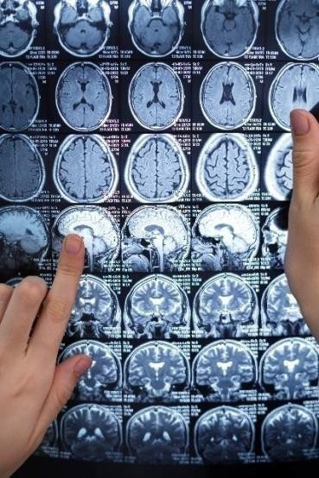
interpretability, speed, and accuracy bridging the gap between traditional radiomics and modern AI-driven medical imaging.

Existing Solutions and Research Gap

Several tools currently exist for brain tissue segmentation and volumetric computation, including FreeSurfer, FSL, SPM, and 3D U-Net–based architectures. While these frameworks have advanced the field of neuroimaging, they often require 3D volumetric data, high-end computational resources, and manual correction by experts. Moreover, their performance can degrade across different MRI scanners and patient demographics due to inconsistencies in acquisition protocols and noise levels.
Recent research in deep-learning–based segmentation (e.g., U-Net, ResNet, and VGG models) has shown impressive accuracy but often sacrifices model interpretability and efficiency. Classical methods such as Fuzzy C-Means (FCM)s clustering, Expectation-Maximization, and Decision Trees offer simpler, explainable results but lack the adaptive learning ability required for heterogeneous MRI data. Thus, there remains a need for a hybrid approach that combines the interpretability of classical ML with the accuracy and learning depth of CNNs.
The proposed research addresses this gap by employing 2D MRI slices from publicly available datasets (Kaggle, TCIA, OASIS) to reconstruct volumetric estimates without requiring full 3D scans. This approach significantly reduces computational complexity while maintaining volumetric accuracy through advanced preprocessing, feature extraction, and hybrid modeling.

Research Scope and Objectives

This project focuses on building a robust, data-driven pipeline for volumetric analysis of brain soft
tissues. The scope includes data collection, image preprocessing, feature extraction, dimensionality reduction, model training, and volumetric computation.
Research Objectives:

To construct a diverse MRI dataset from publicly available repositories (Kaggle, TCIA, OASIS).

To design a MATLAB-based preprocessing pipeline that performs denoising, normalization, skull stripping, and contrast enhancement.

To extract and integrate texture-based, shape-based, and deep CNN features into a hybrid feature matrix.

To apply dimensionality reduction (PCA, t-SNE) for optimized model performance.

To compare Decision Tree, Random Forest, and CNN models for tissue segmentation accuracy.

To compute volumetric ratios of gray matter, white matter, and CSF from reconstructed 2D slices.

To evaluate performance using Dice Similarity Coefficient (DSC), Intersection over Union (IoU), and F1-score metrics.
This structured workflow aims to deliver a computationally efficient and clinically interpretable volumetric analysis system that can be extended to disease-specific segmentation in future research.

Tools and Technologies

The implementation will leverage both MATLAB and Python environments to ensure
compatibility with advanced image processing and ML libraries. MATLAB will handle preprocessing, while Python will be used for training, testing, and evaluating machine-learning models.

Table 1: Tools and Technologies

Category | Technology/Tool | Purpose/Function
Programming Languages | MATLAB, Python | Image preprocessing, feature  extraction, and ML model development
Libraries/Frameworks | TensorFlow, Scikit-  learn, OpenCV | Model training, feature  engineering, and clustering
Datasets | Kaggle Brain MRI,  TCIA, OASIS | Source of 2D MRI brain images
Algorithms | Decision Tree, CNN,  PCA, Fuzzy C-Means (FCM)s | Classification, segmentation,  feature reduction
Evaluation Metrics | Accuracy, Dice Score,  IoU, F1-score | Performance validation
Hardware | GPU-Enabled Machine | Accelerated deep-learning model  training

Project Work Breakdown

Table 2: Project Work Breakdown

Phase | Duration | Focus Area |  | Expected Outcomes
Phase | Months 1– | Literature Review | & | Detailed study of segmentation
1 | 2 | Dataset Collection |  | methods and dataset preparation
Phase 2 | Months 3–  4 | Image Preprocessing ROI Extraction | & | MATLAB-based skull stripping | preprocessing | and
Phase 3 | Months 5–  6 | Feature Extraction & Model Training |  | Generation of feature matrix, training of Decision Tree and CNN models
Phase 4 | Months 7–  8 | Feature Reduction Volumetric Computation | & | PCA/t-SNE for optimization and tissue volume estimation
Phase 5 | Months 9–  10 | Model Evaluation Comparative Analysis | & | Model validation and hybrid accuracy benchmarking
Phase  6 | Months  11–12 | Final Report  Documentation | & | Compilation of results, documentation,  and presentation

Methodology

Overview of Methodology

The proposed research follows a systematic workflow designed to automate the volumetric analysis of brain soft tissue constituents using MRI data. The methodology combines classical image-processing techniques with modern machine-learning and deep-learning approaches to achieve accurate segmentation, clustering, and volumetric computation.
The process begins with the acquisition of publicly available 2D MRI datasets such as Kaggle, TCIA, and OASIS. These datasets provide diverse imaging conditions and subject demographics, ensuring model generalization. The MRI slices are preprocessed in MATLAB to remove noise, normalize intensities, and isolate the brain region. After preprocessing, relevant features are extracted—both hand-crafted (texture and shape-based) and deep features from CNN embeddings. The extracted features are then reduced using Principal Component Analysis (PCA) or t- Distributed Stochastic Neighbor Embedding (t-SNE) to optimize computational efficiency and minimize redundancy.Two models are evaluated for tissue classification: a Decision Tree (for interpretability) and a Convolutional Neural Network (CNN) (for accuracy). The classified outputs are clustered to estimate the volumetric distribution of gray matter, white matter, and cerebrospinal fluid (CSF). Finally, results are validated using statistical metrics such as Dice Similarity Coefficient (DSC), Intersection over Union (IoU), accuracy, and F1-score, followed by

visualization of quantitative results.

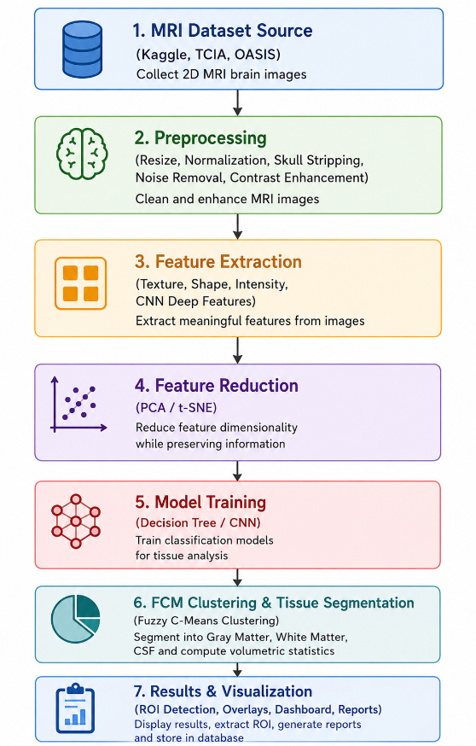
Figure 1: Overview of Methodology

Image Preprocessing

Image preprocessing is a fundamental stage to ensure MRI slices are clean, standardized, and ready for analysis. Variability in scanner settings, patient motion, and noise can distort pixel intensity and affect segmentation accuracy; hence this step enhances data quality.
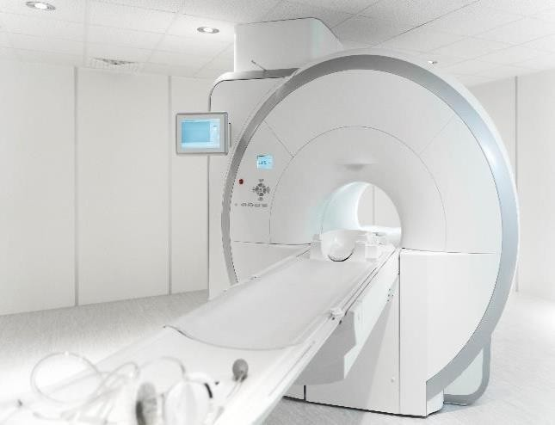
The process begins by importing the MRI data using MATLAB functions (dicomread, niftiread) and converting all images to grayscale. Uniformity in image size is maintained through resizing and cropping, ensuring consistent input dimensions for the models. Noise reduction is applied via Gaussian or median filters to smooth image regions while preserving edges. Next, skull stripping removes non-brain tissue using morphological operations and intensity- based thresholding, retaining only the brain
region of interest (ROI). Histogram equalization enhances contrast, making gray and white matter boundaries clearer, while intensity normalization adjusts pixel ranges for uniform brightness and contrast.
Finally, binary segmentation masks are generated for each slice, isolating meaningful brain regions and preparing data for feature extraction.

Feature Extraction and Reduction

Once the MRI slices are preprocessed, essential image characteristics are extracted to form a

feature matrix that numerically represents tissue structures.

- Texture features:

These describe intensity variations within brain tissues using methods like Gray-Level Co-Occurrence Matrix (GLCM), Local Binary Patterns (LBP), and Haralick features, which capture contrast, correlation, and homogeneity.
- Shape features:

Geometric attributes such as area, eccentricity, and compactness provide information about tissue morphology and spatial distribution.
- Deep CNN features:

Pretrained networks (e.g., MobileNetV2, EfficientNet-B0) are used to extract high-level representations from MRI slices, enabling the system to learn complex patterns automatically.
The resulting hybrid feature set may contain hundreds of variables. Therefore, dimensionality reduction techniques such as PCA and t-SNE are applied to remove redundant or correlated features, preserving only the most informative ones. This step enhances both speed and model interpretability.

Model Training and Classification

The refined feature matrix serves as the input for classification models. Two learning paradigms are compared:
- Decision tree model:
A rule-based algorithm that splits features according to thresholds derived from
information gain or Gini index. It offers transparent decision rules, making the output

interpretable for clinicians.

- Convolutional neural network (CNN):

A multi-layer architecture capable of automatically learning hierarchical spatial features from MRI images. The CNN consists of convolutional layers (for feature detection), pooling layers (for dimensionality reduction), and fully connected layers (for classification). Transfer learning is applied by fine-tuning pretrained networks to adapt to MRI data.
Both models are trained and validated using cross-validation strategies. The Decision Tree serves as a baseline, while the CNN is expected to yield higher segmentation accuracy.

Clustering and Volumetric Estimation

After classification, the segmented tissue regions are clustered based on intensity and spatial proximity. Unsupervised algorithms such as Fuzzy C-Means (FCM)s or DBSCAN group pixels belonging to gray matter, white matter, and CSF. Each cluster’s pixel count is multiplied by voxel dimensions to compute volumetric ratios:
𝑁𝑖

𝑉𝑖 = 𝑁 × 100
𝑡𝑜𝑡𝑎𝑙

where 𝑉𝑖is the percentage volume of tissue i, 𝑁𝑖is the number of pixels in that cluster, and

𝑁𝑡𝑜𝑡𝑎𝑙is the total pixel count.
The final volumetric report expresses the relative percentage of each tissue type, enabling quantitative comparisons across subjects.

Evaluation and Visualization

Model performance is assessed using quantitative metrics:

Accuracy, Precision, Recall, F1-Score measure classification correctness.

Dice Similarity Coefficient (DSC) and Intersection over Union (IoU) evaluate overlap between predicted and ground-truth regions.
Results are visualized through bar charts, confusion matrices, and 2D color-coded tissue maps to depict the volumetric proportions of gray, white, and CSF regions.
These visualizations help verify whether the computed volumetric estimates align with known anatomical expectations.

Chapter 2:
Requirement Specification and Analysis
Requirements analysis is a process of determining user expectations for a new or modified product. These features, called requirements, must be quantifiable, relevant and detailed. In software engineering, such requirements are often called functional specifications. In Chapter 2 we will enlist the functional and non-functional requirements and model functional requirements in the form of use case model.

Functional Requirements

A functional requirement defines a function of a system or its component. Functional requirements may include technical details, data manipulation, processing, and other specific functionalities that define what a system is supposed to accomplish.

Table 3: Functional Requirements

S. Functional Requirement  No |  | Type | Status
1 | Researcher registers and logs into the system | Core | Pending
2 | Researcher uploads MRI images to the system | Core | Pending
3 | System performs automated preprocessing (denoising, skull stripping,  normalization, histogram equalization) | Core | Pending
4 | System extracts texture features (GLCM, LBP) and shape features  (area, eccentricity) from preprocessed images | Core | Pending

5 | System generates deep CNN features using pretrained models  (MobileNetV2 or EfficientNet-B0) | Core | Pending
6 | System applies PCA for dimensionality reduction | Intermediate | Pending
7 | Researcher selects and trains classification model (Decision Tree or  CNN) | Core | Pending
8 | System performs Fuzzy C-Means (FCM)s clustering to differentiate tissue types | Core | Pending
9 | System computes volumetric ratios of gray matter, white matter, and  CSF using voxel scaling | Core | Pending
10 | System evaluates model performance using Dice Score, IoU,  Accuracy, and F1-Score | Intermediate | Pending
11 | System generates volumetric analysis report with tissue percentages  and visualizations | Core | Pending
12 | Researcher views and exports segmentation results and trained  models | Intermediate | Pending
13 | System provides password recovery functionality | Intermediate | Pending
14 | User logs out from the system | Core | Pending

Non-Functional Requirements
A non-functional requirement specifies the criteria used to judge the operation of a system rather than specific behaviors. They are contrasted with functional requirements that define specific actions or processes.

Table 4: Non-Functional Requirements

S. No. | Non-Functional Requirements | Category
1 | The user interface should be intuitive and easy to use for medical  researchers | Usability
2 | The system should provide feedback during image upload and processing | Performance
3 | Preprocessing should complete within 5 minutes for standard MRI datasets | Performance
4 | The system must support secure login with encrypted passwords | Security
5 | All uploaded MRI data must be de-identified and stored securely | Security
6 | The system should process and preprocess images with high accuracy | Reliability
7 | Model training should complete within 2-4 hours on standard hardware | Performance
8 | Trained models should achieve at least 85% Dice Similarity Coefficient | Reliability
9 | The system should handle at least 10-20 concurrent users | Scalability
10 | Database operations should execute within 3 seconds | Performance
11 | The system should maintain detailed logs for reproducibility | Maintainability
12 | The system architecture should be modular for easy updates | Maintainability
13 | Data should be backed up regularly to prevent loss | Security
14 | The system should work on Windows and Linux platforms | Portability

Selected Functional Requirements

The following list contains the functional requirements selected for the current development iteration of the brain volumetric analysis system.

Table 5: Selected Functional Requirements

S. No | Functional Requirements | Type
1 | Researcher registers and logs into the system | New
2 | Researcher uploads MRI images to the system | New
3 | System performs automated preprocessing pipeline | New

System Use Case Modeling

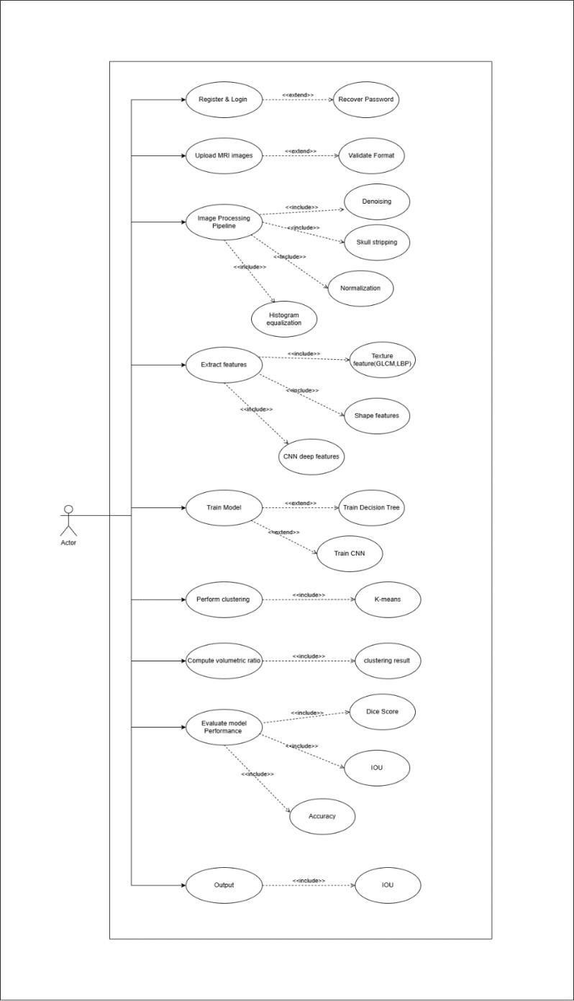

Figure 2: Use Case Diagram

Table 6: Register & Login

Use Case ID: | UC 1
Use Case Name: | Register & Login
Created By: | Hadia Khan | Last Updated By: |  | Daniyal  Ahmed
Date Created: | 11/19/2025 | Last Revision Date |  | 11/9/2025
Actors: | User (Researcher / System Operator)
Description: | This use case allows a user to register a new account and log into the  system. Logging in enables access to dataset uploading, processing, model training, and evaluation modules.
Trigger: | User wants to access the system.
Precondition | - System is running.  - User has a valid account (for login).  - Internet or local access to system UI.
Postcondition: | - User is authenticated and can access the dashboard.
Normal Flow: | Actor |  | System
 | Opens login/registration page
 | Enters credentials |  | Validates inputs  Checks database for credentials

Grants access
Redirects to dashboard
Alternative Flows: | - A1: Invalid credentials → System prompts retry.  - A2: New user selects Register → enters details → Account created.
Exceptions: | - E1: Database connection failure.  - E2: Missing required input fields.

Table 7: Recover Password

Use Case ID: | UC 2
Use Case Name: | Recover Password
Created By: | Daniyal  Ahmed | Last Updated By: | Raja Hasan
Date Created: | 11/9/2025 | Last Revision Date | 11/9/2025
Actors: | User (Researcher / System Operator)
Description: | Allows users to recover their account credentials in case they forget  their password..
Trigger: | User clicks “Forgot Password.”

Precondition | - User already has an account.
Postcondition: | - Password reset link sent OR temporary password generated.
Normal Flow: | Actor | System
 | 1. Requests password recovery | 2. Asks for email
 | 3. Provides email | 4. Validates email and sends  reset link
Alternative Flows: | - A1: User enters wrong email → System shows “email not found.”
Exceptions: | - E1: Email server not reachable.

Table 8: Upload MRI Images

Use Case ID: | UC 3
Use Case Name: | Upload MRI Images
Created By: | Hadia Khan | Last Updated By: | Raja hasan
Date Created: | 11/9/2025 | Last Revision Date | 11/9/2025
Actors: | User
Description: | User uploads MRI slices for preprocessing, feature extraction, and  volumetric analysis.
Trigger: | User selects “Upload Dataset.”

Precondition | - User logged in.  - Dataset available on local system.
Postcondition: | - Images stored and validated.
Normal Flow: | Actor | System
 | 1. Selects MRI images
- Checks file format
- Stores dataset

- Displays upload success
Alternative Flows: | - A1: Multiple images uploaded together.  - A2: Partial upload failure.
Exceptions: | - E1: Invalid file format.  - E2: Corrupted files.

Table 9: Validate Format

Use Case ID: | UC 4
Use Case Name: | Validate Format
Created By: | Hadia Khan | Last Updated By: |  | Raja Hasan
Date Created: | 11/9/2025 | Last Revision Date |  | 11/9/2025
Actors: | System
Description: | Confirms whether uploaded images follow required format (NIfTI,  DICOM, PNG, etc.)
Trigger: | File upload event.
Precondition | - File selected.
Postcondition: | - File accepted OR rejected.
Normal Flow: | Actor |  | System
System automatically reads
metadata, checks headers, and

 |  | validates MRI slice dimensions.
Alternative Flows: | - A1: User chooses to convert file to supported format.
Exceptions: | - E1: Unsupported format detected.

Table 10: Image Processing Pipeline

Use Case ID: | UC 5
Use Case Name: | Image Processing Pipeline
Created By: | Daniyal  Ahmed | Last Updated By: |  | Raja Hasan
Date Created: | 11/9/2025 | Last Revision Date |  | 11/9/2025
Actors: | System (auto-process), User (initiates)
Description: | Executes preprocessing steps: denoising, skull stripping, histogram  equalization, and normalization.
Trigger: | User clicks “Process Images.”
Precondition | - MRI images uploaded.
Postcondition: | - Cleaned images stored and passed to feature extraction.
Normal Flow: | Actor |  | System
 | 1. Starts preprocessing |  | 2. Denoises image

- Performs skull stripping
- Applies histogram equlization

- Norrmalizes intensities
- Saves processed results
Alternative Flows: | - A1: User selects only specific preprocessing steps.
Exceptions: | - E1: Skull stripping fails on low-contrast image.  - E2: Processing pipeline crash.

Table 11: Extract Features

Use Case ID: | UC 6
Use Case Name: | Extract Features
Created By: | Hadia Khan | Last Updated By: | Daniyal  Ahmed
Date Created: | 11/9/2025 | Last Revision Date | 11/9/2025
Actors: | User, System
Description: | Extracts handcrafted (GLCM, LBP, shape) and deep features (CNN  embeddings).
Trigger: | User selects “Extract Features.”

Precondition | - Preprocessed images available.
Postcondition: | - Feature matrix is generated.
Normal Flow: | Actor | System
 | 1. Requests feature extraction | 2. Computes texture features  (GLCM, LBP)
- Computes shape features

- Extracts CNN deep features
- Stores hybrid feature matrix
Alternative Flows: | - A1: User selects “Only CNN features.”  - A2: User selects “Only handcrafted features.”
Exceptions: | - E1: CNN model weights missing.  - E2: Low RAM causes extraction failure.

Table 12: Train Model

Use Case ID: | UC 7
Use Case Name: | Train Model

Created By: | Raja Hasan | Last Updated By: |  | Daniyal  Ahmed
Date Created: | 11/9/2025 | Last Revision Date |  | 11/9/2025
Actors: | User, System
Description: | Train either a Decision Tree model or CNN using the extracted  features.
Trigger: | User selects “Train Model.”
Precondition | - Feature matrix exists.
Postcondition: | - Model is trained and saved.
Normal Flow: | Actor |  | System
 | 1. Selects model type |  | 2. Loads dataset
- Performs training
- Validates model
- Saves model
Alternative Flows: | - A1: User selects both models for comparison.
Exceptions: | - E1: GPU unavailable for CNN training.  - E2: Insufficient training samples.

Table 13: Perform Clustering

Use Case ID: | UC 8
Use Case Name: | Perform Clustering
Created By: | Daniyal  Ahmed | Last Updated By: |  | Hadia Khan
Date Created: | 11/9/2025 | Last Revision Date |  | 11/9/2025
Actors: | System
Description: | Applies Fuzzy C-Means (FCM)s to group pixels into gray matter, white matter, and  CSF.
Trigger: | Model output needs grouping.
Precondition | - Model output or segmentation mask available.
Postcondition: | - Cluster labels stored.
Normal Flow: | Actor |  | System
System runs clustering → assigns tissue labels → generates
segmentation output
Alternative Flows: | - A1: User selects DBSCAN instead of Fuzzy C-Means (FCM)s.
Exceptions: | - E1: Poor intensity contrast → inaccurate clustering.

Table 14: Compute Volumetric Ratio

Use Case ID: | UC 9
Use Case Name: | Compute Volumetric Ratio
Created By: | Raja hasan | Last Updated By: |  | Daniyal  Ahmed
Date Created: | 11/9/2025 | Last Revision Date |  | 11/9/2025
Actors: | System
Description: | Computes volumetric ratio using cluster pixel counts and voxel  scaling.
Trigger: | Clustering finishes.
Precondition | - Clustering complete.
Postcondition: | - Percentage volumes for GM/WM/CSF generated.
Normal Flow: | Actor |  | System
System counts pixels → applies volume formula → stores
quantitative results.
Alternative Flows:

Exceptions: | - E1: Missing slice metadata.

Table 15: Evaluate Model Performance

Use Case ID: | UC 10
Use Case Name: | Evaluate Model Performance
Created By: | Hadia Khan | Last Updated By: |  | Raja Hasan
Date Created: | 11/9/2025 | Last Revision Date |  | 11/9/2025
Actors: | User, System
Description: | Computes DSC, IoU, Accuracy, F1.
Trigger: | User selects “Evaluate Model.”
Precondition | - Predictions + ground truth available.
Postcondition: | - Evaluation scores saved and visualized.
Normal Flow: | Actor |  | System
System loads predicted masks → compares with ground truth →
generates scores → shows graphs.

Alternative Flows: | - A1: User selects custom metric set.
Exceptions: | - E1: Ground truth missing or mismatched.

Table 16: Output Results

Use Case ID: | UC 11
Use Case Name: | Output Results
Created By: | Raja Hasan | Last Updated By: |  | Daniyal  Ahmed
Date Created: | 11/9/2025 | Last Revision Date |  | 11/9/2025
Actors: | User, System
Description: | Displays volumetric ratios, segmentation overlays, evaluation metrics.
Trigger: | Evaluation finished.
Precondition | - Evaluation complete.
Postcondition: | - Final outputs shown in dashboard.
Normal Flow: | Actor |  | System
System displays graphs, numeric

values, and segmentation maps.

Alternative Flows:
Exceptions: | - E1: Visualization component fails.

System Sequence diagram

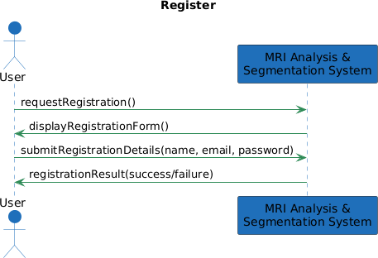
Figure 3: SSD(Register)

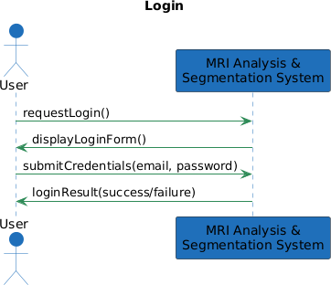
Figure 4: SSD(Login)

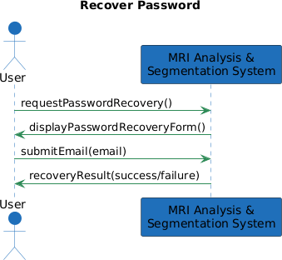
Figure 5: SSD (Recover Password)

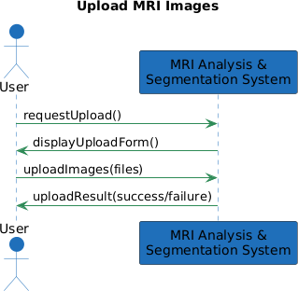
Figure 6: SSD (Upload MRI Images)

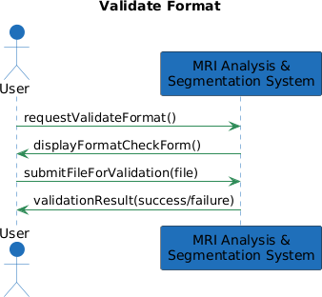
Figure 7: SSD (Validate Form)

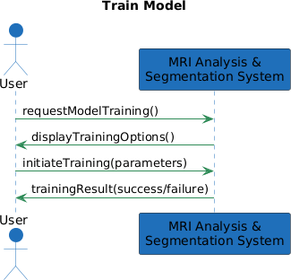
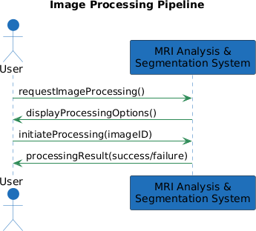
Figure 8: SSD (Image Processing Pipeline)

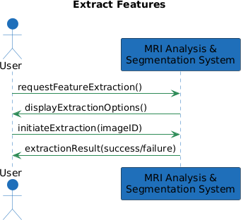
Figure 9: SSD (Extract Features)

Figure 10: Train Model
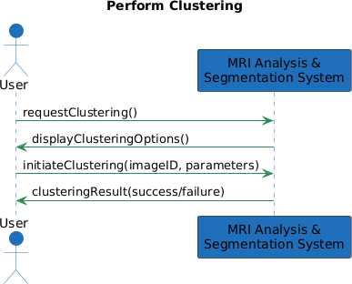
Figure 11: Perform Clustering

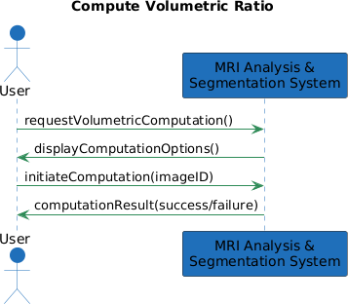

Figure 12: SSD (Compute Volumetric Ratio)

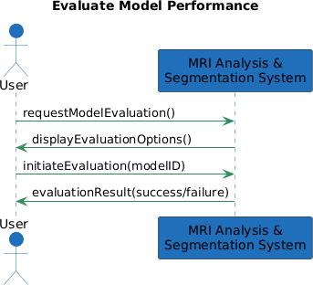
Figure 14: SSD (Evaluate Model Performance

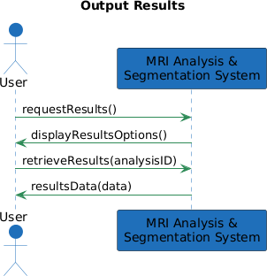
Figure 13: SSD (Output Results)

Domain Model

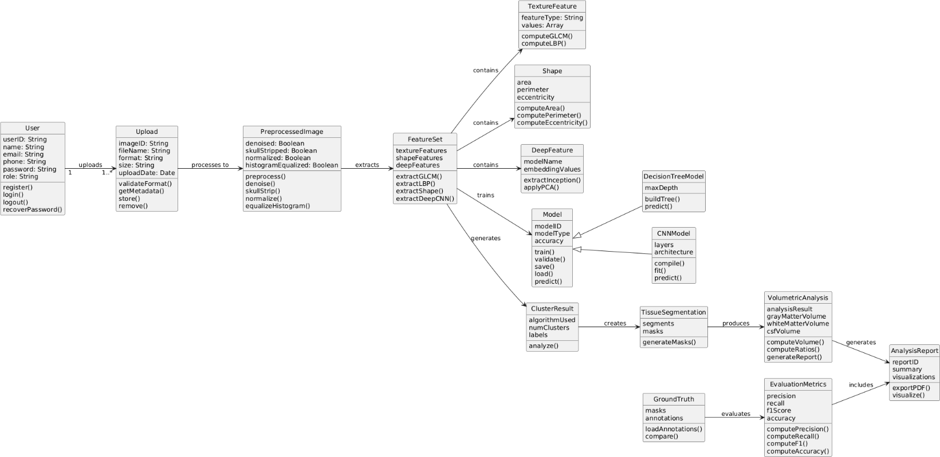
Figure 15: Domain Model

Chapter-3 :System Design

The proposed system follows a structured end-to-end pipeline that converts raw MRI slices into meaningful volumetric information about brain tissues. The process begins with image preprocessing, where the MRI data is cleaned through denoising, skull stripping, histogram equalization, and intensity normalization to ensure consistency across all slices. After preprocessing, the system performs segmentation and tissue isolation to remove irrelevant background and focus solely on the brain region. From the segmented images, multiple types of features are extracted, including texture descriptors, shape characteristics, and deep features obtained through pretrained CNN models. These features are further optimized using dimensionality reduction techniques such as PCA to remove noise and redundancy. The refined feature set is then passed to machine-learning and deep-learning classifiers—such as Decision Trees or CNNs—to categorize different brain tissue types. Once tissue labels are assigned, unsupervised clustering and voxel-based calculations are used to compute volumetric ratios of gray matter, white matter, and cerebrospinal fluid. Finally, the system generates visualizations, reports, and comparative metrics that provide a clear interpretation of segmentation accuracy and tissue volume distribution.

Layer Definition

Table 17: Layers Definition

Layers | Description
Presentation Layer | This layer provides the user-facing interface, including dashboards for hospital admins and doctors. It enables doctor registration, MRI image uploads, viewing analysis results, and downloading reports through a web-based UI.
Layers | Description

Business Logic Layer | This layer handles the system’s core operations, including doctor registration, MRI processing, feature extraction, PCA, model prediction, and volume calculation. It also manages validation, access control, and coordination between the interface and the database.
Database Layer | This layer stores all persistent data, including hospital and doctor accounts, uploaded MRI images, preprocessing outputs, extracted features, PCA components, and generated reports. It also maintains entity relationships and supports fast data retrieval for dashboards and analysis history.

Presentation Layer
The Presentation Layer serves as the primary interaction point between the researcher and the system. It provides an intuitive user interface that allows users to register, log in, upload MRI slices, and monitor the preprocessing and segmentation workflow. This layer also displays visual outputs such as tissue maps, volumetric ratios, performance metrics, and downloadable reports. Its main purpose is to ensure a smooth and accessible experience while effectively presenting complex analytical results.

Application / Business Logic Layer
The Application or Business Logic Layer is responsible for executing the core computational workflow of the system. It handles all major processing tasks, including MRI preprocessing, feature extraction, dimensionality reduction through PCA, and the application of clustering algorithms. This layer also manages the training and execution of machine-learning and deep-learning models such as Decision Trees and CNNs to classify tissue regions. Finally, it computes volumetric estimates of gray matter, white matter, and CSF, ensuring accurate and

reliable analytical results.

Data Layer
The Data Layer is responsible for managing all data-related operations within the system, ensuring reliable storage and retrieval of information. It maintains the MRI datasets, associated metadata, preprocessing outputs, extracted feature matrices, and trained machine-learning models. This layer also stores volumetric results, evaluation metrics, and system logs, providing a structured and secure repository for all analytical components. Its primary role is to support efficient data access and ensure the integrity of the system’s computational workflow.

Software Architecture
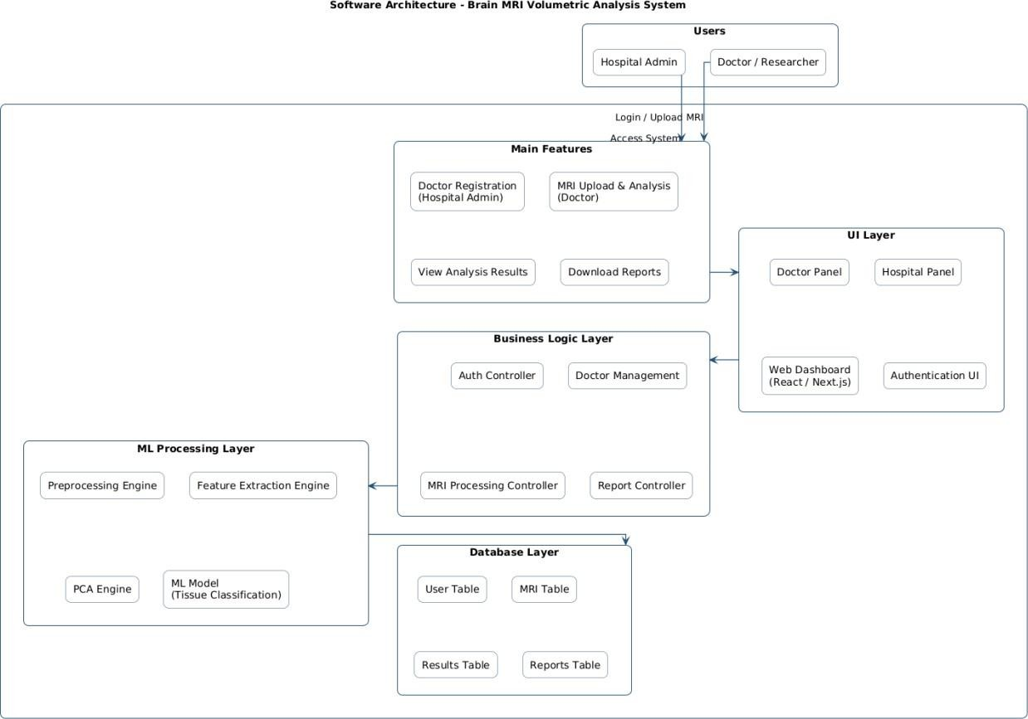
Figure 3.1 : Software Architecture Diagram

Class Diagram

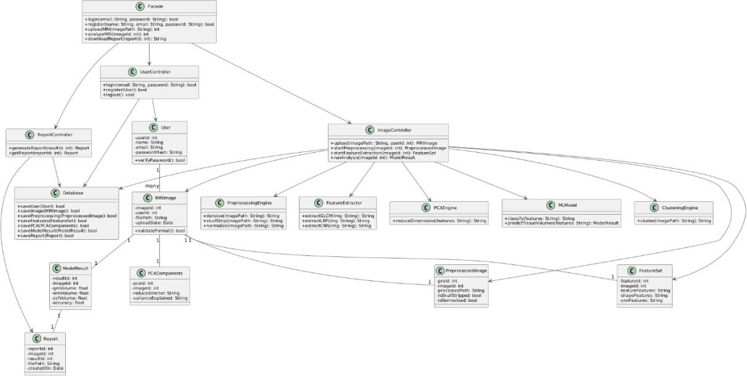
Figure 3.2: UML Class Diagram

- Facade

Provides a simplified interface for login, signup, and image upload operations. Coordinates interactions between controllers and core processing components.
- UserController

Handles user-related operations such as login and registration requests. Validates user credentials and communicates with the Database class.
- User

Represents a doctor or system user with basic account details. Provides functions to verify and update user passwords.
- Image controller:

Manages MRI upload requests and triggers preprocessing, feature extraction, PCA, and model prediction. Acts as the main coordinator for running the complete analysis pipeline.
- Report controller:

Generates reports after analysis is completed and retrieves stored reports from the database. Provides access to downloadable volumetric and segmentation summaries.
- Database:

Stores and retrieves users, MRI images, preprocessing results, feature sets, PCA outputs, and model results. Ensures persistent data handling for the entire system.
- MRI image:

Represents an uploaded MRI image with associated metadata. Stores preprocessing status and volumetric computation details.
- Preprocessing engine:

Handles denoising, skull stripping, intensity normalization, and contrast enhancement. Outputs a cleaned and standardized image for further processing.
- Preprocessed image:

Stores intermediate results after preprocessing, including denoised and normalized images. Acts as input for feature extraction and PCA.

- Feature extractor:

Extracts radiomic (GLCM/LBP), shape-based, and CNN deep features from MRI images. Generates a structured feature set for classification.
- Feature set:

Represents the collected features for a given MRI image. Stores texture, shape, and CNN-derived features in unified form.
- PCA engine:

Applies dimensionality reduction on extracted features. Generates PCA components that improve model efficiency.
- PCA components:

Stores principal components, explained variance, and reduced feature vectors. Used as input for classification models.
- ML model:

Executes classification using Decision Tree or CNN models. Predicts tissue categories and produces final model results.
- Model result:

Contains predicted tissue labels, accuracy, Dice score, and IoU results. Represents the evaluation outcome for a single MRI analysis.
- Clustering engine:

Performs unsupervised clustering (e.g., Fuzzy C-Means (FCM)s) to group tissue regions. Supports the volumetric estimation based on pixel clusters.
- Report:

Stores the final volumetric report, including percentages and performance metrics. Provides formatted results ready for export or visualization.

Sequence Diagram
Sequence Diagram model the flow of logic within your system in a visual manner enabling you both to document and validate your logic, and are commonly used for both analysis and design purposes.

Researcher Registration

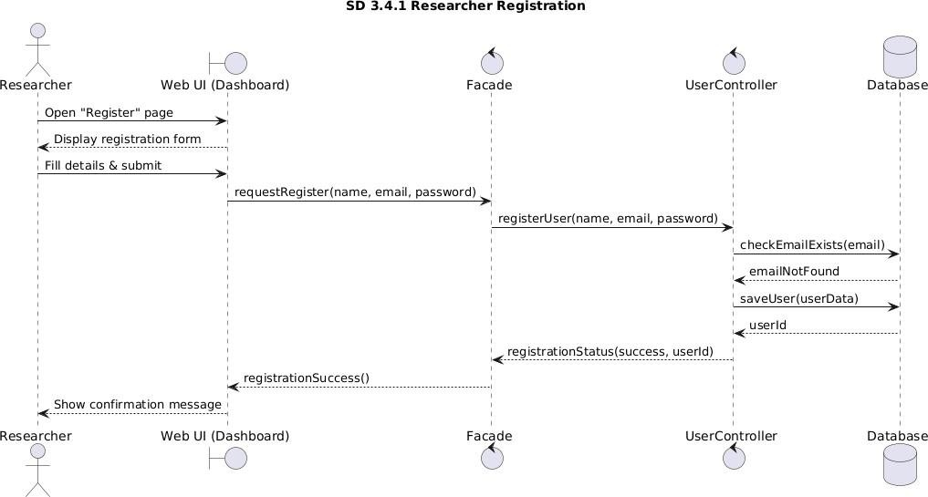
Figure 3.3: Researcher Registeration

Researcher Login

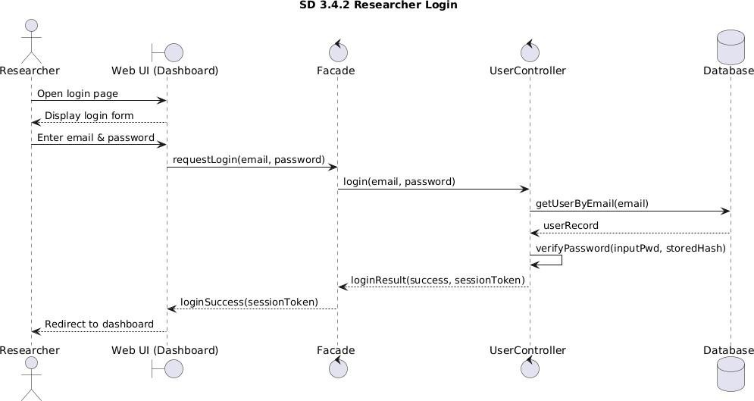
Figure 3.4: Researcher Login

(A) Upload MRI Image & Start Preprocessing

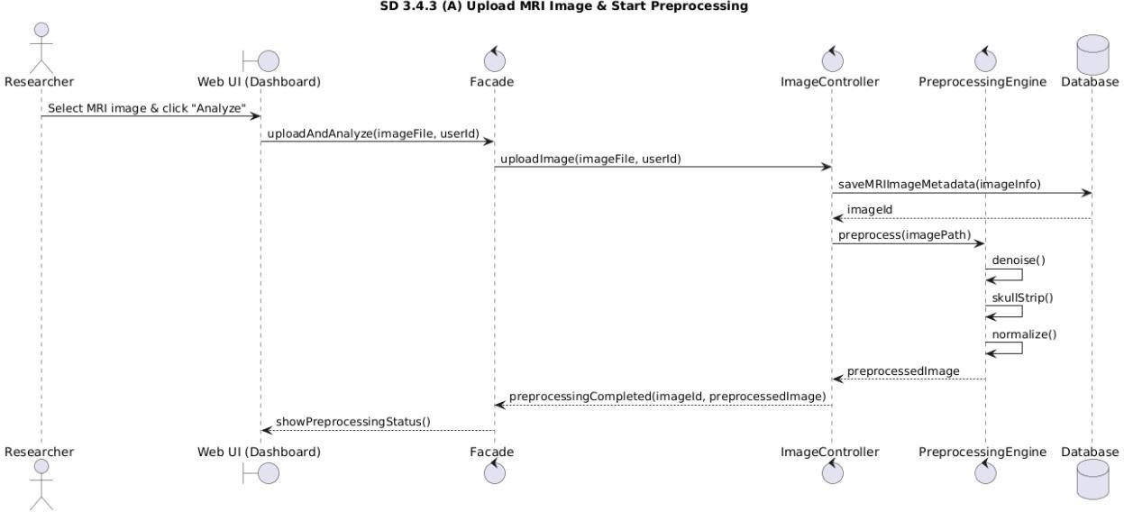
Figure 3.5: Upload MRI Image And Start Processing

(B) Feature Extraction, PCA, Classification & Volumetric Analysis
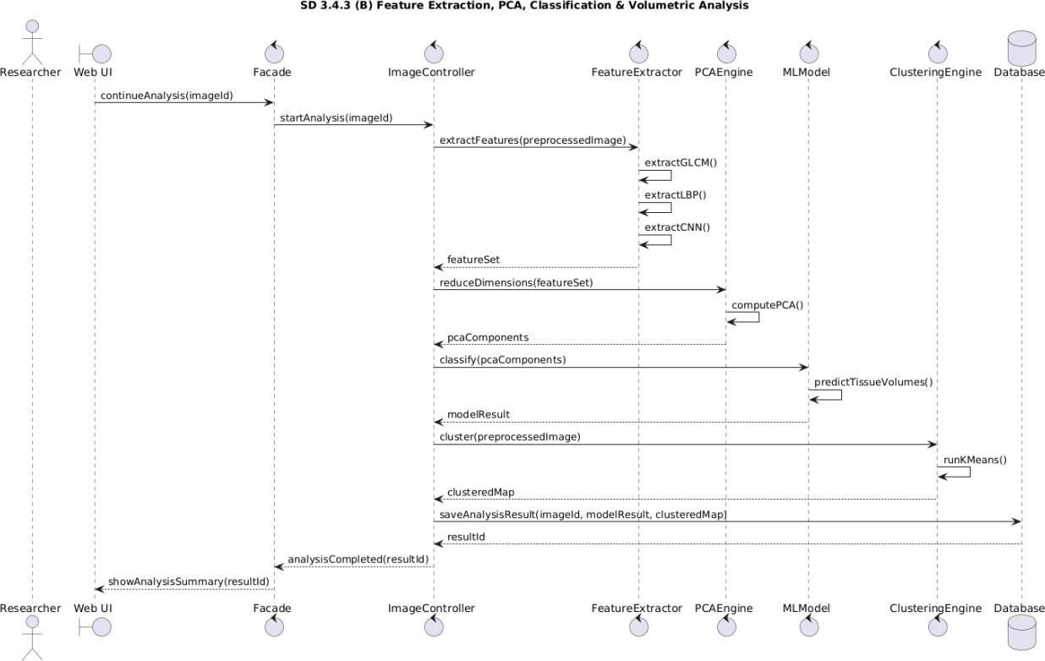
Figure 3.6: Feature Extraction , PCA, Classification & Volumetric Analysis

View & Download Volumetric Report

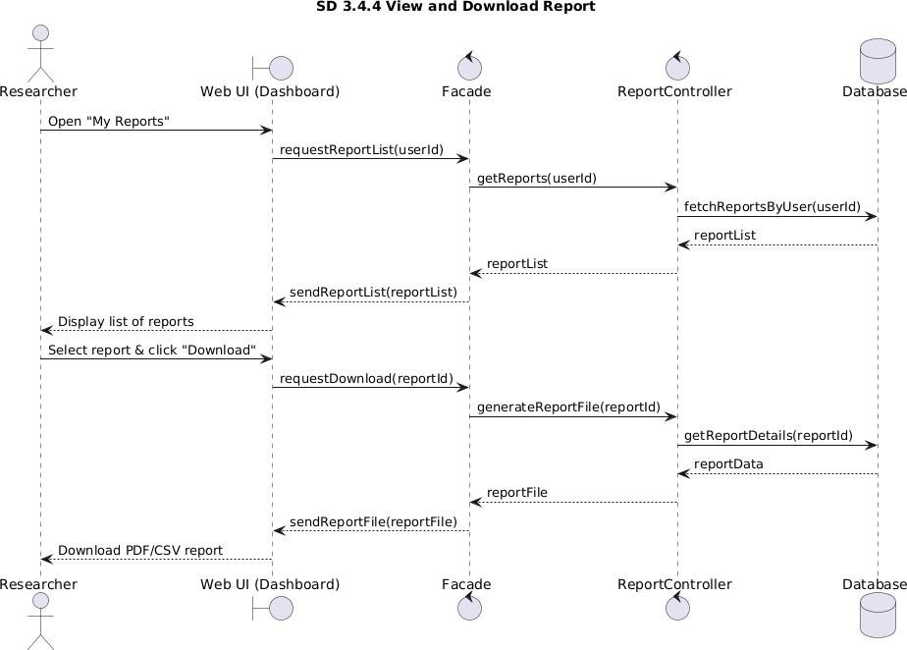
Figure 3.7:View & Download Report

Entity Relationship Diagram

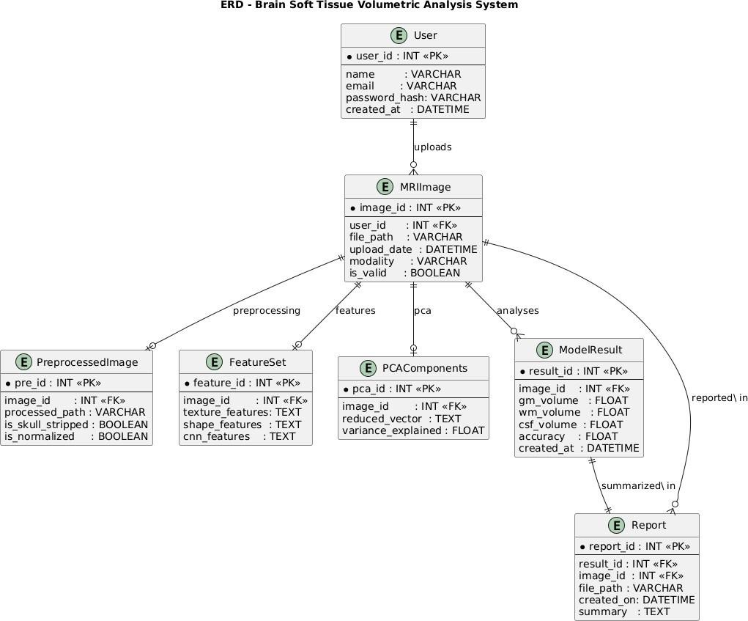
Figure 3.8: ERD Brain Soft Tissue Volumetric Analysis System

Database Schema
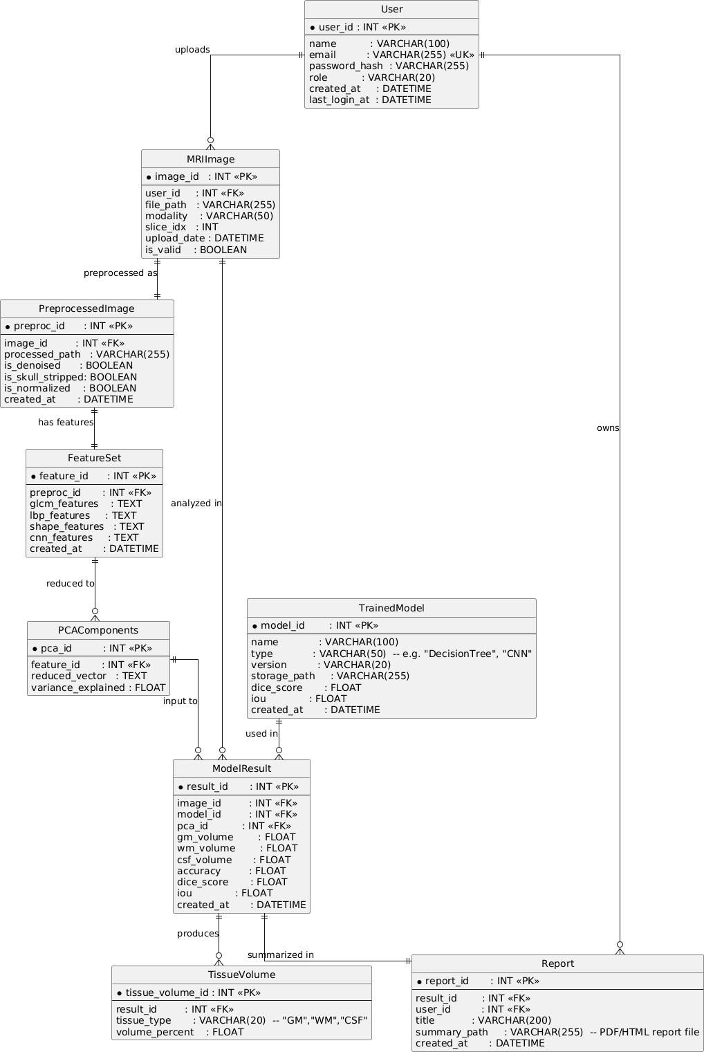
Figure 3.9: Database Schema for Brain Soft Tissue Volumetric Analysis

User Interface Design
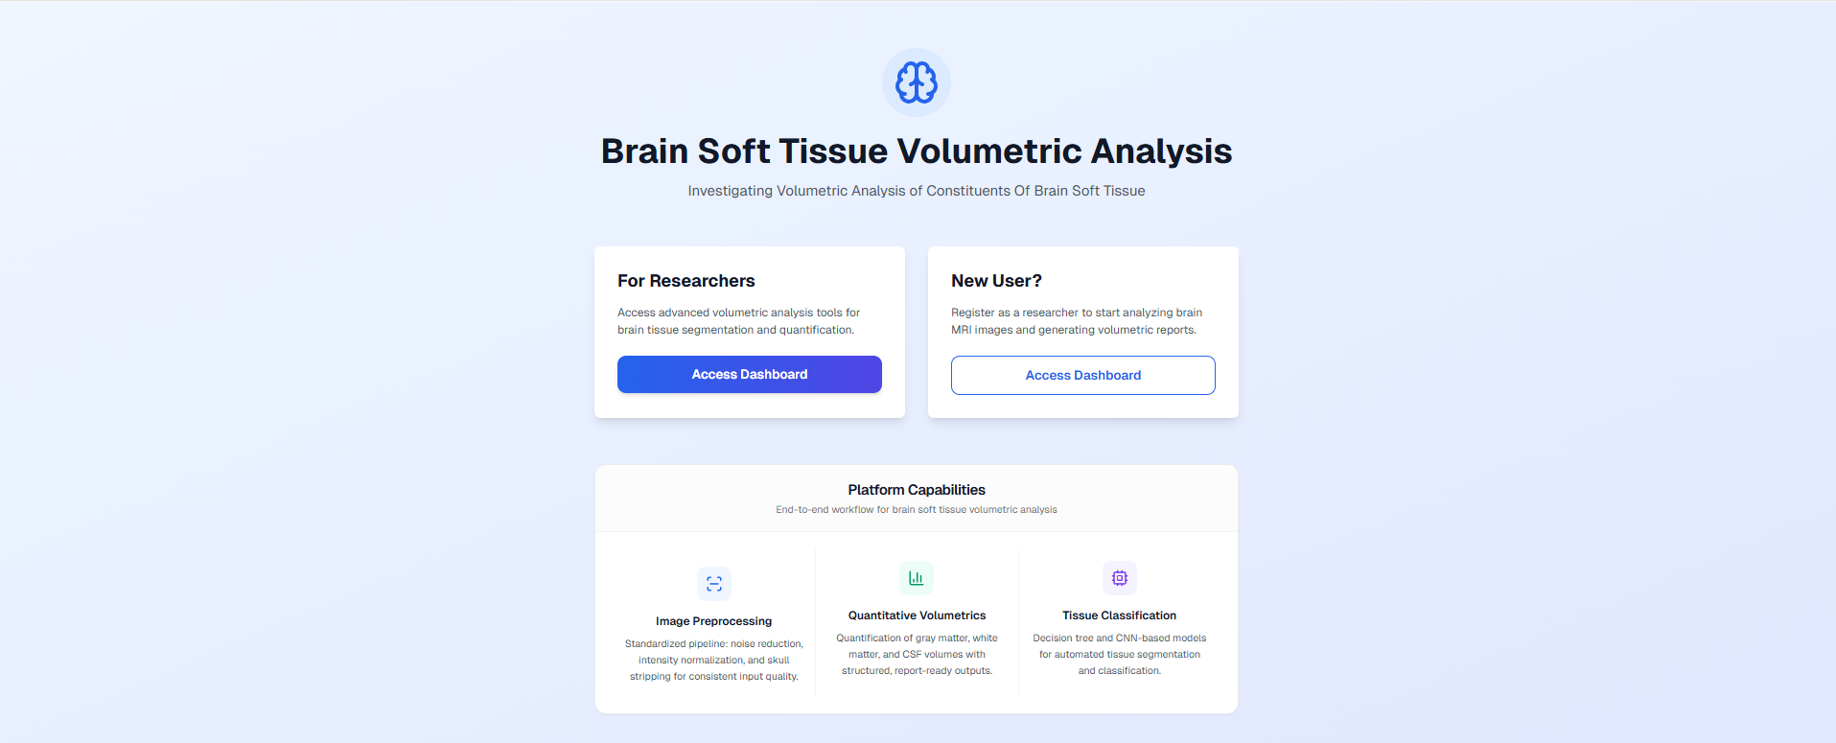

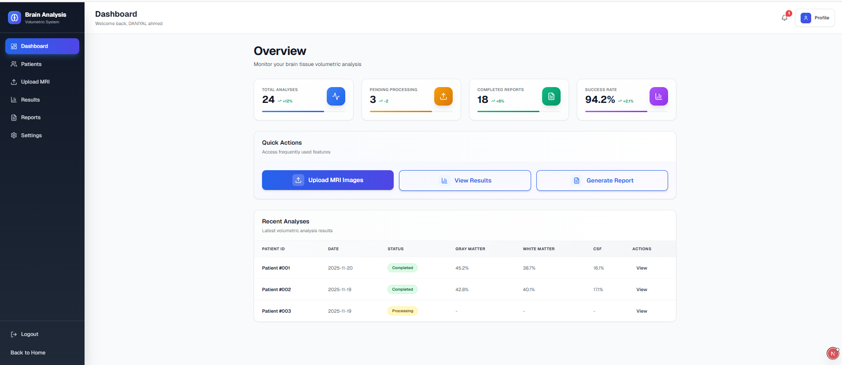

Chapter 4:Implementation Issues

Coding Standards

The Brain Soft Tissue Volumetric Analysis System was developed using a consistent set of coding standards across the frontend and backend. These standards were followed to keep the codebase readable, maintainable, and aligned with common industry practice.

Indentation

The project used spaces for indentation rather than tabs. “The backend (Python) used 4 spaces per indentation level. The frontend (Next.js/TypeScript) used 2 spaces per indentation level, following common JavaScript and TypeScript practice.”. Nested blocks were indented by one extra level. This made control flow and block structure easy to see and reduced inconsistencies when working across different editors and platforms.

Declaration

Variables and functions were declared explicitly. In the backend, type hints were used where appropriate for function parameters and return values to clarify expectations and improve maintainability. In the frontend, TypeScript was used so that key data structures and API responses were typed. Constants were declared where values were reused and not meant to change, and mutable state was kept to a minimum to avoid unintended side effects.

Statement Standards

Statements were generally kept to a single line where possible. Long expressions were split across multiple lines with clear indentation. Conditional and loop bodies were always placed in dedicated blocks rather than on the same line as the condition. Early returns were used to handle error cases and invalid inputs before the main logic, which helped keep functions shorter and easier to follow. Comments were used to clarify non-obvious logic rather than to restate the code.

Naming Conventions

Descriptive names were used for variables, functions, and files. In the backend, functions and variables followed snake_case (e.g. perform_skull_stripping, denoise_method). Class names used PascalCase (e.g. PreprocessingPipeline). In the frontend, camelCase was used for variables and functions (e.g. processedImage, denoiseMethod), and PascalCase for React components and types. File names reflected their purpose: preprocessing logic lived under preprocessing, utilities under utils, and API routes under app/api. This made it easier to locate and understand each part of the system.

Development Enviroment

The development of the Brain Soft Tissue Volumetric Analysis System was carried out using a modern and flexible development environment. The system was developed on a Windows-based operating system using Visual Studio Code (VS Code) as the primary integrated development environment.

Visual Studio Code was selected due to its lightweight architecture, fast performance, and extensive support for modern web and backend technologies. It provides built-in support for JavaScript, Python, and JSON files, which were extensively used in the project. Its extension ecosystem allowed seamless integration of debugging tools, code formatting utilities, and version control support.

The frontend of the system was developed using React and Next.js within VS Code, enabling efficient component-based user interface development. For backend processing, Python scripts were written to perform MRI image preprocessing tasks such as resizing, normalization, noise reduction, and skull stripping.

The development environment also supported terminal integration, allowing the execution of backend scripts and dependency management directly within the editor. This setup improved productivity and reduced development time by enabling real-time testing and debugging.

Overall, the selected development environment provided flexibility, maintainability, and scalability, making it suitable for implementing a research-oriented medical imaging system.

Database Management System

The Brain Soft Tissue Volumetric Analysis System used a structured data management approach to store and manage system-related information. MongoDB was used as the database, with Mongoose as the object-document mapping library. The database stored user account details, such as firstname,lastname, username, email, contact number,PMDC and specialization, as well as patient records, including patient identifier, demographic information, medical history, and notes. Each patient record was linked to the user who created it via an uploadedBy reference, so that data could be associated with the corresponding researcher or clinician account.
Because of the research-oriented nature of the system, MRI image files were not stored in the database. Images were sent to the backend for preprocessing and were either processed in memory or saved temporarily on the server. Processed images were written to a processed/ directory on disk. Preprocessing results, such as processed image data and processing steps, were returned to the frontend through the API and displayed in the user interface but were not persisted in the database. Only user and patient information were stored in MongoDB. This approach kept storage requirements low and avoided storing large image data in the database.
The system supported insertion and retrieval of user and patient data. User registration and login, as well as patient registration and listing, were implemented through API routes that performed these operations. Deletion of records was not implemented in the current version.
Security was considered in the database design. User passwords were hashed using bcrypt before storage, rather than stored in plain text. Access to sensitive functionality, such as creating patients and uploading images, was limited to authenticated users. The frontend used the logged-in user’s identity when creating patient records and when using the upload workflow. This helped protect the confidentiality of user and patient data and reduced the risk of unauthorized access.
Overall, the database management system provided structured storage for users and patients, kept user–patient associations clear, and supported the current workflow. The design allowed for future extension, such as storing classification or volumetric analysis results, if those features were added later.

Software Description

The Brain Soft Tissue Volumetric Analysis System was implemented as a web-based application consisting of a frontend and a backend. The frontend allowed users to register, log in, manage patients, and upload MRI images for preprocessing. The backend received uploaded images, applied a fixed sequence of preprocessing steps, and returned the results. The following subsections describe the software modules that handled image upload, preprocessing, and visualization of the preprocessed output.

User Authentication Module

Input:
- User registration details (firstname ,lastname, username, email, password, specialization)
- Login credentials (email/username and password)




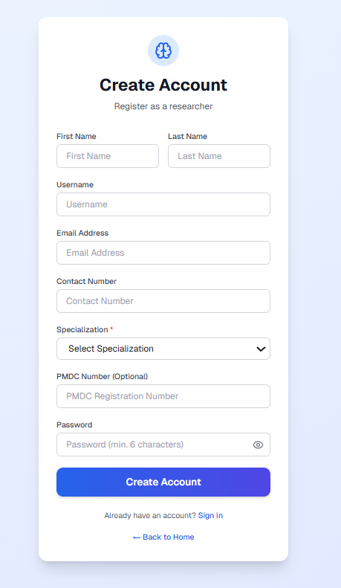
OUPUT

- Successful login and redirection to dashboard

- Error message on invalid credentials

- User session created on successful authentication

Dashboard Interface
Input:
- Authenticated user session

- User navigation actions (menu selection, quick links)
Output:
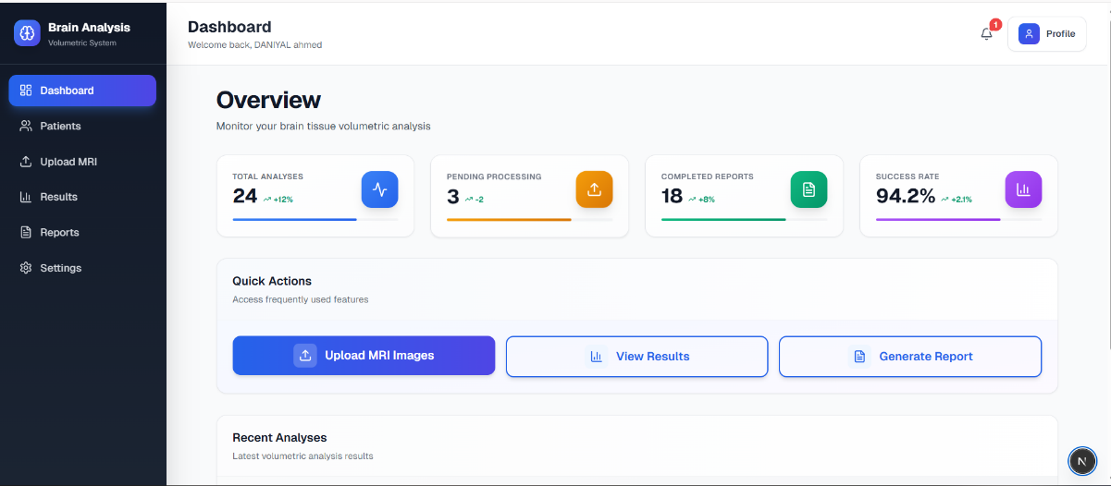

- Dashboard layout displayed with sidebar and header

- Access to patients, upload, results, reports, and settings modules

MRI Image Upload Module
Input:
- Selected or newly created patient

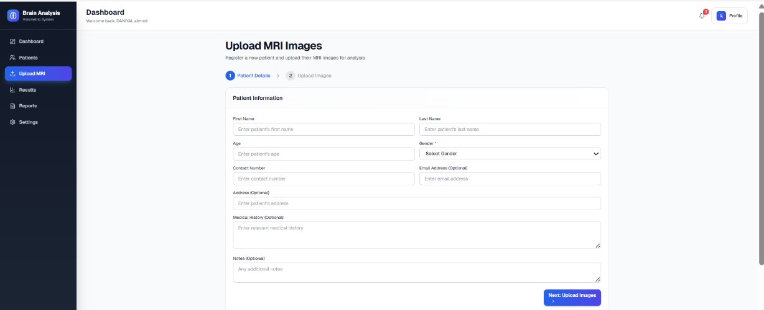
- MRI image files (JPG, PNG, DICOM, NIfTI)

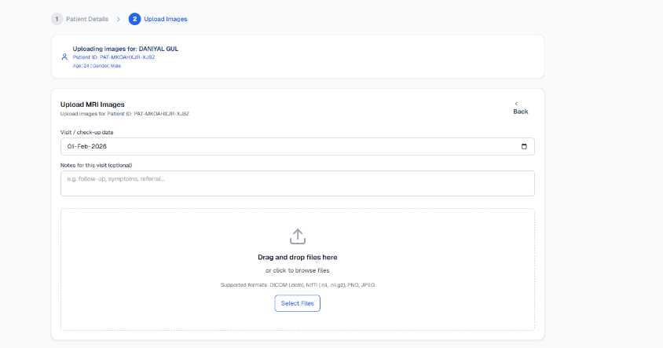
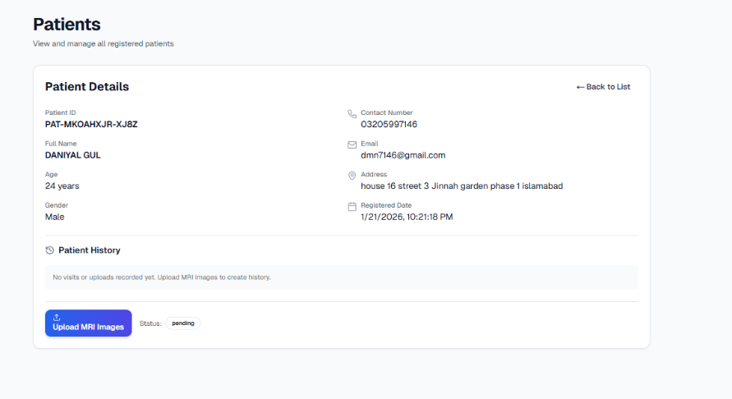
Output:

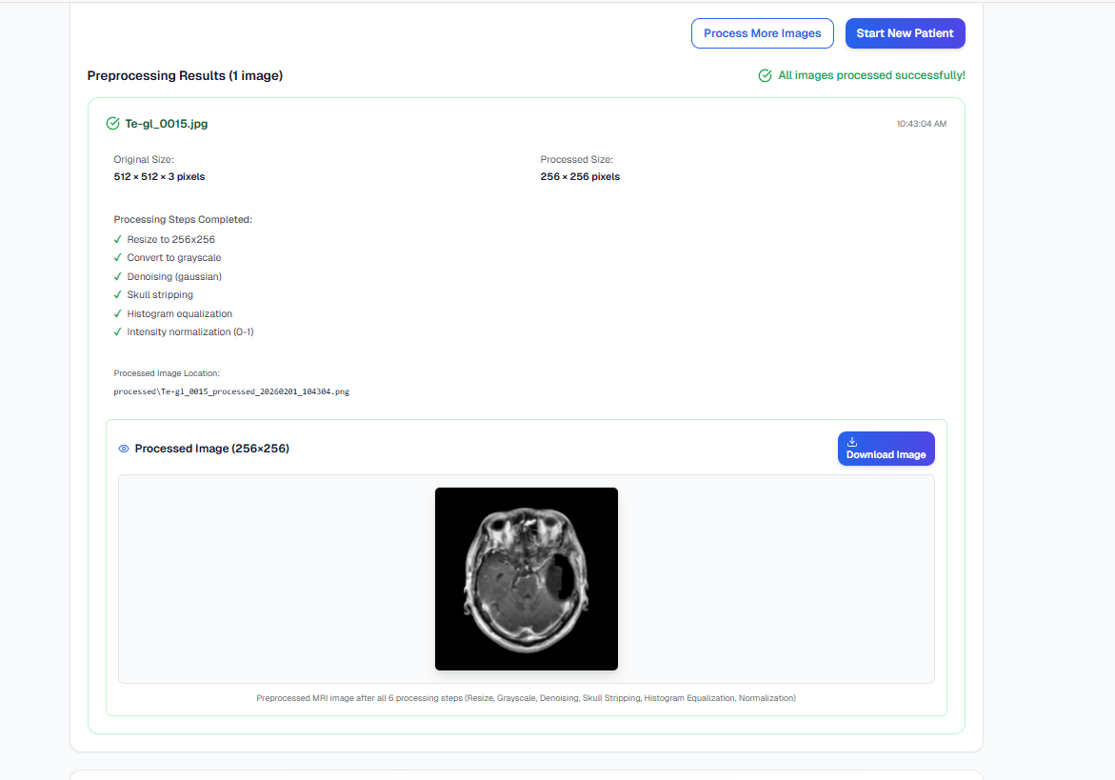

- Upload and processing status displayed

- Preprocessed image and related metadata shown

- Error message on invalid file or upload failure

Image Preprocessing Module
Input:
- Uploaded MRI image data

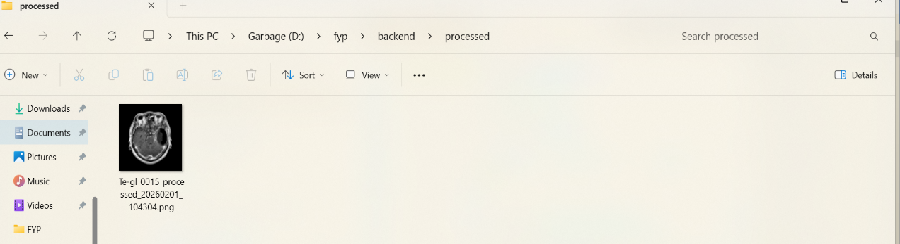
Output: 

- Preprocessed MRI image (resized, denoised, normalized, skull-stripped)
- Processing metadata returned to frontend
- Image stored in server directory

Output Visualization Module
Input:
- Preprocessed image data
- Processing metadata (steps applied, dimensions)
Output:
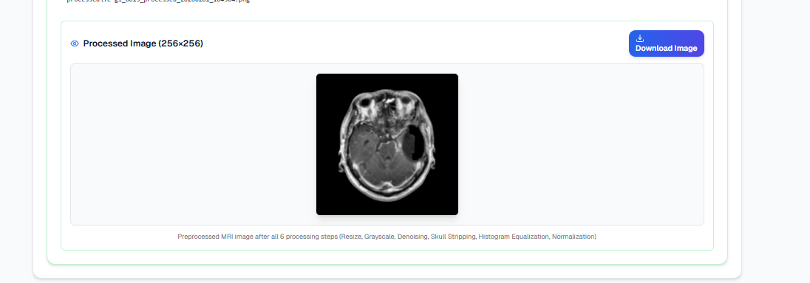

- Display of preprocessed MRI image
- Visualization of applied preprocessing steps
- Option to view or download processed image

Chapter 5:Software Testing

Testing Methodology

Software testing was performed to ensure that the implemented system functions correctly and consistently produces reliable outputs under different operating conditions. As the project primarily focuses on frontend interaction and MRI image preprocessing, black-box testing methodology was selected because it allows effective validation of system functionality without requiring access to the internal code structure.

In black-box testing, the internal implementation of the system is not examined or analyzed. Instead, the system is tested by providing various valid and invalid inputs and then observing and evaluating the generated outputs. This testing approach is suitable for verifying functional behavior such as image upload, execution of preprocessing operations, and visualization of processed MRI images. It also helps confirm that the system meets the specified functional requirements from a user’s perspective.

Each module of the system was tested independently to ensure that all components perform their intended tasks correctly. Test cases were carefully designed to validate system responses, check error handling capabilities, and verify the correctness and consistency of outputs. Special attention was given to handling incorrect inputs, unexpected user actions, and system failures to ensure stability.

The overall testing process ensured that the system behaves as expected under both normal and exceptional conditions. By validating functional accuracy, reliability, and robustness, the testing phase contributed to improving system quality and ensured a smooth and dependable user experience.

Testing Environment
The testing environment was configured to simulate real-world usage conditions and ensure reliable test results. All tests were conducted on a standard desktop system using a web browser to evaluate frontend functionality and MRI image preprocessing operations. The environment supported stable execution of system features and allowed consistent testing of system behavior under normal and error conditions.

Test Cases

Test Cases: User Sign-in
Table 5.1: User Sign-in
Date: | 20 January 2026
System: | Brain Soft Tissue Volumetric Analysis System
Objective: | Verify user sign-in functionality
Test ID: | TC-01
Version: | 1.0
Test Type: | Black Box Testing
Input: | Username = testuser  Password = 123456
Expected Result: | User should be successfully authenticated and redirected to dashboard.
Actual Result: | User logged in successfully and dashboard displayed.
Status: | Pass
Description:
This test case was designed to verify the correct working of the user authentication module. The objective of this test was to ensure that registered users can access the system using valid login credentials. During testing, a valid username and password were provided through the login interface. The system successfully validated the credentials, authenticated the user, and redirected the user to the dashboard screen. This confirms that the sign-in functionality operates correctly and ensures secure access to the system.

Test Case: Invalid Sign In

Table 5.2: Invalid Login Attempt
Date: | 20 January 2026
System: | Brain Soft Tissue Volumetric Analysis System
Objective: | Validate incorrect login handling
Test ID: | TC-02
Version: | 1.0
Test Type: | Black Box Testing
Input: | Username = testuser  Password = wrong123
Expected Result: | System should display an error message for invalid credentials.
Actual Result: | Error message displayed successfully.
Status: | Pass

Description:
This test case was performed to check the system’s ability to handle invalid authentication attempts. Incorrect login credentials were entered intentionally to observe system behavior. The system correctly rejected the login request and displayed an appropriate error message. This test confirms that unauthorized access is prevented and proper validation mechanisms are implemented in the authentication module.

Test Case: MRI Image Upload

Table 5.3: Upload MRI Image
Date: | 20 January 2026
System: | Brain Soft Tissue Volumetric Analysis System
Objective: | Upload MRI image for preprocessing
Test ID: | TC-03
Version: | 1.0
Test Type: | Black Box Testing
Input: | MRI image file (.png / .jpg)
Expected Result: | MRI image should be uploaded successfully.
Actual Result: | Image uploaded without errors.
Status: | Pass
Description:
This test case was conducted to verify the MRI image upload functionality. A valid MRI image file was selected and submitted through the upload interface. The system accepted the image and confirmed successful upload. This test ensures that the system correctly handles valid medical image files and prepares them for preprocessing operations.

Test Case: Invalid File Upload

Table 5.4: Unsupported File Format
Date: | 20 January 2026
System: | Brain Soft Tissue Volumetric Analysis System
Objective: | Validate unsupported file format
Test ID: | TC-04
Version: | 1.0
Test Type: | Black Box Testing
Input: | File type = .pdf
Expected Result: | System should reject unsupported file format and display warning.
Actual Result: | File rejected and error message shown.
Status: | Pass
Description:
This test was executed to ensure that the system properly validates uploaded files. An unsupported file format was intentionally uploaded to test validation rules. The system correctly identified the invalid file type and prevented further processing. An appropriate warning message was displayed to guide the user. This test confirms the robustness of input validation and prevents incorrect data from entering the preprocessing pipeline.

Test Case: Image Preprocessing

Table 5.5: Preprocessing Execution
Date: | 20 January 2026
System: | Brain Soft Tissue Volumetric Analysis System
Objective: | Execute MRI image preprocessing
Test ID: | TC-05
Version: | 1.0
Test Type: | Black Box Testing
Input: | Uploaded MRI image
Expected Result: | Systems should preprocess the MRI image successfully.
Actual Result: | Preprocessed image generated successfully.
Status: | Pass
Description:
This test case was designed to verify the execution of the image preprocessing module of the image. After a valid MRI image was uploaded, the preprocessing pipeline was initiated. The system successfully performed resizing, grayscale conversion, noise reduction, intensity normalization, histogram equalization, and skull stripping. The output image showed improved contrast and reduced background noise, confirming correct execution of preprocessing operations.

Test Case: Output Visualization

Table 5.6: Display Preprocessed Image
Date: | 20 January 2026
System: | Brain Soft Tissue Volumetric Analysis System
Objective: | Display preprocessing output
Test ID: | TC-06
Version: | 1.0
Test Type: | Black Box Testing
Input: | Preprocessed image data
Expected Result: | Preprocessed image should be displayed correctly on the interface.
Actual Result: | Output displayed successfully.
Status: | Pass
Description:
This test case was conducted to verify the output visualization functionality of the system. After preprocessing, the resulting MRI image was displayed on the user interface. The system rendered the processed image without distortion or delay. This confirms that the frontend correctly receives processed data from the backend and presents it in a clear and user-friendly manner.

Test Case: FCM Tissue Segmentation

Table 5.7: FCM Tissue Segmentation
Date: | 20 January 2026
System: | Brain Soft Tissue Volumetric Analysis System
Objective: | Verify Fuzzy C-Means clustering and tissue segmentation
Test ID: | TC-07
Version: | 1.0
Test Type: | Black Box Testing
Input: | Preprocessed MRI brain image
Expected Result: | System should correctly segment Gray Matter (GM), White Matter (WM), and CSF regions.
Actual Result: | Tissue masks generated and displayed successfully.
Status: | Pass

Description:
This test case verifies the tissue segmentation functionality of the system using Fuzzy C-Means (FCM) clustering. After preprocessing, the MRI image was segmented into Gray Matter (GM), White Matter (WM), and Cerebrospinal Fluid (CSF) regions. The generated segmentation masks were displayed correctly on the interface and volumetric percentages were computed successfully.

Test Case: ROI Extraction and Tumor Detection

Table 5.8: ROI Extraction and Tumor Detection
Date: | 20 January 2026
System: | Brain Soft Tissue Volumetric Analysis System
Objective: | Verify suspicious region extraction and ROI detection
Test ID: | TC-08
Version: | 1.0
Test Type: | Black Box Testing
Input: | Segmented abnormal MRI image
Expected Result: | System should identify and highlight suspicious tumor region correctly.
Actual Result: | ROI extracted successfully with bounding box visualization.
Status: | Pass

Description:
This test case verifies the ROI extraction and tumor detection functionality of the system. After tissue segmentation, the system applied morphological operations and connected-component analysis to identify abnormal regions. The suspicious tumor area was successfully highlighted using a bounding box, and the extracted ROI was displayed clearly for visualization and further analysis.

Test Case: Volumetric Ratio Calculation

Table 5.9: Volumetric Ratio Calculation
Date: | 20 January 2026
System: | Brain Soft Tissue Volumetric Analysis System
Objective: | Verify tissue volume and percentage calculation
Test ID: | TC-09
Version: | 1.0
Test Type: | Black Box Testing
Input: | GM, WM, and CSF segmentation masks
Expected Result: | System should compute tissue pixel counts and volumetric percentages accurately.
Actual Result: | Volumetric statistics displayed successfully on dashboard.
Status: | Pass

Description:
This test case verifies the volumetric analysis functionality of the system. After segmentation, the system calculated pixel-based volumetric statistics for Gray Matter (GM), White Matter (WM), and Cerebrospinal Fluid (CSF). The computed percentages and analysis results were displayed correctly on the dashboard interface and stored successfully in the database.

