***FUNDAMENTALS OF PROGRAMMING***

***LAB # 4 TASKS***

**NAME:Daniyal Ahmed**

**CMS:457165**

**CLASS:ME-15**

**SECTION:B**

**DATE:16/10/2023** 

***TASK 1***

//#include <iostream>

//using namespace std;

//int main()

//{

// int a,b,c;

// c=0;

// cout<<"Enter ten numbers :\n " ;

// for(a=1;a<=10;a++){

// cout<<"Enter value no. "<<a<<" :";

// cin>>b;

// c=b+c;

//}

// cout<<"The sum of the ten numbers is : "<<c<<endl;

// return 0;

//}

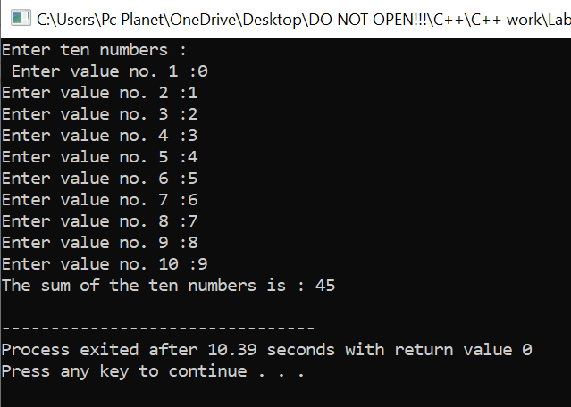

//___________________________________________________________________________________

***TASK 2***

//#include <iostream>

//using namespace std;

//int main()

//{

// int a,b,c;

// cout<<"Enter the number whose table you want : ";

// cin>>a;

// for(b=1;b<=10;b++){

// c=a*b;

// cout<<a<<"*"<<b<<"="<<c<<endl;

// }

// return 0;

//}

//___________________________________________________________________________________

***TASK 3***

//#include <iostream>

//using namespace std;

//int main()

//{

// int a,b,c;

// cout<<"Enter the number for factorial : ";

// cin>>a;

// b=1;

// c=1;

// while(b<=a){

// c=c*b;

// b++;

// }

// cout<<"Factorial of given number is : "<<c;

// return 0;

//}

//___________________________________________________________________________________

***TASK 4***

//#include <iostream>

//using namespace std;

//int main()

//{

// int a,b,c,d=0,e;

// cout<<"Enter the first number from where the fibonacci sequence starts : ";

// cin>>a;

// cout<<"Enter the second number from where the fibonacci sequence starts : ";

// cin>>b;

// cout<<"Enter how many times you want the sequence : ";

// cin>>c;

// while(d<c){

// e=a+b;

// if(a>b){

// b=e;

// }

// else{

// a=e;

// }

// cout<<e<<"\t";

// d++;

// }

// return 0;

//}

//___________________________________________________________________________________