***FUNDAMENTALS OF PROGRAMMING***

***LAB # 4 TASKS***

**NAME:Daniyal Ahmed**

**CMS:457165**

**CLASS:ME-15**

**SECTION:B**

**DATE:29/10/2023** 

***TASK 1***

#include <iostream>

using namespace std;

int main(){

int HCF,LCM,num1,num2;

cout << "Enter 1st number: ";

cin >> num1;

cout << "Enter 2nd number: ";

cin >> num2;

if (num1<num2){

swap(num1,num2);

}

cout<<"The LCM of "<<num2<<" and "<<num1<<" is ";

for(int i=1 ; i<=num1 ; ++i){

if(num1%i==0 && num2%i==0){

if(i!=1){

HCF=i;

}

if(i==1){

HCF=1;

}

}

}

LCM=((num1*num2)/HCF);

cout<<LCM<<" , where the HCF of the following numbers is "<<HCF<<" .";

return 0;

}

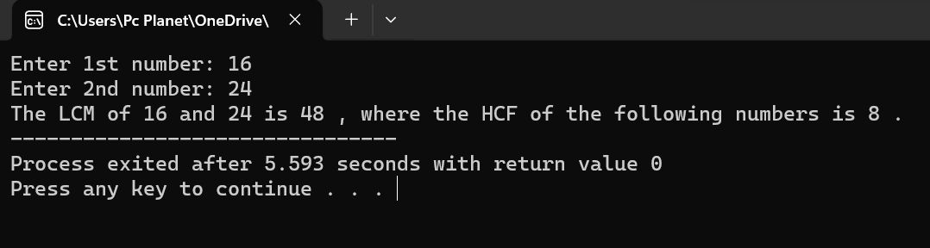

***TASK 2***

#include <iostream>

using namespace std;

int main()

{

int a1,a,sum=0,diff,n;

cout <<"Enter first term : ";

cin>>a1;

cout <<"Enter common differene between the numbers : ";

cin>>diff;

cout <<"Enter the number of terms : ";

cin>>n;

a=a1+((n-1)*diff);

cout<<"The sum of "<<n<<" numbers starting from "<<a1<<" , having a common difference of "<<diff<<" is ";

for(int i=a1;i<=a;i+=diff){

sum=sum+i;

}

cout<<sum<<" .";

return 0;

}

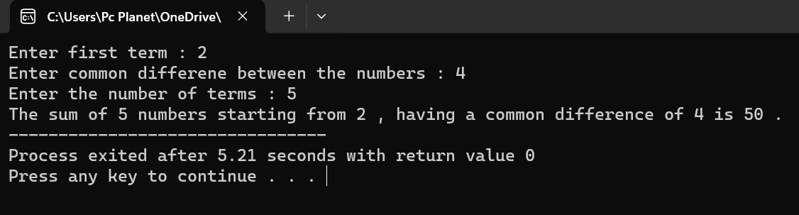

______________________________________________________________________________

***TASK 3***

#include <iostream>

using namespace std;

int main()

{

int height;

cout << "Enter lines till half of diamond: ";

cin >> height;

for(int i=1;i<=height;++i){

for(int j=1;j<=(height-i);++j ){

cout<<" ";

}

for(int k=1;k<=(2*i-1);++k){

cout<<"*";

}

cout<<endl;

}

for(int i=height-1;i>=1;--i){

for(int j=1;j<=height-i;++j){

cout<<" ";

}

for(int k=1;k<=2*i-1;++k){

cout<<"*";

}

cout<<endl;

}

return 0;

}

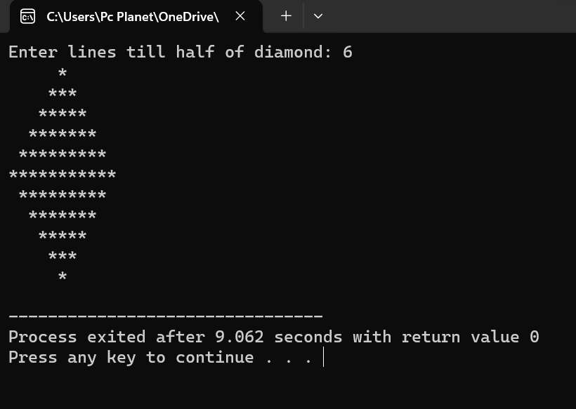

______________________________________________________________________________

***TASK 4***

# include <iostream>

using namespace std;

int main(){

int num,R,Q,binary,multiplier=1;

cout<<"Enter the number : ";

cin>>num;

cout<<"The binary of "<<num<<" is ";

while(num!=0){

Q=num/2;

R=num%2;

binary+=R*multiplier;

num=Q;

multiplier=multiplier*10;

}

cout<<binary;

return 0;

}

______________________________________________________________________________