***FUNDAMENTALS OF PROGRAMMING***

***LAB # 5 TASKS***

**NAME:Daniyal Ahmed**

**CMS:457165**

**CLASS:ME-15**

**SECTION:B**

**DATE:27/10/2023** 

***TASK 1***

#include <iostream>

using namespace std;

int main(){

int x = 1;

do{

cout << "enter a number: ";

cin >> x;

}while (x > 0);

/*Here we first tell the program to display the “enter the number” statement then we take the input. After that we tell the program to continue on running this in loops until the input (value of x) is entered zero or in negative, otherwise it will keep on running the loop.*/

return 0;

}

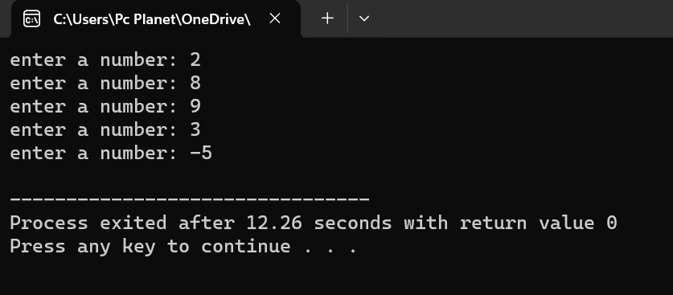

_____________________________________________________________________________________

***TASK 2***

#include <iostream>

using namespace std;

int main(){

double num1,num2,ans;

char op,letter;

do{

cout<<"Enter first number : ";

cin>>num1;

cout<<"Enter second number ";

cin>>num2;

cout<<"Enter operator : ";

cin>>op;

/*In this program we will use switch case to carry out the operations between two numbers .The program will ask for input to either we want to end the program or we want to continue and carry out another binary operation.*/

switch(op){

case '+':

ans=num1+num2;

break;

case '-':

ans=num1-num2;

break;

case '*':

ans=num1*num2;

break;

case '/':

ans=num1/num2;

break;

}

cout<<num1<<op<<num2<<"="<<ans<<endl;

cout<<"Press 'x' to end the program . Press any other key to continue . " ;

cin>>letter;

}while(letter!='x');

return 0;

}

____________________________________________________________________________________

***TASK 3***

#include <iostream>

using namespace std;

int main(){

/*For the program in which we want to get The sum of all even numbers from 2 to 100 (inclusive) we will first of all we will tell the program to continue to carry out the while loop until the count variable reaches 100 where count begins from 2.Then we will add the value of count in sum and also add sum .After that we will increment count by factor of 2 after every loop so that the number will always stay in multiple of 2 (even).Then in the end we will display the sum.*/

int sum1=0,count=2;

while(count<=100){

sum1=sum1 + count;

count+=2;

}

cout<<"The sum of all even numbers from 2 to 100 (inclusive) is "<<sum1<<endl<<endl;

cout<<"and"<<endl<<endl;

int square,num=1,sum2=0;

while(num<=10){

square=num*num;

sum2=square+sum2;

num++;

}

/*For the second part of this task we will declare a variable in which the squares of values is stored.Then SK 4we will add this in sum2 and then add sum2.We will run this loop until the value of num reaches 10 because we wanted to find sum of squares until hundred , which is the square of 10. Then we will increment this num by 1 and the display answer after loop,*/

cout<<"The sum of all squares between 1 and 100 (inclusive) is "<<sum2<<endl;

return 0;

}

_____________________________________________________________________________________

***TASK 4***

#include <iostream>

#include <cmath>

using namespace std;

int main(){

cout<<"Powers of 2 from 0 to 20."<<endl;

/*In this program we use the cmath library in order to use the power function so we can get the power of 2 from zero to 20 , then we display it.*/

int num1=0,ans;

while(num1<=20){

ans=pow(2,num1);

cout<<"2^"<<num1<<"=";

cout<<ans<<endl;

num1++;

}

cout<<endl<<endl<<endl<<"For the sum of odd numbers between two numbers."<<endl;

int inp1,inp2,sum=0;

cout<<"Enter first number : ";

cin>>inp1;

cout<<"Enter second number : ";

cin>>inp2;

/*In order to find the sum of all odd numbers including the first and last value , we first say that if the number is not divisible by two then it will do sum of the numbers .*/

cout<<"The sum of all odd numbers between "<<inp1<<" and "<<inp2<<" is ";

while(inp1<=inp2){

if(inp1%2!=0){

sum=sum+inp1;

}

inp1++;

}

cout<<sum;

return 0;

}

____________________________________________________________________________________