

**FUNDAMENTAL OF PROGRAMMING**

***LAB MANUAL 7***

**LAB TASKS**

**NAME :** Daniyal Ahmed

**CLASS :** ME-15

**SECTION :** B

**CMS ID :** 457165

**DATE:16/11/2023**

**TASK 1**

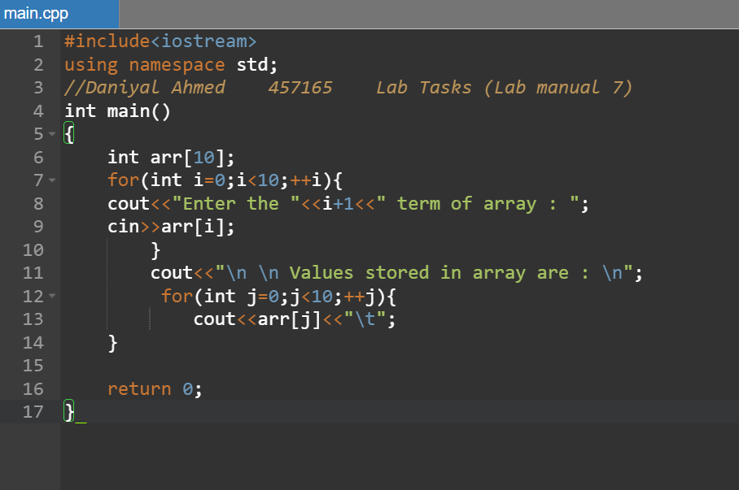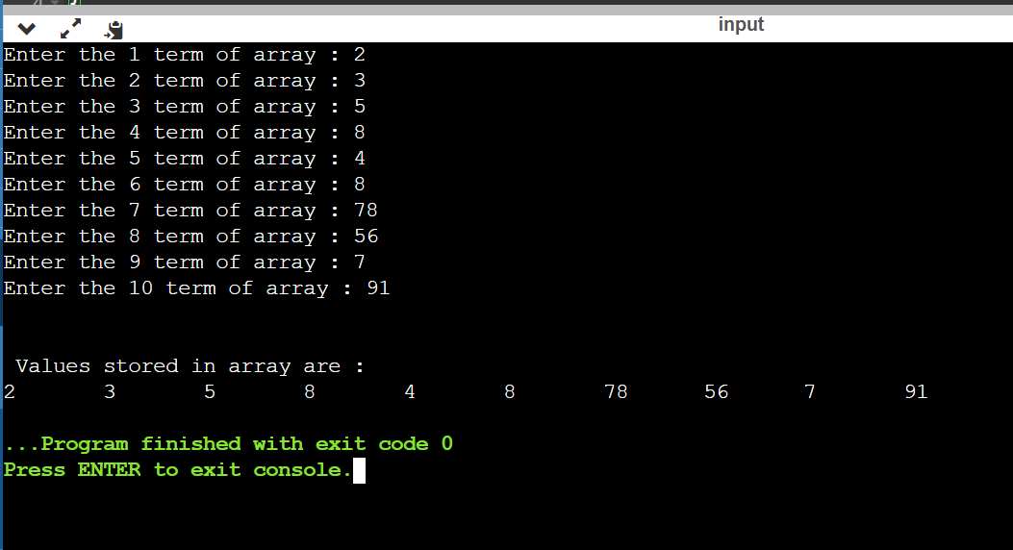

**TASK 2**

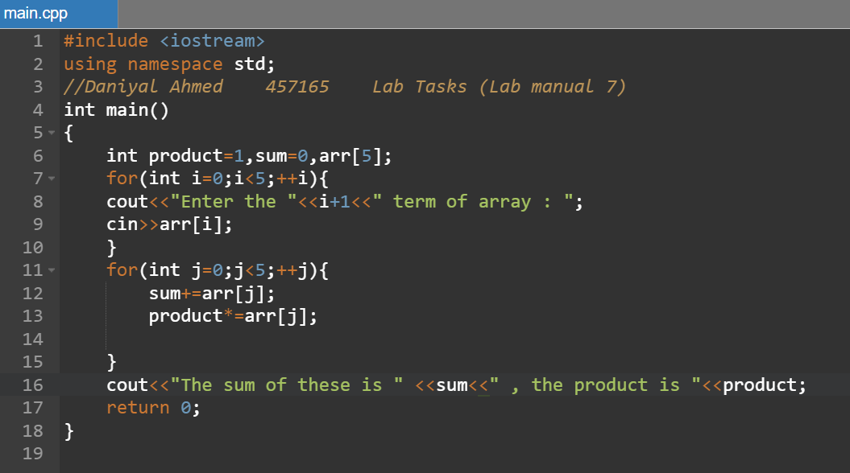

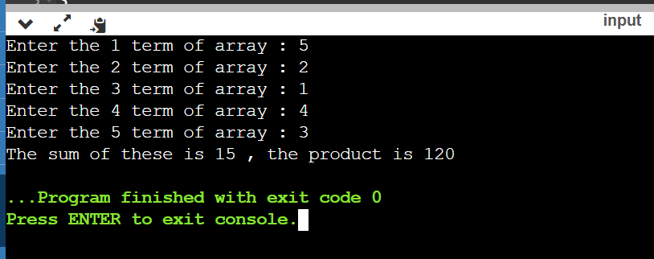

**TASK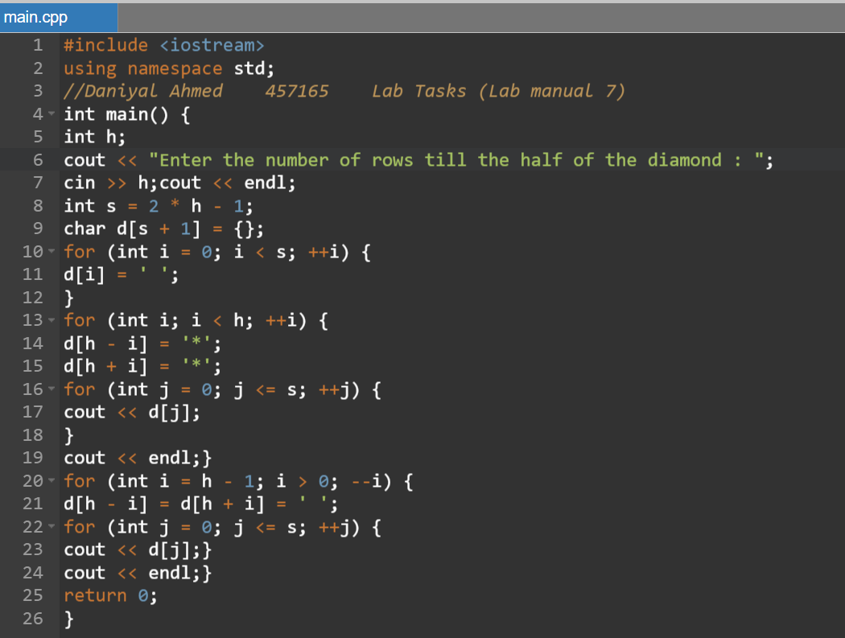 3**