Software Requirements and Design Document
for
FASTBook

Prepared by:
Amna Siddiqui (22i-0830)
Daniyal Faraz (22i-1096)
Hammad Ali (22i-0914)

Intellox Tech CompanyTM

24th November, 2024
Table of Contents
Table of Contents ii
1. Introduction 1
1.1 Purpose 1
1.2 Product Scope 1
1.3 Title 1
1.4 Objectives 1
1.5 Problem Statement 1
2. Overall Description 1
2.1 Product Perspective 1
2.2 Product Functions 2
2.3 List of Use Cases 2
2.4 Extended Use Cases 2
2.5 Use Case Diagram 2
3. Other Nonfunctional Requirements 2
3.1 Performance Requirements 2
3.2 Safety Requirements 2
3.3 Security Requirements 2
3.4 Software Quality Attributes 2
3.5 Business Rules 3
3.6 Operating Environment 3
3.7 User Interfaces 3
4. Domain Model 3
5. System Sequence Diagram 3
6. Sequence Diagram 3
7. Class Diagram 4
8. Component Diagram 4
9. Package Diagram 4
10. Deployment Diagram 4

Introduction

Purpose
This document outlines the functional and non-functional requirements of FASTBook – A social media application designed exclusively for FAST university students. This product focuses on enabling university students to connect, interact, and collaborate through features such as posts, chat, and Q&A functionality.
This document pertains to the initial release of the application and does not cover potential future enhancements or extensions beyond the defined features.

Product Scope
FastBook is a software system designed to make it easy for students to collaborate within the university setting and provide them with a platform for seamless communication and interaction. The application enables students to create and share posts, engage in meaningful discussions through a Q&A section, and build connections via friend requests and chat functionalities through a desktop application connected to a centralized database. This software aligns with the university’s vision of using technology to build a connected student community.

Title
FASTBook – A social media application for FAST university students to connect.

Objectives
- Facilitate Communication: Provide students with a platform for seamless communication and interaction.
- Encourage Collaboration: Promote academic and extracurricular collaboration through activity posts and a Q&A system.
- Strengthen Social Connections: Help students build friendships and interact socially within their university network.
- Streamline Notifications: Notify users of important events, updates, and interactions in real-time.

Problem Statement
In today’s digital age social media platforms are vast and diverse making it difficult for students in a university like FAST to communicate with each other specifically. Students struggle to filter and find peers who share common interests such as sports or working on specific academic projects. Current platforms like Facebook and Instagram do not focus primarily on providing a platform where only specific university students like FAST can communicate.
Our project is a dedicated social media platform exclusively for FAST university students offering effective features that allow users to make connections specifically based on common academic skills, interests, and activities like sports. This platform will make it easier for students to interact, collaborate, and build a supportive university environment.

Overall Description

Product Perspective
Taking inspiration from Facebook, this software is a new self-contained product specifically designed for FAST university students only. It addresses the lack of a centralized platform tailored for academic, social, and extracurricular engagement within this university environment.
This software is built upon the MVC (Model View Controller) architecture design with the following main components for each functionality:
- Model:
  - Represents the data and business logic of the system.
  - Includes modules for user profiles, posts, comments, friend connections, and notifications.
- View:
  - Desktop-based GUI application.
  - Users can register, post activities, manage connections, engage in Q&A, and receive notifications through a responsive and intuitive interface.
- Controller:
  - Acts as an intermediary between the View and the Model.
  - Handles user input, updates the Model, and refreshes the View accordingly.
  - Communicated directly with the database layer.
- Database:
  - Handles all the data storage about posts, users, friends, notifications etc.

Product Functions
- User Management:
  - User registration and login functionality.
  - Profile creation, editing, and deletion.
  - View and manage friend connections (send, accept/reject friend requests).
- Social Media Functions:
  - Create and manage posts (text, images, or activity-based).
  - Comment on, react to, and interact with posts.
  - Participate in Q&A discussions for academic and social collaboration.
- Notification System:
  - Notify users of new activity posts by their friends using an Observer Design Pattern.
  - Provide real-time updates for friend requests, comments, and likes.
- Centralized Data Management:
  - All data, including user profiles, posts, and relationships, is securely stored and managed using a centralized SQL database.

List of Use Cases
- Manage Posts
- Register User
- Manage Questions
- View Profile
- Edit Profile
- Accept/Reject Friend Request
- Send a Friend Request
- Chat with Friends
- Remove Friend
- Comment on Post
- React on Post
- Create Activity Post
- Reply to Activity Post

Extended Use Cases
- Display Notifications

Use Case Diagram
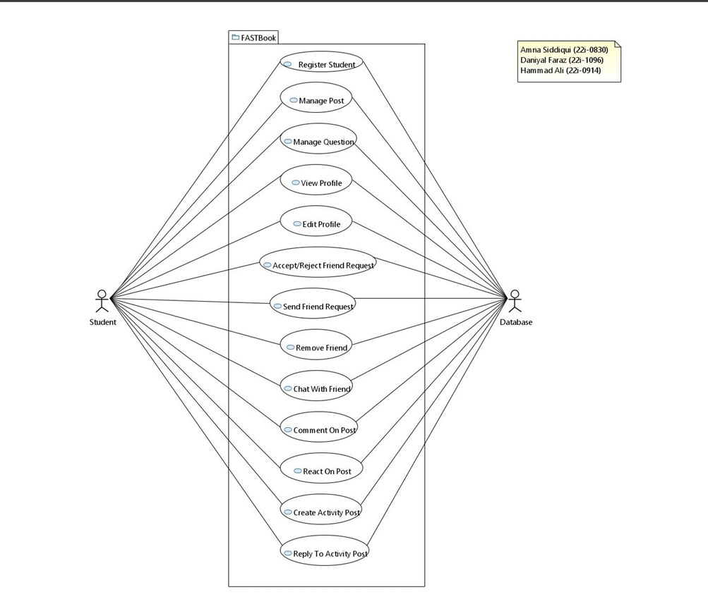

Other Nonfunctional Requirements

Performance Requirements
[None]

Safety Requirements
- Regular backups of the database must be performed at least daily to ensure no significant data loss in case of a system crash.
- Proper error handling and data validation should be implemented to ensure data is correctly entered.

Security Requirements
- The system must enforce secure user authentication by requiring a unique username and password combination for each user account. The system should make sure that the username is a unique roll number of students of FAST university.
- User sessions should be terminated immediately when the user exits the application from any point in the application.

Software Quality Attributes
- Usability: The system should have a simple and intuitive user interface (UI) that allows both novice and experienced users to navigate and perform tasks (such as creating posts, sending messages, or managing friends) without extensive training.
- Reliability: The system should handle user errors gracefully with informative messages, preventing crashes and guiding users to recover from common mistakes.
- Maintainability: The system should be built with modular components following the MVC (Model-View-Controller) design pattern, allowing for easier updates and extensions.
- Robustness: The system must perform both client-side and server-side validation to ensure that all inputs (e.g., user registration, post creation, messaging) are properly formatted and prevent invalid or malicious data from being entered into the system.
- Reusability: Components such as user authentication, notification system, and messaging can be reused in other applications or future versions of the system. Code should be written using object-oriented principles and design patterns that encourage reuse and reduce duplication.

Business Rules
- Only the students of FAST University having an ID can register in the application and log in the application.
- Once logged in, the student can then view different pages (Homepage, Posts, Chat etc).
- The student can comment on, and react to, others’ posts as well as create their posts.
- The student can send friend requests to other students whom they are not friends with in the application.
- Once the student accepts the friend request of another student they are marked as friends in the database.
- The student can only chat with other students if both of them are friends in the application.
- The friend of a student only can receive notifications of the creation of posts by that student.

Operating Environment
- Hardware Platform:
  - A minimum of 2 GHz processor (Intel Core i3 or equivalent recommended for smooth performance).
  - Minimum of 100 MB of available disk space for software installation and local data storage.
- Operating System:
  - Windows
- JDK:
  - Java 22
  - JavaFX 11
- Database:
  - Mysql Database

User Interfaces

The typical flow of the application would be something like this

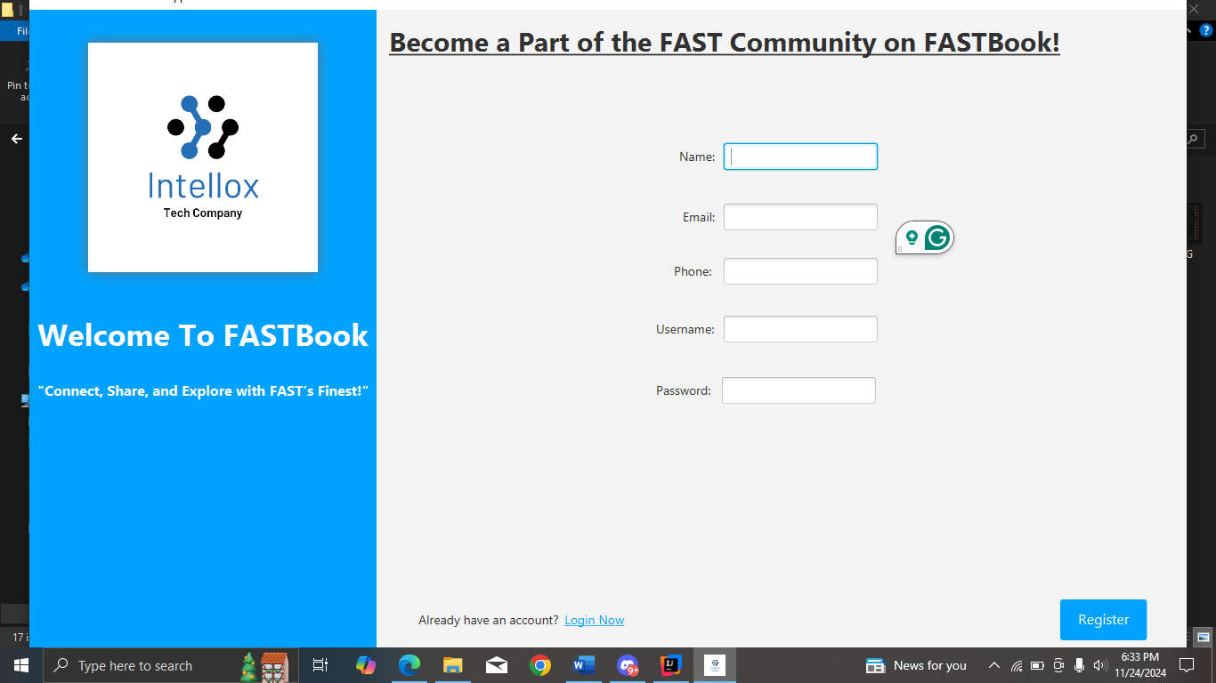
Register Page

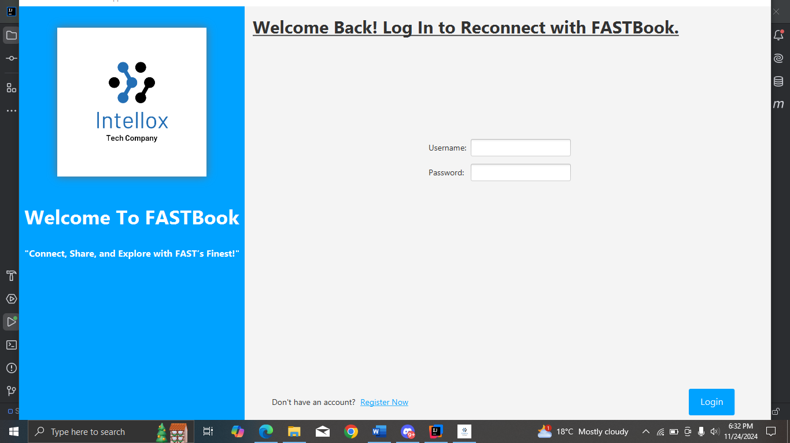
Login Page

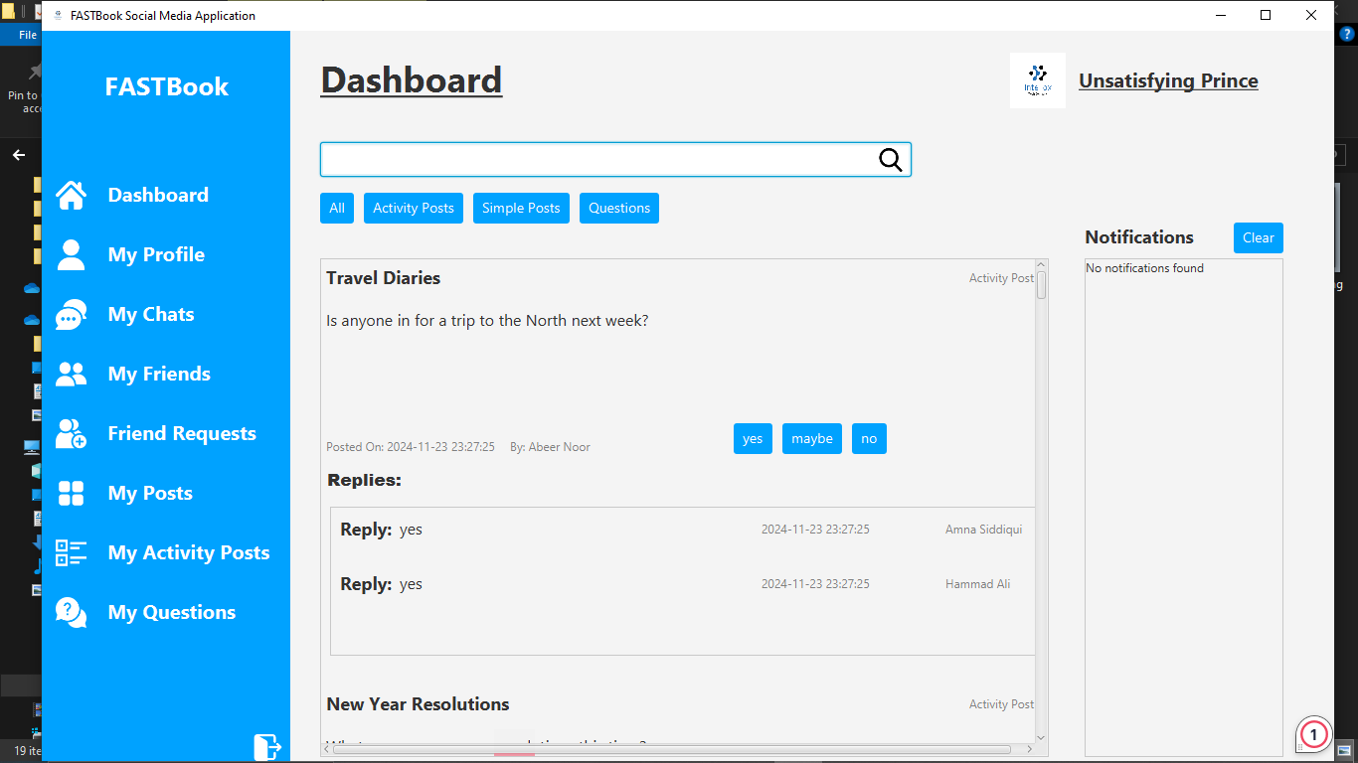
Home Page
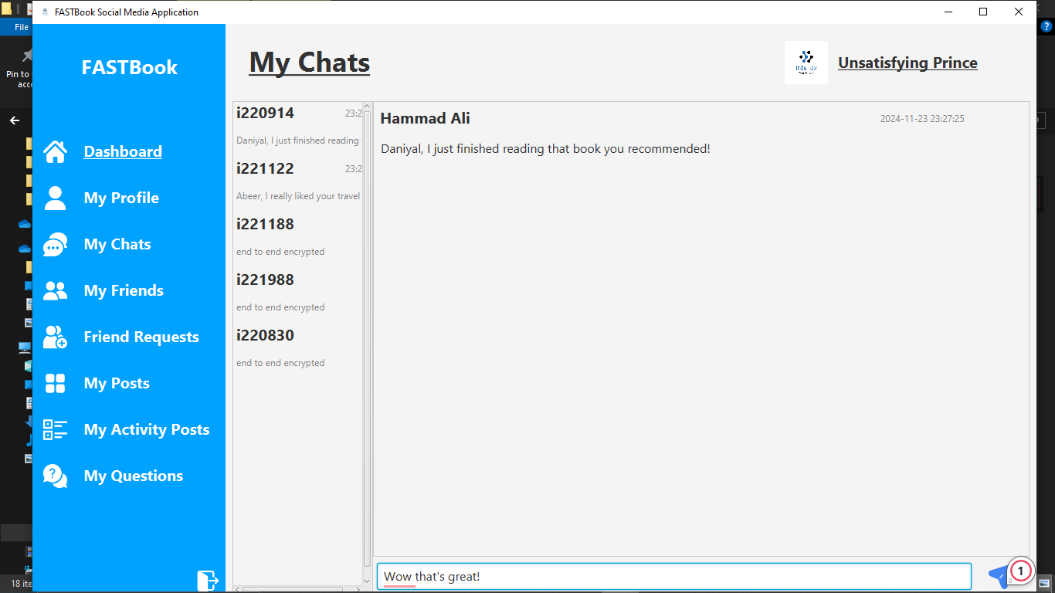
Chat Page

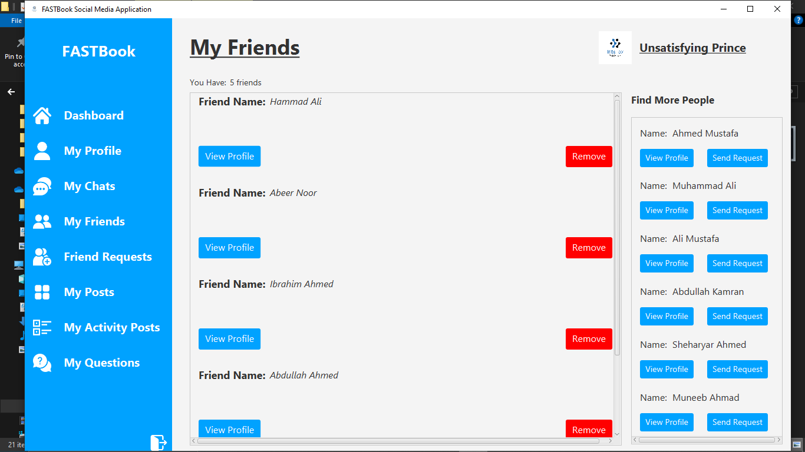
Friends Page
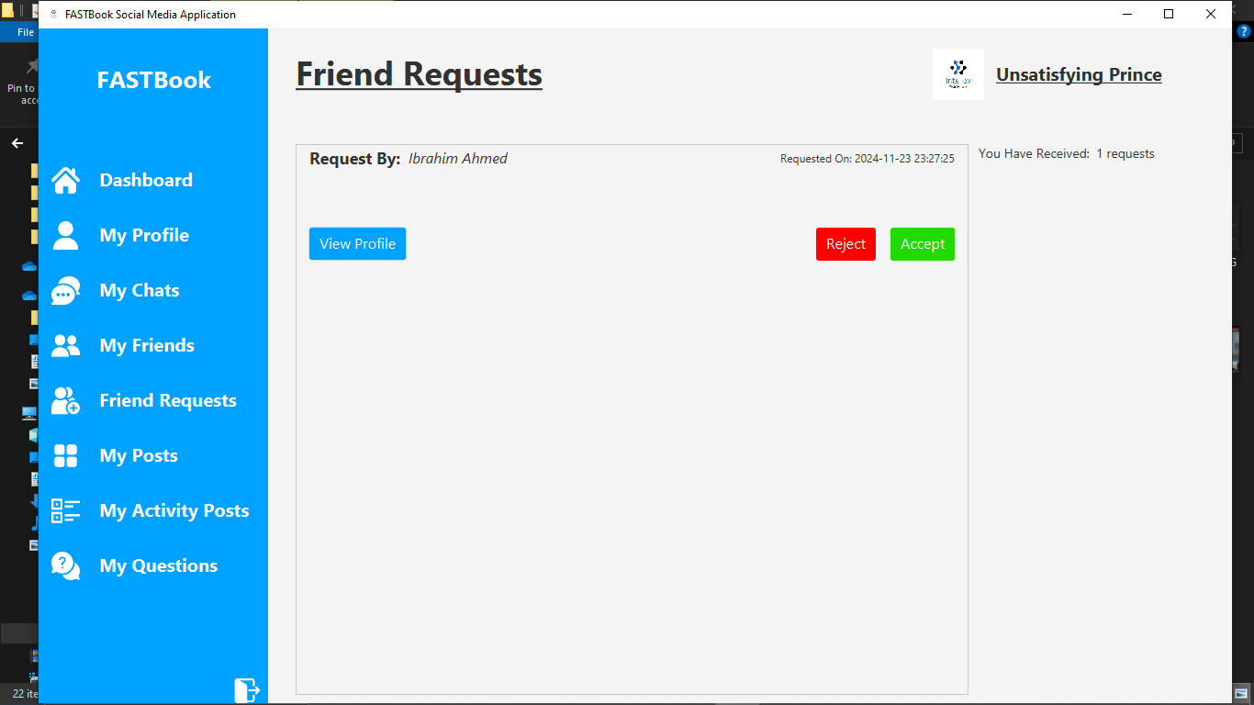
Friend Requests

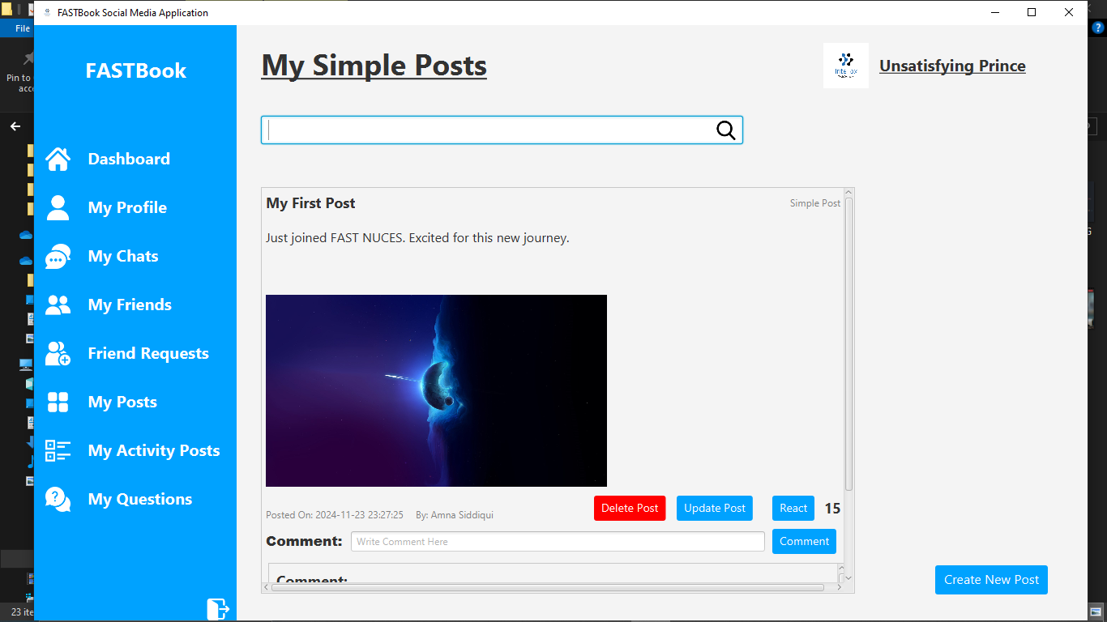
My Posts Page

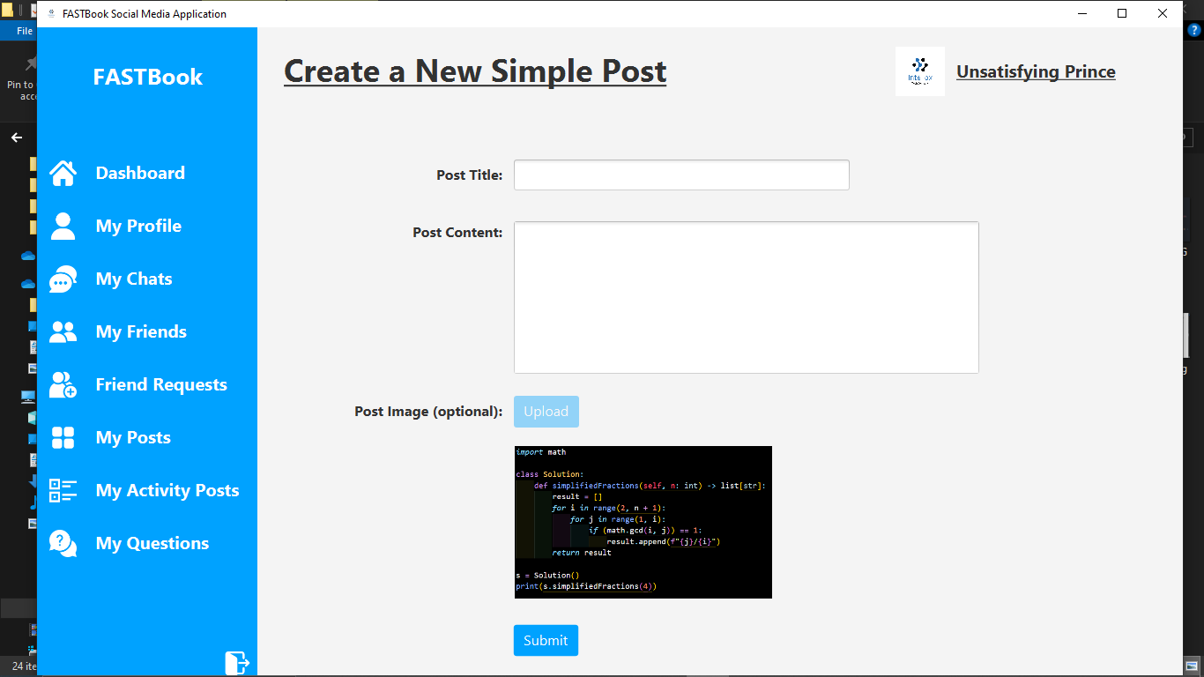
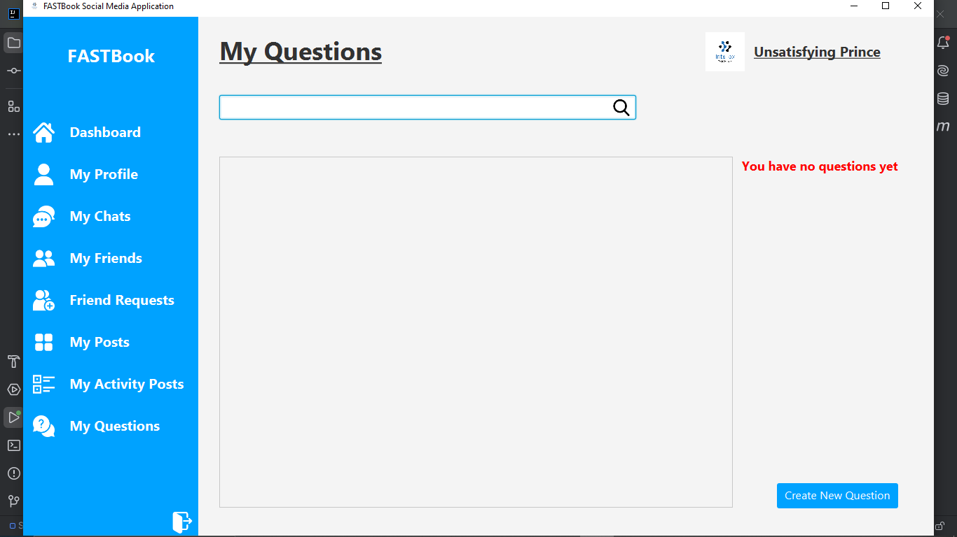
Create Post
My Questions Page

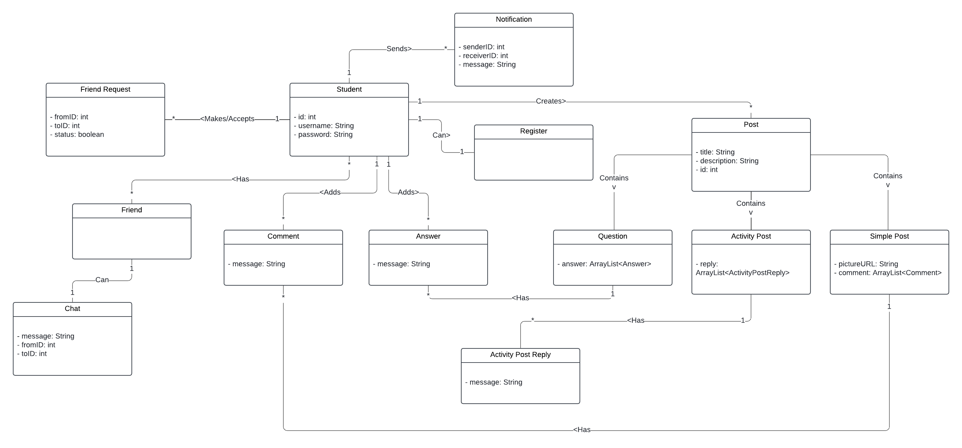
Domain Model

System Sequence Diagram
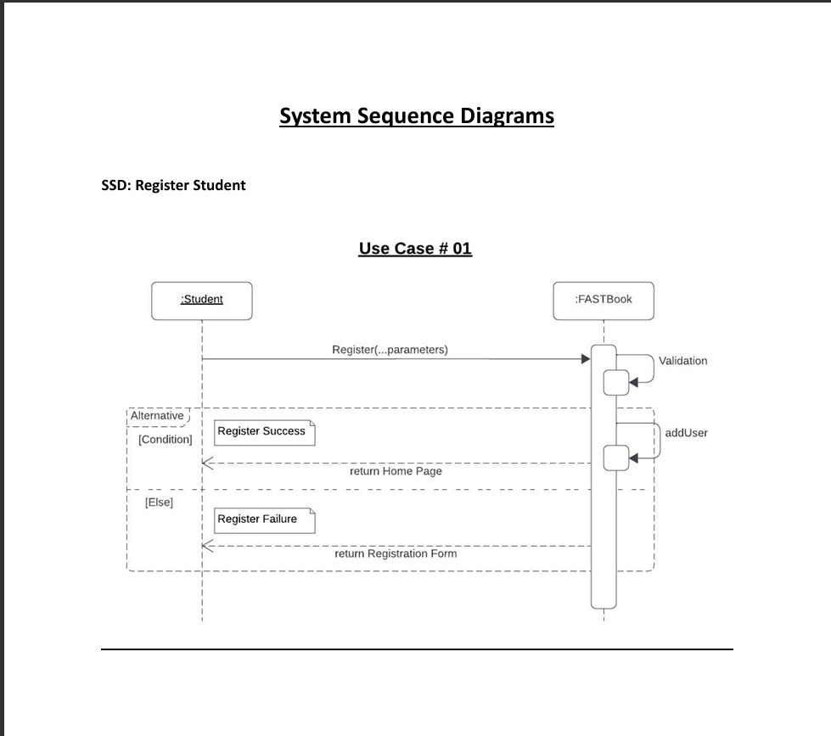

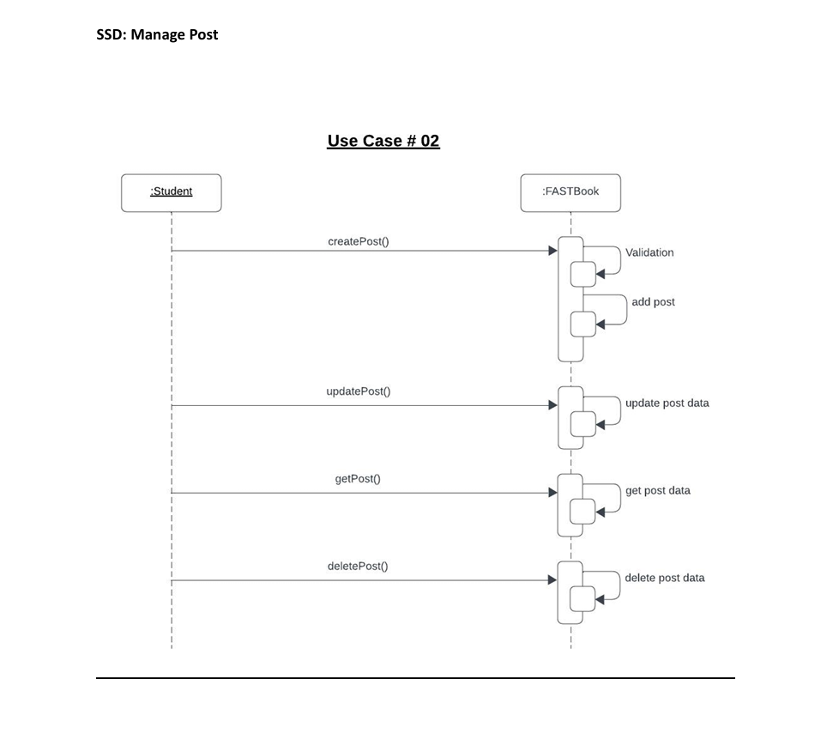

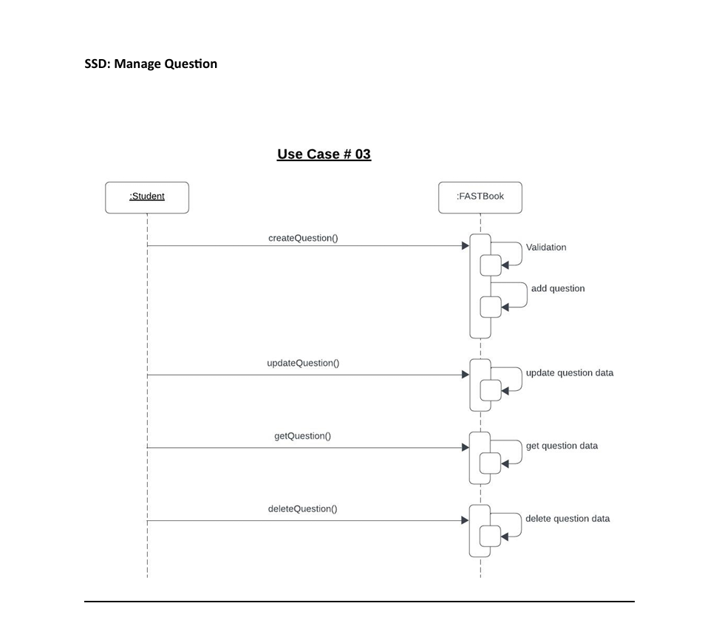

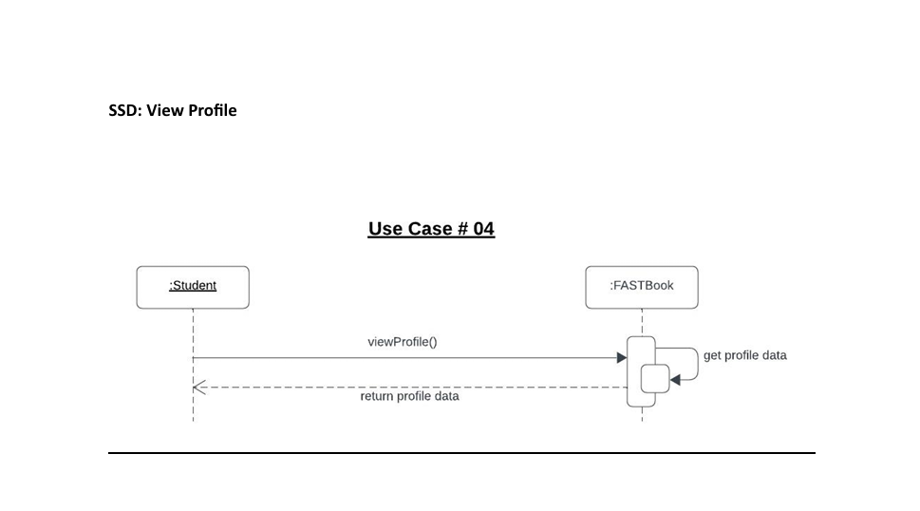

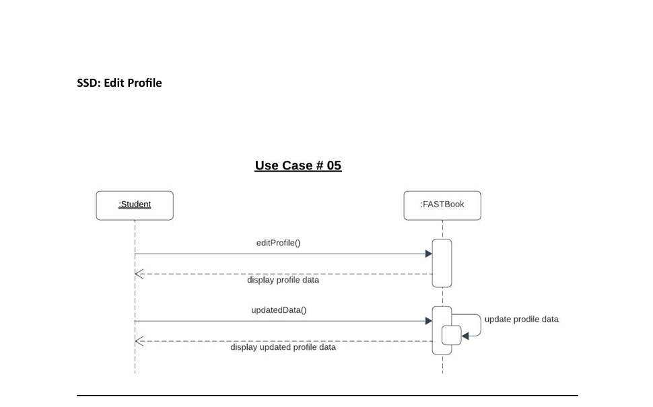

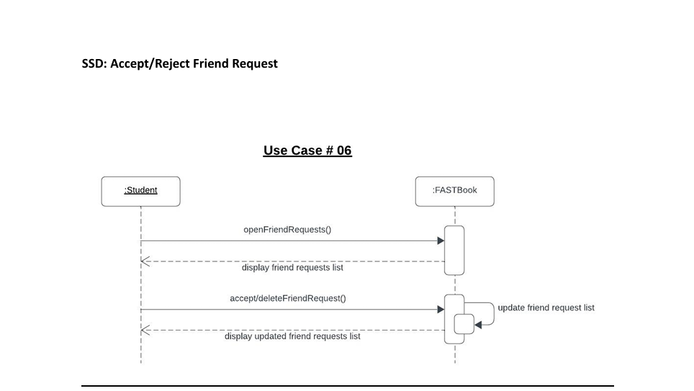

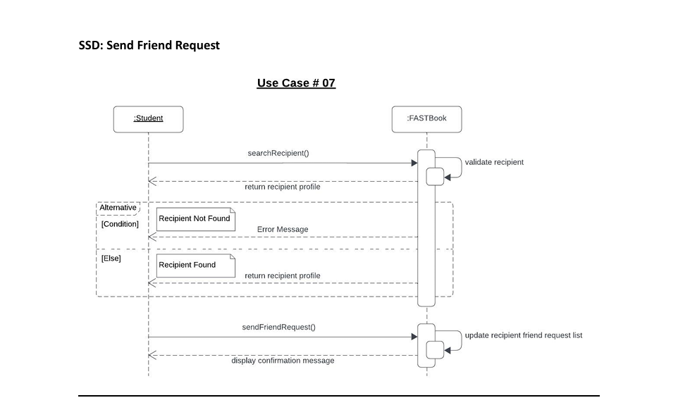
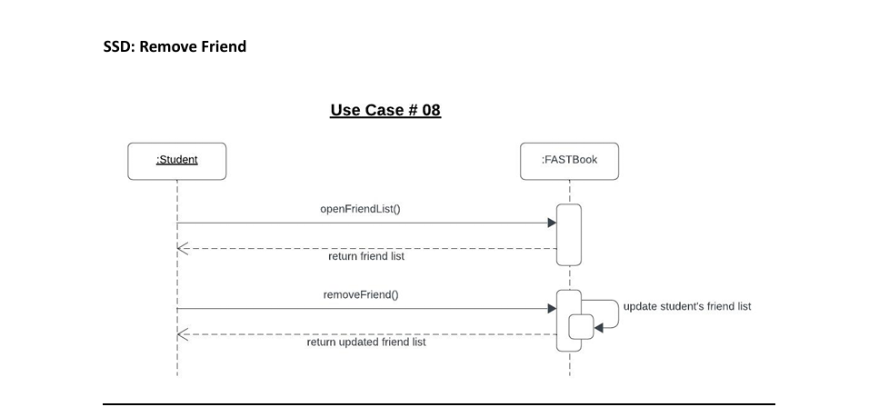

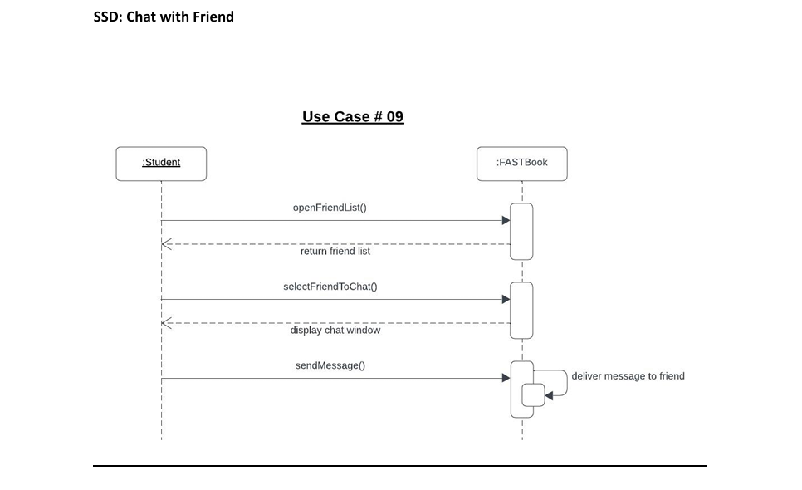

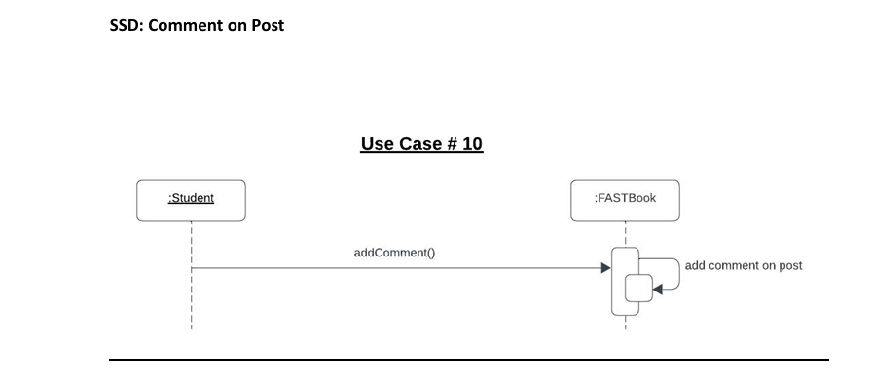

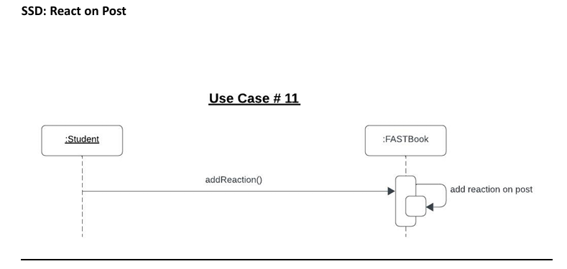

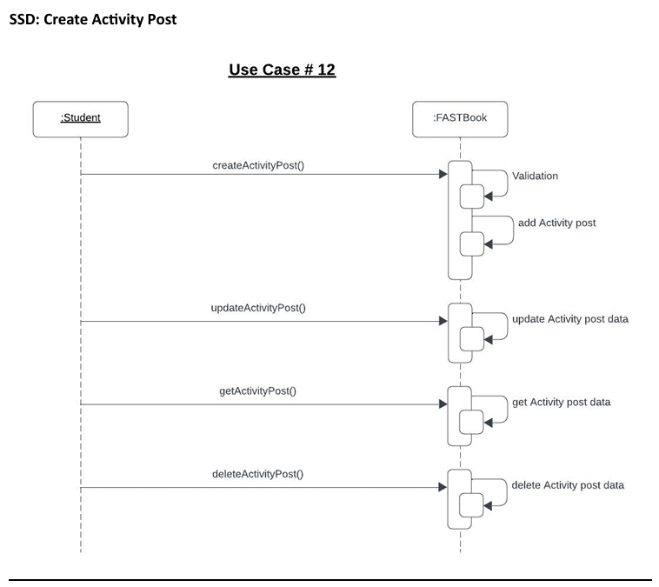
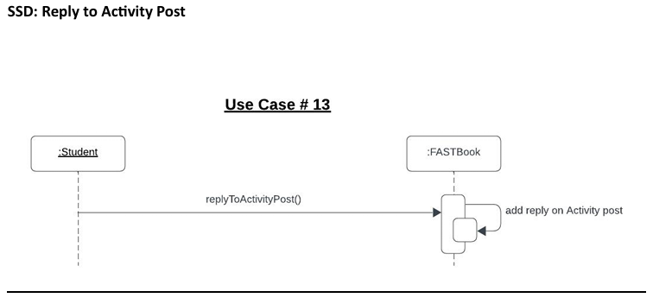

Sequence Diagram

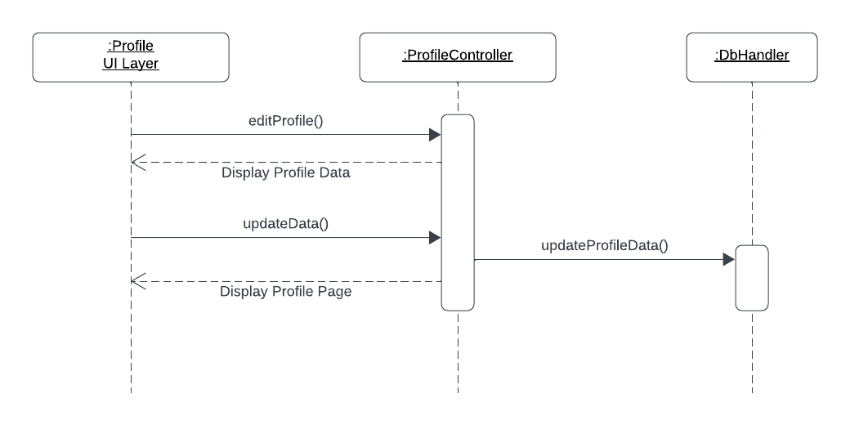

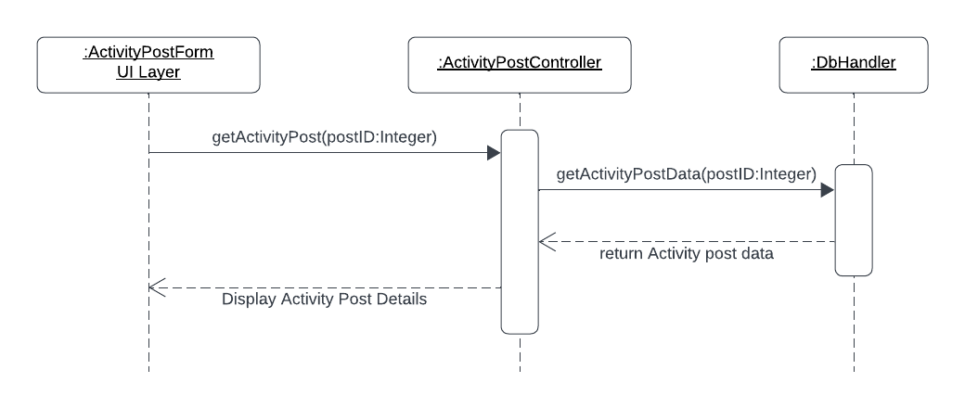

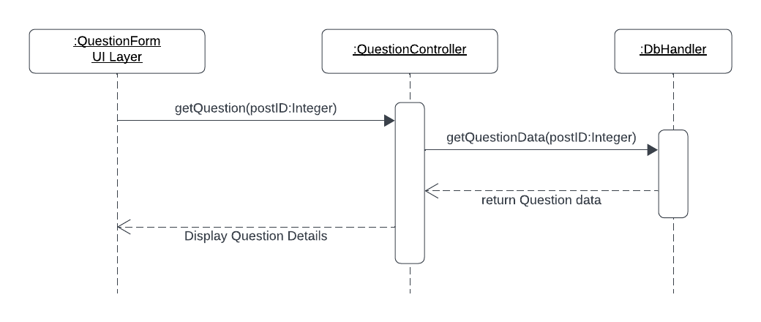

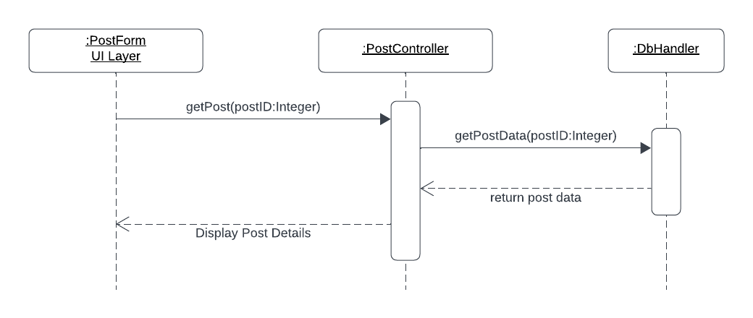

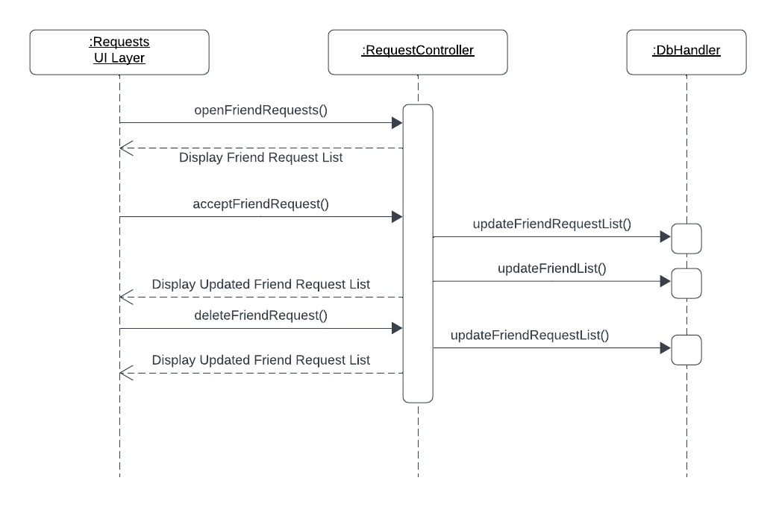

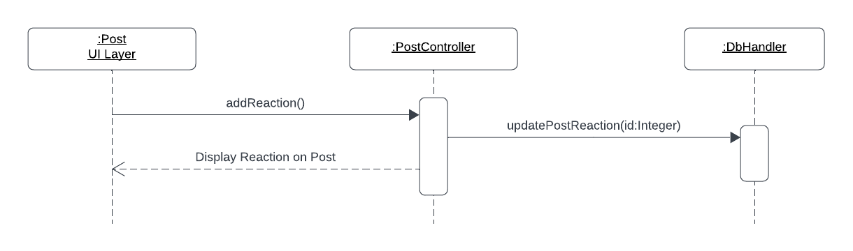

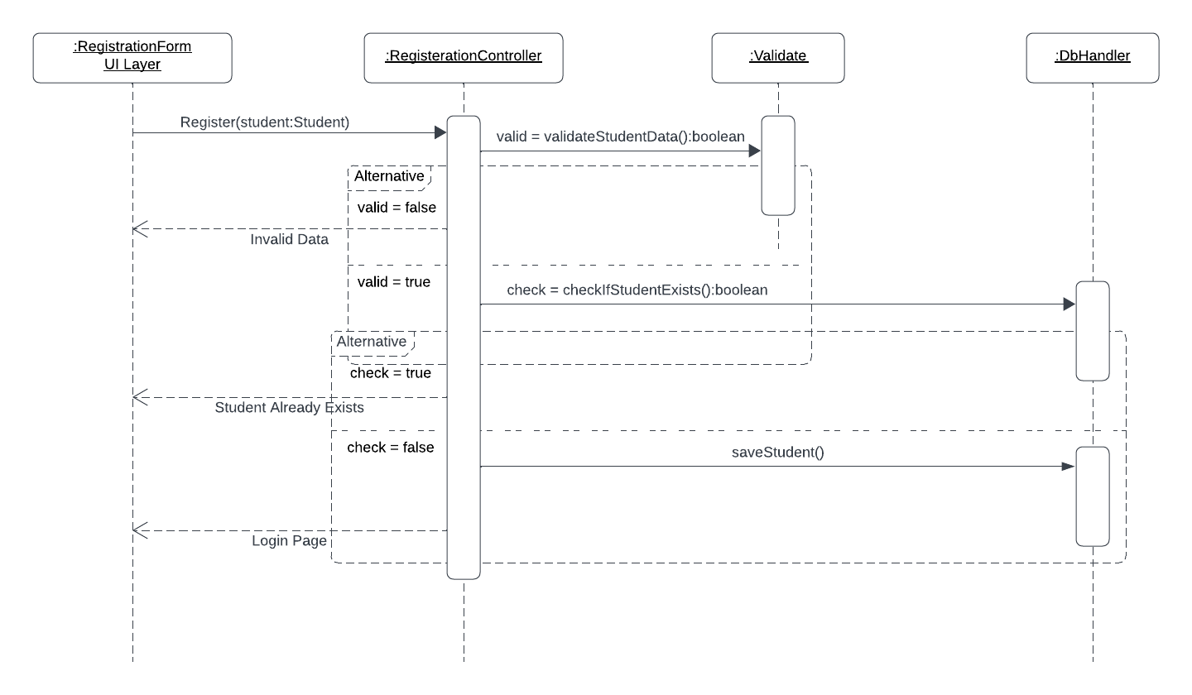

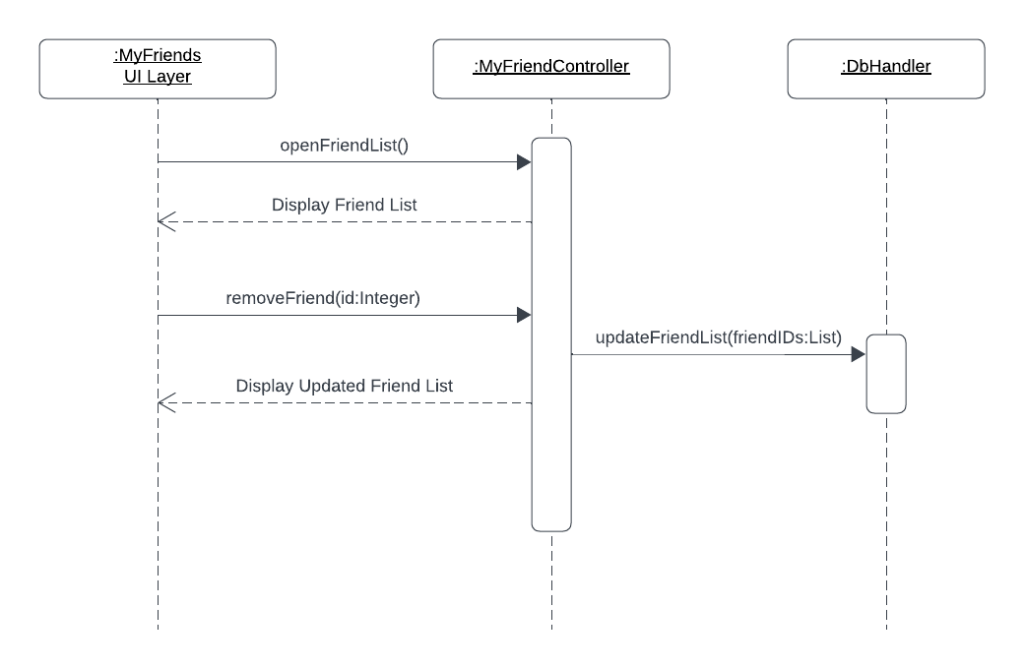

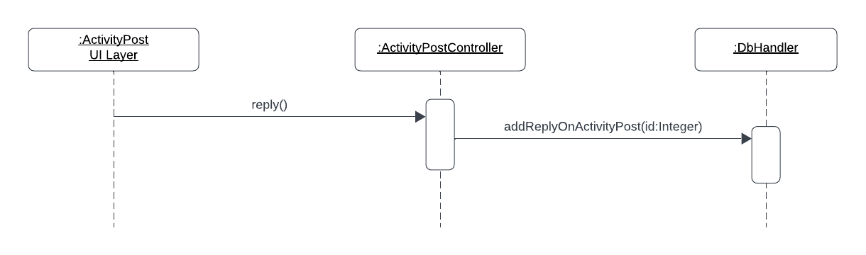

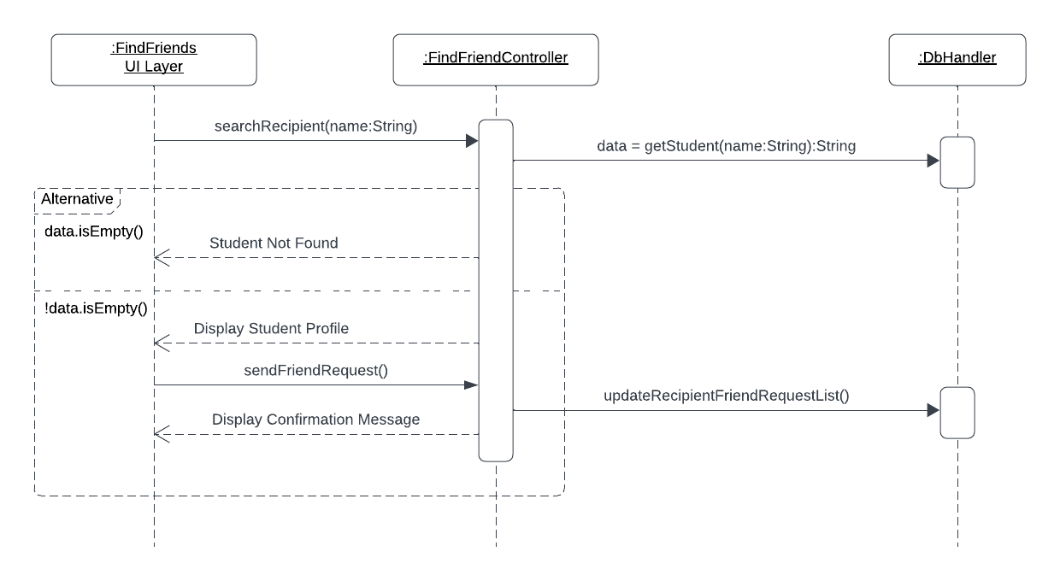

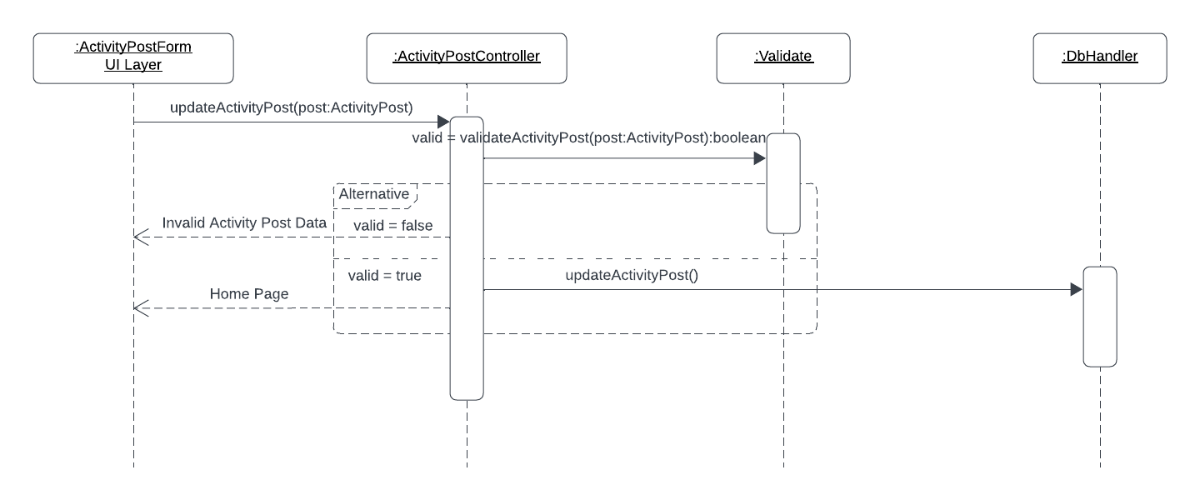

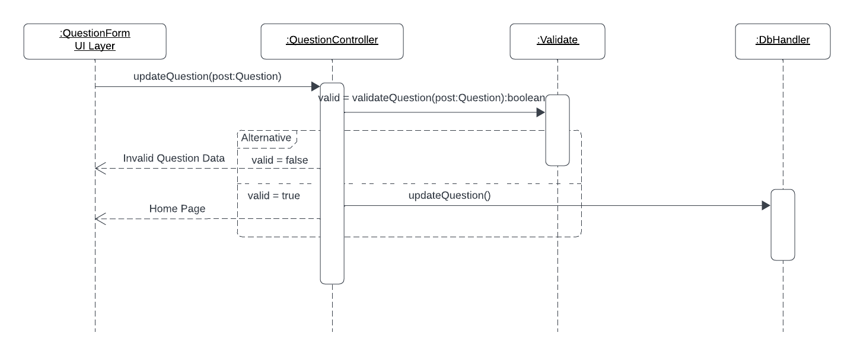

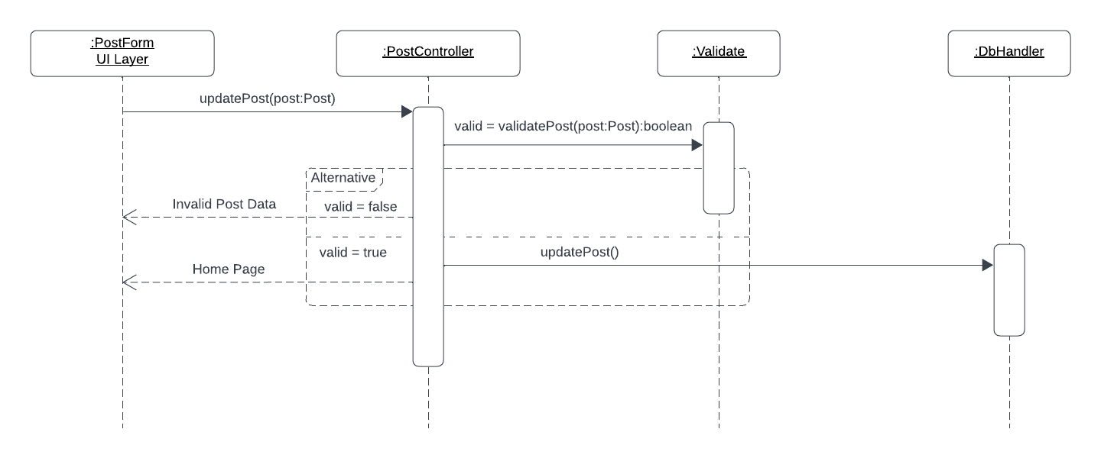

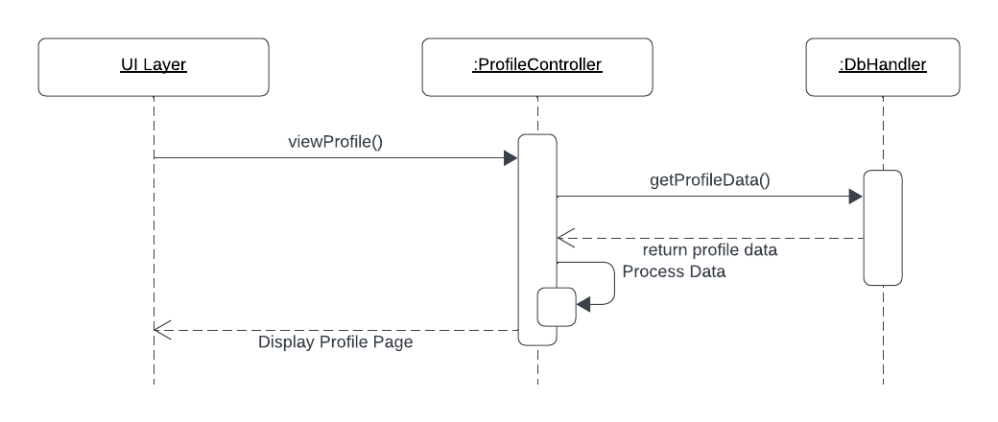
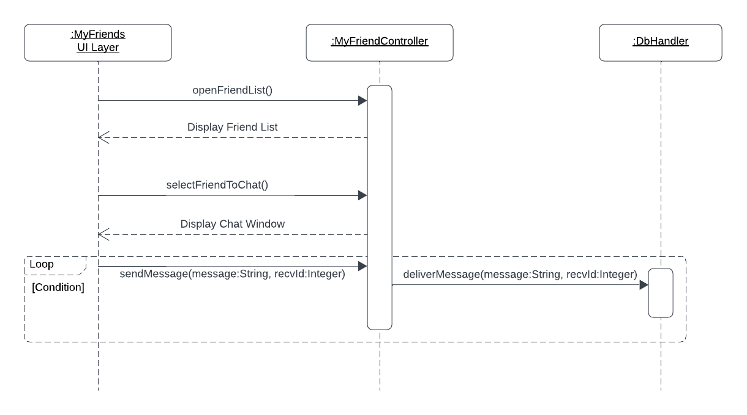

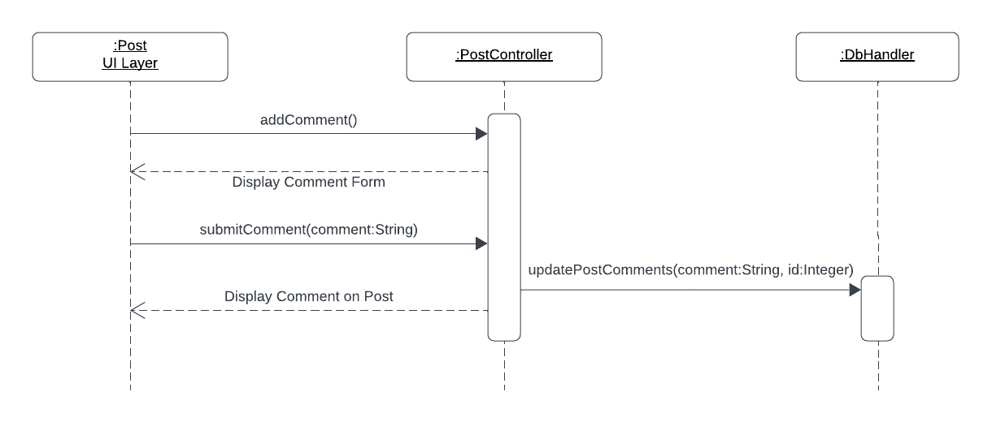
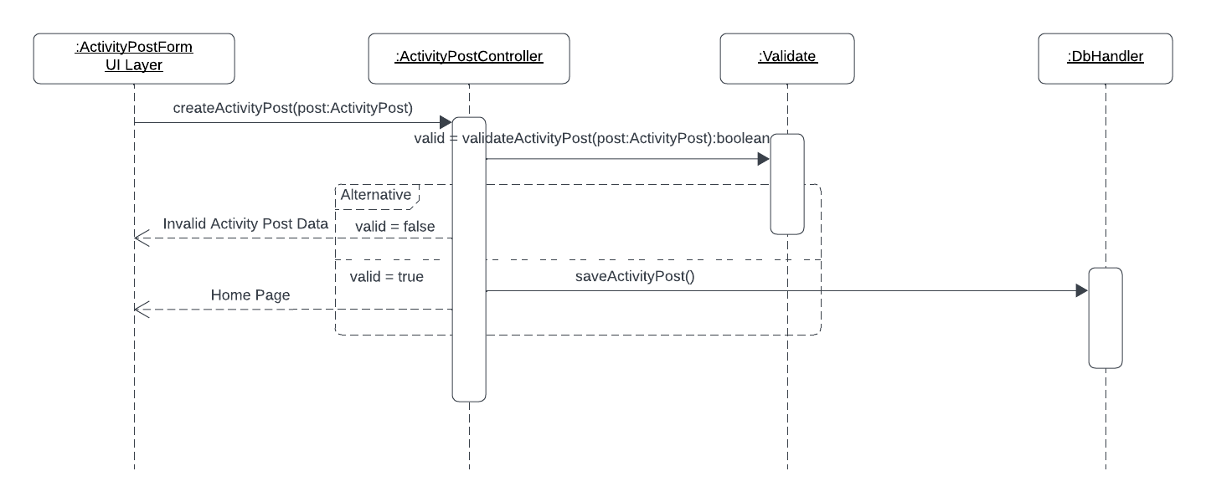

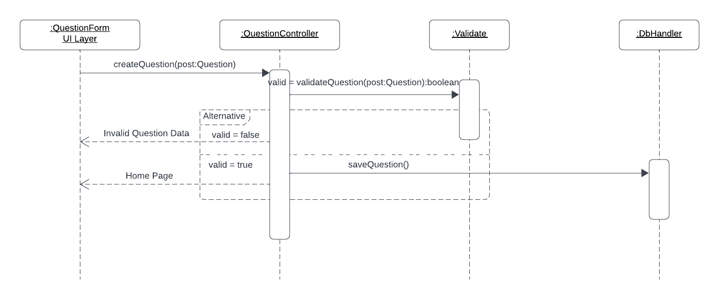

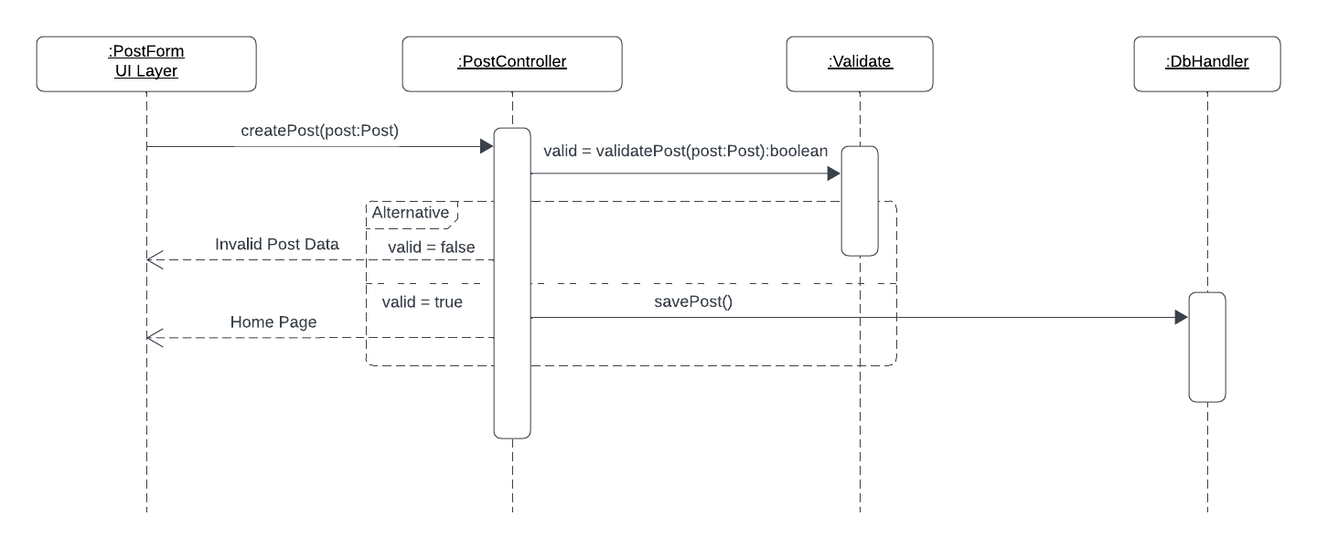

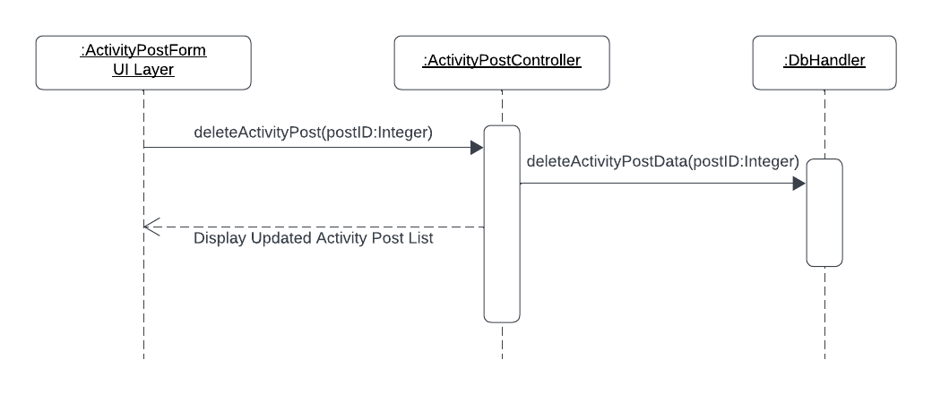

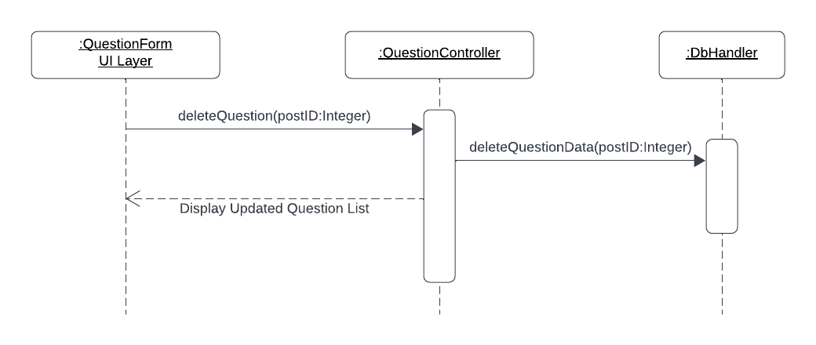

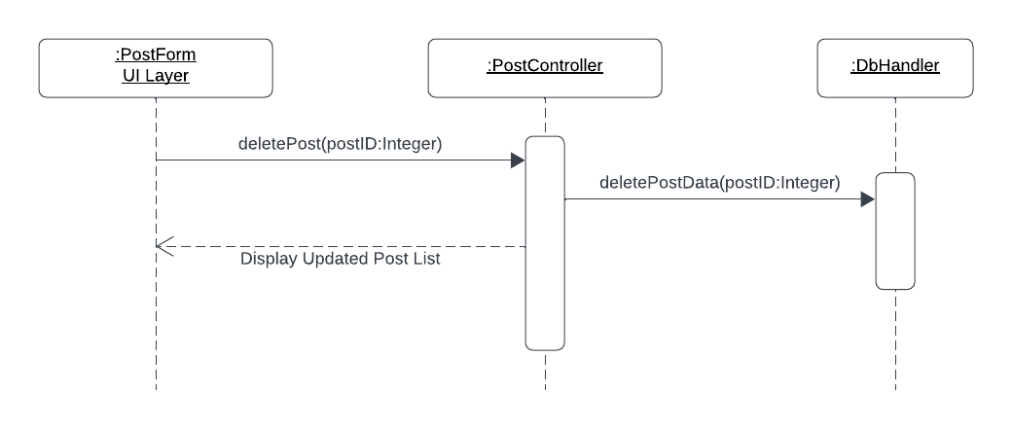

Class Diagram

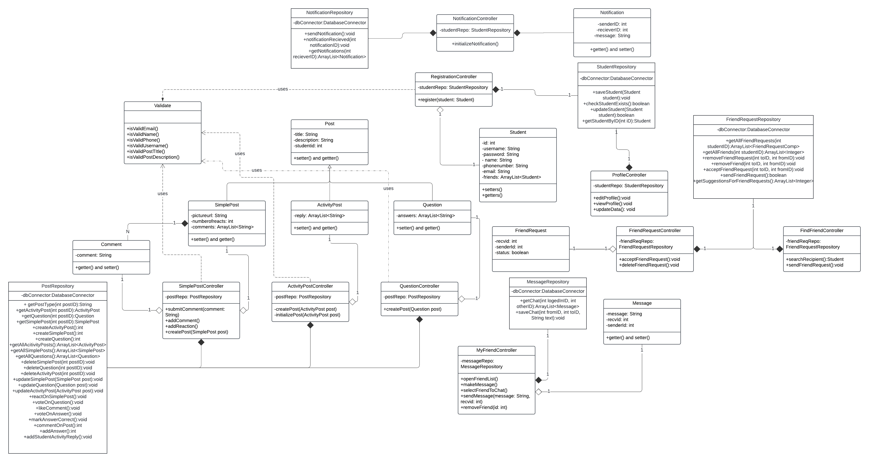

Component Diagram
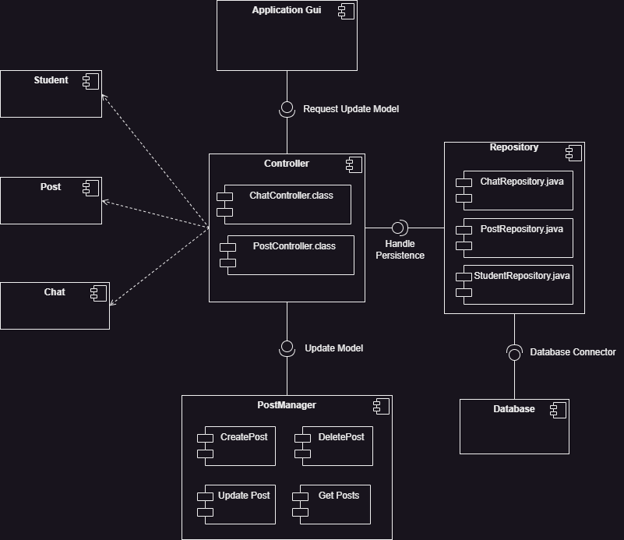

Package Diagram
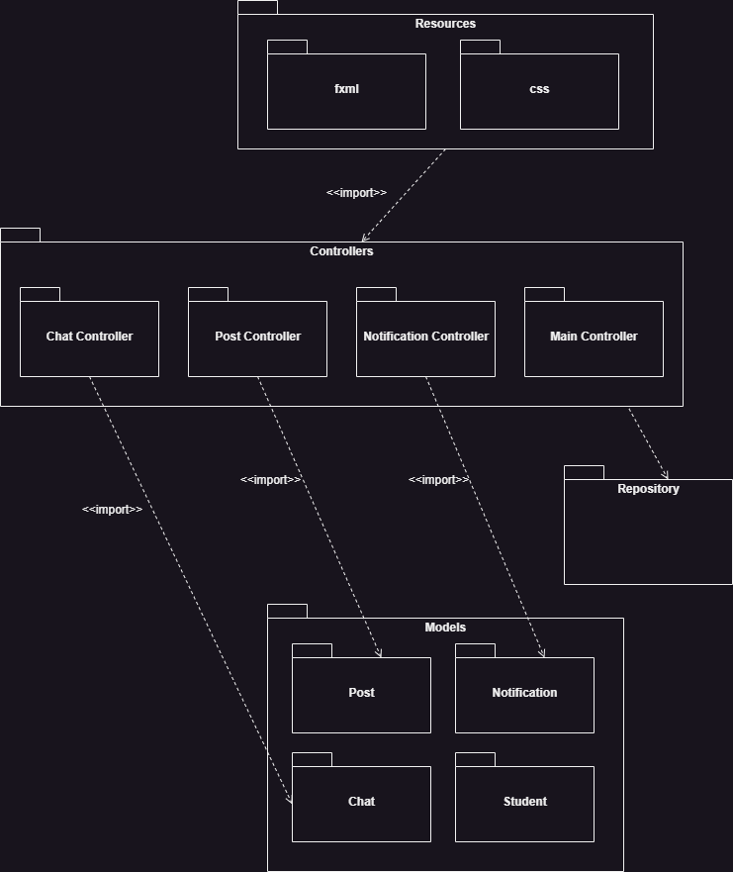

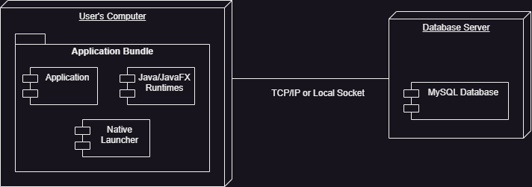
Deployment Diagram

