

**Sir Syed University of Engineering & Technology Department of Software Engineering**

**Project Proposal**

**Deep Learning**

**Project Title:**

**CAR MAKE AND MODEL DETECTION**

|  |  |
| --- | --- |
| Group Members: | Daniyal Hassan  Mesum Ali  Furqan Amir  Mirza Ali Qadar |

|  |  |
| --- | --- |
| Roll numbers: | 2021F-BSE-089  2021F-BSE-075  2021F-BSE-088  2021F-BSE-058 |
| Section: | B |

# Project Objective:

# The objective of this project is to develop a deep learning model that can accurately classify car make and model from input images. By training and validating a dataset using convolutional neural networks (CNNs) and appropriate layers, the model will be capable of identifying the specific make and model of a car from an image.

# Project Description:

# In this project, we will implement a deep learning solution to automate the recognition of car makes and models from images. The dataset will consist of images of cars categorized by their make and model. We will preprocess the data, train a CNN model using various layers such as Conv2D, MaxPooling2D, Flatten, Dense, and Dropout layers, and then validate its performance.

# Project IDE:

**Google Colab**

# Purpose of Project:

The purpose of this project is to demonstrate the capability of deep learning techniques, specifically CNNs, in the domain of image recognition and classification. By accurately identifying car makes and models from images, the model can be applied to various real-world scenarios, including automated vehicle identification in surveillance, automotive industry applications, and smart city initiatives.

**The process will involve:**

1. **Data Collection and Preprocessing:** Gathering a dataset of car images and preparing them for training.
2. **Model Construction:** Designing a CNN architecture with Conv2D layers for feature extraction, MaxPooling2D layers for spatial downsampling, Flatten layer to convert 2D feature maps into 1D vectors, Dense layers for classification, and Dropout layers for regularization to prevent overfitting.
3. **Training and Validation:** Training the model on the dataset, evaluating its performance using validation data, and fine-tuning to achieve optimal results.

**Layers Used:**

* **Conv2D Layer:** Used for convolutional feature extraction from input images.
* **MaxPooling2D Layer:** Performs down-sampling to reduce spatial dimensions.
* **Flatten Layer:** Converts the 2D feature maps into a 1D vector for feeding into dense layers.
* **Dense Layer:** Fully connected layers for classification based on extracted features.
* **Dropout Layer:** Applied to prevent overfitting by randomly dropping units during training.

This combination of layers allows the model to learn hierarchical representations of car images and make predictions based on learned features, resulting in accurate identification of car makes and models from input images.

**User Guide:**

First the User have to upload the picture

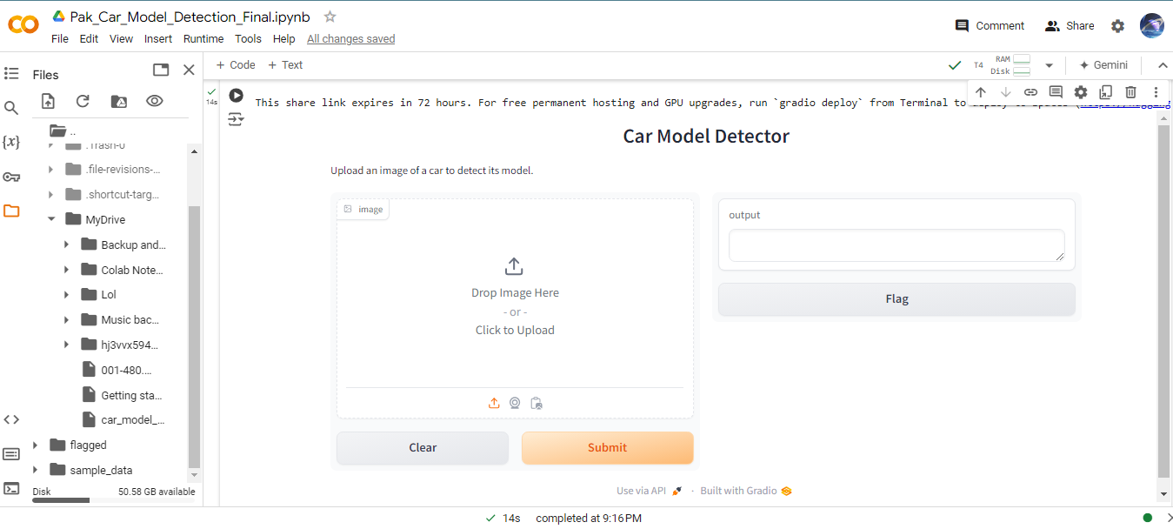

The picture has to be selected from dataset folder containing the train and valid folder which contains the car images

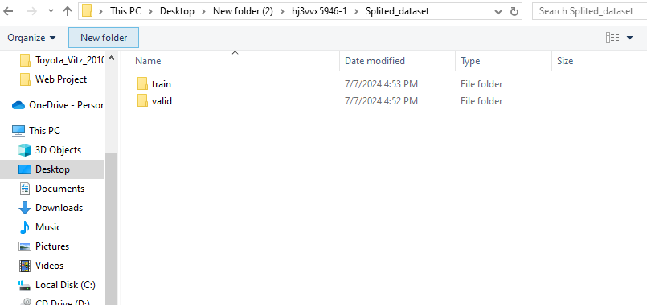

And after getting inside the folder select a picture of any car

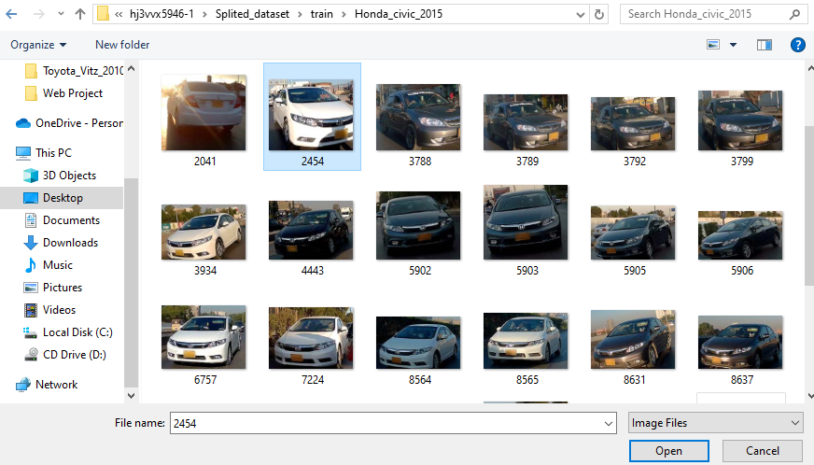

Lastly Click the Submit button to See whether the input image meet the satisfactory result. If the image is correct it will show the car model in output.

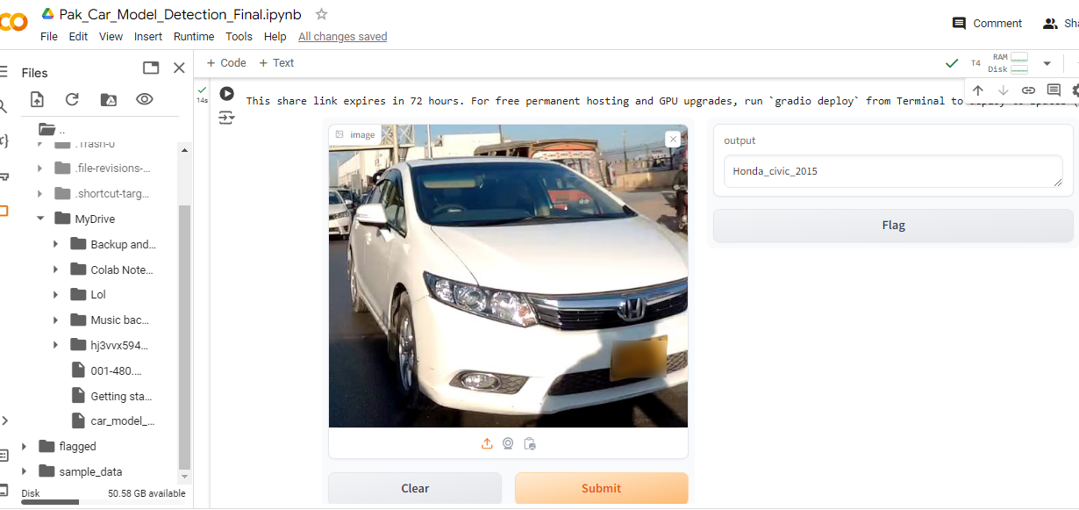

Link To Dataset:

https://data.mendeley.com/datasets/hj3vvx5946/1