Applications of Data Science Project Report

Project title:

Credit Card Fraud Detection

----------------------------------------------------------------------------------------------------------------------

**Dataset Description:**

First of all, I took a dataset of transactions. It is used to detect fraud. There are some important columns like

'Credit Card Number',

'Merchant',

'Category',

'Amount',

'City',

'State',

'Latitude',

'Longitude',

'Transaction Date',

'Transaction Number'

By these columns we can detect that the particular transaction is fraudulent or not.

**Data balance technique:**

Before applying model data was imbalanced but I made the data balanced by the technique of **SMOTE**.

**Model:**

I used **RandomForestClassifier** model for it because this model can be used to predict the fraudulent behavior of the transaction.

**Accuracy of Model:**

Accuracy of the model is almost 99%. It means it is neither overfitting nor underfitting.

**Languages:**

* + Front-end is made of **HTML** and **CSS**.
  + Back-end is made of **Python** in jupyter notebook.
  + **Flask** is used as bridge between front-end and back-end.

**How to run flask code?**

The simple way to run flask code is that we have to

* Open the whole folder where the whole project exists.
* Then press ctrl+**F5** on flask app. Then code will be running.

**Note!**

The project will be run when

* All HTML files will be in **templates** folder.
* All images will be in **static** folder.
* In static folder, we make a subfolder with the name of **css**. All css files will be found in that folder.

**Procedure:**

First of all we run flask app by ctrl+**F5**. Then an interface of **Form.html** will be appeared, then user will upload an image of leaf in the form and that image will be going to flask app. After processing in flask app, if there is no error in flask app then interface of **Result.html** will be appeared.

**How to find that the particular transaction is fraudulent or not?**

If anyone steal someone’s credit card, the fraud can be detected due to following:

* + If he exceeds the limit of amount of cardholder then it can be detected as fraud.
  + If cardholder’s timing of transaction does not match with the transaction of that thief then it can be detected as fraud.
  + If cardholder’s city, state does not match with the transaction of that thief then it can be detected as fraud.

**Form**

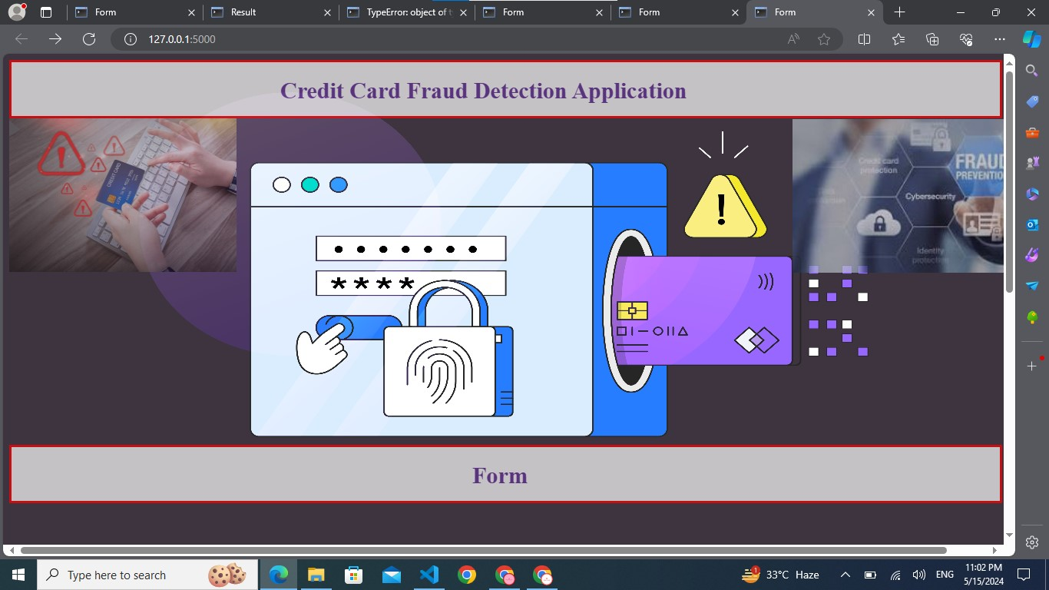

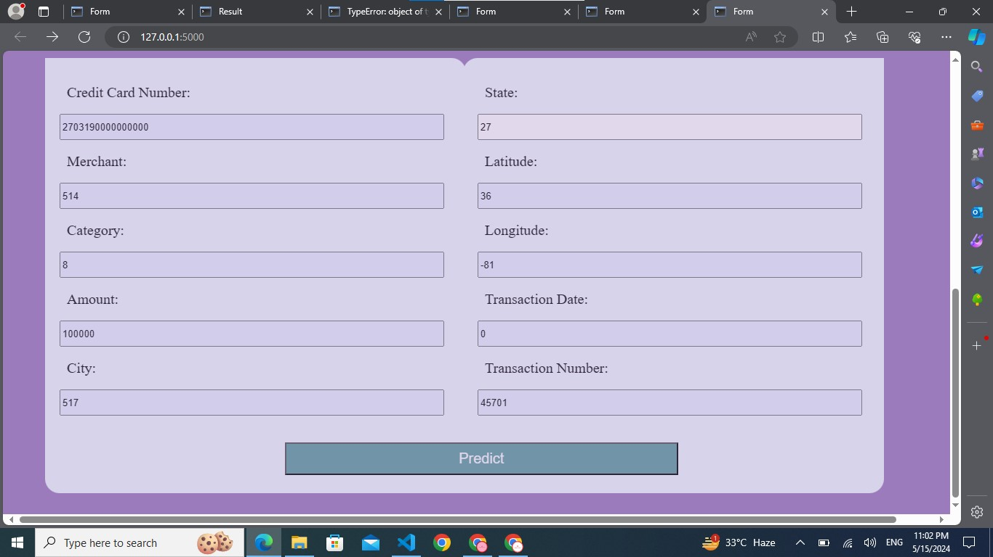

**Result**

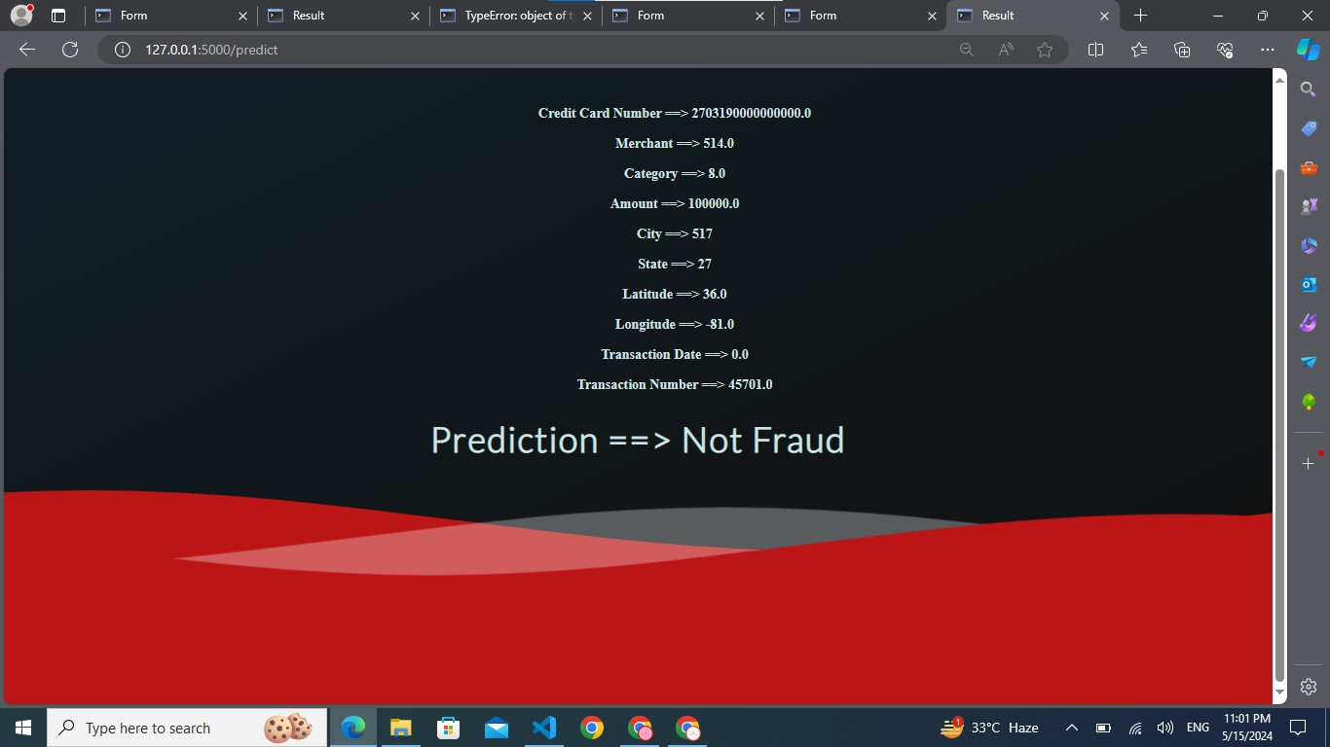

**THE END**