📝 Project Report: Handwritten Digit Recognition Using CNN and Flask

🔹 Project Title:
Handwritten Digit Recognition Using Convolutional Neural Networks (CNN) and Flask Web Interface

🔹 Objective:
The goal of this project is to build a machine learning system capable of recognizing handwritten digits (0–9) drawn by the user in a browser. The system predicts the digit in real-time using a trained deep learning model and provides a confidence score along with probability distribution.

🔹 Tools & Technologies Used:
Component | Technology
Frontend | HTML5, CSS3, JavaScript, Canvas API
Backend | Python 3, Flask (micro web framework)
ML Framework | TensorFlow / Keras
Dataset | MNIST (Modified National Institute of Standards and Technology)
Others | NumPy, Pillow, Base64, JSON

🔹 Dataset Description:
- The MNIST dataset contains 70,000 grayscale images of handwritten digits:
  - 60,000 for training
  - 10,000 for testing
- Each image is 28×28 pixels.
- Labels range from 0 to 9.

🔹 Model Architecture (CNN):
text
CopyEdit
Input: 28x28 grayscale image
→ Conv2D (32 filters, 3x3, ReLU)
→ MaxPooling2D (2x2)
→ Flatten
→ Dense (128 neurons, ReLU)
→ Dense (10 neurons, Softmax)
- Activation Function: ReLU and Softmax
- Optimizer: Adam
- Loss Function: Categorical Crossentropy

🔹 Frontend Functionality:
- User draws a digit on the HTML5 <canvas>.
- On clicking “Predict”, the canvas image is:
  - Captured and converted to Base64 PNG.
  - Sent to Flask backend via POST request.

🔹 Backend Functionality (Flask):
- Receives the image in base64 format.
- Converts it to grayscale using Pillow.
- Resizes to 28×28 and normalizes pixel values.
- Passes the image to the Digit_model_fixed or digit_model model.
- Returns the predicted digit and the full probability vector.

🔹 Output Display:
- Displays:
  - Predicted digit
  - Confidence score (e.g. 98.5%)
  - Probability distribution for all digits (0–9)

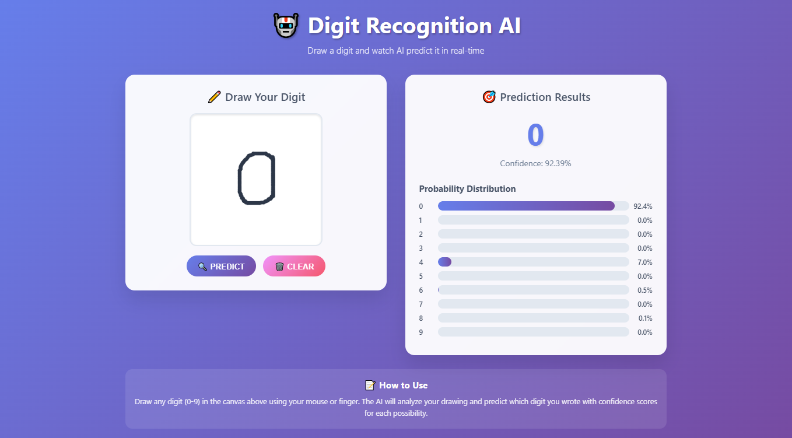

🔹 Key Features:
- Responsive, mobile-friendly UI.
- Real-time predictions with loading spinner.
- Smooth user experience using Canvas API and animation effects.
- Works on mouse and touch devices.

🔹 Conclusion:
This project successfully demonstrates the use of deep learning for a real-time web application. It blends machine learning, web development, and user interaction — a solid example of how AI can be applied in simple yet impactful ways.

