**Data Visualization Project**

**Graph recommendation system**

**----------------------------------------------------------------------**

**Name ==> Daniyal Muneer**

**Roll No. ==> 211980031**

**Data Scientist**

**----------------------------------------------------------------------**

**Report**

**Problem statement:**

Requirement is to make a system in which user comes to system and upload its .csv file and system shows all columns, system asks user to pick No. of columns on which he wants to perform analysis. System also asks user for analysis type (univariate, bivariate, multivariate) and at last system shows all possible plots.

**Objective:**

* + Allow user to upload .csv file
  + To select Analysis type
  + To pick No. of columns
  + To provide relevant recommendation graphs

**Architecture:**

This is user interface given below.

* I used a button for uploading file.
* I used a dropdown arrow for selecting type of analysis.
* I used a button for generating plots.

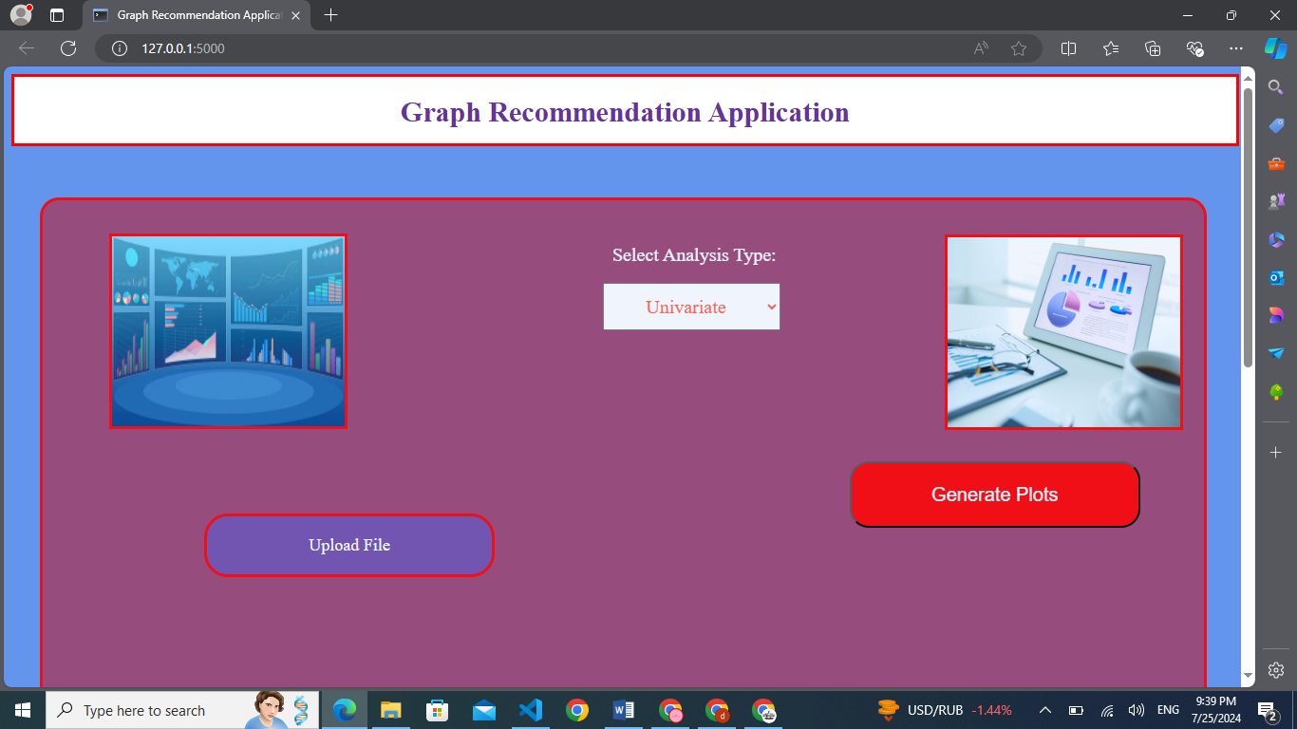

**Component description:**

I used following languages for it.

* I used HTML, CSS, java Script for front-end building.
* I used Python, Flask for back-end building.

**Workflow:**

I used switch-cases in this project.

1. Quantitative vs. Quantitative
2. Categorical vs. Categorical
3. Quantitative vs. Categorical
4. Categorical vs. Quantitative

**Data Visualization functions:**

I used a lot of graphs in this project.

**Univariate Analysis:**

1. Histogram

Quantitative variables

1. Empirical cumulative distribution
2. Area chart
3. Lollipop chart
4. Dot chart

-------------------------

Categorical variables

1. Count plot
2. Bar chart
3. Bubble chart
4. Pie chart
5. Donut chart

-------------------------

Quantitative vs. Quantitative

**Bivariate Analysis:**

1. Scatter plot
2. Line plot

Categorical vs.

Categorical

-------------------------

1. Stacked bar chart
2. Grouped bar chart

15. Segmented bar chart

-------------------------

16. Density plot

Categorical vs. Quantitative /

Quantitative vs.

Categorical

17. Strip plot

18. Box plot

19. Boxen plot

20. Violin plot

21. Swarm plot

-------------------------

**Multivariate Analysis:**

Quantitative vs. Quantitative

22. Heat Map

-------------------------

Categorical vs.

Categorical

23. Tree Map

24. Mosaic plot

-------------------------

Categorical vs. Quantitative /

Quantitative vs.

Categorical

25. Multiple plot

-------------------------

**How to run Code?**

1. First of all, user will come to flask file.
2. He runs the code at going terminal, there will be appeared an IP and click the link.
3. A front-end Website will be opened.
4. User will upload file, select analysis type and pick No. of columns for visualization.

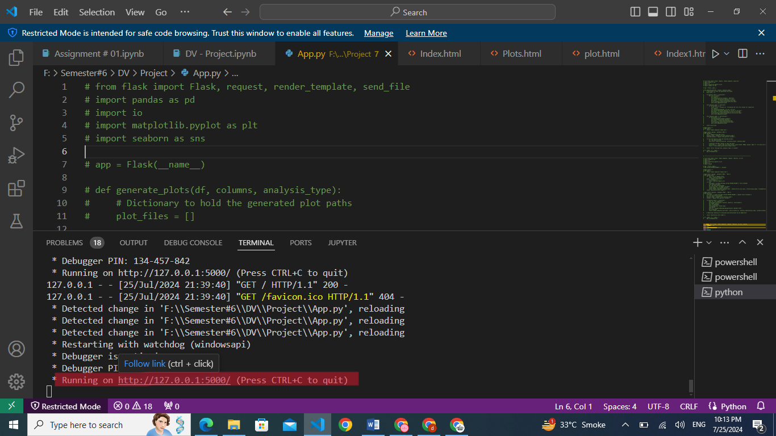

**Flask structure:**

**Uploads:** This folder has all .csv files.

**Templates:** This folder has all front-end files i.e .html

**Static:** This folder has all styling files for front-end i.e .css and all images that are present in front-end website.

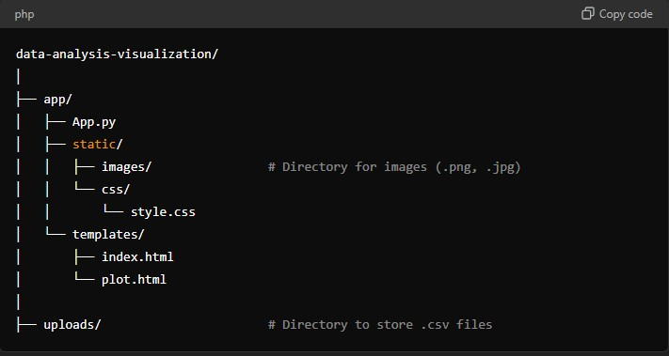

**Conclusion:**

This project is very useful for such a user who have no understanding about data analysis and data visualization. Its interface is very simple and user-friendly. It supports all various types of analysis, making it valuable tool for data analyst. It is very efficient for handling large datasets.

**\*\*\*\*\*\*\*\*\*\*\*\*\*\*THANKS\*\*\*\*\*\*\*\*\*\*\*\*\*\***