Data Mining Project Report

Project title:

Potato leaf disease detection Project

----------------------------------------------------------------------------------------------------------------------

**Dataset Description:**

First of all, I took a dataset of images of leaves of all potatoes where there are folders of dataset like

Training set

Testing set

On training set folder I have trained model and on testing set folder I have tested model.

**Model:**

I used **CNN** model for it because CNN model is used to tackle images data. It is the model of deep learning.

**Accuracy of Model:**

Accuracy of the model is almost 98%. It means it is neither overfitting nor underfitting.

**Languages:**

* + Front-end is made of **HTML** and **CSS**.
  + Back-end is made of **Python** in jupyter notebook.
  + **Flask** is used as bridge between front-end and back-end.

**How to run flask code?**

The simple way to run flask code is that we have to

* Open the whole folder where the whole project exists.
* Then press ctrl+**F5** on flask app. Then code will be running.

**Note!**

The project will be run when

* All HTML files will be in **templates** folder.
* All images will be in **static** folder.

**Procedure:**

First of all we run flask app by ctrl+**F5**. Then an interface of **Form.html** will be appeared, then user will upload an image of leaf in the form and that image will be going to flask app. After processing in flask app, if there is no error in flask app then interface of **Result.html** will be appeared.

**Form**

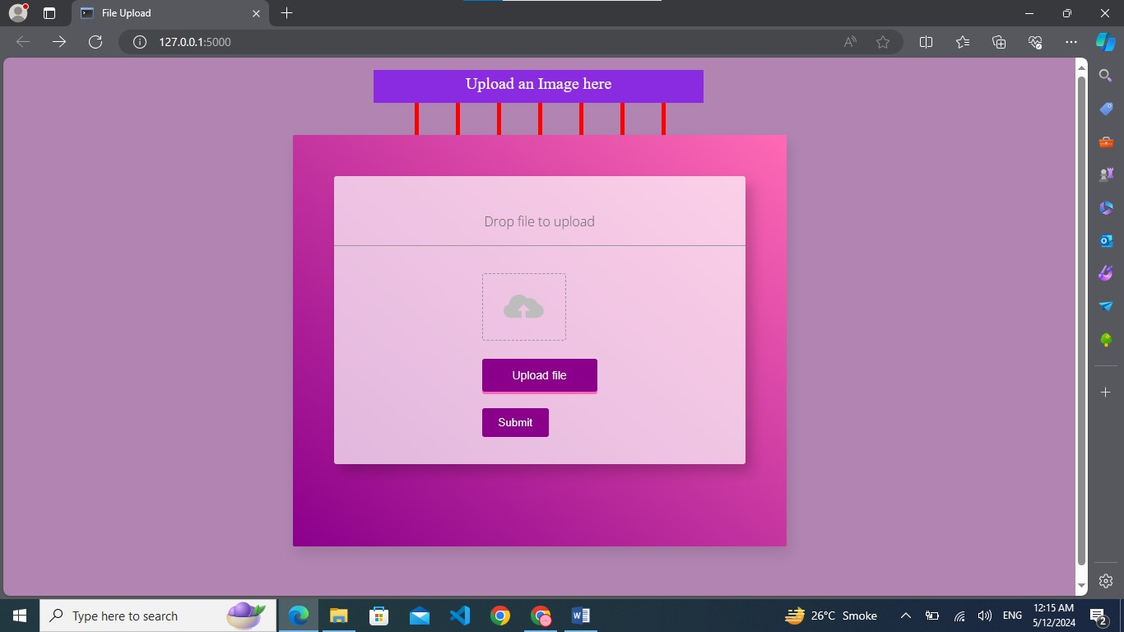

**Result**

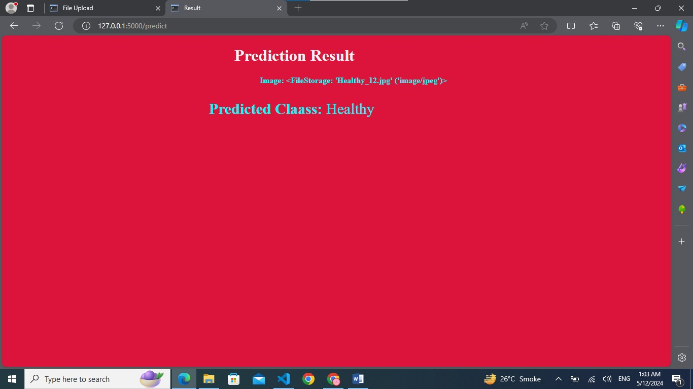

**THE END**