

TRIM-gYM

E-Project Report



**Group Member**

|  |  |  |
| --- | --- | --- |
| *S.No* | *Student ID* | *Student Name* |
| 1 | Student1156376 | MUHAMMAD DANIYAL |
| 2 | Student1145621 | ZAIYAB |

**Project Advisor**

Engr. Gulraiz Gulshan



**Aptech Computer Education**

Korangi Center

**ACKNOWLEDGEMENT**

First of all we would like to thank ALLAH the almighty who make us able to complete this project.

After that we would like to express profound gratitude to our internal project advisor, Center Faculty Head, ***Engr. Gulraeez Gulshan***, for his precious support, back-up, supervision and useful suggestions throughout this project. His moral support and continuous help enabled us to complete our work successfully. We are also highly thankful to the ***Center Management*** for their valuable suggestions, healthy analysis and support throughout this project.

We are grateful to the faculty members of Aptech Korangi Center who were always there to help us despite of their personal workload.

We are as ever, especially indebted to our parents for their love and support throughout our life. We also wish to thank our classmates, friends and all the individuals or groups that were involved in this project by any mean.

-MUHAMMAD SHARIQ

Table of Contents

1 E-Project 5

1.1 Website Features 5

1.2 Site Requirement 6

2 E-Project Design 6

2.1 Sitemap 6

2.2 Website structure 7

2.2.1 Bootstrap Grid System 7

2.2.2 Home Page Layout 9

2.2.3 Services For Men page lay-out 10

2.2.4 Services For Women page lay-out 11

2.2.5 Gallery page lay-out 11

2.2.6 Nutrition page lay-out 12

2.2.7 Facilities page layout 13

2.2.8 Our Branches page layout 14

2.2.9 Contact us Pagelayout 15

2.2.10 Feedback Pagelayout 16

2.2.11 Membership Pagelayout 18

3 E-project snapshots 19

3.1 Home page snapshots 19

4 Contact-Us 22

5 References 22

6 Source code 23

6.1 Main style sheet 23

6.2 Home page source code 28

Table of Figures

Figure 1Technology Used in Project 5

Figure 3 home page snapshot 18

Figure 4 Gallery Page snapshot 19

Figure 5 Facilitiespage snapshot 19

Figure 6 Our Branches snapshot 20

# E-Project

# 

Figure 1Technology Used in Project

## Website Features

* We have used bootstrap framework so as to make our website responsive. Although it is not as responsive as professional websites are, but we have tried basic implementation of a responsive website.
* Smooth hovering effects have been used.
* Color combination is according to Logo.
* Downloading of various book is available for user.

## Site Requirement

Since we have used bootstrap framework, it might have certain compatibility issues. We used the latest version of the framework and yet it has certain limitation. Below-mentioned is the compatibility chart for bootstrap. We highly recommend this website to be opened on “Google Chrome” due the best compatibility available.[4]

|  |  |  |  |  |  |
| --- | --- | --- | --- | --- | --- |
|  | ***Chrome*** | ***Firefox*** | ***Internet Explorer*** | ***Opera*** | ***Safari*** |
| Android | * Supported | * Supported | N/A | * Not Supported | N/A |
| Ios | * Supported | N/A | N/A | * Not Supported | * Supported |
| Mac OS X | * Supported | * Supported | N/A | * Supported | * Supported |
| Windows | * Supported | * Supported | * Supported | * Supported | * Not Supported |

# E-Project Design

## Sitemap

## Website structure

### Bootstrap Grid System

Since we have used bootstrap framework for website. Grid layout [5] making technique have been used in our website. For review, I have mentioned the basic structure of grid system which we have used in our project.

Table 1Bootstrap Grid Information

|  |  |  |  |  |
| --- | --- | --- | --- | --- |
|  | Extra Small Devices  (xs) | Small Devices  (sm) | Medium devices  (md) | Large devices  (lg) |
| Device Type | Phone (<768) | Tablets (≥768px) | Desktops (≥992px) | Desktops (≥1200px) |
| Container width | None (auto) | 750px | 970px | 1170px |
| Class prefix | .col-xs- | .col-sm- | .col-md- | .col-lg- |
| No. of columns | 12 | | | |
| Columns width | Auto | ~62px | ~81px | ~97px |
| Gutter width | 30px (15px on each side of column) | | | |

### Home Page Layout

|  |  |  |  |  |  |  |  |  |  |  |
| --- | --- | --- | --- | --- | --- | --- | --- | --- | --- | --- |
| |  |  |  |  |  |  |  | | --- | --- | --- | --- | --- | --- | --- | | logo | Home | Services | Gallery | Facilities | Our Branches | Contact Us | | | | |
| **Slider** | | | |
| Section For Women | | Section For Men | |
| First Image | Second Image | Third Image | Fourth Image |
| Image | | First Excercise | |
| Second Excercise | | Image | |
| Image | | Third Excercise | |
| Our Trainers | | | |
| Join Membership | | | |
| Why Choose us | | | |
| Footer | | | |

### Services For Men page lay-out

|  |  |  |
| --- | --- | --- |
| NavBar | | |
| Back Ground Image | | |
| Heading | | |
| First Program | Second Program | Third Program |
| Fourth Program | Fifth Program | Sixth Program |
| Footer | | |

### Services For Women page lay-out

|  |  |  |
| --- | --- | --- |
| NavBar | | |
| Back Ground Image | | |
| Heading | | |
| First Program | Second Program | Third Program |
| Fourth Program | Fifth Program | Sixth Program |
| Footer | | |

### Gallery page lay-out

|  |  |  |  |
| --- | --- | --- | --- |
| Navbar | | | |
| Slider | | | |
| Image 1 | Image 2 | Image 3 | Image 4 |
| Image 5 | Image 6 | Image 7 | Image 8 |
| Image 9 | Image 10 | Image 11 | Image 12 |
| Image 13 | Image 14 | Image 15 | Image 16 |
| Image 17 | Image 18 | Image 19 | Image 20 |
| Footer | | | |

### Nutrition page lay-out

|  |  |  |  |
| --- | --- | --- | --- |
| Navbar | | | |
| Bacground Image | | | |
| Heading | | | |
| For Week 1 | For Week 2 | For Week 3 | For Week 4 |
| Footer | | | |

### Facilities page layout

|  |
| --- |
| Navbar |
| Background Image |
| Facilitiy 1 |
| Facility 2 |
| Facility 3 |
| Footer |

### Our Branches page layout

|  |
| --- |
| Navbar |
| Site map of First Branch |
| Site map of Second Branch |
| Site map of Third Branch |
| Site map of Fourth Branch |
| Footer |

### Contact us Pagelayout

|  |
| --- |
| Navbar |
| Form |
| Footer |

### Feedback Pagelayout

|  |
| --- |
| Navbar |
| Form |
| Footer |

### Membership Pagelayout

|  |  |  |
| --- | --- | --- |
| Navbar | | |
| Membership Form | | |
| Package 1 | Package 2 | Package 3 |
| Footer | | |

# E-project snapshots

## Home page snapshots

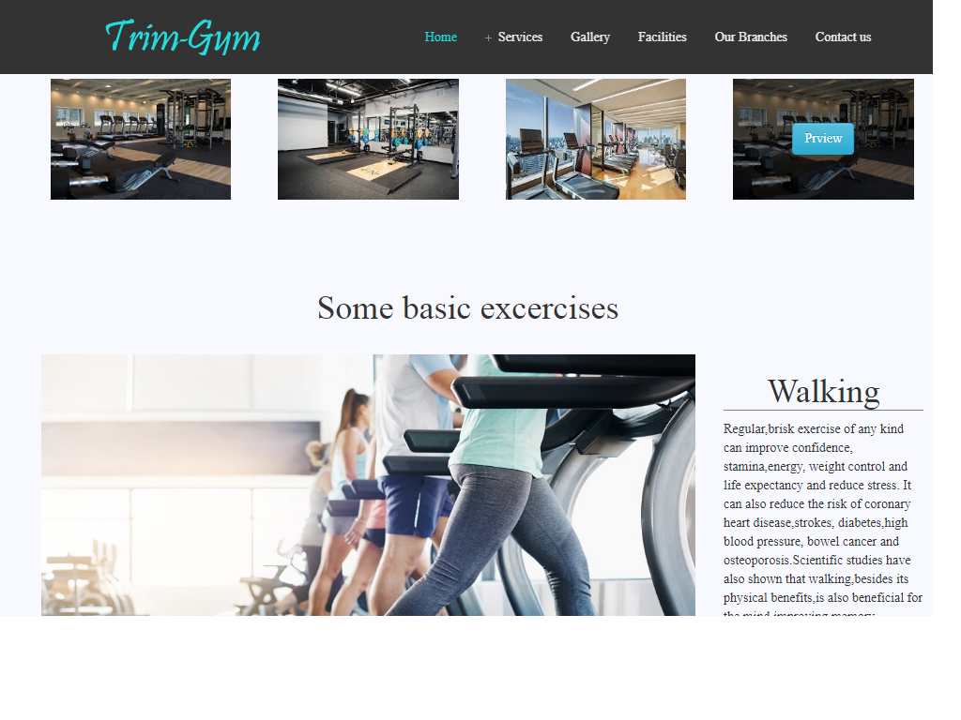

Figure 3 home page snapshot

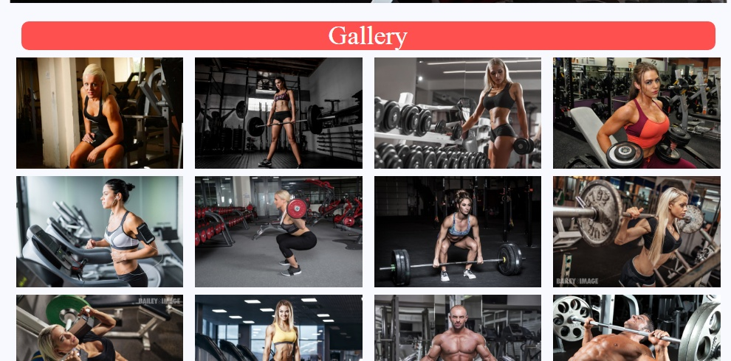

Figure 4 Gallery Page snapshot

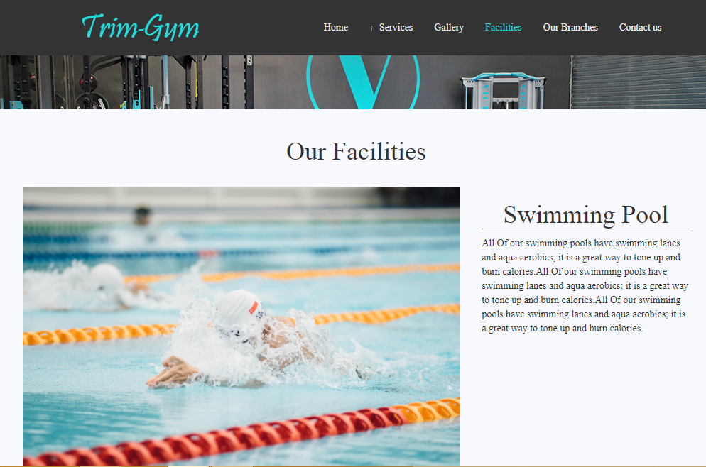

Figure 5 Facilitiespage snapshot

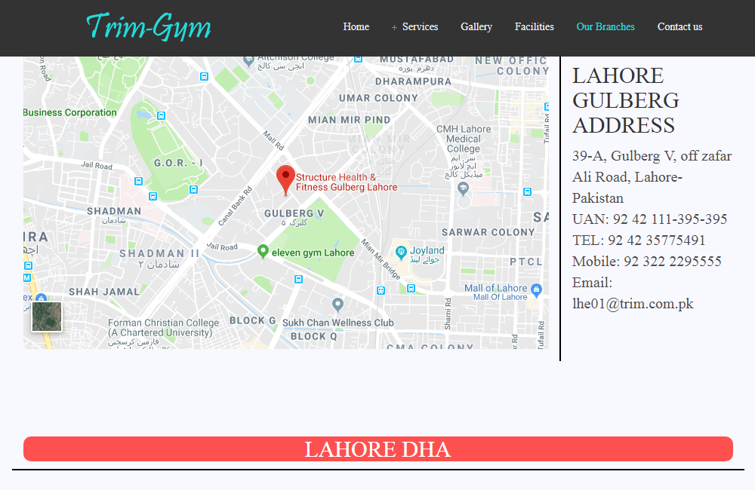

Figure 6 Our Branches snapshot

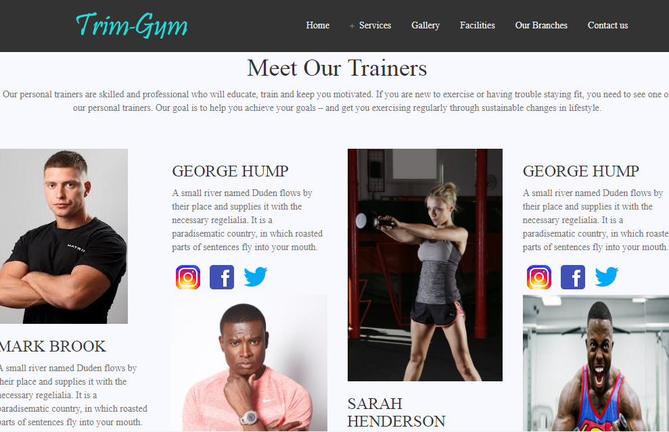

Figure 8 Trainers page snapshot

# Contact-Us

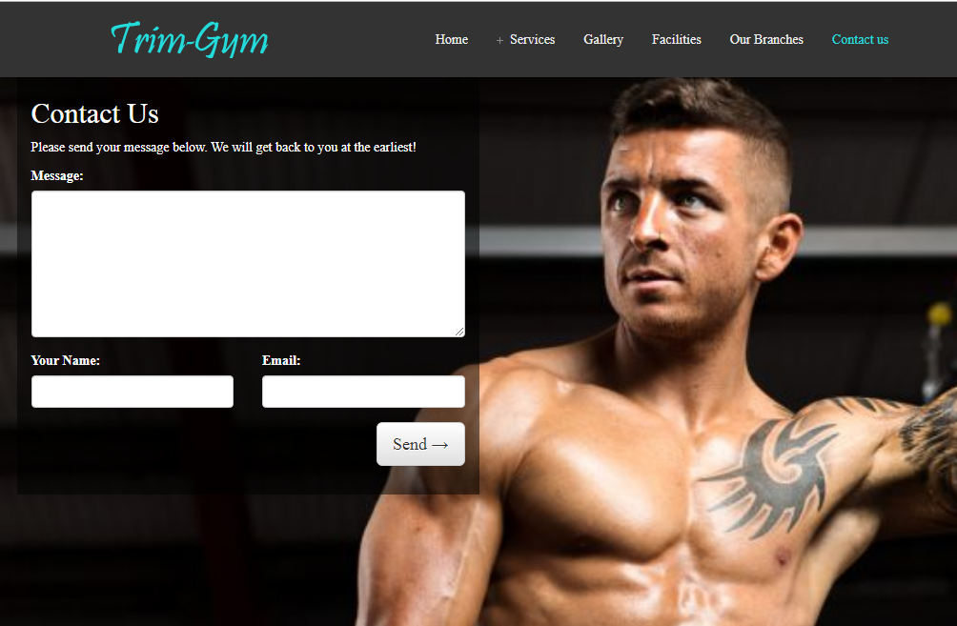

# References

|  |  |
| --- | --- |
| [1] | "jQuery," [Online]. Available: http://jquery.com/. |
| [2] | Bootstrap. [Online]. Available: http://getbootstrap.com/. |
| [3] | F. Awesome. [Online]. Available: http://fortawesome.github.io/Font-Awesome/. |
| [4] | "Bootstrap Support," [Online]. Available: http://getbootstrap.com/getting-started/#support. |
| [5] | "Bootstrap Grid System," [Online]. Available: http://getbootstrap.com/css/#grid. |

# Source code

## Main style sheet

footer {background-color: #111}

footer a{color:white;}

footer h2{ color: #00bff3}

footer a:hover{color:grey;text-decoration: none}

.textbox {

border: 2px inset #00bff3;

outline:0;

height:30px;

width: 275px;

}

body{background-color: #F8F8FF; font-family: Times New Roman, Times, serif;}

html {

scroll-behavior: smooth;

}

.logo-image{

width: 46px;

height: px;

border-radius: 50%;

margin-top: -6px;

}

/*image hover effect in excercise section */

.hvrbox,

.hvrbox * {

box-sizing: border-box;

}

.hvrbox {

position: relative;

display: inline-block;

overflow: hidden;

max-width: 100%;

height: auto;

}

.hvrbox img {

max-width: 100%;

}

.hvrbox .hvrbox-layer_bottom {

display: block;

}

.hvrbox .hvrbox-layer_top {

opacity: 0;

position: absolute;

top: 0;

left: 0;

right: 0;

bottom: 0;

width: 100%;

height: 100%;

background: rgba(0, 0, 0, 0.6);

color: #fff;

padding: 15px;

-moz-transition: all 0.4s ease-in-out 0s;

-webkit-transition: all 0.4s ease-in-out 0s;

-ms-transition: all 0.4s ease-in-out 0s;

transition: all 0.4s ease-in-out 0s;

}

.hvrbox:hover .hvrbox-layer_top,

.hvrbox.active .hvrbox-layer_top {

opacity: 1;

}

.hvrbox .hvrbox-text {

text-align: center;

font-size: 18px;

display: inline-block;

position: absolute;

top: 50%;

left: 50%;

-moz-transform: translate(-50%, -50%);

-webkit-transform: translate(-50%, -50%);

-ms-transform: translate(-50%, -50%);

transform: translate(-50%, -50%);

}

.hvrbox .hvrbox-text_mobile {

font-size: 15px;

border-top: 1px solid rgb(179, 179, 179); /* for old browsers */

border-top: 1px solid rgba(179, 179, 179, 0.7);

margin-top: 5px;

padding-top: 2px;

display: none;

}

.hvrbox.active .hvrbox-text_mobile {

display: block;

}

1.hvrbox,

.hvrbox * {

box-sizing: border-box;

}

.hvrbox {

position: relative;

display: inline-block;

overflow: hidden;

max-width: 100%;

height: auto;

}

.hvrbox img {

max-width: 100%;

}

.hvrbox .hvrbox-layer_bottom {

display: block;

}

.hvrbox .hvrbox-layer_top {

opacity: 0;

position: absolute;

top: 0;

left: 0;

right: 0;

bottom: 0;

width: 100%;

height: 100%;

background: rgba(0, 0, 0, 0.5);

color: #fff;

padding: 15px;

-moz-transition: all 0.4s ease-in-out 0s;

-webkit-transition: all 0.4s ease-in-out 0s;

-ms-transition: all 0.4s ease-in-out 0s;

transition: all 0.4s ease-in-out 0s;

}

.hvrbox:hover .hvrbox-layer_top,

.hvrbox.active .hvrbox-layer_top {

opacity: 1;

}

.hvrbox .hvrbox-text {

text-align: center;

font-size: 18px;

display: inline-block;

position: absolute;

top: 50%;

left: 50%;

-moz-transform: translate(-50%, -50%);

-webkit-transform: translate(-50%, -50%);

-ms-transform: translate(-50%, -50%);

transform: translate(-50%, -50%);

}

.hvrbox .hvrbox-text_mobile {

font-size: 15px;

border-top: 1px solid rgb(179, 179, 179); /* for old browsers */

border-top: 1px solid rgba(179, 179, 179, 0.7);

margin-top: 5px;

padding-top: 2px;

display: none;

}

.hvrbox.active .hvrbox-text_mobile {

display: block;

}

.img hover{ color: red}

.button{font-size: 18px;font-family: Arial, Helvetica, sans-serif;height: 55px;line-height: 18px;background-color: #DC143C;border:1px solid #DC143C}

.button:hover{color:black;background-color: white;transition: 0.9s}

.a{color:#DC143C;text-decoration: none;font-family:Trattatello, fantasy;font-size: 18px}

.a:hover{color: grey;text-decoration: none}

h4 a{color:#484E5B;text-decoration: none;font-size: 25px}

h4 a:hover{color:#DC143C;text-decoration: none}

div button{width:220px;font-size: 20px;font-family: Arial, Helvetica, sans-serif;;background-color: #DC143C;border-radius: 0.5px solid #DC143C;color: white}

.buttons{width:220px;font-size: 20px;font-family: Arial, Helvetica, sans-serif;;background-color: #DC143C;border: 0.5px solid #DC143C;color: white;height: 40px}

.buttons:hover{color:black;background-color: white;transition: 0.9s}

button{ border-radius: 4px;

}

## Home page source code

<!DOCTYPE html>

<html>

<head>

<link rel="stylesheet" href="https://maxcdn.bootstrapcdn.com/bootstrap/3.3.7/css/bootstrap.min.css" integrity="sha384-BVYiiSIFeK1dGmJRAkycuHAHRg32OmUcww7on3RYdg4Va+PmSTsz/K68vbdEjh4u" crossorigin="anonymous">

<!-- Optional theme -->

<link rel="stylesheet" href="https://maxcdn.bootstrapcdn.com/bootstrap/3.3.7/css/bootstrap-theme.min.css" integrity="sha384-rHyoN1iRsVXV4nD0JutlnGaslCJuC7uwjduW9SVrLvRYooPp2bWYgmgJQIXwl/Sp" crossorigin="anonymous">

<script src="https://ajax.googleapis.com/ajax/libs/jquery/1.12.4/jquery.min.js"></script>

<!-- Latest compiled and minified JavaScript -->

<script src="https://maxcdn.bootstrapcdn.com/bootstrap/3.3.7/js/bootstrap.min.js" integrity="sha384-Tc5IQib027qvyjSMfHjOMaLkfuWVxZxUPnCJA7l2mCWNIpG9mGCD8wGNIcPD7Txa" crossorigin="anonymous"></script>

<link rel="stylesheet" type="text/css" href="firstpagecss.css">

<link rel="stylesheet" href="https://use.fontawesome.com/releases/v5.8.0/css/all.css" integrity="sha384-Mmxa0mLqhmOeaE8vgOSbKacftZcsNYDjQzuCOm6D02luYSzBG8vpaOykv9lFQ51Y" crossorigin="anonymous">

<meta charset="utf-8" />

<meta name="author" content="Script Tutorials" />

<meta name="viewport" content="width=device-width, initial-scale=1.0, maximum-scale=1.0, user-scalable=no">

<!-- css font and stylesheet -->

<link href="footer.css" rel="stylesheet">

<!--navbar css-->

<link rel="stylesheet" type="text/css" href="navbrcss.css">

<!--Firstpagecss-->

<link rel="stylesheet" type="text/css" href="cssforallpages.css">

<!--Firstpagescript-->

<script src=jsforallpages.js ></script>

<!--Sponsors slider-->

<!--Nav links-->

<link rel="stylesheet" type="text/css" href="navbar/css/font-awesome.css">

<link rel="stylesheet" type="text/css" href="navbar/css/menu.css">

<script type="text/javascript" src="navbar/js/jquery.js"></script>

<script type="text/javascript" src="navbar/js/function.js"></script>

<!--Com slider-->

<script type="text/javascript">var oCOMScript1798402=document.createElement('script');oCOMScript1798402.src="https://commondatastorage.googleapis.com/comslider/target/users/1553398685x8bdafa2916291f3874b2fac94d879e43/comslider.js?timestamp=1553404687&ct="+Date.now();oCOMScript1798402.type='text/javascript';document.getElementsByTagName("head").item(0).appendChild(oCOMScript1798402);</script>

</head>

<body>

<!--navbar-->

<div id="wrap">

<header class="navbar-fixed-top">

<div class="inner relative">

<a class="logo" href="index.html"><div class="logo-image"><img style="padding-top:10px;"src="logo.png" alt="fresh design web"></div></a>

<a id="menu-toggle" href="#"><i class="icon-reorder"></i></a>

<nav id="navigation">

<ul id="main-menu">

<li class="current-menu-item"><a href="index.html">Home</a></li>

<li class="parent">

<a href="#">Services</a>

<ul class="sub-menu">

<li><a href="formen.html">For Man</a></li>

<li><a href="forwomen.html">For Women</a></li>

<li><a href="nutritionplan.html">Nutrition Plan</a></li>

</ul>

</li>

<li><a href="projectgallery.html">Gallery</a></li>

<li><a href="facilities.html">Facilities</a></li>

<li><a href="ourbranches.html">Our Branches</a></li>

<li><a href="contactus/formpage.html">Contact us</a></li>

</ul>

</nav>

<div class="clear"></div>

</div>

</header>

</div>

<!--Nav End-->

<div class="container-fluid">

<div style="margin-top:40px" class="container">

<!--Com slider-->

<div class="row"><div class="col-lg-12 col-md-12 col-sm-12 col-xs-12" ></div>

<div id="comslider_in_point_1798402"></div></div>

<!--Section for men and women-->

<div class="container">

<div class="row">

<div class="col-lg-6 col-md-6 col-sm-6 col-xs-12"><div class="hvrbox" style="margin: 10px;"><img class="img-responsive" src="images/firstpageimages/women.jpg"><div class="hvrbox-layer_top"> <div class="hvrbox-text"><a class="btn btn-info"" href="forwomen.html">View</a>

</div></div></div></div>

<div class="col-lg-6 col-md-6 col-sm-6 col-xs-12"><div class="hvrbox" style="margin: 10px;"><img class="img-responsive" src="images/firstpageimages/men.jpg"><div class="hvrbox-layer_top"> <div class="hvrbox-text"><a class="btn btn-info" href="formen.html">View</a>

</div></div></div></div>

</div>

</div>

<br><br>

<!--Gallery-->

<div class="container">

<div class="row">

<div class="col-lg-3 col-md-3 col-sm-3 col-xs-12"><div class="hvrbox" style="margin: 10px;"><img class="img-responsive" src="images/firstpageimages/img1.jpg"><div class="hvrbox-layer_top"> <div class="hvrbox-text"><a class="btn btn-info" href="projectgallery.html">Prview</a></div></div></div></div>

<div class="col-lg-3 col-md-3 col-sm-3 col-xs-12 "><div class="hvrbox" style="margin: 10px;"><img class="img-responsive" src="images/firstpageimages/img2.jpg"><div class="hvrbox-layer_top"> <div class="hvrbox-text"><a class="btn btn-info"r" href="projectgallery.html">Prview</a></div></div></div></div>

<div class="col-lg-3 col-md-3 col-sm-3 col-xs-12 "><div class="hvrbox" style="margin: 10px;"><img class="img-responsive" src="images/firstpageimages/img3.jpg"><div class="hvrbox-layer_top"> <div class="hvrbox-text"><a class="btn btn-info"" href="projectgallery.html">Prview</a></div></div></div></div>

<div class="col-lg-3 col-md-3 col-sm-3 col-xs-12"><div class="hvrbox" style="margin: 10px;"><img class="img-responsive" src="images/firstpageimages/img1.jpg"><div class="hvrbox-layer_top"> <div class="hvrbox-text"><a class="btn btn-info"" href="projectgallery.html">Prview</a></div></div></div></div>

</div>

</div>

<br>

<br><br>

<!--Gallery End-->

<!--Basic Excercises-->

<h1 align="center">Some basic excercises</h1>

<br>

<!--First portion-->

<div class="container">

<div class="row">

<!--Imagediv-->

<div class="col-lg-9 col-md-9 col-sm-12 col-xs-12">

<div>

<img src="images/firstpageimages/img5.jpg" class="img-responsive">

</div>

</div>

<!--Imagediv end-->

<!--Content area Start-->

<div class="col-lg-3 col-md-3 col-sm-3 col-xs-12">

<h1 style="border-bottom:1px solid grey" align="center">Walking</h1>

<p>Regular,brisk exercise of any kind can improve confidence, stamina,energy, weight control and life expectancy and reduce stress. It can also reduce the risk of coronary heart disease,strokes, diabetes,high blood pressure, bowel cancer and osteoporosis.Scientific studies have also shown that walking,besides its physical benefits,is also beneficial for the mind,improving memory skills,learning ability,concentration and abstract reasoning, as well as ameliorating spirits.</p>

<a class="a" href="form.html" >Join Now </a>

</div>

</div>

<!--Content area end-->

<!--Firstportion End-->

<br>

<br>

<!--Second portion-->

<div class="row">

<!--Content area Start-->

<div class="col-lg-3 col-md-3 col-sm-3 col-xs-12">

<h1 style="border-bottom:1px solid grey" align="center">YOGA</h1>

<p>Research suggests that yoga practice can protect boys from increases in negative behavior.Physical benefits include increased flexibility, improved coordination and balance, and increased core and body strength. Mental benefits include stronger mind-body connection, increased self-esteem, better focus and concentration, and increased ability to relax and cope with stressful situations.</p>

<a class="a" href="form.html" >Join Now </a>

</div>

<!--Content area end-->

<!--Imagediv-->

<div class="col-lg-9 col-md-9 col-sm-12 col-xs-12">

<div>

<img src="images/firstpageimages/img6.jpg" class="img-responsive">

</div>

</div>

<!--Imagediv end-->

</div>

<!--Second portion End-->

<br>

<br>

<!--Third portion-->

<div class="row">

<!--Imagediv-->

<div class="col-lg-9 col-md-9 col-sm-12 col-xs-12">

<div>

<img src="images/firstpageimages/img7.jpg" class="img-responsive">

</div>

</div>

<!--Imagediv end-->

<!--Content area Start-->

<div class="col-lg-3 col-md-3 col-sm-3 col-xs-12">

<h1 style="border-bottom:1px solid grey" align="center">Zumba</h1>

<p>Zumba is an exercise fitness program created by Colombian dancer and choreographer Alberto "Beto" Perez during the 1990s.[1] Zumba involves dance and aerobic movements performed to energetic music. The choreography incorporates hip-hop, soca, samba, salsa, merengue and mambo. Squats and lunges are also included</p>

<a class="a" href="form.html" >Join Now </a>

</div>

<!--Content area end-->

</div>

</div>

<!--Third portion End-->

<!--------------------Trainers--------------------->

<br>

<div class="container"><div class="row" style="background-image: url(images/img7.png) ;"><div class="col-md-12"><h1 style="color: black" align="center">Meet Our Trainers</h1><p class="text-muted" align="center">Our personal trainers are skilled and professional who will educate, train and keep you motivated. If you are new to exercise or having trouble staying fit, you need to see one of our personal trainers. Our goal is to help you achieve your goals – and get you exercising regularly through sustainable changes in lifestyle.</p><img src="images/trainers.png" class="img-responsive"></div></div></div> <br>

<!----------------------Buttons----------------------------------->

<div class="container"><div class="row">

<div class="col-lg-4 col-md-4 col-sm-4 col-xs-12"><div align="center" style="padding: 10px"><a href="ourtrainers.html">

<button class="buttons">Lahore Gulburg</button></a>

</div></div>

<div class="col-lg-4 col-md-4 col-sm-4 col-xs-12"><div align="center" style="padding: 10px">

<a href="ourtrainers.html"><button class="buttons">Karachi DHA </button></a>

</div></div>

<div class="col-lg-4 col-md-4 col-sm-4 col-xs-12s"><div align="center" style="padding: 10px">

<a href="ourtrainers.html"><button class="buttons">Islamabad DHA </button></a></div>

</div>

</div></div>

<br><br><br><br>

<!--Join us-->

<div class="row">

<div class="col-lg-12 col-md-12 col-sm-12 col-xs-12">

<div style="background-image:url(images/firstpageimages/img9.jpg);font-family: Arial, Helvetica, sans-serif;color:white;padding: 50px ">

<br><br><br><br>

<br><br><br><br><br><br><br><br>

<h4>JOIN YOUR LOCAL !</h4>

<h1>TRIM-MEMBERSHIP</h1>

<h3>GREAT VALUE EVERYDAY </h3>

<br><br><br><br>

<a href="form.html"><button class="button">GET STARTED</button></a>

<br><br><br><br><br><br><br><br><br>

</div>

</div>

</div>

<br><br>

<!--Advertisement section-->

<div class="container-fluid">

<div class="row">

<!--First Product--->

<div style="background-color:#FFFAFA; " class="col-lg-3 col-md-3 col-sm-3 col-xs-12">

<div><br><button style="width:70px ">Sale!</button><a href="#"><img class="img-responsive " src="images/product1.png"></a></div><h4 align="center"><a href="#">Stamina Elliptical<br>Trainer</a></h4><h3 style="color:#484E5B" align="right">£99.99</h3><a href="product.html"><button class="button"><i class="fa fa-shopping-bag" aria-hidden="true"></i> Buy Now</button></a>

</div>

<!--Second Product--->

<div style="background-color:#FFFAFA; " class="col-lg-3 col-md-3 col-sm-3 col-xs-12">

<div><br><button style="width:70px ">Sale!</button><a href="#"><img class="img-responsive" src="images/product2.png"></a></div><h4 align="center"><a href="#">The Ultimate<br>Wheel</a></h4><h3 style="color:#484E5B" align="right">£59.99</h3><a href="product.html"><button class="button"><i class="fa fa-shopping-bag" aria-hidden="true"></i> Buy Now</button></a>

</div>

<!--Third Product--->

<div style="background-color:#FFFAFA;" class="col-lg-3 col-md-3 col-sm-3 col-xs-12">

<div><br><button style="width:70px ">Sale!</button><a href="#"><img class="img-responsive" src="images/product3.png"></a></div><h4 align="center"><a href="#">Excercise yoga Mat<br>for Pilates</a></h4><h3 style="color:#484E5B" align="right">£20.99</h3><a href="product.html"><button class="button"><i class="fa fa-shopping-bag" aria-hidden="true"></i> Buy Now</button></a>

</div>

<!--Fourth Product--->

<div style="background-color:#FFFAFA;" class="col-lg-3 col-md-3 col-sm-3 col-xs-12">

<div><br><button style="width:70px ">Sale!</button><a href="#"><img class="img-responsive" src="images/product6.png"></a></div><h4 align="center"><a href="#">Dumblles<br>2.55KG</a></h4><h3 style="color:#484E5B" align="right">£36.99</h3><a href="product.html"><button class="button"><i class="fa fa-shopping-bag" aria-hidden="true"></i> Buy Now</button></a>

</div>

</div>

<!-- Advertise section end-->

</div><br>

<!--Why Choose us-->

<br><br>

<div class="container-fluid">

<div style="background-color:#D7DBDD;" class="container-fluid" style="background-color: rgb(230,230,216);">

<div class="row">

<div class="col-lg-12 col-md-12 col-sm-12 col-xs-12">

<h1 style="color:black" align="center">Why Choose us ?</h1>

<p style="color:black" >Trim-gym is for adults who have neglected their bodies and want to lose 10 to 50+ pounds, live healthier and get jealous compliments form their friends. We have been recognized Internationally as World Fitness Elite game changers and named Fitness Business of the Year for the United States and Canada for providing exceptional client results! Unlike gym memberships and other generic/fad programs that have failed you in the past, our results-based training focuses on your personal wants and needs, in a fun, social and family style atmosphere that you'll call home.

We don’t follow the traditional gym practices; we have added all the ingredients to make your workout at “Structure” an experience. You will find individual TV’s on all cardio equipment, juice bar, the gem of a glistering swimming pool, sauna, Jacuzzi, showers and locker rooms; in short, you will find an incredibly motivating, intense atmosphere; the best training equipment in the world; some of the best attentive and knowledgeable staff and at the same time a perfect place to relax and let go of your stress!

We have the solution to make it happen for you! Our training facility is a place where people come to get fit, lose weight, learn to exercise right, learn to live better, eat healthier, supplement properly and just feel amazing! In fact, all this is part of every program. No fads. No gimmicks. Just real world in-the-trenches science!</p>

</div>

</div>

</div>

</div></div>

<!--Why Choose us-->

<!--Sponsers slider-->

<br><br>

<!-- Footer-->

<!-- Footer-->

<footer>

<form >

<div style="padding:20px; " class="row">

<div class="col-lg-12 col-md-12 col-sm-12 col-xs-12">

<div align="center">

<h2 style="background-color:transparent; ">Subscribe To our Newsletter</h2>

</div>

<div align="center">

<input id="join" class="textbox form-group" style="" type="text" placeholder="Please Enter Your Email Address"> <button style="background-color: #00bff3;width: 90px" type="submit" class="btn btn-motive">Subscribe</button>

</div>

</div>

</div>

</form>

<!--first section row-->

<div class="row" style="padding: 20px;">

<!--first column start-->

<div class="col-lg-4 col-md-4 col-sm-4 col-xs-12">

<div style="padding-right:20px;padding-left: 20px;border-right:2px solid white; ">

<div style="border-bottom:2px solid white"> <h2 class="ct-footer-list-header">

Who is it For

</h2></div>

<p style="color:white;padding-top: 15px">We cater to business and corporate community, high school or college students and all like-minded people that are driven to attain their fitness goals in an exclusive environment. Every square inch of our facility is dedicated to getting you ideally fit, strong, healthy and mentally tough to face the challenges of everyday life.

</p>

<br><br><br>

</div>

</div>

<!-- first coloumn end-->

<!-- Second coloumn start-->

<div class="col-lg-4 col-md-4 col-sm-4 col-xs-12">

<div style="padding-right:20px;padding-left: 20px;border-right:2px solid white; ">

<div style="border-bottom:2px solid white"> <h2 class="ct-footer-list-header">

Who is it For

</h2></div>

<p style="color:white;padding-top: 15px">We cater to business and corporate community, high school or college students and all like-minded people that are driven to attain their fitness goals in an exclusive environment. Every square inch of our facility is dedicated to getting you ideally fit, strong, healthy and mentally tough to face the challenges of everyday life.

</p>

<br><br><br>

</div>

</div>

<!-- Second coloumn end-->

<!-- Third coloumn start-->

<div class="col-lg-4 col-md-4 col-sm-4 col-xs-12">

<div style="padding-right:20px;padding-left: 20px; ">

<div style="border-bottom:2px solid white"> <h2 class="ct-footer-list-header">

Membership

</h2></div>

<div style="color:white"><br>

<div><a href="aboutus.html">About us</a></div><br>

<div><a href="Eproject.PDF">Download our info PDF</a></div><br>

<div><a href="feedback.html">Feedback</a></div><br>

<div><a href="form.html">Corporate memberships</a></div><br>

<div><a href="privacypolicy.html">Privacy policy</a></div><br><br><br><br><br>

</div>

</div>

</div>

<!-- Third coloumn end-->

</div>

<!--first section row end-->

<!-- Second section start-->

<div class="row" style=";padding:20px;padding-top:30px; border-top: 1px solid rgba(255, 255, 255, 0.1)">

<div class="col-lg-6 col-md-6 col-sm-6 col-xs-12">

<p style="color:white">

Copyright © 2016 Trim-Gym.&nbsp;<a href="">Privacy Policy</a>

</p>

</div>

<div class="col-lg-6 col-md-6 col-sm-6 col-xs-12">

<div style=";color: white;text-decoration: none" class="row">

<div class= "col-lg-3 col-md-3 col-sm-3 col-xs-3"> <a href="https://www.facebook.com/" target="_blank"><img alt="twitter" src="https://www.solodev.com/assets/footer/facebook-white.png"></a></div>

<div class= "col-lg-3 col-md-3 col-sm-3 col-xs-3"> <a href="https://www.youtube.com/" target="_blank"><img alt="youtube" src="https://www.solodev.com/assets/footer/youtube-white.png"></a></div>

<div class= "col-lg-3 col-md-3 col-sm-3 col-xs-3"> <a href="https://www.instagram.com/" target="_blank"><img alt="instagram" src="https://www.solodev.com/assets/footer/instagram-white.png"></div>

<div class= "col-lg-3 col-md-3 col-sm-3 col-xs-3"> <a href="https://twitter.com/" target="_blank"><img alt="twitter" src="https://www.solodev.com/assets/footer/twitter-white.png"></div>

</div>

</div>

</div>

<!--second section end-->

</footer>

</div>

</body>

</html>