  - Task
Relation A)
A)

Superkeys are

EmpID
SSN
Email
EmpID, name
SSN department
Email, phone

B)

Candidate keys

EMPid
SSN
Email

C)
I would choose EMPid as the primary key, because , it is short and simple, it is specifically designed to identify an employee , it doesn’t contain sensitive info, easier to use in foreign key relationships , it is stable compared with attributes such as email or phone number .

D)
Yes they can have the same phone number. The sample data shows different phone numbers , but the relation does not state that Phone must be unique. For exmpl , two employees can share a company phone or office phone.

Relation B)
The primary key should be (StudentID, CourseCode, Section, Semester, Year)

Why i chose them
Studentid - Identifies which student is registered
CourseCode- Identifies the course

Section – Identifies the specific section of the course
Semester - allows the same student to take the same course in different semesters
Year- Distinguishies the same semester across different years.

Additional candidate keys task
Based on business rules there are no candidate keys.

Task 1.2
Foreign key relations
Student.AdvisorID to Professor.ProfID
Professor.Department to Department.DeptCode
Course.DepartmentCode to Department.DeptCode
Department.ChairID to Professor.ProfID
Enrollment.StudentID to Student.StudentID
Enrollment.CourseID to Course.CourseID

Task 2
\

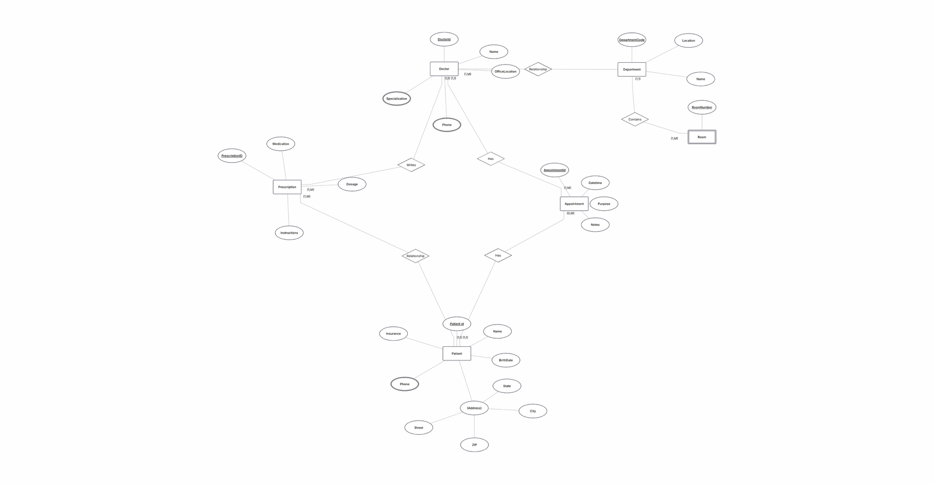

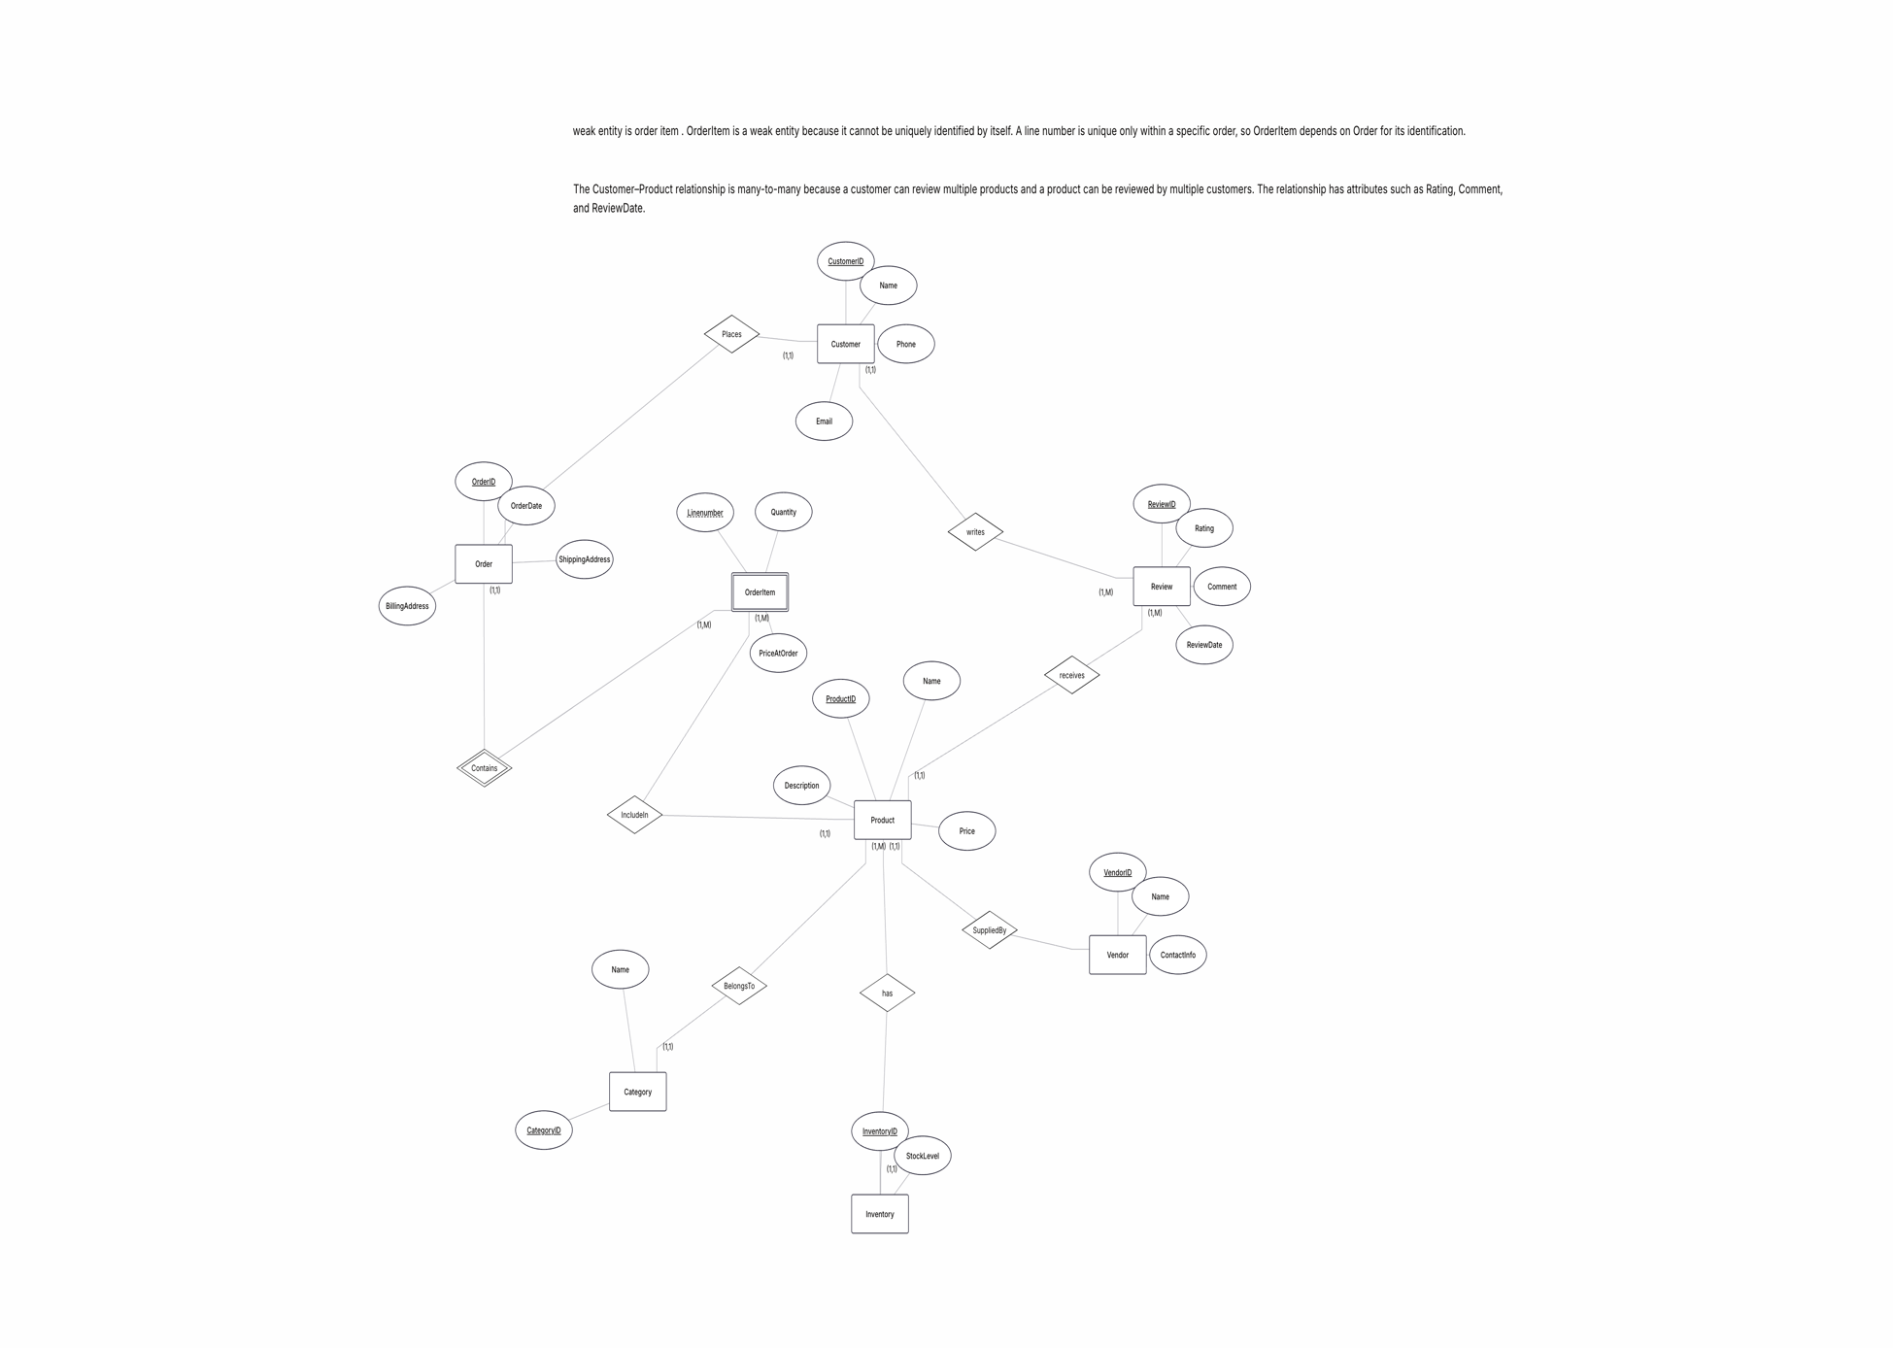

Part 4: Normalization Workshop

Task 4.1: Denormalized Table Analysis

1. Functional Dependencies
StudentID → StudentName, StudentMajor
ProjectID → ProjectTitle, ProjectType, SupervisorID, StartDate, EndDate
SupervisorID → SupervisorName, SupervisorDept
(StudentID, ProjectID) → Role, HoursWorked

2. Problems
Redundancy: Student and project information is repeated in multiple rows.
Update anomaly: Changing a supervisor's department requires updating multiple rows.
Insert anomaly: A new project cannot easily be added if no student is assigned to it.
Delete anomaly: Deleting the only student assigned to a project may also delete the project's information.

3. 1NF
The table is already in 1NF because all attributes contain atomic values and there are no repeating groups.

4. 2NF
Primary Key: (StudentID, ProjectID)
Partial dependencies:
StudentID → StudentName, StudentMajor
ProjectID → ProjectTitle, ProjectType, SupervisorID, StartDate, EndDate
2NF decomposition:
Student(StudentID, StudentName, StudentMajor)
Project(ProjectID, ProjectTitle, ProjectType, SupervisorID, StartDate, EndDate)
StudentProject(StudentID, ProjectID, Role, HoursWorked)

5. 3NF
Transitive dependency:
ProjectID → SupervisorID
SupervisorID → SupervisorName, SupervisorDept
Final 3NF decomposition:
Student(StudentID, StudentName, StudentMajor)
Project(ProjectID, ProjectTitle, ProjectType, SupervisorID, StartDate, EndDate)
Supervisor(SupervisorID, SupervisorName, SupervisorDept)
StudentProject(StudentID, ProjectID, Role, HoursWorked)

Task 4.2: Advanced Normalization

1. Primary Key
The primary key is:
(StudentID, CourseID, TimeSlot, Room)
It identifies a student's enrollment in a specific course section.

2. Functional Dependencies
StudentID → StudentMajor
CourseID → CourseName
InstructorID → InstructorName
(TimeSlot, Room) → Building
(CourseID, TimeSlot, Room) → InstructorID

3. BCNF
The table is not in BCNF because several determinants are not superkeys.
For example:
StudentID → StudentMajor
StudentID does not uniquely identify a row in the original table.

4. BCNF Decomposition
Student(StudentID, StudentMajor)
Course(CourseID, CourseName)
Instructor(InstructorID, InstructorName)
RoomSchedule(TimeSlot, Room, Building)
CourseSection(CourseID, TimeSlot, Room, InstructorID)
Enrollment(StudentID, CourseID, TimeSlot, Room)

5. Information Loss
The decomposition is lossless. The original information can be reconstructed using joins between the tables. No actual information is lost, but retrieving the complete information requires several joins.

Part 5: Design Challenge
Task 5.1: Real-World Application
1. ER Diagram
Entities:
STUDENT: StudentID (PK), FirstName, LastName, Email
CLUB: ClubID (PK), ClubName, Description, FoundedDate
FACULTY: FacultyID (PK), FirstName, LastName, Email
EVENT: EventID (PK), EventName, Description, EventDate, StartTime, EndTime
ROOM: RoomID (PK), Building, RoomNumber, Capacity
ROOM_RESERVATION: ReservationID (PK), ReservationDate, StartTime, EndTime
BUDGET: BudgetID (PK), FiscalYear, AllocatedAmount
EXPENSE: ExpenseID (PK), ExpenseDate, Amount, Description
Relationships:
STUDENT — MEMBER_OF — CLUB
Cardinality: M:N
Relationship attribute: JoinDate
CLUB — ORGANIZES — EVENT
Cardinality: 1:M
Each club can organize zero or many events, while each event belongs to exactly one club.
STUDENT — ATTENDS — EVENT
Cardinality: M:N
Relationship attribute: AttendanceStatus
FACULTY — ADVISES — CLUB
Cardinality: 1:M
Each club has exactly one faculty advisor, while a faculty member can advise multiple clubs.
STUDENT — HOLDS_POSITION — CLUB
Cardinality: M:N
Relationship attributes: Position, StartDate, EndDate
EVENT — HAS_RESERVATION — ROOM_RESERVATION
Cardinality: 1:0..1
An event may have no reservation or one reservation, while each reservation belongs to one event.
ROOM — RESERVES — ROOM_RESERVATION
Cardinality: 1:M
A room can be reserved for many events at different times, while each reservation is for one room.
CLUB — HAS_BUDGET — BUDGET
Cardinality: 1:M
A club may have zero or many budgets, while each budget belongs to one club.
BUDGET — HAS_EXPENSE — EXPENSE
Cardinality: 1:M
A budget may have zero or many expenses, while each expense belongs to one budget.
2. Normalized Relational Schema
STUDENT(StudentID PK, FirstName, LastName, Email)
FACULTY(FacultyID PK, FirstName, LastName, Email)
CLUB(ClubID PK, ClubName, Description, FoundedDate, FacultyID FK)
MEMBERSHIP(StudentID PK, FK, ClubID PK, FK, JoinDate)
EVENT(EventID PK, ClubID FK, EventName, Description, EventDate, StartTime, EndTime)
ATTENDANCE(StudentID PK, FK, EventID PK, FK, AttendanceStatus)
OFFICER(StudentID PK, FK, ClubID PK, FK, Position, StartDate, EndDate)
ROOM(RoomID PK, Building, RoomNumber, Capacity)
ROOM_RESERVATION(ReservationID PK, EventID FK, RoomID FK, ReservationDate, StartTime, EndTime)
BUDGET(BudgetID PK, ClubID FK, FiscalYear, AllocatedAmount)
EXPENSE(ExpenseID PK, BudgetID FK, ExpenseDate, Amount, Description)
Foreign Key References:
CLUB.FacultyID → FACULTY.FacultyID
MEMBERSHIP.StudentID → STUDENT.StudentID
MEMBERSHIP.ClubID → CLUB.ClubID
EVENT.ClubID → CLUB.ClubID
ATTENDANCE.StudentID → STUDENT.StudentID
ATTENDANCE.EventID → EVENT.EventID
OFFICER.StudentID → STUDENT.StudentID
OFFICER.ClubID → CLUB.ClubID
ROOM_RESERVATION.EventID → EVENT.EventID
ROOM_RESERVATION.RoomID → ROOM.RoomID
BUDGET.ClubID → CLUB.ClubID
EXPENSE.BudgetID → BUDGET.BudgetID
3. Design Decision
There are two valid options for storing officer positions. The first option is to store Position directly as an attribute of the HOLDS_POSITION relationship. The second option is to create a separate POSITION entity with attributes such as PositionID and PositionName.
The chosen option is to store Position as an attribute of the HOLDS_POSITION relationship. This design is simpler because the system only needs to record which position a student holds in a particular club. It also allows different students to hold different positions in different clubs. StartDate and EndDate are also stored as attributes of the officer assignment.
4. Example Queries
1. Find all students who are officers in the Computer Science Club, including their positions.
2. List all events scheduled for next week with their room reservations, including the building, room number, and event time.
3. Find all expenses for each student club and show the allocated budget and the amount spent.
