Time Series Analysis
Final Report

Forecasting NVIDIA Stock Closing Prices

Table of Contents
Introduction 1
Literature Review 1
Data Analysis 1
Data Exploration, Visualization, and Sampling 2
Seasonality 3
Stationarity 3
Model 8
Forecast 11
Decomposition Method 12
Structuring the data 12
Detrending and Deseasonalizing 13
Modeling Trends 15
Forecasting 26
Conclusion 27
References 28

Introduction
This study focuses on the historical closing prices of NVIDIA Corporation (NVDA) to perform a comprehensive time series analysis. NVIDIA is a global leader in graphics processing units (GPUs) and has significantly influenced sectors such as gaming, artificial intelligence (AI), machine learning, autonomous vehicles, and high-performance computing. Given its pivotal role in the semiconductor industry and continuous innovation in AI hardware and software, NVIDIA’s stock has garnered substantial attention from investors, researchers, and analysts.
Modeling and forecasting NVIDIA’s stock prices is particularly compelling due to its sensitivity to macroeconomic trends, technological innovation cycles, and global demand for GPUs and AI infrastructure. Accurate forecasting can inform investment strategies, risk management, and financial planning. This study utilizes NVIDIA’s daily closing stock prices to explore trends, seasonality, stationarity, and predictive modeling techniques commonly employed in time series analysis.

Literature Review
NVIDIA has been extensively studied in both financial and technological contexts. Financially, researchers have analyzed the volatility and growth patterns of NVIDIA’s stock in relation to broader market indices. For instance, a study examined NVIDIA’s stock returns alongside other tech stocks, highlighting its high growth potential and elevated volatility. Advanced forecasting models, such as Long Short-Term Memory (LSTM) neural networks, have been employed to predict NVIDIA’s stock prices, demonstrating improved accuracy over traditional models
Technologically, NVIDIA’s contributions to AI development have been significant. The introduction of CUDA-enabled GPUs and Tensor Cores has positioned NVIDIA at the forefront of AI research. Notably, the success of the AlexNet model in the 2012 ImageNet competition, which utilized NVIDIA GPUs for training, marked a turning point in deep learning and computer vision. This achievement underscored the importance of GPU acceleration in AI advancements.
Furthermore, studies have explored the correlation between NVIDIA’s stock price and developments in AI markets, semiconductor supply chains, and public interest in blockchain technologies, which rely heavily on GPU mining. This body of literature emphasizes the multifaceted nature of NVIDIA’s stock movements and the value of modeling it within a time series framework.

Data Analysis
In this section, we employ an extensive analytical framework grounded in modern time series methodologies, including the Box-Jenkins (BJ) approach, to rigorously examine the structural properties and dynamics of the observed data. By leveraging advanced techniques such as ARIMA modeling, we systematically identify underlying patterns, and trends.

Data Exploration, Visualization, and Sampling
The dataset consists of the daily closing prices of NVIDIA Corporation’s (NVDA) stock, spanning a specified period (1999 - 2025). The closing price, measured in US dollars (USD), represents the final trading price of NVIDIA’s stock at the end of each trading session on the NASDAQ exchange. Given NVIDIA’s significant growth in the technology sector—particularly in graphics processing units (GPUs), artificial intelligence, and data center solutions. The scale of the closing price is in absolute USD values.
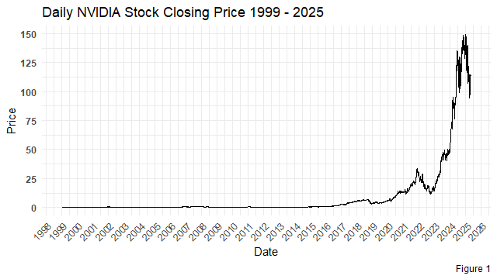
The time series plot displays NVIDIA’s daily closing prices (in USD) over a multi-year period, revealing key patterns in its price movements. A clear upward trend after 2016 and 2022 dominates the series, reflecting NVIDIA’s long-term growth driven by its expanding market share in GPUs, AI, and data center technologies. The plot may also show sudden deviations (e.g., during pandemics, macroeconomic shocks or product launches), emphasizing the interplay between structural trends and periodic influences.

We will focuse on the period from 2012 to 2025, this sampled timeframe with size $n=3355$ observations captures NVIDIA’s pivotal transformation from a graphics processing unit (GPU) manufacturer to a global leader in artificial intelligence (AI), machine learning (ML), and deep learning (DL). This era marks NVIDIA’s aggressive expansion into AI-driven markets, including the introduction of its revolutionary CUDA parallel computing platform (2012), the rise of deep learning frameworks like TensorFlow and PyTorch, and the launch of AI-optimized hardware such as the Volta (2017) and Ampere (2020) architectures. By 2025, NVIDIA solidified its dominance in AI acceleration, data centers, and autonomous systems, making this period critical for studying how technological innovation and market adoption influenced its stock performance. The dataset thus provides a unique lens to examine long-term trends, and seasonal patterns tied to product cycles in the tech sector.
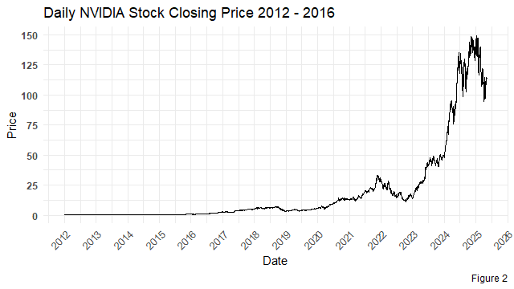

Seasonality
The data shows a strong upward trend over time (especially post-2016), driven by NVIDIA’s growth in AI, GPUs, and data center markets.
Short-term fluctuations are visible, but these appear more like random noise rather than regular seasonal patterns. In addition to non clear repeating cycles are evident at first glance.
The plot does not show significant seasonality. The primary patterns are a strong trend and stochastic variance.
We will work with yearly average to removes these fluctuations and show a longer-term trend.

Stationarity
As we said, we will work with the yearly average data which emphasizes long-term movements.
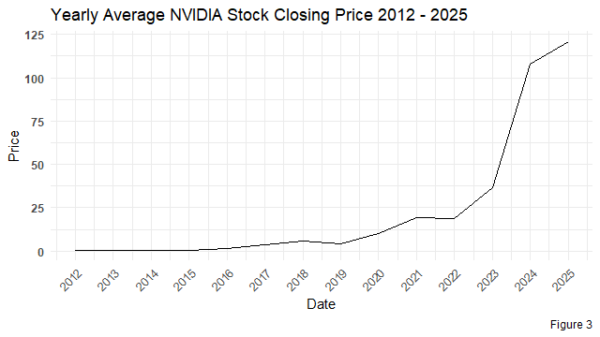
From the plot, the data shows a clear upward exponential trend, especially post-2016. And, variance increases with price level (larger swings at higher prices).
Trend implies non constant mean and varianc eviolate the conditions of weak-stationarity.
We check the ACF and PACF.
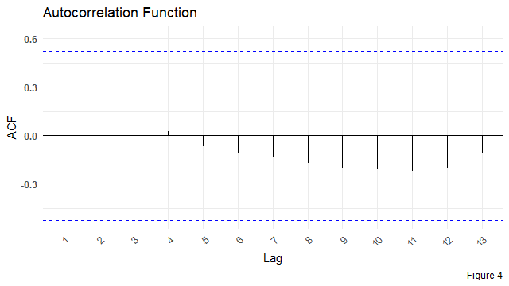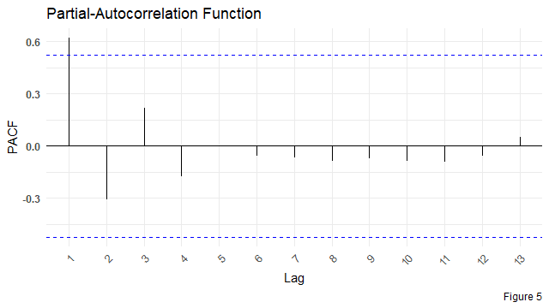 The ACF decays after many lags which. Hence, there is a strong trend \ Also, there is no seasonal spikes.
The PACF also cuts off after many lags.

Log Transformation
We will first apply a log transformation $log\left(y_{t}\right)$ to stabilize the variance and mitigate heteroscedasticity in the NVIDIA stock price data.
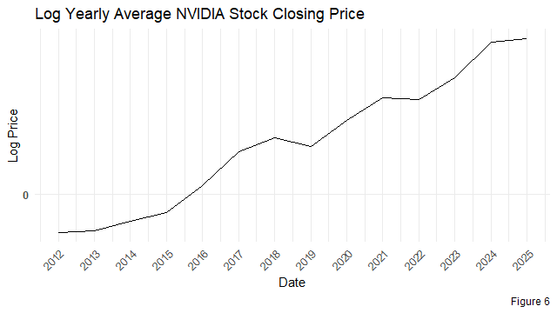
The log transformation successfully addressed the heteroscedasticity in the NVIDIA stock price data by stabilizing the variance across different price levels, ensuring that variability no longer scales with the magnitude of the prices. However, the trend component remains intact, as the log-transformed data still exhibits a persistent upward or downward movement over time. To achieve full stationarity, we will now address this remaining trend through differencing, which will isolate the underlying stochastic patterns and prepare the data for further analysi.

Log Transformation First-Difference
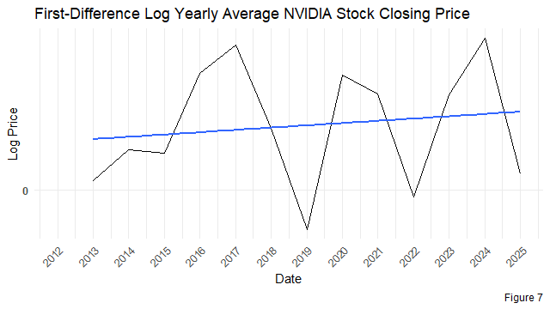
The first differencing of the log-transformed series effectively stabilized the mean, as evidenced by the near-flat regression line fitted to the differenced data. By computing the log returns $\left(Δlog\left(y_{t}\right)=log\left(y_{t}\right)-log\left(y_{t-1}\right)\right)$, we removed the dominant trend component, leaving a series that fluctuates around a constant mean close to zero.
Now the ACF plot is: 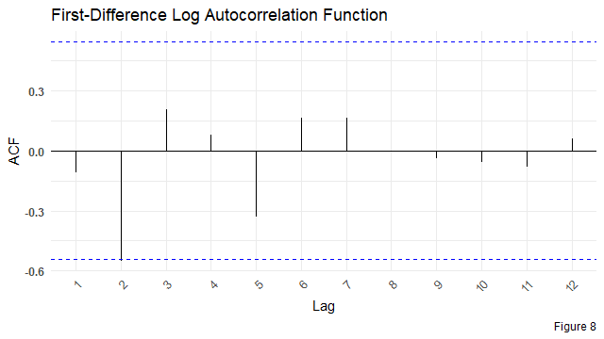
And the PACF plot is: 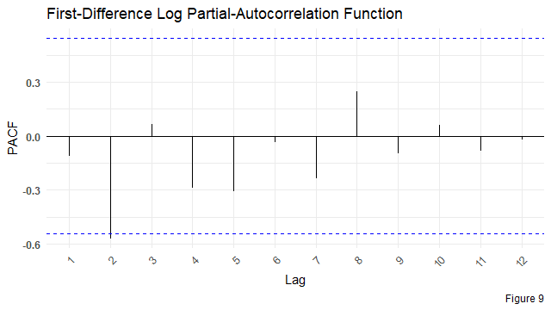
- The ACF
  - Lag 2 shows a significant negative autocorrelation, suggesting short-term dependence at that lag.
  - Most other lags fall within the 95% confidence bounds, indicating no strong autocorrelation.
  - This behavior suggests that the first differencing effectively removed trend and made the series close to stationary.
- The PACF
  - Lag 2 again shows a significant negative partial autocorrelation, reinforcing the ACF result.
The ACF and PACF jointly suggest that The series is stationary after the log first difference.

Model
In the model we will use the auto.arima() function from forecast package in R to model the log of the yearly average data.
## Series: log_ya
## ARIMA(0,1,1)
##
## Coefficients:
## ma1
## 0.7192
## s.e. 0.1966
##
## sigma^2 = 0.2545: log likelihood = -9.39
## AIC=22.79 AICc=23.99 BIC=23.92
##
## Training set error measures:
## ME RMSE MAE MPE MAPE MASE
## Training set 0.2375567 0.4670132 0.3441149 21.80252 33.96912 0.674782
## ACF1
## Training set -0.2917028
When using the auto.arima function on the log-transformed yearly average data, the model returned an $\text{ARIMA}\left(0,1,1\right)$ configuration. This indicates that the function automatically identified the need for first differencing, as we did manually to derive stationarity in the data. First differencing is applied to make a time series stationary by removing any trend or systematic changes in the data. By differencing the log-transformed series once, we eliminate any potential non-stationarity, thus making the series suitable for modeling. The $\text{ARIMA}\left(0,1,1\right)$ model suggests that the series has no autoregressive components ($\text{AR}\left(0\right)$) and a moving average component of order 1 ($\text{MA}\left(1\right)$), with first differencing applied to achieve stationarity. This matches the approach we took manually to ensure that the data met the assumptions required for effective time series modeling.
The model will be
$$y_{t}=y_{t-1}+ε_{t}-0.7192ε_{t-1}$$
Coefficient Testing
##
## z test of coefficients:
##
## Estimate Std. Error z value Pr(>|z|)
## ma1 0.71918 0.19661 3.6578 0.0002544 ***
## ---
## Signif. codes: 0 '***' 0.001 '**' 0.01 '*' 0.05 '.' 0.1 ' ' 1
$∵θ$ is signifcant, The $\text{MA}\left(1\right)$ term improves model fit.
ACF and PACF of residuals
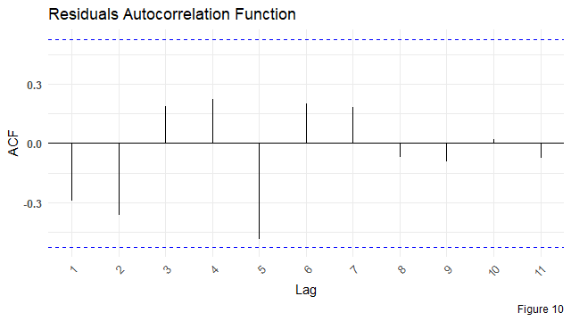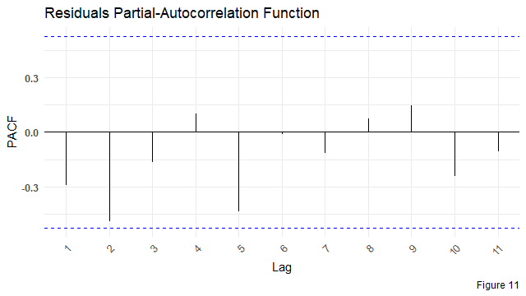
The visuals show No significant spikes at any lag. We will check by using Boxs’ test.
Ljung-Box and Box-Pierce tests
$$H_{0}:\text{residuals are uncorrelated}$$
$$H_{1}:\text{residuals show autocorrelation}$$
##
## Box-Ljung test
##
## data: res
## X-squared = 1.4662, df = 1, p-value = 0.226
##
## Box-Pierce test
##
## data: res
## X-squared = 1.1913, df = 1, p-value = 0.2751
As we can see, the p-value of both tests is $P\text{-value}>0.05$, so we accept the null hypothesis, which is that the residuals are uncorrelated; hence, the model is adequate.
Accuracy
Using accuracy function
## ME RMSE MAE MPE MAPE MASE
## Training set 0.2375567 0.4670132 0.3441149 21.80252 33.96912 0.674782
## ACF1
## Training set -0.2917028
- MAE implies that on average, forecasts deviate by 0.3441149 unit.
- MASE $<1$ beats naive benchmark
- The MAPE implies biased forecasts for low-volume data which is (common in volatile series like stock prices).

Forecast
Using forecast function
## Point Forecast Lo 80 Hi 80 Lo 95 Hi 95
## 15 4.566731 3.920260 5.213201 3.57803873 5.555422
## 16 4.566731 3.281012 5.852449 2.60039402 6.533067
## 17 4.566731 2.867255 6.266207 1.96760623 7.165855
## 18 4.566731 2.536123 6.597338 1.46118469 7.672276
## 19 4.566731 2.251884 6.881577 1.02647873 8.106982
## 20 4.566731 1.998918 7.134543 0.63960045 8.493861
## 21 4.566731 1.768730 7.364731 0.28755788 8.845903
## 22 4.566731 1.556090 7.577371 -0.03764635 9.171108
## 23 4.566731 1.357509 7.775952 -0.34134998 9.474811
## 24 4.566731 1.170520 7.962942 -0.62732590 9.760787
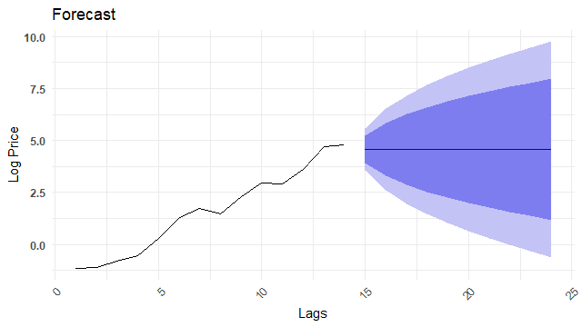

Decomposition Method
The decomposition method is a classical time series analysis technique that breaks down a time series into its fundamental components to better understand its structure, trends, and patterns. This method is particularly useful for forecasting and smoothing data.

Structuring the data
Since we will apply the decomposition method to analyze the time series, we first aggregate the data into monthly averages to ensure consistent seasonal patterns and improve trend visibility.
## [1] "--- Trend ---"
## Jan Feb Mar Apr May Jun
## 1999 NA NA NA NA NA NA
## 2000 0.11436471 0.13231059 0.15163555 0.17032735 0.18625857 0.19652775
## 2001 0.25138496 0.25618561 0.25719163 0.25767634 0.26616159 0.28672469
## 2002 0.34009993 0.32280788 0.30508824 0.28837403 0.26722116 0.23940067
## 2003 0.10912496 0.11303990
## Jul Aug Sep Oct Nov Dec
## 1999 0.04591803 0.05030396 0.05839861 0.06904592 0.08043654 0.09625900
## 2000 0.20369644 0.21146821 0.21728599 0.22414420 0.23514914 0.24518439
## 2001 0.31416200 0.33804713 0.35587974 0.36409503 0.36221645 0.35328635
## 2002 0.20609853 0.17411136 0.14697372 0.12668732 0.11394689 0.10834417
## 2003
## [1] "--- Seasonal ---"
## Jan Feb Mar Apr May Jun Jul
## 1999 1.0066685 1.0271814 1.0268740 1.0134241 1.0202139 1.0507085 0.9719162
## 2000 1.0066685 1.0271814 1.0268740 1.0134241 1.0202139 1.0507085 0.9719162
## 2001 1.0066685 1.0271814 1.0268740 1.0134241 1.0202139 1.0507085 0.9719162
## 2002 1.0066685 1.0271814 1.0268740 1.0134241 1.0202139 1.0507085 0.9719162
## 2003 1.0066685 1.0271814
## Aug Sep Oct Nov Dec
## 1999 0.9671126 0.9637881 0.9411112 1.0023045 1.0086970
## 2000 0.9671126 0.9637881 0.9411112 1.0023045 1.0086970
## 2001 0.9671126 0.9637881 0.9411112 1.0023045 1.0086970
## 2002 0.9671126 0.9637881 0.9411112 1.0023045 1.0086970
## 2003
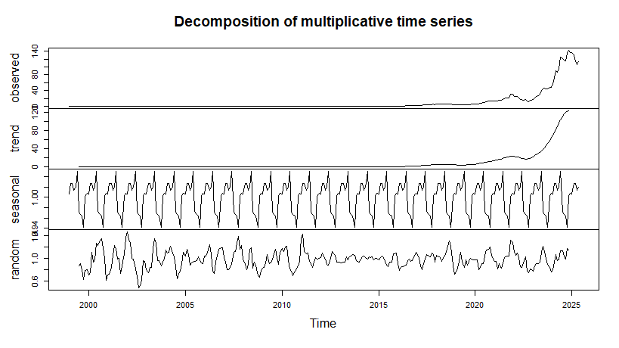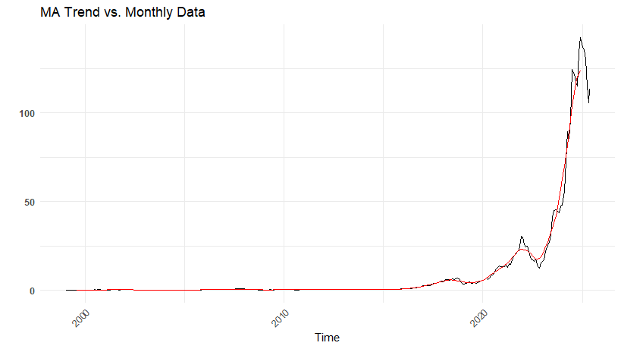
The decompose() method in R applies a centered moving average with a window size of $k=12$ (for monthly data) to estimate the trend component, resulting in the first and last 6 observations being NA due to boundary effects. The seasonal factors, which are centered around 1 (Which is 100 in the scale used in the Course) in the multiplicative model, indicate the relative impact of seasonality on the trend. If these factors are close to 1, it implies that seasonality has negligible influence on the time series for those periods, aligning with the initial findings in the modern approach analysis. This suggests that the observed fluctuations are primarily driven by trend and random noise rather than systematic seasonal patterns.

Detrending and Deseasonalizing
Detrending and deseasonalizing are crucial steps in time series analysis because they help isolate the core patterns of the data by removing predictable influences. Detrending eliminates long-term movements or trends, allowing analysts to focus on the underlying structure without the distortion of upward or downward drifts. Deseasonalizing, on the other hand, removes repeating seasonal effects, making it easier to detect other meaningful signals or irregular variations. These processes are especially important for improving the accuracy of forecasting models, as most models perform better when applied to a stationary series—one without trend or seasonality. By cleaning the data through detrending and deseasonalizing, we ensure that the model learns from the true behavior of the time series rather than being misled by predictable, non-informative patterns.
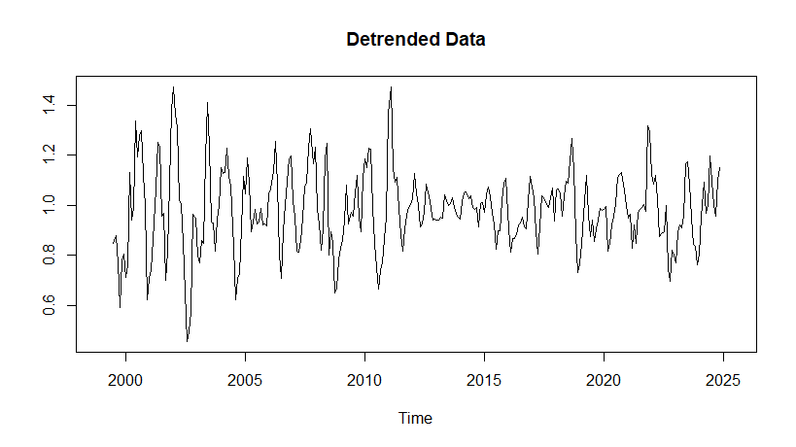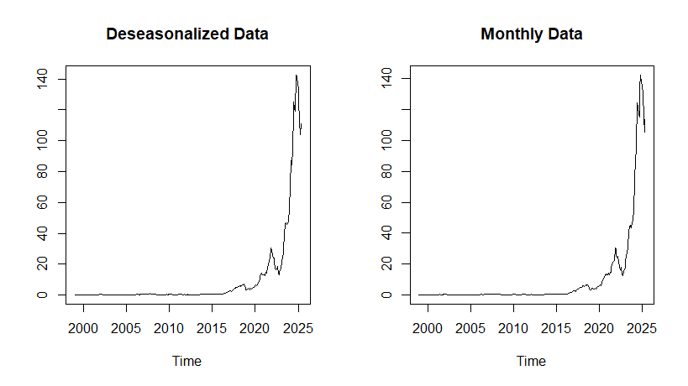
The plots of the deseasonalized data and the actual data show minimal differences, indicating that seasonality has negligible impact on this time series. This suggests that the observed patterns are predominantly driven by trends, cyclical fluctuations, or irregular noise, rather than systematic seasonal variations.

Modeling Trends
The goal is to model the underlying trend while explicitly removing seasonal fluctuations. This approach isolates the long-term movement of the series, making it useful for forecasting.
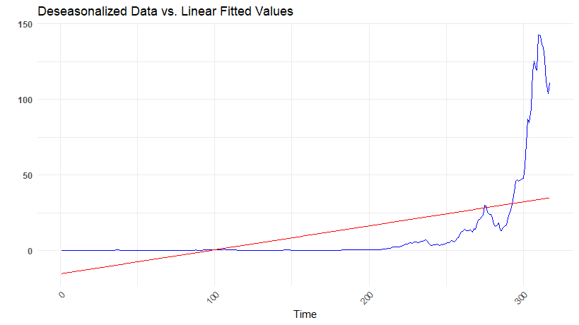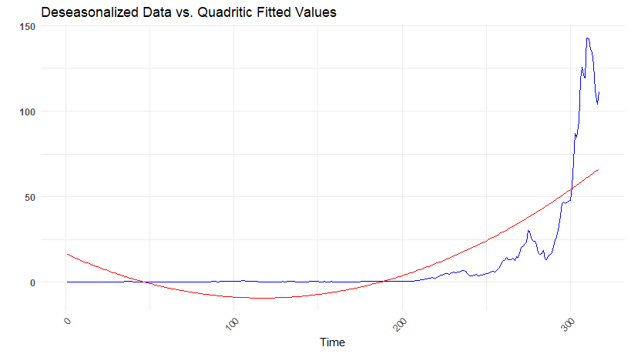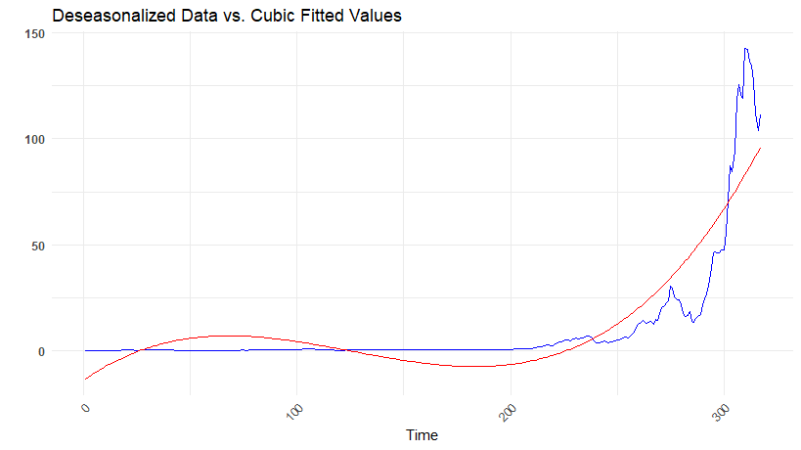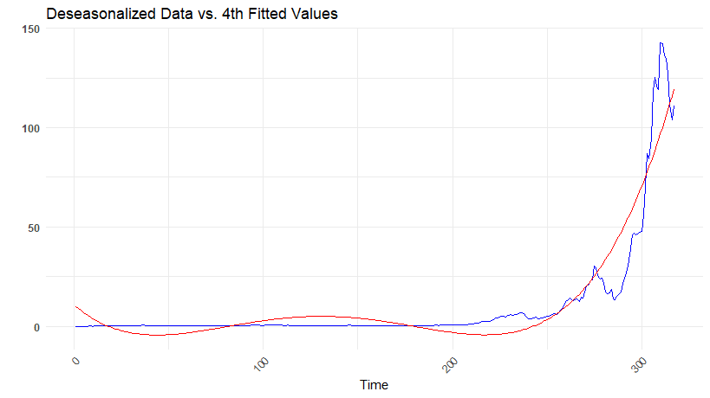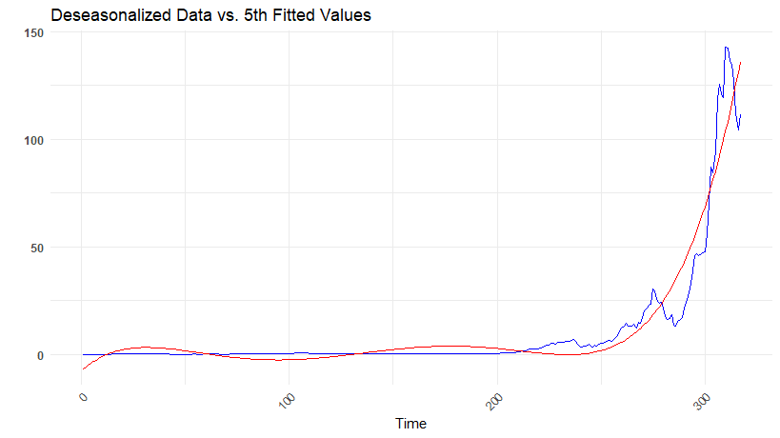
We can check the accuracy, coeff test and vif of the previous models
##
## --- Linear Model ---
## MSE: 259.4309
## MAD: 18.56753
## MAPE: 12.63162
##
##
## Call:
## lm(formula = deseasonalized ~ time_points)
##
## Residuals:
## Min 1Q Median 3Q Max
## -20.175 -13.616 -4.782 6.547 108.847
##
## Coefficients:
## Estimate Std. Error t value Pr(>|t|)
## (Intercept) -15.28264 2.46181 -6.208 1.69e-09 ***
## time_points 0.15853 0.01342 11.813 < 2e-16 ***
## ---
## Signif. codes: 0 '***' 0.001 '**' 0.01 '*' 0.05 '.' 0.1 ' ' 1
##
## Residual standard error: 21.86 on 315 degrees of freedom
## Multiple R-squared: 0.307, Adjusted R-squared: 0.3048
## F-statistic: 139.6 on 1 and 315 DF, p-value: < 2.2e-16
##
##
## --- Quadratic Model ---
## MSE: 439.946
## MAD: 15.15544
## MAPE: 9.19615
##
## Call:
## lm(formula = deseasonalized ~ time_points + I(time_points^2))
##
## Residuals:
## Min 1Q Median 3Q Max
## -31.450 -9.311 0.074 7.695 81.628
##
## Coefficients:
## Estimate Std. Error t value Pr(>|t|)
## (Intercept) 16.614900 2.827045 5.877 1.07e-08 ***
## time_points -0.441427 0.041053 -10.752 < 2e-16 ***
## I(time_points^2) 0.001887 0.000125 15.090 < 2e-16 ***
## ---
## Signif. codes: 0 '***' 0.001 '**' 0.01 '*' 0.05 '.' 0.1 ' ' 1
##
## Residual standard error: 16.67 on 314 degrees of freedom
## Multiple R-squared: 0.5983, Adjusted R-squared: 0.5958
## F-statistic: 233.9 on 2 and 314 DF, p-value: < 2.2e-16
##
## VIF
## time_points I(time_points^2)
## 16.09539 16.09539
##
## --- Cubic Model ---
## MSE: 562.8635
## MAD: 9.745822
## MAPE: 7.304998
##
## Call:
## lm(formula = deseasonalized ~ time_points + I(time_points^2) +
## +I(time_points^3))
##
## Residuals:
## Min 1Q Median 3Q Max
## -33.981 -6.217 -0.013 6.069 59.605
##
## Coefficients:
## Estimate Std. Error t value Pr(>|t|)
## (Intercept) -1.402e+01 2.767e+00 -5.066 6.97e-07 ***
## time_points 7.055e-01 7.524e-02 9.376 < 2e-16 ***
## I(time_points^2) -7.116e-03 5.493e-04 -12.953 < 2e-16 ***
## I(time_points^3) 1.887e-05 1.136e-06 16.619 < 2e-16 ***
## ---
## Signif. codes: 0 '***' 0.001 '**' 0.01 '*' 0.05 '.' 0.1 ' ' 1
##
## Residual standard error: 12.17 on 313 degrees of freedom
## Multiple R-squared: 0.7866, Adjusted R-squared: 0.7846
## F-statistic: 384.6 on 3 and 313 DF, p-value: < 2.2e-16
##
## VIF
## time_points I(time_points^2) I(time_points^3)
## 101.4397 583.0445 227.2433
##
## --- Fourth Model ---
## MSE: 630.3184
## MAD: 5.671828
## MAPE: 5.730933
##
## Call:
## lm(formula = deseasonalized ~ time_points + I(time_points^2) +
## I(time_points^3) + I(time_points^4))
##
## Residuals:
## Min 1Q Median 3Q Max
## -29.931 -3.623 0.311 3.945 45.804
##
## Coefficients:
## Estimate Std. Error t value Pr(>|t|)
## (Intercept) 1.073e+01 2.619e+00 4.098 5.32e-05 ***
## time_points -8.293e-01 1.137e-01 -7.292 2.53e-12 ***
## I(time_points^2) 1.452e-02 1.451e-03 10.008 < 2e-16 ***
## I(time_points^3) -8.686e-05 6.851e-06 -12.679 < 2e-16 ***
## I(time_points^4) 1.662e-07 1.069e-08 15.556 < 2e-16 ***
## ---
## Signif. codes: 0 '***' 0.001 '**' 0.01 '*' 0.05 '.' 0.1 ' ' 1
##
## Residual standard error: 9.149 on 312 degrees of freedom
## Multiple R-squared: 0.8798, Adjusted R-squared: 0.8783
## F-statistic: 571 on 4 and 312 DF, p-value: < 2.2e-16
##
## VIF
## time_points I(time_points^2) I(time_points^3) I(time_points^4)
## 410.1581 7199.8855 14636.3331 3178.8078
##
## --- Fifth Model ---
## MSE: 657.5012
## MAD: 2.837823
## MAPE: 4.469217
##
## Call:
## lm(formula = deseasonalized ~ time_points + I(time_points^2) +
## I(time_points^3) + I(time_points^4) + I(time_points^5))
##
## Residuals:
## Min 1Q Median 3Q Max
## -26.516 -2.604 0.170 2.957 38.866
##
## Coefficients:
## Estimate Std. Error t value Pr(>|t|)
## (Intercept) -7.412e+00 2.598e+00 -2.853 0.00462 **
## time_points 8.454e-01 1.642e-01 5.149 4.65e-07 ***
## I(time_points^2) -2.211e-02 3.187e-03 -6.938 2.32e-11 ***
## I(time_points^3) 2.196e-04 2.536e-05 8.657 2.65e-16 ***
## I(time_points^4) -9.171e-07 8.788e-08 -10.436 < 2e-16 ***
## I(time_points^5) 1.363e-09 1.100e-10 12.389 < 2e-16 ***
## ---
## Signif. codes: 0 '***' 0.001 '**' 0.01 '*' 0.05 '.' 0.1 ' ' 1
##
## Residual standard error: 7.498 on 311 degrees of freedom
## Multiple R-squared: 0.9195, Adjusted R-squared: 0.9182
## F-statistic: 710.8 on 5 and 311 DF, p-value: < 2.2e-16
##
## VIF
## time_points I(time_points^2) I(time_points^3) I(time_points^4)
## 1272.87 51707.70 298715.58 319948.22
## I(time_points^5)
## 44862.17
We noticed that the model demonstrates improved goodness-of-fit starting from the 5th-order polynomial, capturing nonlinear trends more effectively than lower-order polynomials. However, this higher complexity introduces blown-up multicollinearity among the polynomial terms, inflating standard errors and rendering some coefficients statistically insignificant. To address this issue while maintaining model flexibility, we apply a log transformation to the dependent variable. This transformation helps linearize exponential trends, reduces heteroskedasticity, and often yields a more parsimonious model with interpretable coefficients.

Log Transformation
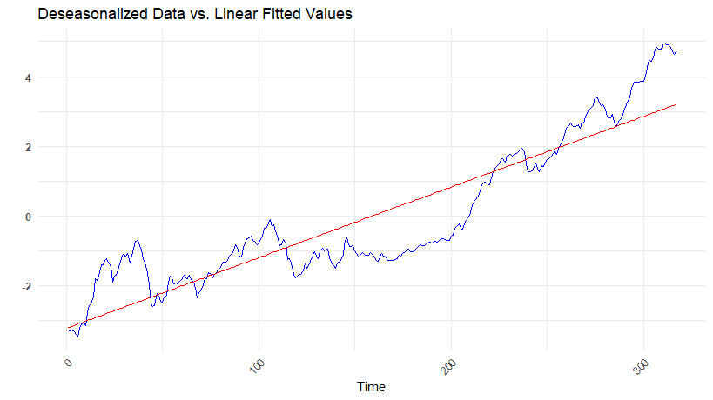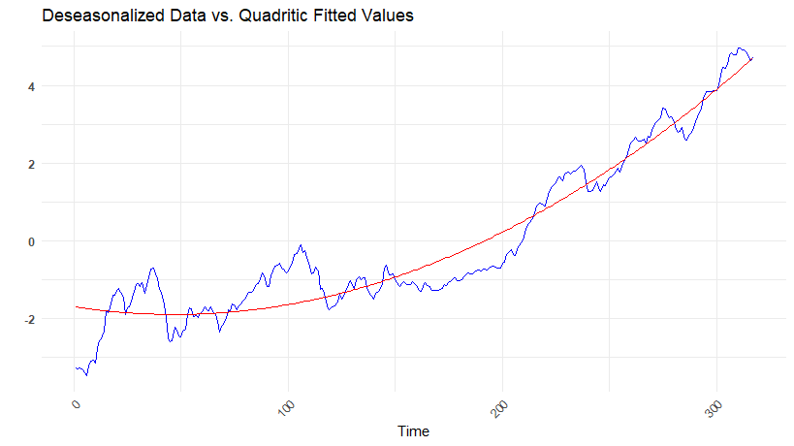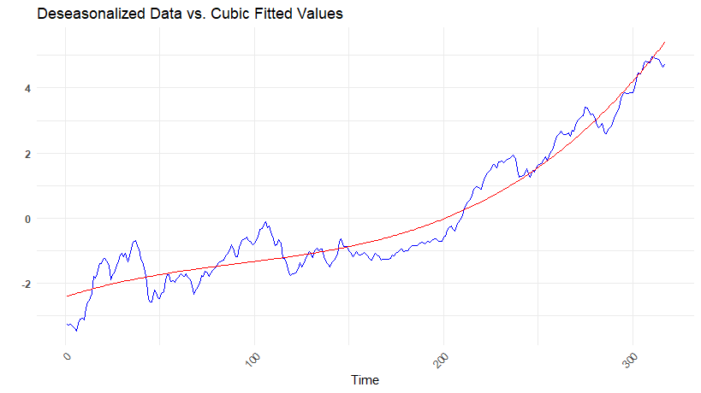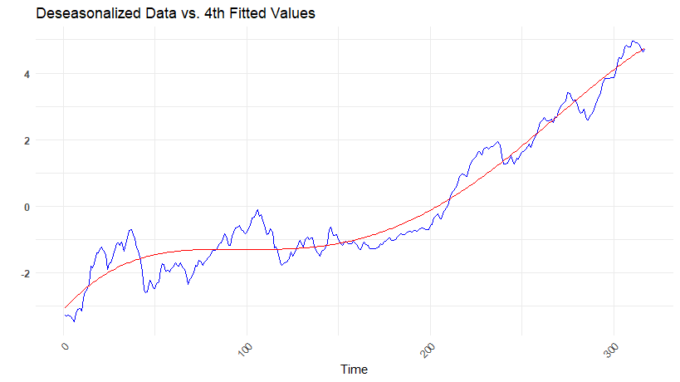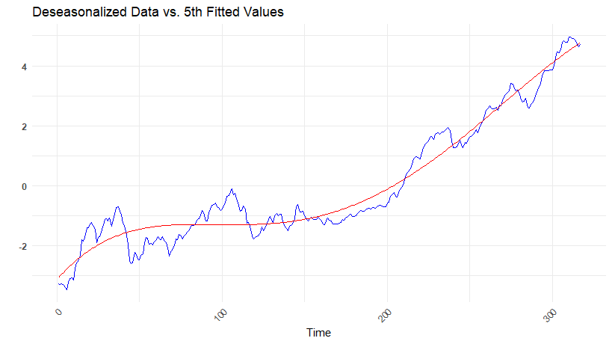
##
## --- Linear Model ---
## MSE: 0.8050825
## MAD: 2.371041
## MAPE: 0.8730028
##
##
## Call:
## lm(formula = log(deseasonalized) ~ time_points)
##
## Residuals:
## Min 1Q Median 3Q Max
## -1.5138 -0.6573 0.0648 0.5691 1.9054
##
## Coefficients:
## Estimate Std. Error t value Pr(>|t|)
## (Intercept) -3.2201082 0.1013499 -31.77 <2e-16 ***
## time_points 0.0202436 0.0005525 36.64 <2e-16 ***
## ---
## Signif. codes: 0 '***' 0.001 '**' 0.01 '*' 0.05 '.' 0.1 ' ' 1
##
## Residual standard error: 0.9001 on 315 degrees of freedom
## Multiple R-squared: 0.81, Adjusted R-squared: 0.8094
## F-statistic: 1343 on 1 and 315 DF, p-value: < 2.2e-16
##
##
## --- Quadratic Model ---
## MSE: 0.3454481
## MAD: 1.612035
## MAPE: 0.5946502
##
## Call:
## lm(formula = log(deseasonalized) ~ time_points + I(time_points^2))
##
## Residuals:
## Min 1Q Median 3Q Max
## -1.72094 -0.38196 0.03728 0.42070 1.46768
##
## Coefficients:
## Estimate Std. Error t value Pr(>|t|)
## (Intercept) -1.690e+00 1.001e-01 -16.874 < 2e-16 ***
## time_points -8.541e-03 1.454e-03 -5.874 1.09e-08 ***
## I(time_points^2) 9.052e-05 4.428e-06 20.440 < 2e-16 ***
## ---
## Signif. codes: 0 '***' 0.001 '**' 0.01 '*' 0.05 '.' 0.1 ' ' 1
##
## Residual standard error: 0.5905 on 314 degrees of freedom
## Multiple R-squared: 0.9185, Adjusted R-squared: 0.9179
## F-statistic: 1769 on 2 and 314 DF, p-value: < 2.2e-16
##
## VIF
## time_points I(time_points^2)
## 16.09539 16.09539
##
## --- Cubic Model ---
## MSE: 0.2722353
## MAD: 1.430734
## MAPE: 0.471293
##
## Call:
## lm(formula = log(deseasonalized) ~ time_points + I(time_points^2) +
## +I(time_points^3))
##
## Residuals:
## Min 1Q Median 3Q Max
## -1.14765 -0.44620 -0.05565 0.41209 1.17551
##
## Coefficients:
## Estimate Std. Error t value Pr(>|t|)
## (Intercept) -2.419e+00 1.194e-01 -20.266 < 2e-16 ***
## time_points 1.877e-02 3.246e-03 5.784 1.77e-08 ***
## I(time_points^2) -1.239e-04 2.370e-05 -5.228 3.14e-07 ***
## I(time_points^3) 4.495e-07 4.899e-08 9.175 < 2e-16 ***
## ---
## Signif. codes: 0 '***' 0.001 '**' 0.01 '*' 0.05 '.' 0.1 ' ' 1
##
## Residual standard error: 0.5251 on 313 degrees of freedom
## Multiple R-squared: 0.9357, Adjusted R-squared: 0.9351
## F-statistic: 1519 on 3 and 313 DF, p-value: < 2.2e-16
##
## VIF
## time_points I(time_points^2) I(time_points^3)
## 101.4397 583.0445 227.2433
##
## --- Fourth Model ---
## MSE: 0.2225111
## MAD: 1.032263
## MAPE: 0.4238374
##
## Call:
## lm(formula = log(deseasonalized) ~ time_points + I(time_points^2) +
## I(time_points^3) + I(time_points^4))
##
## Residuals:
## Min 1Q Median 3Q Max
## -1.06537 -0.35754 -0.07233 0.34328 1.18245
##
## Coefficients:
## Estimate Std. Error t value Pr(>|t|)
## (Intercept) -3.110e+00 1.361e-01 -22.850 < 2e-16 ***
## time_points 6.159e-02 5.910e-03 10.421 < 2e-16 ***
## I(time_points^2) -7.275e-04 7.541e-05 -9.648 < 2e-16 ***
## I(time_points^3) 3.399e-06 3.560e-07 9.547 < 2e-16 ***
## I(time_points^4) -4.638e-09 5.555e-10 -8.350 2.26e-15 ***
## ---
## Signif. codes: 0 '***' 0.001 '**' 0.01 '*' 0.05 '.' 0.1 ' ' 1
##
## Residual standard error: 0.4755 on 312 degrees of freedom
## Multiple R-squared: 0.9475, Adjusted R-squared: 0.9468
## F-statistic: 1407 on 4 and 312 DF, p-value: < 2.2e-16
##
## VIF
## time_points I(time_points^2) I(time_points^3) I(time_points^4)
## 410.1581 7199.8855 14636.3331 3178.8078
##
## --- Fifth Model ---
## MSE: 0.2224965
## MAD: 1.02821
## MAPE: 0.4254487
##
## Call:
## lm(formula = log(deseasonalized) ~ time_points + I(time_points^2) +
## I(time_points^3) + I(time_points^4) + I(time_points^5))
##
## Residuals:
## Min 1Q Median 3Q Max
## -1.07031 -0.35883 -0.07188 0.33962 1.18666
##
## Coefficients:
## Estimate Std. Error t value Pr(>|t|)
## (Intercept) -3.123e+00 1.650e-01 -18.925 < 2e-16 ***
## time_points 6.281e-02 1.043e-02 6.023 4.82e-09 ***
## I(time_points^2) -7.543e-04 2.024e-04 -3.727 0.00023 ***
## I(time_points^3) 3.623e-06 1.611e-06 2.249 0.02521 *
## I(time_points^4) -5.430e-09 5.581e-09 -0.973 0.33140
## I(time_points^5) 9.957e-13 6.986e-12 0.143 0.88675
## ---
## Signif. codes: 0 '***' 0.001 '**' 0.01 '*' 0.05 '.' 0.1 ' ' 1
##
## Residual standard error: 0.4762 on 311 degrees of freedom
## Multiple R-squared: 0.9475, Adjusted R-squared: 0.9466
## F-statistic: 1122 on 5 and 311 DF, p-value: < 2.2e-16
##
## VIF
## time_points I(time_points^2) I(time_points^3) I(time_points^4)
## 1272.87 51707.70 298715.58 319948.22
## I(time_points^5)
## 44862.17
After applying the log transformation, we evaluated polynomial models of varying complexity and found that the fourth-order polynomial (quartic) model strikes an optimal balance between flexibility and robustness. Unlike higher-order polynomials, the cubic specification avoids the extreme multicollinearity, ensuring stable coefficient estimates with statistical significance. Additionally, it achieves competitive error metrics—low MSE, MAD, and MAPE, demonstrating strong predictive performance without overfitting. By retaining interpretability while capturing essential nonlinear trends, the quartic model emerges as the most reliable choice for inference and forecasting.

Forecasting
The chosen quartic model with log transformation provides reliable forecasts by capturing the underlying trend while avoiding overfitting and multicollinearity issues. Forecasts are generated by applying the inverse log transformation to revert predictions back to the original scale, ensuring interpretable results. The model’s performance is validated through low error metrics (MSE, MAD, MAPE). This approach balances simplicity and accuracy, making it suitable for short-to-medium-term predictions.
Forecasting the next year
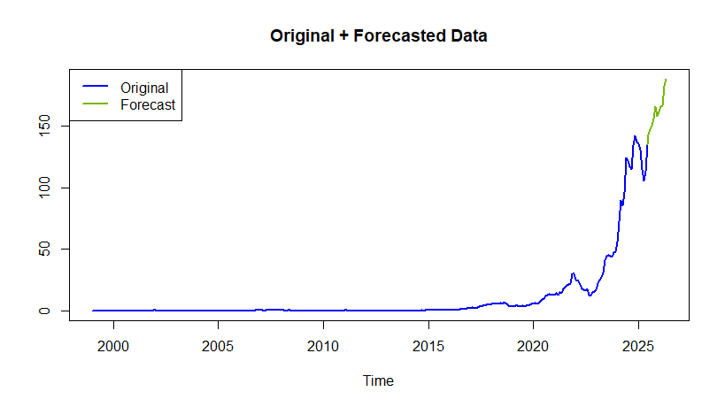
## fit lwr upr
## 1 134.2816 50.74569 355.3317
## 2 138.8184 52.30917 368.3973
## 3 143.4206 53.87692 381.7865
## 4 148.0825 55.44509 395.4978
## 5 152.7975 57.00959 409.5290
## 6 157.5590 58.56607 423.8772
## 7 162.3593 60.10995 438.5388
## 8 167.1906 61.63642 453.5095
## 9 172.0443 63.14045 468.7843
## 10 176.9113 64.61681 484.3572
## 11 181.7820 66.06010 500.2216
## 12 186.6461 67.46477 516.3700
The predicted values were back-transformed from the logarithmic scale to return to the original units after reapplying seasonal factors, preserving the log-normality assumption of the underlying data distribution. This critical step ensures our forecasts maintain the multiplicative nature of percentage-based growth while properly accounting for seasonal fluctuations. For the upcoming 12 months, the model projects an upward trajectory in stock prices. This positive trend could be due to the massive contribution in AI or the new extraordinary GPUs.

Conclusion
In this project, we began by performing thorough data wrangling and structuring to prepare the time series data for analysis. We initially applied a modern forecasting approach using the Box-Jenkins methodology (ARIMA modeling). However, this approach produced constant forecasted values, suggesting it was not well-suited for capturing the underlying trend in the data. We then turned to a classical decomposition method, which involved separating the series into trend, seasonal, and irregular components. After modeling the deseasonalized data with a polynomial trend and reapplying the seasonal factors, the decomposition-based forecast delivered a much more accurate and meaningful projection.
The decomposition forecast indicated a steady upward trend in Nvidia’s stock prices. This growth is likely driven by the company’s strategic role in AI innovation, increasing demand for GPUs, and broader technological advancement.
This analysis holds significant value in the context of investment decision-making. By identifying trends and seasonal behavior in stock prices, investors can make more informed choices about entry and exit points. Forecasting models, particularly those based on decomposition, offer a transparent and interpretable framework for anticipating future market behavior — a critical advantage in volatile and innovation-driven sectors like semiconductors and AI. Ultimately, this project demonstrates how time series analysis can provide both strategic insights and practical tools for financial forecasting and investment planning.

References
Businessnoon. (2025, April 2). Inside Nvidia’s bold moves in AI startup investments. Businessnoon - Daily Updates for the Business-Minded. https://businessnoon.com/inside-nvidias-bold-moves-in-ai-startup-investments/?utm_source=chatgpt.com
Ferguson, M. (2025, March 23). Nvidia’s AI dominion: Expanding frontiers and dominating markets. OpenTools. https://opentools.ai/news/nvidias-ai-dominion-expanding-frontiers-and-dominating-markets?utm_source=chatgpt.com
Merritt, R. (2024, October 16). Why GPUs are great for AI | NVIDIA blog. NVIDIA Blog. https://blogs.nvidia.com/blog/why-gpus-are-great-for-ai/?utm_source=chatgpt.com
Tatananni, M., Swint, B., & Clark, A. (2025, May 15). Nvidia stock rises. CoreWeave results are good news after all. Barrons. https://www.barrons.com/articles/nvidia-stock-price-coreweave-chips-ai-6118c997?utm_source=chatgpt.com
TheDayAfterAI News. (2024, November 24). Why GPUs are the powerhouse of AI: NVIDIA’s Game-Changing Role in Machine Learning — TheDayAfterAI News. https://thedayafterai.squarespace.com/featured/why-gpus-are-the-powerhouse-of-ai-nvidias-game-changing-role-in-machine-learning?utm_source=chatgpt.com

Data Set
https://macrotrends.net/stocks/charts/NVDA/nvidia/stock-price-history

