**Canine Coaching Classes**

**The Big Dogs**

**Jeff Pollock #991440611**

**(INSERT OTHER STUDENT NAMES/NUMBERS)**

**SYST28951**  
**Systems Development Methodologies**

**Susan Burgess**

**Table of Contents**

**Client Overview: 3**

**System Vision: 3**

**Context Diagram: 4**

**Use Case Diagram: 5**

**Use Case Narratives: 6**

**Domain Class Diagram: 6**

# 

# 

# 

# 

## Client Overview:

Canine Coaching Classes is a dog training business that offers both private in-home sessions and group classes at its own facility. The services provided include obedience training, agility, recall, tracking, and daycare. The company categorizes dogs by age and condition, such as puppy, adolescent, adult, senior, and disabled. Group classes are limited to six dogs, while private sessions are one-on-one.

The business is currently managed through a fully manual system where the Office Manager handles customer interactions, trainer schedules, and payments, all recorded on paper. This outdated approach limits efficiency, customer reach, and the ability to generate useful reports.

Stakeholders:

Owner: Oversees business direction and expects system reports for strategic decisions.

Office Manager: Manages scheduling, customer communications, and payments. Will rely heavily on the new system.

Trainers: Need access to their schedules and pay information through the system.

Customers: Expect to book services, make payments, receive confirmations, and leave feedback online.

## System Vision:

Problem: Canine Coaching Classes relies on a manual, paper-based system for bookings, scheduling, payments, and record-keeping. This makes it difficult to manage operations, communicate effectively with customers, and generate reports on revenue or service demand.

Capabilities of the New System:

* Online booking and cancellation for training and daycare
* Integration with debit/credit card payment systems
* Automated confirmation emails and follow-ups for customer reviews
* Trainer access to schedules and paystubs
* Office Manager control over employee scheduling
* Generation of monthly business reports
* Contact database for promotions and marketing

Business Benefits: The new system will significantly reduce administrative work, improve customer satisfaction with 24/7 booking access, enhance revenue tracking and forecasting, and help the business grow its online presence through reviews and marketing. It will also support future expansion by allowing for easy reporting and data-driven decisions.

## Context Diagram:

## Use Case Diagram:

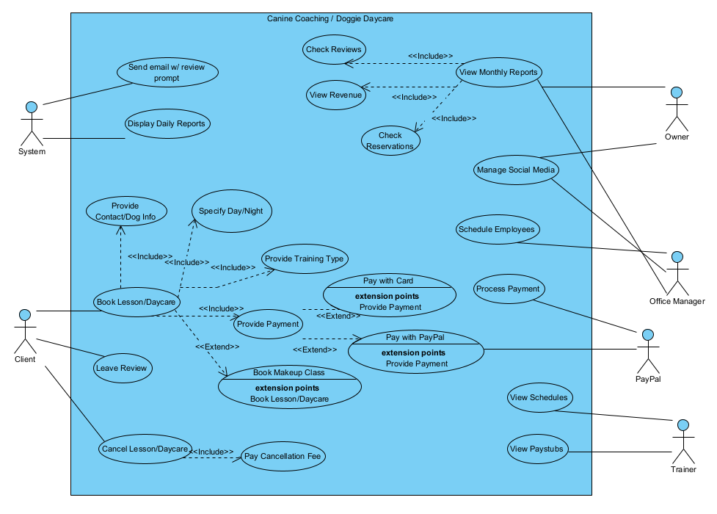

## 

## Use Case Narratives:

**Book Lesson or Daycare (JDP)**

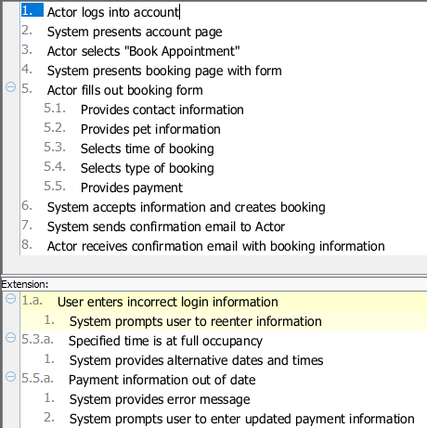

This use case was chosen as it is the most essential part of this new system, to make it easier for clients to book daycare or lessons online. It’s important that it operates without errors for efficiency and customer satisfaction.

**View Monthly Reports (JPOG)**

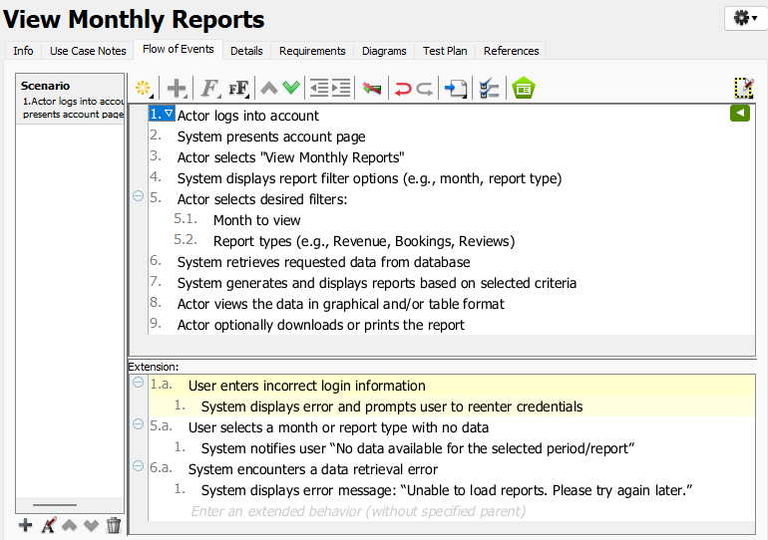

The "View Monthly Reports" use case is important because it provides the Owner and Office Manager with critical insights into the business’s performance. By accessing data such as revenue, cancellations, and training trends, they can make informed decisions, identify growth opportunities, and address operational issues proactively.

## 

## 

## Domain Class Diagram: