**Canine Coaching Classes**

**The Big Dogs**

**Deliverable 3**

**Jeff Pollock #991440611**

**Daniel Bajenov #991751839**

**Juan Pablo Ordonez Gomez #991745862**

**Omar Abdulhamid #991774516**

**SYST28951**  
**Systems Development Methodologies**

**Susan Burgess**

**Table of Contents**

Use Case Narratives 2

Class Diagrams 2

Storyboard 2

Sequence Diagram 2

# Use Case Narratives

**Book Lesson/Daycare**

Happy Path Scenario:

Alternate Scenario:

This scenario builds off the happy path with the possibility that the booking page will keep the clients pet/payment information in the cookies/cache. This ultimately makes it a quick an easy booking process for the user.

**View Monthly Reports:**

Happy Path Scenario:

Alternate Scenario:

This scenario involves the possibility of being able to request recurring report emails from the system, as opposed to having to log in and check whenever the actor would like to see reports.

**Schedule Employees:**

Happy Path Scenario:

Alternate Scenario:

This alternate scenario involves the use of a drag and drop scheduling system that would allow for a more streamlined approach to employee scheduling.

**Cancel Lesson/Daycare**

Happy Path Scenario:

Alternate Scenario:

This scenario is built around the possibility of customers being able to chat with support agents to cancel lessons or daycare. This would make it easier for less tech-savvy folks to cancel their appointments. All necessary fees still apply.

# Class Diagrams

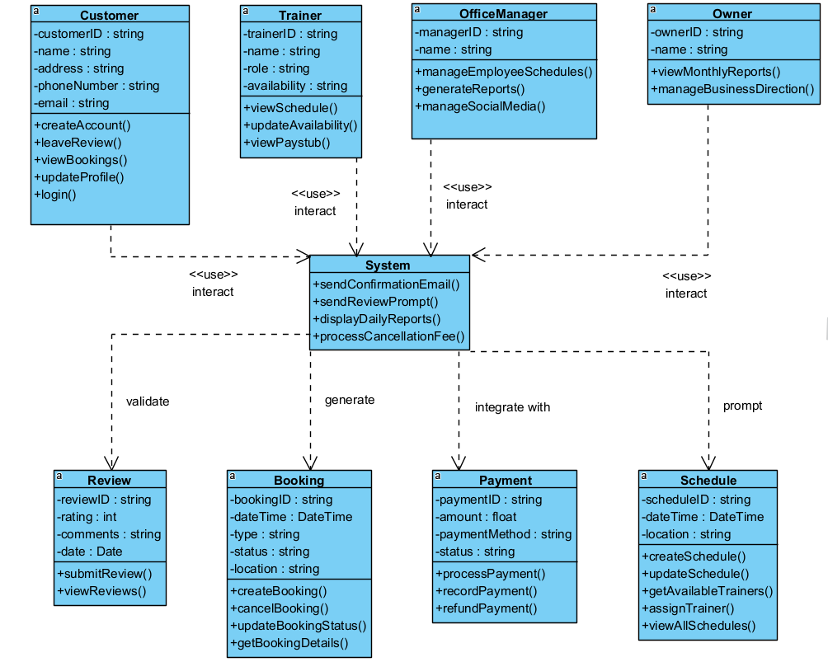

# Storyboard

# Sequence Diagram

**Book Lesson/Daycare**

**View Monthly Reports:**

**Schedule Employees:**

**Cancel Lesson/Daycare**

