

Well, Sonic-ish. Vaguely Sonic-inspired is more accurate. Collect things, hit things, try not to get your character killed and basically win the game by getting through the levels.

Look at how the Godot 2D platformer demos work, see which'd work best for you and steal adapt bits as necessary.

How should the game levels be structured?

All levels (zones, acts, whatever you want to call them) should inherit from a class. This means that scenes and nodes can expect a consistent tree structure.

All play levels should have, at a minimum, the HUD layer/scene; an AudioStreamPlayer (to play music files); a Timer to handle timing issues.

One scene containing the above which loads a sub-scene containing the actual level data, or self-contained? Self-contained.

Everything else should be added by script. Nodes should be used to keep things grouped together (items, enemies etc.).

The root node of any level should be identified by the name Level. The AudioStreamPlayer for music should be called Music_Player (and always explicitly referred to by full path).

level_generic.tscn is a basic (script-less) boilerplate template for level scene structure. level_generic.gd is a basic script that must be inherited by whatever script you attach to a level scene.

Node Level
hud_layer
AudioStreamPlayer Music_Player
TileMap
Timer Timer_Level

How should the player character be structured?

The root node of the player character should be a RigidBody2D (mode set to Character) with the name of the playable character. Not sure if animations should be AnimatedSprite or Sprite – whichever I can get to work best at the end of the day, but it must be consistent between all playable characters at least. And there should be an AudioStreamPlayer to play certain jingles called Jingle_Player. Finally, there needs to be a Camera2D that is set to follow the player character.

There is a script called generic.gd which contains generic definitions for use by all playable characters. It should be inherited by the script attached to a named playable character (so inherits RigidBody2D itself). Character-specific functions and values can then be defined there. If the character needs time-related functionality it has its own Timer.

Note that generic.tscn – a boilerplate template for playable characters – doesn't by default have any scripts attached to it! This is up to you.

RigidBody2D Character name
[Animated?]Sprite
AudioStreamPlayer Jingle_Player
Camera2D
Timer Timer_Player

How should the game look?

Roughly?

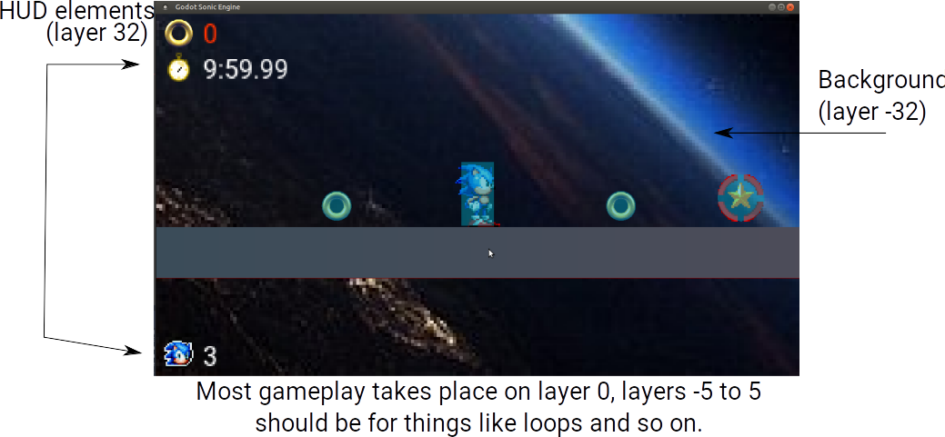

For parallax backgrounds, the background layers should be from -32 to -40. -99 should be used for hiding things during certain times (like cutscenes).

