Application Diagram/functions:

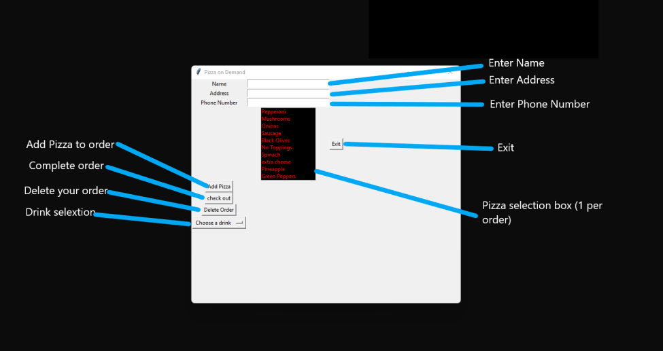

Greetings:

Thank you for downloading.

Beware that this application is held together by shoestrings and glue. By that I mean it barely works.

Reason for creation:

This application was created for a software development class that I am taking to complete my associates. If you have opened the application prior to reading this, I am sure you can tell I probably bit off more I can chew. I only had a little over 2 weeks to prepare this application with only 6 weeks of programing experience. That is why it is one window with no pictures. I seriously could not get it to work so it’s a grey background, with no pictures and barely functions.

I am horrible at coding :D

Distribution terms and conditions:

This is open source if you want to use or share (as if)