COSC 455
Programming Languages: Design and Implementation
Fall 2026

Project #1 – Phase 1: ANTLR Grammar Test Cases

Name: Richard Savoca

ANTLR Grammar. The following is my full ANTLR grammar for my LOLCODE Markdown language (Lolcode.g). To test it, I opened the grammar in ANTLRWorks, selected lolcode as the start rule in the Interpreter tab, entered each test input and hit the play button.

grammar Lolcode;

// Parser Rules
lolcode
: HAI prologue KBYE EOF
;

prologue
: comment prologue
| head body
| variable_define body
| body_element body_items
|
;

head
: MAEK_HEAD title MKAY
;

title
: GIMMEH_TITLE text OIC
;

comment
: OBTW more_text TLDR
;

body
: var_defs body_items
;

body_items
: body_item*
;

body_item
: comment
| body_element
;

body_element
: paragraph
| bold
| list
| link
| newline
| variable_use
| WORD
;

var_defs
: variable_define*
;

variable_define
: IHAZ WORD ITIZ text MKAY
;

variable_use
: GIMMEH_VAR WORD OIC
;

paragraph
: MAEK_PARAGRAF var_defs inner_paragraph MKAY
;

inner_paragraph
: inner_text*
;

inner_text
: comment
| bold
| list
| link
| newline
| variable_use
| WORD
;

bold
: GIMMEH_BOLD var_defs inner_bold OIC
;

inner_bold
: (variable_use | WORD)*
;

list
: MAEK_LIST list_items MKAY
;

list_items
: list_item more_items
;

more_items
: (list_item | comment)*
;

list_item
: GIMMEH_ITEM var_defs inner_list OIC
;

inner_list
: (bold | variable_use | WORD)*
;

link
: GIMMEH_LINX WORD OIC
;

newline
: NEWLINE
;

text
: WORD more_text
;

more_text
: WORD*
;

// Lexical Tokens
HAI
: '#' H A I
;

KBYE
: '#' K B Y E
;

OBTW
: '#' O B T W
;

TLDR
: '#' T L D R
;

MKAY
: '#' M K A Y
;

OIC
: '#' O I C
;

IHAZ
: '#' I H A Z
;

ITIZ
: '#' I T I Z
;

NEWLINE
: '#' N E W L I N E
;

MAEK_HEAD
: '#' M A E K SPACE H E A D
;

MAEK_PARAGRAF
: '#' M A E K SPACE P A R A G R A F
;

MAEK_LIST
: '#' M A E K SPACE L I S T
;

GIMMEH_TITLE
: '#' G I M M E H SPACE T I T L E
;

GIMMEH_BOLD
: '#' G I M M E H SPACE B O L D
;

GIMMEH_ITEM
: '#' G I M M E H SPACE I T E M
;

GIMMEH_LINX
: '#' G I M M E H SPACE L I N X
;

GIMMEH_VAR
: '#' G I M M E H SPACE V A R
;

WORD
: TEXT_CHAR+
;

// Whitespace handling
WS
: (' ' | '\t' | '\r' | '\n')+ { $channel = HIDDEN; }
;

fragment SPACE
: (' ' | '\t' | '\r' | '\n')+
;

fragment TEXT_CHAR
: 'a'..'z' | 'A'..'Z' | '0'..'9'
| ',' | '.' | '"' | '\'' | ':' | '?' | '!' | '%' | '=' | '/'
;

// Case-insensitive letters
fragment A : 'a' | 'A' ;
fragment B : 'b' | 'B' ;
fragment C : 'c' | 'C' ;
fragment D : 'd' | 'D' ;
fragment E : 'e' | 'E' ;
fragment F : 'f' | 'F' ;
fragment G : 'g' | 'G' ;
fragment H : 'h' | 'H' ;
fragment I : 'i' | 'I' ;
fragment K : 'k' | 'K' ;
fragment L : 'l' | 'L' ;
fragment M : 'm' | 'M' ;
fragment N : 'n' | 'N' ;
fragment O : 'o' | 'O' ;
fragment P : 'p' | 'P' ;
fragment R : 'r' | 'R' ;
fragment S : 's' | 'S' ;
fragment T : 't' | 'T' ;
fragment V : 'v' | 'V' ;
fragment W : 'w' | 'W' ;
fragment X : 'x' | 'X' ;
fragment Y : 'y' | 'Y' ;
fragment Z : 'z' | 'Z' ;

Valid Test Cases. The following inputs are valid LOLCODE Markdown and parse without any errors.

valid1_simpsons.lol
#HAI
#OBTW This is a LOLCODE Markdown source file #TLDR
#MAEK HEAD
#GIMMEH TITLE The Simpsons #OIC
#MKAY
#MAEK PARAGRAF
The Simpsons! #NEWLINE

#GIMMEH LINX www.thesimpsons.com #OIC

#NEWLINE

The members of the #GIMMEH BOLD Simpson #OIC family are:

#MAEK LIST
#GIMMEH ITEM Homer Simpson #OIC
#GIMMEH ITEM Marge Simpson #OIC
#GIMMEH ITEM Bart Simpson #OIC
#GIMMEH ITEM Lisa Simpson #OIC
#GIMMEH ITEM Maggie Simpson #OIC
#MKAY

#NEWLINE

#MKAY
#KBYE
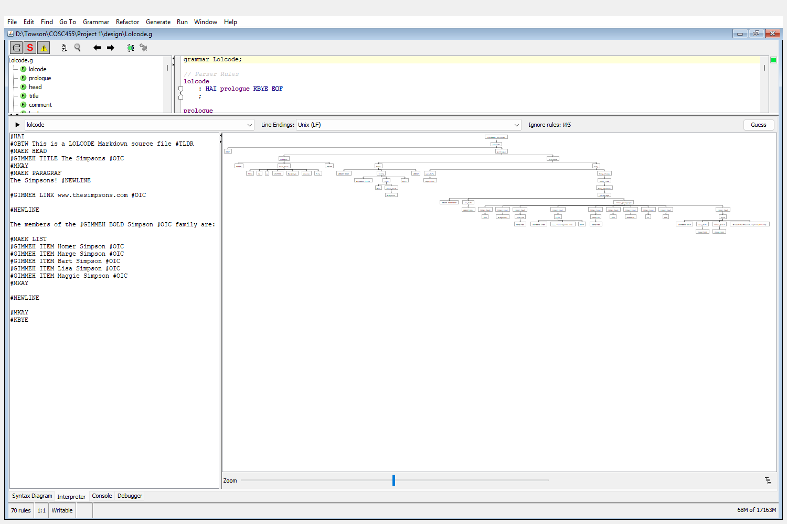

valid2_variables.lol
#HAI
#IHAZ lastname #ITIZ Simpson #MKAY
#MAEK PARAGRAF
The members of the #GIMMEH BOLD #GIMMEH VAR lastname #OIC #OIC are:
#MAEK LIST
#GIMMEH ITEM Homer #GIMMEH VAR lastname #OIC #OIC
#GIMMEH ITEM Marge #GIMMEH VAR lastname #OIC #OIC
#GIMMEH ITEM Bart #GIMMEH VAR lastname #OIC #OIC
#GIMMEH ITEM Lisa #GIMMEH VAR lastname #OIC #OIC
#GIMMEH ITEM Maggie #GIMMEH VAR lastname #OIC #OIC
#MKAY
#MKAY
#KBYE
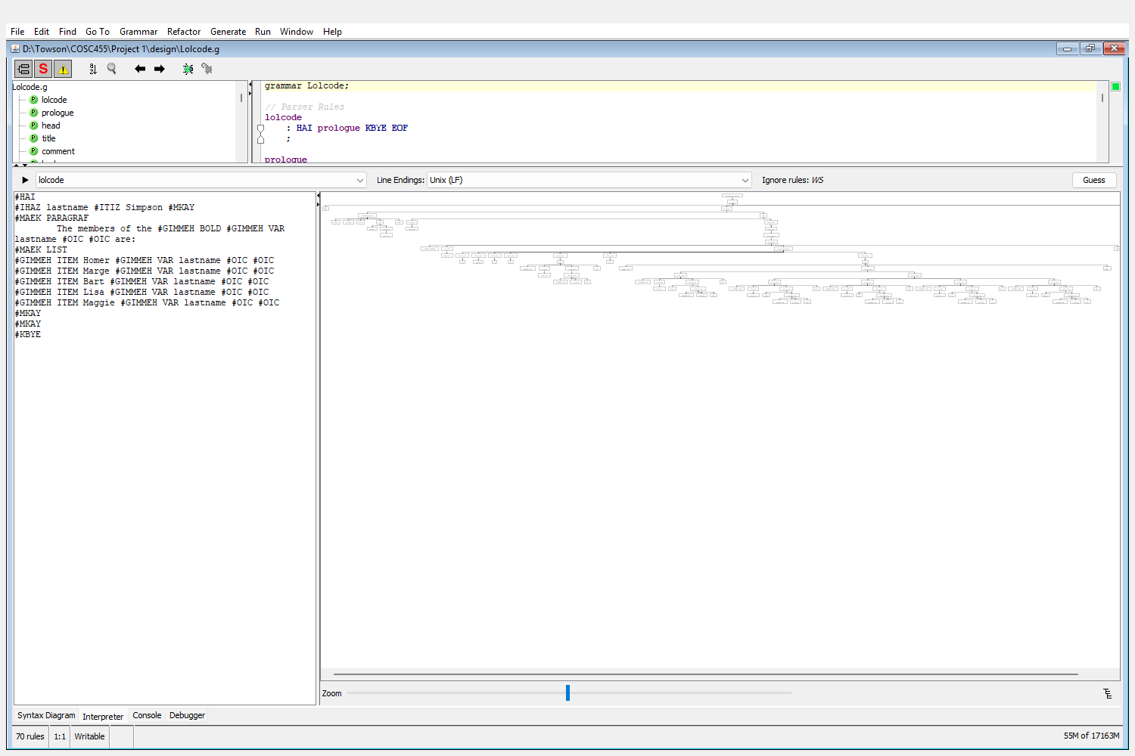

valid3_scope.lol
#HAI
#IHAZ myname #ITIZ Josh #MKAY
Hi, my name is #GIMMEH VAR myname #OIC .

#MAEK PARAGRAF
#IHAZ myname #ITIZ Jon #MKAY
Inside the paragraph block, my name is #GIMMEH VAR myname #OIC
#MKAY
Now my name is #GIMMEH VAR myname #OIC again.
#KBYE
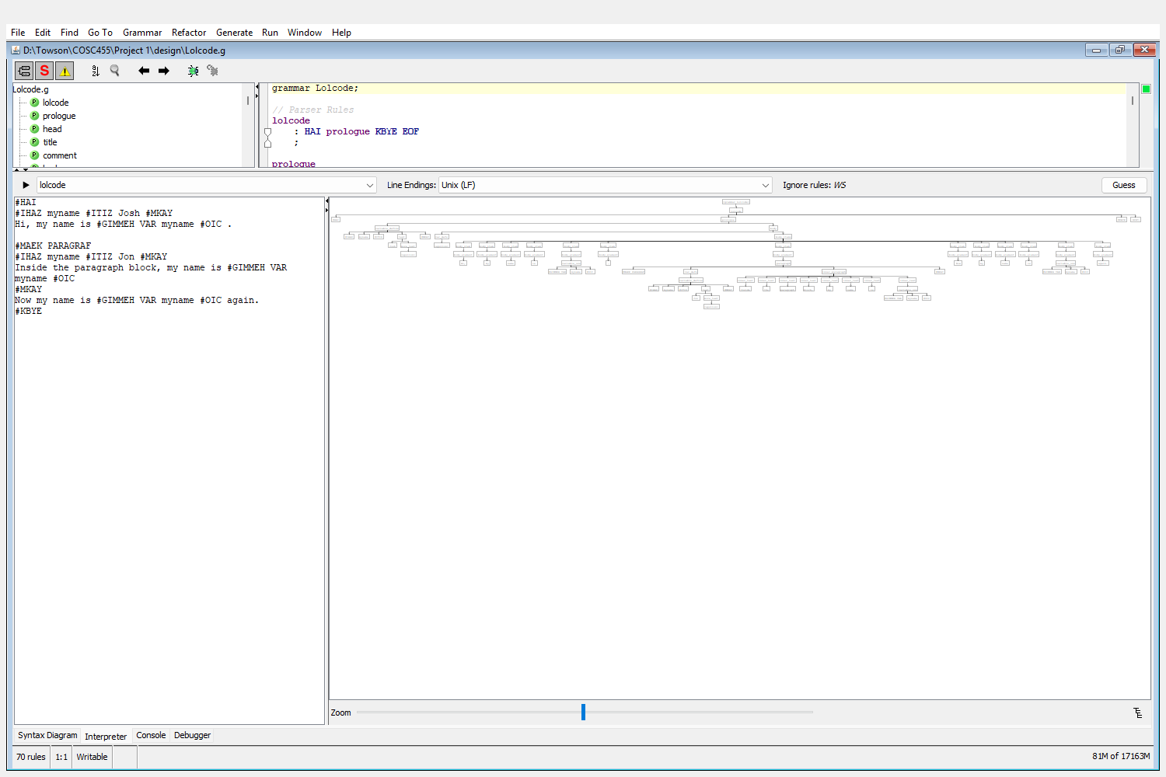

valid4_mixed_case.lol
#hai
#obtw comments may come before the head #tldr
#Maek Head
#gimmeh title Case Test #oic
#mkay
#IHAZ site #ITIZ www.towson.edu #MKAY
#gimmeh bold Bold outside a paragraph #OIC #newline
#Gimmeh Linx www.towson.edu #Oic
#maek paragraf
Visit #GIMMEH VAR site #OIC today! #OBTW a comment in a paragraph #TLDR
#maek list
#gimmeh item One #gimmeh bold two #oic #oic
#OBTW comment between items #TLDR
#gimmeh item Three #oic
#mkay
#mkay
#kbye
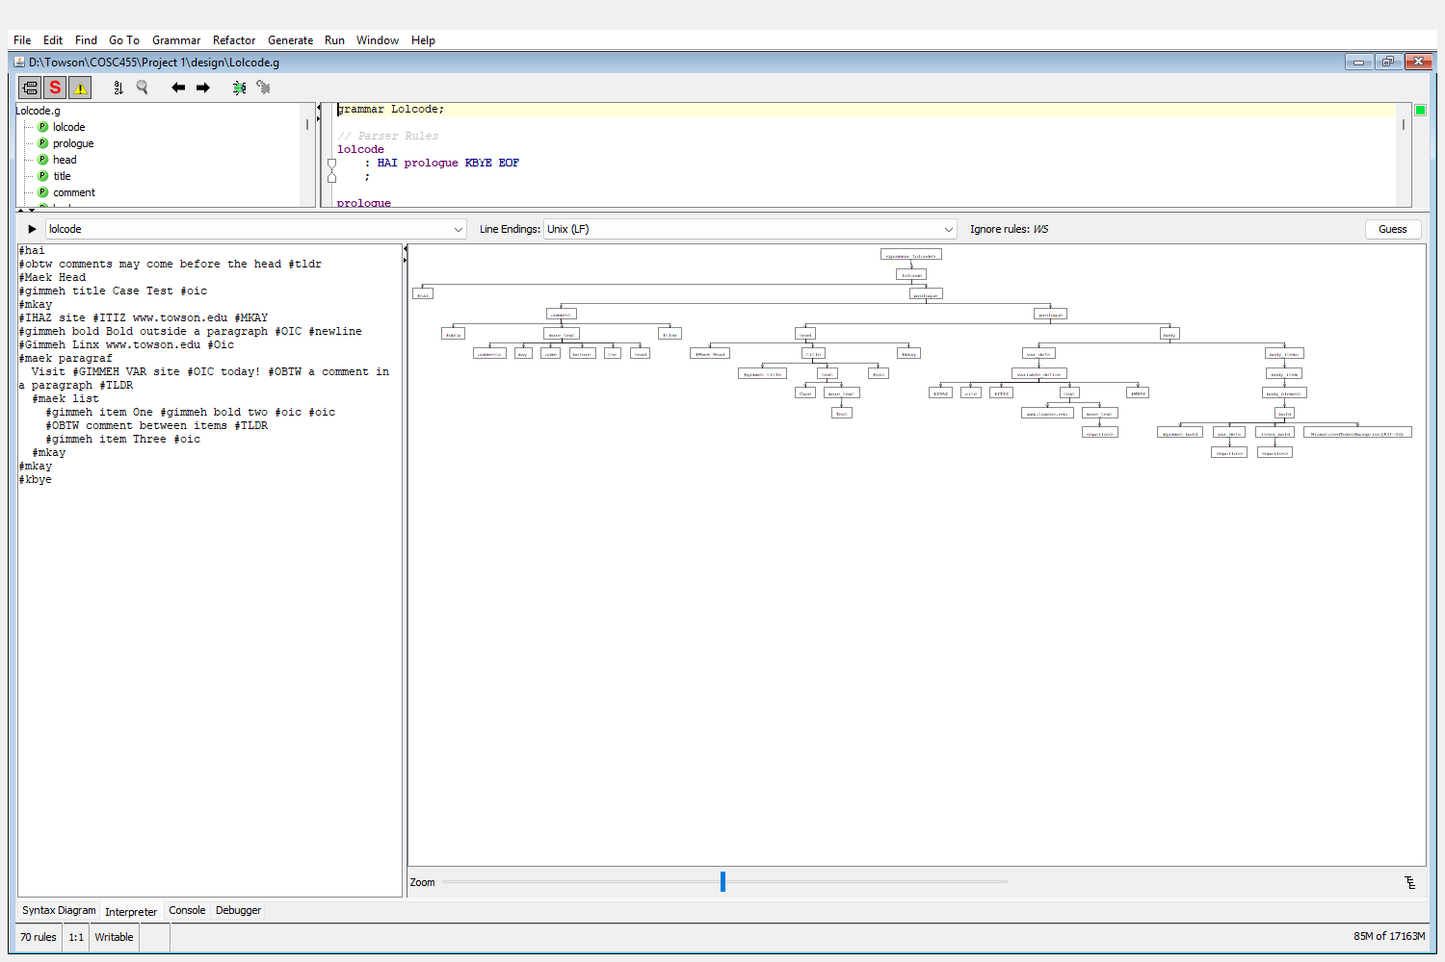

valid5_minimal.lol
#HAI
#KBYE
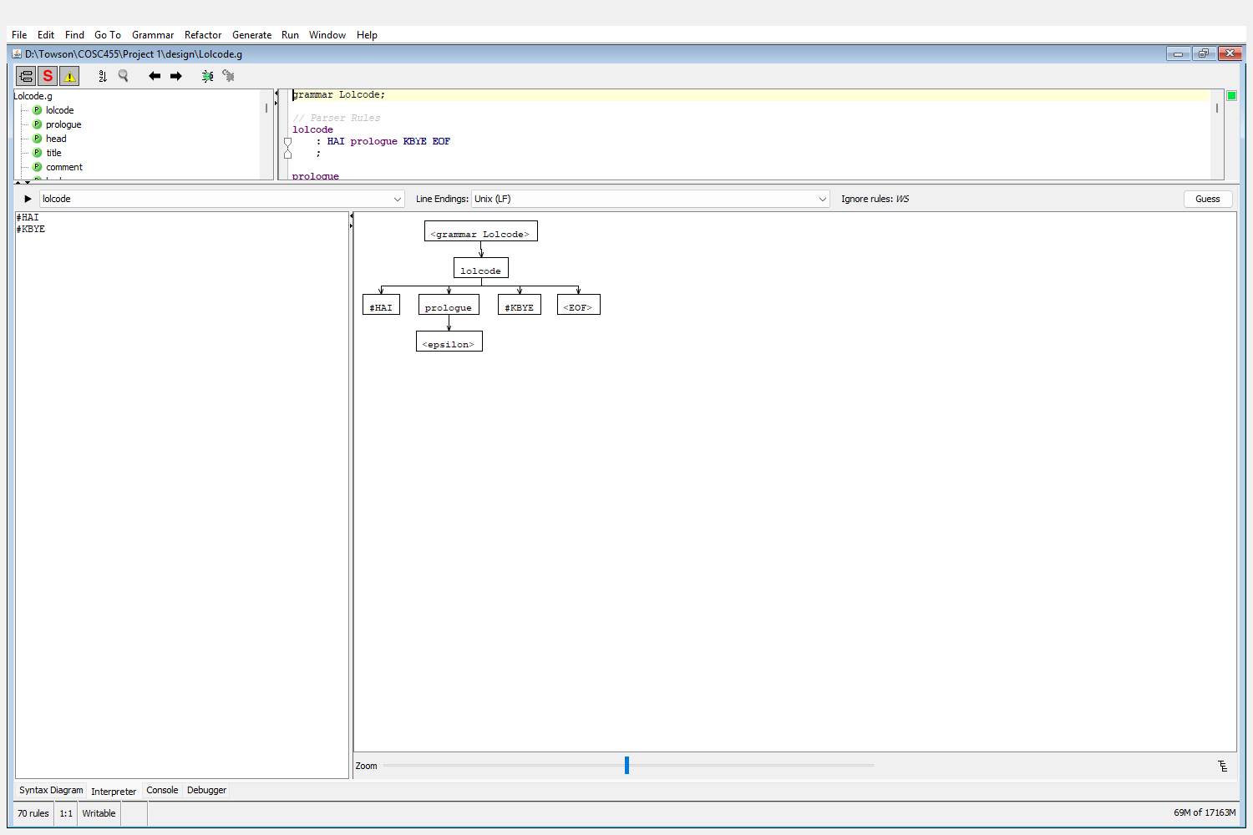

Invalid Test Cases. The following inputs are not valid LOLCODE Markdown and are rejected by the grammar.

invalid1_missing_kbye.lol
#HAI
#MAEK PARAGRAF Hello world #MKAY
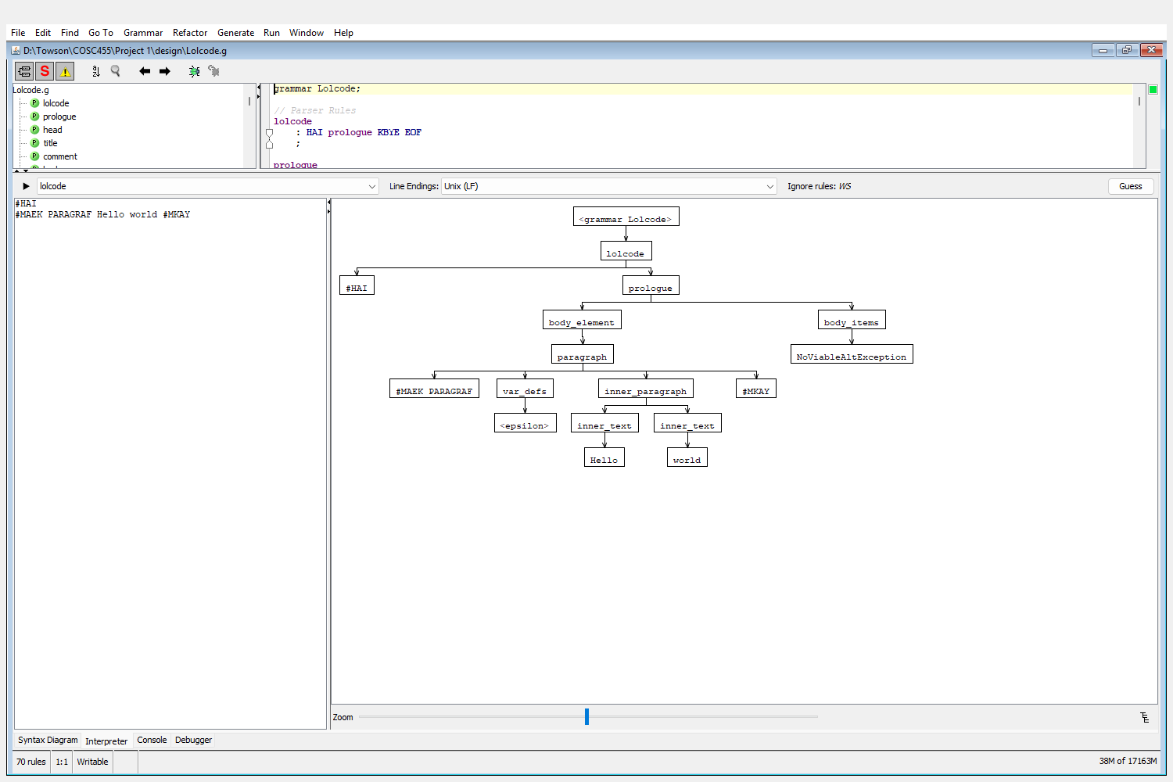
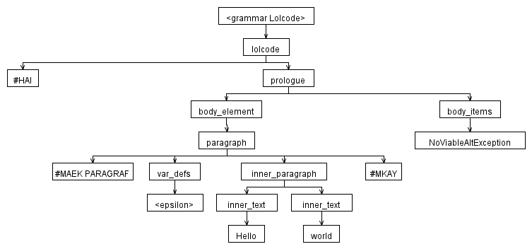
The parser correctly processes the paragraph and then reaches the end of the file. The rule that detects this error is body_items. The lolcode rule requires #KBYE at the end of the file, but the input ends instead. The exact token that caused this rule violation was <EOF>.

invalid2_head_not_first.lol
#HAI
#MAEK PARAGRAF Hello #MKAY
#MAEK HEAD
#GIMMEH TITLE Too late #OIC
#MKAY
#KBYE
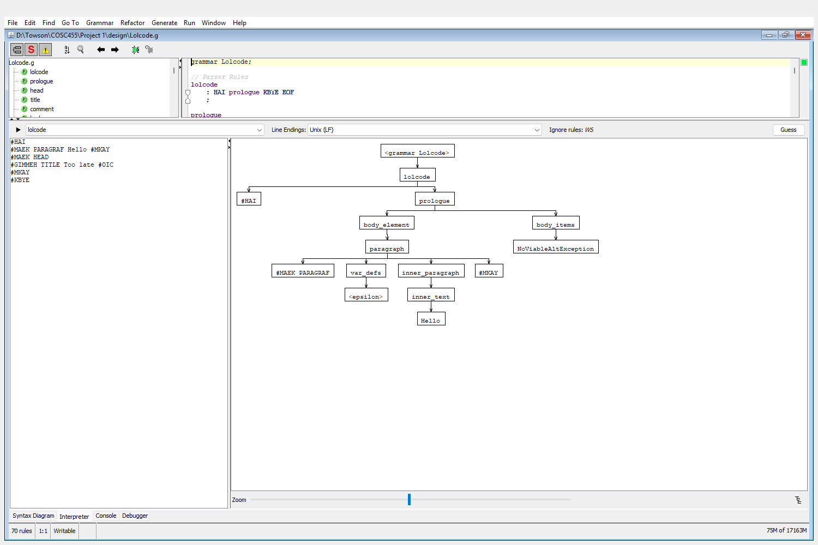
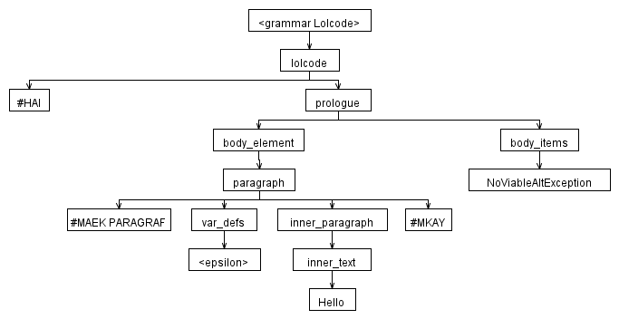
The parser correctly processes the paragraph and then moves on to body_items. The rule that detects this error is body_items. The head is only allowed right after #HAI (or after comments), so once the body has started there is no rule that allows it. The exact token that caused this rule violation was '#MAEK HEAD'.

invalid3_nested_paragraph.lol
#HAI
#MAEK PARAGRAF
Outer
#MAEK PARAGRAF Inner #MKAY
#MKAY
#KBYE
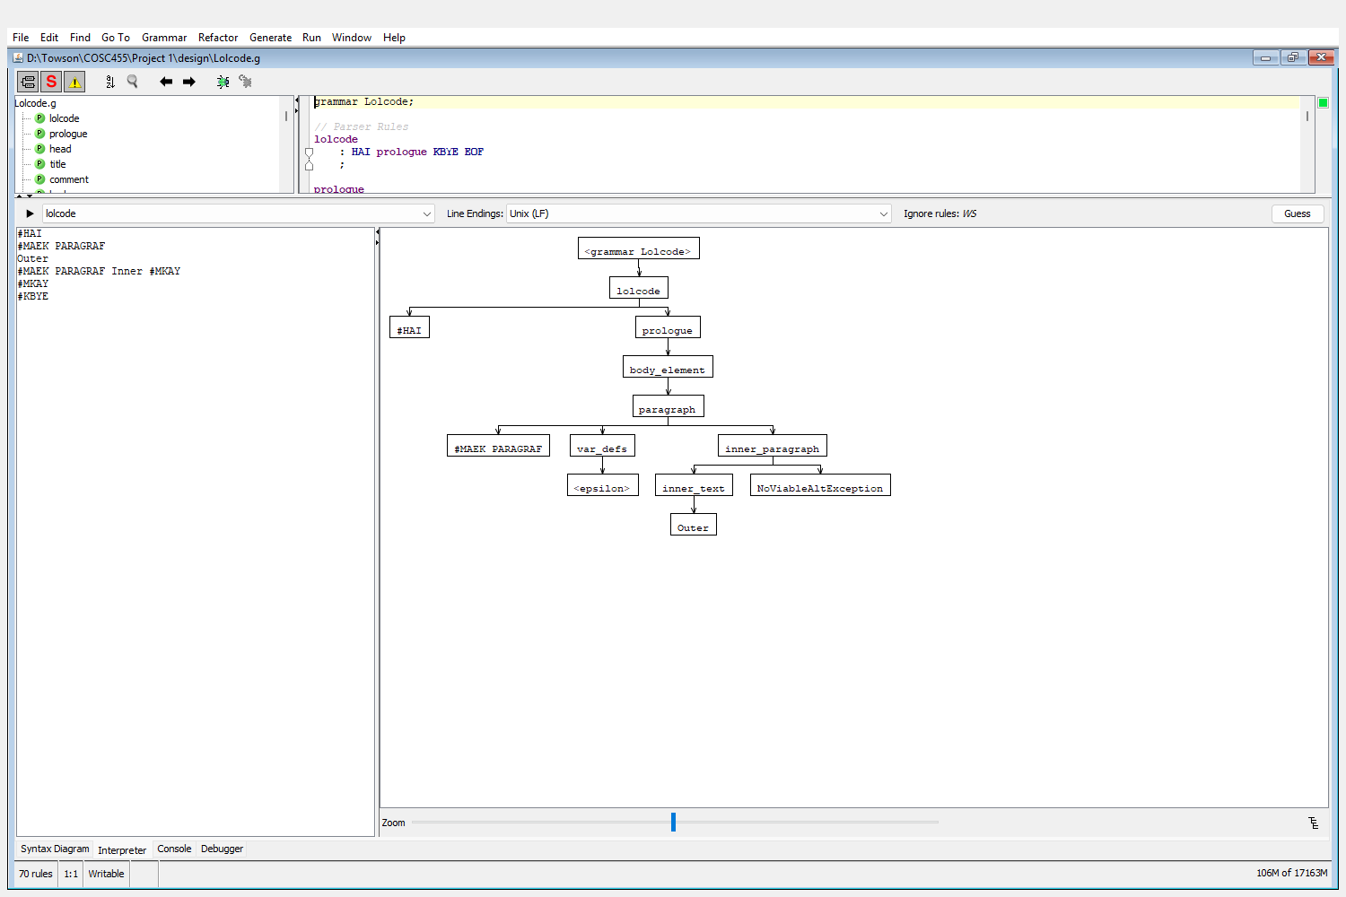
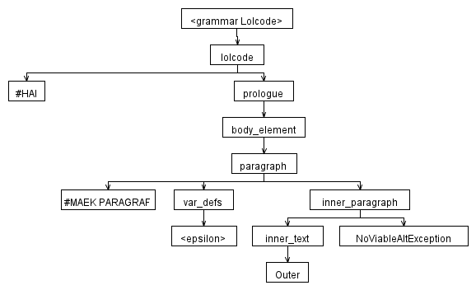
The parser fails inside the first paragraph after reading the word 'Outer'. The rule that detects this error is inner_paragraph. The inner_text rule does not include paragraph, so a paragraph cannot go inside another paragraph. The exact token that caused this rule violation was '#MAEK PARAGRAF'.

invalid4_list_without_item.lol
#HAI
#MAEK LIST
Some text before the first item
#GIMMEH ITEM One #OIC
#MKAY
#KBYE
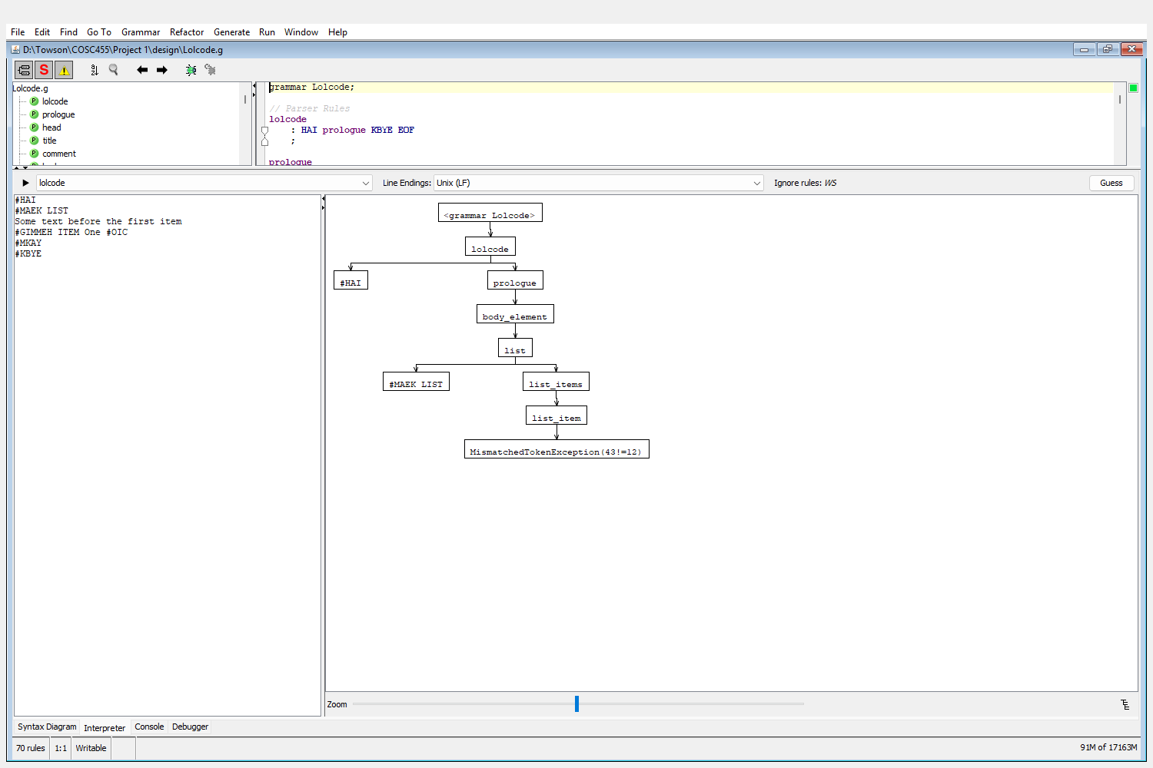
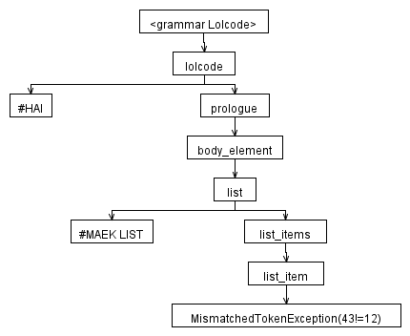
The parser fails right after #MAEK LIST. The rule that detects this error is list_item. The list_items rule says a list must start with a list_item, which must begin with #GIMMEH ITEM, but a word was given instead. The exact token that caused this rule violation was 'Some'.

invalid5_lexical_error.lol
#HAI
#HEY this is not an annotation
#KBYE
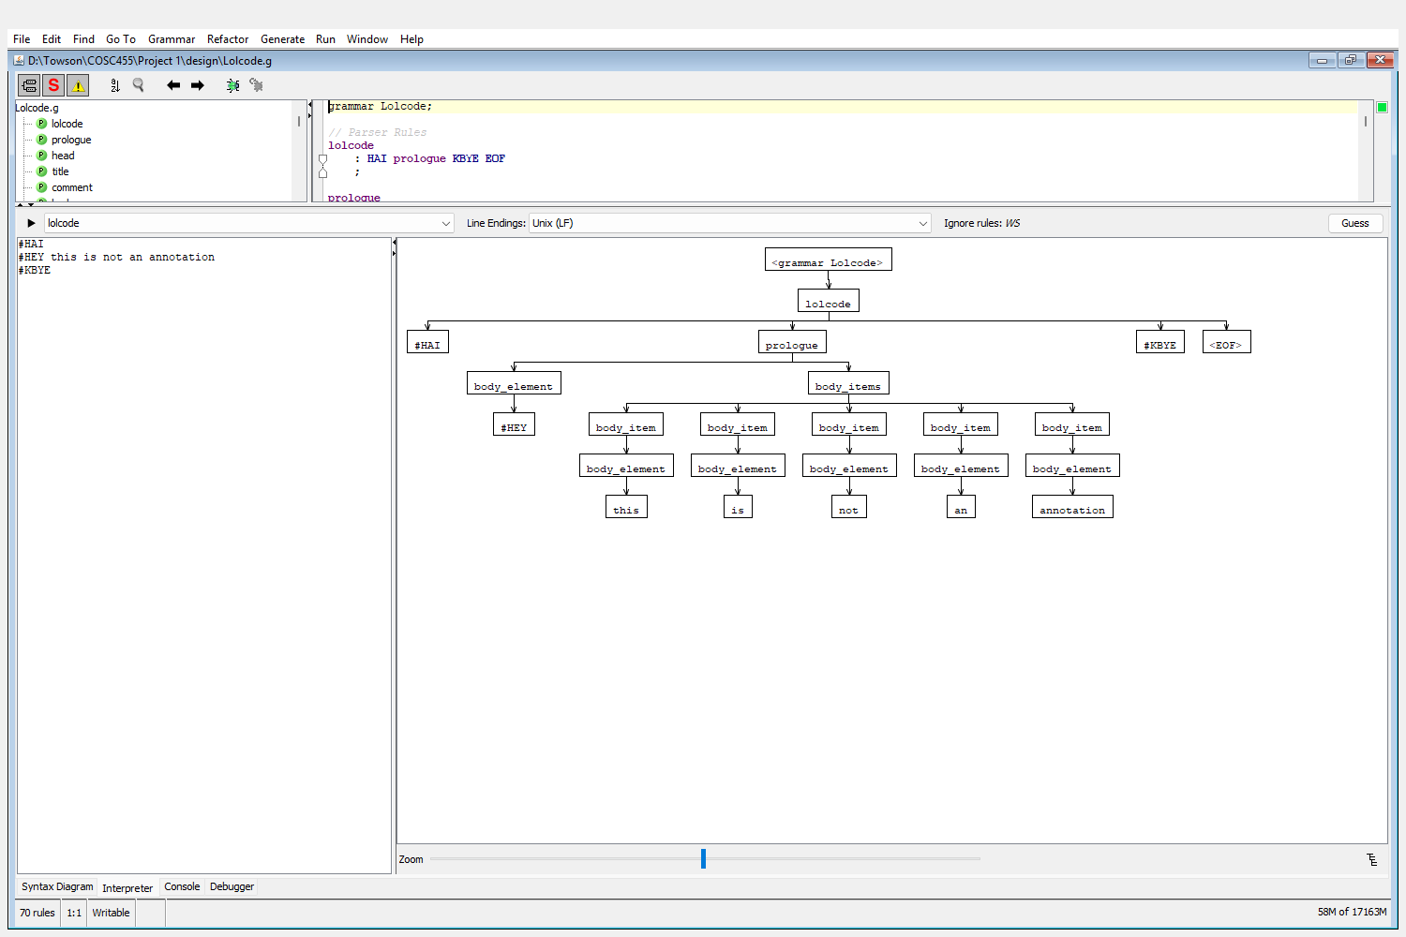
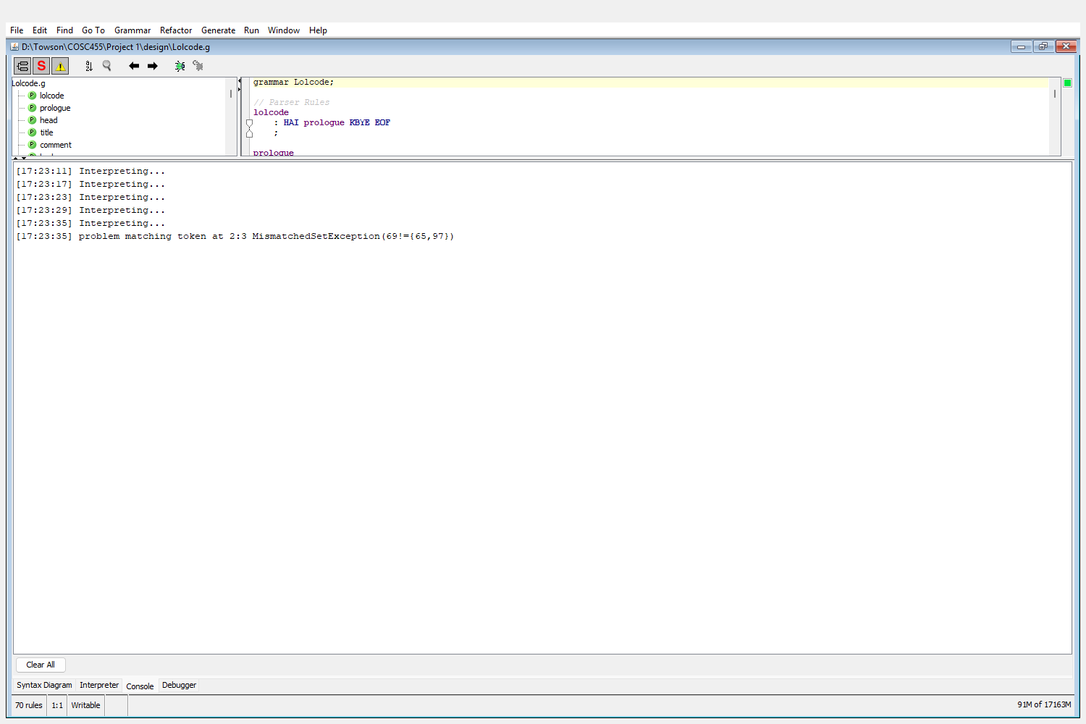
This is a lexical error instead of a syntax error. The lexer reads '#H' and expects the rest of '#HAI', but the next character is 'E', so no token matches '#HEY'. ANTLRWorks still shows a parse tree for this input, so the error can be seen in the Console tab, which reports MismatchedSetException at line 2, position 3.

invalid6_ihaz_not_first.lol
#HAI
#MAEK PARAGRAF
Some text first
#IHAZ x #ITIZ late #MKAY
#MKAY
#KBYE
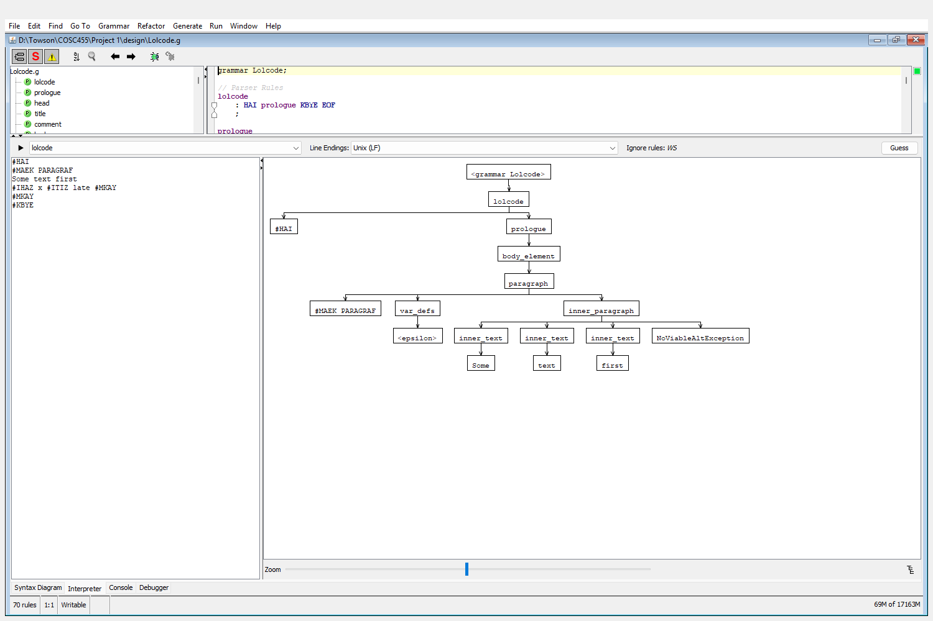
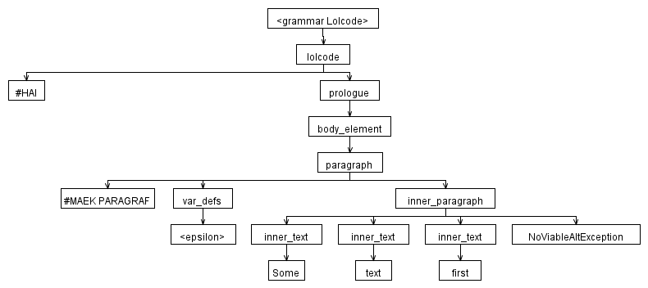
The parser fails inside the paragraph after reading 'Some text first'. The rule that detects this error is inner_paragraph. A variable definition is only allowed at the start of a block (var_defs), so it cannot come after text. The exact token that caused this rule violation was '#IHAZ'.

invalid7_bold_in_title.lol
#HAI
#MAEK HEAD
#GIMMEH TITLE A #GIMMEH BOLD bold #OIC title #OIC
#MKAY
#KBYE
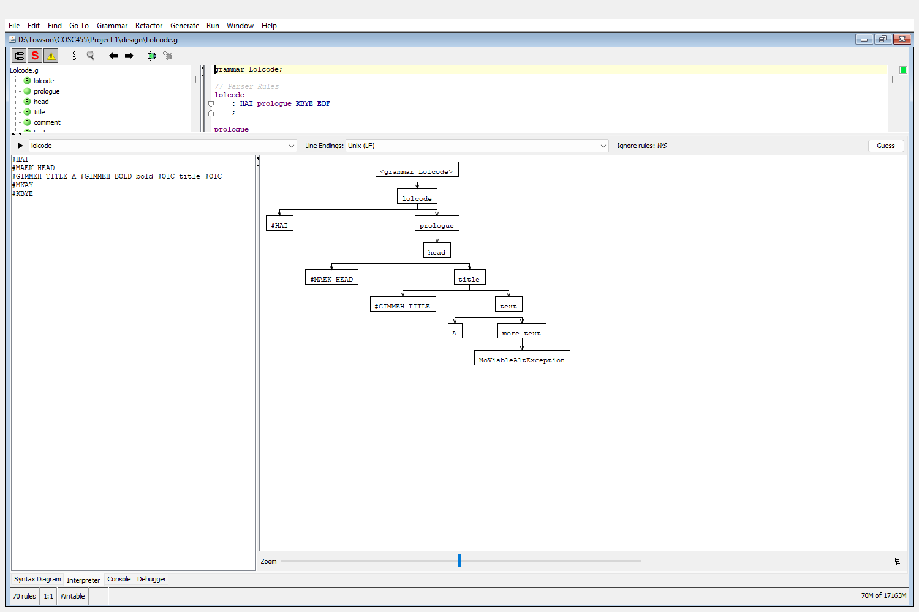
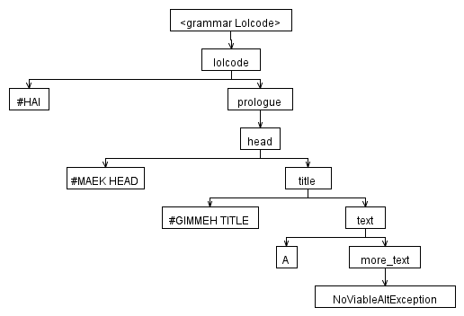
The parser fails inside the title after reading the word 'A'. The rule that detects this error is more_text. The title rule only allows plain text, so a bold annotation cannot go inside it. The exact token that caused this rule violation was '#GIMMEH BOLD'.

invalid8_varname_with_space.lol
#HAI
#IHAZ last name #ITIZ Simpson #MKAY
#KBYE
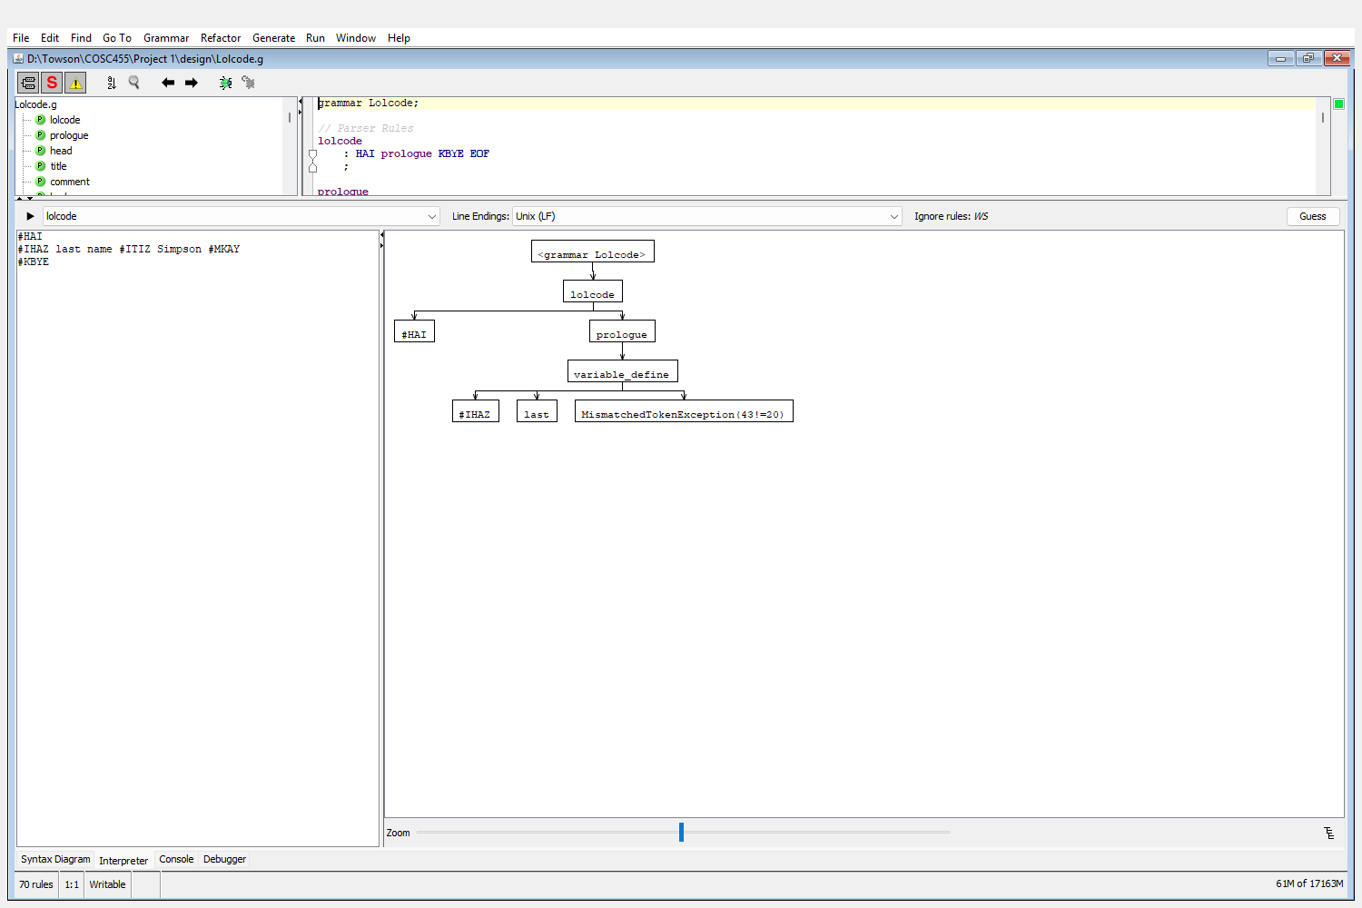
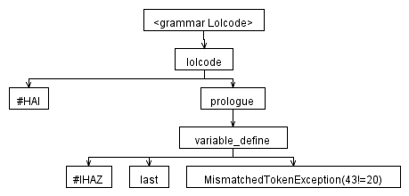
The parser fails in variable_define after reading the variable name 'last'. The rule expects #ITIZ right after a one-word variable name, but another word was given instead. The exact token that caused this rule violation was 'name'.

