**Requirements for “SimpleMessenger” (Java) Web service**

1. Tomcat
2. Java SDK/JDK

**Requirements for “SimpleMessenger” Client (C#)**

1. .Net Framework 4.0 or higher

**Running Web Service on Tomcat Server**

1. Tomcat should be installed.
2. Extract the contents from the **messengerApplication** zip folder
3. Navigate to the **messengerWebService(Java)**  and copy the following folders  
   **simpleMessage**
4. Place the copied folder into Tomcat /work/Catalina/localhost
5. Start Tomcat, test the following wsdl url to make sure the web service is successfully running.  
   <http://localhost:8070/SimpleMessage/services/messengerWebService?wsdl>

**Running messenger client (C#)**

1. Messenger client to interface with the web service is written in C#. Requires .Net Framework 4.0 or higher to run
2. Extract the **messengerApplication** zip folder
3. Naviagate into the **messengerClient(C#)** folder.
4. Open the “**messengerClient1.exe.config**” file
5. Navigate to the “value” xml tag that holds the web service url (screenshot below)  
   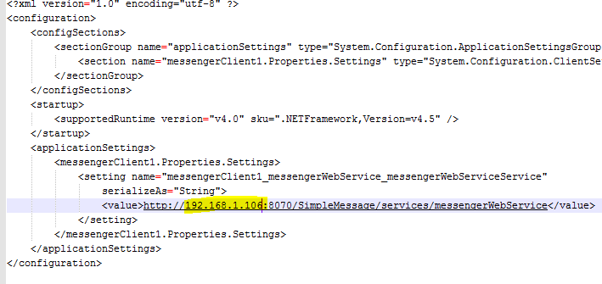
6. Confirm the ipaddress in the url is that of the host machine that the webservice is running on
7. Double Click on the **messengerClient1.exe** to start the client application
8. To log into chat, enter a name in the “your name” textfield and click “Enter chat” button.  
   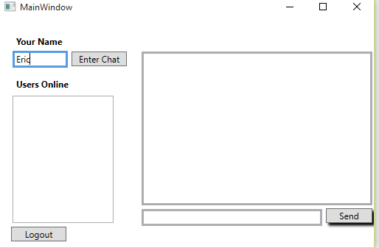
9. Once logged in, Your username will appear in the “users online” list and also any other users currently logged onto this chat session  
   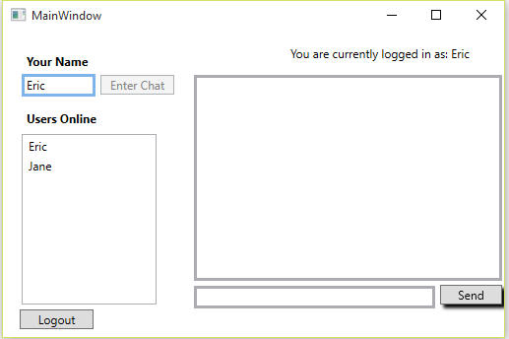
10. To send a message to a user, select their name on the users list, type a message in the message textbox and hit the send button.  
    