WEEK 04 - BUSINESS INTELLIGENCE

1. FACT TABLE DEFINITION

Business Process: Student Enrollment and Academic Performance
For this model, the selected business process is student enrollment and academic performance at a university.
This model continues the work developed in the previous weeks, where the academic performance of university students was identified as a data problem. The objective is to organize enrollment and academic performance information so it can be analyzed and used to support academic decisions.
The fact table represents the academic performance of a student in a course during an academic period.

Business Question
What is the percentage of students with low academic performance, and which courses and academic programs have the highest number of students with low performance?
This question is related to the analysis of academic performance and can help the university identify courses or programs where additional academic support may be necessary.

KPI: Low Academic Performance Rate
The main KPI is Low Academic Performance Rate.
The KPI can be calculated using the following formula:
Low Academic Performance Rate =
(Number of students with low academic performance / Total number of enrolled students) × 100

Target
The target is to maintain the Low Academic Performance Rate at 10% or less.
If the percentage is higher than 10%, the university can investigate possible causes and implement actions such as:
- Tutoring
- Academic support
- Monitoring of students with low performance

2. OLTP AND OLAP

Source System: OLTP
The source system is an OLTP (Online Transaction Processing) system.
The university enrollment system is used to perform daily operational activities such as:
- Student enrollment
- Course registration
- Updating student information
- Registering academic periods
OLTP systems are designed for frequent transactions and operational processes. They are not primarily designed for complex historical analysis.

Analytical System: OLAP
For analysis, the information should be transformed and stored in an OLAP/Data Warehouse environment.
The Data Warehouse allows historical academic information to be organized and analyzed efficiently.
It can combine data from different academic periods and allow users to:
- Identify trends
- Compare courses and academic programs
- Calculate KPIs
- Analyze academic performance
- Support decision-making

General Data Flow
OLTP → ETL → Data Warehouse → OLAP / BI → Dashboard and Reports
This separation allows the operational system to continue processing daily transactions while the analytical environment is used for business intelligence and decision-making.

3. STAR SCHEMA
The star schema contains one central fact table and four dimensions.

Fact Table: FACT_ACADEMIC_PERFORMANCE
The fact table contains the keys of the dimensions and the measures required for academic analysis.

Measures
Measure | Description
student_count | Represents the number of students and can be aggregated.
grade | Represents the student's grade in the course and can be analyzed using averages, maximums, or minimums.
failed_course_count | Indicates whether the student failed the course and can be summed.
low_performance_flag | Indicates whether the student has low academic performance and can be used to calculate the Low Academic Performance Rate.

Important Note About Grades
Grades are not treated as a summable measure because adding grades from different students does not provide meaningful information.
Instead, grades can be analyzed using:
- Average
- Maximum
- Minimum

FACT_ACADEMIC_PERFORMANCE Structure
Field | Description
performance_id | Primary key. Unique identifier of the academic performance record.
time_id | Foreign key. Identifies the academic period and date.
student_id | Foreign key. Identifies the student.
course_id | Foreign key. Identifies the course.
program_id | Foreign key. Identifies the academic program.
student_count | Measure. Represents the number of students.
grade | Measure. Represents the student's grade in the course.
failed_course_count | Measure. Indicates whether the student failed the course.
low_performance_flag | Measure. Indicates whether the student has low academic performance.

4. DIMENSION DESIGN
The model contains four dimensions, including the required Time dimension.

4.1 Time Dimension: DIM_TIME
The Time dimension allows academic performance data to be analyzed according to different time periods.

Attributes
Attribute | Description
time_id | Unique identifier of the time record.
date | Specific date.
day | Day of the month.
month | Month of the year.
quarter | Quarter of the year.
year | Calendar year.
academic_period | Academic period or semester.

4.2 Student Dimension: DIM_STUDENT
The Student dimension allows academic performance data to be analyzed according to student characteristics.

Attributes
Attribute | Description
student_id | Unique identifier of the student.
name | Student's name.
age | Student's age.
gender | Student's gender.
semester | Current semester of the student.

4.3 Course Dimension: DIM_COURSE
The Course dimension allows academic performance data to be analyzed according to courses.

Attributes
Attribute | Description
course_id | Unique identifier of the course.
course_name | Name of the course.
course_code | Official course code.
credits | Number of academic credits.
course_type | Type or category of the course.

4.4 Academic Program Dimension: DIM_PROGRAM
The Academic Program dimension allows academic performance data to be analyzed according to the academic program of the student.

Attributes
Attribute | Description
program_id | Unique identifier of the academic program.
program_name | Name of the academic program.
faculty | Faculty to which the program belongs.
academic_level | Academic level of the program.

5. STAR SCHEMA DIAGRAM
The star schema consists of a central fact table and four dimensions connected through their keys.
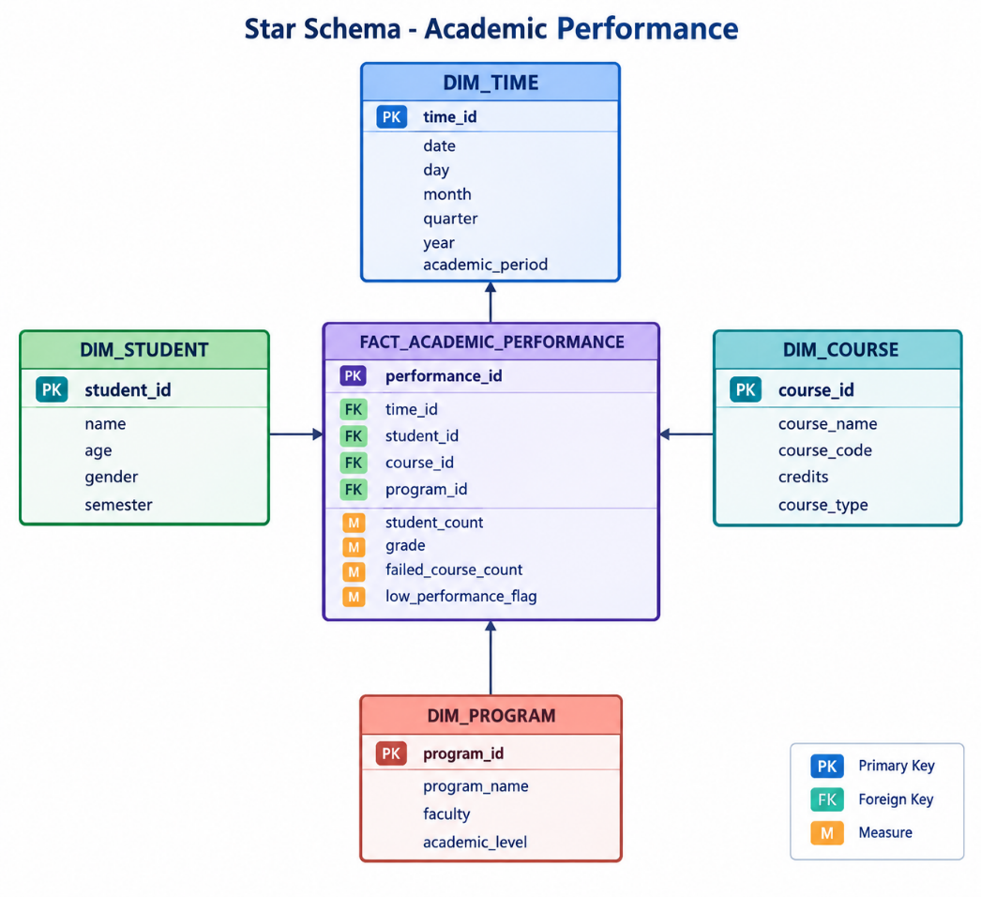

6. BUSINESS QUESTIONS THE MODEL CAN ANSWER

Question 1
What is the Low Academic Performance Rate by academic period?
This allows the university to compare academic periods and determine whether low academic performance is increasing or decreasing over time.

Question 2
Which courses and academic programs have the highest number of students with low academic performance?
This allows the university to identify areas where additional academic support or intervention may be required.

7. MODEL AND QUESTIONS
The star schema uses FACT_ACADEMIC_PERFORMANCE as the central fact table.
It contains measures such as:
- student_count
- grade
- failed_course_count
- low_performance_flag
The model includes four dimensions:
- DIM_TIME
- DIM_STUDENT
- DIM_COURSE
- DIM_PROGRAM
The model can answer the question of how the Low Academic Performance Rate changes by academic period.
It can also identify which courses and academic programs have the highest number of students with low academic performance.
This information can help the university make decisions about:
- Tutoring
- Academic support
- Student monitoring

8. CONCLUSION
The proposed Business Intelligence model organizes university enrollment and academic performance information using a Star Schema.
The central fact table, FACT_ACADEMIC_PERFORMANCE, stores academic performance measures and connects them to four dimensions:
- Time
- Student
- Course
- Academic Program
The model separates the operational OLTP system from the analytical OLAP/Data Warehouse environment through an ETL process.
The main KPI is the Low Academic Performance Rate, with a target of 10% or less.
The model provides the university with useful information to identify academic performance trends, detect courses and academic programs with higher levels of low performance, and support decisions related to tutoring, academic support, and student monitoring.

