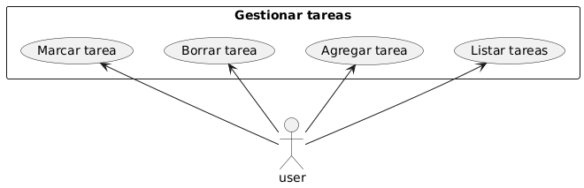
@startuml

actor user

rectangle "Gestionar tareas" {
usecase "Listar tareas" as u1
usecase "Agregar tarea" as u2
usecase "Borrar tarea" as u3
usecase "Marcar tarea" as u4

}

user -up-> u1
user -up-> u2
user -up-> u3
user -up-> u4

@enduml

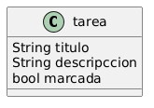
@startuml
class tarea {
String titulo
String descripccion
bool marcada
}

@enduml

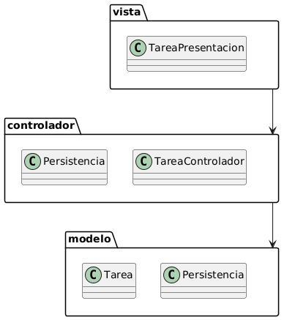
@startuml
folder vista {
class "TareaPresentacion"
}

folder modelo{
class "Tarea"
class "Persistencia"
}

folder controlador {
class "Persistencia"
class "TareaControlador"
}

vista --> controlador
controlador --> modelo

@enduml

