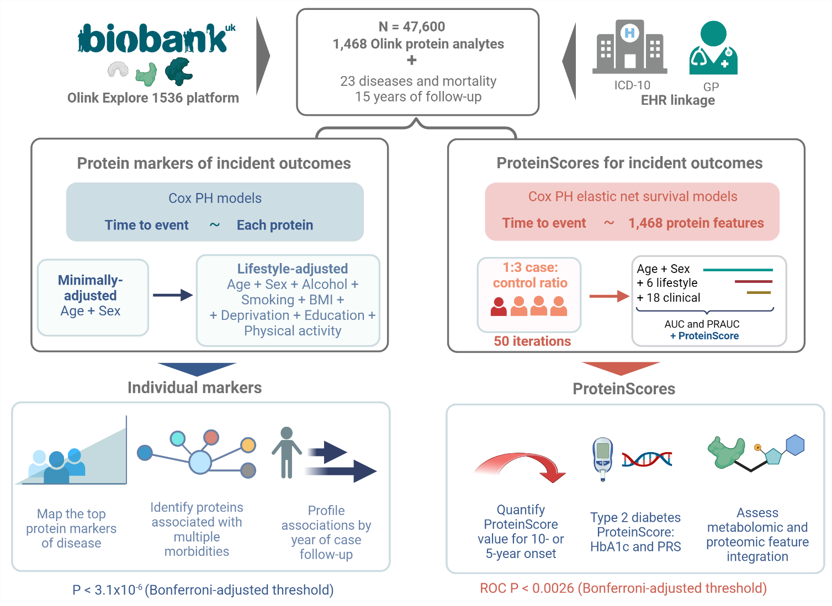
Extended Data Figure 1. Study design summary for protein assessment of leading incident diseases in the UK Biobank (N=47,600). Individual Cox proportional hazards (PH) models were used to profile relationships between baseline protein analytes and incident diseases or death, over a maximum of 15 years of electronic health linkage pertaining to cases. Associations that had P < 3.1x10⁻⁶ (Bonferroni-adjusted threshold) in minimally-adjusted (age and sex) and lifestyle-adjusted models were retained. Proteins associated with multiple morbidities were identified and associations were explored by year of case follow-up. Next, proteomic predictors (ProteinScores) were trained using Cox PH elastic net regression for 19 of the incident outcomes with a minimum of 150 cases. All ProteinScores were developed for 10-year onset of disease, except endometriosis, cystitis and amyotrophic lateral sclerosis that had case distributions that were better-suited to 5-year assessment (80% of cases diagnosed by year 8 of follow-up). Of fifty ProteinScore iterations with randomly sampled train and test populations, the ProteinScore with median improvement in AUC beyond a minimally-adjusted model was selected. Improvements in AUC due to adding the ProteinScores into models with increasingly complex covariate structures were quantified. The type 2 diabetes trait was taken forward as a case study to explore the potential value ProteinScores may offer, in the context of HbA1c (a clinically used biomarker) and a polygenic risk score (PRS). Integration of metabolomics features for scoring was investigated for death and type 2 diabetes outcomes as case studies.

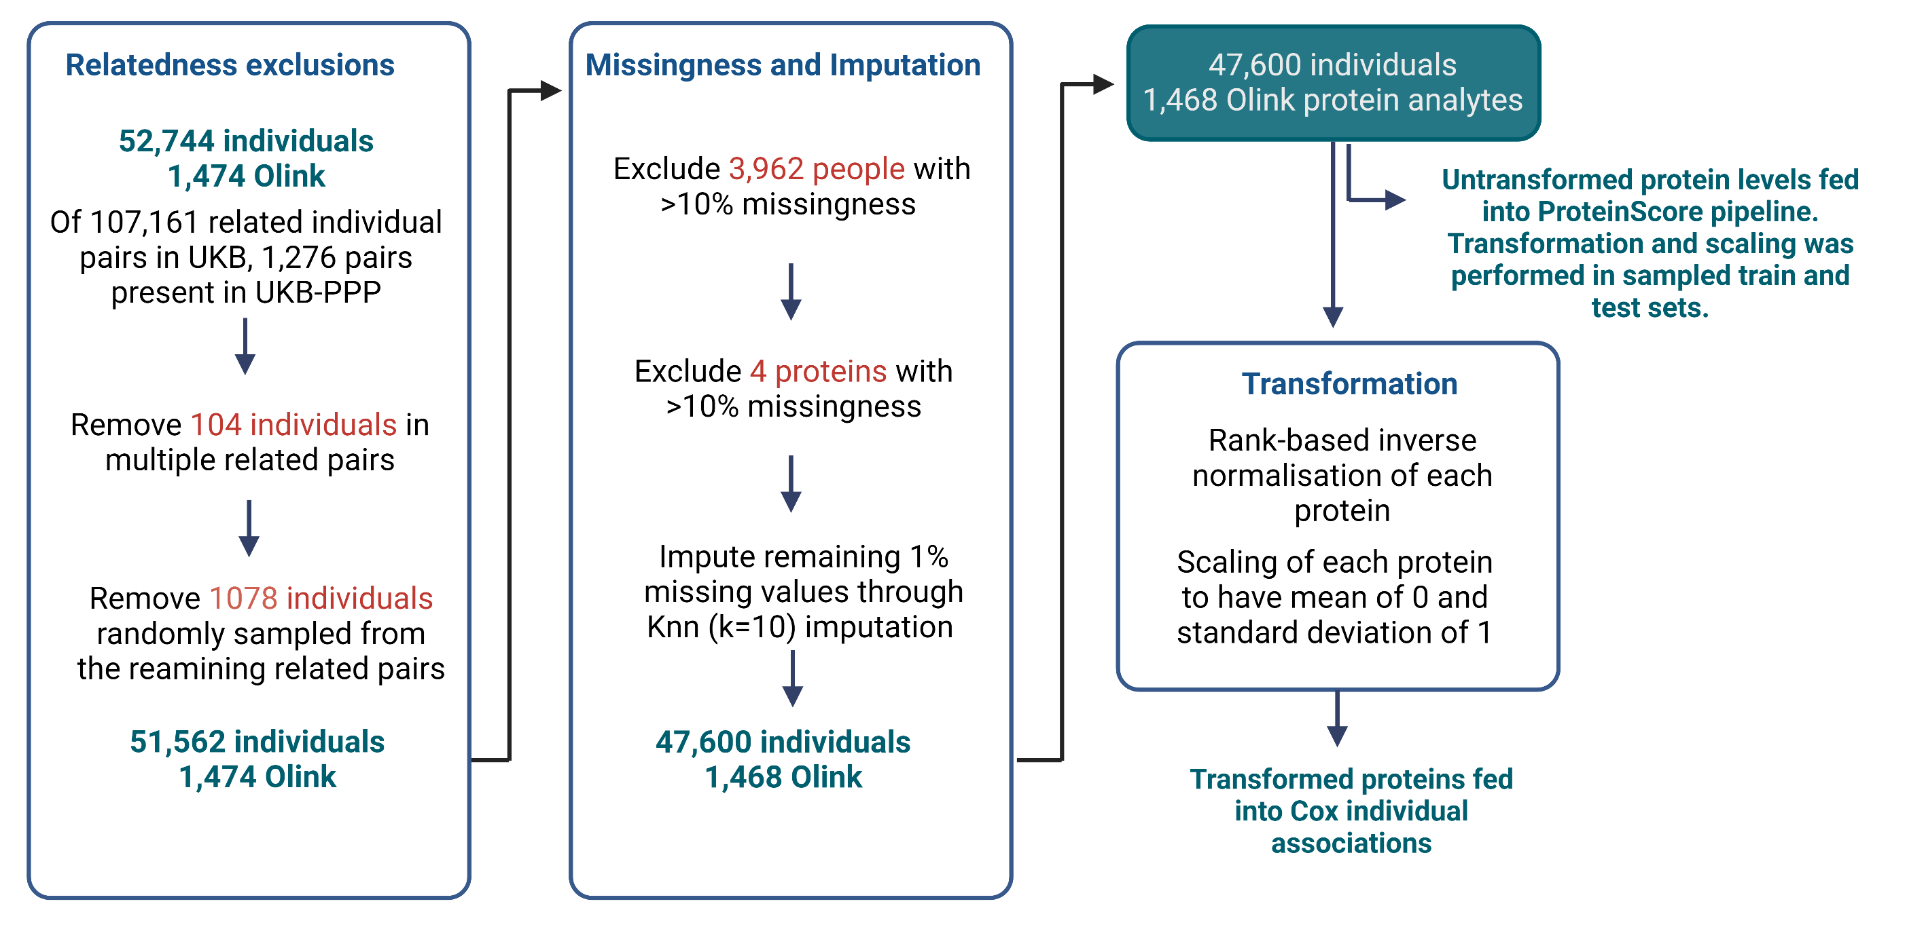
Extended Data Figure 2. Summary of processing steps applied to the protein measurement data in UKB-PPP. Related individuals were excluded, leaving a dataset containing 51,562 individuals with 1,474 Olink protein analytes measured. Next, 3,962 individuals that had >10% missing data were excluded, followed by four proteins that had >10% missing data. The remaining missing protein measurements (1% of total measurements) were imputed through K-nearest neighbours (Knn; k=10) imputation. The final dataset was comprised of 47,600 individuals and 1,468 Olink protein analytes. Protein levels were rank-based inverse normalised and scaled to have a mean of 0 and standard deviation of 1 prior to individual Cox PH analyses. Untransformed protein levels were fed into the model pipeline for ProteinScore development and were rank-based inverse normalised and scaled to have a mean of 0 and standard deviation of 1 in train and test sets separately once these were sampled for each outcome.

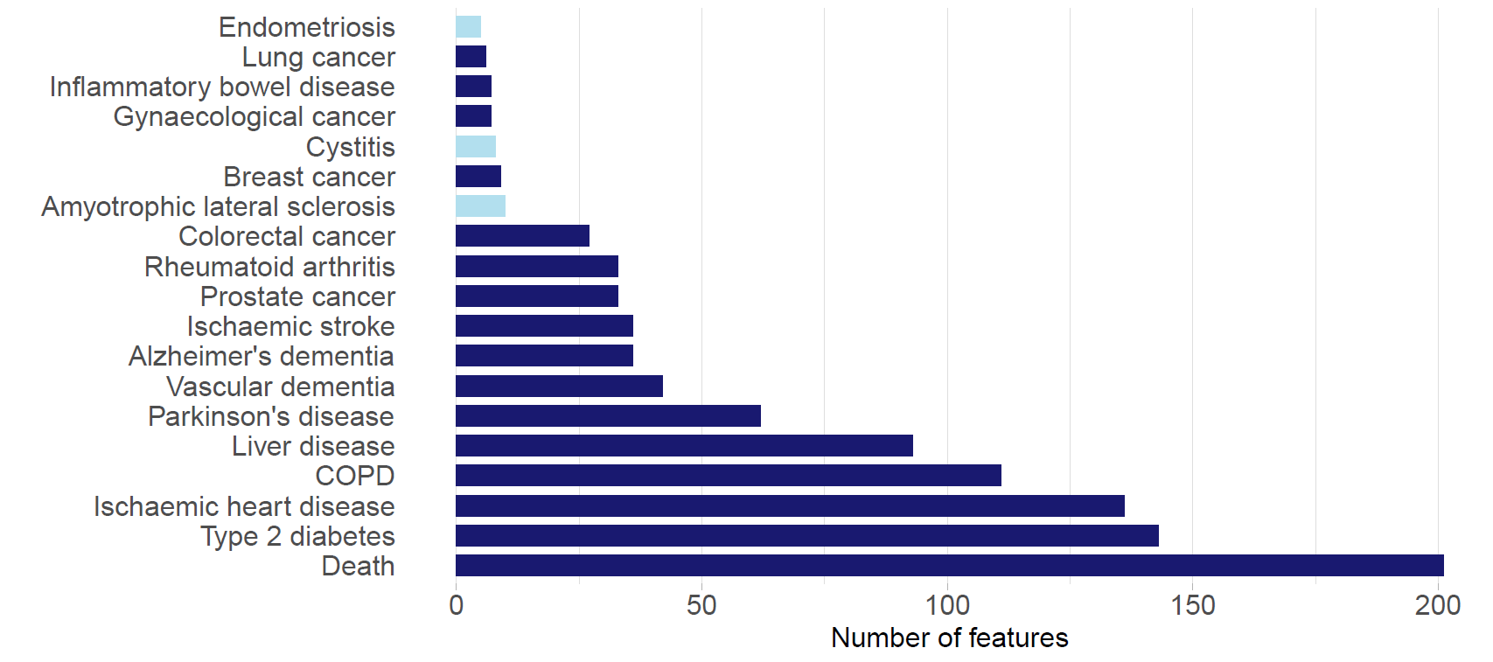
Extended Data Figure 3. ProteinScore feature selection. The total number of contributing protein analyte features selected for each ProteinScore. Incident outcomes that were assessed for 5-year onset (light blue) and 10-year onset (dark blue) are delineated.

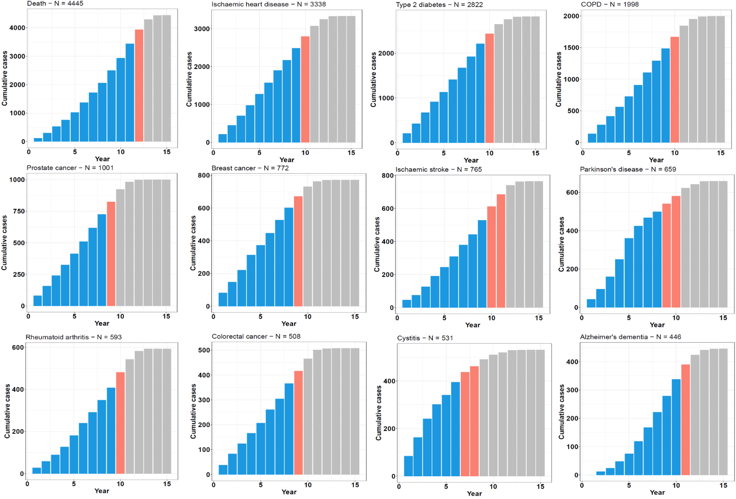
Extended Data Figure 4. Cumulative time-to-onset for cases by outcome in the UK Biobank PPP sample. Case counts are shown for each trait, with the number of cases by year of follow-up plotted cumulatively and the year that the proportion of cases diagnosed reached 80% (orange) and 90% (grey) demarcated. COPD: chronic obstructive pulmonary disease.

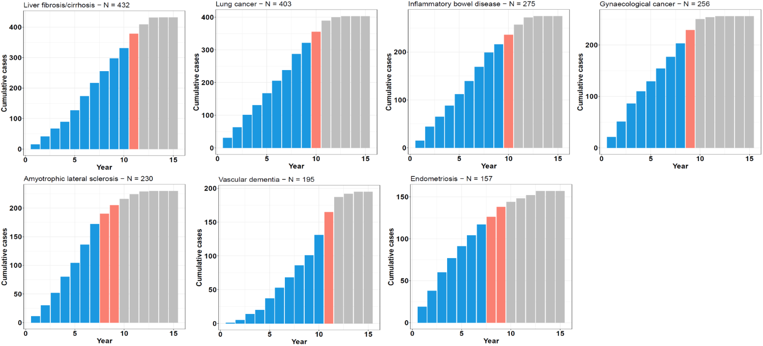
Extended Data Figure 5. Cumulative time-to-onset for cases by outcome in the UK Biobank PPP sample. Case counts are shown for each trait, with the number of cases by year of follow-up plotted cumulatively and the year that the proportion of cases diagnosed reached 80% (orange) and 90% (grey) demarcated.

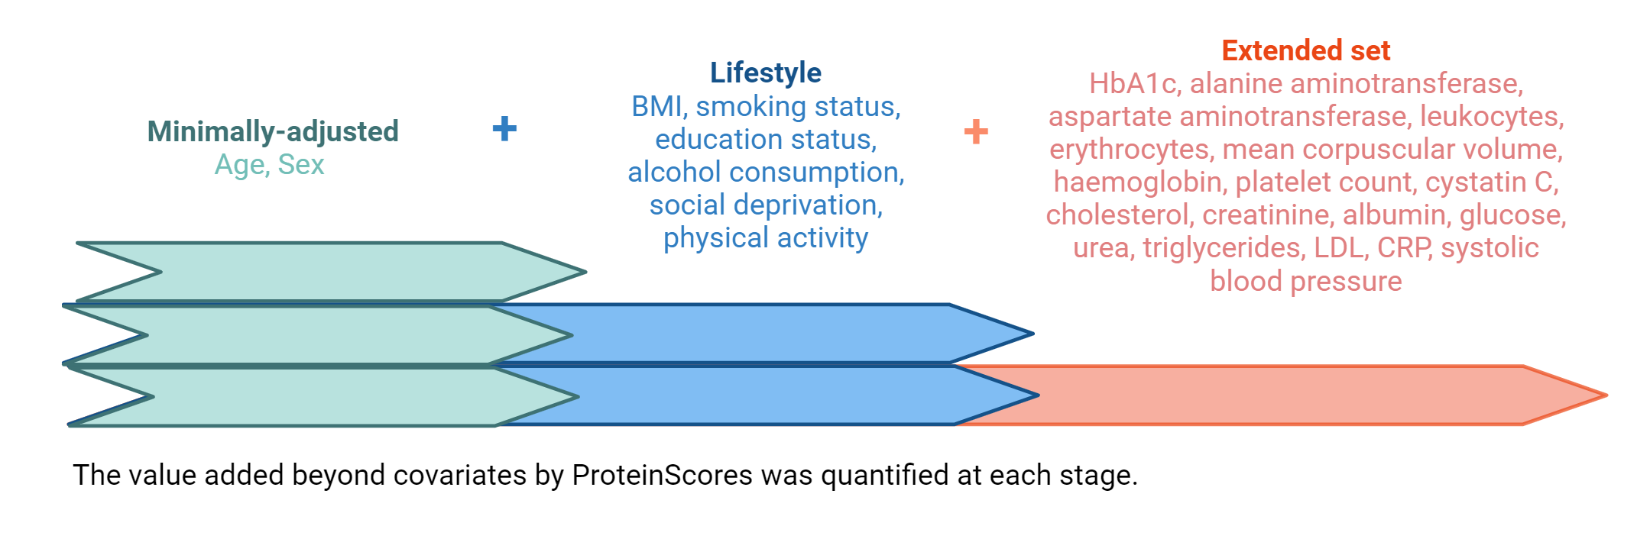
Extended Data Figure 6. Comprehensive covariates that were modelled to evaluate the value added by the ProteinScores beyond these covariates. Three increasingly complex sets of covariates were considered: 1) age and sex (where traits had not been sex-stratified), 2) further adjustment for a core set of six lifestyle and health covariates (BMI, alcohol consumption, social deprivation, educational attainment, smoking status and physical activity) and 3) further adjustment for an extended set of 18 biochemistry and physical attributes that are measurable in clinical settings. Performance when using only the ProteinScores was also considered. When modelled alongside age and sex, 26 possible covariates were therefore used in maximally-adjusted models.

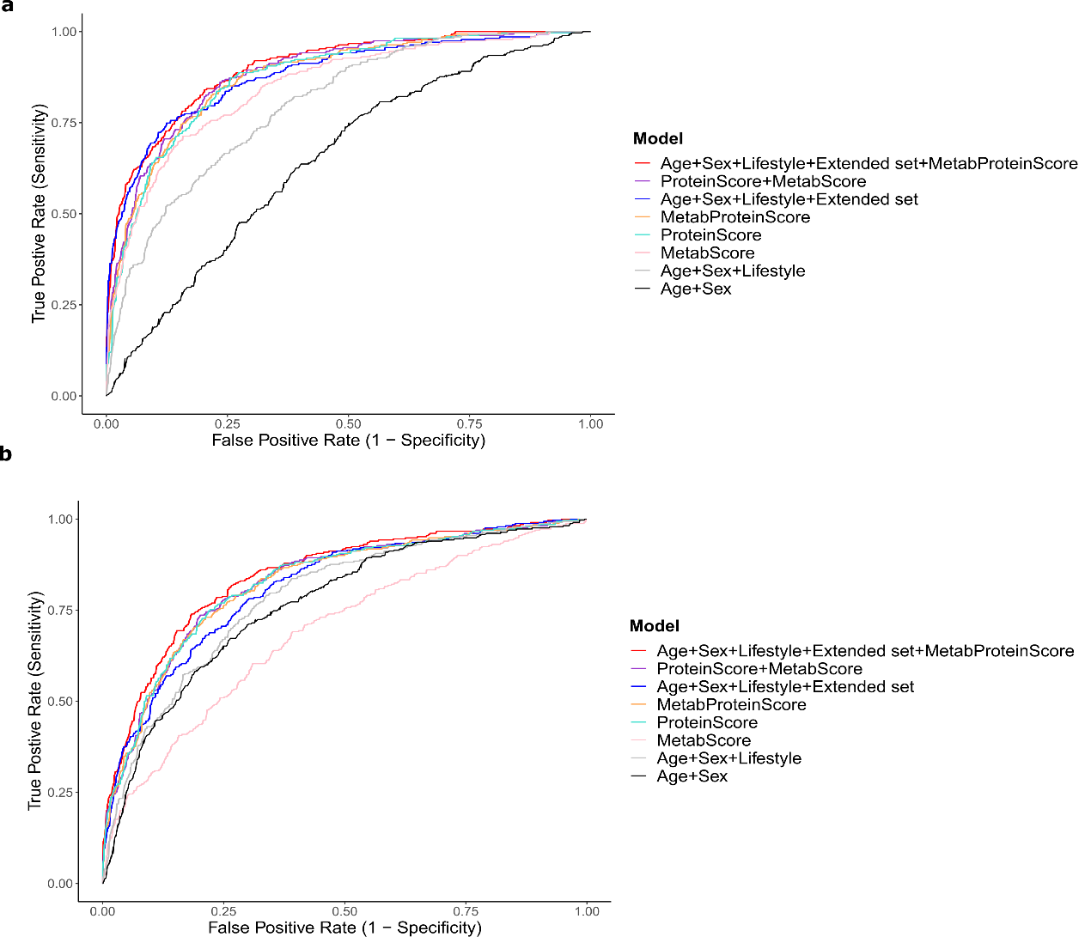
Extended Data Figure 7. Comparison of metabolomic and proteomic feature performance for type 2 diabetes (a) and all-cause mortality (b) traits. ROC curves for 10-year onset scores developed in the subsets of the type 2 diabetes and all-cause mortality training and test populations that had metabolomics and proteomics available. A Metabolomic score (MetaboScore), ProteinScore, and a joint omics score (MetaboProteinScore) are modelled individually and concurrently and benchmarked against either age and sex, six lifestyle factors, or an ‘extended set’ including these variables in addition to a further 18 clinically-relevant covariates. Full summary statistics are available in Supplementary Table 16.
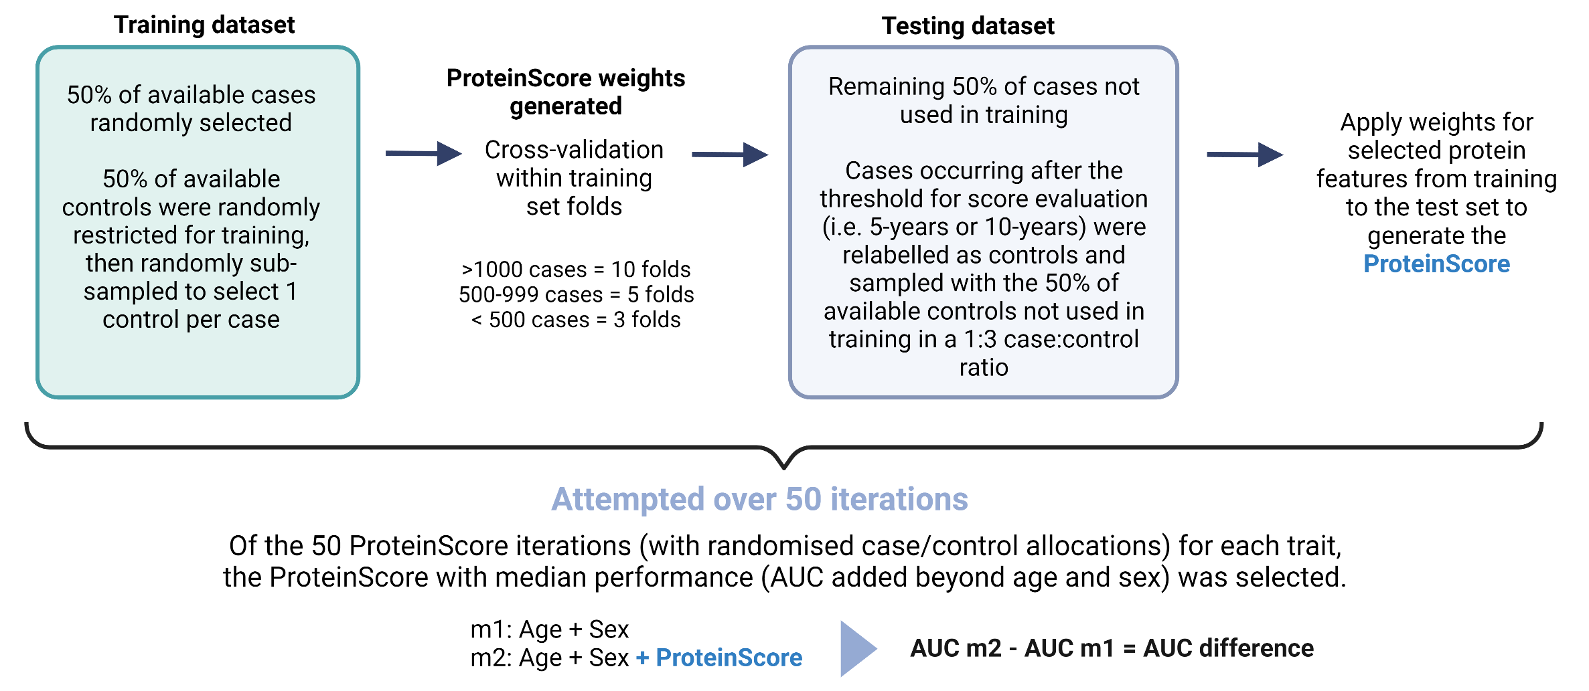
Extended Data Figure 8. Summary of the ProteinScore development pipeline. ProteinScores were developed across fifty randomised iterations. For each iteration, 50% of available cases were randomly allocated to the training set and 50% of controls were randomly sampled to obtain a 1:3 case:control ratio. Cox PH elastic net regression with cross-fold validation across folds of the training sample was used to derive weighting coefficients. The 50% of cases that were not included in the training set were allocated to the test set. If cases in the test set occurred after the threshold for onset evaluation (i.e. 5-year or 10-year), they were relabelled as controls and randomly sampled with the 50% of controls not considered during training, to obtain a 1:3 case:control ratio. Of the fifty ProteinScore iterations tested, the ProteinScore that yielded the median incremental difference to the Area Under the Curve (AUC) beyond a minimally-adjusted model was identified. If no features were selected for an iteration, it was weighted with a performance of 0 in median AUC selection. If features were selected for an iteration but the randomly sampled test set included no cases at or beyond the onset threshold (precluding extraction of baseline hazard at this point for AUC calculation) these models were excluded from the median ProteinScore selection.

