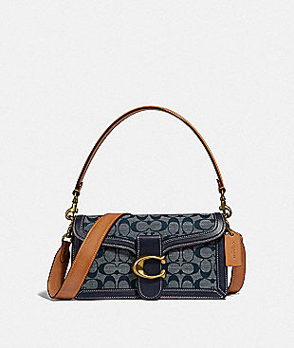

tabby shoulder bag 26 in signature chambray $350

https://www.coach.com/coach-tabby-shoulder-bag-26-in-signature-chambray/3700.html?dwvar_color=B4RA3&cgid=women-handbags-shoulder-bags

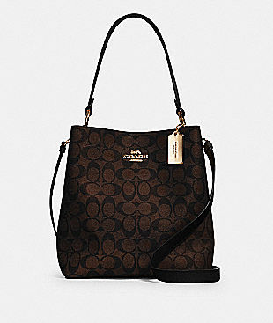

town bucket bag in signature canvas Now $179

https://www.coachoutlet.com/coach-town-bucket-bag-in-signature-canvas/91512.html?dwvar_color=IMAA8&cgid=shop-bags-shoulder-bagssimilarity: 14

--------------------------The end-------------------------------

--------------------------Another one---------------------------

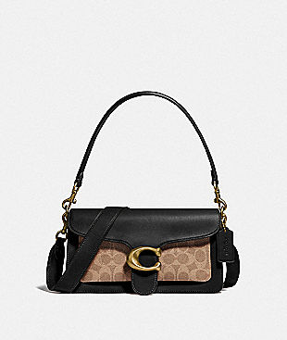

tabby shoulder bag 26 with signature canvas $350

https://www.coach.com/coach-tabby-shoulder-bag-26-with-signature-canvas/91215.html?dwvar_color=B4OOH&cgid=women-handbags-shoulder-bags

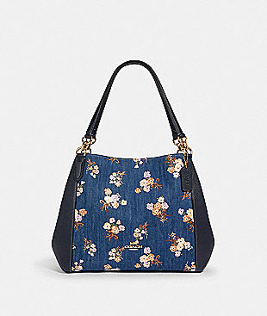

hallie shoulder bag with painted floral box print Now $149

https://www.coachoutlet.com/coach-hallie-shoulder-bag-with-painted-floral-box-print/91047.html?dwvar_color=IMDEI&cgid=shop-bags-shoulder-bagssimilarity: 10

--------------------------The end-------------------------------

--------------------------Another one---------------------------

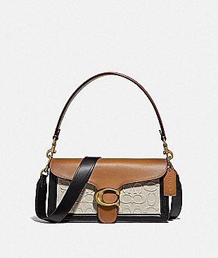

tabby shoulder bag 26 in blocked signature canvas $325

https://www.coach.com/coach-tabby-shoulder-bag-26-in-blocked-signature-canvas/89148.html?dwvar_color=B4PU2&cgid=women-handbags-shoulder-bags

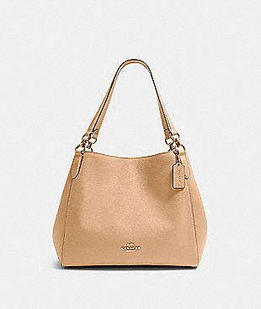

hallie shoulder bag Now $149

https://www.coachoutlet.com/coach-hallie-shoulder-bag/80268.html?dwvar_color=IMTAU&cgid=shop-bags-shoulder-bagssimilarity: 14

--------------------------The end-------------------------------

--------------------------Another one---------------------------

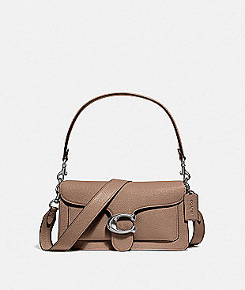

tabby shoulder bag 26 $350

https://www.coach.com/coach-tabby-shoulder-bag-26/73995.html?dwvar_color=LHTAU&cgid=women-handbags-shoulder-bags



hallie shoulder bag with painted floral box print Now $149

https://www.coachoutlet.com/coach-hallie-shoulder-bag-with-painted-floral-box-print/91047.html?dwvar_color=IMDEI&cgid=shop-bags-shoulder-bagssimilarity: 10

--------------------------The end-------------------------------

--------------------------Another one---------------------------

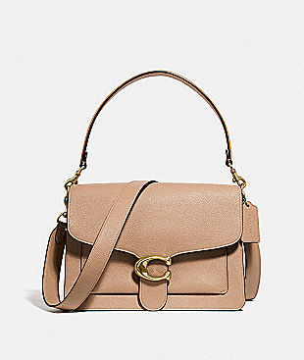

tabby shoulder bag $450

https://www.coach.com/coach-tabby-shoulder-bag/73723.html?dwvar_color=B4EQO&cgid=women-handbags-shoulder-bags

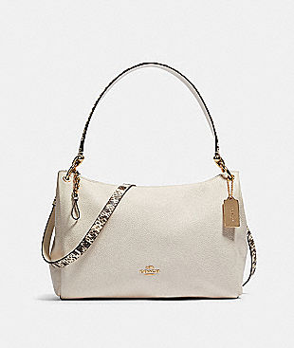

mia shoulder bag Now $129

https://www.coachoutlet.com/coach-mia-shoulder-bag/F80323.html?dwvar_color=IMCHK&cgid=shop-bags-shoulder-bagssimilarity: 14

--------------------------The end-------------------------------

--------------------------Another one---------------------------

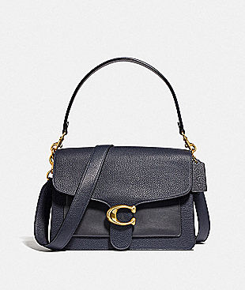

tabby shoulder bag $450

https://www.coach.com/coach-tabby-shoulder-bag/73724.html?dwvar_color=B4BHP&cgid=women-handbags-shoulder-bags

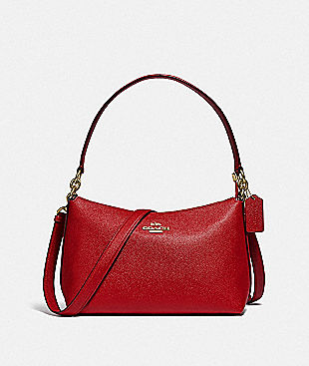

lewis shoulder bag Now $99

https://www.coachoutlet.com/coach-lewis-shoulder-bag/F80058.html?dwvar_color=IMDN8&cgid=shop-bags-shoulder-bagssimilarity: 14

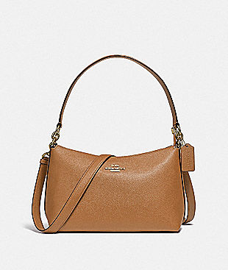

lewis shoulder bag Now $99

https://www.coachoutlet.com/coach-lewis-shoulder-bag/F80058.html?dwvar_color=IMLQD&cgid=shop-bags-shoulder-bagssimilarity: 14

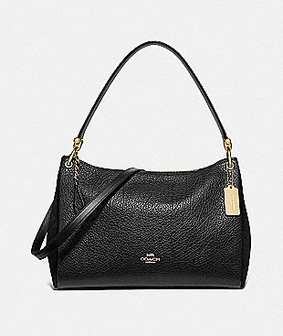

mia shoulder bag Now $129

https://www.coachoutlet.com/coach-mia-shoulder-bag/F76921.html?dwvar_color=IMBLK&cgid=shop-bags-shoulder-bagssimilarity: 10

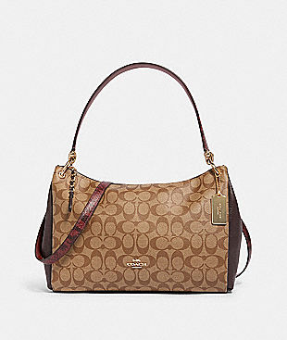

mia shoulder bag in signature canvas Now $129

https://www.coachoutlet.com/coach-mia-shoulder-bag-in-signature-canvas/F80324.html?dwvar_color=IME7V&cgid=shop-bags-shoulder-bagssimilarity: 14

--------------------------The end-------------------------------

--------------------------Another one---------------------------

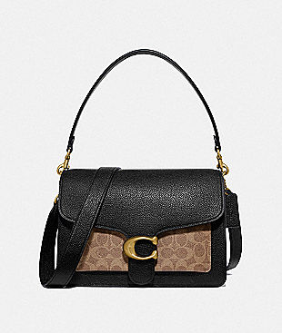

tabby shoulder bag with signature canvas $450

https://www.coach.com/coach-tabby-shoulder-bag-with-signature-canvas/79594.html?dwvar_color=B4NQ6&cgid=women-handbags-shoulder-bags

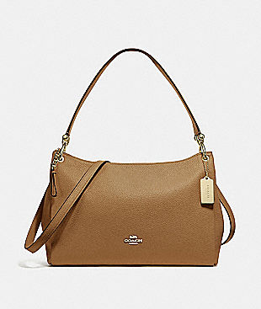

mia shoulder bag Now $119

https://www.coachoutlet.com/coach-mia-shoulder-bag/F28966.html?dwvar_color=IMLQD&cgid=shop-bags-shoulder-bagssimilarity: 14



mia shoulder bag in signature canvas Now $129

https://www.coachoutlet.com/coach-mia-shoulder-bag-in-signature-canvas/F80324.html?dwvar_color=IME7V&cgid=shop-bags-shoulder-bagssimilarity: 14

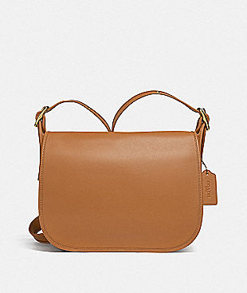

patricia saddle bag Now $129

https://www.coachoutlet.com/coach-patricia-saddle-bag/F88145.html?dwvar_color=IMLQD&cgid=shop-bags-shoulder-bagssimilarity: 12

--------------------------The end-------------------------------

--------------------------Another one---------------------------

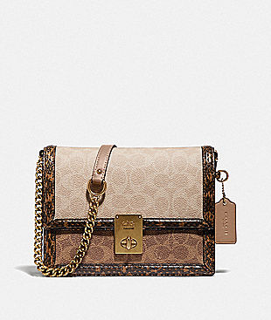

hutton shoulder bag in blocked signature canvas... $495

https://www.coach.com/coach-hutton-shoulder-bag-in-blocked-signature-canvas-with-snakeskin-detail/89068.html?dwvar_color=B4PVR&cgid=women-handbags-shoulder-bags

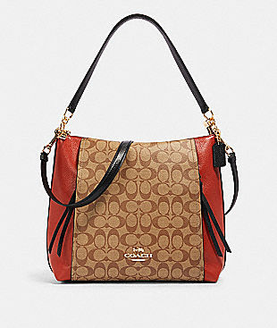

marlon hobo in colorblock signature canvas Now $149

https://www.coachoutlet.com/coach-marlon-hobo-in-colorblock-signature-canvas/91386.html?dwvar_color=IME7V&cgid=shop-bags-shoulder-bagssimilarity: 14

--------------------------The end-------------------------------

--------------------------Another one---------------------------

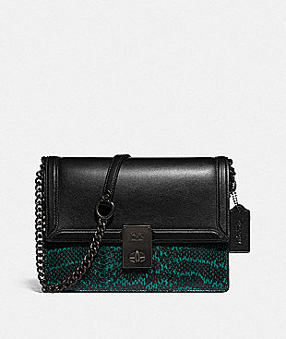

hutton shoulder bag with colorblock snakeskin... $450

https://www.coach.com/coach-hutton-shoulder-bag-with-colorblock-snakeskin-detail/89069.html?dwvar_color=V5PTN&cgid=women-handbags-shoulder-bags

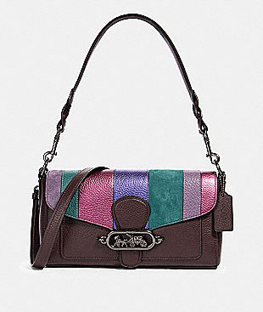

jade shoulder bag with piecing Now $129

https://www.coachoutlet.com/coach-jade-shoulder-bag-with-piecing/91095.html?dwvar_color=QBFCG&cgid=shop-bags-shoulder-bagssimilarity: 14

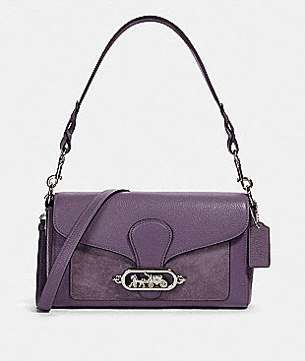

jade shoulder bag Now $129

https://www.coachoutlet.com/coach-jade-shoulder-bag/91027.html?dwvar_color=SVO6T&cgid=shop-bags-shoulder-bagssimilarity: 14

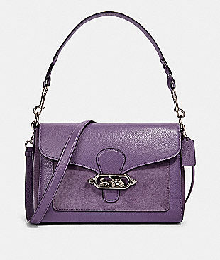

jade messenger Now $149

https://www.coachoutlet.com/coach-jade-messenger/91395.html?dwvar_color=SVO6T&cgid=shop-bags-shoulder-bagssimilarity: 14



patricia saddle bag Now $129

https://www.coachoutlet.com/coach-patricia-saddle-bag/F88145.html?dwvar_color=IMLQD&cgid=shop-bags-shoulder-bagssimilarity: 12

--------------------------The end-------------------------------

--------------------------Another one---------------------------

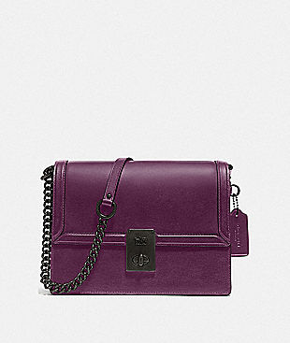

hutton shoulder bag $395

https://www.coach.com/coach-hutton-shoulder-bag/88342.html?dwvar_color=V5BOY&cgid=women-handbags-shoulder-bags



jade shoulder bag Now $129

https://www.coachoutlet.com/coach-jade-shoulder-bag/91027.html?dwvar_color=SVO6T&cgid=shop-bags-shoulder-bagssimilarity: 14



patricia saddle bag Now $129

https://www.coachoutlet.com/coach-patricia-saddle-bag/F88145.html?dwvar_color=IMLQD&cgid=shop-bags-shoulder-bagssimilarity: 12

--------------------------The end-------------------------------

--------------------------Another one---------------------------

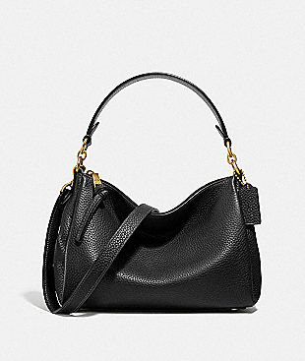

shay crossbody $250

https://www.coach.com/coach-shay-crossbody/601.html?dwvar_color=B4%2FBK&cgid=women-handbags-shoulder-bags



mia shoulder bag Now $129

https://www.coachoutlet.com/coach-mia-shoulder-bag/F76921.html?dwvar_color=IMBLK&cgid=shop-bags-shoulder-bagssimilarity: 10

--------------------------The end-------------------------------

--------------------------Another one---------------------------

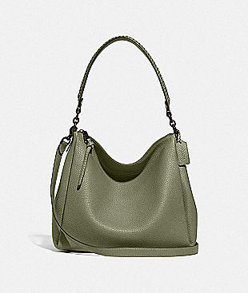

shay shoulder bag with whipstitch detail $375

https://www.coach.com/coach-shay-shoulder-bag-with-whipstitch-detail/594.html?dwvar_color=V5QUF&cgid=women-handbags-shoulder-bags



hallie shoulder bag with painted floral box print Now $149

https://www.coachoutlet.com/coach-hallie-shoulder-bag-with-painted-floral-box-print/91047.html?dwvar_color=IMDEI&cgid=shop-bags-shoulder-bagssimilarity: 10

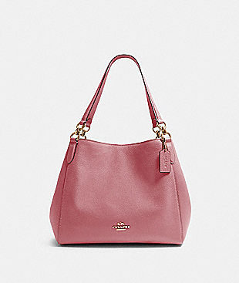

hallie shoulder bag Now $149

https://www.coachoutlet.com/coach-hallie-shoulder-bag/80268.html?dwvar_color=IMROS&cgid=shop-bags-shoulder-bagssimilarity: 14

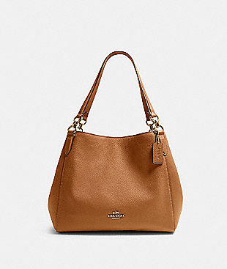

hallie shoulder bag Now $149

https://www.coachoutlet.com/coach-hallie-shoulder-bag/F80268.html?dwvar_color=IMLQD&cgid=shop-bags-shoulder-bagssimilarity: 14

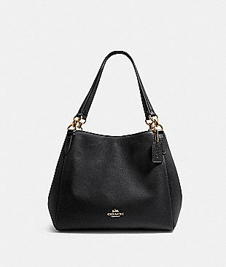

hallie shoulder bag Now $149

https://www.coachoutlet.com/coach-hallie-shoulder-bag/F80268.html?dwvar_color=IMBLK&cgid=shop-bags-shoulder-bagssimilarity: 14

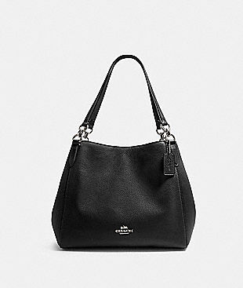

hallie shoulder bag Now $149

https://www.coachoutlet.com/coach-hallie-shoulder-bag/F80268.html?dwvar_color=SV%2FBK&cgid=shop-bags-shoulder-bagssimilarity: 14

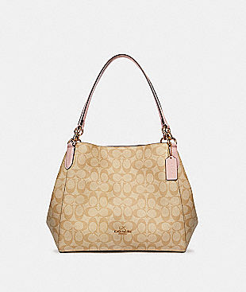

hallie shoulder bag in signature canvas Now $149

https://www.coachoutlet.com/coach-hallie-shoulder-bag-in-signature-canvas/80298.html?dwvar_color=IMQBX&cgid=shop-bags-shoulder-bagssimilarity: 14

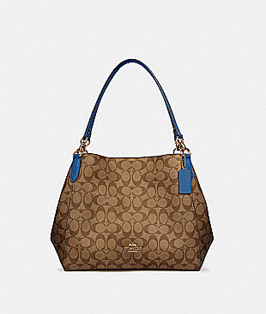

hallie shoulder bag in signature canvas Now $149

https://www.coachoutlet.com/coach-hallie-shoulder-bag-in-signature-canvas/80298.html?dwvar_color=IMQBA&cgid=shop-bags-shoulder-bagssimilarity: 14

--------------------------The end-------------------------------

--------------------------Another one---------------------------

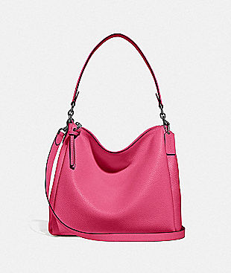

shay shoulder bag $350

https://www.coach.com/coach-shay-shoulder-bag/93811.html?dwvar_color=V5NOG&cgid=women-handbags-shoulder-bags



town bucket bag in signature canvas Now $179

https://www.coachoutlet.com/coach-town-bucket-bag-in-signature-canvas/91512.html?dwvar_color=IMAA8&cgid=shop-bags-shoulder-bagssimilarity: 14

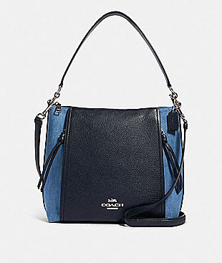

marlon hobo Now $149

https://www.coachoutlet.com/coach-marlon-hobo/91528.html?dwvar_color=SVM64&cgid=shop-bags-shoulder-bagssimilarity: 14

--------------------------The end-------------------------------

--------------------------Another one---------------------------

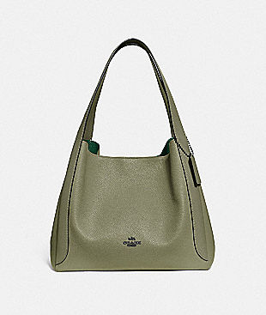

hadley hobo $395

https://www.coach.com/coach-hadley-hobo/73549.html?dwvar_color=V5QUF&cgid=women-handbags-shoulder-bags



hallie shoulder bag with painted floral box print Now $149

https://www.coachoutlet.com/coach-hallie-shoulder-bag-with-painted-floral-box-print/91047.html?dwvar_color=IMDEI&cgid=shop-bags-shoulder-bagssimilarity: 10



hallie shoulder bag Now $149

https://www.coachoutlet.com/coach-hallie-shoulder-bag/80268.html?dwvar_color=IMROS&cgid=shop-bags-shoulder-bagssimilarity: 14



hallie shoulder bag Now $149

https://www.coachoutlet.com/coach-hallie-shoulder-bag/80268.html?dwvar_color=IMTAU&cgid=shop-bags-shoulder-bagssimilarity: 14



hallie shoulder bag Now $149

https://www.coachoutlet.com/coach-hallie-shoulder-bag/F80268.html?dwvar_color=IMLQD&cgid=shop-bags-shoulder-bagssimilarity: 14

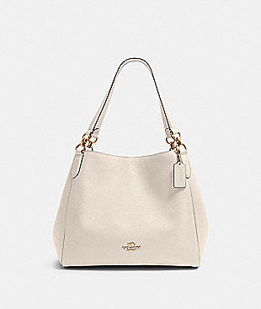

hallie shoulder bag Now $149

https://www.coachoutlet.com/coach-hallie-shoulder-bag/80268.html?dwvar_color=IMCHK&cgid=shop-bags-shoulder-bagssimilarity: 12



hallie shoulder bag Now $149

https://www.coachoutlet.com/coach-hallie-shoulder-bag/F80268.html?dwvar_color=IMBLK&cgid=shop-bags-shoulder-bagssimilarity: 14



hallie shoulder bag Now $149

https://www.coachoutlet.com/coach-hallie-shoulder-bag/F80268.html?dwvar_color=SV%2FBK&cgid=shop-bags-shoulder-bagssimilarity: 14



hallie shoulder bag in signature canvas Now $149

https://www.coachoutlet.com/coach-hallie-shoulder-bag-in-signature-canvas/80298.html?dwvar_color=IMQBX&cgid=shop-bags-shoulder-bagssimilarity: 14



hallie shoulder bag in signature canvas Now $149

https://www.coachoutlet.com/coach-hallie-shoulder-bag-in-signature-canvas/80298.html?dwvar_color=IMQBA&cgid=shop-bags-shoulder-bagssimilarity: 14

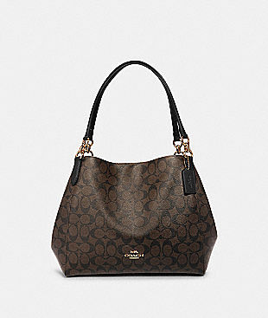

hallie shoulder bag in signature canvas Now $149

https://www.coachoutlet.com/coach-hallie-shoulder-bag-in-signature-canvas/F80298.html?dwvar_color=IMAA8&cgid=shop-bags-shoulder-bagssimilarity: 14

--------------------------The end-------------------------------

--------------------------Another one---------------------------

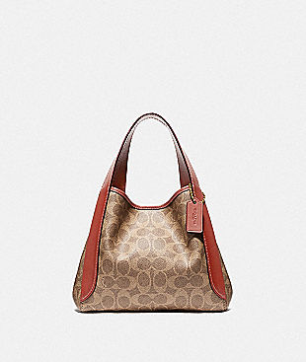

hadley hobo 21 in signature canvas $275

https://www.coach.com/coach-hadley-hobo-21-in-signature-canvas/79251.html?dwvar_color=B4NQ4&cgid=women-handbags-shoulder-bags

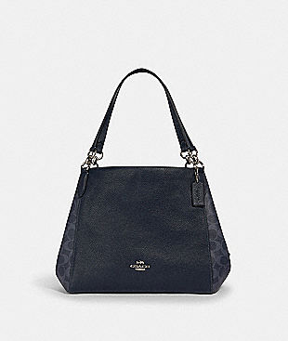

hallie shoulder bag in signature canvas Now $149

https://www.coachoutlet.com/coach-hallie-shoulder-bag-in-signature-canvas/91133.html?dwvar_color=SVM2Q&cgid=shop-bags-shoulder-bagssimilarity: 14

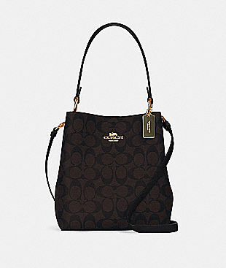

small town bucket bag in signature canvas Now $149

https://www.coachoutlet.com/coach-small-town-bucket-bag-in-signature-canvas/2312.html?dwvar_color=IMAA8&cgid=shop-bags-shoulder-bagssimilarity: 10

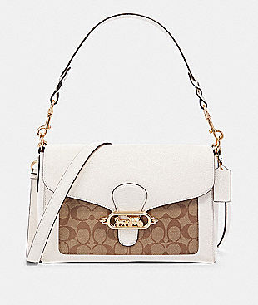

jade messenger with signature canvas detail Now $149

https://www.coachoutlet.com/coach-jade-messenger-with-signature-canvas-detail/F81992.html?dwvar_color=IMDJ8&cgid=shop-bags-shoulder-bagssimilarity: 14

--------------------------The end-------------------------------

--------------------------Another one---------------------------

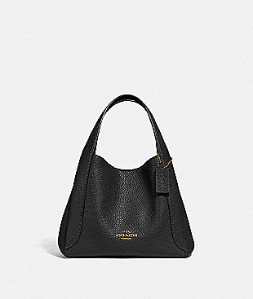

hadley hobo 21 $275

https://www.coach.com/coach-hadley-hobo-21/78800.html?dwvar_color=GDBLK&cgid=women-handbags-shoulder-bags



hallie shoulder bag in signature canvas Now $149

https://www.coachoutlet.com/coach-hallie-shoulder-bag-in-signature-canvas/91133.html?dwvar_color=SVM2Q&cgid=shop-bags-shoulder-bagssimilarity: 14



small town bucket bag in signature canvas Now $149

https://www.coachoutlet.com/coach-small-town-bucket-bag-in-signature-canvas/2312.html?dwvar_color=IMAA8&cgid=shop-bags-shoulder-bagssimilarity: 10

--------------------------The end-------------------------------

--------------------------Another one---------------------------

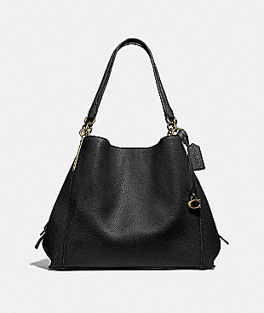

dalton 31 $395

https://www.coach.com/coach-dalton-31/73545.html?dwvar_color=GDBLK&cgid=women-handbags-shoulder-bags



hallie shoulder bag in signature canvas Now $149

https://www.coachoutlet.com/coach-hallie-shoulder-bag-in-signature-canvas/80298.html?dwvar_color=IMQBX&cgid=shop-bags-shoulder-bagssimilarity: 14



hallie shoulder bag in signature canvas Now $149

https://www.coachoutlet.com/coach-hallie-shoulder-bag-in-signature-canvas/80298.html?dwvar_color=IMQBA&cgid=shop-bags-shoulder-bagssimilarity: 14



hallie shoulder bag in signature canvas Now $149

https://www.coachoutlet.com/coach-hallie-shoulder-bag-in-signature-canvas/F80298.html?dwvar_color=IMAA8&cgid=shop-bags-shoulder-bagssimilarity: 14

--------------------------The end-------------------------------

--------------------------Another one---------------------------

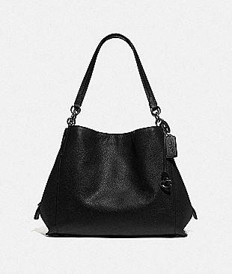

dalton 31 $395

https://www.coach.com/coach-dalton-31/78364.html?dwvar_color=GM%2FBK&cgid=women-handbags-shoulder-bags



hallie shoulder bag with painted floral box print Now $149

https://www.coachoutlet.com/coach-hallie-shoulder-bag-with-painted-floral-box-print/91047.html?dwvar_color=IMDEI&cgid=shop-bags-shoulder-bagssimilarity: 10



hallie shoulder bag Now $149

https://www.coachoutlet.com/coach-hallie-shoulder-bag/F80268.html?dwvar_color=IMLQD&cgid=shop-bags-shoulder-bagssimilarity: 14



hallie shoulder bag Now $149

https://www.coachoutlet.com/coach-hallie-shoulder-bag/F80268.html?dwvar_color=IMBLK&cgid=shop-bags-shoulder-bagssimilarity: 14



hallie shoulder bag Now $149

https://www.coachoutlet.com/coach-hallie-shoulder-bag/F80268.html?dwvar_color=SV%2FBK&cgid=shop-bags-shoulder-bagssimilarity: 14



hallie shoulder bag in signature canvas Now $149

https://www.coachoutlet.com/coach-hallie-shoulder-bag-in-signature-canvas/80298.html?dwvar_color=IMQBX&cgid=shop-bags-shoulder-bagssimilarity: 14



hallie shoulder bag in signature canvas Now $149

https://www.coachoutlet.com/coach-hallie-shoulder-bag-in-signature-canvas/80298.html?dwvar_color=IMQBA&cgid=shop-bags-shoulder-bagssimilarity: 14



hallie shoulder bag in signature canvas Now $149

https://www.coachoutlet.com/coach-hallie-shoulder-bag-in-signature-canvas/F80298.html?dwvar_color=IMAA8&cgid=shop-bags-shoulder-bagssimilarity: 14



marlon hobo Now $149

https://www.coachoutlet.com/coach-marlon-hobo/91528.html?dwvar_color=SVM64&cgid=shop-bags-shoulder-bagssimilarity: 14

--------------------------The end-------------------------------

--------------------------Another one---------------------------

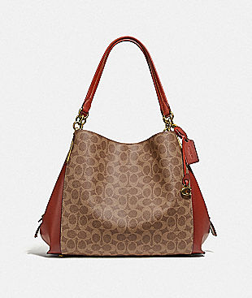

dalton 31 in signature canvas $395

https://www.coach.com/coach-dalton-31-in-signature-canvas/76069.html?dwvar_color=B4NQ4&cgid=women-handbags-shoulder-bags



hallie shoulder bag Now $149

https://www.coachoutlet.com/coach-hallie-shoulder-bag/F80268.html?dwvar_color=IMLQD&cgid=shop-bags-shoulder-bagssimilarity: 14



hallie shoulder bag in signature canvas Now $149

https://www.coachoutlet.com/coach-hallie-shoulder-bag-in-signature-canvas/80298.html?dwvar_color=IMQBX&cgid=shop-bags-shoulder-bagssimilarity: 14



hallie shoulder bag in signature canvas Now $149

https://www.coachoutlet.com/coach-hallie-shoulder-bag-in-signature-canvas/80298.html?dwvar_color=IMQBA&cgid=shop-bags-shoulder-bagssimilarity: 14

--------------------------The end-------------------------------

--------------------------Another one---------------------------

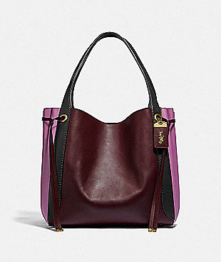

harmony hobo in colorblock $695

https://www.coach.com/coach-harmony-hobo-in-colorblock/53353.html?dwvar_color=B4AX2&cgid=women-handbags-shoulder-bags



hallie shoulder bag in signature canvas Now $149

https://www.coachoutlet.com/coach-hallie-shoulder-bag-in-signature-canvas/80298.html?dwvar_color=IMQBX&cgid=shop-bags-shoulder-bagssimilarity: 14



hallie shoulder bag in signature canvas Now $149

https://www.coachoutlet.com/coach-hallie-shoulder-bag-in-signature-canvas/80298.html?dwvar_color=IMQBA&cgid=shop-bags-shoulder-bagssimilarity: 14



hallie shoulder bag in signature canvas Now $149

https://www.coachoutlet.com/coach-hallie-shoulder-bag-in-signature-canvas/F80298.html?dwvar_color=IMAA8&cgid=shop-bags-shoulder-bagssimilarity: 14



town bucket bag in signature canvas Now $179

https://www.coachoutlet.com/coach-town-bucket-bag-in-signature-canvas/91512.html?dwvar_color=IMAA8&cgid=shop-bags-shoulder-bagssimilarity: 14



marlon hobo Now $149

https://www.coachoutlet.com/coach-marlon-hobo/91528.html?dwvar_color=SVM64&cgid=shop-bags-shoulder-bagssimilarity: 14

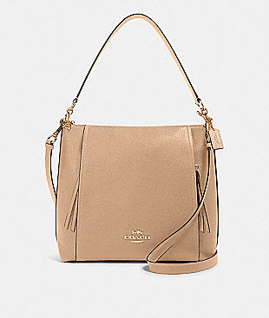

marlon hobo Now $149

https://www.coachoutlet.com/coach-marlon-hobo/79994.html?dwvar_color=IMTAU&cgid=shop-bags-shoulder-bagssimilarity: 14

--------------------------The end-------------------------------

--------------------------Another one---------------------------

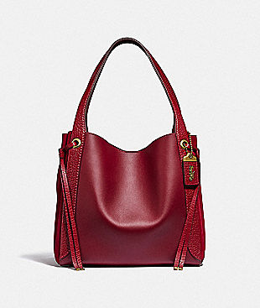

harmony hobo $695

https://www.coach.com/coach-harmony-hobo/53352.html?dwvar_color=B4PE2&cgid=women-handbags-shoulder-bags



hallie shoulder bag with painted floral box print Now $149

https://www.coachoutlet.com/coach-hallie-shoulder-bag-with-painted-floral-box-print/91047.html?dwvar_color=IMDEI&cgid=shop-bags-shoulder-bagssimilarity: 10



hallie shoulder bag Now $149

https://www.coachoutlet.com/coach-hallie-shoulder-bag/80268.html?dwvar_color=IMROS&cgid=shop-bags-shoulder-bagssimilarity: 14



hallie shoulder bag Now $149

https://www.coachoutlet.com/coach-hallie-shoulder-bag/F80268.html?dwvar_color=IMBLK&cgid=shop-bags-shoulder-bagssimilarity: 14



hallie shoulder bag Now $149

https://www.coachoutlet.com/coach-hallie-shoulder-bag/F80268.html?dwvar_color=SV%2FBK&cgid=shop-bags-shoulder-bagssimilarity: 14



hallie shoulder bag in signature canvas Now $149

https://www.coachoutlet.com/coach-hallie-shoulder-bag-in-signature-canvas/80298.html?dwvar_color=IMQBX&cgid=shop-bags-shoulder-bagssimilarity: 14



hallie shoulder bag in signature canvas Now $149

https://www.coachoutlet.com/coach-hallie-shoulder-bag-in-signature-canvas/80298.html?dwvar_color=IMQBA&cgid=shop-bags-shoulder-bagssimilarity: 14



marlon hobo Now $149

https://www.coachoutlet.com/coach-marlon-hobo/91528.html?dwvar_color=SVM64&cgid=shop-bags-shoulder-bagssimilarity: 14



marlon hobo Now $149

https://www.coachoutlet.com/coach-marlon-hobo/79994.html?dwvar_color=IMTAU&cgid=shop-bags-shoulder-bagssimilarity: 14

--------------------------The end-------------------------------

--------------------------Another one---------------------------

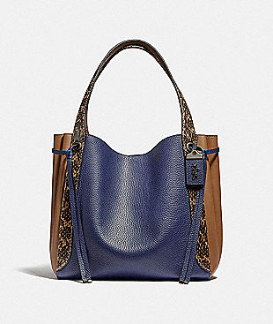

harmony hobo in colorblock with snakeskin detail $795

https://www.coach.com/coach-harmony-hobo-in-colorblock-with-snakeskin-detail/89578.html?dwvar_color=V5O4R&cgid=women-handbags-shoulder-bags

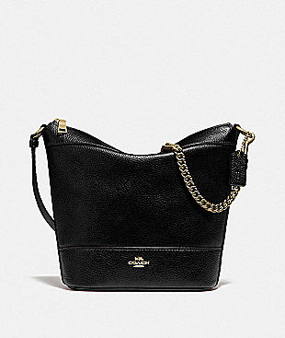

small paxton duffle Now $99

https://www.coachoutlet.com/coach-small-paxton-duffle/F76668.html?dwvar_color=IMBLK&cgid=shop-bags-shoulder-bagssimilarity: 14

--------------------------The end-------------------------------

--------------------------Another one---------------------------

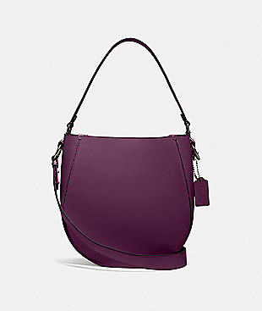

maddy hobo $450

https://www.coach.com/coach-maddy-hobo/88344.html?dwvar_color=V5BOY&cgid=women-handbags-shoulder-bags

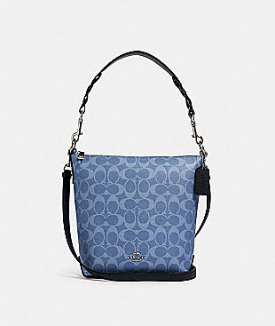

mini abby duffle in signature canvas Now $89

https://www.coachoutlet.com/coach-mini-abby-duffle-in-signature-canvas/93999.html?dwvar_color=SVLID&cgid=shop-bags-shoulder-bagssimilarity: 14

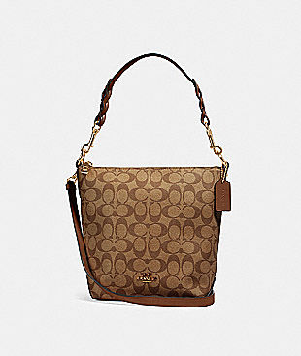

mini abby duffle in signature canvas Now $89

https://www.coachoutlet.com/coach-mini-abby-duffle-in-signature-canvas/87826.html?dwvar_color=IME74&cgid=shop-bags-shoulder-bagssimilarity: 14

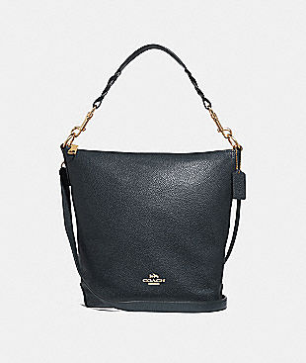

abby duffle Now $129

https://www.coachoutlet.com/coach-abby-duffle/F31507.html?dwvar_color=IMMID&cgid=shop-bags-shoulder-bagssimilarity: 14

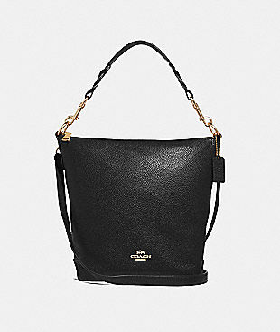

abby duffle Now $129

https://www.coachoutlet.com/coach-abby-duffle/F31507.html?dwvar_color=IMBLK&cgid=shop-bags-shoulder-bagssimilarity: 14

--------------------------The end-------------------------------

--------------------------Another one---------------------------

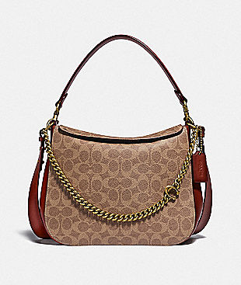

signature chain hobo in signature canvas $350

https://www.coach.com/coach-signature-chain-hobo-in-signature-canvas/89177.html?dwvar_color=B4NQ4&cgid=women-handbags-shoulder-bags



jade shoulder bag with piecing Now $129

https://www.coachoutlet.com/coach-jade-shoulder-bag-with-piecing/91095.html?dwvar_color=QBFCG&cgid=shop-bags-shoulder-bagssimilarity: 14

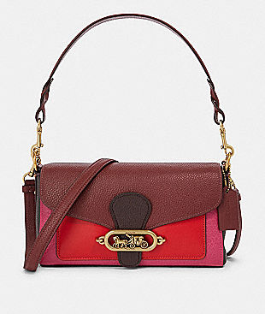

small jade shoulder bag in colorblock Now $129

https://www.coachoutlet.com/coach-small-jade-shoulder-bag-in-colorblock/F91070.html?dwvar_color=OLQEF&cgid=shop-bags-shoulder-bagssimilarity: 14



mia shoulder bag Now $119

https://www.coachoutlet.com/coach-mia-shoulder-bag/F28966.html?dwvar_color=IMLQD&cgid=shop-bags-shoulder-bagssimilarity: 14



patricia saddle bag Now $129

https://www.coachoutlet.com/coach-patricia-saddle-bag/F88145.html?dwvar_color=IMLQD&cgid=shop-bags-shoulder-bagssimilarity: 12

--------------------------The end-------------------------------

--------------------------Another one---------------------------

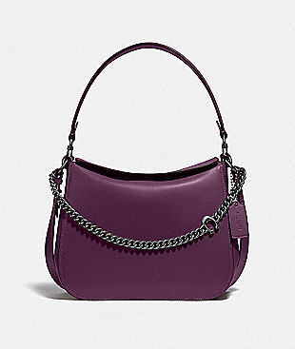

signature chain hobo $350

https://www.coach.com/coach-signature-chain-hobo/89178.html?dwvar_color=V5BOY&cgid=women-handbags-shoulder-bags



jade shoulder bag with piecing Now $129

https://www.coachoutlet.com/coach-jade-shoulder-bag-with-piecing/91095.html?dwvar_color=QBFCG&cgid=shop-bags-shoulder-bagssimilarity: 14

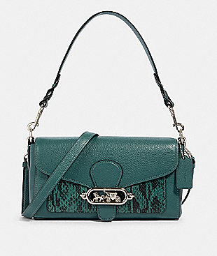

jade shoulder bag Now $129

https://www.coachoutlet.com/coach-jade-shoulder-bag/91034.html?dwvar_color=SVM7Q&cgid=shop-bags-shoulder-bagssimilarity: 14



jade shoulder bag Now $129

https://www.coachoutlet.com/coach-jade-shoulder-bag/91027.html?dwvar_color=SVO6T&cgid=shop-bags-shoulder-bagssimilarity: 14

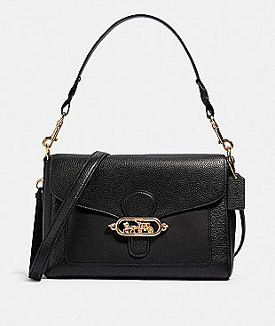

jade messenger Now $149

https://www.coachoutlet.com/coach-jade-messenger/91396.html?dwvar_color=IMBLK&cgid=shop-bags-shoulder-bagssimilarity: 14

--------------------------The end-------------------------------

--------------------------Another one---------------------------

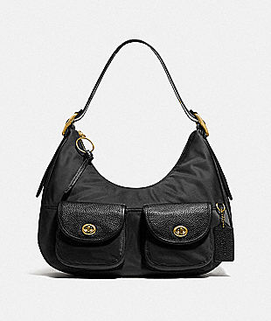

cargo hobo with vintage rose print interior $250

https://www.coach.com/coach-cargo-hobo-with-vintage-rose-print-interior/3171.html?dwvar_color=B4%2FBK&cgid=women-handbags-shoulder-bags



hallie shoulder bag in signature canvas Now $149

https://www.coachoutlet.com/coach-hallie-shoulder-bag-in-signature-canvas/80298.html?dwvar_color=IMQBX&cgid=shop-bags-shoulder-bagssimilarity: 14



hallie shoulder bag in signature canvas Now $149

https://www.coachoutlet.com/coach-hallie-shoulder-bag-in-signature-canvas/80298.html?dwvar_color=IMQBA&cgid=shop-bags-shoulder-bagssimilarity: 14



town bucket bag in signature canvas Now $179

https://www.coachoutlet.com/coach-town-bucket-bag-in-signature-canvas/91512.html?dwvar_color=IMAA8&cgid=shop-bags-shoulder-bagssimilarity: 14



marlon hobo in colorblock signature canvas Now $149

https://www.coachoutlet.com/coach-marlon-hobo-in-colorblock-signature-canvas/91386.html?dwvar_color=IME7V&cgid=shop-bags-shoulder-bagssimilarity: 14

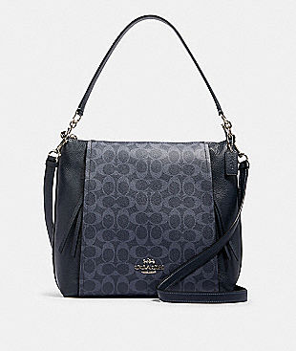

marlon hobo in signature canvas Now $149

https://www.coachoutlet.com/coach-marlon-hobo-in-signature-canvas/91526.html?dwvar_color=SVM2Q&cgid=shop-bags-shoulder-bagssimilarity: 14

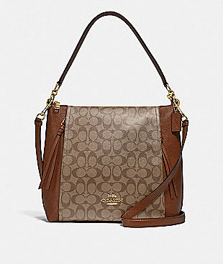

marlon hobo in signature canvas Now $149

https://www.coachoutlet.com/coach-marlon-hobo-in-signature-canvas/F79993.html?dwvar_color=IME74&cgid=shop-bags-shoulder-bagssimilarity: 14



mia shoulder bag Now $129

https://www.coachoutlet.com/coach-mia-shoulder-bag/F76921.html?dwvar_color=IMBLK&cgid=shop-bags-shoulder-bagssimilarity: 10

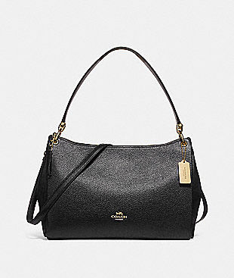

mia shoulder bag Now $119

https://www.coachoutlet.com/coach-mia-shoulder-bag/F28966.html?dwvar_color=IMBLK&cgid=shop-bags-shoulder-bagssimilarity: 14

--------------------------The end-------------------------------

--------------------------Another one---------------------------

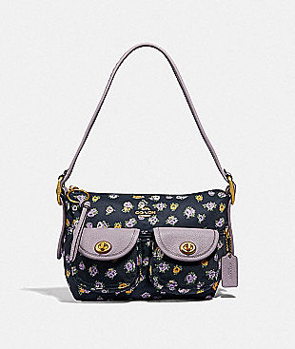

cargo shoulder bag with vintage rose print $195

https://www.coach.com/coach-cargo-shoulder-bag-with-vintage-rose-print/596.html?dwvar_color=B4BHP&cgid=women-handbags-shoulder-bags

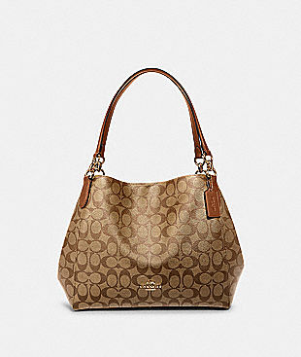

hallie shoulder bag in signature canvas Now $149

https://www.coachoutlet.com/coach-hallie-shoulder-bag-in-signature-canvas/F80298.html?dwvar_color=IME74&cgid=shop-bags-shoulder-bagssimilarity: 14



hallie shoulder bag in signature canvas Now $149

https://www.coachoutlet.com/coach-hallie-shoulder-bag-in-signature-canvas/F80298.html?dwvar_color=IMAA8&cgid=shop-bags-shoulder-bagssimilarity: 14



marlon hobo Now $149

https://www.coachoutlet.com/coach-marlon-hobo/91528.html?dwvar_color=SVM64&cgid=shop-bags-shoulder-bagssimilarity: 14

--------------------------The end-------------------------------

--------------------------Another one---------------------------

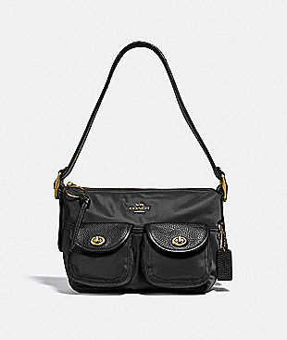

cargo shoulder bag with vintage rose print... $195

https://www.coach.com/coach-cargo-shoulder-bag-with-vintage-rose-print-interior/3135.html?dwvar_color=B4%2FBK&cgid=women-handbags-shoulder-bags



marlon hobo Now $149

https://www.coachoutlet.com/coach-marlon-hobo/91528.html?dwvar_color=SVM64&cgid=shop-bags-shoulder-bagssimilarity: 14



mia shoulder bag Now $119

https://www.coachoutlet.com/coach-mia-shoulder-bag/F28966.html?dwvar_color=IMBLK&cgid=shop-bags-shoulder-bagssimilarity: 14

--------------------------The end-------------------------------

--------------------------Another one---------------------------

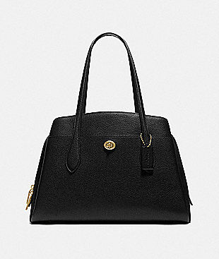

lora carryall $395

https://www.coach.com/coach-lora-carryall/89486.html?dwvar_color=B4%2FBK&cgid=women-handbags-shoulder-bags



mia shoulder bag in signature canvas Now $129

https://www.coachoutlet.com/coach-mia-shoulder-bag-in-signature-canvas/F80324.html?dwvar_color=IME7V&cgid=shop-bags-shoulder-bagssimilarity: 14

--------------------------The end-------------------------------

--------------------------Another one---------------------------

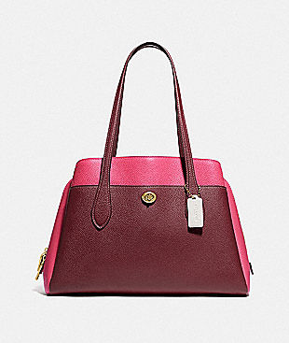

lora carryall in colorblock $395

https://www.coach.com/coach-lora-carryall-in-colorblock/654.html?dwvar_color=B4MZI&cgid=women-handbags-shoulder-bags

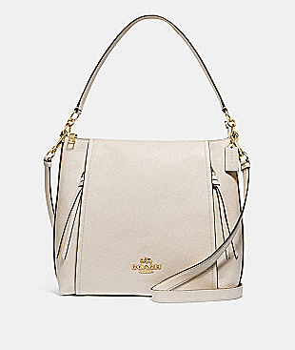

marlon hobo Now $149

https://www.coachoutlet.com/coach-marlon-hobo/F79994.html?dwvar_color=IMCHK&cgid=shop-bags-shoulder-bagssimilarity: 14



mia shoulder bag in signature canvas Now $129

https://www.coachoutlet.com/coach-mia-shoulder-bag-in-signature-canvas/F80324.html?dwvar_color=IME7V&cgid=shop-bags-shoulder-bagssimilarity: 14

--------------------------The end-------------------------------

--------------------------Another one---------------------------

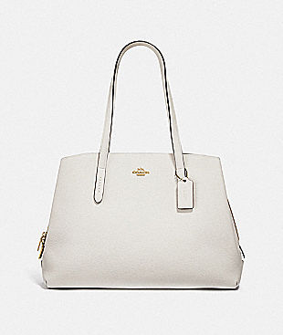

charlie carryall 40 $425

https://www.coach.com/coach-charlie-carryall-40/52547.html?dwvar_color=GD%2FHA&cgid=women-handbags-shoulder-bags



mia shoulder bag Now $129

https://www.coachoutlet.com/coach-mia-shoulder-bag/F76921.html?dwvar_color=IMBLK&cgid=shop-bags-shoulder-bagssimilarity: 10

--------------------------The end-------------------------------

--------------------------Another one---------------------------

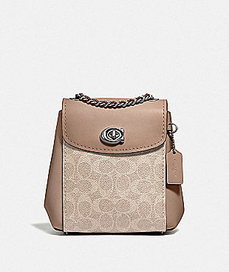

parker convertible backpack 16 in signature canvas $295

https://www.coach.com/coach-parker-convertible-backpack-16-in-signature-canvas/69650.html?dwvar_color=LHPVT&cgid=women-handbags-shoulder-bags



hallie shoulder bag Now $149

https://www.coachoutlet.com/coach-hallie-shoulder-bag/80268.html?dwvar_color=IMROS&cgid=shop-bags-shoulder-bagssimilarity: 14



hallie shoulder bag Now $149

https://www.coachoutlet.com/coach-hallie-shoulder-bag/80268.html?dwvar_color=IMTAU&cgid=shop-bags-shoulder-bagssimilarity: 14



hallie shoulder bag Now $149

https://www.coachoutlet.com/coach-hallie-shoulder-bag/F80268.html?dwvar_color=IMLQD&cgid=shop-bags-shoulder-bagssimilarity: 14



hallie shoulder bag in signature canvas Now $149

https://www.coachoutlet.com/coach-hallie-shoulder-bag-in-signature-canvas/80298.html?dwvar_color=IMQBX&cgid=shop-bags-shoulder-bagssimilarity: 14

--------------------------The end-------------------------------

--------------------------Another one---------------------------