Just for titles | 09:45 02Mar2016

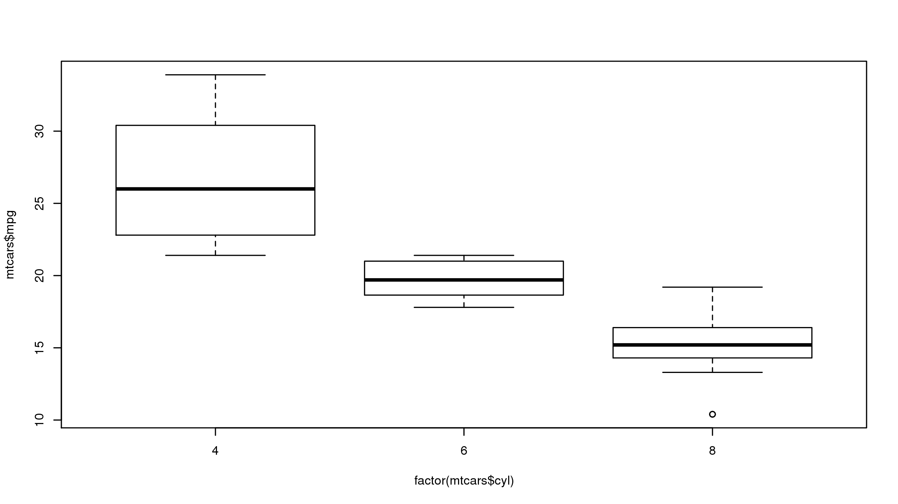

Just for footnotes
Program Location: Where the program is
Output Location: Where the output is
Data Location: Where the data is

