Areal Data

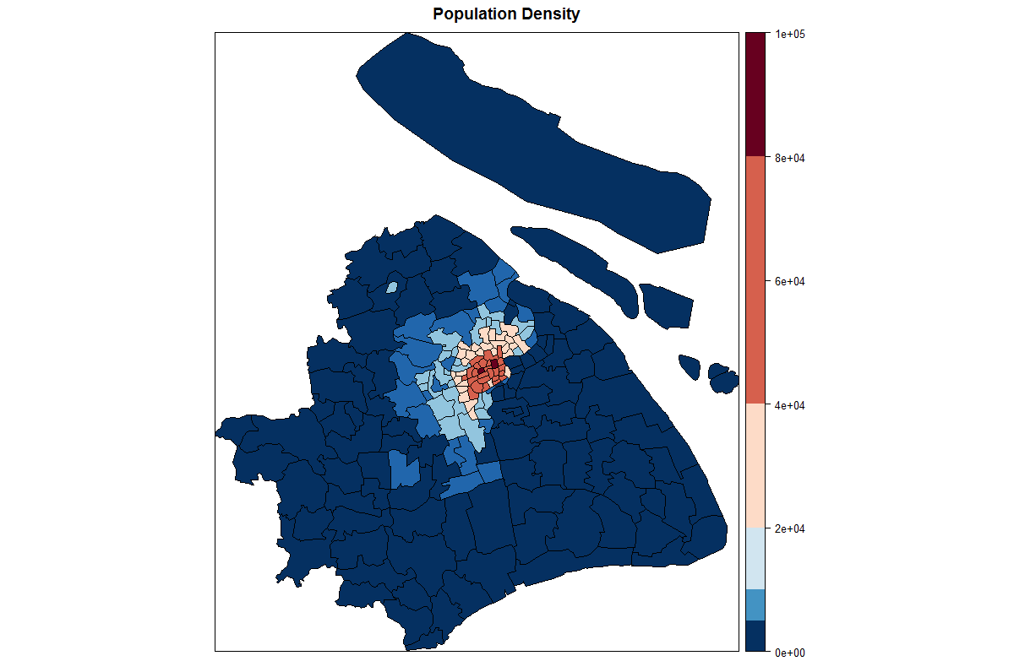

> mn.moran.out = moran.test(mn.poly$Density, listw=mn.listw , zero.policy=TRUE)

> mn.geary.out = geary.test(mn.poly$Density, listw=mn.listw , zero.policy=TRUE)

> print(mn.moran.out)

Moran I test under randomisation

data: mn.poly$Density

weights: mn.listw

Moran I statistic standard deviate = 18.592, p-value < 2.2e-16

alternative hypothesis: greater

sample estimates:

Moran I statistic Expectation Variance

0.797624536 -0.005988024 0.001868316

> print(mn.geary.out)

Geary C test under randomisation

data: mn.poly$Density

weights: mn.listw

Geary C statistic standard deviate = 11.596, p-value < 2.2e-16

alternative hypothesis: Expectation greater than statistic

sample estimates:

Geary C statistic Expectation Variance

0.207894852 1.000000000 0.004665971

SAR Model

> mn.sar.out = spautolm(Density~ 1, data=mn.poly, family="SAR", listw=mn.listw, zero.policy=TRUE)

> summary(mn.sar.out)

Call: spautolm(formula = Density ~ 1, data = mn.poly, listw = mn.listw,

family = "SAR", zero.policy = TRUE)

Residuals:

Min 1Q Median 3Q Max

-16992.6 -4622.0 -1575.8 2694.7 45719.0

Regions with no neighbours included:

15

Coefficients:

Estimate Std. Error z value Pr(>|z|)

(Intercept) 13554.0 2066.1 6.5601 5.377e-11

Lambda: 0.12774 LR test value: 216.7 p-value: < 2.22e-16

Numerical Hessian standard error of lambda: 0.0015537

Log likelihood: -1810.965

ML residual variance (sigma squared): 99914000, (sigma: 9995.7)

Number of observations: 169

Number of parameters estimated: 3

AIC: 3627.9

CAR Model

> ##CAR model regressing rates.FT on NWBIR79.FT

> mn.car.out = spautolm(Density~ 1, data=mn.poly, family="CAR", listw=mn.listw, zero.policy=TRUE)

> summary(mn.car.out)

Call: spautolm(formula = Density ~ 1, data = mn.poly, listw = mn.listw,

family = "CAR", zero.policy = TRUE)

Residuals:

Min 1Q Median 3Q Max

-16345.7 -5372.4 -2026.6 2094.5 44688.5

Regions with no neighbours included:

15

Coefficients:

Estimate Std. Error z value Pr(>|z|)

(Intercept) 15851.1 2050.1 7.7317 1.066e-14

Lambda: 0.12881 LR test value: 147.86 p-value: < 2.22e-16

Numerical Hessian standard error of lambda: 0.00073622

Log likelihood: -1845.382

ML residual variance (sigma squared): 162440000, (sigma: 12745)

Number of observations: 169

Number of parameters estimated: 3

AIC: 3696.8

