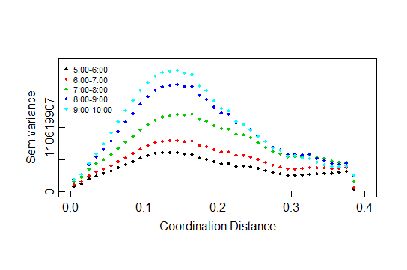

fit from original data set : lat, long, freq

the semivariogram seems not right ( bell shaped)

I took a log scale of “freq” and got the plot below, seems better

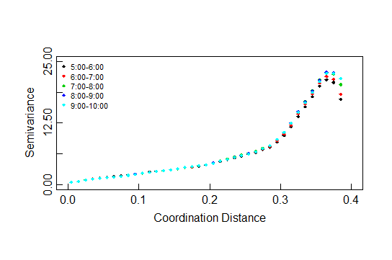

but when I fit different covariance model, it seems the fitted line is not good for the later part (see plot below) I tried several model , still similar result. Do you have any better idea? (codes in “02_GSM_illustrationPlot.R”)

