STAT 5544 Final Report

Spatial Analysis

Fall 2016

**Spatial Pattern of Population Movement Using Cellular Data**

Wenyu Gao, Danni Lu

# Abstract

As increasing number of people are living in urban area, rising issue such as deteriorating periodical traffic congestion in central business districts is gaining more and more attention. The fundamental question to alleviate traffic congestion in urban area is to figure out where the population origins and how population moves spatially. In this report, we applied a spatiotemporal model to analyze the characteristics of population density in metropolitan based on cellular data. Specifically, taking Shanghai as a case study, the spatial and temporal pattern of population density was discussed. Different spatial models were fitted and compared. Predictions were made based on selected models and the results are displayed in choropleth map. The population movement pattern is discussed based on the map. Results show that during the morning peak hours, population move from all over the city to central areas. Areas with relative high population density expand, grow and converge along transportation corridors.

# Keywords:

Periodical Traffic, Population Movement, Spatial Analysis, Cellular data.

# Introduction

Worldwide, urban population has been growing steadily during the past decades, from 33.56% of the world’s population in 1960 to 53.86% in 2015. In developed country, the proportion is even higher. 82% of total population in United States was from urban area in 2015(World Bank, 2015). As increasing number of people are living in urban area, the rising issues such as limited land resource and deteriorating recurrent traffic congestion are repeatedly emphasized by transportation planning institutes. One of the major causes of recurrent traffic congestion is high intensity development in districts where the traffic attraction exceeds the accommodation volume of traffic system. Central Business District (CBD) is therefore becoming the key area to congestion solution as it has been bringing remarkable pressure to transportation system during peak hours in weekday due to their high traffic attraction (Willett K, 2006).

Central Business District (CBD) is a major destination for urban area. According to a traffic survey of 63 cities in US in 1950s, about one in every five metropolitan residents has at least one destination in the CBD during each weekday (Foley D L, 1952). Integration of multiple services within a small area is convenient not only for people living in the vicinity but also for people living elsewhere in the city. However, the price to pay is that area with higher developing density requires transportation system with larger capacity during peak hours (Mindali O, 2004), especially in big metropolitan like New York, Sydney and Shanghai. As a consequence, traffic congestion in CBD areas has become a bottleneck for every growing metropolitan to serve better city life.

Researchers have been seeking for solutions to alleviating recurrent traffic congestion for years. Sufficient work has been done on analyzing spatial and temporal characteristic of travel behavior during peak hours. Traditional method to acquire travel pattern information is to conduct household survey, which is usually inefficient and expensive. Nowadays, high density of cellular towers and deep penetration of wireless service provides us with detailed travel information with high accuracy in precise timings. Previous studies have shown a promising future of mobile data in exploring commuting traffic. Compared with traditional way of exploring travel pattern, cellular data stands out for wider coverage area, better representative of population with all kinds of travel pattern, and more detailed information with high accuracy and precise timing. Thus, cellular data allows us to study temporal and spatial travel characteristics of higher graininess.

Midtown in Shanghai is one of the largest central business districts in the world, which makes it a suitable place to study travel pattern related to CBD. Based on cellular data collected in Shanghai, we’re going to discuss spatial and temporal characteristics of travel pattern related to CBD in Shanghai. In this study, we treat the study area as a continuous field. In section 1, we give a brief introduction of our data, the goal of our study, and make some exploratory analysis to prepare spatial data for modeling. In section 2, we introduce the methodology adopted to build, evaluate and apply the spatial models we fit. In section 3, we demonstrate and discuss the results of our empirical study, model fitting and prediction. At last, conclusions are drawn from the results and discussion.

# Data Description

We collected geodetic position information of all users in Shanghai from China Mobile for a continuous 24-hour period. China Mobile is the biggest carrier in China, with 64% total ownership in China (China Mobile, China Unicom and China Telecom, 2016). The dataset includes coded mobile phone ID, date, time, latitude and longitude of corresponding cellular tower. Cellular towers are infrastructure that enables voice and data services for mobile phones. They operate in different radio frequencies, and allow users to maintain their connections while traveling from one base station to another. In total, we collected more than 1.1 billion cell tower hands-off records. These records are from 37,450 different cell towers all over Shanghai with average density of 5.91 cell tower per kilometer square.

One issue of adopting cellular data is privacy of participants (Steenbruggen, John, 2013). To protect their privacy, all records are anonymized and replaced by an identifier ID before we got access to it. In addition, records were aggregated by areal unit and time period before analyzing and visualizing. No personal information is involved and displayed in the research.

The spatial pattern of population density has a direct relationship with traffic demand. Every morning on weekday, metropolitan sees a population movement from every corner of the city to CBD areas. During peak hours, the traffic on roads and crowding transport is at its highest. The huge increment of population brings tremendous pressure to transportation system near CBD areas. In traditional traffic survey, no standard areal definition of CBD was followed (Foley D L., 1952). Though the importance of CBD in transportation is self-evident, it is much more of a general concept in transportation study. Luckily, the comprehensive information of cellular data provides us a way to identify CBD by its transportation characteristics. In this study, we focus on main districts that are circled by Outer Expressway in Shanghai (Figure 1).

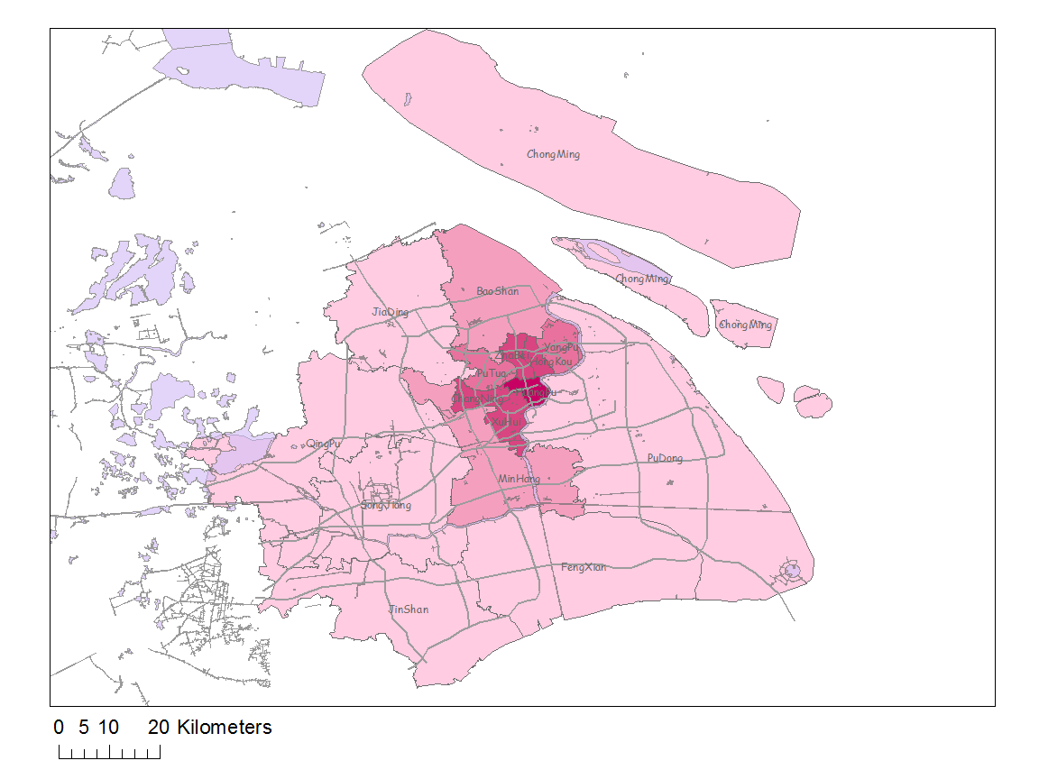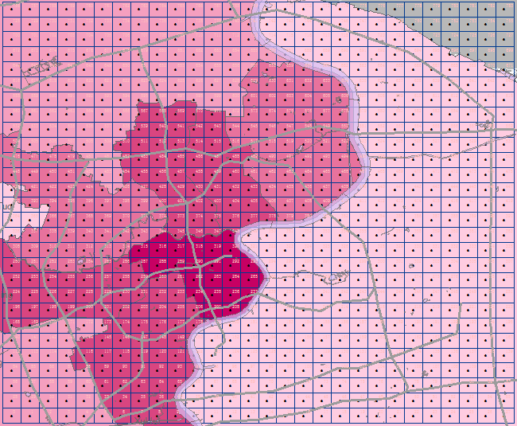

Figure 1. Study Area and Aggregation Grid

The accuracy of location information we get depends on the density of cell towers. Instead of accurate location of mobile phone users, cellular data recorded location of cell tower that is nearest to the mobile phone users. As we can see in Figure 2, cell towers are not evenly spaced. The density in the center area is higher than outer areas. As a result, the coverage area of each cellular tower is different. To simplify the situation, study area is partitioned into a 28*28 grid, each areal unit is one square kilometer. All cellular information from one areal unit is aggregated into one fictional cell tower in the geo-center of the areal unit (Figure 2). Hence, we have a regular point-referenced data to establish spatial model. In terms of study period, our goal is exploring spatial and temporal pattern of population in rush hours in the morning. Previous study shows typical morning rush hours for metropolitan CBDs are between 7:00 and 9:00 am. Therefore, we extract cellular data from 5:00 am to 10:00 am to cover this range.

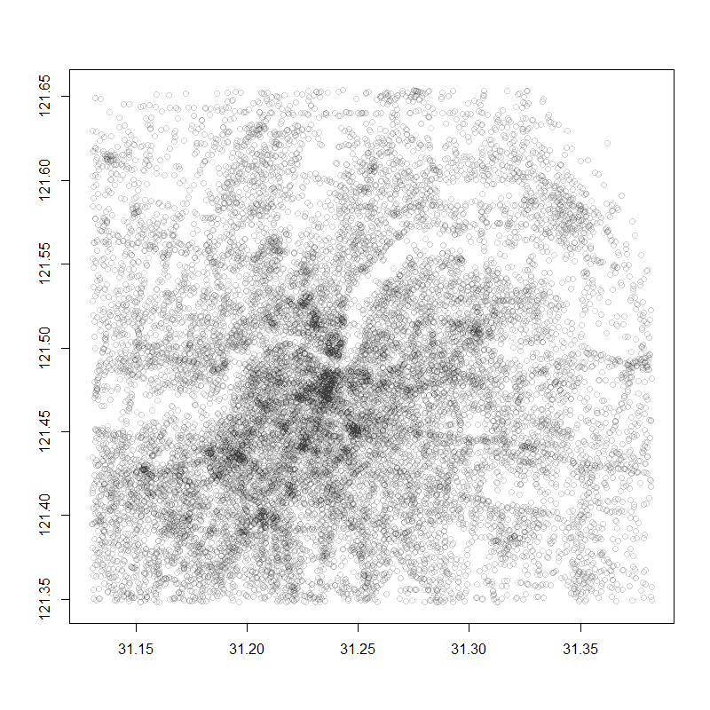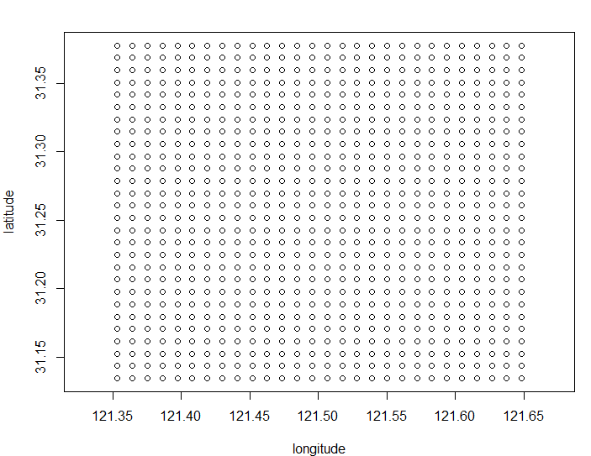

Figure 2. Original Cell Towers and Aggregated Cell Towers

# Exploratory Data Analysis

* 1. **Illustration of Variables**

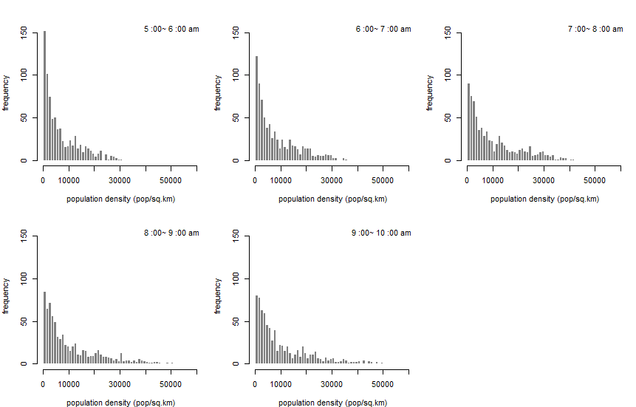

Histogram of population density in each hour

The response for our study is population density and its distribution for each hour is shown in Figure above. As is shown, population density is highly right skewed. The right tail becomes heavier over time from 5:00-6:00 am to 9:00-10:00 am. Instead of assuming a normal distributed response, we can assume population density is more like Gamma distributed. The summary statistics for population density at each hour are shown in Table below. It shows an increasing trend of average population density across the study area.

Population Density Table

|  |  |  |  |  |  |  |
| --- | --- | --- | --- | --- | --- | --- |
|  | **Min.** | **1st Qu.** | **Median** | **Mean** | **3rd Qu.** | **Max.** |
| **5:00-6:00** | 0 | 1378 | 4217 | 7003 | 11200 | 33550 |
| **6:00-7:00** | 0 | 1849 | 5322 | 8421 | 13430 | 36390 |
| **7:00-8:00** | 0 | 2452 | 6940 | 10550 | 16050 | 47720 |
| **8:00-9:00** | 0 | 2588 | 7033 | 11440 | 16990 | 68800 |
| **9:00-10:00** | 0 | 2554 | 6772 | 11450 | 17050 | 83820 |

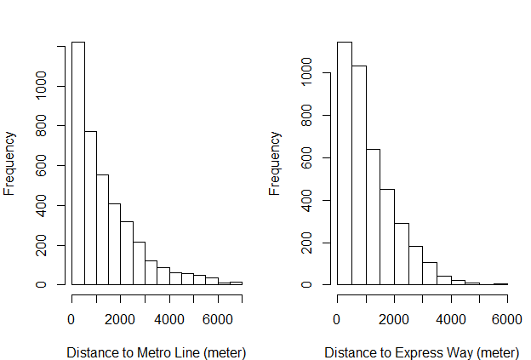

Figure. Histogram of covariates

As for

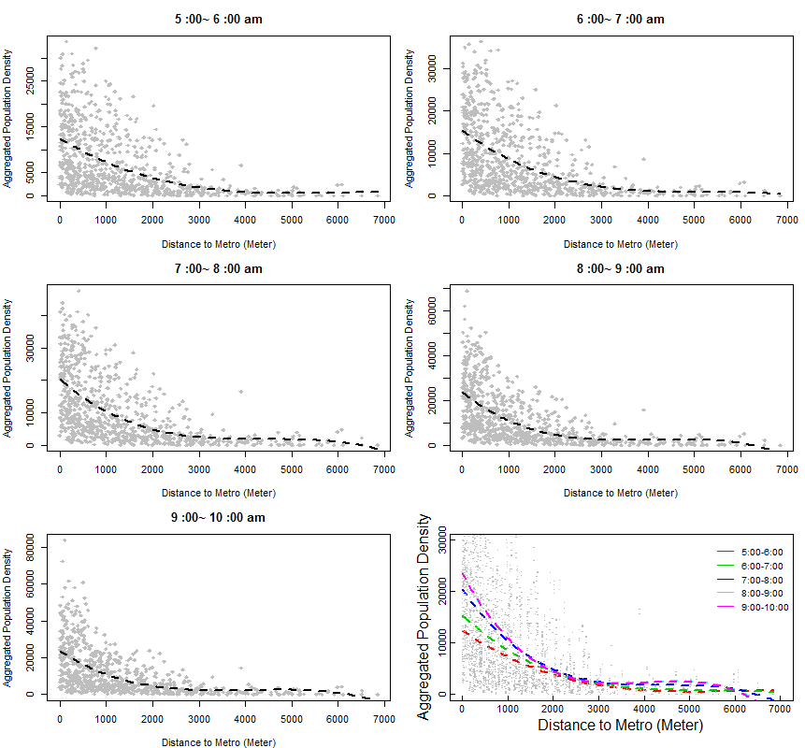

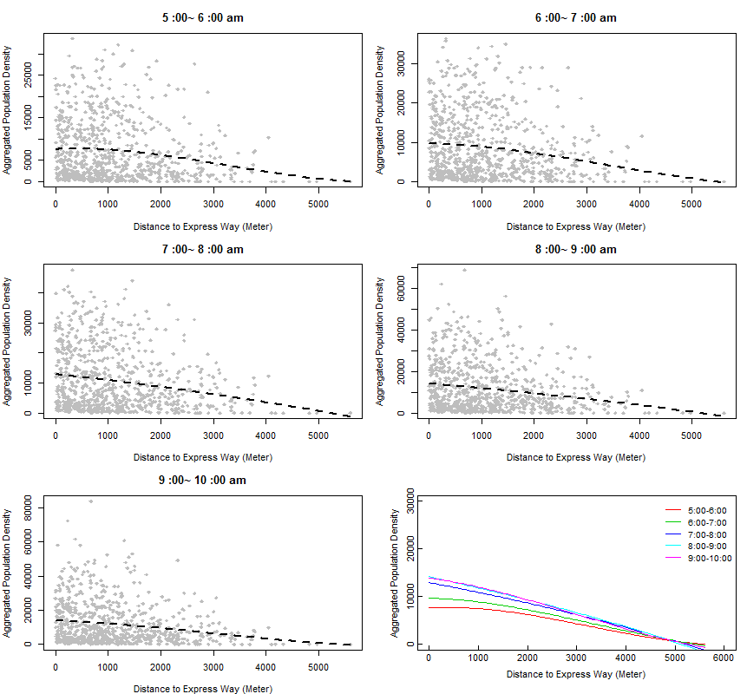

* 1. **Spatial Trend**

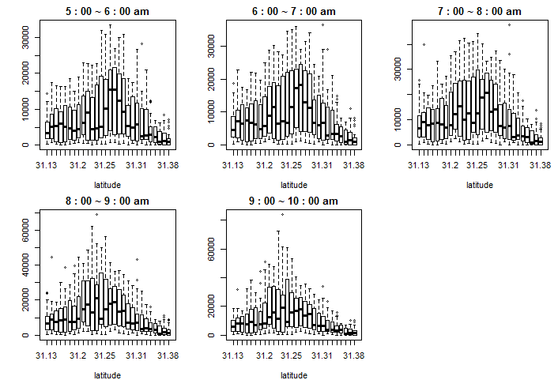

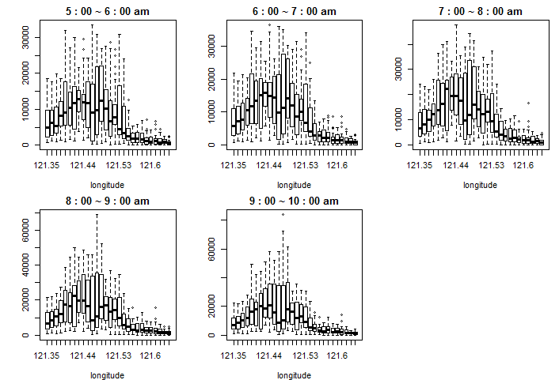

Stepwise selection (AIC):

;

;

;

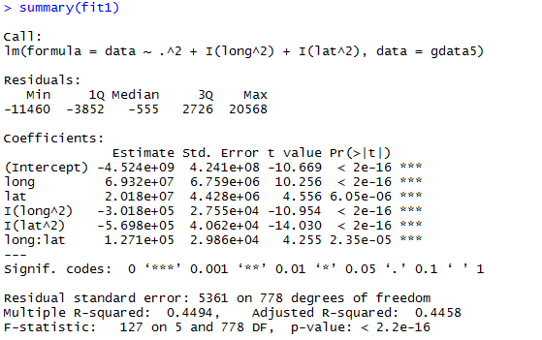

Define new response as residual from full model:

* 1. **Isotropy Assumption**

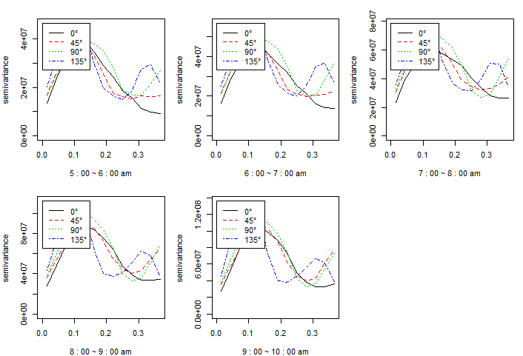

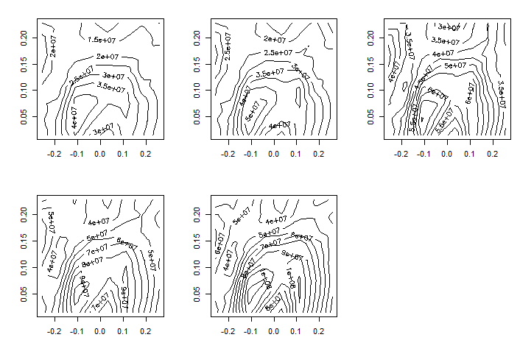

# Model Fitting and Prediction

* 1. **Semivariogram Fitting**

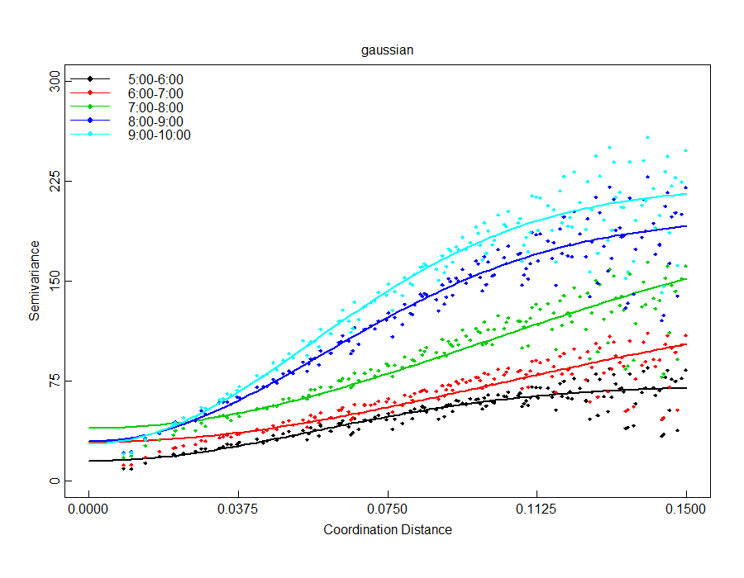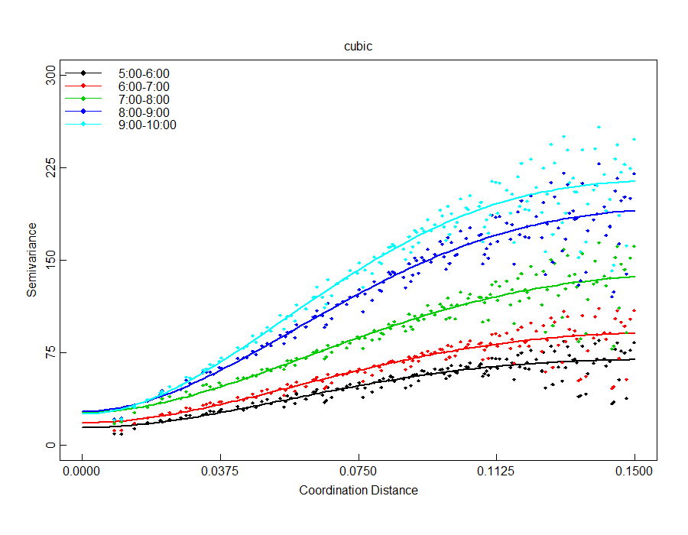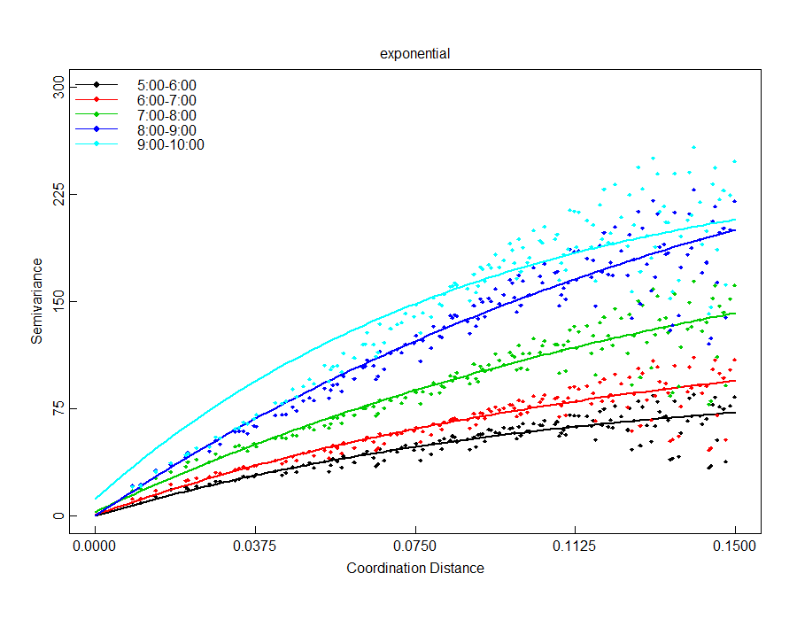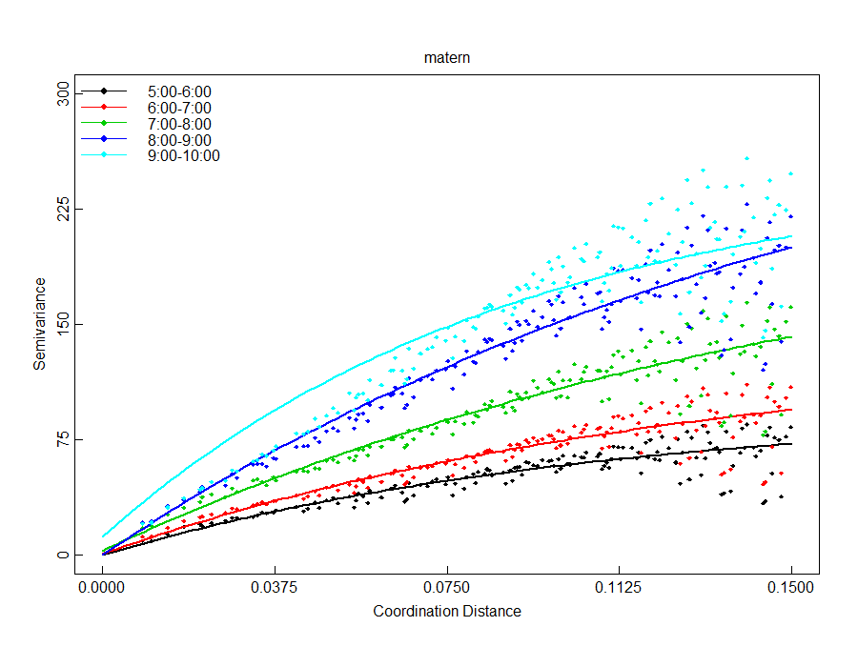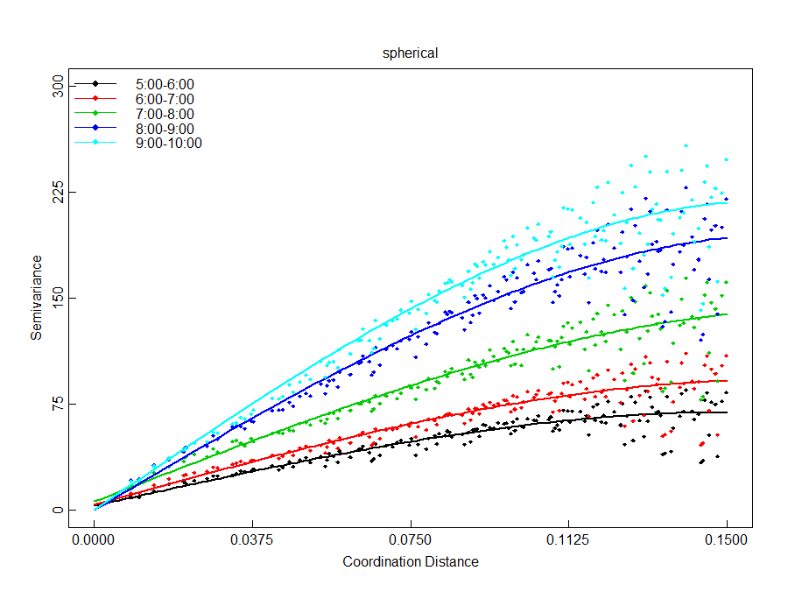

* 1. **Model Compare**
  2. **Prediction**

To evaluate the spatial pattern of the population density, we used the Kriging method. The method could provide a smooth surface of population density. The first step in Kriging method is fitting semivariogram model, which provides crucial quantitative evaluation on the spatial patterns of population density. We applied the method to the data from 5:00am to 10:00am.

For the aggregated cellular data, we consider the aggregated cell towers in the geo-center of each areal unit as sampled sites. In total, we have 784 evenly spaced sites, denoted as. We then use the information from discrete sampled sites to make inference about the continuous field of study area. Since each areal unit is one square kilometer, number of mobile users in aggregated cell tower provides a reasonable estimate for population density of the site. Assuming there is no difference in ownership among different areas in Shanghai, the number of mobile users of sampled site is proportional to true population density. Population movement is a continuous spatial process. As a result, locations near a high population density site are more likely to be high density. Generally, we assume the spatial association between two sites mainly depends on distance. That is, the correlation between two sites can be expressed as a function of distance,

where *d* is distance between two sites is number of mobile user at site . Semivariogram is an important function to indicate spatial correlation. In isotropy cases, semivariogram is defined as

.

The calculation form for semivariogram is . A larger semivariogram indicating larger variability in the random field, which in normalized case suggesting weaker spatial correlation.

To calculate empirical semivariogram using cellular data within study area, we use Hawkins-Cressie semivariogram estimator (Hawkins and Cressie, 1980) which gives relative robust estimate in case of outliers.

In the study, we treat our study area as a continuous random field. In this field, population movement is considered as a continuous process. As a result, the population density at each particular time should be a smooth surface. During the process of data collecting, data cleaning and data aggregating, we’re unavoidably involving random errors. In order to eliminate the effect caused by random error and focus on the main trend of spatial pattern, we use Ordinary Kriging method to make prediction of study area using aggregated data. Kriging is a continuous interpolating method for spatial data. It weights the surrounding measured values to derive a prediction for an unmeasured location. The general formula for Kriging is formed as a weighted sum of the data:

We solve for the estimate that minimize squared error loss (Banerjee, etc. 2014):

Thus, we incorporate the semivariogram structure in the Kriging model to predict unmeasured locations.

We obtained empirical semivariogram using Hawkins and Cressie method mentioned above. We then further fitted five different semivariogram models: Gaussian, Cubic, Spherical, Matern and Exponential. Using least square method, Cubic model turned out to be best fit in terms of minimizing total residual sum of square. Fitted curve for each time period is shown in Figure 4 on top of scatter points of empirical semivariogram. Corresponding estimated model parameters for each time period are shown in Table 1. The plot shows an increasing trend of semivariogram with respect to spatial distance. Theoretically, at zero separation distance, the semivariogram value is 0. However, at an infinitesimally small separation distance, the semivariogram often exhibits a nugget effect, which is some value greater than 0. In our fitted plots, the intercepts for each hour range from 14.22 to 27.28. This can be attributed to measurement errors or variation at distances smaller than the aggregation interval or both. We also notice that at a certain distance, the model levels out. The distance where the model first flattens out is known as the range. Sample locations separated by distances smaller than the range are spatially autocorrelated, whereas locations farther apart than the range are not. According to the fitted model, the range for different time periods are similar. Average speaking, locations within 19 km are correlated while locations further apart are not. The max semivariogram value attained at the range is called the sill, indicating the upper limit of variation across the study region.

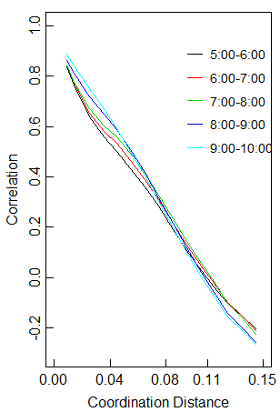

0 4 8 12 16 0 4 8 12 16

Distance (Km) 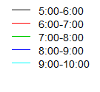 Distance (Km)



Figure 4. Semivariogram and Fitted Models

Table 1. Estimated Spherical Model Parameters

|  |  |  |  |  |  |  |
| --- | --- | --- | --- | --- | --- | --- |
|  | **Nugget** | | **Sill** | | **Phi** | **Range** |
| 5:00 ~6:00 | | 0.8011 | | 37.7828 | 0.1054 | 0.1054 |
| 6:00 ~7:00 | | 1.9464 | | 47.8717 | 0.1074 | 0.1074 |
| 7:00 ~8:00 | | 4.7192 | | 65.0074 | 0.1086 | 0.1086 |
| 8:00 ~9:00 | | 1.9597 | | 84.0722 | 0.1037 | 0.1037 |
| 9:00 ~10:00 | | 0.0000 | | 90.8891 | 0.1047 | 0.1047 |

As is shown in Figure 4, the max variations in population density increase in the morning. During 5:00 to 6:00 am, the sill is around 37, which is relatively small, indicating a homogeneous spatial pattern. The variation in population density keeps increasing over time in the morning. During 9:00 to 10:00 in the morning, the sill tripled compared with 5:00 to 6:00 time period, indicating a relatively heterogeneous distribution of population density. Correspondingly, after standardizing the semivariogram, we obtain the correlation in population density across the study region (Figure 4. right side plot). Uniformly, the correlation among locations decreases as distance increases for all time periods. The correlation dropped to zero around 10 km.

In addition to the spatial pattern, we discover a significant relation of population density and distance to transportation corridor. In Shanghai, express ways (dark blue in figure) and metro lines (grey lines in figure) are highly overlapped, making up main transportation corridors that carry most of daily traffic in Shanghai. We set distances to metro line and expressway as covariates to fit a generalized addictive model with gamma family. Covariates include distance to metro line, distance to expressway, their quadratic form and interaction. To account for spatial autocorrelation, we also include a spatial component in the generalized addictive model. Best model is selected using AIC criterion and the estimates are shown in Table 2. Result shows there is a significant effect of square of distance to metro line, distance to expressway and the interaction. As gamma family uses an inverse link function, we conclude that a larger distance to metro line gives smaller population density, while the effect of distance to expressway depends on the interaction term.

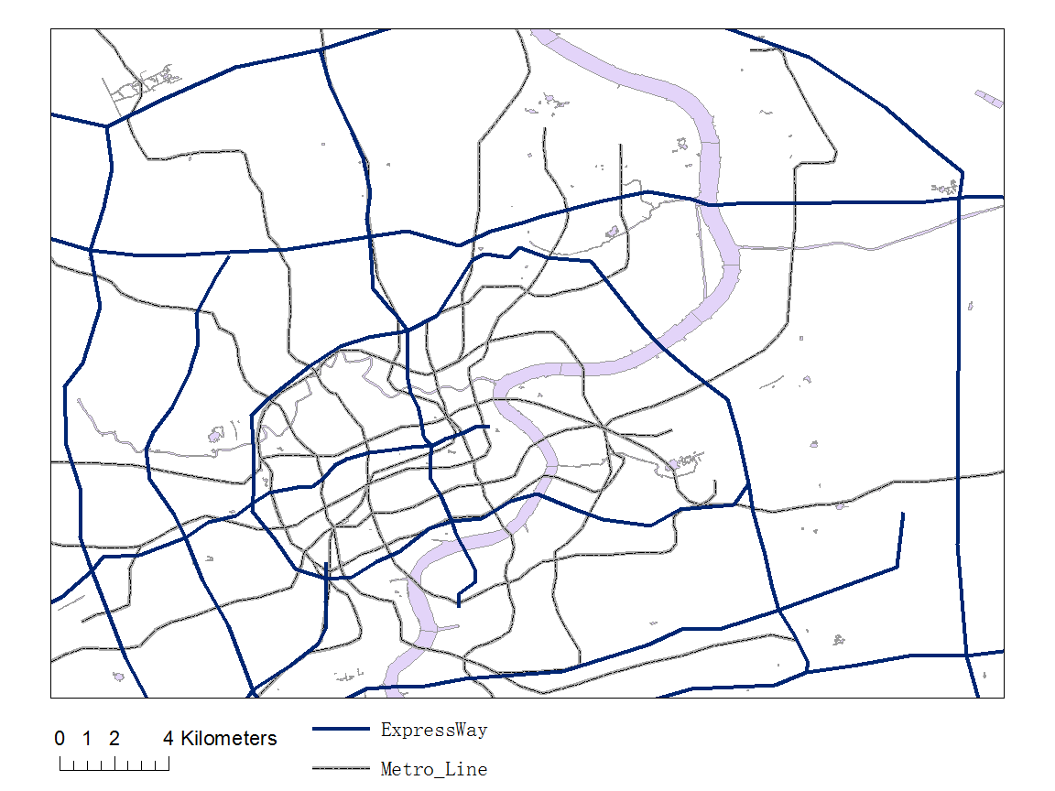

Figure 2. Main Transportation Corridors in Study Region

Table 2. Estimates and P values for GAM model

|  |  |  |
| --- | --- | --- |
| Term | Estimate | P value |
| Distance to Metro | 6.947e-09 | 0.1313 |
| Distance to Expressway | -4.564e-09 | 0.0102 |
| Distance to Metro^2 | 7.422e-12 | 0.0001 |
| Distance to Metro* Distance to Expressway | 5.605e-12 | 0.0217 |
| s (longitude, latitude) | -- | <2e-16 |

# Discussion: Spatial and Temporal Pattern of Population Density

Based on the Kriging model established above, we displayed the relative population density of each time period during morning peak in Figure 3. Since we aggregated the cellular data in an hourly basis, the estimate of population density could be larger than true value, but it doesn’t affect the relative trend. The Figures show three major spatial processes over time during morning peak in a typical weekday: expanding, growing and converging along traffic corridors (Figure 2). In Shanghai, express ways (dark blue in figure) and metro lines (grey lines in figure) are highly overlapped, making up main transportation corridors that carrying most of daily traffic in Shanghai.



Figure 2. Main Transportation Corridors in Study Region

Early in the morning (5:00 ~ 6:00 am), the population density is relatively homogeneous with density less than 20000 per square kilometer for most area. As shown in the figure, except for the overall uniform pattern, there are multiple weak centers where population density is relatively higher. Among these weak centers, sub centers scattered sparsely around the main center which is much larger than sub centers. The main center located in the middle and extended toward northeast, suggesting relatively high density residential area in the northeast part. In the next hour (6:00 ~7:00 am), the area of centers grew and sub centers began extending towards main center. Population density corridors formed in the process, connecting different centers. This may suggest people began to leave residential area and head to their destinations, creating population density corridors that extend from residential area to other areas. During this process, there is no significant increase in population density within study area.

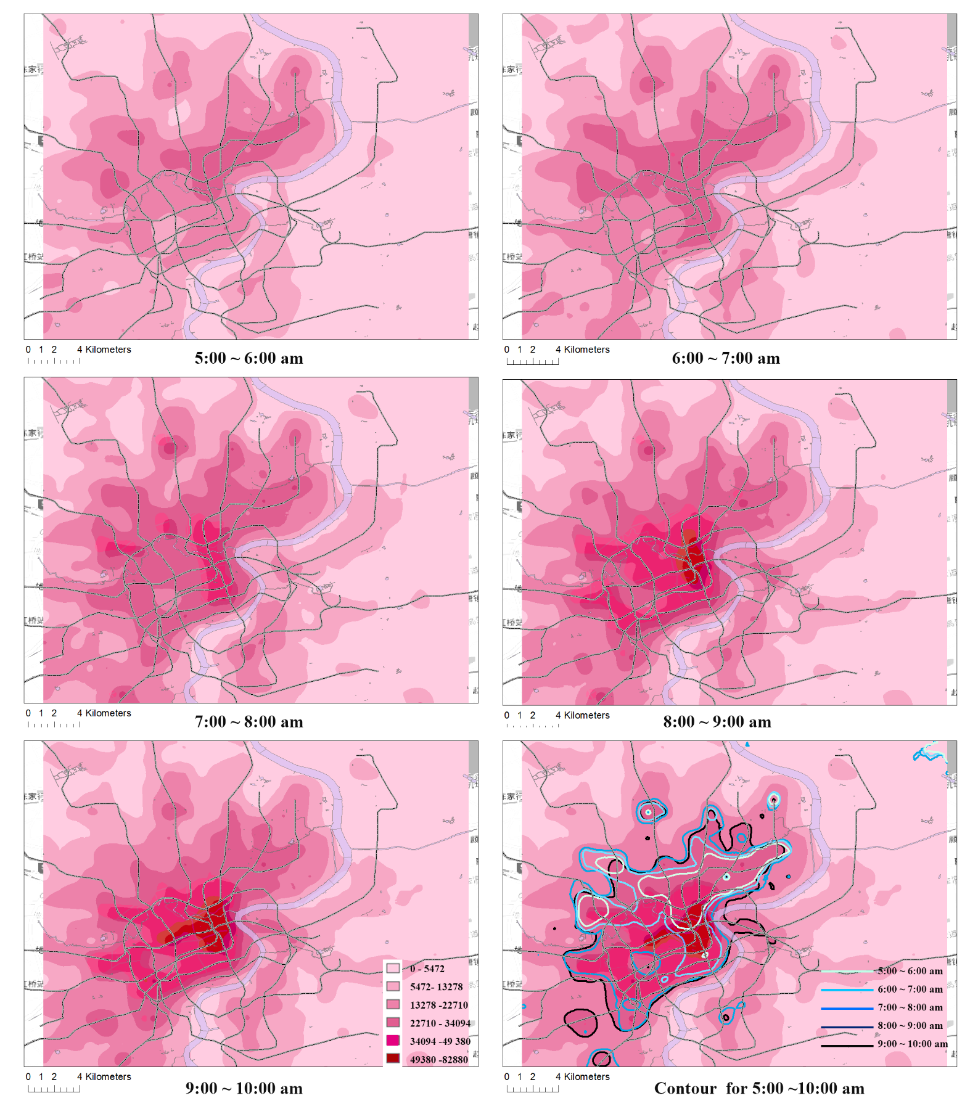

Figure 3. Choropleth Map of Relative Population Density and Contour

From 7:00 to 8:00 in the morning, area of relative high density centers continues to expand while population began to concentrate at some districts, generating new centers of higher population density. The growing of population density continued for the next hour (8:00 ~ 9:00). High density centers in central area keep expanding and connected each other. Significant growth in population density was identified during this period. In central area, the population density doubled to more than 50000 populations per square kilometers. The contour plot shows the expanding trend of relative high population area. Area with population density higher than 22710 pop/km^2 during each hour was outlined in different color. The area expanding process began at 5:00 am, extending from northeast to southwest for three hours and end at 8:00 am. This shows a general southwest moving pattern of population during morning peak. After 8:00 am, the expending process fades while population begins concentrating in the center.

After 9:00 in the morning, sub centers in outer area fade while the population density in central area keeps growing. An observable centripetal tendency of population movement was detected. The population decrease in sub centers suggesting most people has leaving their resident areas at 9:00. While the keep increasing trend of population density in central area reveals the huge attraction force of CBD area. As is shown in the figure, after 9:00 am, there was only one main center and a minor sub center left. At the end of morning peak, population density in central areas has tripled compared to 5:00 in the morning. The main center included the Bund, Nanjing East Road, Nanjing West Road and New World area. The minor sub center is Xujiahui commercial district. Those areas are all major CBD integrating commercial, shopping and entertainment centers. Integrated CBDs are key causes for periodical high traffic pressure. CBDs integrated with shopping center and entertainment center are of great convenience in our daily life. However, the tremendous traffic attraction exerts great periodical pressure to the local transportation system.