Appendix

Use of AI Tools
I acknowledge the use of [Gemini] for the purpose of [data masking, scaling, and imputation].
Declaration
By submitting this assessment, I confirm that I have read the CCT policy on academic misconduct and understand the implications of submitting work that is not my own or does not appropriately reference material taken from a third party or other source.
I declare it to be my own work and that all material from third parties has been appropriately referenced.
I further confirm that this work has not previously been submitted for assessment by myself or someone else in CCT College Dublin or any other higher education institution.

AI competence | Reflective prompts (to students) | Lecturer expectations | Student response
Delegation  Deciding whether & when to use AI | Identify the specific tasks in this assessment where you chose to use AI, and explain your reasoning. Where did AI add value? Where did you decide not to use it, and why? | You may use AI to support your learning and development of the application. Clearly identify where you used AI and where you completed the work independently. | Briefly state which parts of your application assessment you used AI for and why.  1. In part 7 (Data Source), in order to transform a real-time operational dataset into something I can work on for this project, I used AI to generate an authentic dataset (1000 rows,11 columns) based on the original dataset (84 rows,11 columns) using data masking and scaling.  2. In the part of 7.Data Source, I use AI for solving a visualization issue with plotting the Poisson distribution for VIP tickets, as the 501 overlapping labels, turning your x-axis into a solid black bar,I need to get a better and clearer visualization.
Description  How you prompted the AI | Include the exact prompts you used in your appendix (recorded on the AI Tools declaration). Reflect on how you communicated your goals to the AI — did you need to iterate or refine your prompts to get useful output? | You must provide the exact prompts and relevant AI outputs used during the development of your application. | Include the exact AI prompts and outputs in your submitted AI-use Word document.  Prompt 1:  “I recorded operational data of a company for the daily tourists and staff numbers , some numbers were random or wrong as well , I want to use it to do my CA project for data analysis, I changed or deleted some columns and rename them by masking the data, can you generate a 100% legal raw dataset based on the dataset I already updated? do not clean the data, leave the raw data as it is . and tell me where you change the data exactly” (output: dataset)  Prompt 2:  “# Parameters  lambda_vip = 484  k = np.arange(0, 501) # number of having 500 VIP visitors (0 to 500)  # Poisson probability mass function (pmf)  poisson_pmf = poisson.pmf(k, lambda_vip)”  (output: correct python code)
Discernment  Evaluating what the AI produced | In your reflection, critically evaluate the AI output: what did you accept, modify, or reject — and why? Assess accuracy, relevance, and quality. You are responsible for verifying all AI-generated content before submitting. | You are responsible for checking, testing and understanding any AI-generated code or suggestions before using them in your work. | Briefly explain how you verified the AI output and what you accepted, modified or rejected.  1.I accept the AI output as it utilizes for this analysis and turns the original dataset into simulated and anonymized operational time-series records representing visitor numbers and staffing allocations across operational departments, which is workable for my project. But as in real practice, there are traffic peak on public and bank holidays like St Patrick Day, Xmas, and New Year’s day, I adjusted the numbers for those public holidays in order to get a more accurate analysis.  2. I fully accept the AI output as it is the correct way to get the right distribution for a large data range from 0-500.
Diligence  Responsibility for your AI use | Declare all AI tools used and cite them here. Briefly outline how you considered data protection, copyright, and ethical responsibilities when choosing what to input into any AI system. Unauthorized use is subject to CCT disciplinary procedures. | Declare all AI tools used. Do not enter personal, confidential or sensitive information into AI tools. Any external sources used should be appropriately referenced. | List the AI tools used and briefly explain how you used them responsibly.  I used Gemini pro for the research and I use it responsibly to solve specific data problems, coding issues only.

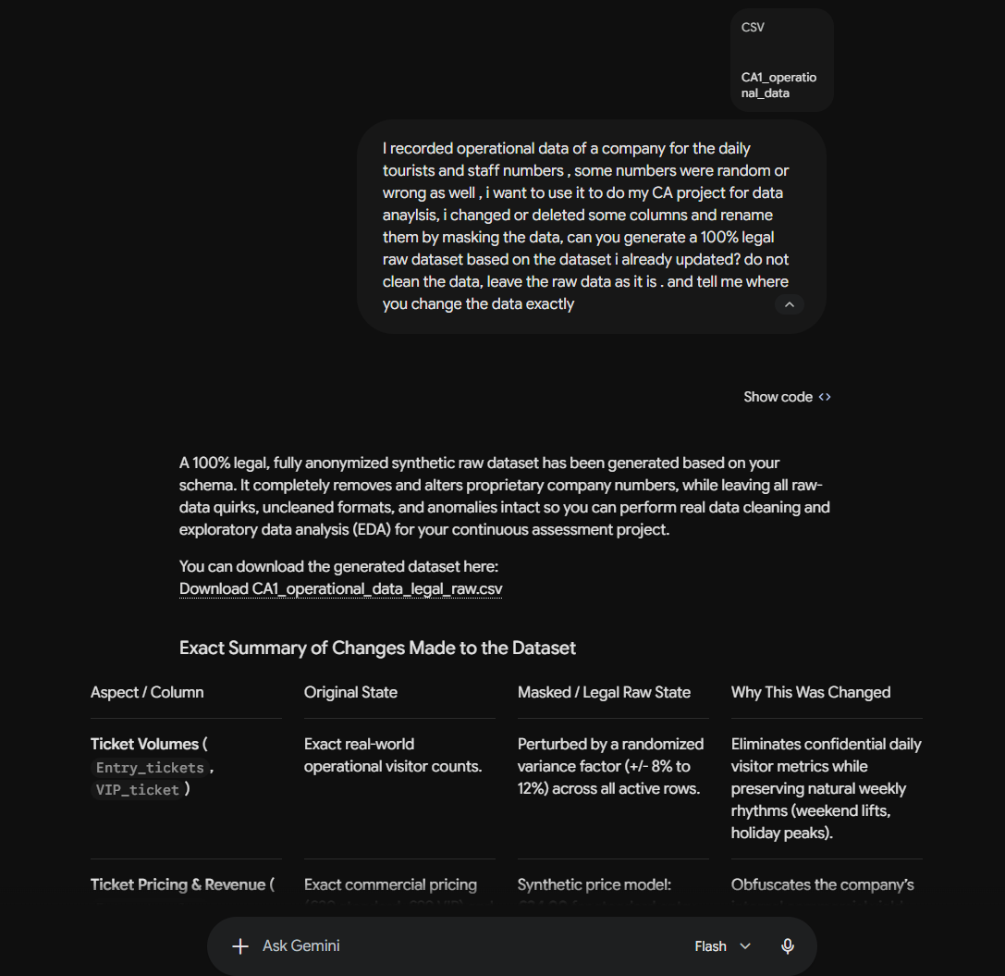
(Prompt 1: screenshot)

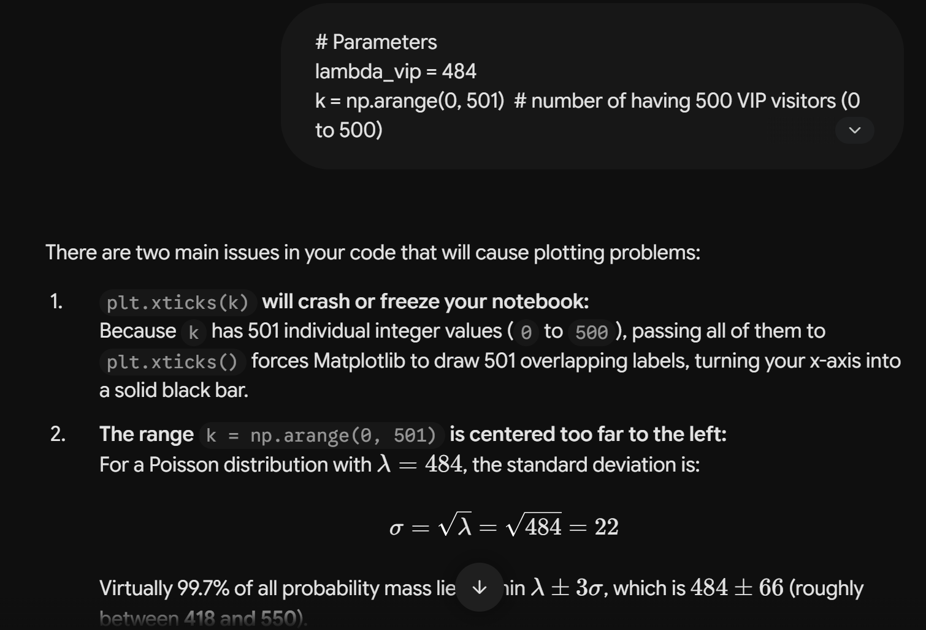
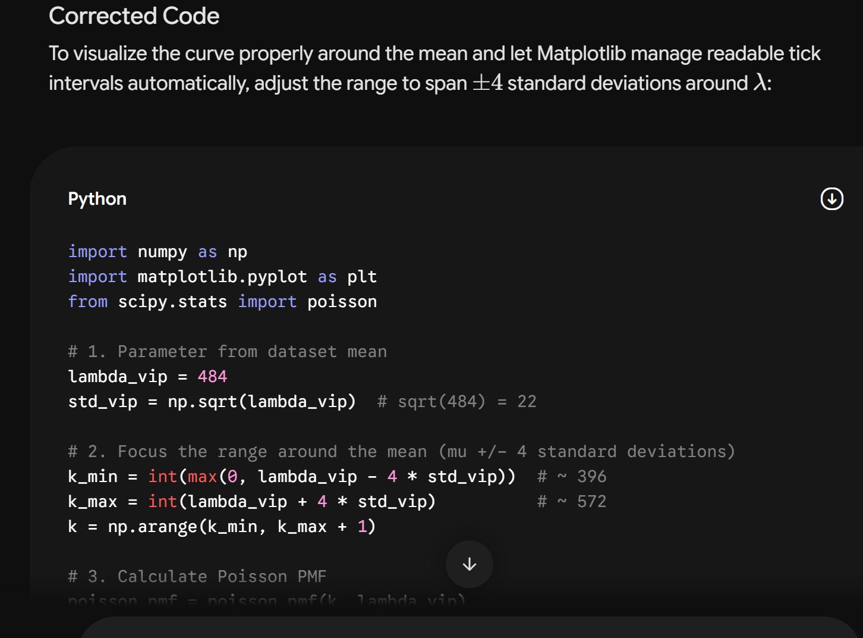
(Prompt 2: screenshot)

Adapted from the AI Fluency Framework (Dakan, Feller, Anthropic, 2025).

