Evidence Phase 1

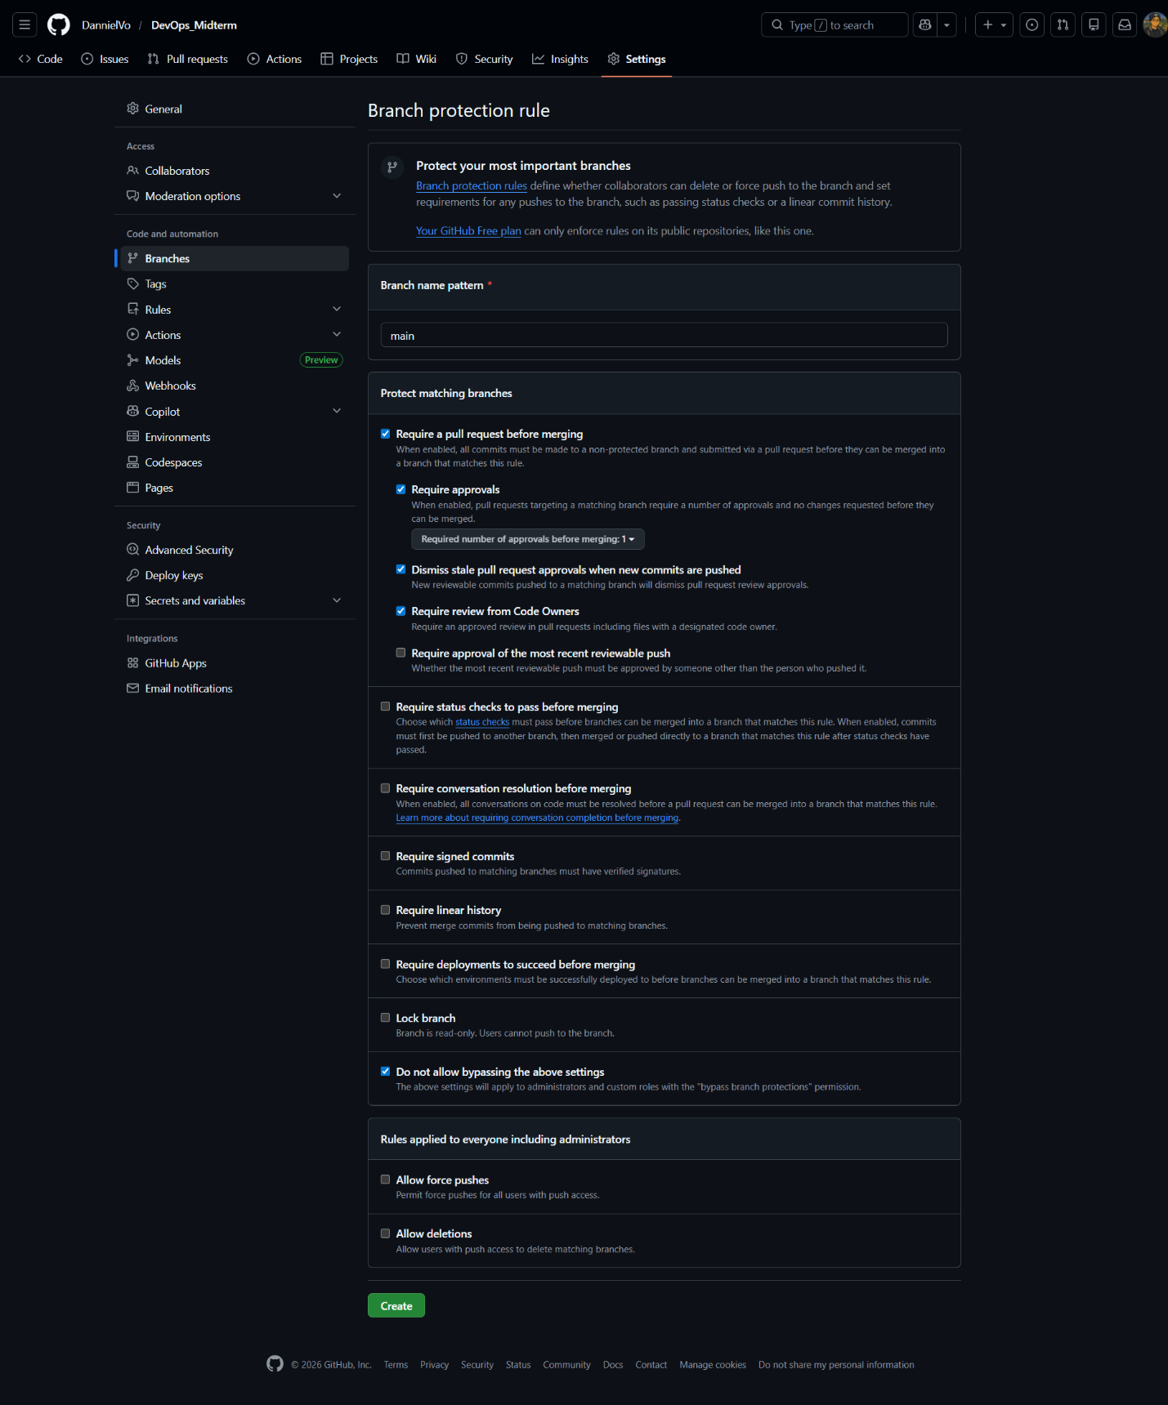
Figure 1. Branch protection settings
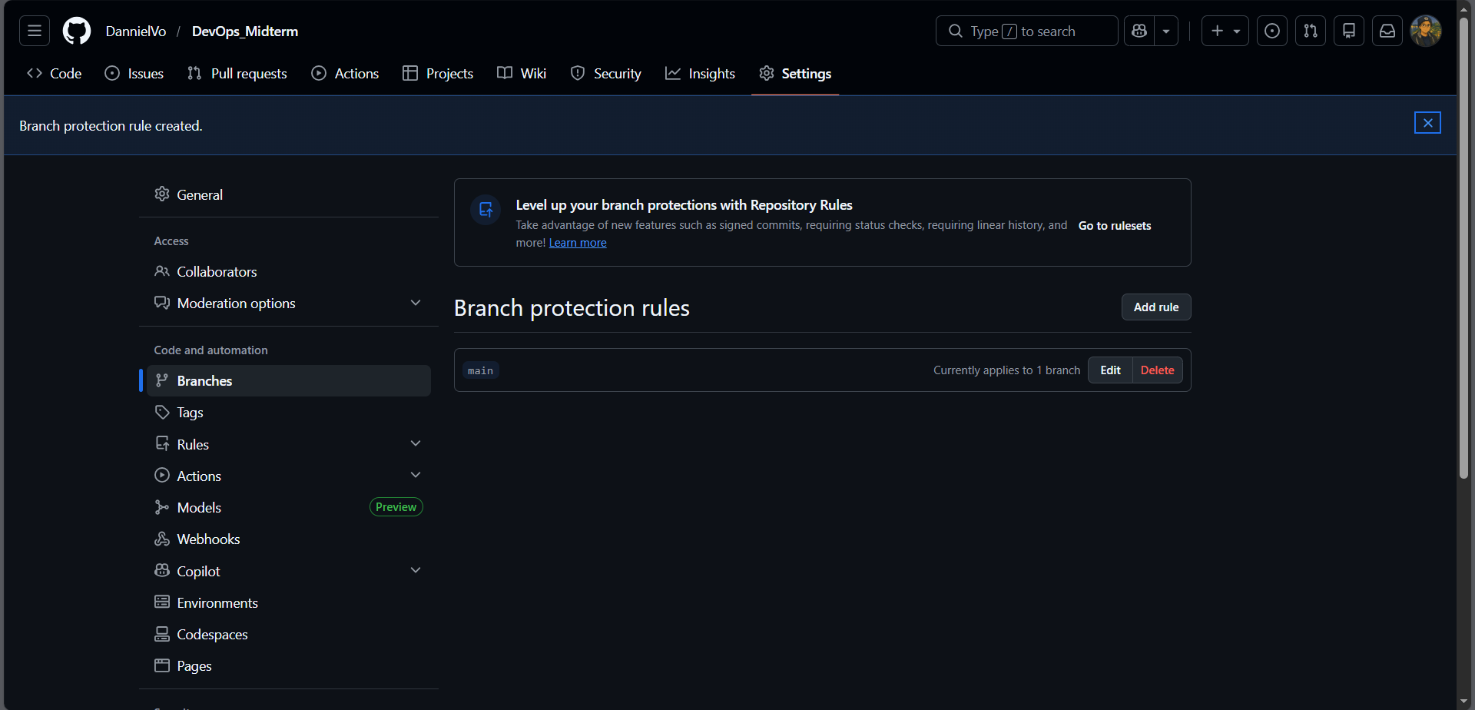
Figure 2. Branch protection rules

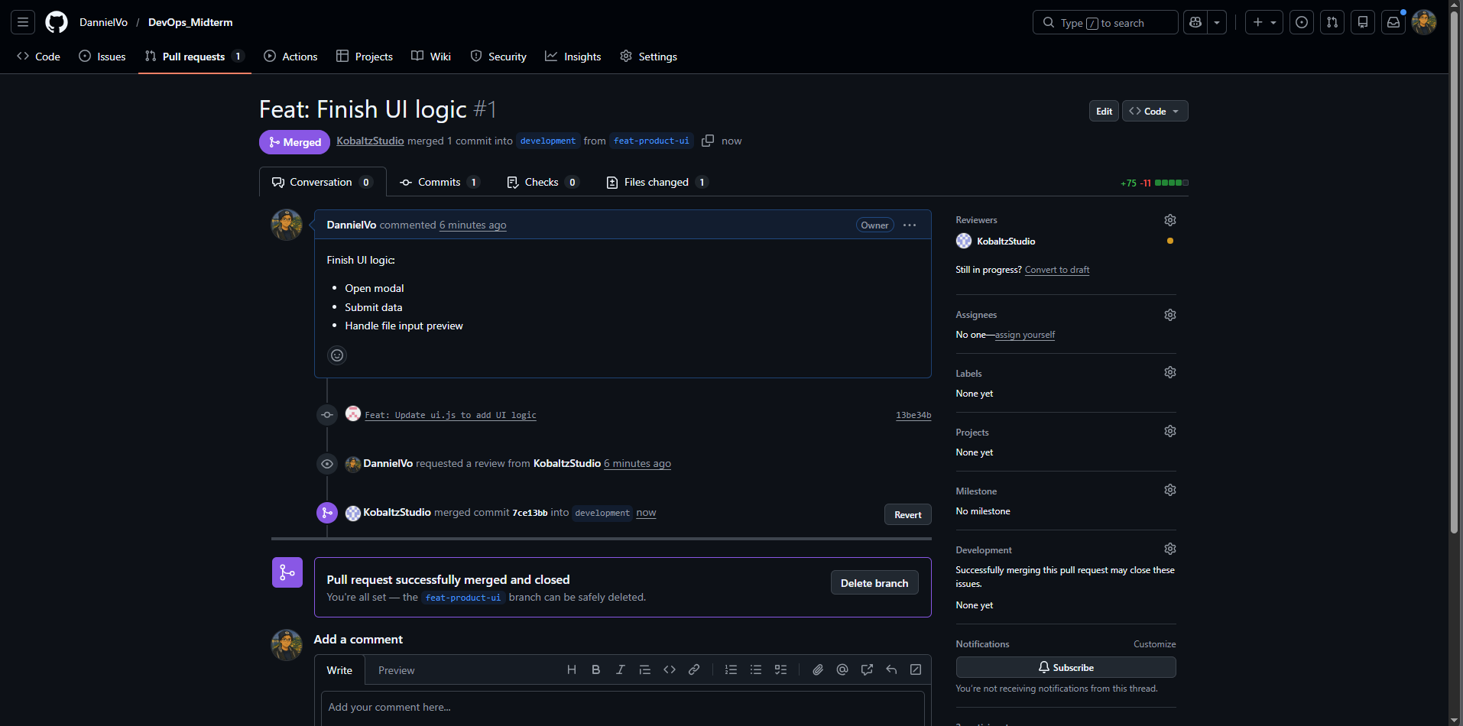
Figure 3. Pull request from feat-product-ui to development
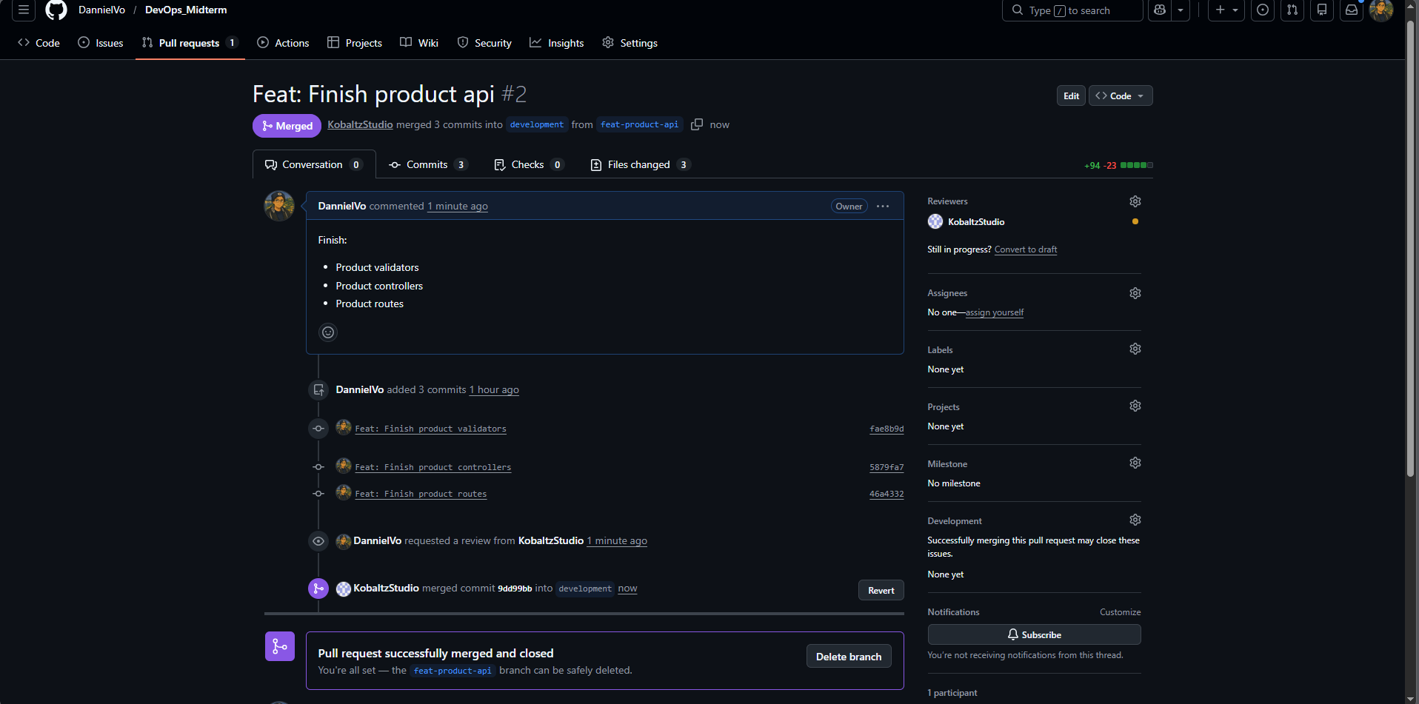
Figure 4. Pull request from feat-product-api to development

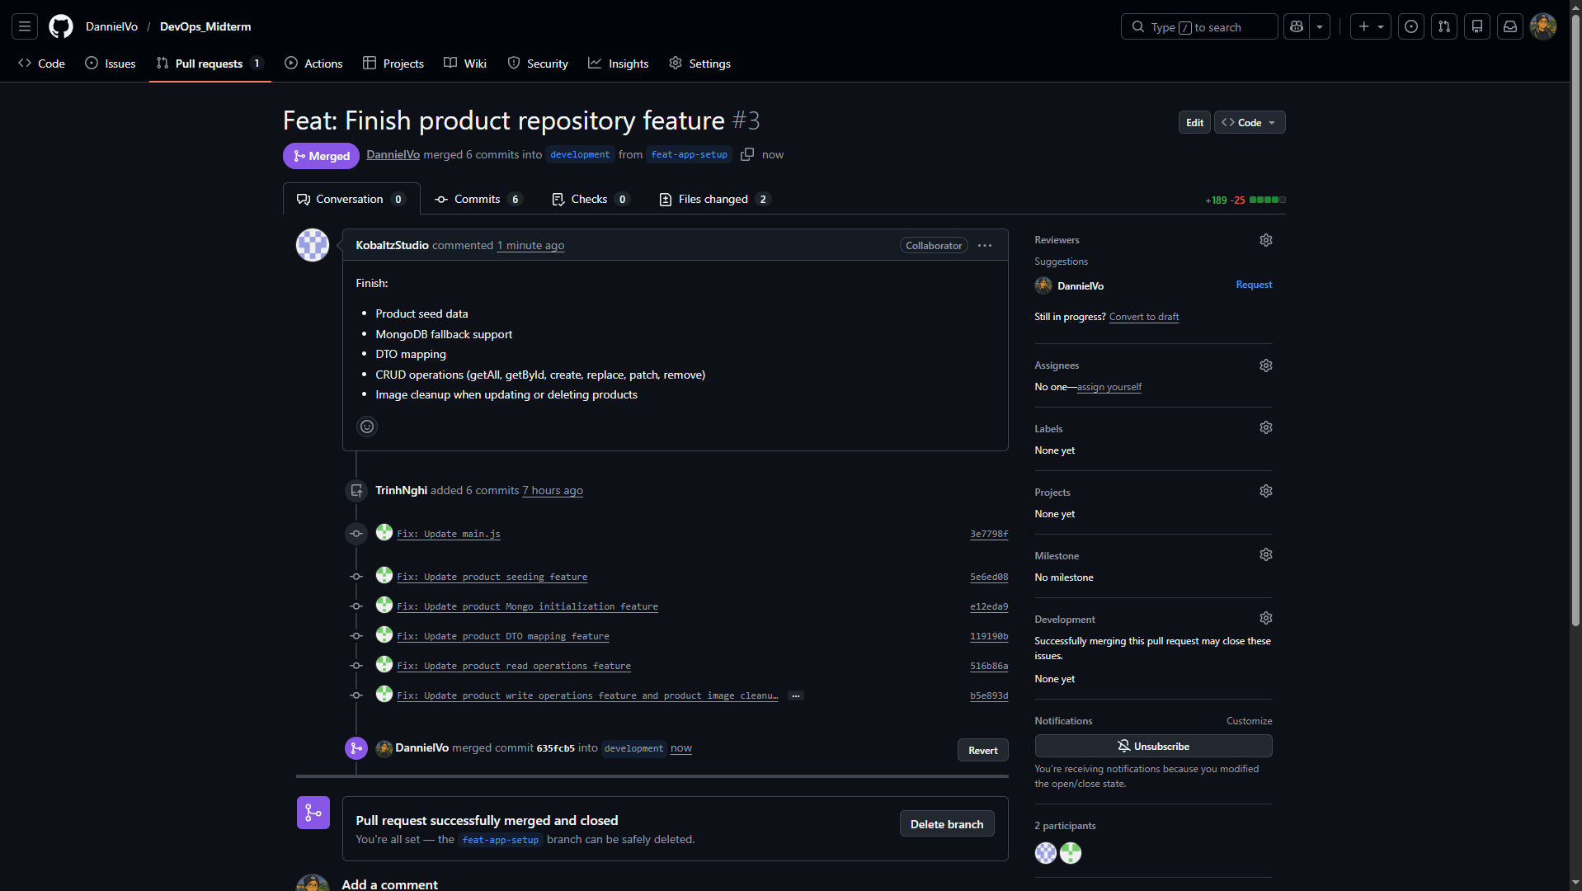
Figure 5. Pull request from feat-app-setup to development
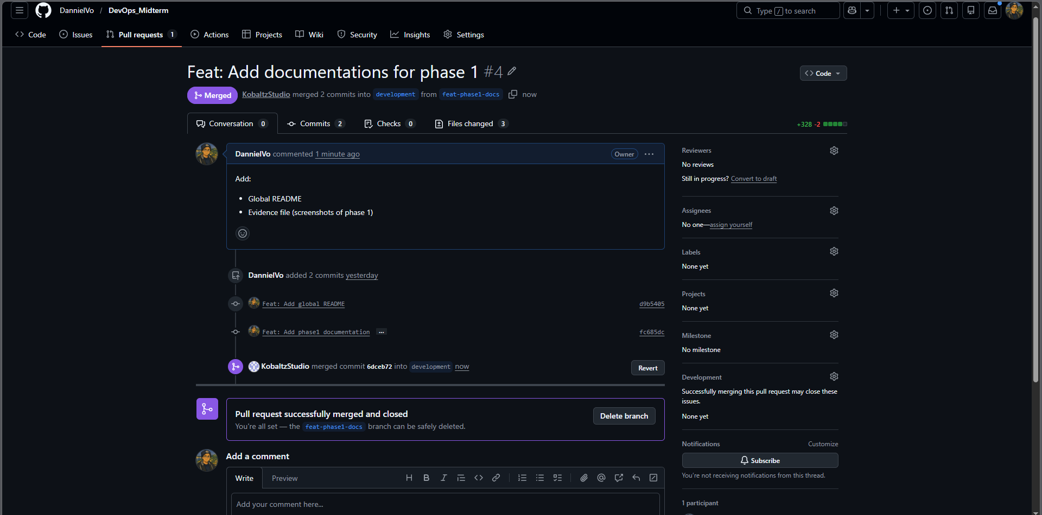
Figure 6. Pull request from feat-phase1-docs to development

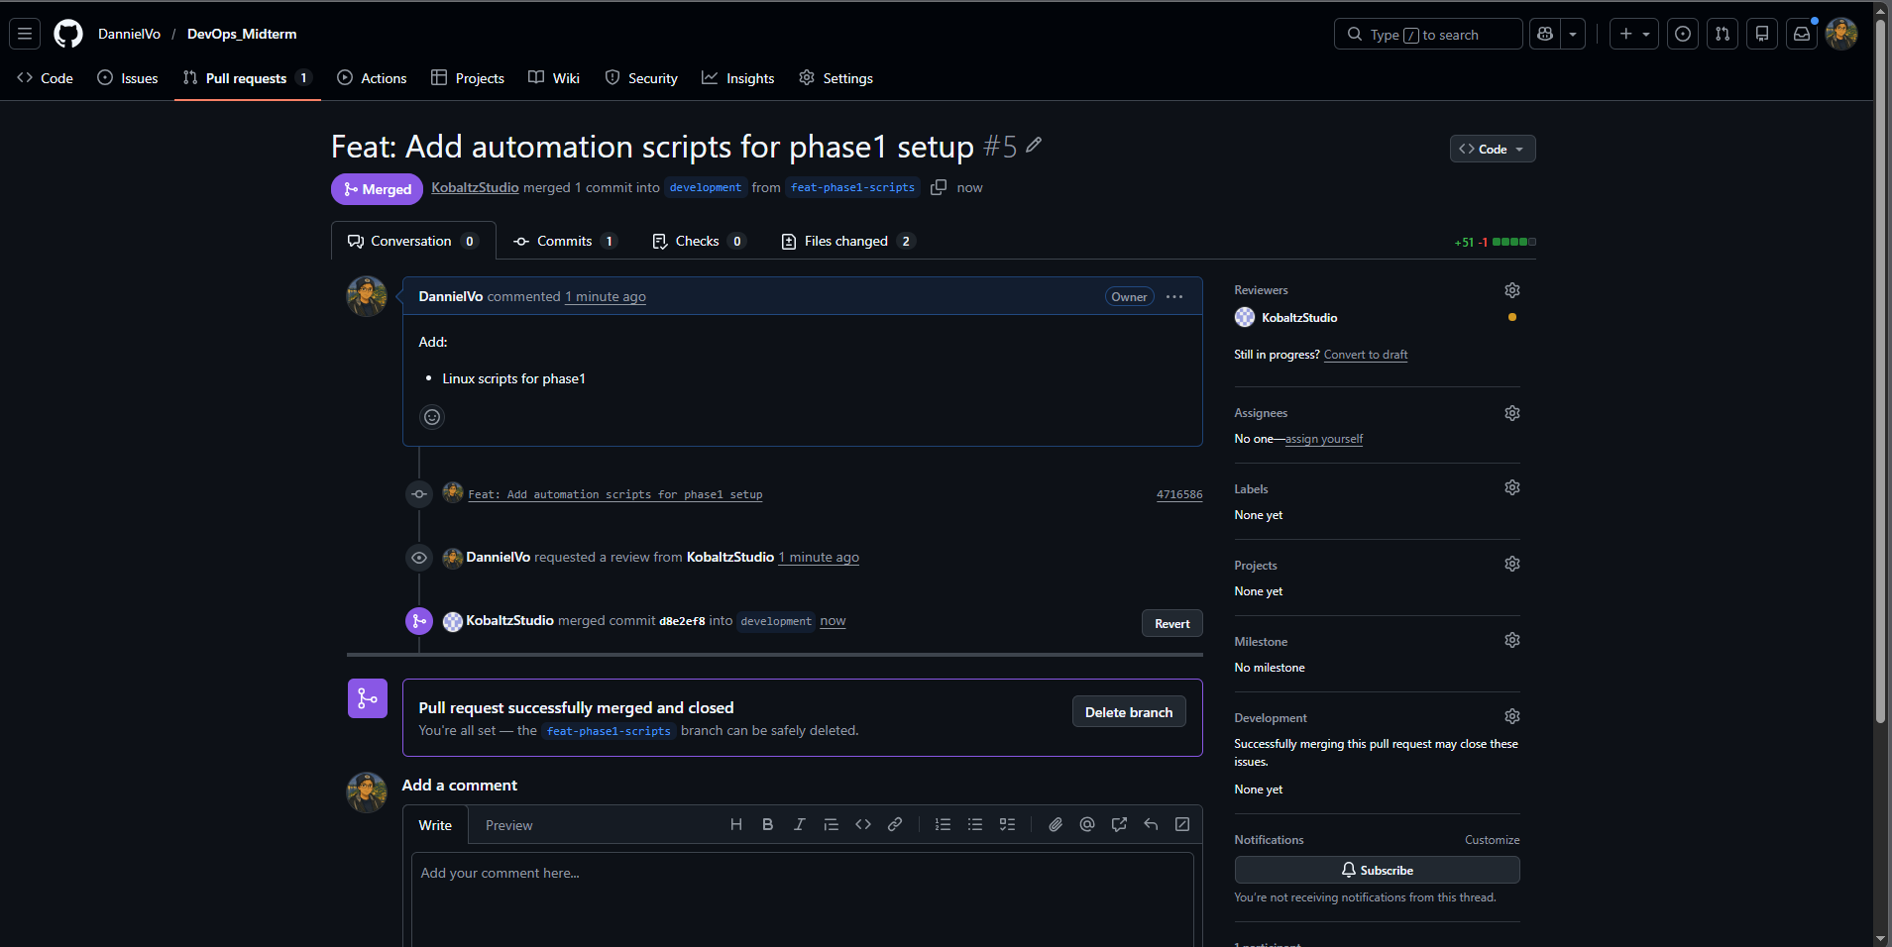
Figure 7. Pull request from feat-phase1-scripts to development

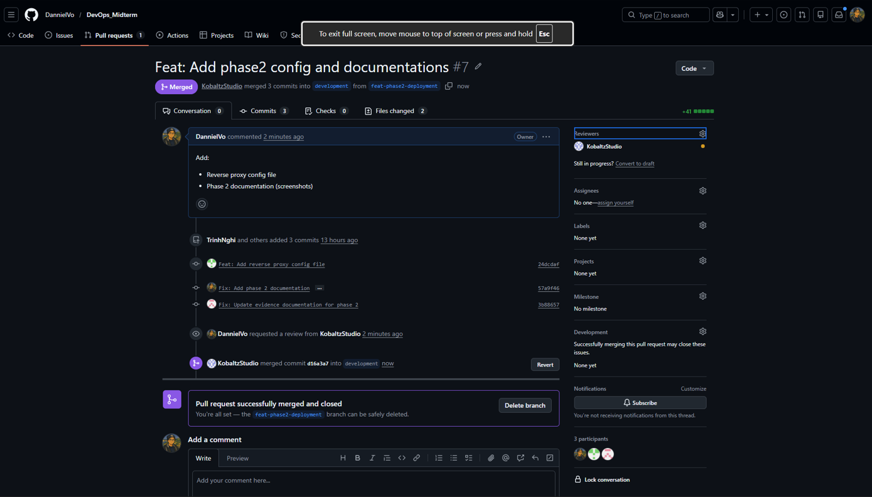
Figure 8. Pull request from feat-phase2-deployment to development

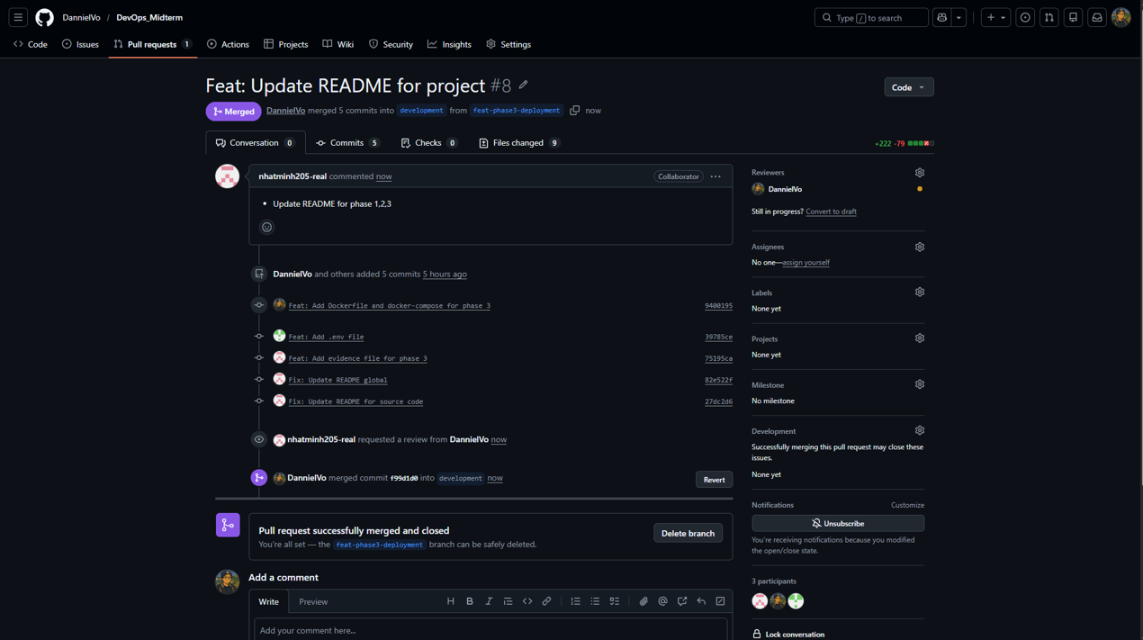
Figure 9. Pull request from feat-phase3-deployment to development
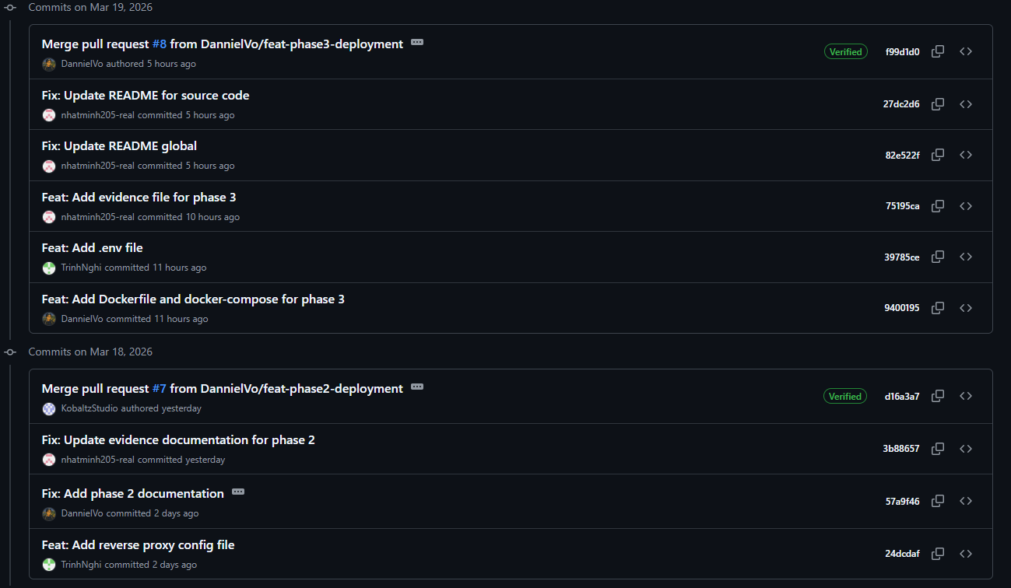
Figure 10. Commit histories of branch development

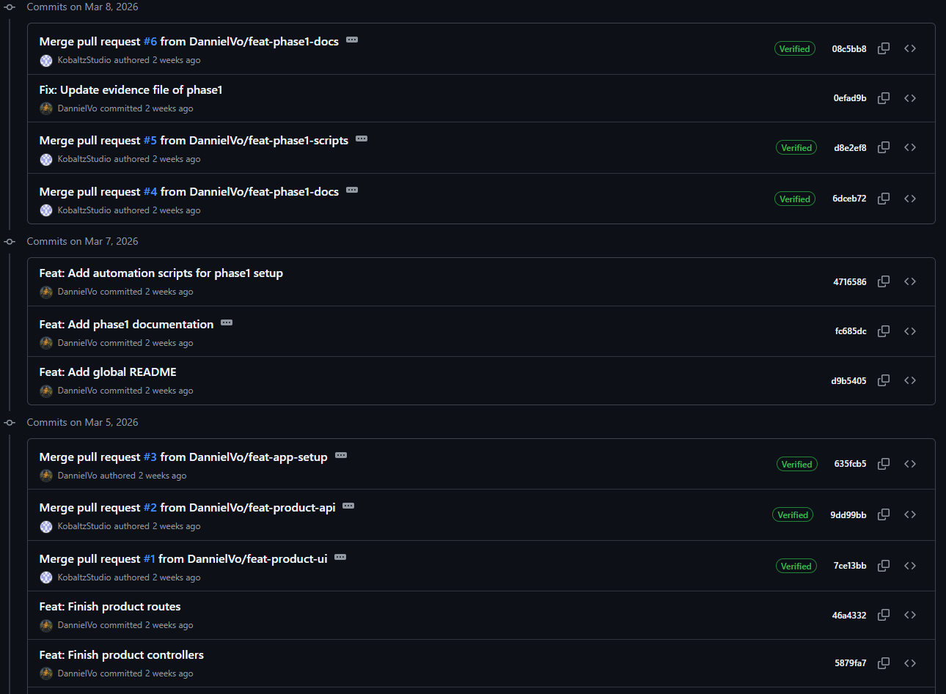
Figure 11. Commit histories of branch development (continue)

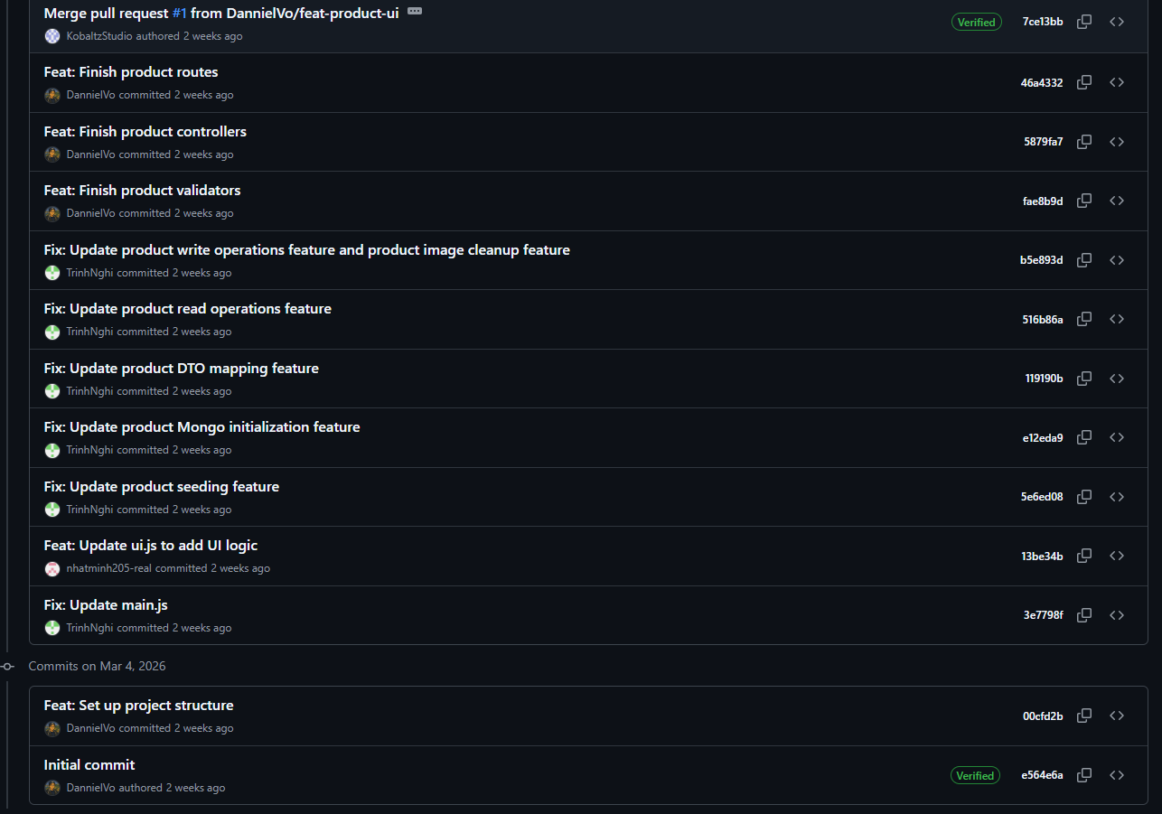
Figure 12. Commit histories of branch development (continue)

