**Part 3:**

Answer the following questions.

What is GitHub?

* It is a web-based open-source repository hosting service using Git. It provides access control and several collaboration feature such as bug tracking, feature requests, task management for every project.

When was it created?

* Github was created on Feb 8, 2008.

Why? By who?

* Github was created by Tom Preston-Werner, Chris Wanstrath, P. J. Hyett, Scott Chacon.

What similar platforms exist?

* Other similar platforms are GitLab, Beanstalk, SourceForge, Launchpad, Gitea, Gogs.

Why would you use such a platform?

* Such platforms allows the code to be reviewed by the community.
* The coder can collaborate and track changes in the code across different versions.
* As platforms like GitHub are a repository, it allows the users work to be reachable to the public.

**Part -4 (Tutorial Screen shots.)**

Level 1 code (To Commit): -

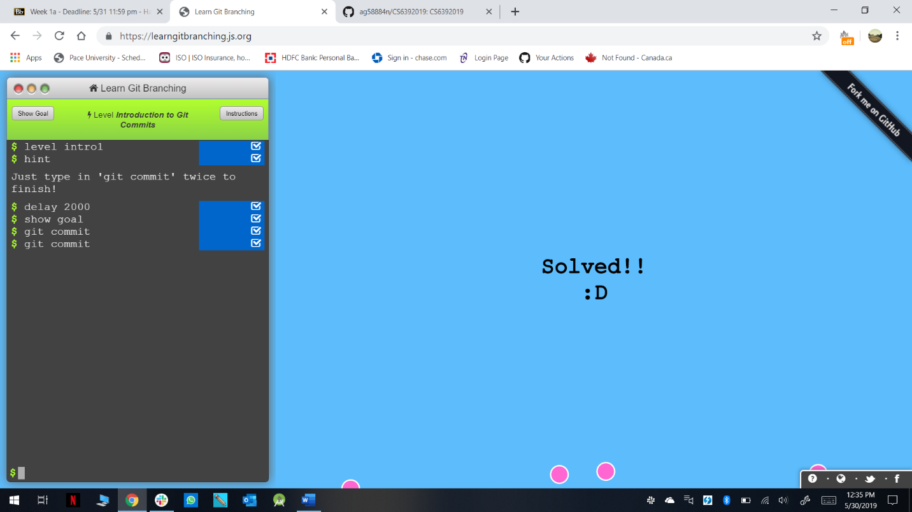

Level 2 code (Branching): -

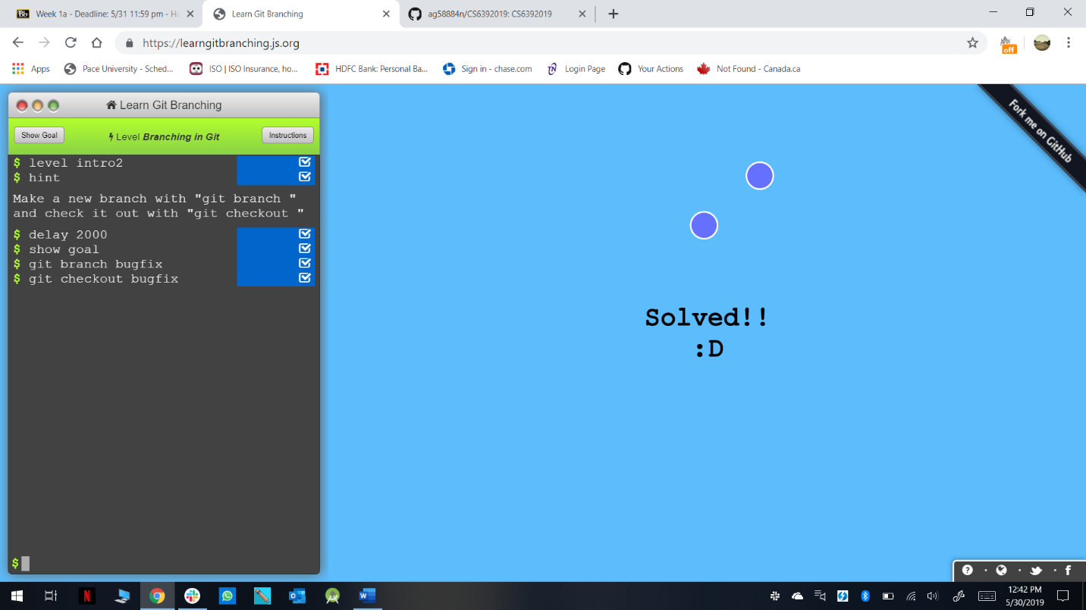

Level 3 code (Merging in Git): -

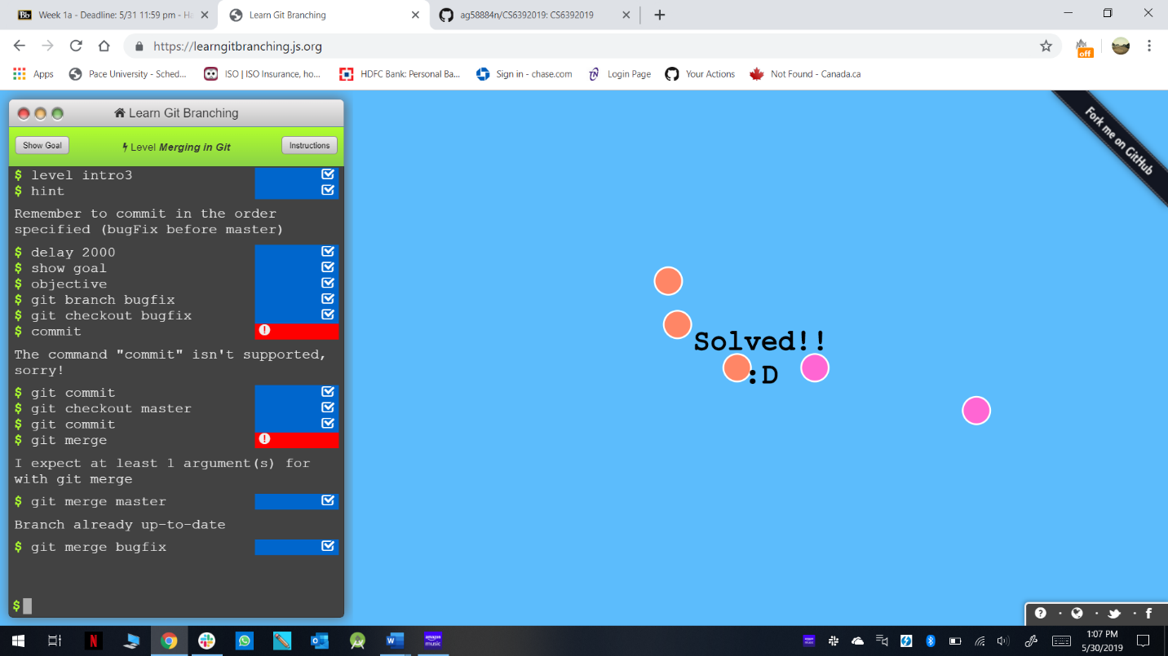

Level 4(Rebase Introduction): -

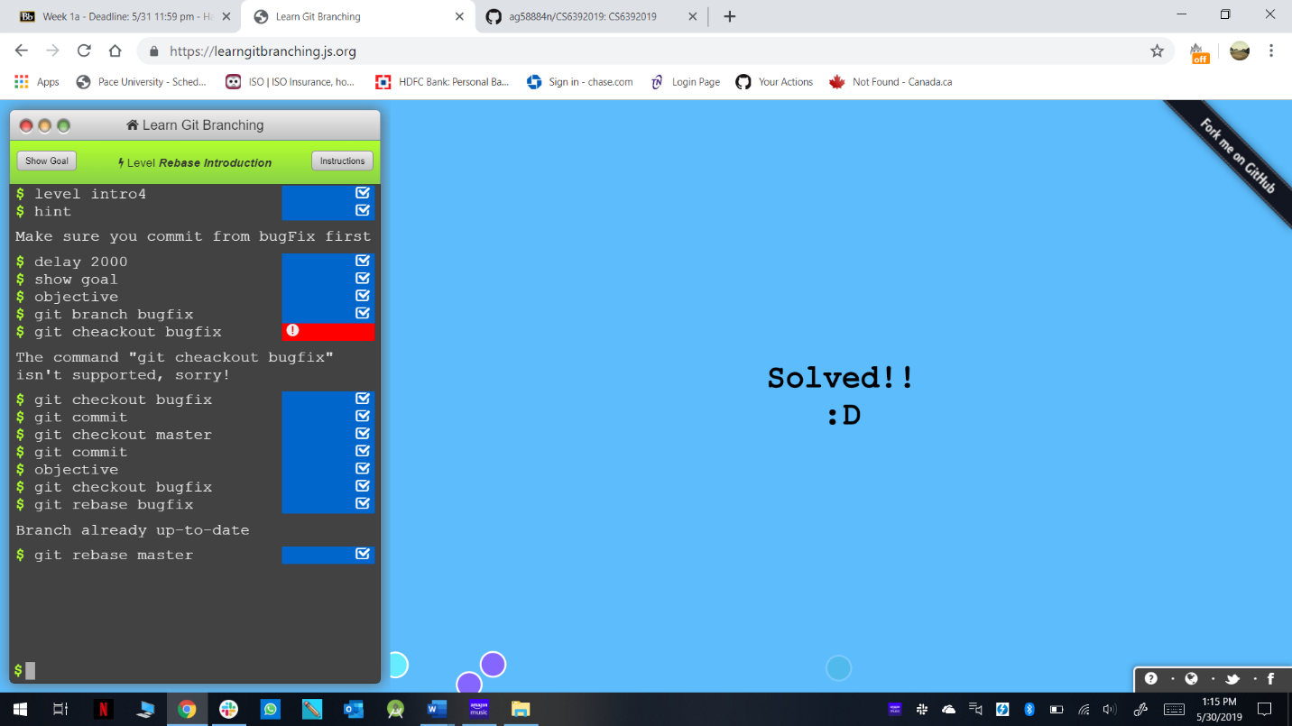

Level 5(Moving Around): -

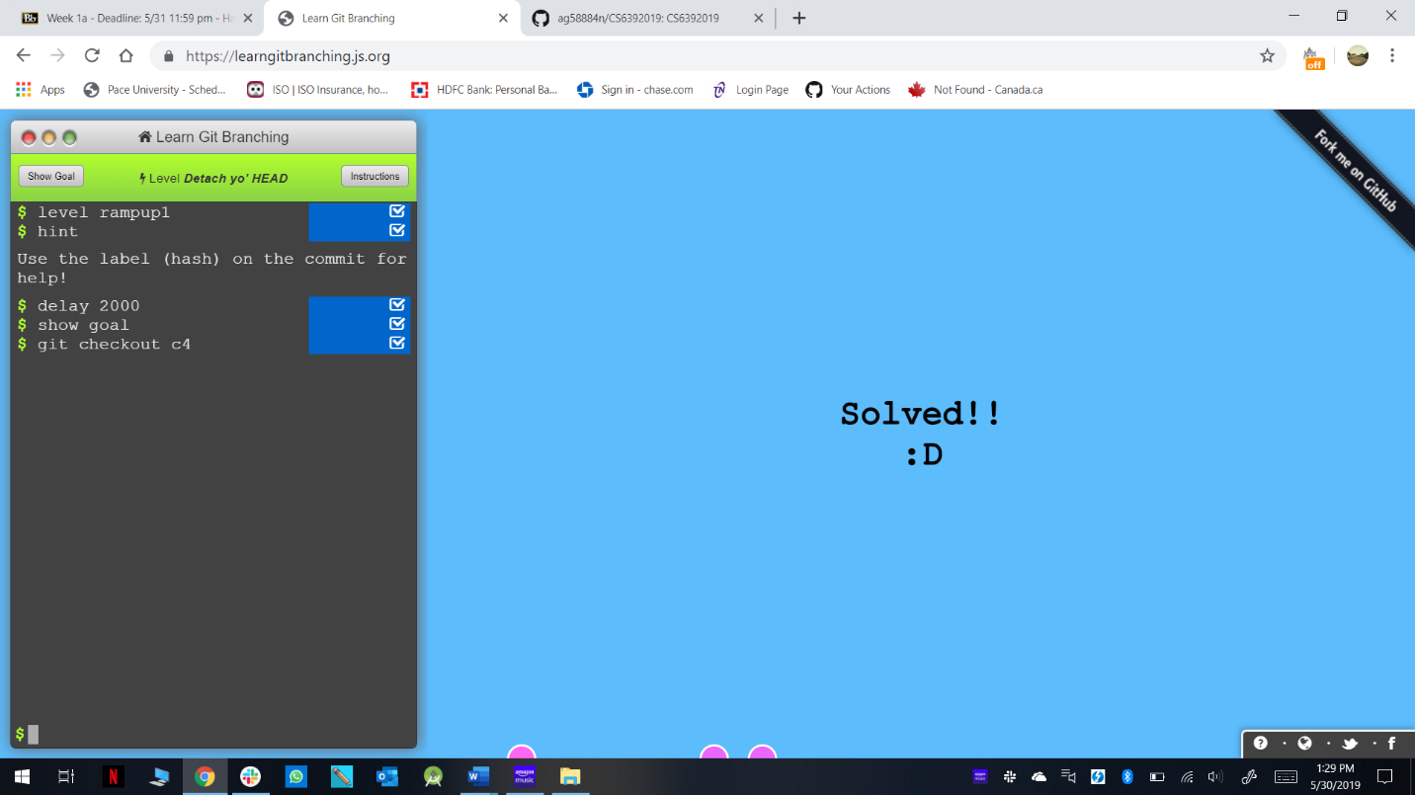

Level 6(Relative Reference): -

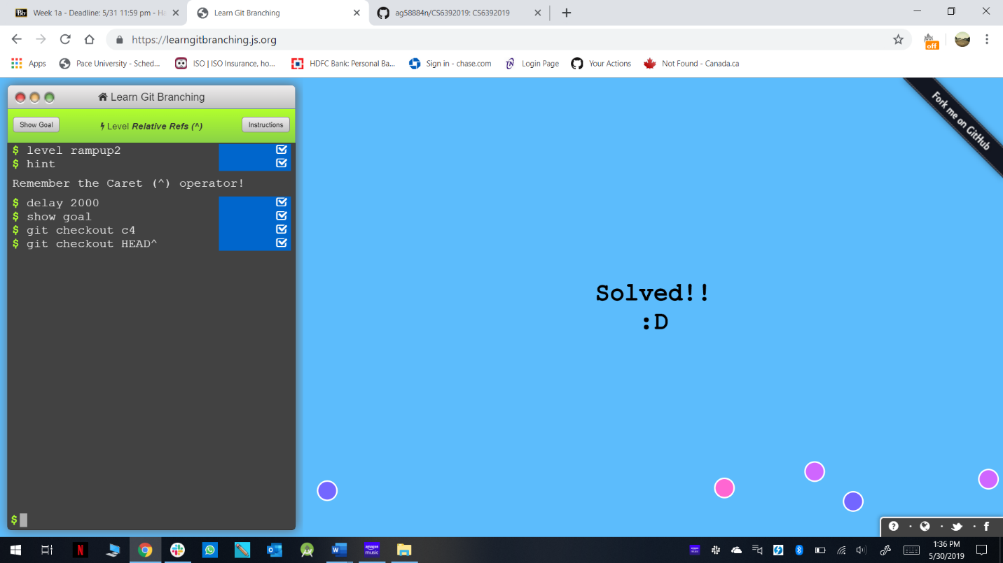

Level 7(Relative Reference-2): -

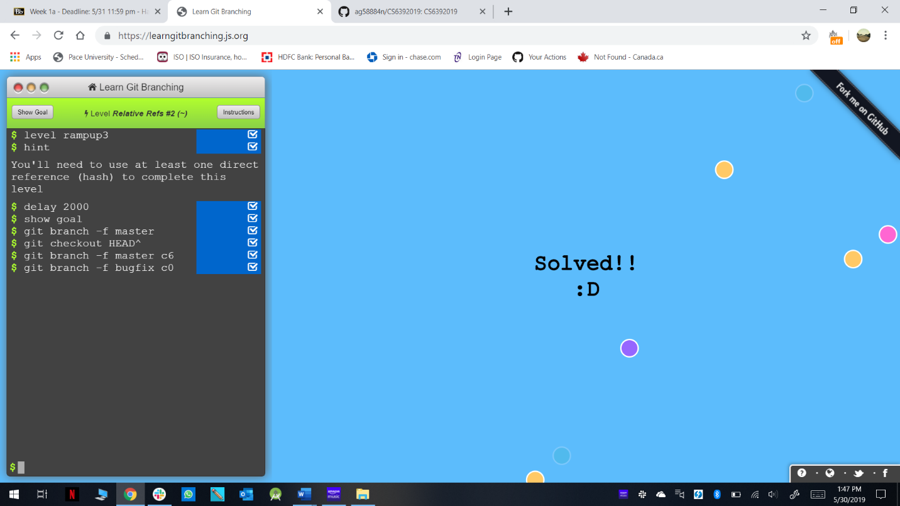

Level 8(Reversing Changes in Git): -

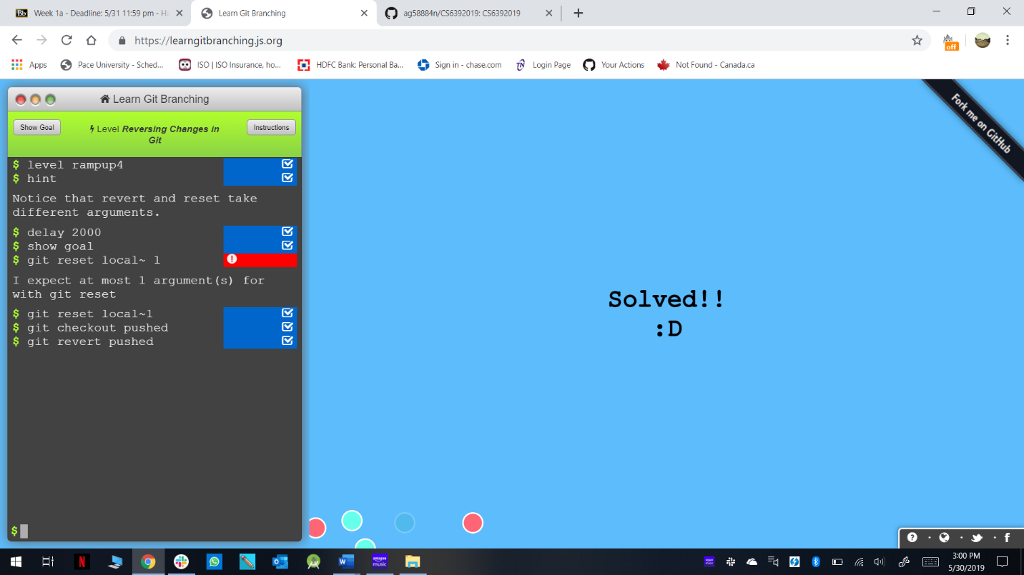

Level 9(Cherry-pick Intro): -

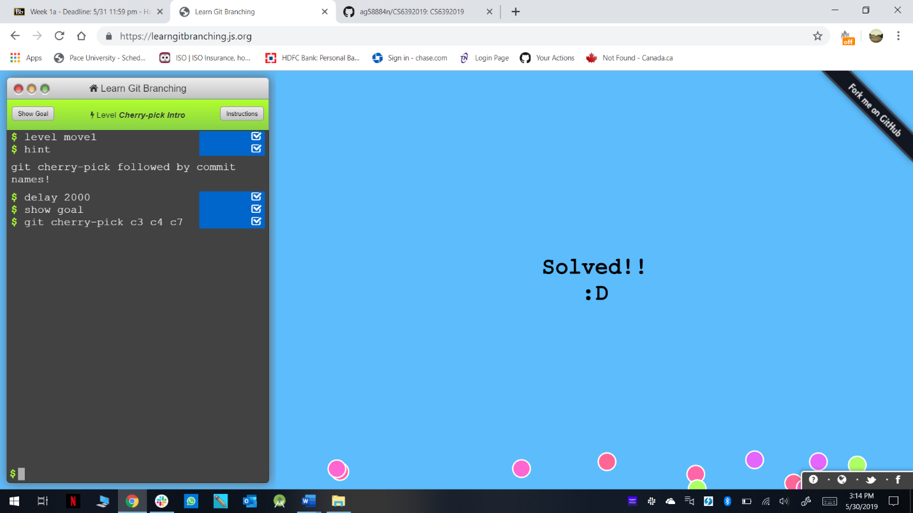

Level 10(Interactive Rebase Intro): -

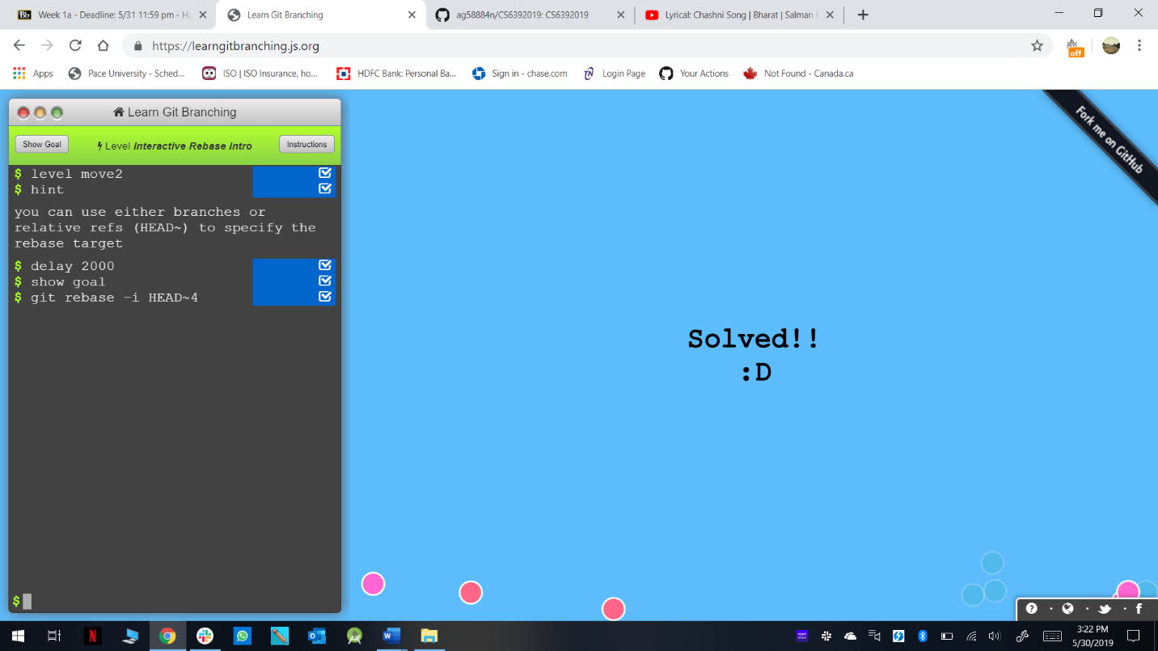

Level 11(Grabbing Just 1 Commit): -

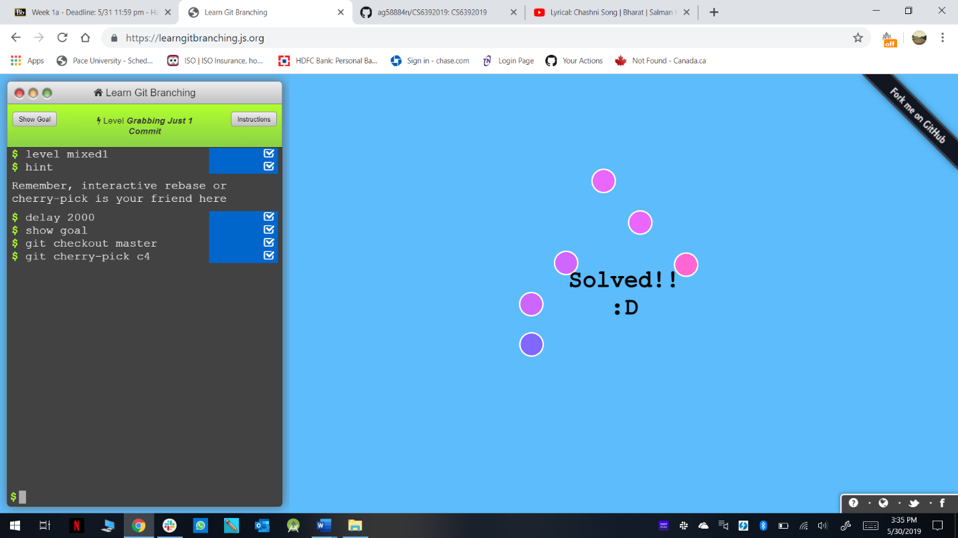

Level 12(Juggling Commits): -

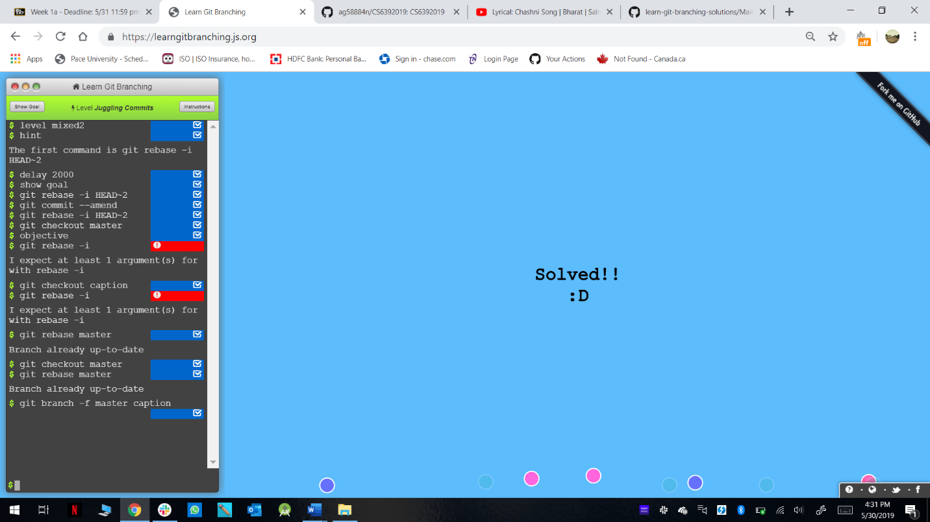

Level 13(Juggling Commits-2): -

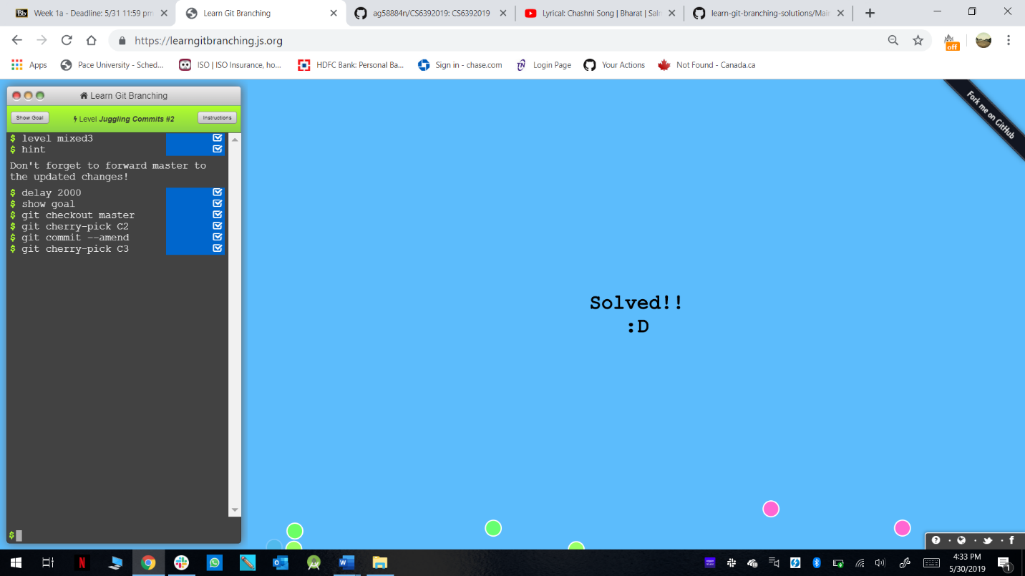

Level 14(Git Tags): -

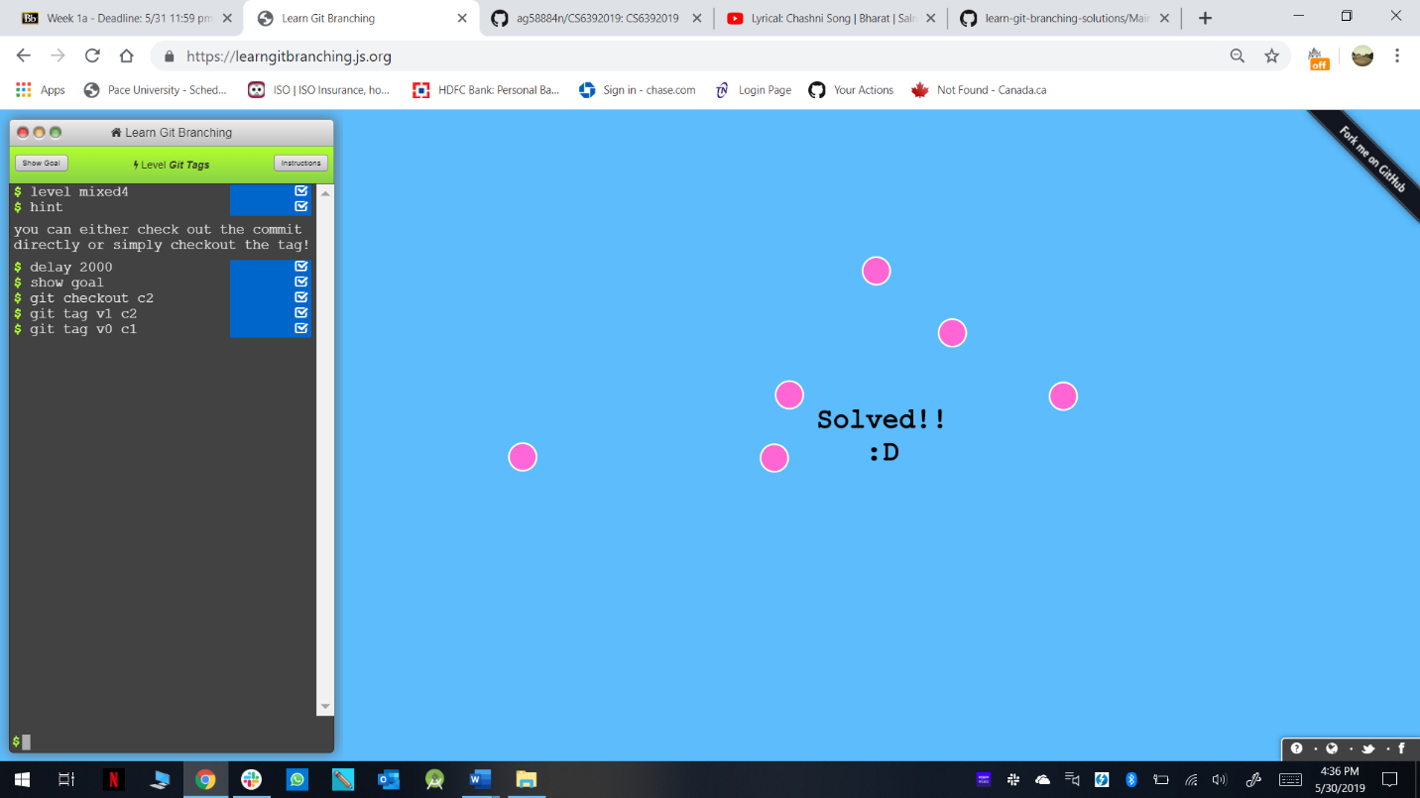

Level 15(Git Describe): -

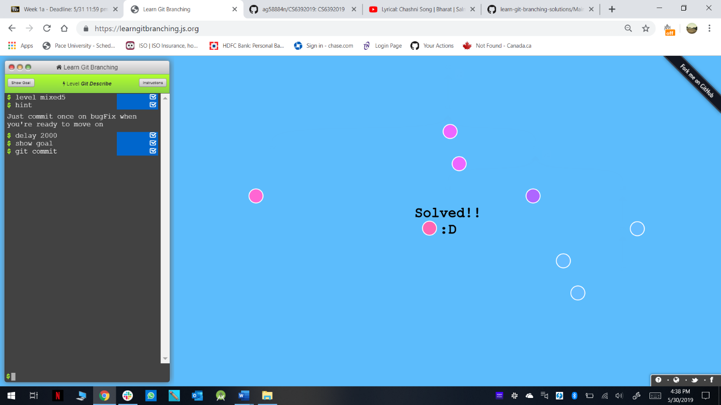

Level 16(Rebasing over 9000 times): -

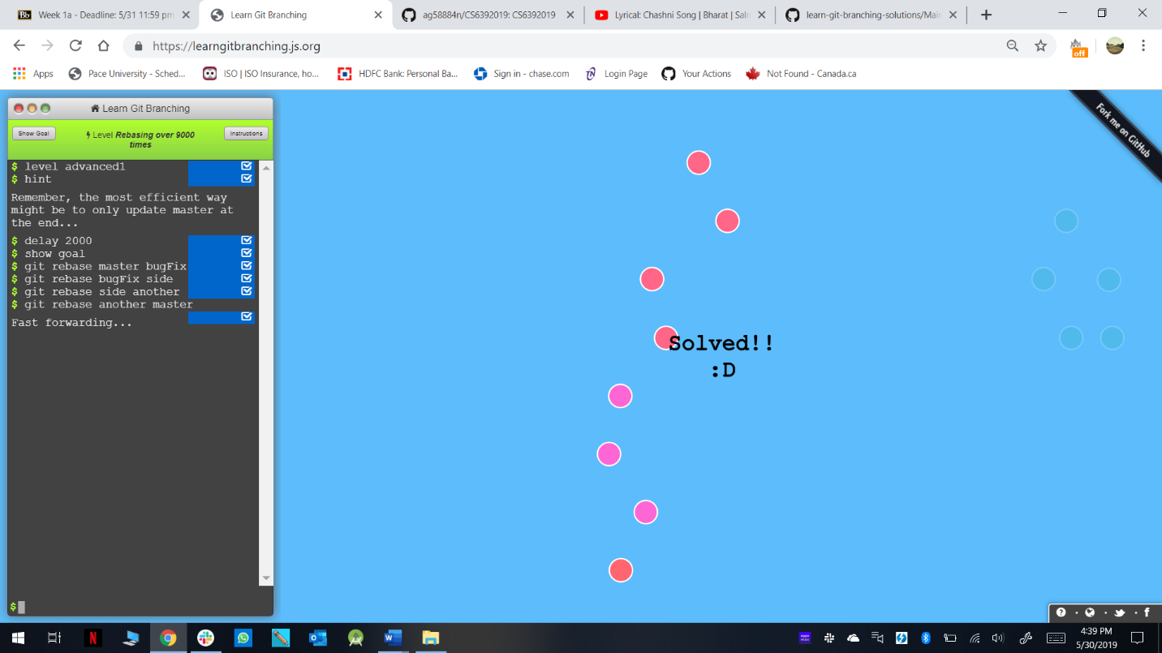

Level 17(Multiple Parents): -

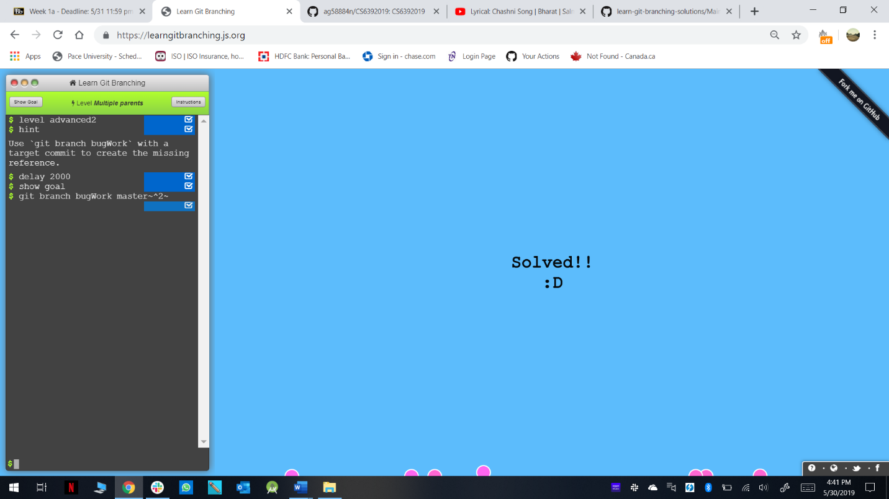

Level 18(Branch Spaghetti): -

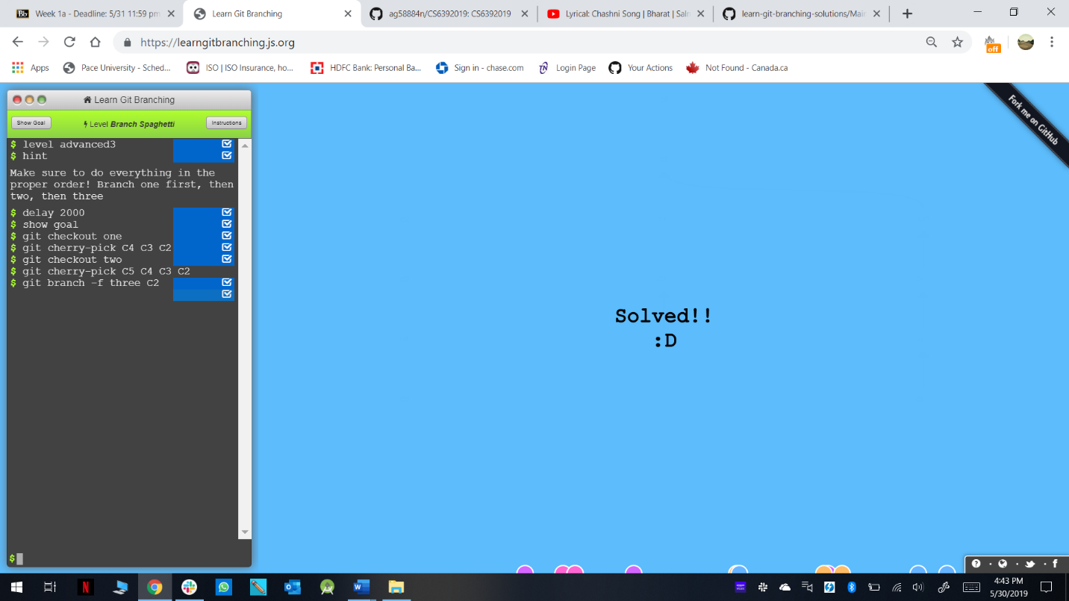

Final List: -

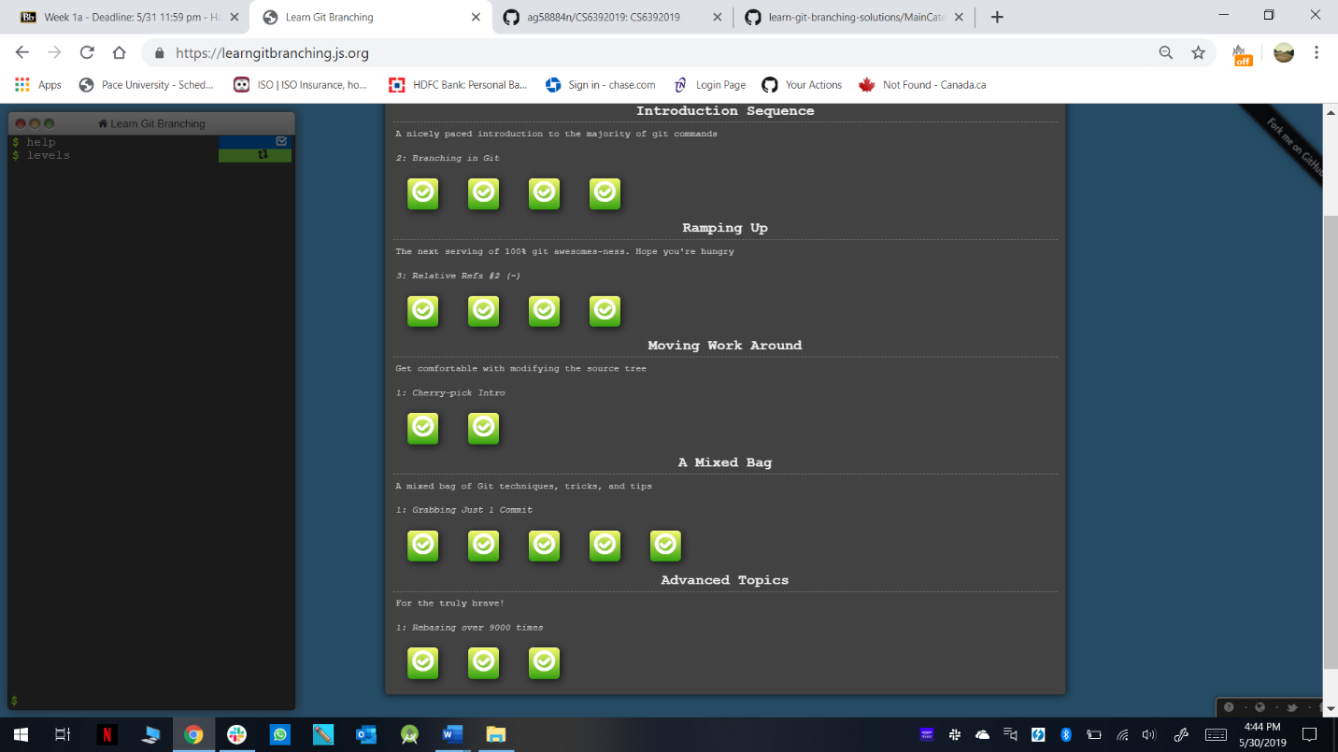

**Part 5:**

Define the following terms in the context of Git (2 lines maximum):

* Repository: - A directory or storage space where projects can live. It can be a folder on computer, or it can be a storage space on GitHub or another online host. Files such as code files, text files, image files, etc can be stored in repository.
* Commit: - This is the command that gives Git the power. When you Commit, you are taking a snapshot of repository at that point in time, giving a checkpoint to which, you can reevaluate or restore projects to any previous date.
* Push: - Pushing refers to sending your committed changes to a remote repository, such as repository hosted on GitHub. For e.g. if you change something locally, you want to then “push” those changes so that others can access them.
* Branch: - The Branch command lets the user to build timeline of commits, of changes and file additions. It allows working with multiple collaborators.
* Fork: - A fork is a copy of a repository. Forking a repository allows you to freely experiment with changes without affecting the original project.
* Merge: - When you’re done working on a branch, you can merge your changes back to the master branch, which is visible to all collaborators.
* Clone: - Cloning a git repository means that you create a local copy of the code provided by developer. Cloning a repository means that you are downloading a copy of the source code from the source control.
* Pull: - if you are working on a local computer and want the most up-to-date version of your repository to work with, “pull” changes down from GitHub with command git pull.
* Pull request: - Pull request lets you tell others about the changes you have pushed to a branch in a repository on GitHub.