**CS639 SummerI 2019**

**Exercise on GitHub and Git**

**Danni Huang**

**Part 1 :**

GitHub Name: DannnniHuang

GitHub Link: <https://github.com/DannnniHuang>

**Part 3 Answers:**

Answer the following questions.

What is GitHub? When was it created? Why? By who? What similar platforms exist? Why would you use such a platform? (Answer between 5 and 10 lines).

GitHub is a web-based hosting service for version control using Git. It is used for computer code. It offers all of the distributed version control and source code management functionality of Git. GitHub was created in Feb 2008. And it was developed by Chris Wanstrath, P.J.Hyett, Tom Preston-Werner and Scott Chacon. GitLab, Bitbucket, Beanstalk, Launchpad and Sourceforge are the similar platforms. The reason of using such a platform is that it is a free open source software development and distribution platform. It provides an assortment of tools for building and collaborating on software projects in a faster manner.

**Part 4 Answers:**

1. **Introduction to Git Commits**

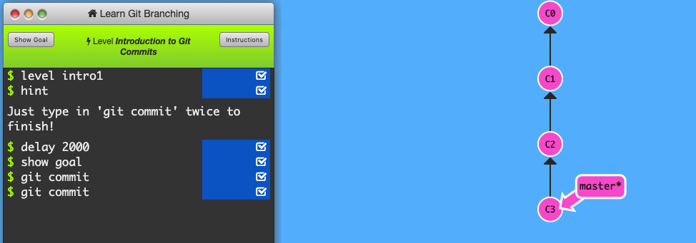

1. **Branching in Git**

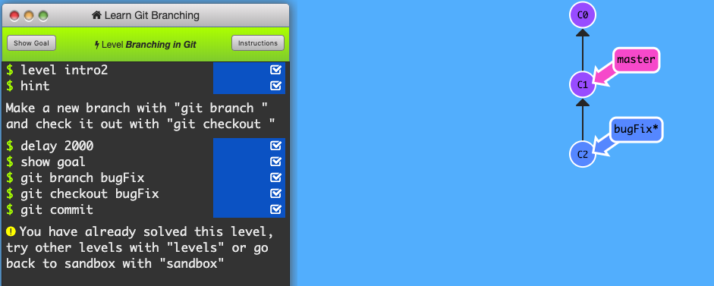

1. **Merging in Git**

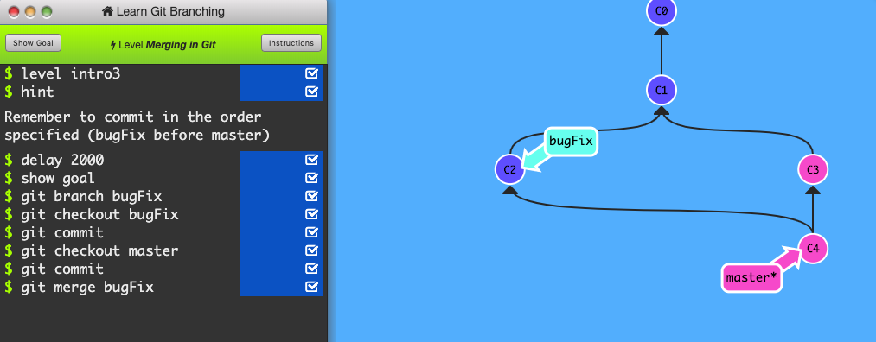

1. **Rebase Introduction**

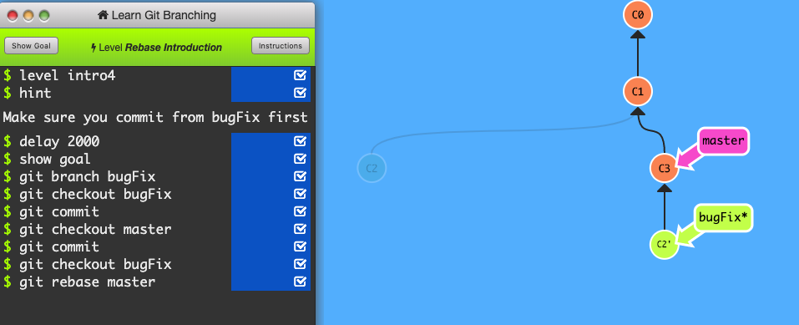

**Part 5 Answers:**

Define the following terms in the context of Git (2 lines maximum):

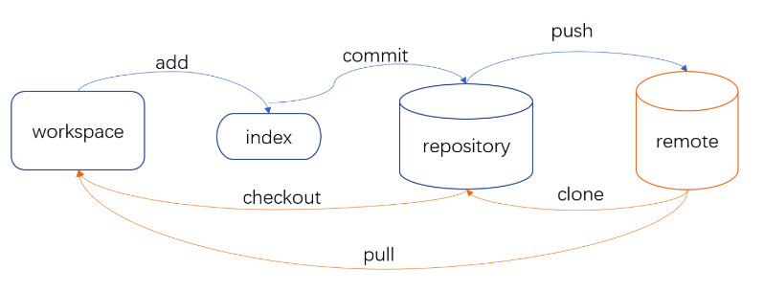

* Repository：It is a central file storage location which can be accessed by multiple users.
* Commit: The command is used to save your changes to the local repository.
* Push: The command is used to upload local repository content to a remote repository.
* Branch: It is simply a lightweight movable pointer to one of these commits.
* Fork: It is a copy of a repository. Forking a repository allows you to freely experiment with changes without affecting the original project.
* Merge: The git merge command lets you take the independent lines of development created by git branch and integrate them into a single branch.
* Clone : The command is used to target an existing repository and create a clone, or copy of the target repository.
* Pull: The command is used for fetch and download content from a remote repository and immediately update the local repository to match that content
* Pull request: It can let you tell others about changes you have pushed to a GitHub repository.

**Part 6 Answers:**

CS6392019 Repository :

<https://github.com/DannnniHuang/CS6392019/tree/master>

**Part 7 Answers:**

Retrieve the README.md file at: <https://github.com/paceuniversity/courses>;

Create a fork in the project and made changes by add HuangDanni, May 30, 2019, 1:41PM;

Created a pull request and submit;

The pull request will be reviewed and merge the pull request to the master branch;

The README.md file will be updated.

The commands and strategy use to push the file in GitHub:

1. $ cd Desktop

#directory to Desktop.

1. $ mkdlr GitHub

#make directory called GitHub on Desktop.

1. $ cd GitHub

#directory to GitHub.

1. $ git clone

#Copy the repository from online GitHub to my desktop.

1. $ git pull origin your-branch

#Update the README file.

1. $ git add

#Adds the file to local repository and stages it for commit.

1. $ git commit –m “HuangDanniGitTutorial-May-30-2019”

#Commits the tracked changes and prepares them to be pushed to a remote repository.

1. $ git push origin your-branch

#Pushes the changes in local repository .

1. Create a Pull Request on GitHub

**Part 8 Answers:**

Add an issue:

<https://github.com/DannnniHuang/CS6392019/issues>

**Part 9 Answers:**

Add the title in wiki:

<https://github.com/DannnniHuang/CS6392019/wiki/CS-639-2019>