

ECE 528/L

Robotics and Embedded Systems with Lab

Project
Load Strain Gauge Motor Control
Due Date: 5/8/2026

Daniel Puga
Instructor: Aaron Nanas
Spring 2026

Introduction:
The purpose of this project is to implement an interface between a load strain gauge sensor and a motor. The design will have an interface between the load strain gauge sensor and FPGA to determine the amount of load being applied to the sensor. The FPGA logic will determine the duty cycle value, based on the load value being read, to control the motor at different speeds. Refer to Figure 1, for design diagram.

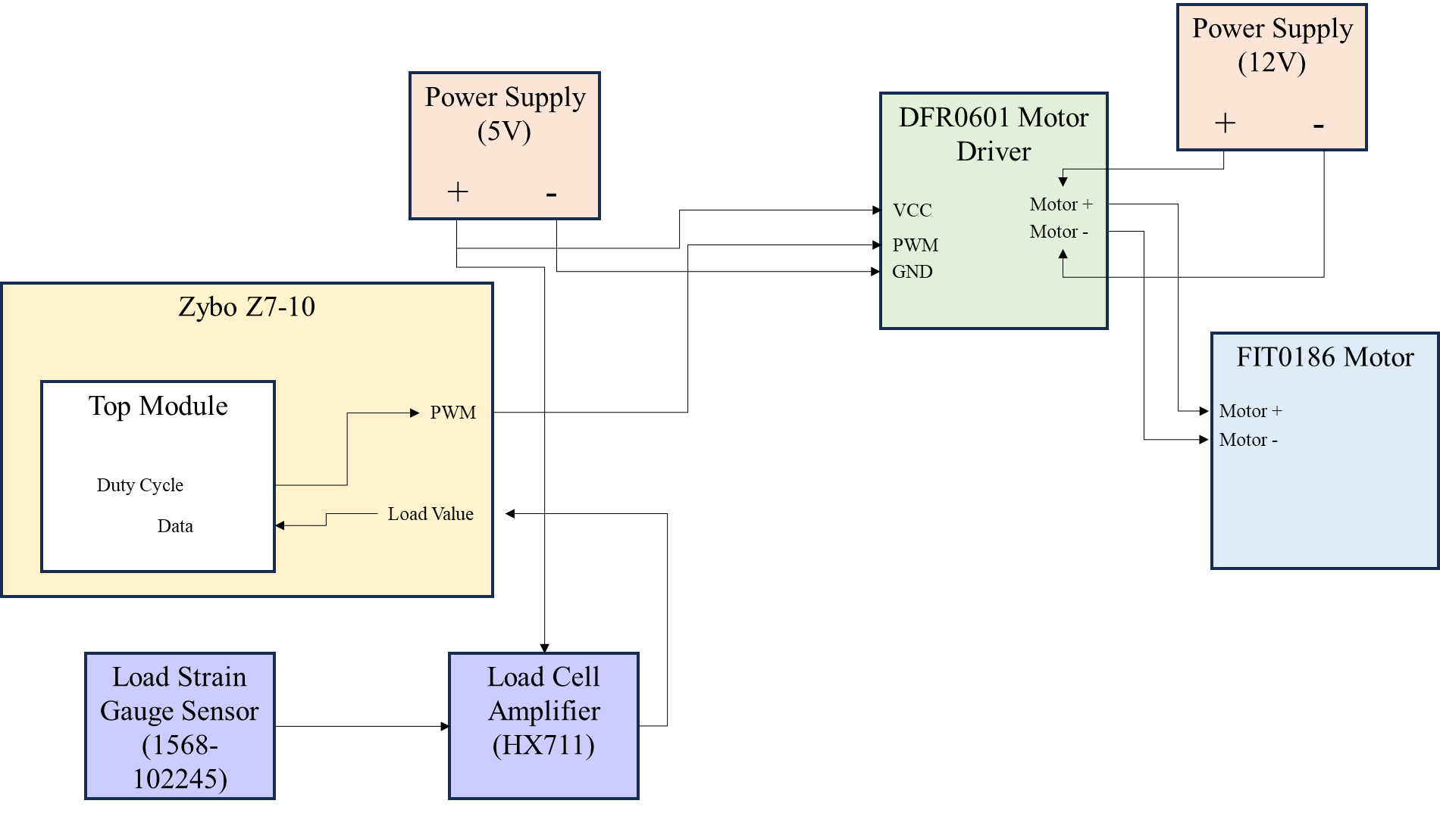
Figure 1 Design Diagram

The load strain gauge sensor has a wheatstone bridge configuration and will output a differential voltage to the Load Cell Amplifier board. The board will then amplify the signal and send the signal to an ADC. The ADC is a HX711 IC component with a serial communication to interface and read the value of the sensor. The serial interface consists of two signals the PD_SCK and DOUT. The FPGA logic has a finite state machine that will wait for the DOUT signal to go low and then send pulses through the PD_SCK to shift the data out of the ADC. Refer to Figure 2, for the Finite State Machine diagram. After 25 pulses the data will be completely shifted out and the state machine will transition back to a state to wait for the DOUT signal to go low. A delay state is implement based on the diagram provide by the ADC datasheet. The low pulse and high pulse states are used to implement the 500 kHz clock needed for the ADC. Refer to Figure 3, for HX711 datasheet’s serial communication.
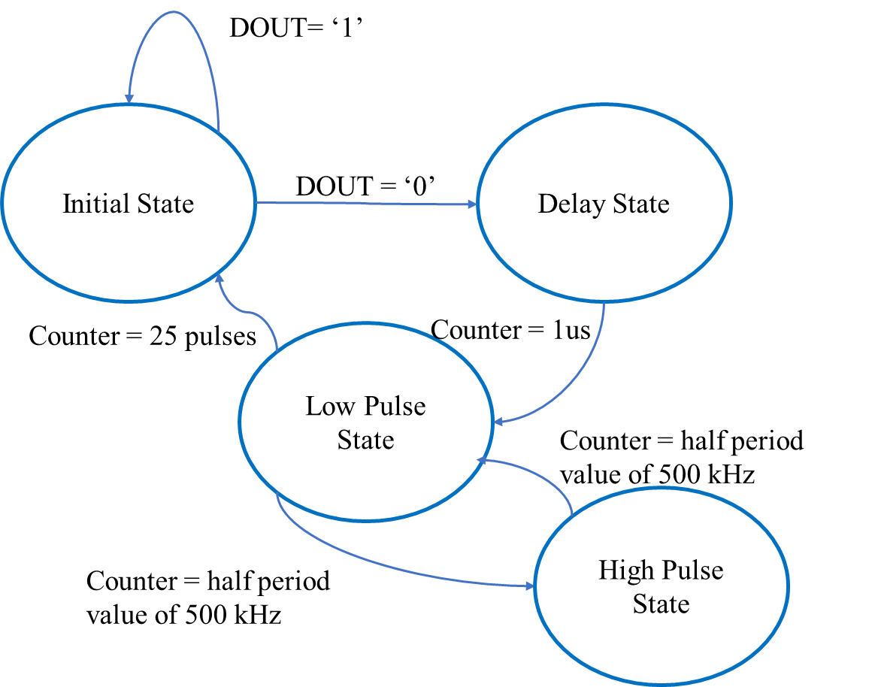
Figure 2 FSM Diagram

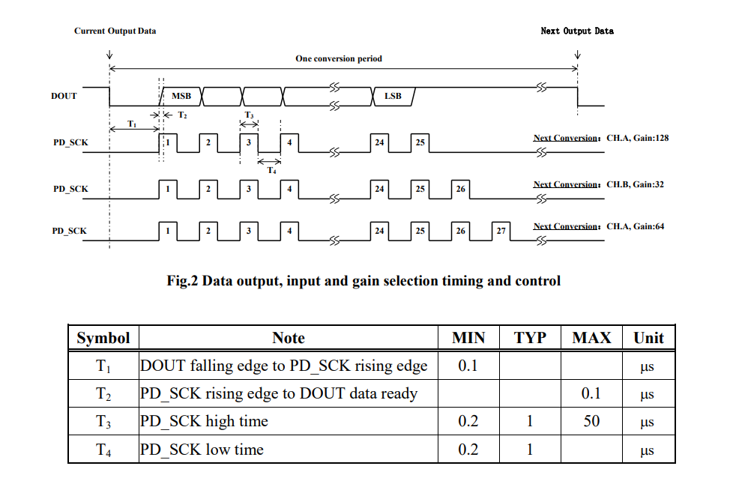
Figure 3 HX711 Serial Communication
After the serial communication between the FPGA and ADC has a read a value. The value will then determine the duty cycle for the PWM signal. The logic will read the load count value and determine within ranges what duty cycle to output between 25%, 50%, and 75%. The duty cycle value is then sent to the PWM module to output a 500 kHz PWM signal. This signal will then be outputted to the motor driver to drive the motor at the speed commanded by the signal value.
The pins used for the FPGA are shown in Table 1. The pins are used to interface between the motor driver board and the load amplifier board.
Table 1 FPGA Pin Description
FPGA Pin | Name
V12 | PWM
+3.3V | VDD
H15 | DAT
V13 | PD_SCK
GND | GND
K17 | CLK

Components Used:
The components used in the lab was Zybo Z7-10 SOC FPGA, 1568-102245 Load Strain Gauge sensor, HX711 Load Cell Amplifier, DFR0601 Motor Driver, and a FIT0186 motor.

Analysis and Results:
The results I achieved while performing this project was the implementation of the ADC FSM logic. I was able to design the FSM to perform the logic provided by the ADC datasheet. I then created a testbench to simulate the DOUT signal sending data and verify the logic. Figure 4 shows the overall simulation results. Figure 5 shows a closer look at the data being shifted out and the state machine transitioning to read the next data packet.

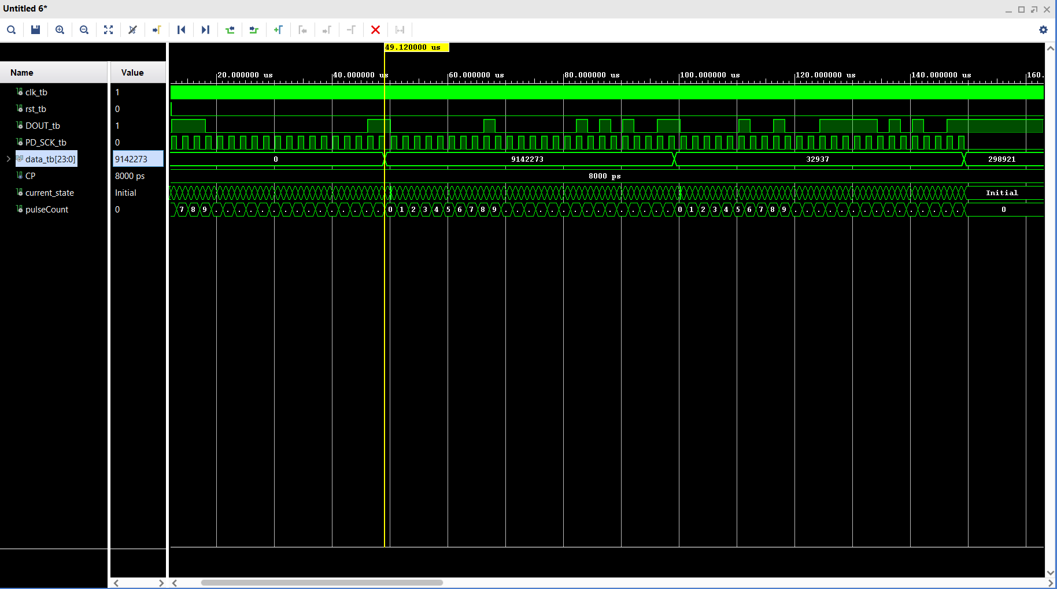
Figure 4 ADC Overall Simulation
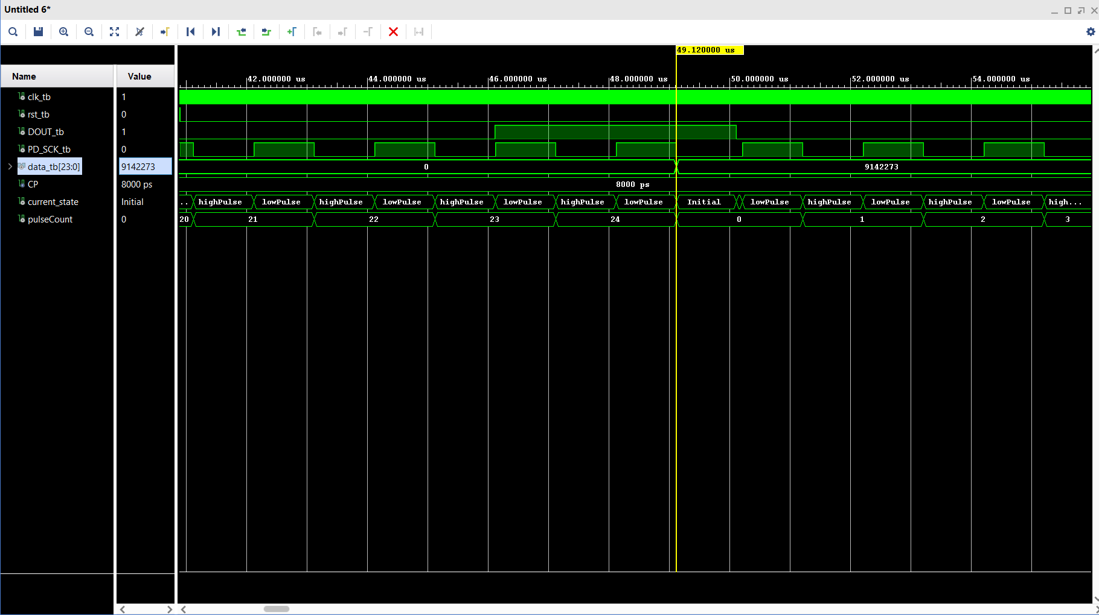
Figure 5 ADC State Transition
After verifying the ADC module, I verified the top module to ensure the PWM and duty cycle logic was implemented correctly. The results for this is shown in Figure 6.
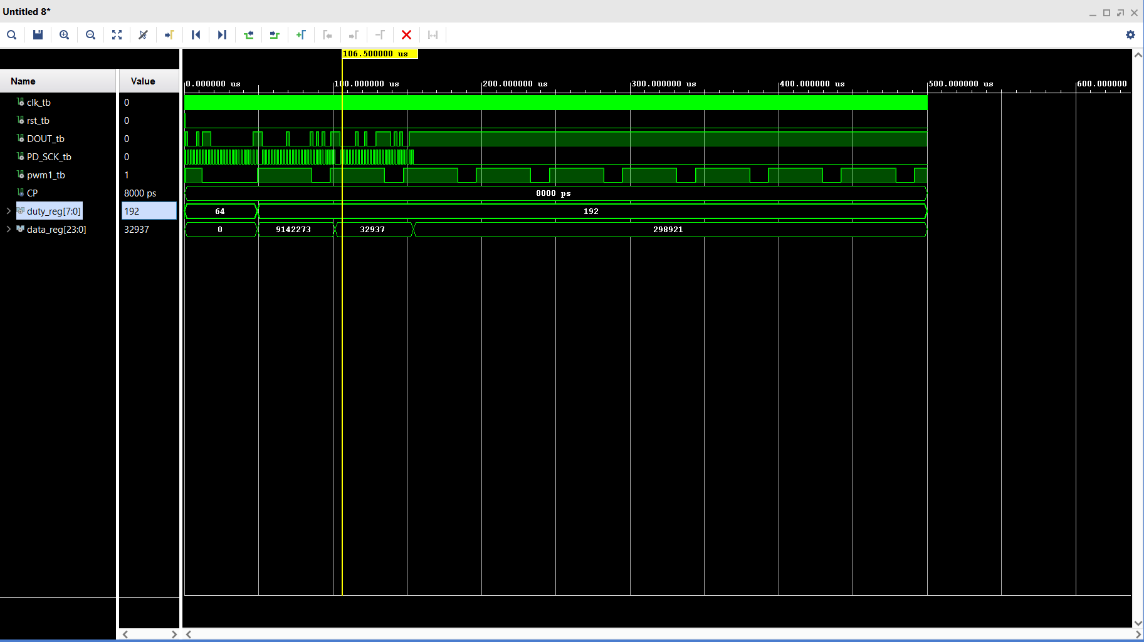
Figure 6 Top Module Simulation

After verifying the firmware implementation, I began to setup the hardware connections. Refer to Figure 7, for the hardware setup. Once the connections were wired I programmed the FPGA to run the logic. The results showed the sensor being pressed and the motor being driven at a lower or higher duty cycle depending on the amount of load being read.

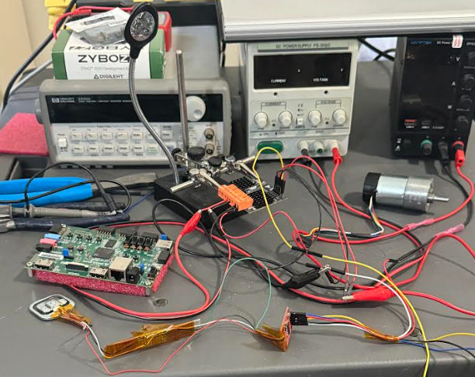
Figure 7 Hardware Setup
Author Contribution:
I contributed to all the tasks for this lab and for the lab report writing process as well.

Conclusion:
The concepts I learned in this project was the implementation of serial communication logic. By determining the frequency and state logic I can create logic to communicate with an ADC chip. I also learned to control duty cycle of a PWM signal that can then be used to drive a motor. Overall this project helped me improve on my Finite State Machine skills to implement control of clock signals and data being shifted from an ADC. These skills can be helpful in determining control of a motor used in various applications to create precise control and simulate feedback from different sensors.

References
- https://mm.digikey.com/Volume0/opasdata/d220001/medias/docus/864/Load_Cell_Amp_HX711_HookupGuide.pdf
- https://cdn.sparkfun.com/assets/b/f/5/a/e/hx711F_EN.pdf
- https://digilent.com/reference/programmable-logic/zybo-z7/start?__cf_chl_tk=FnIjEIdsYphcOEP8PRRqJPGqR0DndaE4oR6BzCgPU5U-1774497152-1.0.1.1-o7kanW2yYK6V37WnRpZVQU34.7h7d2R0aiotLLyNNqc

