Final Report

Table of Contents
Final Report 3
Scope 3
Limitations and Constraints 3
Strategic Recommendations 3
Engagement Narrative 4
Findings 4
Tester Qualifications 5

Final report

Scope
This security review only focused on the FinalProject.cpp program and the two CSV data files. The goal was to look through the code and find any weaknesses or unsafe programming practices that could cause problems or be misused. The review included reading every function inside FinalProject.cpp, checking how it opens files, handles user input, runs threads, changes permissions, and uses system commands. The program was compiled and tested on an Ubuntu Linux virtual machine.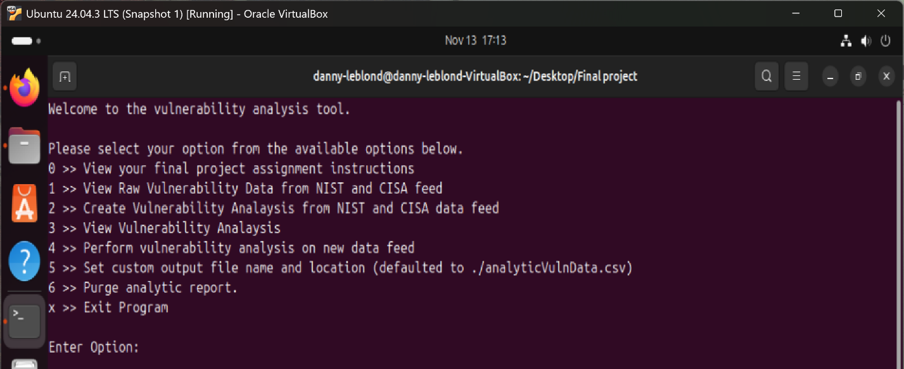
Anything outside this program was not part of the assessment. No outside servers, networks, or real systems were tested. This review assumed the CSV files were normal text files and not harmful. The review did not include performance testing or advanced network testing. Only the code inside FinalProject.cpp and how it behaves in the testing environment were evaluated.

Limitations and Constraints

The review only looked at the FinalProject.cpp code and the two CSV files it uses. No other systems or programs were tested. This was a white-box assessment which means I had full access to the code and was not guessing how it works from the outside.

Vulnerabilities/ Executive Summary
- Vulnerability: Uninitialized Variable
Code lines: 92, 109-110
Risk: Moderate
Theme: Bad input handling
Takeaway: The program uses a variable before giving it a real value. This can make the program act randomly or crash.
int result; // not set yet

while(result != EOF) // used before its set set
{
result = fscanf(...);
}

- Vulnerability: Unsafe String Handling (Missing Null Terminator)
Code lines: 94–96, 118–119
Risk: Moderate
Theme: Unsafe memory use
Takeaway: The program copies text into a small buffer but doesn’t end the string the right way. This can make the program read past memory.
strncpy(firstThreeChars, str, 3); // may not end with '\0'
strcmp(cve, firstThreeChars);

- Vulnerability: File Not Closed
Code lines: 99–131
Risk: low
Theme: Poor resource management
Takeaway: The program opens a file but never closes it.

fileHandle = fopen(...); // opened
// no fclose() anywhere
- Vulnerability: Buffer Overflow in Menu Input
Code lines: 467–480
Risk: High
Theme: Unsafe user input
Takeaway: The program reads user input into a tiny 2-character space. If the user types more than one character, it can overflow.

char menuOptionAsChar[2];
cin >> menuOptionAsChar;

- Vulnerability: Data Race on Global cvssAnalysis
Code lines: 30, 297–312 + analyze functions
Risk: High
Theme: Bad multithreading
Takeaway: Multiple threads change the same global variable at the same time. This makes the output messy or broken because they step on each other
string cvssAnalysis; // shared by all threads
cvssAnalysis += "..."; // edited by many threads at once

- Vulnerability: Threading Design Flaw (No Real Parallel Work)
Code lines: 359–412, 500–506
Risk: low
Theme: Inefficient threading
Takeaway: A lock stops all threads from running at the same time. This defeats the whole point of threading and slows everything down.
threadAccessController.lock();
- Vulnerability: Variadic Function Misuse
Code lines: 315–340, 444
Risk: High
Theme: Unsafe function handling
Takeaway: The program expects two messages but sometimes only gets one. Also, va_end is never called. This can cause crashes.
endMessage = va_arg(args, const char*);
startMessage = va_arg(args, const char*);
progressBar(1,"File Purge Completed");
- Vulnerability: Weak Privilege Management
Code lines: 372–380
Risk: Moderate
Theme: Poor permission handling
Takeaway: The program changes user permissions but never checks if it actually worked. This can cause dangerous behavior if the program is running with wrong permissions.
seteuid(getuid()); // no error check
seteuid(previousEUID); // no error check

- Vulnerability: Command Injection
Code lines: 349–353, 438–441
Risk: Critical
Theme: Dangerous OS command use
Takeaway: The program lets the user control part of a command that gets sent to the system shell. This can let someone run harmful commands on the computer.
getline(cin, directoryPathAnalyticReport); // user input
system(("rm " + directoryPathAnalyticReport).c_str());
- Vulnerability: Overly Permissive File Permissions
Code lines: 438
Risk: high
Theme: Unsafe file permissions
Takeaway: Giving a file 777 permissions means anyone on the system can read, write, or run it.
permissionChangeCommand = "chmod 777 " + directoryPathAnalyticReport;
- Vulnerability: Uninitialized Variable Used in Condition
Code lines: 417, 445–448
Risk: Moderate
Theme: error handling
Takeaway: The program checks the value of a variable that was never set, so the decision is made using random data.
int status; // never set
if(status == -1) // randomness

- Vulnerability: system("clear") Use
Code lines: 35–36
Risk: Low
Theme: Unsafe OS function
Takeaway: Using system("clear") is not recommended because system calls can be risky and slower than safer alternatives.
system("clear");
- Vulnerability: Missing Input Validation on fscanf
Code lines: 110–117
Risk: Low → Moderate
Theme: Poor input validation / Weak error checking

Executive takeaway: The program reads CSV data using fscanf but does not fully check for errors or bad input. If the CSV file bad, the program may skip data and could make incomplete results.
result = fscanf(fileHandle, "%1023[^,\n]", str);
if(result == 0)
{
result = fscanf(fileHandle, "%*c");
}

Strategic Recommendations
To improve the security for this program, couple things should be done. First the code should not have bad system calls and use safer functions instead. The program should also include stronger input checks so it can handle bad or unexpected data without problems. File handling, threading, and permission changes should be done more carefully to prevent mistakes or misuse. Also the program should use clear and consistent error checking so problems can be found quickly.
The very first thing to fix is the command injection issue because it is the most dangerous problem in the whole program. This bug allows the user’s input to be added directly into a system command, which means an attacker could type extra commands that the computer will run. This could let someone delete files, steal data, or even take over the whole system. Because the attack is easy to do and can cause instant damage, it must be fixed first. Next the buffer overflow and the unsafe variadic function should be fixed since they can cause crashes. While these issues are serious, they are still less dangerous than the command injection problem. A buffer overflow can break the program or allow memory corruption but it has more guessing or specific input to exploit. The unsafe variadic function can also read the wrong data and cause crashes, but it does not give an attacker full control of the system like command injection does. These problems are still important to fix quickly, but they do not pose the same problem of system takeover risk. After those are fixed, the program should focus on the data race in the global variable and the unsafe file permissions. Once the big dangers things are taken care of, the remaining issues like uninitialized variables, weak input checks, and small mistakes should be fixed to make the program run better.

Engagement Narrative
For this review, I put all the project files into my Ubuntu virtual machine and compiled the program using the g++ command. After the program was running, I went through each menu option to see how the program handled input, files, and user actions. I also opened the C++ file and read through the code line by line to see how it worked. While testing I looked for unsafe parts of the code, like system commands, memory stuff, and problems with threads. I also checked how the program opened files, changed permissions, and handled the data from the CSV files. As I found problems, I wrote down the line numbers and the problem.

Tester Qualifications
The skills that i have that qualify me to make this report are, I am a senior in the Secure Software Development bachelor’s program at Red Rocks Community College, where I have learned how to find and fix security problems in code. My classes have included Secure Coding, Secure Software Development in C/C++, Software Security Testing, Secure Code Vulnerabilities I and II, and Network and Database Security. In these classes, I learned things like memory safety, input checks, threading problems, file I/O, POSIX basics, and privilege management, and all of that connects directly to this project.
For this project, I went line by line through the code many times, focusing on one type of issue at a time until I felt I found everything related to that category. I looked at each part if found and wrote done the problem as I went through and then I fixed problems directly in the source code, which helped me understand exactly how each vulnerability worked and make sure the fix actually solved it.

