TEAM DERP

Black Hole Down

Team Members:

Danny Martins – 100830563 - Danny_Martins50@hotmail.com

Jack Wiebe - 100325674 – [jack.b.wiebe@gmail.com](mailto:jack.b.wiebe@gmail.com)

Nikolas Niemczak – 101001850 – [nikolasniemczak@gmail.com](mailto:nikolasniemczak@gmail.com)

Timothy Fernado – 101025928 – [timothy.fernado@georgebrown.ca](mailto:timothy.fernado@georgebrown.ca)

Anselmo Rodrigues – 1007926690 – selmoro@hotmail.com

Genre: Retro Arcade 2D Party Game

Setting and Ascetics:

The game will have a sci-fi retro look with mild space themes. Lots of glow and neon looks. Bloom effects, particle effects and other visual tricks to augment the otherwise simple looks, virtually no animations other than simple rotations and translations. Almost everything in the game is a primitive.

High Concept

Black Hole Down is a retro 2d space game where players compete in various game modes. The main idea of the game is you pilot a small primitively shaped ship where the only movement controls are tilt left / right and adding thrust in the direction your ship is facing. The player must maintain fuel levels while trying to avoid all outer walls. Players are free to hit each other (without death) but will cause them to ricochet off each other, making staying in control harder. A player hitting any of the outer walls results in death. Players must keep track of their fuel gages. Fuel will deplete while applying thrust anywhere outside of a circle. After running out of fuel that player can no longer thrust and will inevitably fall and die due to gravity. (Game modes are in table 1) Fuel is replenished while inside the circle. There are items that appear throughout the level. These items spawn at “n” second intervals and can be picked up by any player. Items are stored and used on player button press anytime the player likes. All items are single use. Refer to item chart for details on items (Table 3). Players can choose between a few different classes (or ship types) players can select the same ships as other players. Refer to ship chart for details on ship types(table 2). Each ship has its own unique ability some are passive and some are active.

Game Modes (Table 1)

|  |  |  |
| --- | --- | --- |
| Name | Player Count | Description |
| Standard (Danny) | 2-4 | Items spawn at some interval of time. Collision with outer walls results in death. Collision with other players results in standard physics interaction. Safety circles spawn at random positions within the map. Players within the circle regain fuel and do not use fuel while in the circle. The circle lasts for only a few seconds then is removed and after a small delay is re-spawned in another position. On every re-spawn the circle’s scale is lowered. The smallest the circle can be is about the size of the player. The round ends when one player is left standing. |
| Ping-Pong (Danny) (Omitted) | 2-4 | Same as standard but the circle moves constantly and never respawns. Upon the circle hitting a wall it changes direction and increases speed. Items spawn and a higher rate as well. |
| Attrition (Danny) | 2-4 | There is only one giant circle that constantly shrinks. No random item spawns. Items are given to all players every “n” seconds. If a player is knocked out of the circle they get stuck and can no longer thrust but can still rotate. These players still get items at the same interval and can use them to influence the players still active in the circle. NO GRAPPLING HOOKS |

Classes (ship types) (Table 2)

|  |  |
| --- | --- |
| Name | Perk |
| Hammer Head (Nick) (Done) | (Shaped like a T) (Passive) Has more mass and a “battering ram”, knocks other players around easier with less impact on your own momentum. Accelerates slower |
| Jester (Selmo) | (Active Ability) (Shaped like H on bottom tie fighter on top) Has a backward thruster as well as a forward. Can be used to trick opponents and maneuver with greater ease. Maybe forward thrust adds force to others? |
| Specter (Nick) (Done) | (Active Ability) Can phase out of space for a short moment allowing you to pass through other players and items. |
| Buzz Kill (Either) (Done) | (Active Ability)Has above average mass than regular ships. Has most fuel than all other ships. Has a buzzsaw that can be toggled depletes fuel when saw is on. Adds torque to ships you hit with the saw. |
| Rift (Selmo) | (Active Ability) Has a short range blink to get out of sticky situations. |

Items (Table 3)

|  |  |
| --- | --- |
| Name | Effect |
| Fireworks (Tim) (Done) (Has issues) | Fires a firework in direction your ship is facing, explodes on player impact or on detonate, causing explosion that pushes all players in range away. |
| Fuel Reserve (Tim) | For a short while you don’t use up fuel while outside of the circle. |
| Grappling Hook (Jack) | Hooks onto another player pull that player back and yourself forward, if the hook hits an item it pulls that toward you. No matter what you hit it will change your momentum. You can also grapple onto walls. |
| Speed Augment Chip (Tim) | Fires a small bullet in your ships direction. If it hits another player it augments their thrusters by double, making it way harder to control movement. If you miss it augments your own thrusters by double. Don’t miss. |
| Explosive Trail (Jack) | The thruster trail coming out of your ship slightly pushes other players back. |
| Pocket Black Hole (Jack) | Lobs a projectile that after a short delay creates a small black hole that pulls players in its range toward the center as well as adding small amounts of torque. |

CONTROLS:

(Figure 1)

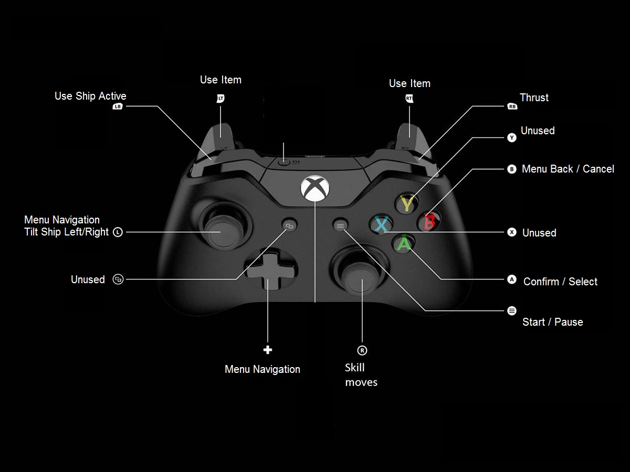

UI Flow Diagram

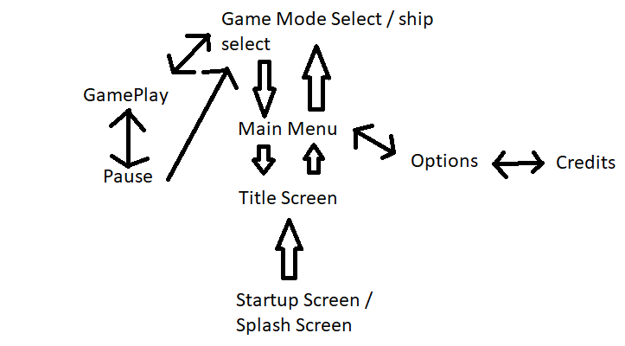

Screens

Startup / Splash Screen

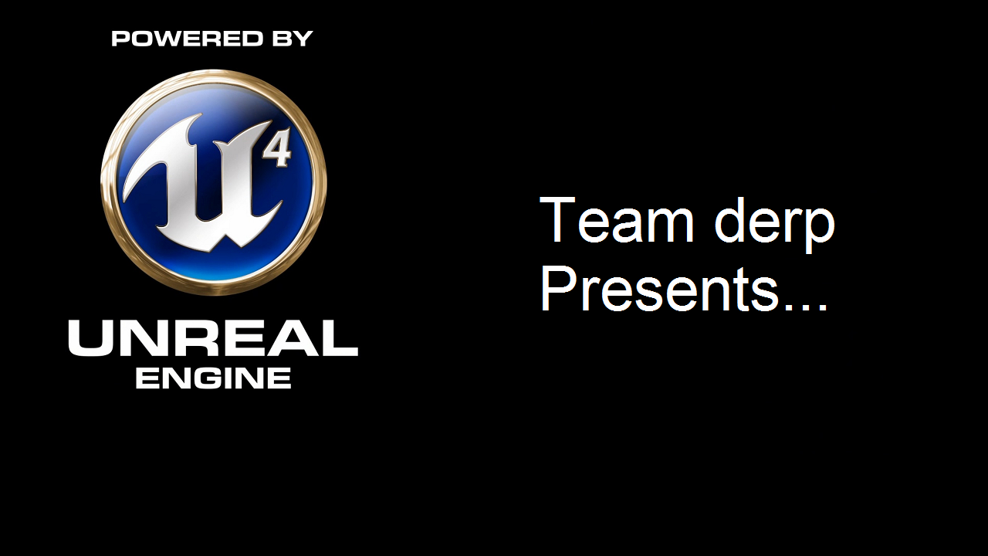

Title Screen

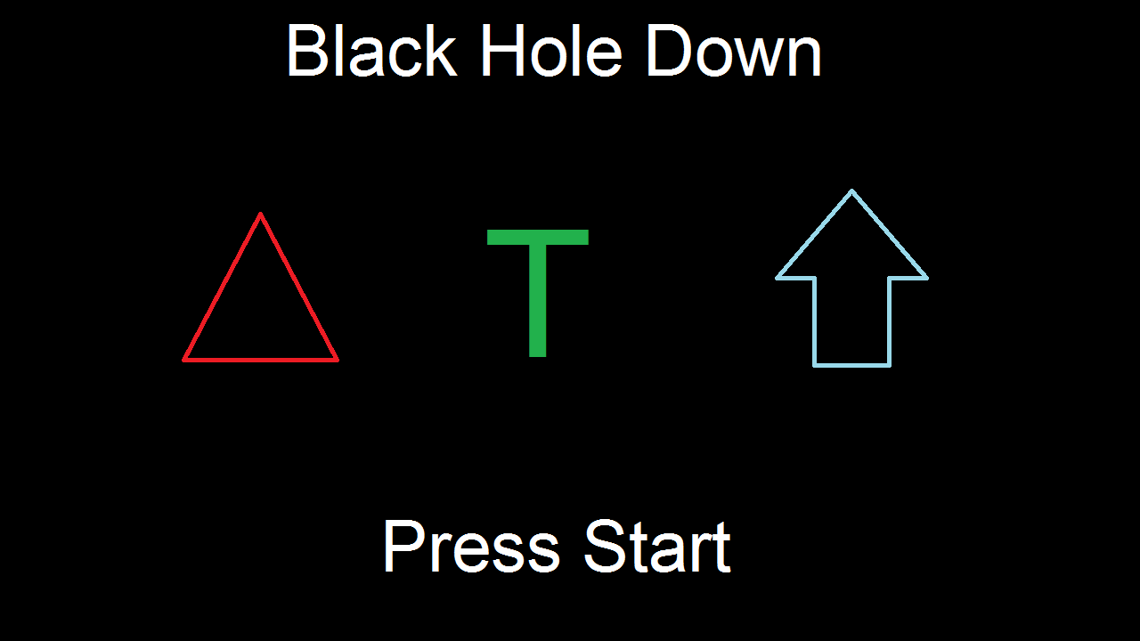

Main Menu

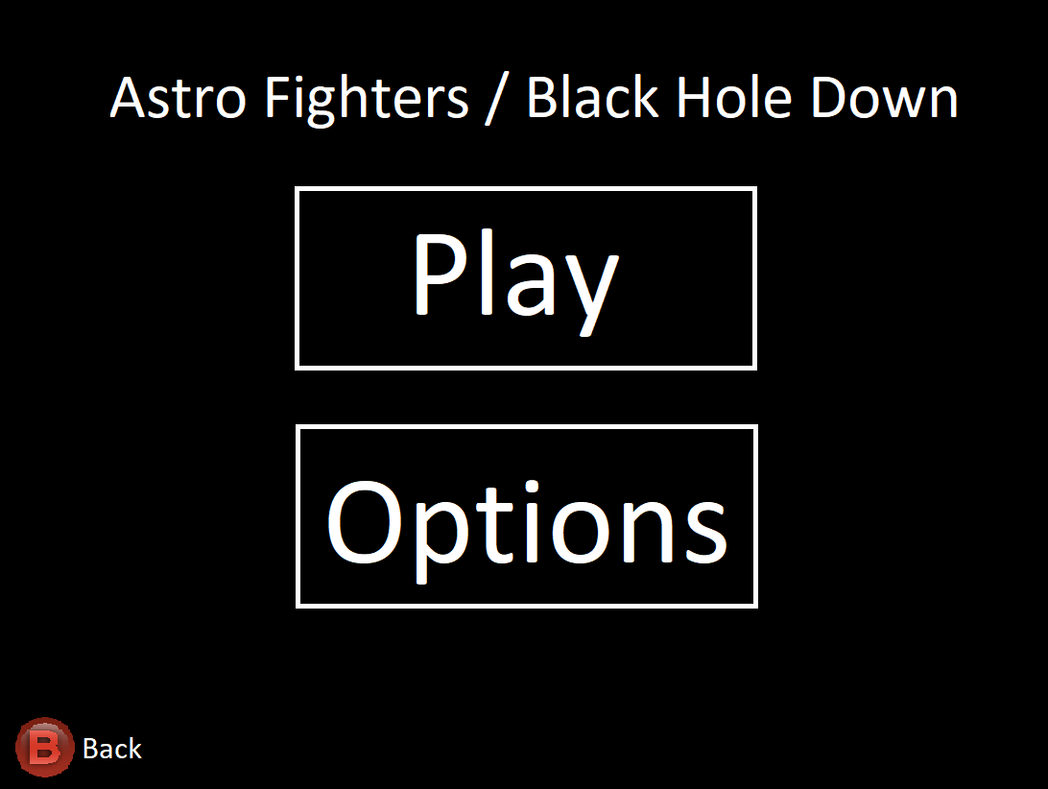

Options

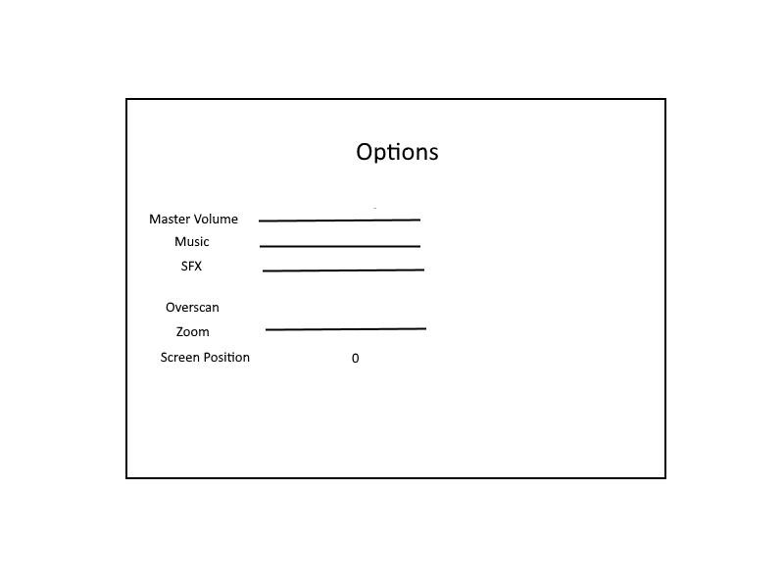

Credits

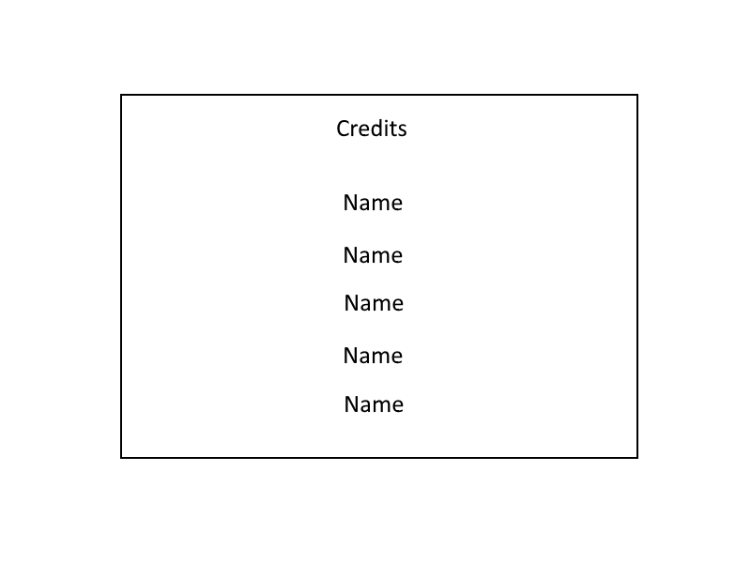

Game Mode / Character Select

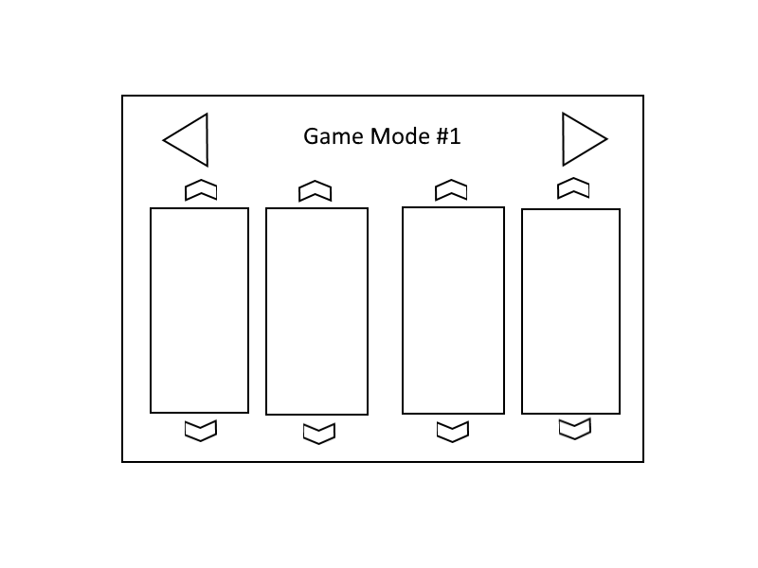

Game Play

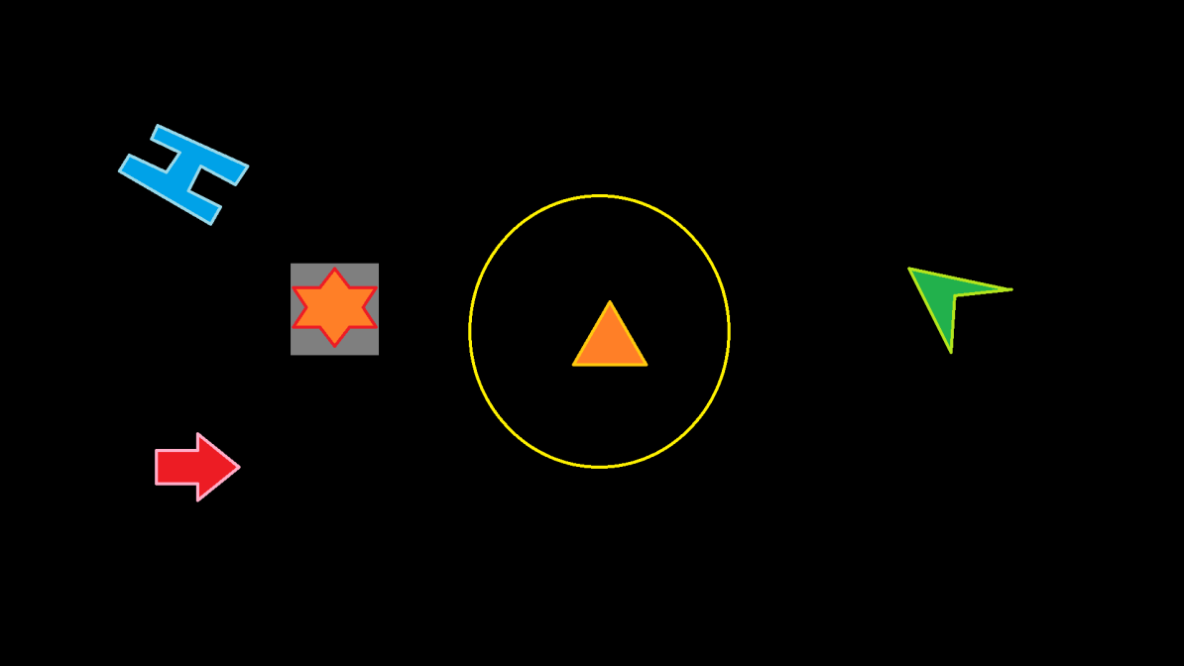

Paused

